Methodology Flowchart – Interfacing LoRa SX1278 with STM32 (Sender & Receiver)

This document describes the step-by-step methodology for interfacing the LoRa SX1278 module with the STM32 microcontroller, including both sender and receiver functionalities. It outlines the common initialization steps, followed by separate algorithms for the sender and receiver.

Flowchart Overview:

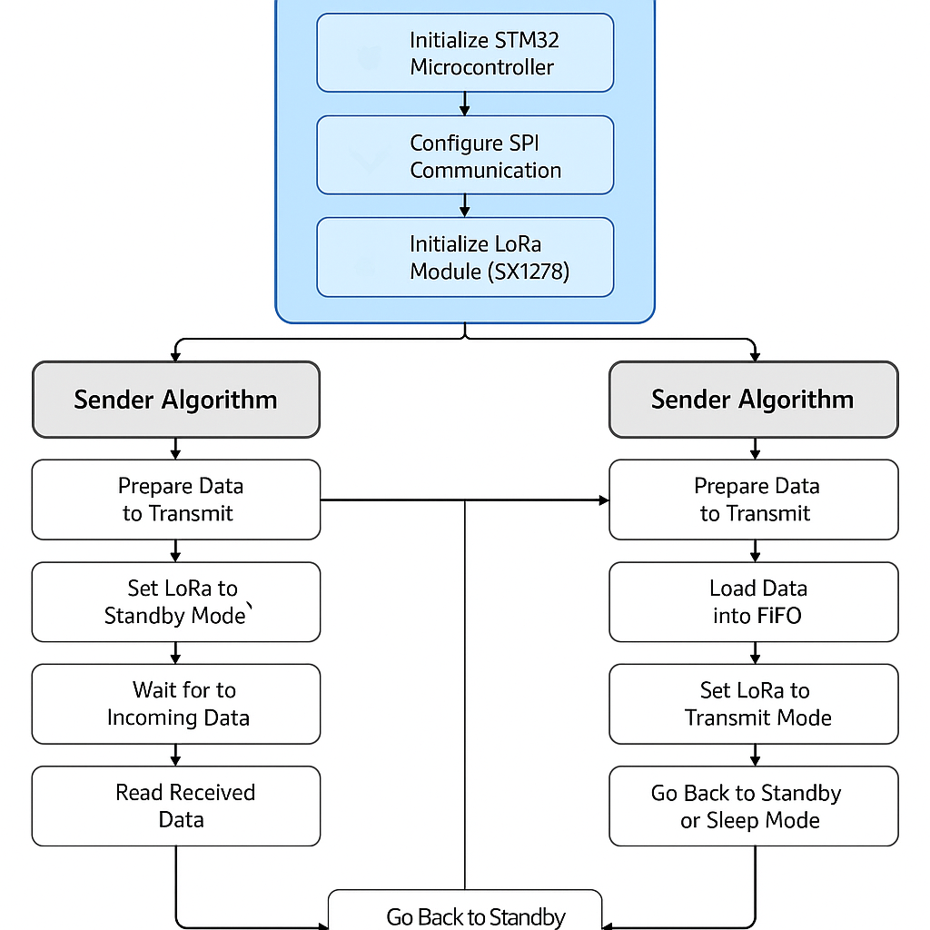

# Common Setup (Sender & Receiver)

1. Initialize STM32 Microcontroller: Set up system clock, configure GPIOs, SPI, and UART.

2. Configure SPI Communication: Initialize SPI with appropriate parameters (mode 0, MSB first, clock <10 MHz).

3. Initialize LoRa Module (SX1278): Reset LoRa, check version register, set frequency, configure SF, BW, CR, and power levels.

# Sender Algorithm

1. Prepare Data to Transmit: Gather and convert sensor or message data to string/byte array.

2. Set LoRa to Standby Mode: Ensure LoRa is ready before loading data.

3. Load Data into FIFO: Write payload to LoRa’s FIFO buffer.

4. Set LoRa to Transmit Mode: Trigger transmission and wait for TX_DONE.

5. Wait for Transmission Completion: Monitor IRQ or polling for TX_DONE flag.

6. Go Back to Standby or Sleep Mode: Save power after transmission.

# Receiver Algorithm

1. Set LoRa to Receive Mode: Choose continuous or single mode as needed.

2. Wait for Incoming Data: Monitor IRQ flags for RX_DONE.

3. Read Received Data: Access data from FIFO, check RSSI/SNR.

4. Process and Display Data: Convert and send data via UART.

5. Clear IRQ Flags: Reset interrupts to get ready for next packet.