**Infosys Recruitment Process 2025 Eligibility Criteria:**

|  |  |
| --- | --- |
| **Criteria** | **Details** |
| **Academic Qualification** | – Class 10th: 60% (6 CGPA) or above – Class 12th: 60% (6 CGPA) or above – College Graduation: 68% (6 CGPA on 10) or above |
| **Eligible Passing Year** | 2025 |
| **College Qualification Required** | – B.E., B.Tech. (All branches) , MCA , M.Sc. , BSc/BCA |
| **Eligible Branches** | All engineering branches |
| **Other Important Criteria** | – All percentages/CGPA should be calculated as a simple average for all subjects, semesters, and years, including electives, optional subjects, additional subjects, practical subjects, and languages. – No backlogs allowed at the time of the selection process – Maximum of 2 years education gap allowed between 10th and graduation – Candidates who participated in any Infosys interview process in the last 9 months are not eligible – Must be from a full-time degree course recognized by the Central/State Government of India – No pending attendance requirements with the college – If the candidate has completed both Class 12 and a Diploma, the higher score will be considered. – Candidates must be willing to relocate and work with different technologies as required by Infosys. |
| **Documents Required** | – 10th, 12th, and Graduation original mark sheets and copies – Updated resume (copy) – Passport size photographs – Original government-issued ID (Aadhar Card, PAN Card, Voter ID, Passport, etc.) |

Infosys Recruitment Process 2024

**Infosys Recruitment Process 2025 Job Role & Salary Package:**

|  |  |
| --- | --- |
| **Role** | **Salary (LPA)** |
| **Specialist Programmer** | ₹9.5 LPA |
| **Digital Specialist Engineer** | ₹6.25 LPA |
| **System Engineer** | ₹3.6 LPA |

Infosys Recruitment Process 2025

**Infosys Recruitment Process 2025 Hiring Workflow**

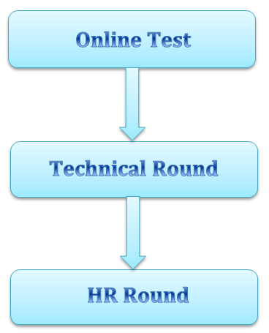

**Infosys Recruitment Process 2025: Complete Playlist**

**[Watch Now!](https://www.youtube.com/playlist?list=PLYA_1SYVpPQxZ_-VA2LvEZwKJ42W6BAxg" \t "_blank)**

**Infosys Recruitment Process 2025 Exam Pattern**

**Round 1:**

**Online Test:** The Infosys online test consists of questions in Quantitative Ability, Reasoning, and Verbal Ability, with a total duration of 95 minutes. Each section has a designated time limit, and all questions within a section must be completed within that time. While candidates can attempt the questions in any order within a section, they cannot switch between sections. This means a candidate must complete one section before moving on to the next.

|  |  |  |
| --- | --- | --- |
| **Section** | **No. of questions in test** | **Total Time** |
| **Mathematical Ability** | 10 Questions | 35 mins |
| **Reasoning Ability** | 15 Questions | 25 mins |
| **Verbal Ability** | 20 Questions | 20 mins |
| **Pseudo Code** | 5 Questions | 10 mins |
| **Puzzle Solving** | 4 Questions | 10 mins |

Infosys Recruitment Process 2025

**Round 2:**

**Technical + HR Interview:**

* This is a mandatory round.
* The Technical and HR interviews are conducted in a single session.
* Duration: Varies based on the interviewer, typically between 15-30 minutes.

**Technical:**

* OOP
* DBMS
* In depth knowledge of Preferred Programming Language
* SQL
* DSA
* Project In Depth Knowledge
* Any one of the trending technology
* Stream specific important topics

**HR:**

* Introduction
* Behavioural Questions
* Good research about the company

**Infosys Recruitment Process 2025 Detailed Syllabus**:

**Infosys Mathematical Ability Detailed Syllabus:**

* Number series and Letter series
* Time and Work
* Time, Speed and Distance
* Probability
* Ratio and Proportions
* Average
* Percentage
* Alligations and Mixtures
* Seating arrangements
* Permutation and combination
* Profit and Loss
* Direction sense
* Cryparithmetic

**Infosys Logical Reasoning Detailed Syllabus:**

* Puzzle
* Arrangements
* Syllogisms
* Coding Decoding
* Number series
* Clocks and Calendar
* Data Sufficiency
* Most logical choice
* Logical Deduction

**Infosys Verbal Ability Detailed Syllabus:**

* Sentence completion (4 Questions)
* Error correction (4 Questions)
* Error detection/ Identify correct sentence (4 Questions)
* Reading comprehension (5 Questions)
* Critical reasoning (3 Questions)

**Important concepts:** Tenses, Verbs, Articles, Vocabulary, Prepositions, Subject-Verb agreement, Parallelism

(Note: English is always said to be the toughest of the three sections in the Infosys online test, not because of the number of questions and shorter duration but due to the difficulty of the questions which are usually of GRE and CAT level)

**Infosys Pseudocode Detailed Syllabus:**

* Loops
* Operators
* Nested If-Else conditions
* Inheritance
* Method overriding
* Array
* Complexity analysis
* Insertion sorting
* Resizable array
* Functions
* Conditional statements