**CMSC 140 Programming Project 2**

**Chapter Covered:**

* Chapter 4

**Concepts tested in this project**

* [ALL concepts from previous projects]
* Selection control structure
  + The if statement
  + The switch statement (optional)
* Relational operators and logical operators
  + Use of relational and logical operators to check numeric ranges
* User friendly
  + Use of user friendly user prompt and simple input validation
  + Use of meaningful output labels and format
  + Use of output manipulators
* Working with string type
* Use of getline()

**Project Description**

There are two main systems for measuring distance, weight and temperature, the Imperial System of Measurement and the Metric System of Measurement. Most countries use the Metric System, which uses the measuring units such as meters and grams and adds prefixes like kilo, milli and centi to count orders of magnitude. In the United States, we use the older Imperial system, where things are measured in feet, inches and pounds.

Write a program that shows the following menu options and lets the user to convert from Metric to Imperial system:

Converter Toolkit

--------------------

1. Temperature Converter

2. Distance Converter

3. Weight Converter

4. Quit

* If the user enters 1, the program should ask for the temperature in Celsius and convert it to Fahrenheit
* If the user enters 2, the program should ask for the distance in Kilometer and convert it to Mile
* If the user enters 3, the program should ask for the weight in Kilogram and convert it to Pound
* If the user enters 4, the program should end.

**Project Specifications**

Input for this project:

* the user must enter an number to select a menu option
* the user must enter temperature in Celsius
* the user must enter distance in Kilometer
* the user must enter weight in Kilogram
* the user must enter a country name

Input Validation:

* Do not accept a number outside the range of 1 through 4 for the menu option. Be sure to display appropriate error message if the input is invalid.
* Do not accept negative numbers for distance and weight. Be sure to display appropriate error message if the input is invalid.

Output: The program should display the following:

* a menu for Converter Toolkit
* temperature in Fahrenheit, distance in miles or weight in pounds
* a country name
* Programmer’s full name
* project number
* a due date

**Processing Requirements**

1. The program should use at least one selection control structure (if – else statement)
2. Be sure to convert as specified. For example, convert temperature from Celsius to Fahrenheit, not the other way around.
3. Use the following for converting input:

* 1 kilometer = 0.6 mile,
* 1 kilogram = 2.2 pounds,
* The formula for converting Celsius degree to Fahrenheit is:

***F = (9/5)*C + 32*** where F is the temperature in Fahrenheit and C is the temperature in Celsius

1. Convert temperature to a whole number such as 78, distance to two positions after decimal point (for example 84.56) and weight to one position after decimal point (For example 121.6).

**Sample Screen Output #1:**

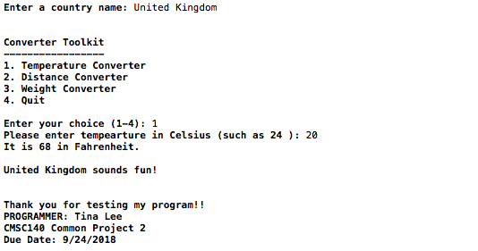

**Sample Screen Output #2:**

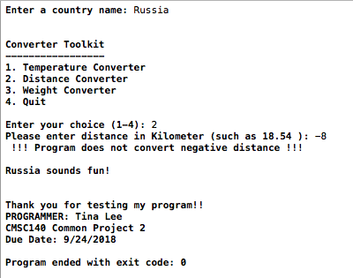

**Special Project Submission Requirements**

**Deliverables:**

* Intermediate deliverable:

Program design- Flowchart and/or pseudo code for the Program due one week after project is given. An intermediate assignment will be created for submission. Flowchart/pseudo code can be submitted electronically in the following format: word document, pdf or handwritten flowchart/pseudo code picture saved as .jpg or png.

**NOTE**: Be sure to check also

1. CMSC140 Common Project Submission Requirements (.docx)
2. CMSC140 Grading Rubric_CheckList-Project 2 (.xlsx)

**Test Plan**

Test your program with at least two more test cases. Use the given data as an example. Record your data for input and output in the following table. **Make sure your tests cover all the possible scenarios.**

|  |  |  |  |  |  |
| --- | --- | --- | --- | --- | --- |
| **Test Case #** | **Input** | **Actual Input** | **Expected Output** | **Actual Output** | **Did the test pass?** |
| 1 | Choice 1  Temp 20 |  | 68 |  |  |
| 2 | Choice 2  Distance -8 |  | Error message |  |  |
| 3 |  |  |  |  |  |
| 4 |  |  |  |  |  |