**How to download and install eclipse, and create Java Project**

1. Before downloading Eclipse, you need to install Java JDK 1.8

**(Don’t be fancy, download 1.8!!!)**

<http://www.oracle.com/technetwork/java/javase/downloads/index.html>

* 1. Select Java SE 8u201/Java SE 8u202
  2. Click JDK Download

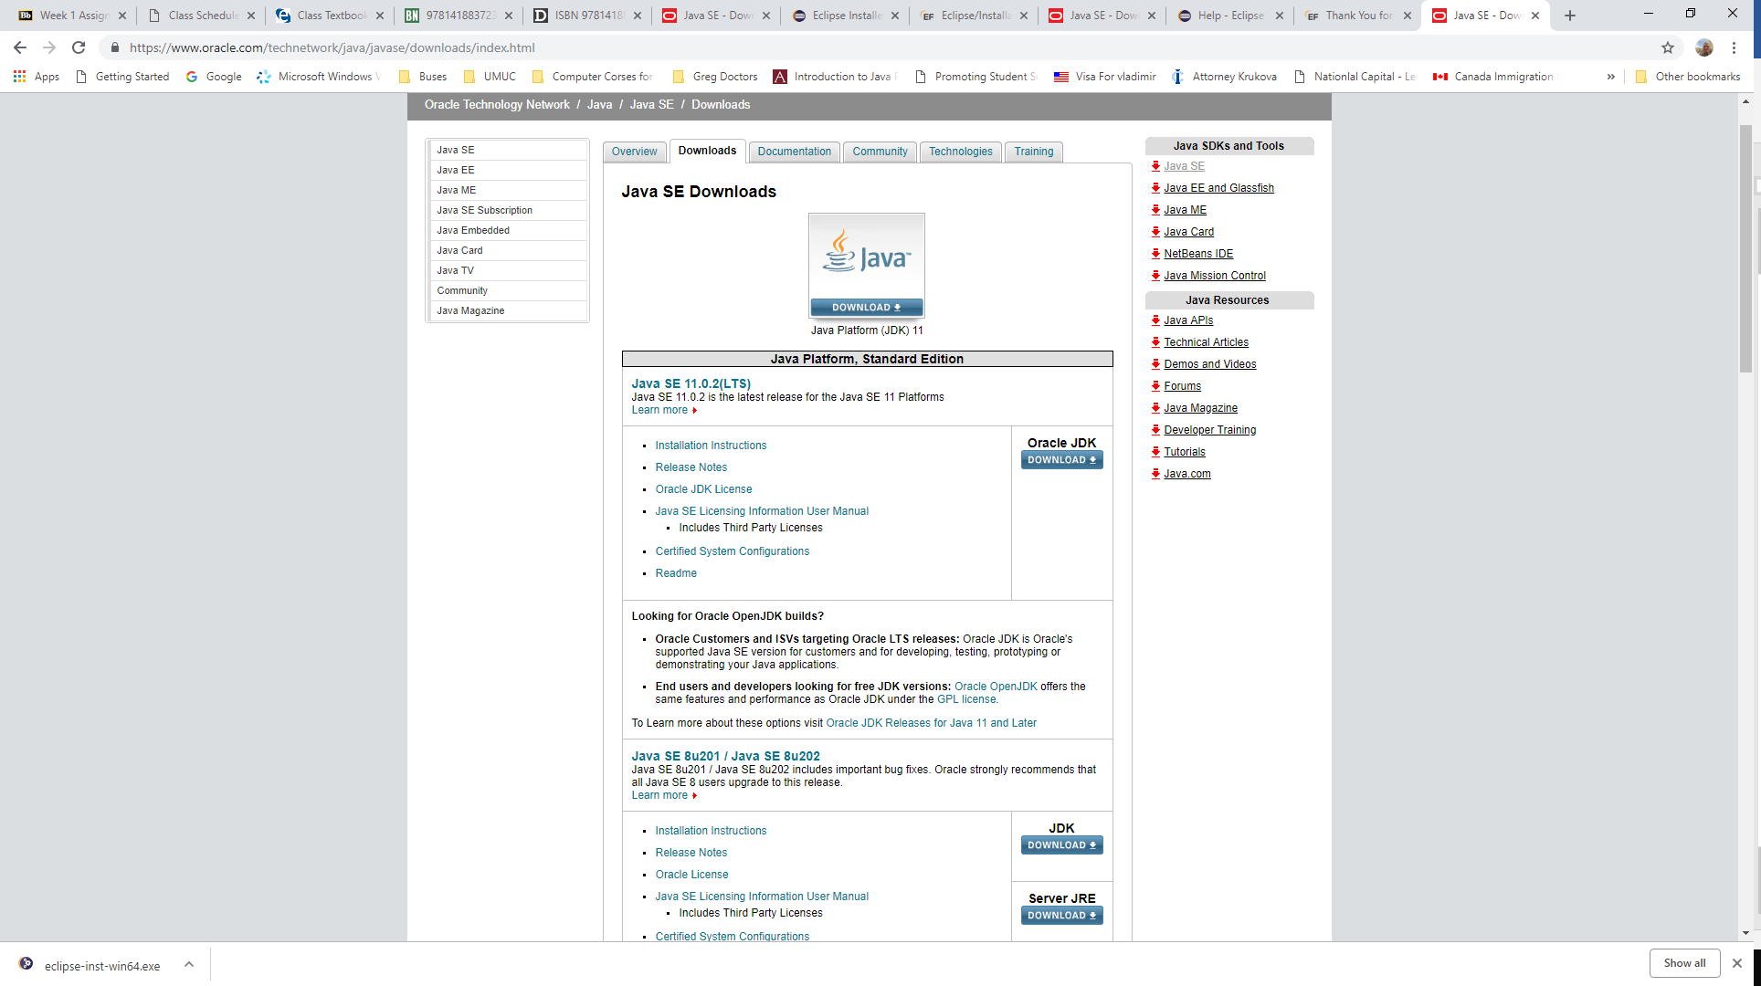

Select Product for your System, for example Windows x64, and click download

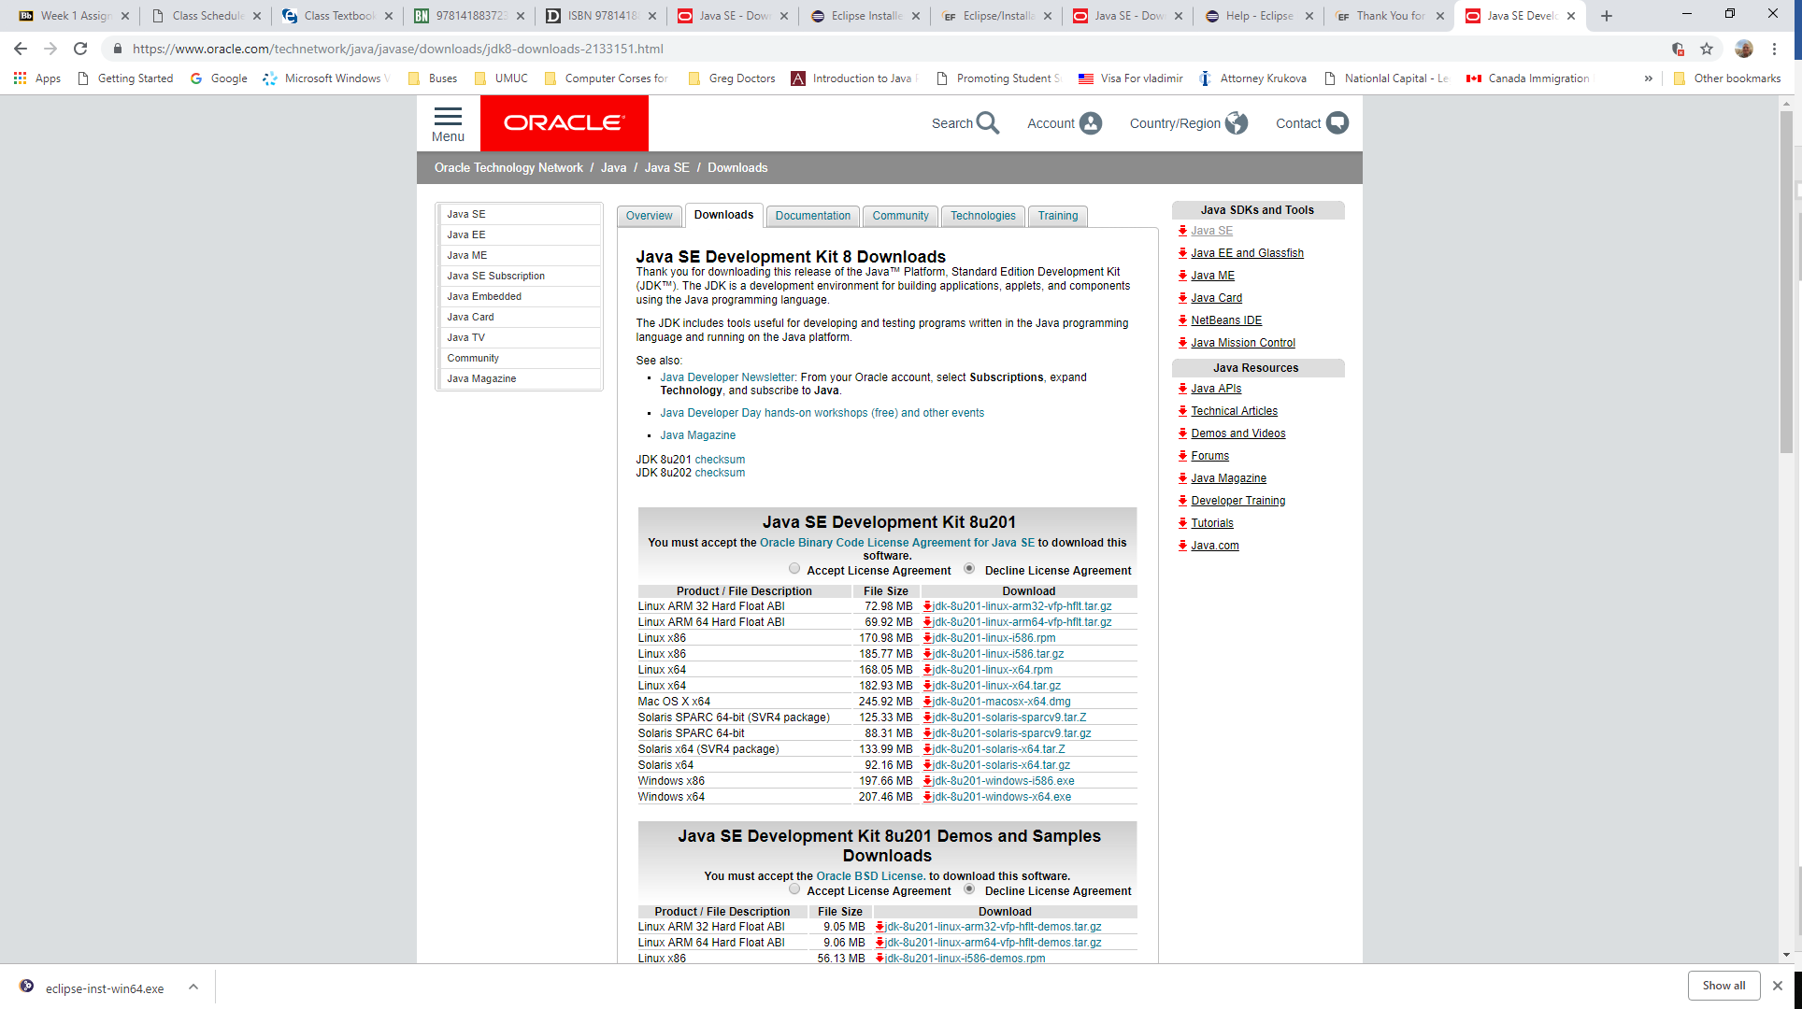

Then click jdk-8u201-windows-x64.exe file

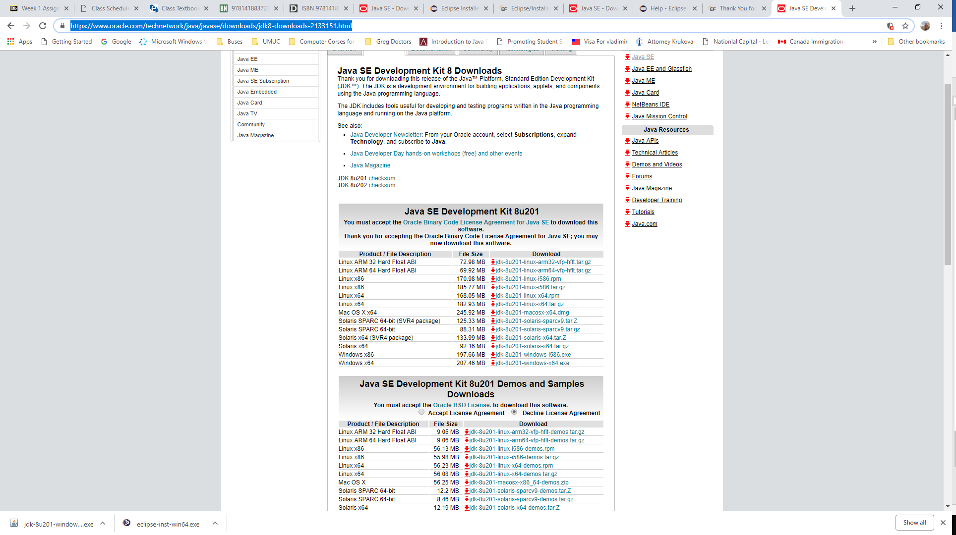

Click next

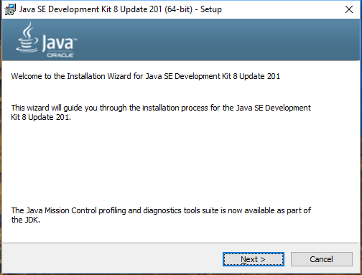

Click Next

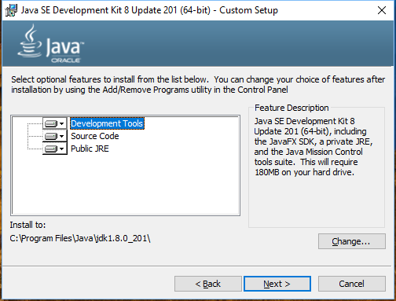

Click OK

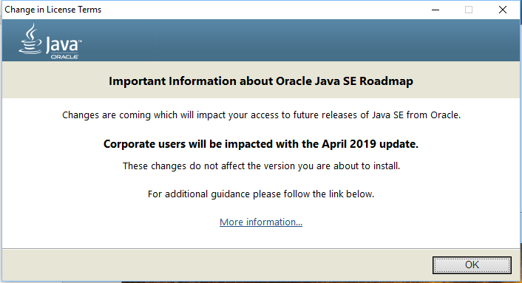

Click Next

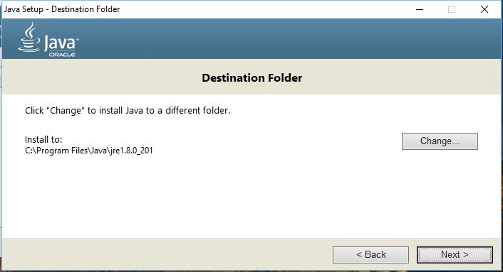

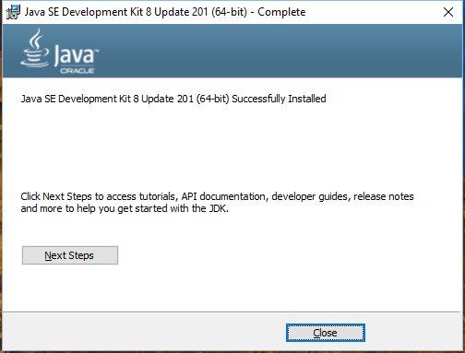

1. How to download, install eclipse and create Java Project

Go to website [www.eclipse.org/download](http://www.eclipse.org/download)

Click Download Packages

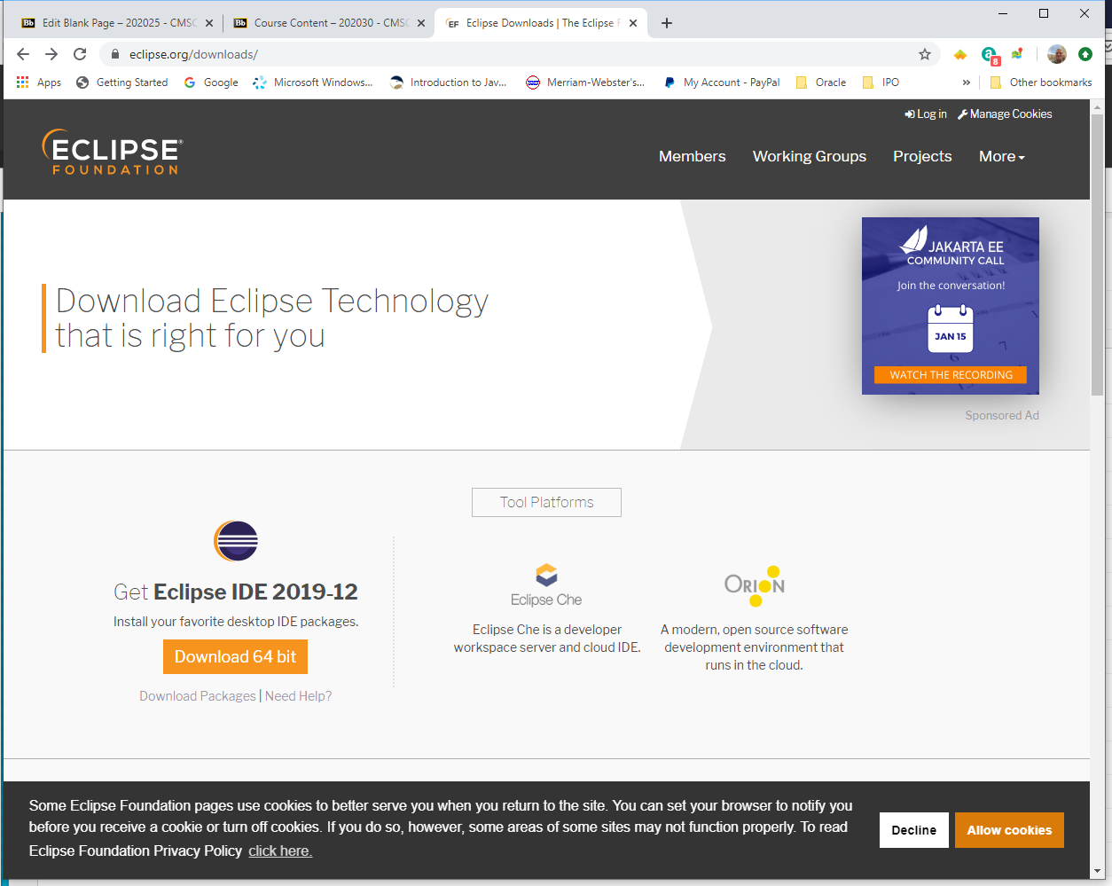

Select Eclipse IDE for Java Developer for your Operating System (Windows or Mac) and click it.

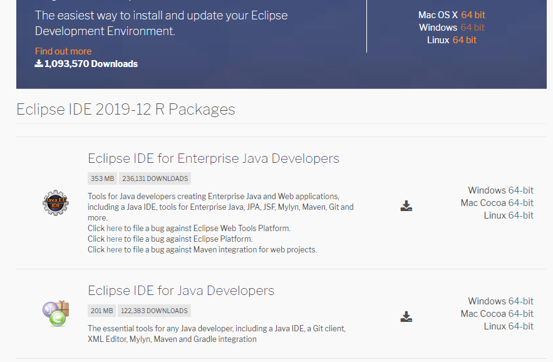

**For Windows 64:**

Click a button “Download”

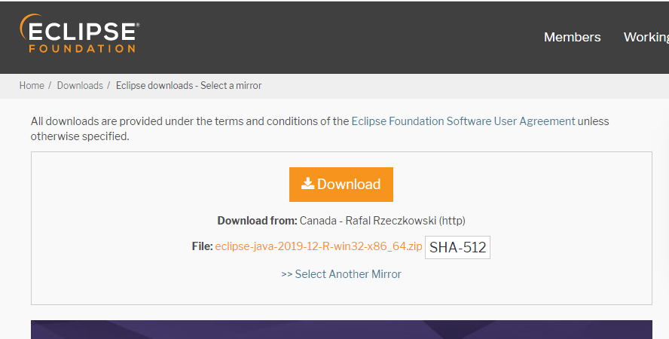

then download and unzip a file eclipse-java-2019-12-R-win32-x86_64.zip in eclipse directory and click

eclipse.exe

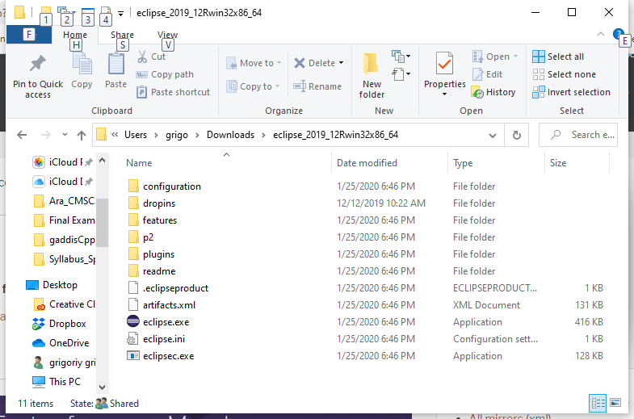

Click Launch

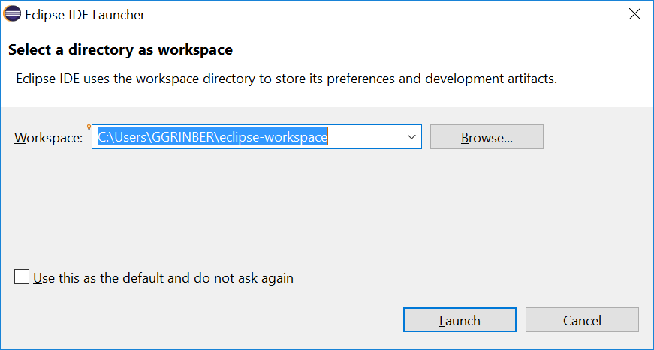

Click Create a new Java Project

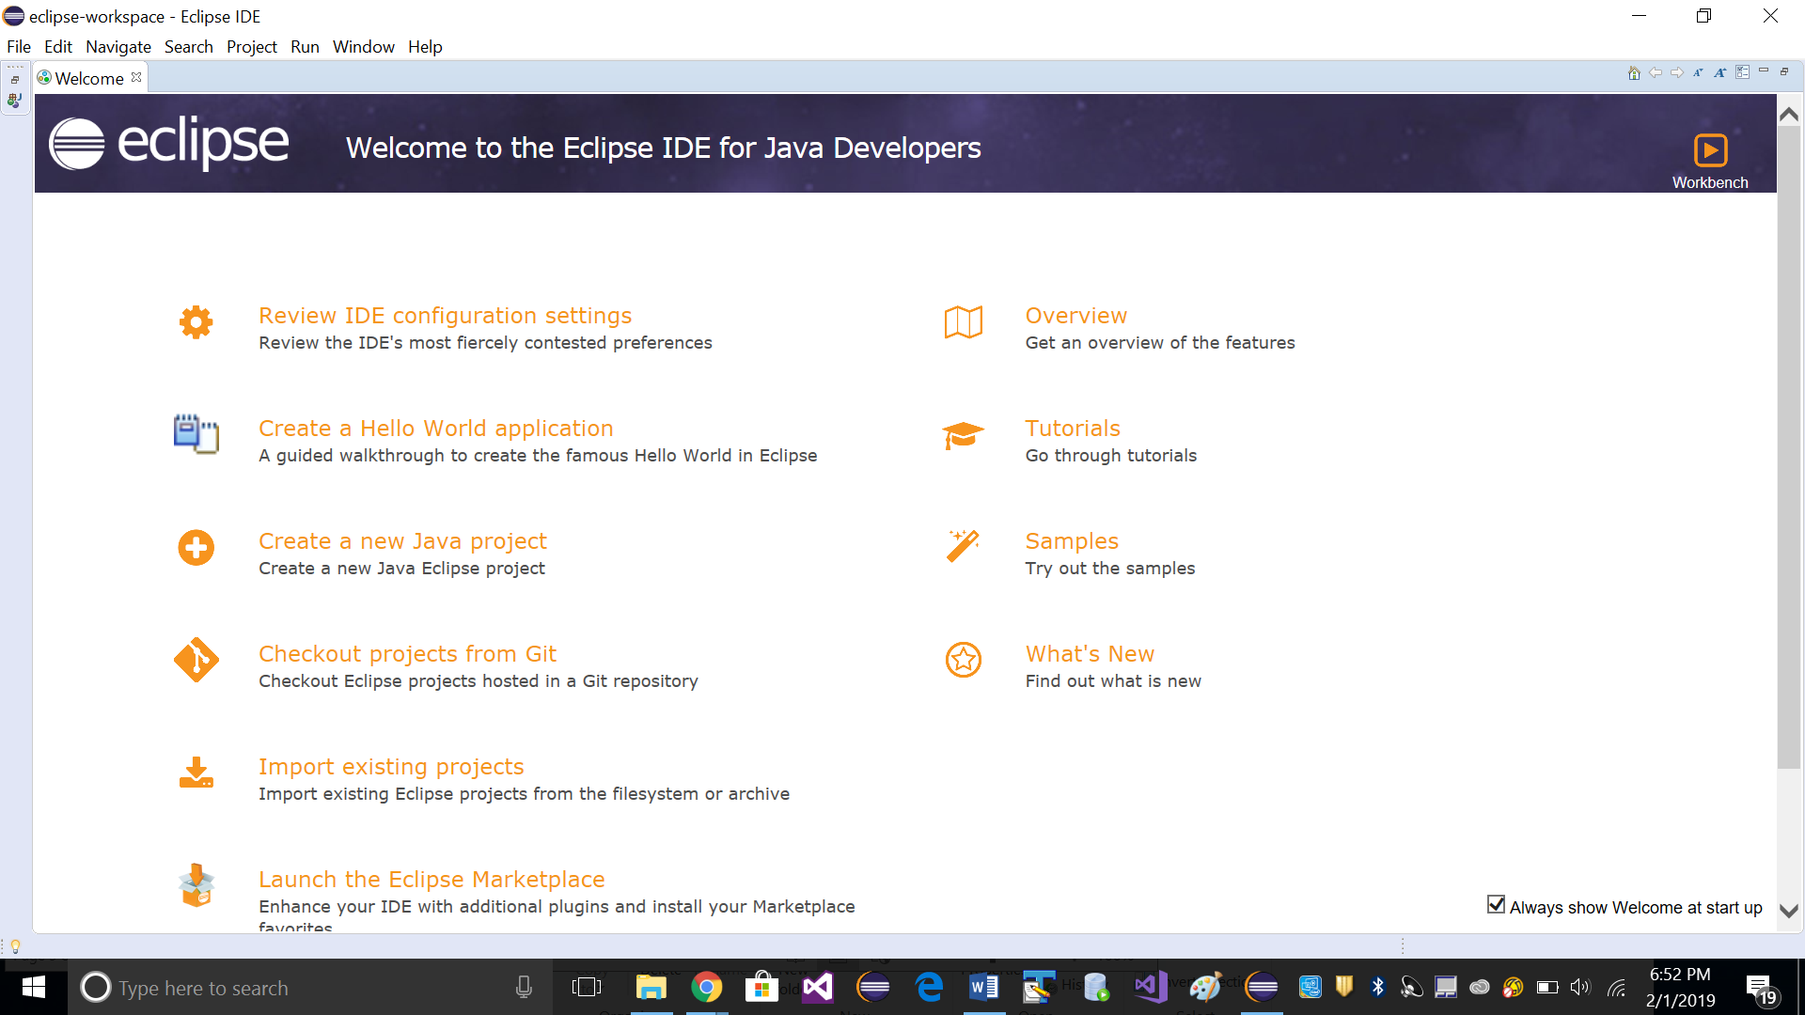

Type a Project Name In “New Java Project”, for example “cmsc201Spring20” and click Finish

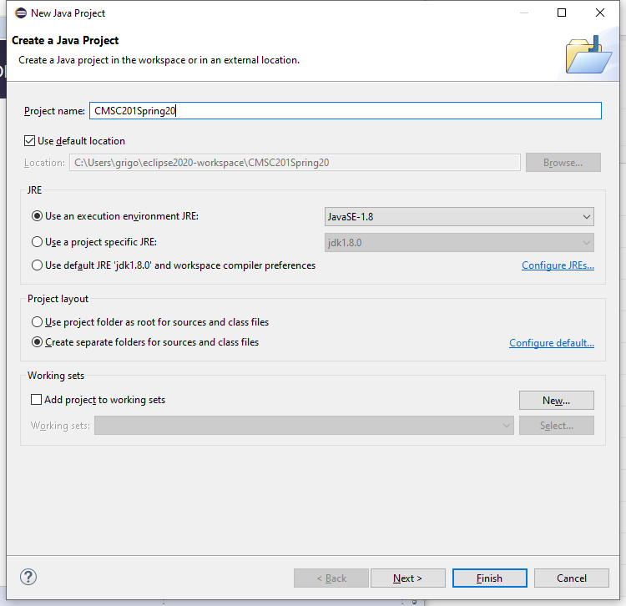

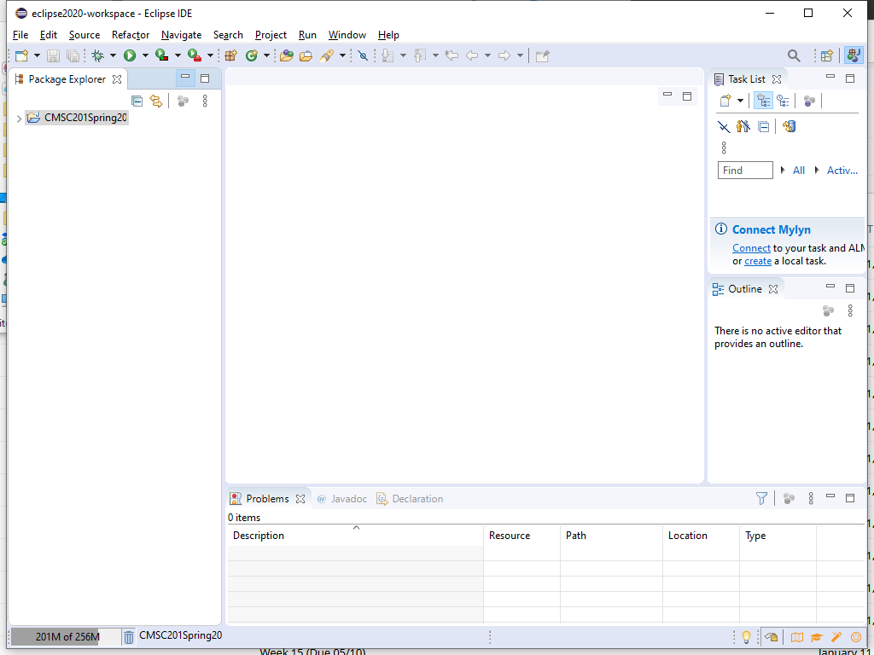

Right Click “CMSC201Spring20”-> Select “New”-> Select “Class”

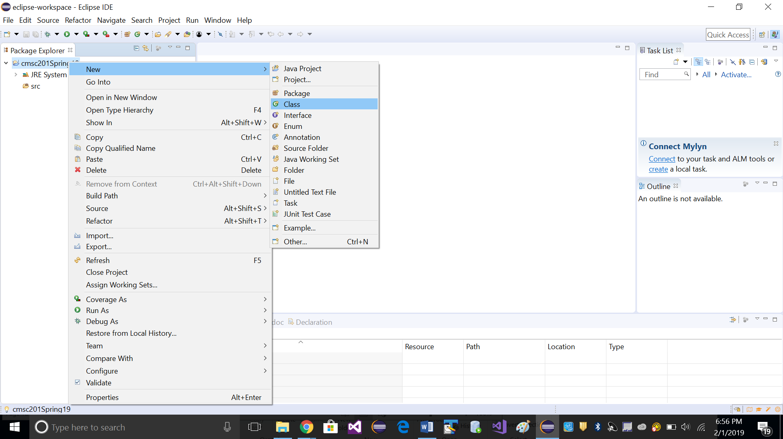

Fill out fields Source folder, Package, and Name. Check checkbox “public static void main” and click Finish

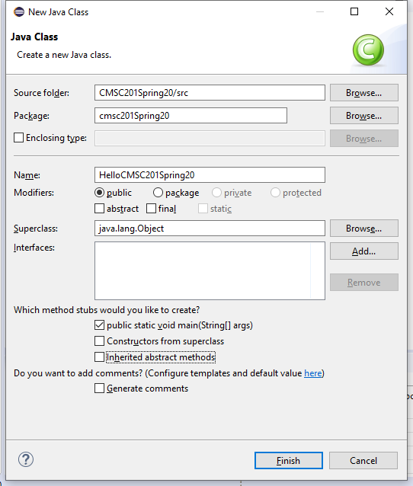

Type the following text here “System.out.println (“Hello CMSC 201 Spring20!”);

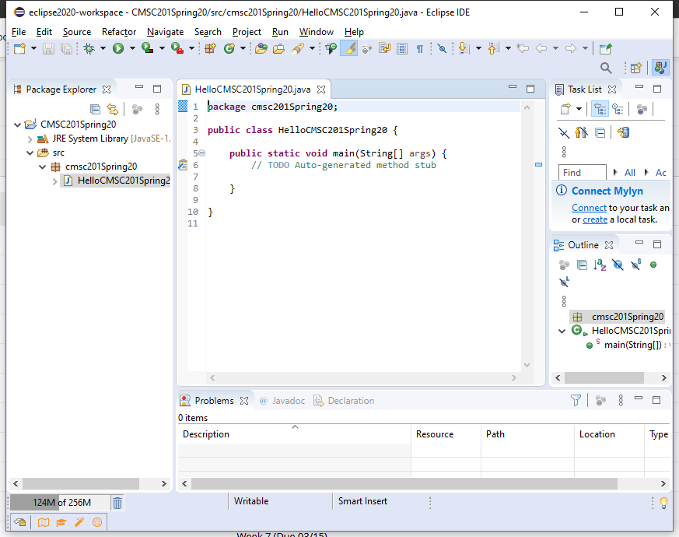

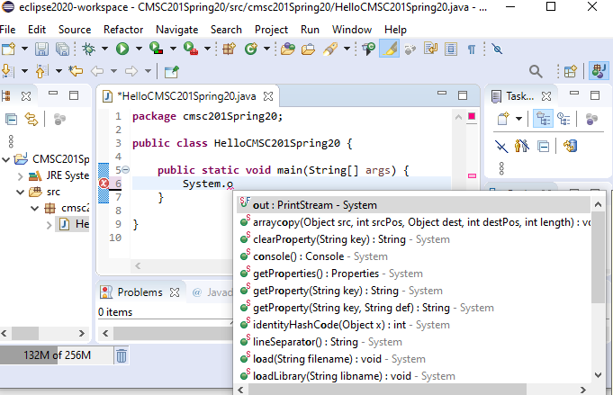

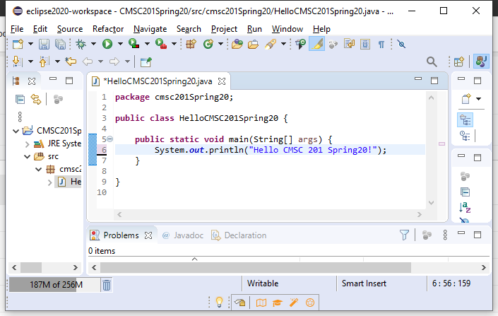

Then click arrow, select Run As and click 1 Java Application to run your Program:

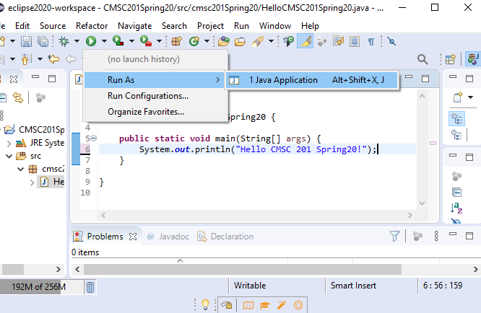

Click OK in Dialog Box ”Save and Launch”

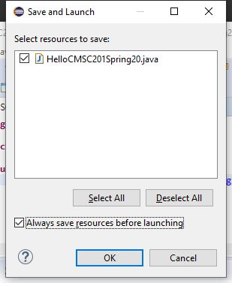

You can see output:

