Lab 2 Screen Shots

Task #1 Compilation Error Fixed

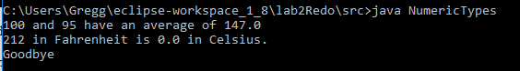

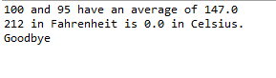

Task #2 Logic Errors Fixed

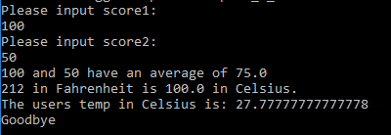

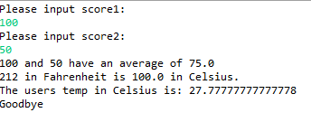

Task #3 User Input collected via Scanner

