Travel Preparation

By Meghana Arvind

Contents

Traveling 3

Importance of Travel Preparation 3

Warnings 3

Travel Preparation 3

Documentation 4

Schedule 3

Clothing 5

Electronics 6

Accommodation 6

Food 7

First Aid 8

Currency 9

Conclusion 10

Index 11

# Travel

Travel is a common adventure of many people worldwide. Whether it is local, domestic, or international, there are many options for sightseeing and excursions. Travel can be especially interesting if you are an avid photographer, writer, or even a souvenir collector. One exciting aspect to travel is that you can fill in a map of the world and increase the count of places you have visited with each trip you take. Regardless of your final destination, travel can provide many unique experiences that you can talk about for years to come. However, travel quite often requires a lot of preparation in advance.

# Importance of Travel Preparation

Despite the reason of your travel, planning and preparation allows you to:

Have a confirmed schedule of your activities

Be prepared for the unexpected, such as inclement weather, illness, or loss of valuable items

# Warnings

**Warning**: Weather could suddenly change at any point in time - see “Clothing.”

**Warning**: You may get sick, especially if you enter places where germs spread easily, such as a beach or a swimming pool, or if a disease is common – see “First Aid.”

**Warning**: If you travel abroad, there may be safety and security advisories due to various events that are occurring in the country of interest.

* + If you are a United States (US) citizen, check the [US State Department](https://travel.state.gov/content/travel/en/traveladvisories/traveladvisories.html) website, which provides travel advisories for different countries.
  + If you are located outside of the US, your country’s government website may contain information about travel advisories.

# Travel Preparation

## Schedule

When you create a travel schedule, arrange the following information in an organized manner in order for anyone who accesses the schedule to be informed, in detail, of expectations:

Dates and times of travel

Methods of transportation

Accommodation

Places you will travel to

People you will travel with

Expected weather for your dates of travel

Attractions you will visit and ticket requirements

Nearby restaurants and shopping

Many popular travel websites such as [KAYAK.com](https://www.kayak.com/), [Expedia](http://www.expedia.com), and [TripAdvisor](http://www.tripadvisor.com) provide further information on all of the above. The main purpose of such travel websites is to purchase transportation, accommodation, and excursions for travel; However, if you have more specific concerns that those websites do not provide easily, there are also many forums with questions and answers from experienced travelers that address many common concerns, such as weather and safety of destinations. You can find the forums either through a search engine or through the travel websites themselves.

## Documentation

Ensure that your travel documentation is up to date - the expiration date of any documents should be after the last date of your travel. If possible, prepare your documentation ahead of time, especially if there is a deadline by which your documentation will need to be ready.

If you will need to apply for or renew documentation, search for the office closest to you that provides travel documentation services. Take note of any requirements needed for travel documentation as well as processing time.

* Requirements may include: proof of citizenship, proof of emergency or scheduled travel, identification, photo, and/or a processing fee
* Processing time can be up to over a month or as little as few weeks for expedited service

**Figure 1: Passport  
  
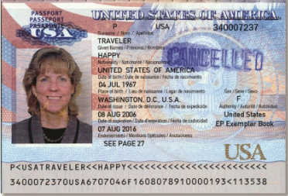**

For example, if your date of travel ends on August 1, 2016, be sure that your passport expiration date is on or after August 2, 2016. (In Figure 1, the passport expiration date is August 7, 2016).

For international travel, you may need to apply for a visa, which depends on the following factors:

Purpose of travel: tourism, business, employment, or education

Length of stay

Country of citizenship

Check your country of interest’s visa requirements for further information.

In case you lose your documentation:

Ensure that you can easily access a copy of your documentation, whether it is a printed or electronic copy. If you have a printed copy on your person, it will be helpful in the case that you are not able to access an electronic copy.

If you can easily access a phone or the Internet, contact your country of citizenship’s closest embassy or consulate office within the country you are traveling and provide them with detailed information about your specific situation.

## Clothing

Ensure that you bring clothing and footwear both appropriate to weather and the purpose of your trip.  
  
Weather is likely to change, and if it is for the worse, outdoor activities can often become difficult. Extra clothing will protect you in inclement weather as well as provide a change of clean clothes.

In general: undergarments, shirts, pants, sweatshirts, jackets, gloves, hats, scarves, socks, and/or footwear

Rain: poncho or a raincoat

Snow: snow pants, thermals, long socks

If you will participate in an activity that involves a lot of strenuous walking, such as hiking, you should wear comfortable sneakers instead of open-toed footwear, such as sandals.  
  
**Figure 2: Example of inappropriate footwear for going hiking  
  
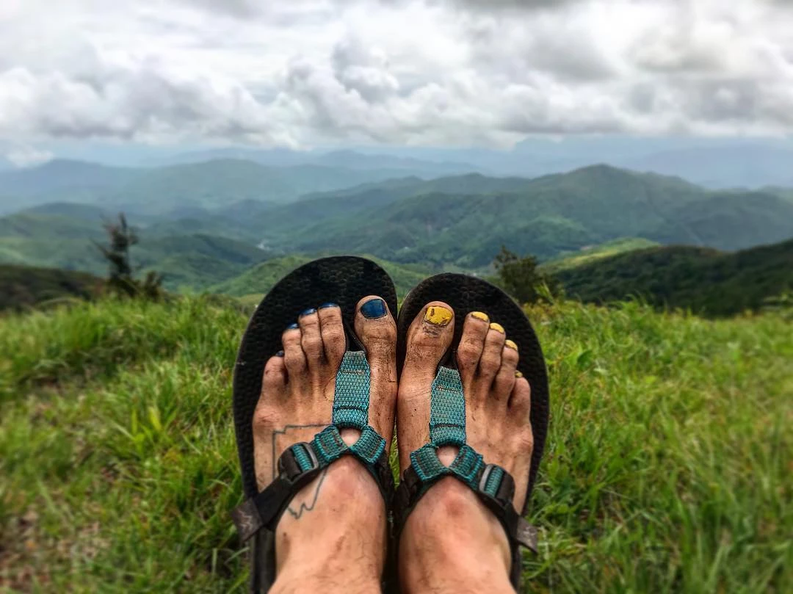**  
If possible, you should always pack a pair of comfortable and if possible, clean, sneakers. Sneakers will protect your feet from insects, animals, and inclement weather as well as serve as formal footwear in places where casual, open-toed footwear may not be not permitted.

## Electronics

Electronics are essential, especially for communication.

Ensure that you can easily access a list of your emergency contacts, whether it is a printed or electronic copy. If you have a printed list on your person, it will be helpful in the case that you are not able to access the contacts electronically. Emergency contacts can include:

Family or friends

Your country of citizenship’s embassy and consulate

Medical clinics (hospitals, doctor’s offices, urgent care)

Local police

The following is a list of recommended electronics to bring on any type of travel:

|  |  |
| --- | --- |
| Highly Recommended | Optional |
| Cell phones or hand held radios for places that may not have good cellular signal | Camera |
| Chargers for any electronics | Forms of entertainment such as video games, handheld devices, etc. |
| Extra batteries | Headphones |
| Flashlight |  |

## Accommodation

Based on various criteria, there are many options for accommodation during your trip. Travel websites such as [KAYAK.com](https://www.kayak.com/), [Expedia](http://www.expedia.com), and [TripAdvisor](http://www.tripadvisor.com) provide various options for accommodation; However, for a larger variety of options, websites such as [Booking.com](http://www.booking.com) and [Hotels.com](http://www.hotels.com) are specifically meant to research and book accommodations.   
  
Criteria to filter with can include budget, type of accommodation, inclusions in the accommodation, options for food, length of stay, safety, location, and much more. Often, the travel websites allow you to filter by any or all of the criteria and will provide you with the best options based on those filters. Although the websites provide you with location information such as nearby attractions, shopping, and restaurants, you may have to perform further research into the safety of that area.   
  
Figure 3: Example for a search on Booking.com for a stay in Boston, filtered by various criteria such as location, dates of travel, budget, and type of accommodation on Booking.com  
  
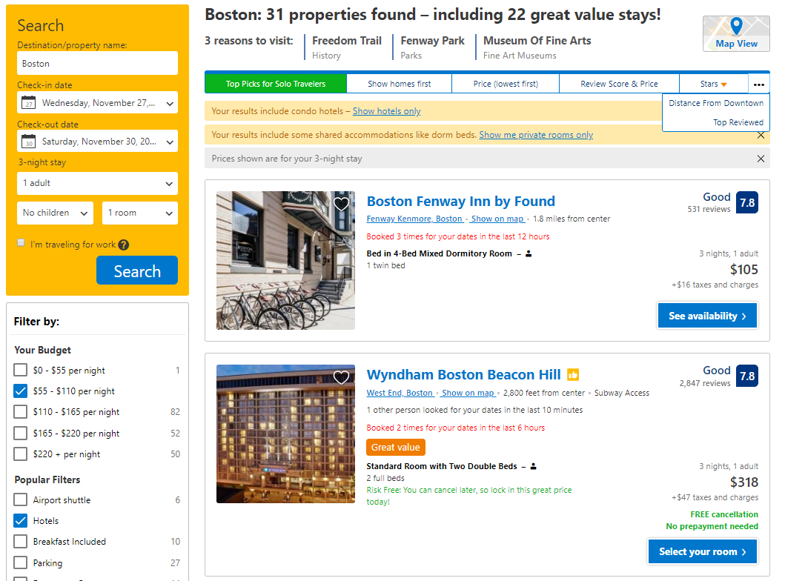

## Food

Keep food such as a small set of snacks during your travel, especially if there are no restaurants or stores located nearby.   
  
The food should be non-perishable, should not leak, and should be easy to travel with.

Examples include:

Chips packets

Juice boxes

Trail mix

You also should always have plenty of drinking water with you. Drinking water can help you stay hydrated and energized as well as satisfy your hunger if you do not have food to eat.

## First Aid

Always have first aid items (even a small kit with the essentials) with you in case of emergencies, to temporarily reduce any pain.

For immediate treatment, pack the following recommended items:

First aid kit that includes items such as:

* + Band-aids
  + Antiseptic cream
  + Gauze
  + Dressing
  + Sticky tape
  + Cleansing wipes

Different medication such as cough medicine, pain reliever, and antacids for heartburn or stomach acid

Know where the closest medical clinics are within every place you will travel to, including urgent care, hospitals, and doctors’ offices. Take note of their contact information as well as the most convenient method of transportation to those places.

Research or contact your medical coverage provider to know if the coverage will apply to where you will travel. If necessary, purchase coverage that is accepted in your location of travel for everyone you will travel with for the duration of your trip.

If you will require vaccination before traveling, go to a medical clinic for any specific vaccinations that you may need. Request official documentation from the clinic if you are asked for proof of vaccination on your trip.

**Figure 3: Sample first aid kit for international travel**

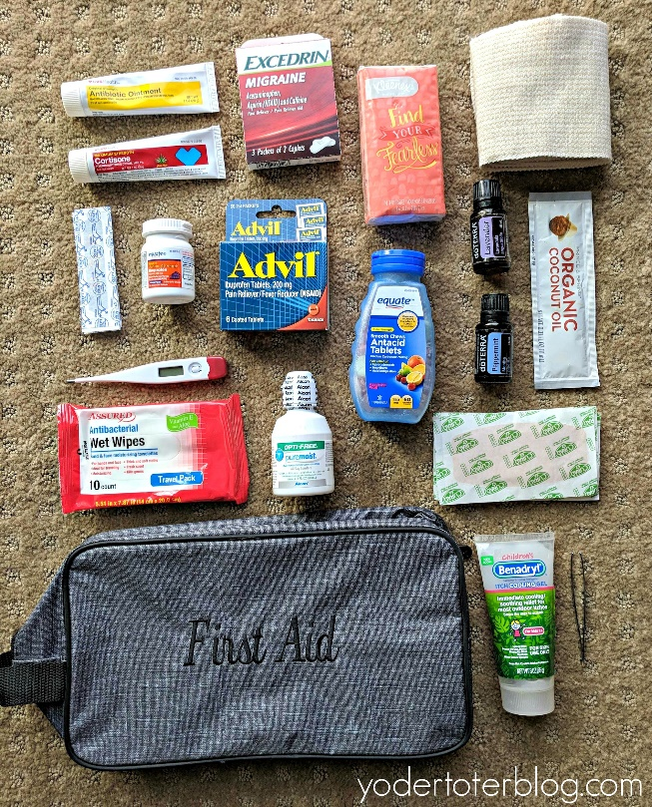   
  
This example travel first aid kit includes: pain medication, antacids, wet wipes, band-aids, gauze, a thermometer, and more.

## Currency

Without currency, it is almost impossible to travel. It is especially important to have enough money during your travel in case of any emergencies.

Research the currency exchange rates (if applicable) in advance - not all places will accept your country’s currency, especially in any smaller or local shops.

You should carry both cash and a credit card, for a few reasons:

* + Not all places will accept cards.
  + Either the cash or card(s) can potentially get stolen, which means that one can be the backup for the other.

If you lose some or all sources of your currency during your travel, you can use some of the following options:

If you have easy access to a phone or the Internet, you can contact:

* + Friends or relatives to send you cash
  + Your bank to cancel any credit cards
  + Your country of citizenship’s closest embassy or consulate office within the country you are traveling and provide them with detailed information about your specific situation

You can withdraw cash from an ATM; However, be aware of ATM fees as well as identity theft if the ATM is not located in a safe and secure area.

# Conclusion

The most important part of travel, if appropriate, is to relax and have fun! Travel can bring a great deal of stress into peoples’ lives; However, once you complete the trip, you will come to realize it was worth every moment.

# Index

A

Accommodation

budget, 7

C

Clothing

footwear, 5

inclement, 5

strenuous walking, 5

Currency

ATM, 10

exchange rates, 9

D

Documentation

expiration, 4

identification, 4

passport, 4

proof of, 4

visa, 4

E

Electronics

communication, 6

F

First Aid

clinics, 8

medical coverage, 8

medication, 8

treatment, 8

vaccination, 8

L

lose

currency, 9

documentation, 5

P

Preparation, 4

Accommodation, 6

Clothing, 5

Currency, 9

Documentation, 4

Electronics, 6

First Aid, 8

Food, 7

Schedule, 3

S

Schedule

purchase, 4

travel websites, 4

T

Traveling, 3

W

Warning, 3

advisories, 3

safety, 3

security, 3

sick, 3

Weather, 3