Practical
Emma Cliffe
2025-10-13

Todo
Have a look at the GitHub course repository issue. The work below should be done as part of a GitHub repository.
- Download, read through and knit the attached R markdown file (R_Rstudio_Rmarkdown.Rmd) to pdf. This is to ensure you are able to output pdfs, which you will need to submit your final report.
- Create a new R markdown file.
- Create at least two code chunks in between your text. (It can be any text and any code, it doesn’t need to be meaningful.)
- In your text, add section headers, and at least one numbered list and one unordered list.
Remember to tick off each item on the course repository issue as you complete them!
That is the numbered list done, since I copied and pasted it and had to add the numbers back! I’ve added a section header already. Here are two code blocks (though I added the one above too).
summary(cars)
## speed dist
## Min. : 4.0 Min. : 2.00
## 1st Qu.:12.0 1st Qu.: 26.00
## Median :15.0 Median : 36.00
## Mean :15.4 Mean : 42.98
## 3rd Qu.:19.0 3rd Qu.: 56.00
## Max. :25.0 Max. :120.00
describe(cars)
## vars n mean sd median trimmed mad min max range skew kurtosis
## speed 1 50 15.40 5.29 15 15.47 5.93 4 25 21 -0.11 -0.67
## dist 2 50 42.98 25.77 36 40.88 23.72 2 120 118 0.76 0.12
## se
## speed 0.75
## dist 3.64
A very quick visual…
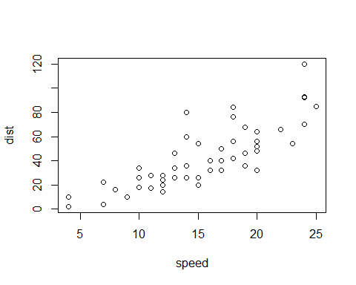

Have I finished?
- Now I have…
- Once it is published on github, anyway

