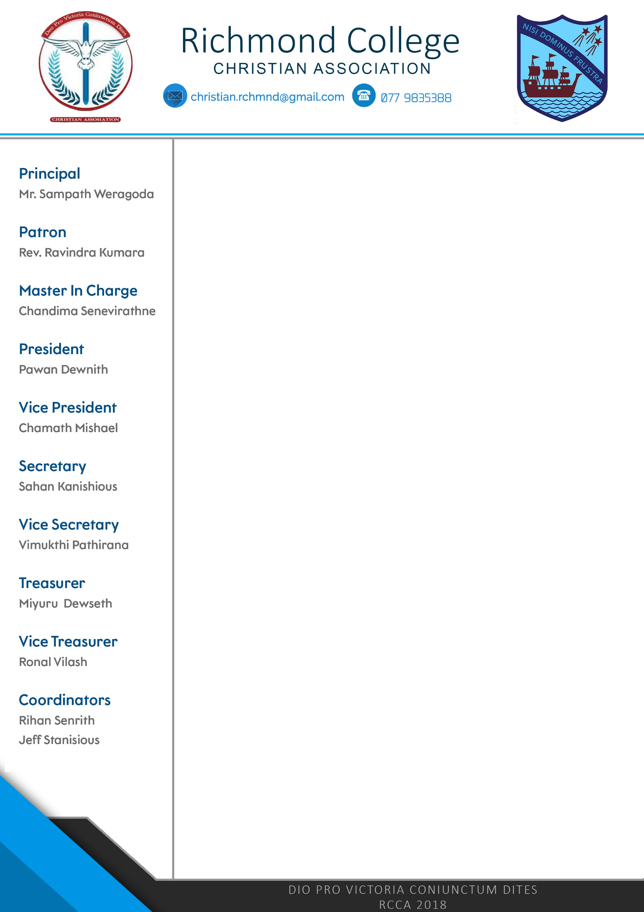

The Secretary,Christian Association,Richmond College,Galle.Dear Sir / Madam,Request for DonationsIt is with great pleasure, The Christian Association of Richmond College, Galle, wishesTo organize the annual Christmas Programme to display the talents and skills of the young Richmondites who will conquer the world tomorrow.This event is scheduled to be held on 5th December 2018. As a school association, organizing a programme of the magnitude is a difficult venture as it requires a lot of financial support. But, bearing the fact in mind, ‘if there is a will, there is a way’ we are determined to make this event a successful and a memorable one with the generosity and the goodwill of well-wishers and great personalities like you.

Therefore, your kind contributions, both financial and materials according to to your capacity are very much appreciated.

The proposed budget is as follows,

* Refreshments for 400 packs Rs. 45,000
* Souvenirs Rs. 70,000
* Lights & Sounds Rs. 50, 000
* Decorations Rs. 30, 000
* Other Expenses Rs. 15, 000

We are looking forward to making this event a glorious and a memorable one. For further information in this regard, please do not hesitate to contact the President (RCCA) on the following numbers.

0779835388 / 0722464618

Your kind consideration and cooperation in this regard are highly appreciated.

Thanking you,

Yours Faithfully,

…………………………….. ……………………………..

Secretary President

……………………………. ……………………………..

Teacher in Charge Principal