Question 1:

**The sequence diagram must ‘add’ data to the system**

**Case study:** Naheed works with Susan to support Customers, specializing in working with new customers. She spends a large portion of her day responding to customer request for service, resolving existing customer concerns and responds to customer feedback

This diagram is for adding customer information the process that take place through. The process shows how Naheed interact with system and customer to insert information and kind of the service they need. The class diagram is provided for better understanding of the project.

Question 2a:

**Case study:** Jie receives and ensures that all bills are paid – this includes utilities, marketing expenses, supplies and employee payroll. Jie then sends 5% of profit cheques to the local schools that have applied for donation.

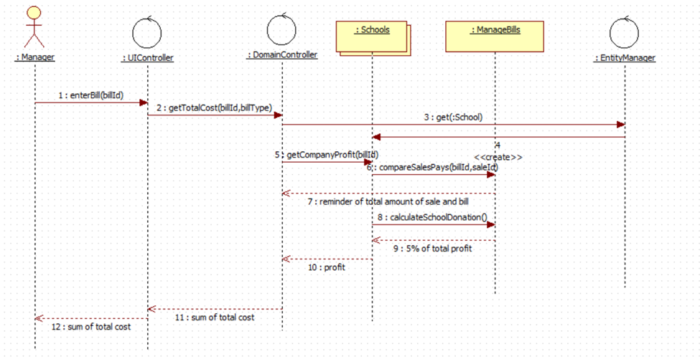

The process shows how Jie the manager of company receive bills and calculate the total cost of company. Actually, it show how he calculate the profit and sends 5% percent of the profit for school donation. The generalized and inherited class are shown in class diagram in the UML file.

Question 2b:

**The sequence diagram must ‘update’ existing data in the system**

**Case study:** Jie receives and ensures that all bills are paid – this includes utilities, marketing expenses, supplies and employee payroll. The majority of Antoine’s Landscaping employees are seasonal help, contractors and part-time staff. Every week, seasonal help and part-time staff submit time sheets to Jie and contractors submit invoices when their respective projects are complete

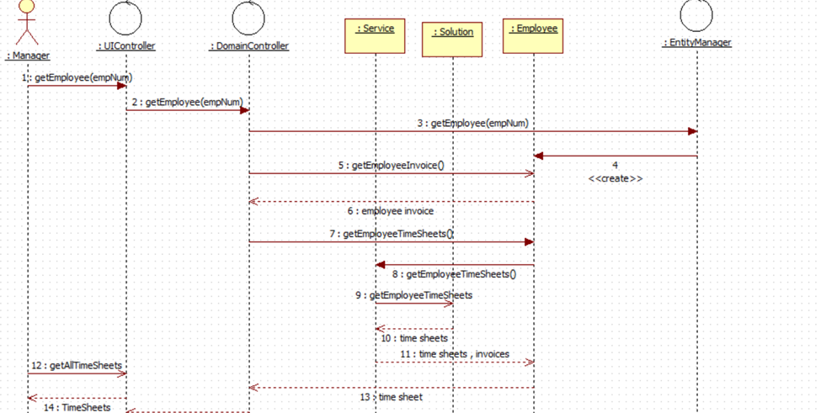

The process shows how Jie interacts with employee and get time sheet and calculate the invoices of them. The process above shows how he manages the bills ad works with different type of employee. The generalized and inherited classes are shown in class diagram in UML file.

Question 3:

**process that utilizes a service controller.**

**Case study:** Gerald has an in-demand ability to bring customer’s large scale project ideas to award-winning reality. Gerald works with customers to produce blueprints of their properties incorporating new design ideas

The process shows how Gerald interact with customers to get their idea and make blueprint of the project by them The process is using UI controller and under the controller in the class diagram of UML file all the controller are gathered.

Question 4:

Designing an Object Database schema based on a Class Diagram helps us to understand the purpose of the process and the way it gets forms. System Analysis helps us to have a good observation of the project. It helps to make the work easier for clients to understand the project. Drawing diagrams helps us to reduce name and process conflict in the project and reduce time-consuming. The purpose of UML is visually representing a system along with its main actors, roles, actions, artifacts, or classes, to better understand, alter, maintain, or document information of a system.