CS-2001 Data Structures, Spring 2024

Understanding a project is a part of project marking.

**Submission instructions:**

You should do this project in groups of 4 (having less than 4 members is not recommended and requires special permission). Submit this project in Google Classroom as a single zip file containing all your code and other files, named with your group number (register your group number in a separately provided Google Sheet). The file naming format is group<NUMBER>_project.zip.

**Deadline for the submission is 13th May 2024**

Your implementation must be modular, with separate class and header files for all modules.

**Final Project: Network Emulator**

A network is a set of connected electronic devices such as routers, and computers etc., where each device has a unique identification address (e.g., IP address). A message is sent from one device to another using the destination (recipient) address. Clearly, the message will have to follow a route (i.e., path of routers) in the network to get delivered to the desired destination device. On the path, each router checks the destination address of the message and forward it accordingly to the next router or the destination computer. For this purpose, a router typically maintains a table (named as routing table) containing the information about where to forward a message with certain destination address.

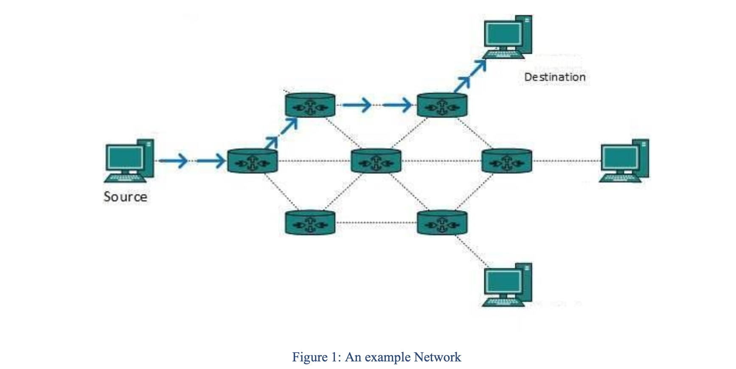

**Router**

A router consists of three main components namely incoming queue, routing table and outgoing queues as shown in Figure 2.

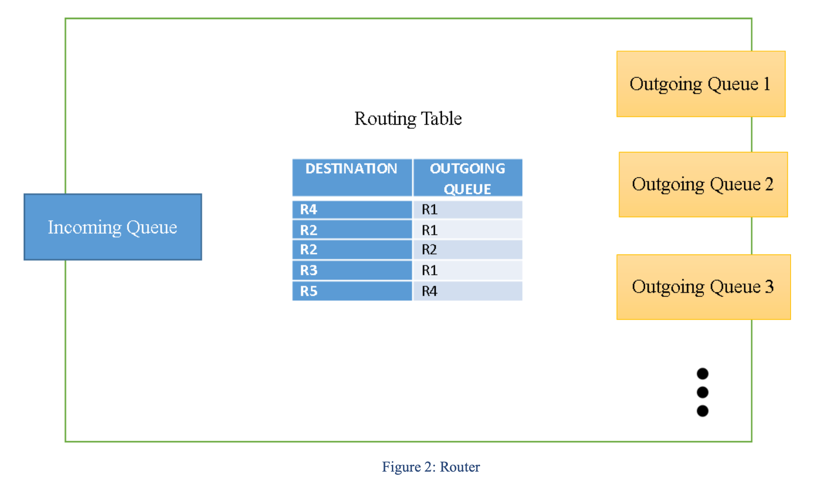

**Incoming Queue:** A router maintains a single queue (for the sake of this project) to receives all incoming messages. Messages are received either from previous routers in the path or directly from the end machines/computers. Router retrieves messages from the incoming queue one by one, makes the routing decision (i.e., identifies the next router) using the routing table, and forwards the message to the corresponding outgoing queue for transmission to the next router on the path to the destination machine.

Incoming messages can be of different priority and therefore are kept in a priority queue. A router always processes the message with highest priority first out of all the messages in the incoming queue.

**Outgoing Queues:** A separate queue is maintained for each outgoing connection to a router or to a destination machine. Each outgoing queue is a normal queue (FIFO) because priority is already handled by the incoming queue. Messages in the outgoing queues are forwarded to the corresponding routers and machines.

**Routing Table:** A routing table stores a list of destination, outgoing queue (i.e., router) pairs. In this project, we assume that routing table contains a separate entry for each (possible) destination in the system. Given the destination address in the message the routing table is used to find the next router (or machine if the destination machine is directly connected to the router) in the path to the desired destination machine.

**Phase 1: Implementation of a router**

In this phase, you are required to implement the router functionality. Implementation details for individual router components are provided below.

**Incoming Queue (binary heap):** In this project priority can be represented by an integer value between 0 and 10 (10 means higher priority).

**Outgoing Queue (FIFO):** Usually the message takes some time to be forwarded on the physical link from one router to another, this is called latency or delay. To simulate the concept of latency we assume that the messages are buffered in the outgoing queue of previous router for 1 second before moving into the incoming queue of the next router (on the path). In other words, messages are moved from the outgoing queue of previous router/machine to the incoming queue of the next router - one by one (each experiencing 1sec delay at its turn).

**Routing Table:** Table 1 shows a sample routing table. Just to make things easy, we have assumed that the routing table consists of only two fields. The *destination* field indicates the target machine (represented with prefix M) to which the message is being forwarded and the *outgoing queue* field specifies the next best router (represented with prefix R) to reach the target/destination.

You are required to implement the functionality of routing table using an appropriate data structure of your choice.

**Message Format:** Each message will have six fields as shown in Table 2 namely,

* **Message id (integer):** A unique identifier that is used to differentiate between different messages from the same machine.
* **Priority (integer):** An integer with values from 0 to 10 indicating the priority of the message.
* **Source address (string):** The address of the machine that sends the message. In this project, addresses of the machines/computers are represented by M prefix followed by a unique identifier, e.g., M1, M2, M6 etc. Likewise, the addresses of the routers are represented by R prefix followed by a unique identifier such as R1, R2 etc.
* **Destination address (string):** The address of the target machine that is the recipient of this message. Destination address is used by the routing table to make decision about the next router to forward the message.
* **Payload (string):** Payload contains the actual text/data of the message, e.g., “hello world”, “how are you” etc.
* **Trace (string):** This field is used for testing the correct working of your network emulator. It indicates the path taken by a message from the source address through the intermediate routers on the path until the message reaches the destination. Initially this field only contains the source address. However, as message is forwarded on the path towards the destination each intermediate router adds its own address to this field.

**Commands:** You code should recognize and implement following commands.

- **Send message (send msg):** It should be possible to send the message using command line and file. There can be multiple messages in a file (see Table 3) in colon separated format, e.g., message id: priority: src: dest: payload etc. Each message should be on a separate line.

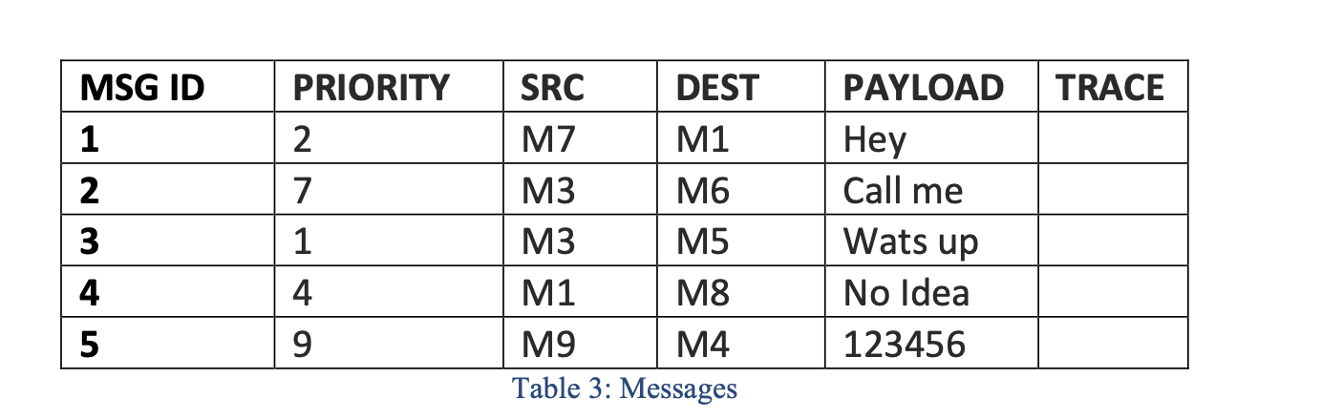

- **Change routing table (change RT):** The project should provide the functionality to change (i.e., add or remove) entries from routing table entries using both command line and file. The file can contain multiple entries in colon separated format, e.g., dest address: router. Each entry should be on separate line.

- **Print path:** During routing *trace* field of each message is updated with the path information (as mentioned above). Once the message is delivered to the destination, your program should write the path followed by the message from the source to destination in a file (path.txt) in the colon separated format, e.g., message id: source address: router 1: ... : router n: destination address. Each trace should be on a separate line.

**Query Format:** Your code should cater the following query formats

* command + filename
* command + contents of file

**Sample Queries:** The following sample queries must be handled by your program

* -  **send msg** hello.txt
* -  **change RT R1 add** rt_1.csv
* -  **change RT R2 remove** rt_2.csv
* -  **print path** M6 **to** M9
* -  **print path** M6 to *
* -  **print path** * to M9

**Phase 2: Network Emulator**

Phase 1 mostly focusses on implementing the functionality of a single router. In phase 2, you will implement the complete computer network and emulate the sending/routing of messages from the source machine to the destination via multiple intermediate routers. In this project, assume that in your network each machine/computer is always connected to one router as shown in Figure 3. Therefore, each machine maintains one outgoing queue and one incoming queue. Both of these queues are normal queues (FIFO) but the outgoing queue will have timer based mechanism as discussed in phase 1.

In phase 2, you are required to read a .csv adjacency list and create the emulated network from it. A sample .csv file of a graph containing machines and routers is attached along the project as “network.csv” (see Figure 3). In the first step you will read the graph from network.csv and construct the routing tables for each router. Do not make any routing table for the machines because they will not perform any routing and solely forward the messages to the routers they are connected with. You must use Dijkstra algorithm for constructing the routing table of each router. In particular, you are supposed to run Dijkstra algorithm for each router R1 and accordingly create its (i.e., R1’s) routing table.

**Example:** Consider Figure 3 as a sample network. In this network each machine is only connected with one router and each router has its routing table. Note that each edge in the network has a weight and you’ll use this weight to compute the shortest path for each destination/machine from your current router using Dijkstra algorithm and thus will populate the routing tables accordingly.

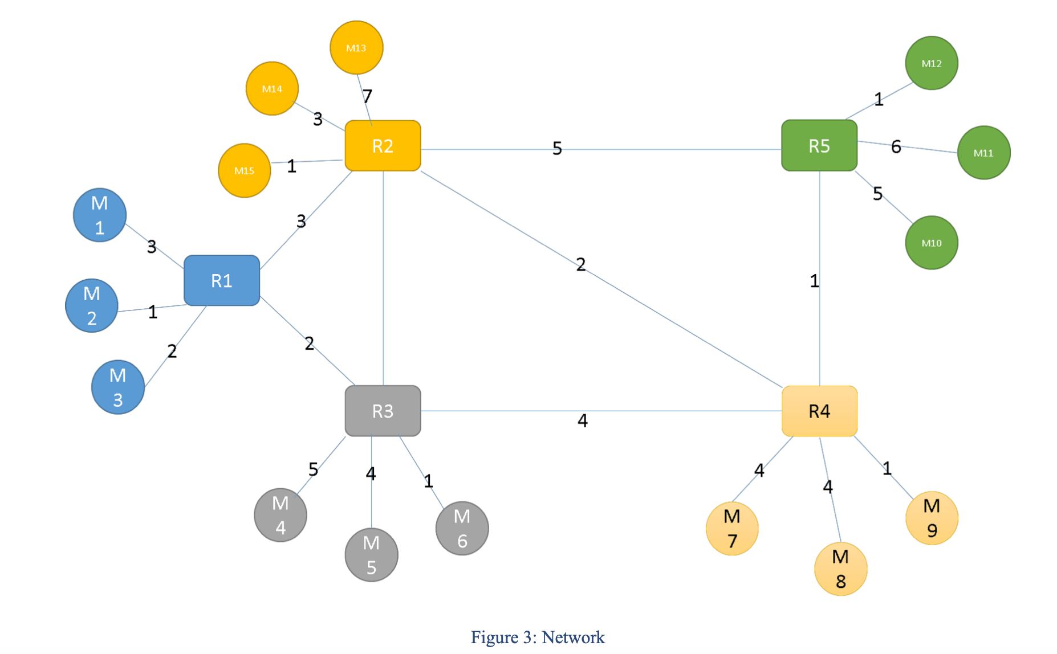

**CSV file format:** Attached .csv file is in the form of a symmetric matrix in which the symbol ‘?’ depicts that there is no edge between the correspondents (routers/machine) and any numeric value (e.g., 3, 4, 5 etc.) depicts that there is a weighted edge between the correspondents.

**Message forwarding:** To send a message m, a machine adds m to its outgoing queue from where m is moved to the incoming queue of the connected router after emulating a network delay of one second (at its turn in case multiple messages are already in the outgoing queue of the machine) as mentioned above. This message after getting processed by the router (i.e., after routing decision) will be forwarded to its outgoing queue. Same procedure will be followed on each router unless the message reaches its destination, i.e., target machine.

**Interrupt mechanism:** To ensure that each message in any of the outgoing queues emulates a network delay of one second, you may have to implement timer-based interrupt mechanism. In particular, after every one second you will halt the normal execution of your code and call a function that will remove one message from each outgoing queue (in your network) and will insert it in the incoming queue of next router or machine and then resume the normal execution of the code. Consequently, message in any of the outgoing queue will not leave the outgoing queue unless the (interrupt) function is called. For this purpose, your program may register for timer interrupt using the function calls of the operating system. As a result, the rough structure of your program may be as follows:

* A function to handle timer interrupts and move messages from outgoing to incoming queues.
* A for or while loop to perform routing and gets user input from command line or through files.

**Commands:** In addition to the commands mentioned in the phase 1, you have to implement the following additional command.

**Change Edge Weight (change edge)**: Your program should be able to change the weights of the edges in the network graph dynamically during execution and accordingly update the routing tables (by re-applying Dijkstra algorithm) and thereby influencing routing of messages at runtime. The new edge weights can be entered from the command prompt or by providing an adjacency matrix in the csv file in the format described above. For example,

o **change edge** network.csv

o **change edge** R1, R2, 25

o **change edge** M1, R5, 25