Take-home exercise01

YUAN Yihao

2025-05-11

# Part 1

# 1.0 Overview

## 1.1 Background

Analysis on demographic structures and distribution of Singapore in 2024

## 1.2 Objective

Identify the gender distribution by age

Identify the age distribution by region

Conduct more detailed analysis on the regions with distinct characteristics

## 1.3 The Data

*Singapore Residents by Planning Area / Subzone, Single Year of Age and Sex, June 2024* dataset shares by [Department of Statistics, Singapore (DOS)](https://www.singstat.gov.sg/)

# 2. Packages

pacman::p_load(ggiraph, plotly,   
 patchwork, DT, tidyverse)

# 3. Getting Started

## 3.1 Importing data

res_data <- read_csv("respopagesex2024/respopagesex2024.csv")

## 3.2 Data cleaning

### 3.2.1 Check missing values

res_data %>% filter(if_any(everything(), is.na))

# A tibble: 0 × 6  
# ℹ 6 variables: PA <chr>, SZ <chr>, Age <chr>, Sex <chr>, Pop <dbl>,  
# Time <dbl>

colSums(is.na(res_data))

PA SZ Age Sex Pop Time   
 0 0 0 0 0 0

### 3.2.2 Change data values

res_data <- res_data %>%  
 mutate(Age = ifelse(Age == "90_and_Over", "90", Age),  
 Age = as.numeric(Age))

### 3.2.3 Check and Convert data type

str(res_data)

tibble [60,424 × 6] (S3: tbl_df/tbl/data.frame)  
 $ PA : chr [1:60424] "Ang Mo Kio" "Ang Mo Kio" "Ang Mo Kio" "Ang Mo Kio" ...  
 $ SZ : chr [1:60424] "Ang Mo Kio Town Centre" "Ang Mo Kio Town Centre" "Ang Mo Kio Town Centre" "Ang Mo Kio Town Centre" ...  
 $ Age : num [1:60424] 0 0 1 1 2 2 3 3 4 4 ...  
 $ Sex : chr [1:60424] "Males" "Females" "Males" "Females" ...  
 $ Pop : num [1:60424] 10 10 10 10 10 10 10 10 30 10 ...  
 $ Time: num [1:60424] 2024 2024 2024 2024 2024 ...

res_data <- res_data %>%  
 mutate(  
 Age = as.numeric(Age),  
 Pop = as.numeric(Pop)  
 )

### 3.2.4 Data glimpse

str(res_data)

tibble [60,424 × 6] (S3: tbl_df/tbl/data.frame)  
 $ PA : chr [1:60424] "Ang Mo Kio" "Ang Mo Kio" "Ang Mo Kio" "Ang Mo Kio" ...  
 $ SZ : chr [1:60424] "Ang Mo Kio Town Centre" "Ang Mo Kio Town Centre" "Ang Mo Kio Town Centre" "Ang Mo Kio Town Centre" ...  
 $ Age : num [1:60424] 0 0 1 1 2 2 3 3 4 4 ...  
 $ Sex : chr [1:60424] "Males" "Females" "Males" "Females" ...  
 $ Pop : num [1:60424] 10 10 10 10 10 10 10 10 30 10 ...  
 $ Time: num [1:60424] 2024 2024 2024 2024 2024 ...

# 4. Exploratory Visual Analysis

## 4.1 Population by Age and Sex

The grey area represents the lower population for males and females. The colored bars represent the number of population exceeded another gender

library(dplyr)  
library(ggplot2)  
  
  
grouped_data <- res_data %>%  
 group_by(Age, Sex) %>%  
 summarise(Pop = sum(Pop, na.rm = TRUE), .groups = "drop")  
  
  
wide_data <- grouped_data %>%  
 pivot_wider(names_from = Sex, values_from = Pop, values_fill = 0) %>%  
 mutate(  
 min_pop = pmin(Males, Females),  
 male_extra = ifelse(Males > Females, Males - Females, 0),  
 female_extra = ifelse(Females > Males, Females - Males, 0)  
 )  
  
  
ggplot() +  
  
 geom_col(data = wide_data, aes(x = Age, y = min_pop),   
 fill = "gray70", width = 0.6) +  
  
  
 geom_col(data = wide_data, aes(x = Age, y = male_extra),   
 fill = "steelblue", width = 0.6) +  
  
  
 geom_col(data = wide_data, aes(x = Age, y = female_extra),   
 fill = "tomato", width = 0.6) +  
  
 labs(  
 title = "Population by Age and Sex",  
 x = "Age",  
 y = "Population"  
 ) +  
 theme_minimal()

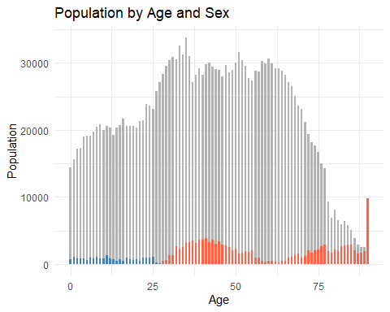

Observations: Obviously, in the age range of 0 to 30, the male population is larger than the female population. However, from 30 to 90, the female population is significantly larger than the male population.

## 4.2 Population by Age Group and Planning Area Analyze the number of the aging population in each region.

res_data_grouped <- res_data %>%  
 mutate(AgeGroup = case_when(  
 Age >= 0 & Age <= 20 ~ "Under Age",  
 Age >= 21 & Age <= 60 ~ "Adult",  
 Age >= 61 ~ "Aging"  
 )) %>%  
 group_by(PA, AgeGroup) %>%  
 summarise(Pop = sum(Pop, na.rm = TRUE), .groups = "drop")  
  
res_data_grouped_filtered <- res_data_grouped %>%  
 filter(AgeGroup != "Adult")  
  
ggplot(res_data_grouped_filtered, aes(x = Pop, y = reorder(PA, Pop), fill = AgeGroup)) +  
 geom_col(position = position_dodge(width = 0.9), width = 0.4) +  
 labs(  
 title = "Population by Age Group and Planning Area",  
 x = "Population",  
 y = "Planning Area",  
 fill = "Age Group"  
 ) +  
 scale_y_discrete(expand = expansion(mult = c(0.4, 0.4))) +   
 theme_minimal() +  
 theme(  
 axis.text.y = element_text(size = 3, margin = margin(r = 5)),   
 legend.position = "top"  
 )

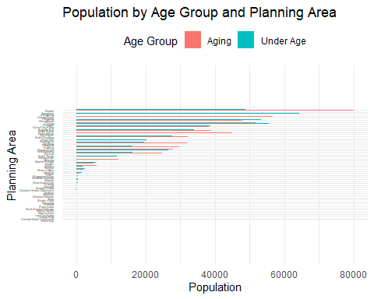

Observations: Given the large number of regions, it is proposed to construct new variables in order to more intuitively analyze and understand the distribution and proportion of the aging population.

## 4.3 Aging-to-Under-Age Population Ratio by Planning Area

library(dplyr)  
  
  
age_summary <- res_data_grouped %>%  
 filter(AgeGroup %in% c("Under Age", "Aging")) %>%  
 group_by(PA, AgeGroup) %>%  
 summarise(Total = sum(Pop), .groups = "drop")  
  
  
age_ratio <- age_summary %>%  
 tidyr::pivot_wider(names_from = AgeGroup, values_from = Total) %>%  
 mutate(ratio = Aging / `Under Age`)

ggplot(age_ratio, aes(x = ratio, y = reorder(PA, ratio))) +  
 geom_col(fill = "steelblue") +  
 labs(  
 title = "Aging-to-Under-Age Population Ratio by Planning Area",  
 x = "Aging / Under Age Ratio",  
 y = "Planning Area"  
 ) +  
 theme_minimal() +  
 theme(  
 axis.text.y = element_text(size = 5),  
 plot.title = element_text(face = "bold")  
 )

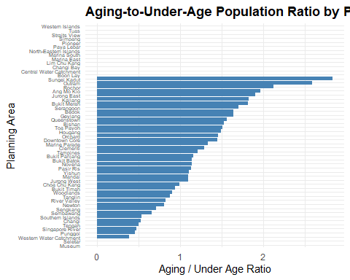

Observation: From this chart, we can see the ranking of regions with a larger proportion of the elderly population.

# PART 2 Peer Learning

Comment for 2nd plot in https://pengxinhuang.netlify.app/take-home_ex01/#age-structure-comparison-across-planning-areas

pros 1. Appropriate type of plot. Easier to know the distribution. 2. Choose some typical area to represent diffirent area’s distribution. 3. Put plots together to compare

cons 1. X-axis: The data has negative numbers 2. Y-axis: The text overlaps, and the last group is NA 3. Overall: The X-axis index of the four pictures are different, which may cause some population misguidance

res_data <- res_data %>%  
 mutate(Age_group = case_when(  
 Age == "90_and_Over" ~ "90_and_Over",  
 TRUE ~ paste0(floor(as.numeric(Age) / 10) * 10, "-", floor(as.numeric(Age) / 10) * 10 + 9)  
 ))  
agg_data <- res_data %>%  
 group_by(PA, Age_group, Sex) %>%  
 summarise(Pop = sum(Pop, na.rm = TRUE)) %>%  
 ungroup()  
agg_data <- agg_data %>%  
 mutate(Pop_plot = ifelse(Sex == "Males", -Pop, Pop))  
ggplot(agg_data %>% filter(PA %in% c("Bedok", "Bukit Timah", "Outram", "Tampines")),  
 aes(x = Pop_plot, y = Age_group, fill = Sex)) +  
 geom_bar(stat = "identity", width = 0.8) +  
 scale_fill_manual(values = c("Males" = "steelblue", "Females" = "tomato")) +  
 scale_x_continuous(labels = abs) +  
 facet_wrap(~PA, ncol = 2, scales = "fixed") +  
 labs(title = "Population Pyramids of Selected Planning Areas (2024)",  
 subtitle = "Representing new township (Tampines), mature estate (Bedok), high-income area (Bukit Timah),\nand historical district (Outram)",  
 x = "Population",  
 y = NULL,  
 fill = "Sex") +  
 theme_minimal() +  
 theme(  
 axis.text.y = element_text(size = 8),  
 plot.subtitle = element_text(size = 9, hjust = 0.5),  
 strip.text = element_text(face = "bold")  
 )

