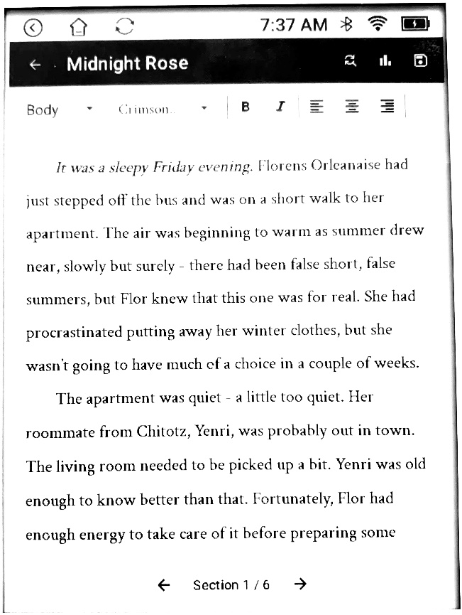
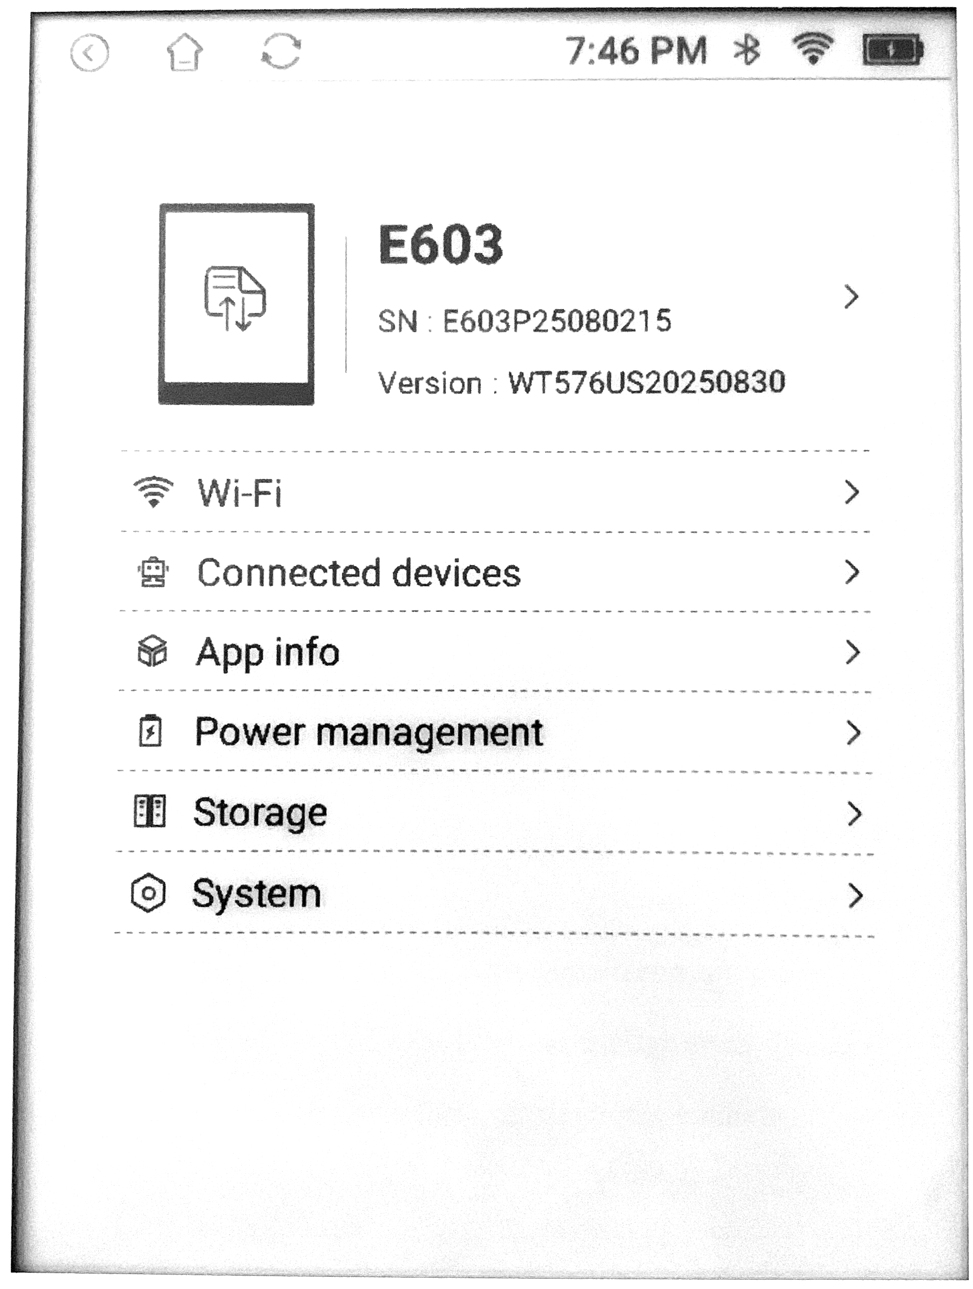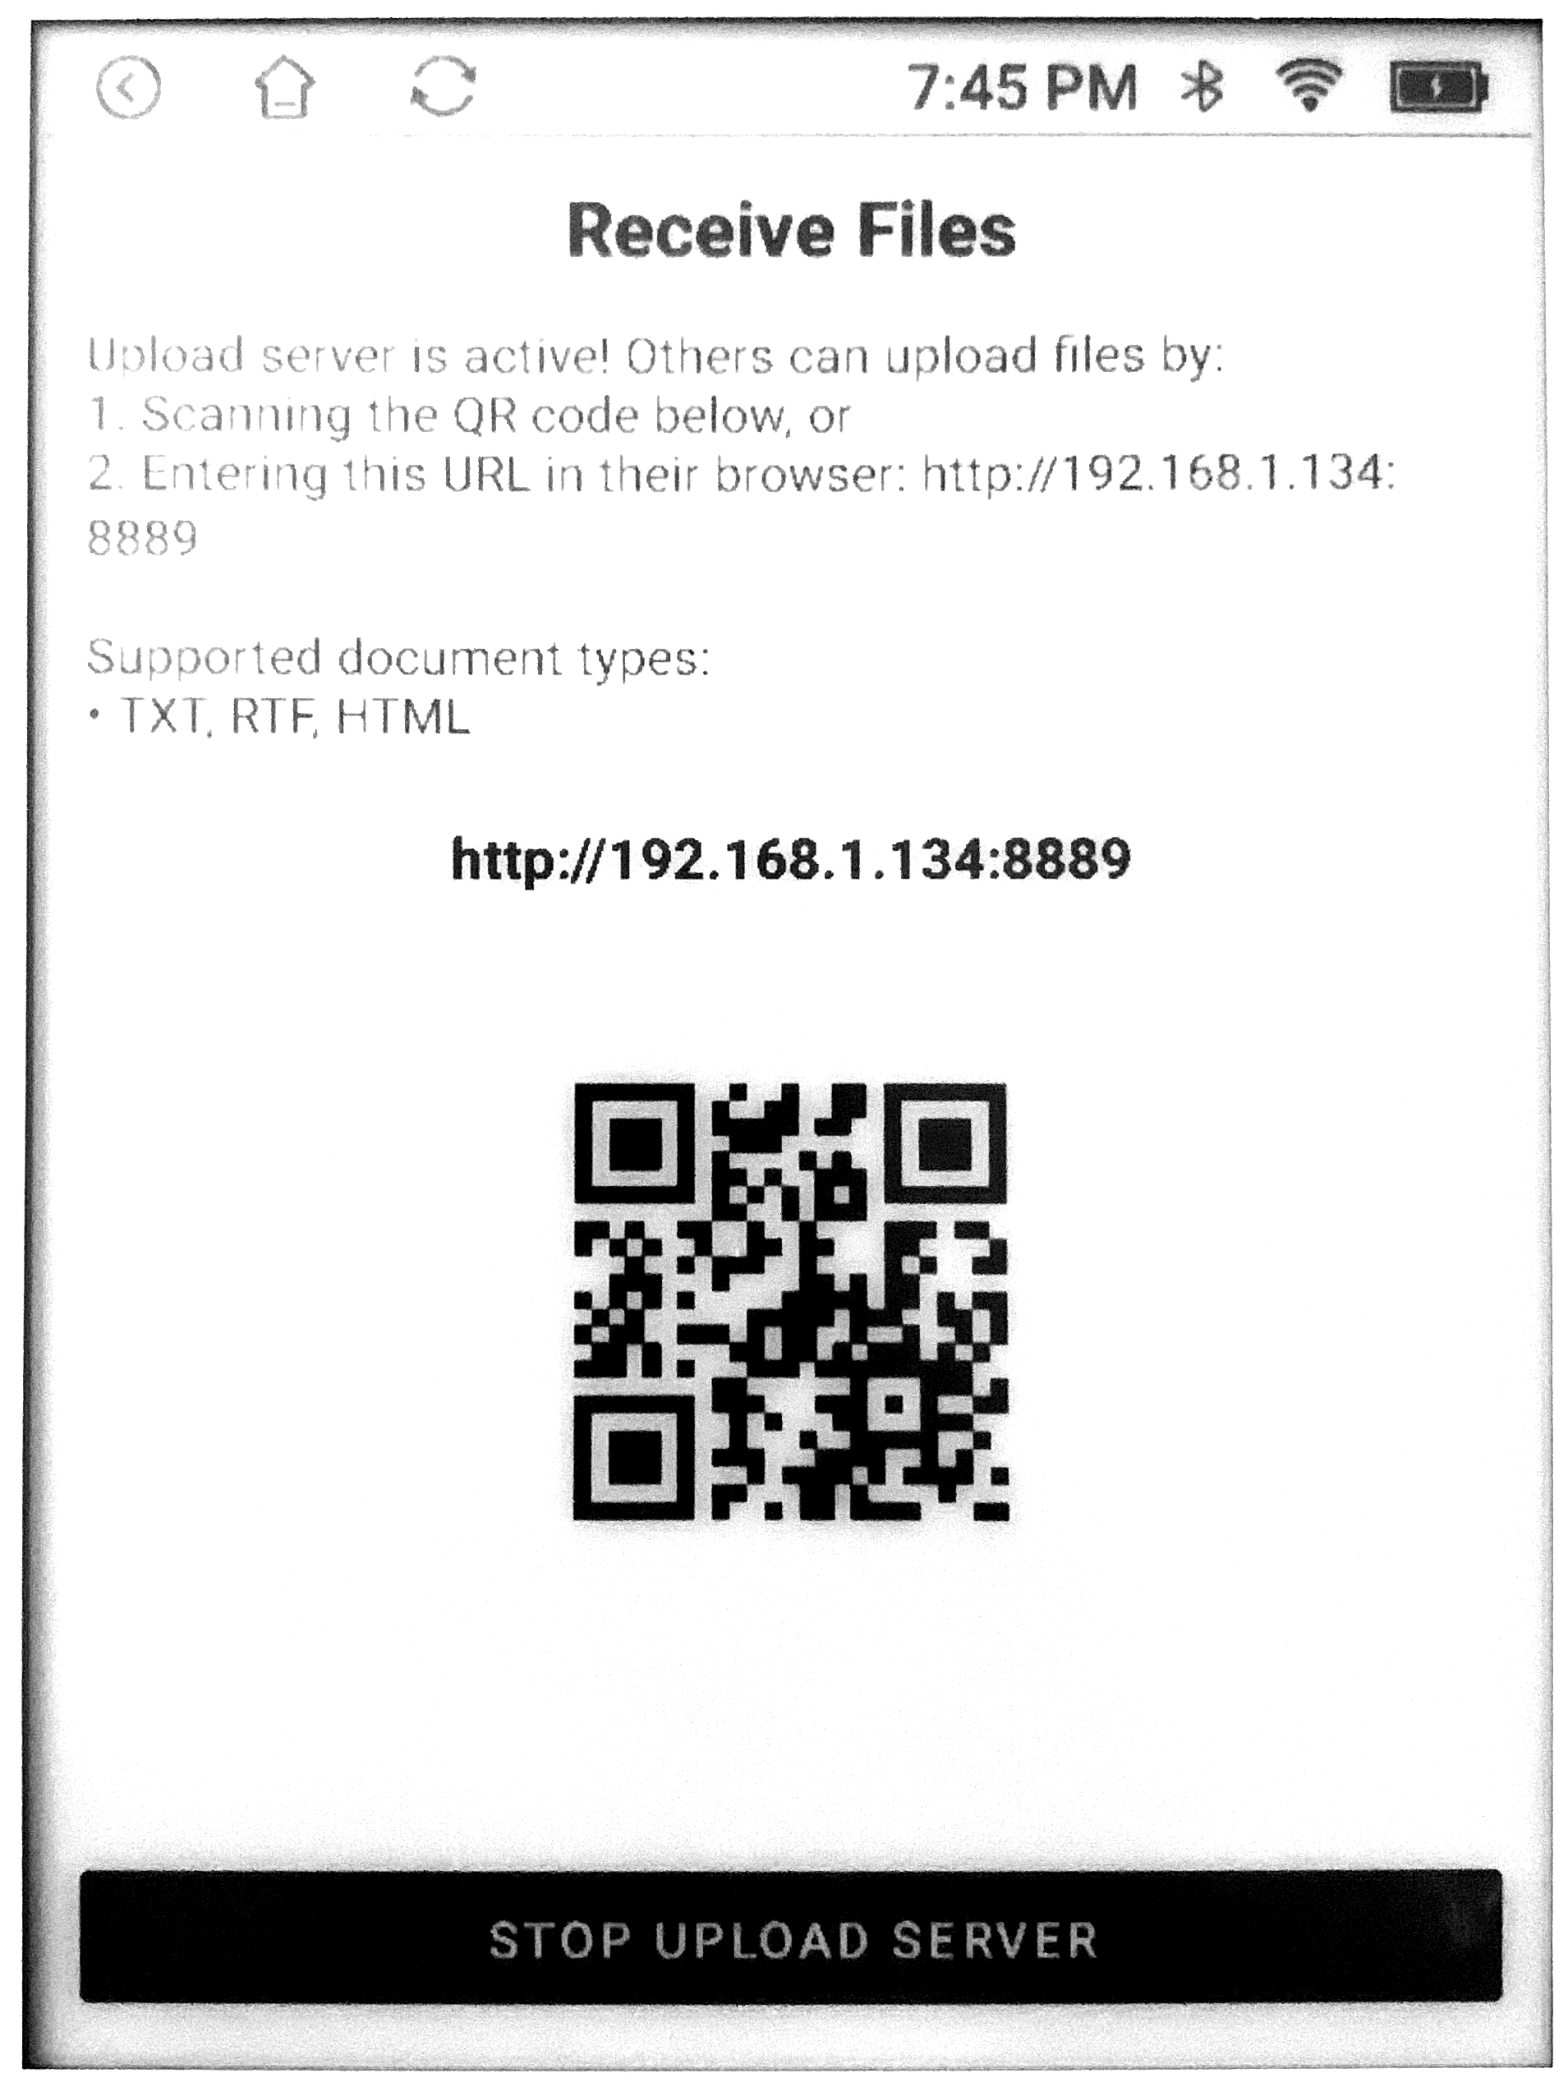
You can connect to Wi-Fi or Bluetooth keyboards from the SETTINGS menu, on the home page.
Simply navigate to Wi-Fi to connect to a network, and Connected Devices to connect to a Bluetooth keyboard.
You must do this before receiving or sharing stories.
Once you create or open up a story, you are taken to the story screen. This resembles a traditional Word Processor, with size, font, format, and justification tools.
At the bottom of the page, you will see the “Section” header. This is not user-controlled – “Sections” are automatically created by the Gnimble software in order to keep the device fast. They are not visible when you go to export documents.
The function buttons at the top of the screen will allow you to:
- Find and Replace text
- Pull up document Statistics (like word count)
- Save your document

“Thank you so much for purchasing a Gnimble Typewriter!
We hope you have fun while writing!”
You may select the “RECEIVE” icon from the bottom of the home screen. It will take you to a very similar menu, which is accessed from your web browser in much the same way.
From this page, you can upload stories from other device. All word processors – such as Microsoft Word or Google Docs – can export TXT (lowest detail), RTF (medium detail), or HTML (highest detail) documents.
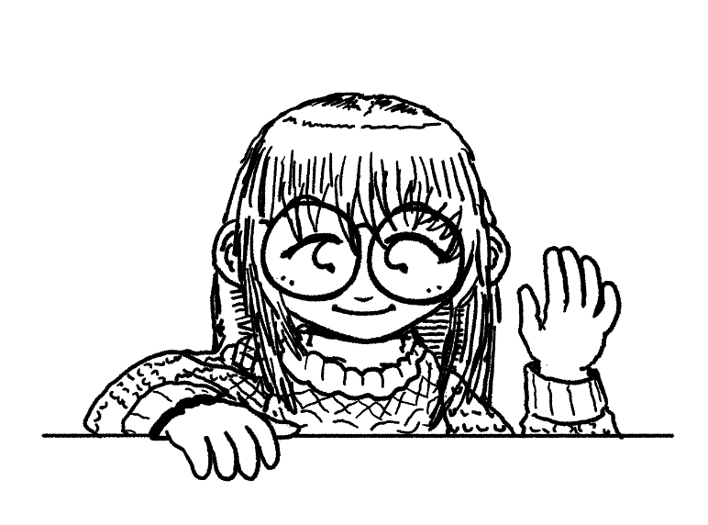
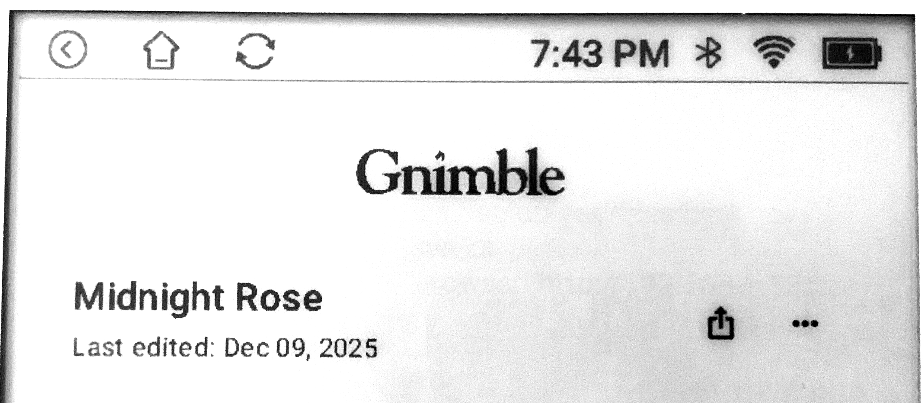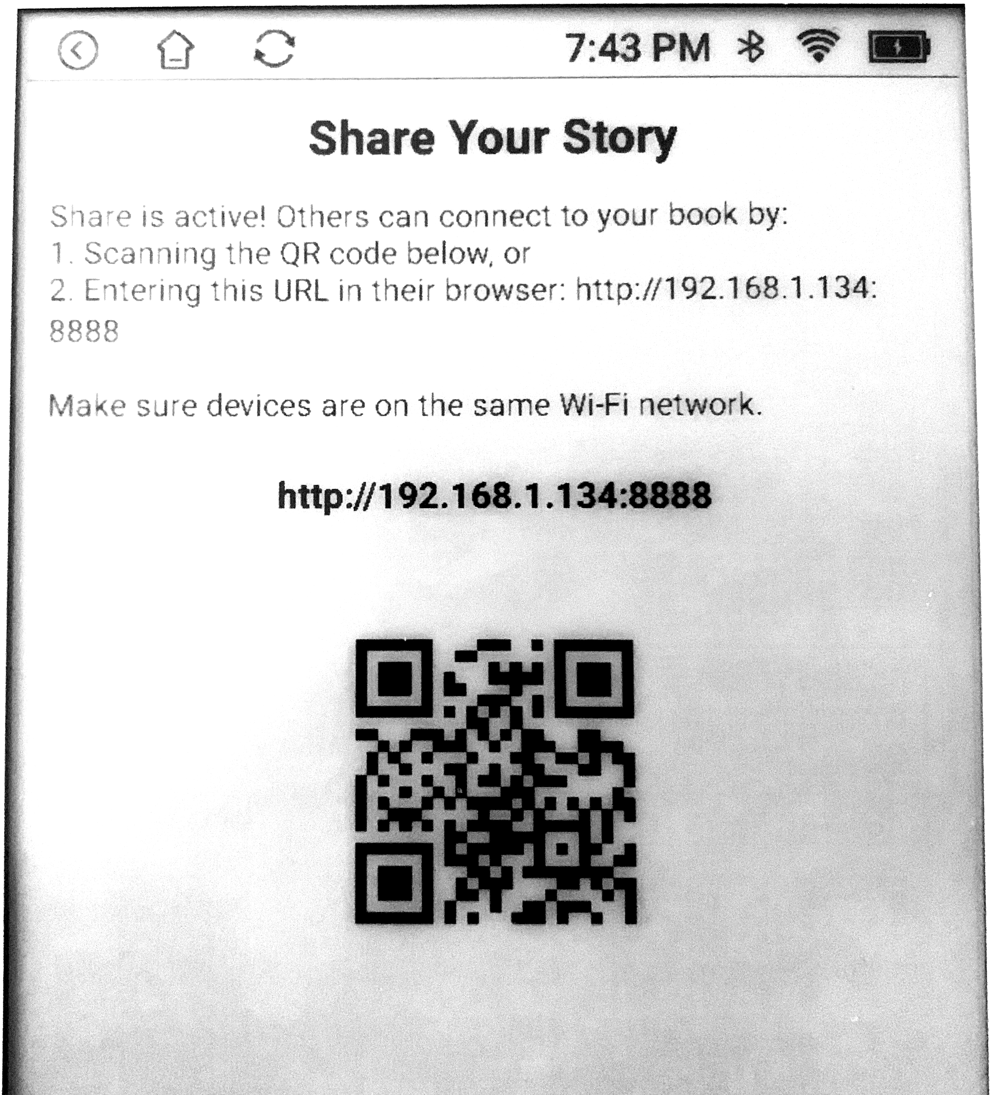
Please note: The device is not slow, it has an “e-paper” display, like an e-reader. This allows the device to stay easy on your eyes for long periods of time. It just takes a second to refresh the display.
“Hi! I’m Lori!
Thank you so much for purchasing a
Gnimble Typewriter from Cinemint!
Since you’re here, why don’t we go over how
your new typewriter works?”
On the top part of the screen, you will see three icons: BACK, HOME, and REFRESH.
REFRESH is useful for refreshing the e-paper display, in case it begins to look “messy”.
There are icons for the time, Bluetooth/Wi-Fi status, and your battery.
You may tap this bar to access quick settings, such as to control your screen contrast.
Next to each book, you will see a “SHARE” icon, and a menu. “SHARE” opens the share screen (shown later), while the menu gives you the option to RENAME or DELETE your story.
At the bottom of the home screen, you can “IMPORT”, “ADD”, or go to your “SETTINGS”.

Unlike other electronic typewriters, there are no accounts to log into or memory cards to lose. The device has a tiny web server running directly on it – so books can be added or moved through the web browser, on either your PC or smartphone.
The “SHARE” icon next to your story opens the share menu. If you are not connected to Wi-Fi, the link will say “localhost”. Otherwise, it will show a series of numbers.
To see your story, go to your web browser (on a device connected to the same Wi-Fi network) and enter in this string of numbers as the address.
Alternatively, scan the QR code, and it will take you to the page!

