Ça c’est tout, mon j’sus paré
Mes bagages, c’est d’jà paqueté
Je connais l’avenir c’est pus ça ç’tait
Mais tout quelque chose va dêtre okay
Pendant que nous autres, on après s’coller!

Vous Voilà written and illustrated
by E. Howard Hill

All Rights Reserved.

Thanks to my friends who helped me name characters, inspired situations, and supported me through wanting to see this project come through in one way or another. I know I couldn’t make a full cartoon series, but I hope this is the next best thing – enjoy!

Thanks to les braves gens at r/cajunfrench for checking and helping me with my Louisiana French!

Merci de votre aide!

Mini Language Guide

In the Republic of Les Laurentides, Quebecois French is spoken in the north and Louisiana French is spoken in the south. This book is translated to English, but a few words are kept in French for flavor. Here’s a little guide to help!

Bête Cow / Stupid
Bougre Guy
Bien It’s good
Ça va How are you?
Cher Dear / Car
Clope Cigarette
Couillon Foolish
Fais Do-Do Party (lit: “to sleep”)
Je suis désolé I’m sorry
Mais non But no
Mère Mother
Père Father
Quoi faire What to do
Salut Hi

Part One
or, “The Impulsive Decisions of Scared and Confused Individuals Can Yield Unusual Results.”

Tape 1
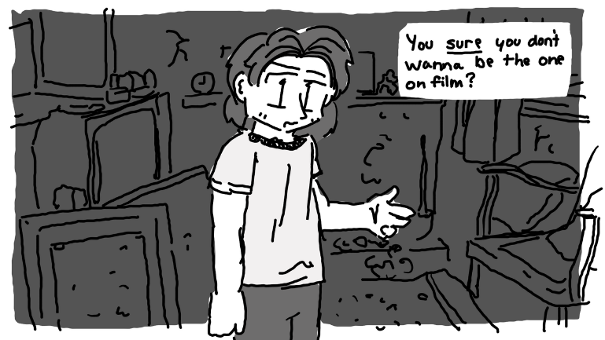
1992/06/11

"No! You got me the camera, you're in front."
Aaron sighed. "Alright. So, what do you want me to say?"
"I dunno. Pretend like we're shooting a documentary or something."
He coughed, looking around the room to find some shred of something - anything to talk about. The walls were cracked, and the wallpaper was spoiled. Way too much paper and trash were spread across the rotting carpet. It smelled, but a breeze coming in through a hole in the wall made it tolerable.
"I mean, I guess every place has a story, even random abandoned houses... I don't know, is that what you want me to talk about?"
Maple sighed. "Make something up!"
"Bon." He cleared his throat. "Hundreds of years ago, fairies crafted this castle out of what little material they had available. When settlers moved to the Laurentides, they saw this structure and thought... Man, that's sick. Let's take that exact design and make millions of ‘em across the country. And so, they did, and before long, it seemed like everyone lived a cheap recreation of the fairies' castles. That's when the fairies got mad, and after the legal system got established, they tried to make a lawsuit out of it, but it fell through because you can't copyright good design."
"Shame."
"Yes, it was a real shame."
The two heard a car outside pull up.
"Just like the fact that we have to go."
Maple stomped her foot. "But- “
"Cops...!" he hissed. "Quick out the back door!"
Right before Maple turned off the camera, or at least, right before she thought she turned off the camera, she pointed it at the floor, giggling a bit under her breath. "Best birthday ever."
The sound of a slamming door could be heard from the other room.
"HEY!" shouted a man in thick Creole French, "WHAT ARE Y’ALL DOING ON MY PROPERTY?"
Maple sucked in air. So, it wasn't the police. It was the property owner. Oh boy.
She dumped the camera into her backpack, slipping her free arm through one of the satchels to keep it completely stable. The sound of the man was getting louder, as was the sound of the two siblings. Tape watchers wouldn't have known what was going on, besides from their quiet attempts to escape. At least, until there was a gunshot.
Maple and Aaron stopped breathing.
"I got this," whispered Maple, taking off her backpack.
"No, you- WHAT- “ hissed Aaron.
"HEY!" shouted Maple, "Stop shooting us or I’ll burn it down!"
"Do what, now?"
The sound of a flame immediately crackled.
The man panicked and raised his gun, but Maple lunged faster. The sounds of dripping metal and a confused old man filled the space.
"Ye’... Ye’ twisted my barrel."
"I did."
"I... I think I'm gonna go home now."
"Not a bad idea."
He left the room.
Maple dashed over to her backpack, lifting out the camera and pointing it straight at her face. Her fiery orange hair glimmered nearly as much as her grin. The shot wasn't in focus at all, but it didn't need to be. "I just made a gun pretzel," she squeaked.
"MAPLE!" hissed Aaron, "Ce n'est pas bon! Dude! What the heck?"
"LOOK!" she squealed, pointing the camera at the ground were some of the steel had dripped off and onto the floor, "DO YOU SEE THAT?"
He sighed. "You keep making decisions like this, and they’re going to catch up to you, you know."
"Eh, maybe."
"Can we leave the property now?"
"Maybe he'll let us live here if I threaten to break more of his guns."
"No!" said Aaron, shortly. Maple turned the camera to her brother to catch him crossing his arms. "We're not going to hold him captive on his own property, that’s wrong in so many ways."
"So, we're sleeping in the car again?"
"Yes!"
Maple blinked. "Why?"
"Because we own it!"
Her frown could be heard in her voice. "That's a bête reason. Besides, it's my birthday. I'm a teenager now, I can do whatever I want."
"Society doesn't care!"
"But you care, and you're not society."
He grumbled.
"Hey. Louder for the camera."
He continued mumbling. "If you're staying here, I'm staying here too, but only for today, am I clear?"
The camera made a wide zoom up to his face.
"Focusing in on... the best big brother on the planet.”
"Shut up."
"You shut up!"
And with that, the camera turned off.

Tape 2
1993/07/01

"Bon, I'm filming again."
Aaron had his hands on the wheels, his full attention on the road. "Why now?"
"Why not now?"
"Do you want me to film you when you get behind the wheel?"
"Uh.. What do you think?"
He sighed. "Fair enough. Now, I don't have too much gas left, so we won't do too much, bien?
Maple nodded, and it shook the camera a bit. "But didn't you get that new job so you can afford more gas?"
"No, I got an interview, not a job. It's not a guarantee."
"Bet it'd be a little easier if you, y'know, had help."
"Maple, we've talked about this."
She groaned. "When are we finally getting there?"
"We're there." He put the car into neutral. "The supermarket parking lot is probably the best possible place to get these techniques down. Now, do you need me to remind you of anything, or do you think you want to just get behind the wheel and take it for a spin?"
"I'll just try it out. I think I know enough."
She dumped the camcorder on the dashboard and popped off her seatbelt, nearly sprinting over to the driver's side, already there by the time Aaron was just stepping out. In an instant, she was behind the wheel, gripping it with a fierce intensity. It felt good to be fourteen. It felt good to be behind the wheel of what had been her home for so long. She felt butterflies in her stomach that nearly made her a bit queasy. Her hands couldn't help but shake. She was ready; so, so ready.
Aaron started shooting out words like an auctioneer. "Alright, so the first thing you want to do is- “
"Hey, chill. You're stressing me out."
"Got it. Sorry. But don’t just straight turn the car on, you want to disengage the engine otherwise the gear box will-… Right, right, you know."
She sighed, smiling. Then, she adjusted her seat a bit and tested out the clutch. After going through the engine startup process, she popped the car into first gear and pushed down on the accelerator, bursting into a fit of nervous giggles.
"You're scaring me."
"I'm fine with that,'" she chirped, slowly accelerating to ten or so kilometers per hour.
"Bon, now we're going to try the- Maple!"
She slammed on the brake, throwing them both forward just a bit. "What?"
"Lightly on the brake! That nearly launched me through the window!"
"You've done it that hard before!"
He sighed. "Only in emergencies, you hear? Look, you want to do it slower than that or you'll hurt the car. But don’t stall it either, careful with the clutch."
"I thought you said that acceleration was slow, breaking was fast."
"Not that fast."
"Right, right, whatever. I'm going to try second gear, now."
"Maple, there's a car coming up on your left."
"Yeah?"
"MAPLE!"
"I'm braking! I'm braking! Gosh!"
The car jolted a bit. Maple's face went completely flushed, and Aaron sort of stared ahead, dumbfounded. The car stopped. There were no noises of anything going wrong in the engine, or any frustrated noises from the two, just silence. Dead, unnatural silence. Even the radio, which had been going quietly, stopped, though the hum of the engine kept the camera shaking.
An orc man walked up to the driver's side door, knocking angrily on the glass.
"I mean," defended Maple, "I was braking lighter that time."
"...I said emergencies were the exception."
"How was I supposed to know that was an emergency?"
Knock, knock, knock. "HEY!"
"You know... I could just drive out of here really fast."
Aaron sighed. "No. Roll down the window."
She grinned. "I think I will drive away really fast."
"No!!"
"If I roll down and talk to the guy, he's just going to insult me and nothing's going to get resolved."
"Look, we need to make sure that- “
Maple rolled down the window slightly.
"YOU DIRTY PIECE OF- “
She rolled it back up. "Your point?"
"Stay here." He unbuckled his seat belt. "I'll talk to- Hey, are you-?"
Maple grinned, as the world outside the car slowly began to move backwards.
"Maple, stop the car. I told you not to- “
"You told me not to drive away really fast when, in fact, I am driving away really slow."
"No! I told you- “
"What? I can't hear you, I'm too busy driving away from the conflict."
BANG!
"MAPLE!! Dag nabbit- he's attacking the car!!"
Coolly and in an instant, she set the gear to reverse. and floored it. Aaron gripped his seat, muttering something under his breath.

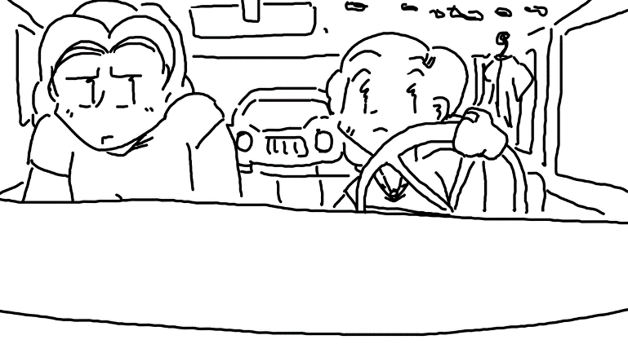
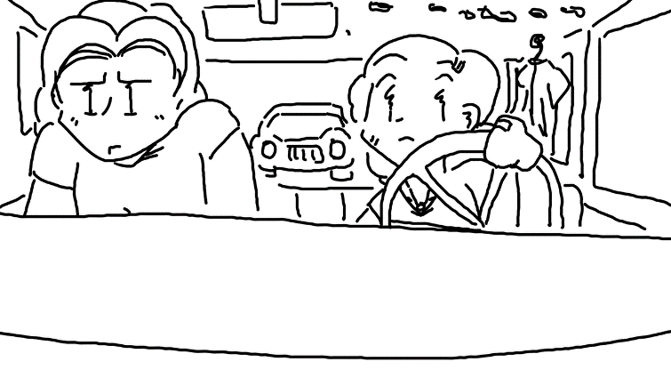
“WHAM!” said her car as she collided into yet another one behind her.
"You're going to be the death of me..." whispered Aaron.
"W-Wait, I can fix this!" she squeaked, frantically trying to remember what to do. She popped the clutch, changed gears, and accelerated fast enough to bring it up to third gear. Aaron gripped the seat even harder as she sat right on top of the speed limit, merging into traffic, and speeding down the highway without as much as a second thought. Or at least, no more thinking than she was doing - she was nearly hyperventilating, gripping the wheel so hard that it wouldn't have been much of a surprise if it just came completely off.
"MAPLE!"
"WHAT?"
"PULL OVER!"
Despite her accidents, she seemed to have a good understanding of the driver's education she had taken. She pulled off to the side in front of a gas station, hands still shaking.
"Maple."
"...I'm sorry, I- “
"..."
She sniffed, tearing up. "Alright, I made a dumb mistake. I’m sorry."
Aaron crossed his arms, letting out his breath in short bursts.
Maple shrugged. "...You, um... Y-You do have to admit, it was pretty fun."
He smiled. "It was. Just a bit. And you did manage to make it this far without idling."
"And we got the whole thing on video."
"You understand that if those people ever see us on the road again, we're dead, oui?"
She fidgeted awkwardly. "M-hmm."
They were both silent for a few seconds.
"I'm driving now."
"Right, right, I'll get out."
"And we're doing this exercise outside of city limits next time."
"Of course."
"Now to see how much damage we got."
"Hey- Can... Can we do that after we get back to the apartment?"
"Sure, whatever. Are you gonna shut off the camera? You’ve only got so much tape."
"Yeah, right, good idea." She reached for the camcorder and shut it off.

Tape 3
1997/07/13

Aaron Tremblay was by himself in the living room / kitchen combination area, alone with the camera. There wasn't a lot of wiggle room, but he made do with enough room to stand. He couldn't quite see that it wasn't eye level and that he was off focus to the left, even if he knew he wouldn’t care. He kept nervously clenching and unclenching his fists - his nerves made it clear that something else was on his mind.
"Hey, Maple. Uh... So, you know how you kept telling me that I could use your camera and I kept procrastinating? Well, I'm done procrastinating, hehe... I just wanted to record you a short video while you were out of the house, which, you are a lot, and I don't blame you. And I really don't have much more to give you on your way out that I haven't already, but I thought I'd finally take care of that video you've been wanting me to do, so, uh... here it goes."
"I know you're nervous about college. I know high school wasn't really your thing and you feel like it’s all stupid. I... know I've already tried explaining that these scholarships aren't very common, there really aren't a lot of wood elves in this parish, but you know what? You're bigger than this parish. I've known it since we were kids. It's why I keep pushing you so hard. And you're going to be on your own, an adult, doing whatever you want, and I'm really excited. You've got the potential to be the best sorceress in Carolina. I mean it. I'm not exaggerating. You've done so many cool things. I'm going to miss you a lot. I already do. But it's worth it when I think of all the stuff you'll do. The cool friends you'll make. Charlottesville University is a big deal, Maple. Please don't forget about me when you're rich and famous."
"That's all I wanted to say. I don't want to take up all your videotape. And I know you might not ever see this. But you know what? ...I think you'll see it at the right time. Maple? I'm proud of you, and I love you no matter what, you know that, oui?"

Maple’s Rapidly Dwindling Options
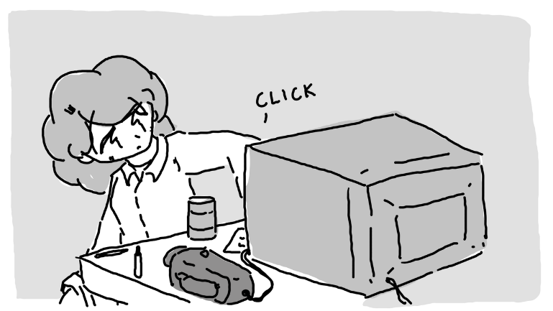
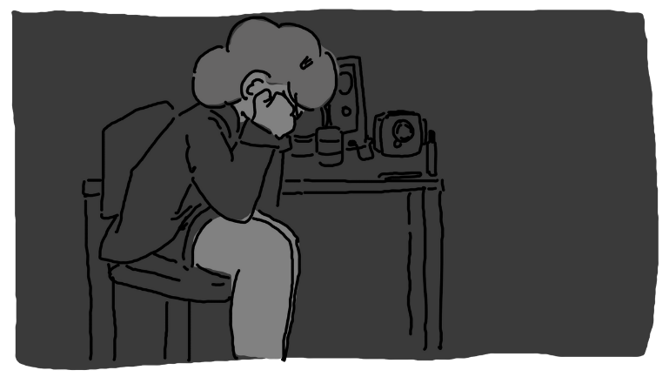

Of course she had taken her camcorder to college, and about a month and a half into it, she needed it. Yeah, Aaron knew exactly how to encourage her while simultaneously make her feel like a terrible person. Not that he knew he was doing it, of course. But he definitely was.
After checking to make sure her roommate was gone, she pulled a clope out of a drawer and snuck over to the window. She snapped, and a little fire on the tip of her finger lit the tip. Every puff dulled her tensions, but she couldn't help but think back to all the times Aaron told her to stop smoking - it was just too expensive.
She considered the off-campus floor fais do-do that night - music, dancing, social interaction. Maybe she could find someone to convince her that being single was a bad idea. There was a paper due tomorrow that she didn't plan on doing. Potions class. She simply could not fathom why potions class could possibly in any way be relevant to a sorceress majoring in Warlocking.
"Hey, Maple!"
"ENO- “ she squeaked, tossing the clope out the window, "You're... You're back early."
Maple sighed. Enoki Ramirez. Her personality was like a gas station icee – sweet enough to keep a child happy for ten minutes while rotting every tooth out of their head.
Enoki sniffed the air like a puppy, her face mellow and unphased. "It smells spicy."
"I was, um… I.."
Enoki began to wave her arms around...
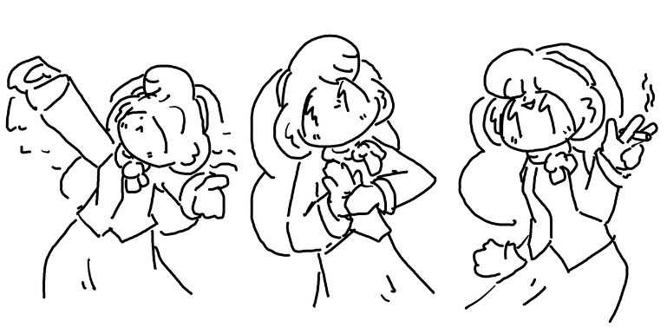
...producing a clope from one of her thick, velvet sleeves. It was even still burning.
"Is this your card?"
Maple stomped over and stole it from her. "How did you do that? I thought you hadn't taken conjuration yet."
She giggled. "I'm not supposed to tell you how I do my tricks, silly!"
"You jerk!"
"Couillon!" She handed Maple the clope before walking over to her bed, sitting down on it. "So, what's wrong?"
Maple began to puff on the clope that Enoki had produced from her sleeve. "You wouldn't understand."
"I might a little bit."
She sighed. "I don't know what to do."
"So... I was thinking..."
Maple feigned ignoring her and leaned against a shelf.
"How about we run away from the school?"
She scrunched her eyes a bit. "You worded that as if it's not a figure of speech."
"You know, just up and leave. Pack bags. See where the road takes us."
"Enoki, are you out of your mind?"
"I don't think so."
Maple took out her clope and began to examine it. "You see nothing wrong with two teenage girls, barely adults, in the middle of the woods for miles, with no money and no discernable end goal? Doesn't that sound like a really, really bad idea to you?"
"No."
"And, uh- Isn't your père Amihan Ramirez? The Amihan Ramirez?"
"Yeah."
"And you don't see any problems with this?"
She beamed ear to ear. "None at all."
"I guess I've got no reason to keep from dreaming. Now, uh... I'm going to start working on my paper for tomorrow, don't bother me." She got up and walked over to a desk on the other side of the room, clicking on a light and sitting down.
"Didn't you wanna go to that fais tonight? They’re gonna have ping pong and snacks and- “
Maple looked over her shoulder. "Not this time. Don't bother me."
"I won't make a peep."
"Good." With that, she pulled out a sheet of paper and began to brainstorm a topic. "Hey, uh... You don't happen to have any extra copies of reference material from when you took potions, do you?"
No response.
Maple looked over, and Enoki was sitting in her bed. She had opened her backpack and pulled out a package of sliced mushrooms, eating them straight out of the bag. Maple blinked a few times, confused.
"You heard me, oui?"
Enoki nodded.
"Well, do you?"
She nodded again.
Maple groaned. "You can talk when I'm talking to you."
Enoki made no clear gesture to indicate whether she was listening.
When she finally sat down to write the paper, she tried to remember anything from class. Anything at all. Not that she had been paying attention, of course - it was in the morning, and more often than not, she was hungover, and her head hurt far too much to pay attention.
But having Enoki's notes from when she took the class were nice. Maybe she could even steal the same topic and just change a few of the notes. She wondered if any of the professors might catch on, with this being the work of the famous Enoki Ramirez, of course. She hoped not.
She really didn't want to start writing this paper, and as she did her best to think of literally anything else, she wondered if maybe she could make a tape to send back to Aaron. If he had a video player, of course. He could always rent one from the video rental place right down the road from the apartment if he needed to, of course.
Maybe a letter would be better, anyway. The paper was already in front of her, after all.

Letter to Aaron

Cher Aaron, ça va?

Hey, so, I suck at writing letters. I'm sorry I haven't called in a few weeks - the phone is kind of expensive and everyone on my floor likes using it all the time. But I'm going to try and see if I can send a letter instead.
School's been great, but I really, really don't think I fit in here. I watched the tape you made for me. I really wanted to cry. I didn't realize how much I missed you until I got here. I haven't been doing too great, but I'm going to do better. I promise.
So, there's this crazy thing - I'm still roommates with Enoki Ramirez, and I still can't figure out how I feel about her. She gets under my skin sometimes, but, well... she’s got crazy magic. She came in, pulling a clope out of her velvet coat sleeve. A lit-up, on-fire clope. And it was just there without any smoke. She calls these things magic tricks, and I know she's just a human like you, but sometimes I wonder. Other than my fire power, her being my roommate is sort of the only thing I have going to brag about at. Can't imagine why everyone around here is so obsessed with her though, huh? I guess that's what money does to you.
But enough me. You find a girlfriend yet? I hope you find someone now that I'm out of your hair. I can't think of anyone on the planet who knows how to treat a woman better.

Take care of yourself, please.
- your little sister no matter what,
Maple Tremblay

Potions Class

The hominy was getting to her head. If she had to smell hominy for another ten minutes, she was going to go completely crazy - dump the tables over, spill the ingredients, knock over the microscope shelves, see if she could pull the whiteboard off the wall... the works. She wanted to kick something, scream, punch the walls, something, anything to relieve her stress.
Her lab workbook wanted her to get through twenty more experiments, and she knew that this lab sheet was due tomorrow. She would have been motivated more if she found it relevant. Or interesting. Or she had more than ten minutes before the whole lab closed. Or even if it felt like it belonged here - turning water into hydrogen peroxide? What was this, alchemy? What did alchemy have anything to do with potions? Weren't potions good luck charms or transformation juices or something? Couldn't they just turn water into hydrogen peroxide without magic?
The clock was ticking. Every tick, a minute went by. She was sweating, and it made her feel disgusting. The words were jumbling up in front of her, and she had just about enough.
Eh, who cared if the paper wasn't complete?
She packed up her bags five minutes before ten o'clock at night - when the doors locked to the science building. Gritting her teeth, she popped her backpack on.
It was a lonely walk back to her dorm, but the tone change upon walking in was immediate. It seemed like everyone - or at least the nerdier types - were out in the lobby. It was both guys and girls, since that particular dorm complex housed both guys and girls on different floors. They were all sitting around the common room television, enamored with some sort of video game. She didn't think much of it, beginning to walk past the hubbub until she heard her name.
"MAPLE!"
She turned slowly. It was Enoki with a controller in her hand, staring at her, leading the rest of the crowd to do the same.
Maple gritted her teeth. "What?"
"C'meer! I need tah’ show you somethin'!"
Begrudgingly, Maple began to walk over. She figured that, if Enoki wasn't coming back to the room before long, that she wouldn't be able to get much sleep, anyway. But sleep sounded really good to her at that time.
"That a video game?" asked Maple.
"Uh huh!"
"Where's the keyboard?"
"It's from Nippon - it doesn't have one!" She shoved an awkwardly shaped controller into Maple's hand. "It's a fighting game!! That's Nim McNeely over there, he's really good at it!"
Maple looked over to the couch in front of the television, reserved for the players but surrounded by an audience of nerds. On it was a sylph - sort of like a wind fairy, but the same size as everyone else. He sat on his knees; his feet tucked up behind him. He had wispy white hair and skin so painfully white that he was indistinguishable from an albino human. He wore a flowered button-down shirt and a smug expression, and the moment Maple made eye contact, a bright cherry blush.
"What? You want me to play him?"
"Uh-huh!!" chirped Enoki.
"Fine," she groaned. "I'll play him."
She sat down on the couch.
Nim leaned over just a bit. "So you're Maple?" he asked, speaking a thick Oned accent.
"Yeah," she replied, not giving him eye contact.
"Aye, I'm a.. Ya’ need help with the controls?"
"Is it just this wiggly stick to move and the buttons to fight?"
He sharply inhaled. "Sort of, oui."
The television script flashed text in Nipponese. Maple hadn't the faintest clue what it was saying, but she assumed that it had something to do with starting. The game started, and she was impressed with the three-dimensional graphics. It was much, much more realistic than the arcade games at the mall. When she finally got a chance to see the fighting stage, she was automatically given a character with a design that was clearly aimed at a male audience. Go figure.
Then, the game started. Confused, she started pushing random buttons, getting frustrated and confused at how fast the two characters were punching and jumping. She seemed to be doing the same thing over and over again, no matter what she pushed, and he was flipping and kicking in ways she couldn't figure out. In no time at all, he had won, leaving her even more stressed than in class.
She threw the controller on the ground, standing up and grabbing her backpack. "I hate it."
"Wait!" chirped Enoki, "Just one more time, please? I think you'll get it this time!!"
Considering her options for a moment, she slowly put her bag back down and picked up the bizarre controller. She sat back down, exhaling slowly.
"Hey, uh.." coughed Nim, "So, what I'm doing to do all those moves is- “
"Look, dude, I just got out of a class, I really don't want to start another one."
"Right, right, sorry."
The match restarted. She breathed slowly, trying to pick up on what exactly was going on. He landed a punch first, but she quickly responded with a kick attack. She smiled. It felt really good to land that kick.
As it went on, people started putting bets on who would win. She was still button mashing, but at least she had found some kind of pattern - halfway through it became clear that Nim wasn't holding back on her anymore. After all, if this game was new, then Nim didn't have all that much of an advantage over her, did he?
Enoki yawned, smiling. "Welp I'm heading up to bed. You guys have fun, ok? I'm keeping the game console down here with the television."
Maple was listening, but because she was listening, she lost the match to a kick she forgot to block.
She turned to Nim, death in her eyes. "We're playing again."
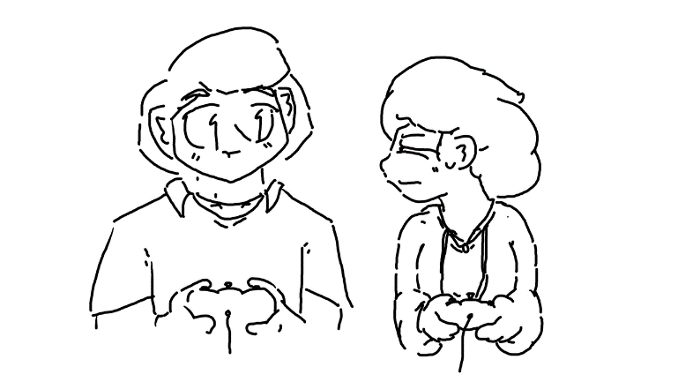
He shrugged. "I'm fine with that."
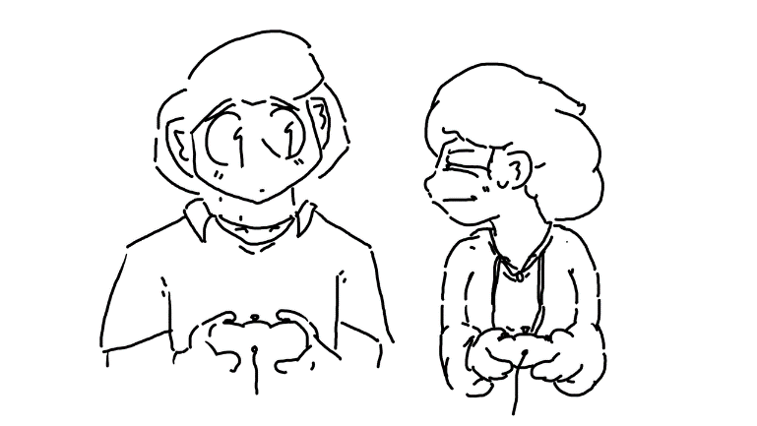

And Enoki was already gone.

They Actually Do It

Maple had just about enough. Dinner was over, and it was just about time to lock herself in her room and pretend to be a plant. She dragged herself into her room, slung her backpack to the ground, and fell over into her bed. Using feel, she located one of the books she had due for a literature paper still laying atop her sheets, and with a single hand, she popped it open and held it over her face. There was no way she was going to be ready for her literature final by tomorrow - she wasn't even halfway through. But that was alright, she wasn't even planning on being on campus tomorrow. She was only reading because she couldn’t think of anything better to do.
She could hear Enoki's footsteps as she ran through the dormitory hallway. In an instant, she was in the room and threw herself into her own bed, posing dramatically and ready to catch up with Maple.
"So whatcha readin'?"
"A book."
"...Cool."
"M-hm."
Enoki poked her brain for something to talk about. The end of the semester was coming up, so that could be a decent topic.
"Sooooo... You want to get started packing?"
"I don't really want to do anything."
"Me either." Next topic. "You were worried about potions class, how'd that go?"
Maple slammed her book shut. No use in trying to read. "It's over. I don't ever have to think about it ever again."
Enoki gasped dramatically. "You passed? Was it the extra credit you took?"
"I lied about that extra credit so you wouldn't worry about me."
Enoki winced. "Ouch."
Maple sat up, letting out a heavy sigh. "Bon, so, you know that thing we were talking about? I'm in."
She squeaked in excitement. "For reals?"
"It's happening. I got my bag packed."
Enoki was rocking back in forth, nearly about to burst at the seams. "Uh-huh??"
"Get a map out and I'll show you what route I'm thinking."
In a heartbeat, Enoki snatched a map of North America out from one of her drawers. Maple had expected her to find it in one of her dozens upon dozens of pre-bought textbooks but having a full-sized rollout map was going to make planning much, much easier. Upon closer inspection, though, Maple realized that it was a map of campus, not of the world. Huh... she could have sworn that there was a world map on the other side.
"There we go," chirped Enoki, "Map of the town."
"...Flip it over so we can see the whole country."
She flipped it over, and sure enough, there was a map of the North Columbian continent.

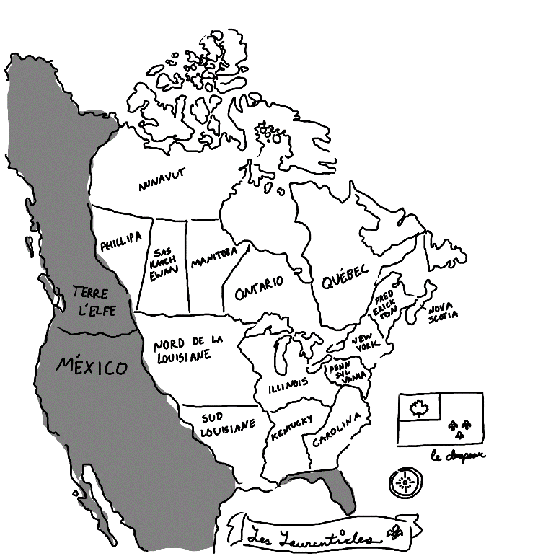
Maple leaned in to draw on it with an erasable marker. "We're down here. Say we cut north; I'm estimating it should take us about two weeks on foot to get up north out of Carolina."
Enoki touched the map with her finger. "What if we just cut to here and take a taxi?"
Maple took a deep breath, sitting up. "Enoki... Taxis cost money."
"But food does too, and, I mean, the less days we stay out, the less days we gotta put in, if you know what I'm sayin'."
"...You do the math on that, I'm not in the mood- “ She lifted a finger. "Wait, no. I don't know if I trust you to do the math on that."
Enoki giggled under her breath as Maple continued to plot their route.
Some time went by. Enoki had already gone to get snacks and then proceeded to eat all of the snacks. Maple seemed obsessive, but she knew many of these roads. That, and they were two college-age girls, one of whom was an easy, highly attractive target. This wasn't going to be easy, whatever they were doing. Maple wasn't even sure where she wanted to go, at least not for sure. Just out of the Carolina Province. Somewhere up north. Somewhere that Aaron wouldn't think to check.
"Yeah..." sighed Maple, "This route should be painless. We just need to take the map with us and we're good as gold."
Enoki leaned in. "Can I pack snacks?"
Maple pointed at her. "Please."

Into the Woods

Campus was still visible, back behind a hill. In front of two girls was nothing but woods. Lots and lots of woods. It was the best way to escape without getting caught, but... it was a lot of trees. Maple stared at it as if she were attempting to figure out how to walk directly through a brick wall. That, and of course, whether this adventure would even be worth it.
"...Boo!"
Foomp, said the ground as Maple landed on it. "Ahh..!!?"
"What, you scared of the..." She twiddled her fingers. "SpooOOoooOOky trees?"
"Aaron's probably waiting for me somewhere on campus in his car, and I'm disappearing into the woods," she replied with a thick undertone of annoyance.
"Well, yeah. He probably is."
"Did.. you, uhm.. Leave a note for everyone else like I suggested?"
Enoki put a hand on Maple's shoulder. "They'll understand."
Maple sighed in relief, knowing that Enoki probably found the perfect words to say to keep Aaron from worrying. It was like a boulder had been lifted off her shoulders. "Whew..."
So, into the woods they went.

The Martians Leave a Note

Felix and Coralie had successfully infiltrated Maple and Enoki's room. That is - the door was left open and they walked in without permission. Felix stood by the door, coolly leaning against it to guard and make sure no one else had access to this treasure trove. Coralie had already made her way to one of the desks, picking up a note from the top and reading it aloud.
Chers 'tits terriens,

Cette note a été écrite par les martiens qui viennent d'enlever Enoki Ramirez et Maple Tremblay. Cherchez-les pas parce qu'on est occupés à les disséquer pour trouver ce qui les rend si magnifques. Continuez voir vos vies ennuyantes comme si cette note a jamais existé. Merci ♡

On vous envoie nos amicales pensées,
~ Les Extraterrestres

"Dear puny earthlings,
This note was written by Martians who have just abducted Enoki Ramirez and Maple Tremblay. Do not look for them, as we are busy dissecting them to figure out what makes them so awesome. Please continue with your mediocre lives as if this note never existed.
Thank you ♡
- The Martians."

Coralie just stared at it, mildly confused. "Hmm. I wonder who wrote it."
Felix shoved his hands into his trouser pockets. "Who do you think wrote it?"
She scoffed, letting the note fall a bit. "I know who wrote it, I-..." That's when she noticed something fall out and begin to drift to the ground like a leaf. "Hey, look- “
"Yo, a fifty?"

Into the Woods (cont’d,)

A few hours of trekking went by. It was kind of remarkable that they hadn't encountered any roads yet. They hadn't eaten anything so far, but Maple was sure to bring a steel cup, one that she had owned since she was much younger. A few times, they would stop by a stream, and she would light a small fire underneath until it began to boil. They'd wait for it to cool off and then drink it. It tasted like dirt and had a grainy aftertaste, something Enoki wasn't familiar with, but at least it wasn't going to kill them.
At some point, Maple eventually became hungry. She stopped, turned around, and facing Enoki. "Alright, I'm famished, let's see what snacks you- “
Enoki spun around, letting Maple see inside her backpack.
"Um... Enoki?"
"Uh huh?"
"Did you mean to pack nothing but portabella mushrooms?"
"All the vending machines were in the student center!" She held her hands like a crooked businessman. "I had to bribe some workers in the dining hall to gimme all their extra mushrooms."
"Did they have literally anything else?"
"I mean, yeah, but... What else do you need?"
Maple was short with her. "I'm intolerant to mushrooms. We've talked about this."
"Oh." She folded her hands in front of her and leaned back. "Well, that... would have been good to know earlier."
Maple groaned.
"Hey, but can't you just magically transform them into something you like?"
"I failed that class. Didn't you get an A?"
"I guessed on all the tests and got everything right, so I didn't actually... uh... learn anything."
Maple died inside. "Oh."
Over the next hours or so, Maple had decided not to eat anything at all, but the two made great progress. The sun had completely set and the two had decided to camp for the night. They sat on the ground around a bundle of sticks that Maple had caught on fire. It was a bit chilly, but not uncomfortable, especially near the fire.
"Hey!" chirped Enoki, "You get the tent, Maple?"
"We weren't ever going to have a tent. How could we have gotten a tent?"
"A bedsheet or somethin'?"
Maple sighed. "Look, I'm fine just sleeping on the ground, that was up to you if you wanted to bring something to sleep in."
"Oh, I'm fine without a tent, just the stars above my head... and the creepy, crawly, death parasites from below, crawling in through my skin and mind-controlling me to drown myself in the ocean."
"...Enoki, this isn't Australia."
Enoki looked up at the stars. There were quite a few up there. "You ever think the stars looked like little fairies, and when they twinkle, it's like their way of saying 'salut'?"
"No, I think fairies look like fairies."
"You're no fun!"
Maple stood up and kicked the fire out. "Shh!"
"You 'shh'!"
Maple whispered harshly. "No, I mean, shut up and listen, I hear something." The two were quiet, and the house of horse hooves faintly echoed through the woods. "What's that?"
"Oh, probably the blind elves, coming to take away lost humans and hold them for ransom."
"Shut up!" she hissed.
"I'm serious!"
Maple sighed. "See, that's your problem, you keep coming up with stupid explanations for everything, and then I can't trust you when something serious happens."
"...Hey, Maple?"
"Yes?"
"If they're blind, why did you put out the fire?"
In an instant, the two of them were grabbed by their legs and held upside-down like sacks of potatoes. For only a split second, they could see who was before them - a dark rider on a dark horse, no eyes in his sockets, limbs stretched and far too long for his body, strength far exceeding his reach. Maple couldn't make a sound, she could hardly breathe- the wind had been knocked out of her, and her eyes were reeling as she tried to figure out where he stood in relation to her.
"I mean," pointed out Enoki, "It just seemed a little silly."

Felix and Coralie’s Last Dinner

Felix stared at his glass of chocolate milk. He really didn’t want any more of it, but he understand that he was under oath – he had to drink it. There wasn’t an option.
In a huff, Coralie slammed her chocolate milk back onto the table. “I just did cup five. You?”

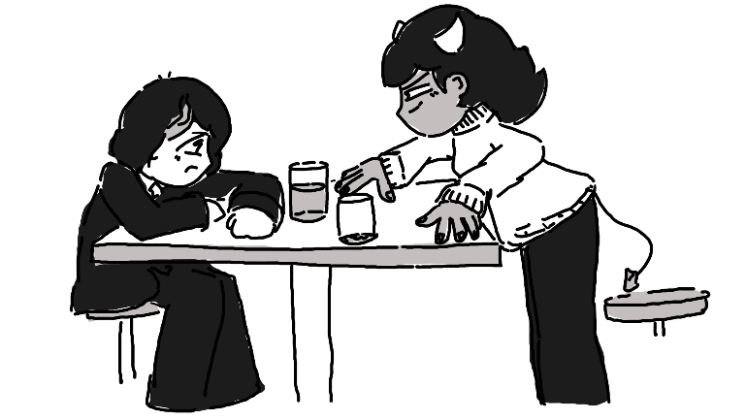

“Five, too… This has got to be the dumbest tradition on the planet.”
“And?”
He held his breath, downing yet another glass of chocolate milk. These bi-weekly challenges had turned his love for the stuff into a deep-seated, burning hatred, but he had to do it. This was the last time they’d be able to hang out in the dining hall over lunch until the semester picked back up. And if Coralie was going to do it, then he wasn’t going to let himself get shown up.
“So,” sighed Coralie, wiping the milk off her pink face, “How you feeling?”
“Sick,” he replied, wanting to take a trip to the restroom to purge his stomach.
She chuckled. “Think about how I feel. This is all sour to me.”
He stuck his tongue out. “Why are we doing this?”
“I thought this was your idea.”
“I…” he groaned. “Bon, I think we’re done. Five is a good limit.”
“Oh, I meant that I had five before that glass. I’m on six right now. You’re gonna have to get another glass if you want to be even.”
He frowned. “Fine.”
“Hey- before you go,” she leaned in, “You wanna talk about that note? I mean, have you seen Enoki or Maple anywhere on campus since then? You don’t suppose they... just... left, did they?”
“We’re all adults, we can do what we want.”
Coralie kept her voice down. “But Enoki Ramirez of all people, do you think… I don’t know, don’t you think it’s a little suspicious that she left without any security or anything? Being that famous?”
“Well, when you put it that way… Dude, you don’t think she’s gonna go missing and they’ll have some kind of ransom, do you?”
“That’s exactly what I’m thinking.”
“Dude, how rich do you think we could be?”
“Famous. Rich and famous.”
“Right, right…”
Coralie leaned back and stretched. “Well, I’ll get my car ready.”
“Wait, we’re heading out tonight?”
“Yeah! Who knows where they’ll be by tomorrow? Let’s do some interviews with people on their floor and see what we can learn first, and then get a move on! After you drink one more chocolate milk.” She grinned. “I’ll wait.”
He groaned deeply, standing up. “We’re picking a different stupid tradition next semester, bien?”

Now They Half to Escape

When Maple finally came to, it was just about impossible for her to not panic. She was sitting on a chair, hands tied behind her back and a sack over her head. It smelled like corn. Almost immediately, she began to hyperventilate, trying to use her powers to burn her way out, but... nothing seemed to happen.
"I.. I-I.. I can't burn my way out.. ENOKI, I CAN'T BURN MY WAY OUT- “
"It’s alright, be calm." Her slightly muffled voice was coming from right behind her, facing away. She might have been tied up to a chair, too.
"GIVE ME A SINGLE REASON WHY I- “
A big wooden door creaked open, and a gruff voice from the other side opened it up. "HEY, COULD YE KEEP IT DOWN? We're making some phone calls and trying to count ransom cash! Geez…”
Maple would have easily burned the entire place down then and there if her fire powers were back.
"May I have a glass of water?" asked Enoki.
"NO!" the guy shouted, slamming the wooden door shut. His voice began to trail off. “Freakin’ no!”
Enoki frowned. "Well," she whispered, "That guy's rude."
"I-I can't believe I did this.." whimpered Maple, "I-I can't believe it, I'm gonna die here.. I have no idea what they're going to do to us, and it's all my fault.. I-If I wasn't so selfish, I.. I-I, well, I guess this is what I wanted.. Now Aaron's not going to have to worry about me getting in the way of his life anymore, I'll just be dead somewhere, and- “
"Hey, Maple?"
"What?" she hissed.
Enoki's grin could be heard in her whispered voice. "They tied mah sleeves and not mah wrists, so I just slipped out, stay quiet." And in a moment, the sack from Maple's head was whipped off. "Ta-da!"
"Why isn’t my magic working?" hissed Maple, still trying to burn her way out of the ropes, which had been tied to her wrists instead of her sleeves.
"It's prolly that thing on your ankle," she pointed out.
Maple lifted her leg. Sure enough, there was a small device tied to it with a pulsing crystal sticking out the front. She had never seen anything like it before. It must have been dark elf magic that the blind elves were borrowing for some reason. She tried to use her fire magic, but instead of producing fire, the crystal began to glow. It must have been absorbing her energy or something. She wasn't really sure what it was doing. They probably talked about this in one of the classes she slept through.
"As long as that thing is touching you, it's going to absorb all the energy from your skin," commented Enoki, "So..." She grinned, rubbing her hands together eagerly. "Bon, so, I've got an idea, you won't like it, but I've always wanted to do this on somebody else, and- “
Maple glared. "What on earth are you talking about?"
She picked up a handsaw from off the ground. "We're in a barn, yeah? There's a box over there, and... Well... I'm a magician... And if we can get PART of you not touching the anklet..."
Maple's eyes widened. "No. No, no, no. You are not sawing me in half!"

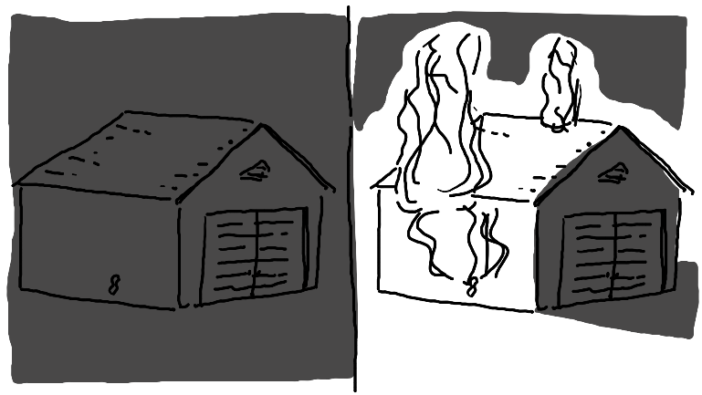
The moment they could make it out, the two ran away from the barn as fast as they could. They chased their shadows - the light of the barn was enough to give them a good sense of direction. To their benefit, they knew that the blind elves were particularly keen on sound, but the sheer roar from the flames, and now exploding gasoline, should be enough to keep them off their trail. They were exhausted, but they were also terrified, so that did wonders to their sense of motivation.
Maple was still a little freaking out over having been sawed in half, used as a flamethrower, and then put back together, but she tried not to think about it too much.
Finally, after a hazy night of frantic escape, the two found themselves asleep under trees, besides a road. The sun was just coming up over the horizon. How long had they been there asleep? Were they using some kind of sleeping spell to keep them there? Maple didn't want to think about it, nor did she want to know what would have happened if they had stayed there - they were safe now, or at least it seemed like it.
Enoki’s head popped out of a pile of leaves that she had been sleeping in. "Hey, Maple? Where are we again?"
Maple yawned, opting instead to have slept standing up against a tree. "Farther north. We really need to get this off my foot before we do anything else."
"Prolly a locksmith in town'll do it. Let's find a bus stop and go!"
"Enoki... Those.. cost money. They stole our backpacks. You're going to have to realize one of these days that- “
"Hey, Maple? What's that behind your ear?" She reached behind Maple's ear, gasping and retrieving a note. "It's a twenty!"
"Hold up, can you just pull money out from behind people's ears?"
She giggled. "Can’t tell my tricks.”
"I... don't know how to feel about that."
“Let's go find a bus!"
"Yeah, let's."

Nim Sees Suspicious Activity

Somehow the semester was already over. It didn’t feel right, but it was. And to think – he had finally worked up the courage to ask Maple out. Like, for real. To coffee. Or something. Not that he could find her anywhere – she’d been missing for a day. He figured she’d just up and left already. Figured. She probably didn’t think much of him anyway.
Ring… Ring… Ring…
It was his parents again for the four-hundred thousandth time. No, he didn’t need their help moving out – they lived twenty minutes away, he could easily back into their place by himself. Besides, he needed the time by himself. No parents, no Maple to distract him from-
And then a familiar face popped up on the side of the road. It was just for an instant, but Nim swore that he saw Maple Tremblay and Enoki Ramirez walking to a gas station. Strange.
Yeah, he didn’t care much to be alone anymore.
Quickly, he turned his car around and drove up the road to find them. The gas station wasn’t all too far away from a bus stop, and just as he caught sight of them again, he saw them hop onto the bus. He squinted, paying close attention to the license plate. MBL-002. He needed a pneumonic to remember it. Maple Bourbon Latte. Mmm… that was his favorite order from his local coffee place, a place he really wanted to show Maple if he would have been keen enough to have asked her out a week ago instead of today.
Yes, he knew it was a bit creepy to be following them. He was prepared to deal with that, or at least he figured he was. But something about the two disappearing from their dorm, especially Enoki, who he half-expected to be taken home by helicopter, didn’t sit right with him. He wanted to figure out what was going on. And he could use this as a decent excuse from having to call his parents back. And maybe as a decent excuse to finally ask Maple out.
They started driving away. For a moment, he considered chasing the bus, but instead, he raced back to the school. He was only about ten minutes away, after all. In the meantime, he’d make a phone call.
“Yes, this is Nim McNeely. I’m requesting a secondary officer. I think I’m on the cusp of a missing person’s- No, I swear this is a real case, I’m not just pranking in again… No! No! Mais non! I-… It’s about Enoki Ramirez and Maple- “
They hung up.
He sighed, driving back. If they didn’t listen to him about his rapidly forming suspicious, he’d just go tell them in person.
Ring… Ring…
Why on earth did his parents keep calling him?
He peeked down for a second, and no- this was the university police department calling him back. He picked back up, confused.
“Hey, Nim, we got word from the police chief. He wants you to report back immediately.”
Hoo boy, this was going to be fun.
When Nim pulled up to the police office, he dashed in. He almost never went in without his uniform, but that wasn’t relevant at the moment. He hesitated a bit, but he found himself in the university police chief’s office, sitting across from a desk. He hadn’t met the new chief in person yet, he was always busy at the wrong times, but this was one heck of a first meeting.
The chief himself, a green orc with thick eyebrows, had very little decoration, aside from a nameplate reading Chief Maurice LaPointe. He stared him down silently.
“I… er, is there anything you’d like to talk about?” asked Nim, confused by his silence.
The chief pushed a button on a small tape machine. It seemed to be wired to his office phone. “Bonjour,” it spoke, “We’re here on behalf of the Maria Ramirez Development Foundation. Our Maria Ramirez Retrieval Agents noticed that her room was notably vacant. For security reasons, it is of great importance that her disappearance is top-secret. Anyone who knows of their whereabouts is to remain undercover and act with discretion. Anyone who aids with the retrieval of Maria Ramirez, without bringing external attention, will be awarded a sum of one thousand Laurentide dollars.”
Nim froze. “You’re… um… you’re not serious, aren’t you? Does that mean they’re gonna pay me a thousand dollars just for not telling anyone about this?”
Chief Maurice nodded.
He laughed, leaning back. “Wow. This was not what I was expecting. I was fully expecting to get fired or something. So, um, anyway, I know their license plate number. I caught sight of the bus they caught while I was heading over here.”
He leaned in.
“Yeah! MBL-002.”
The police chief stood up, grabbing his keys off his desk. He walked over to the door, gesturing for Nim to follow. He didn’t smile, smirk, or even show his eyes, so Nim wasn’t quite sure what to expect.
Goawn was lounging in the lobby. He was supposed to be the station dire wolf, but while he was almost big enough, his behavior would have fit a loaf of soggy bread much more fittingly. Police chief whistled, and Goawn poked his head up, rolling around until he was within hand range. The chief kept walking out the door, the dog waddling close behind, Nim at the flank.
“You’re… taking me with ye’, are you?”
Maurice nodded, getting in the driver’s side seat. Nim climbed in the passengers’ side, and Goawn barely squeezed into the back.
Nim’s face was full of a goofy grin. “One thousand dollars… I don’t even know what I’d do with one thousand dollars.” His smile faded a bit. ”Probably pay for textbooks or something.”
Maurice put the police car into gear and began to drive. No questions, no phone calls, no intercom, he just drove. The longer it went, the more unnerved Nim became by the whole thing.
“Are you not going to make any phone calls? Was that license plate enough to figure out where they are?”
He nodded.
“Dang… You’re good.”

Old Lady Purse Thieves

“FELIX!”
“Hmm?”
Coralie was shaking him by the collar of his suitcoat. “Look at that bus!”
Felix, who had slumped over asleep in the passenger side of Coralie’s car, sprung up to take a look. They were parked at a gas station not all too far away from a bus stop, and at that bus stop, boarding the bus, were Maple and Enoki.
“Is that them??”
Felix squinted. “Yeah… Yeah, I think so.”
Coralie tried to start her car up. It turned over a few times, but it wouldn’t start. She hit the steering wheel with her palm in anger. Deeply confused by this, Felix started at the dashboard. No, she wasn’t out of gas. The battery seemed fine.
“What the heck?!” she screamed, face turning a bright cherry red.
“Dude, when was the last time you got your oil changed?”
“It was just…” She looked up at the sticker. “I was supposed to get it changed at 150,000 miles.”
“And how many miles do you have on it?”
“…a lot more than that. Hey… You mind going inside and getting some snacks? I’m fine with anything spicy. I’m just going to be in the car screaming and I don’t want you to hear me. Here’s a ten.” She handed him a bill. “See ya’ in a bit.”
“Hehe, yeah you too…”

…

After a few moments, he returned with some snacks in tow – two bags of spicy Gusanitos chips, some Beignets, and two bottles of cola. The closer he got to Coralie’s beater car, the more he expected to see her in distress, but in all honesty – she was fine, just listening to some radio on what little car battery she had left.
“I.. got you your favorite chips,” he said, “And you can have some of mine, but I know you’re not really into hors d'oeuvre.”
“Oh, thanks! You’re a good friend.” She started chowing down into the chips.
Felix opened one of the sodas. “You, um, you look calm now.”
“I just needed to take out my anger. I'm happy now.”
“Hey, um… The bite mark out of that telephone pole over there, was that-?”
“I’m happy now. That’s all that matters.”
They ate their food in silence for a bit.
“So, what now?”
“I’m debating calling my père,” she replied.
“We could call my uncle, he lives- “
“No thank you, I want to keep my arms.”
Felix squinted out the window. “Hey, you see that police car at the red light?”
“Yeah?”
“Isn’t that Nim? The sylph? Wasn't he friends with Maple?”
Coraline squinted over at Felix. “How would you know that?”
“They played that stupid video game every other day for months in the lobby, how did you NOT know that?”
She crossed her arms. “I didn’t care?”
“We got to get their attention.”
Coralie slammed her chips down into the dashboard and jumped out of the car. “Follow me – I’ve got an idea.”
Down over by the bus stop was a bench. A little old lady was sitting down, holding a purse in front of her. She seemed to be a Mònn d'Plonj – part dragon, part human. This woman where Coralie’s undivided attention was. Felix did his best to catch up, but by the time he was there, she was already in cahoots with the old lady.
“Hey, can we pretend to steal your purse?”
The light turned green.
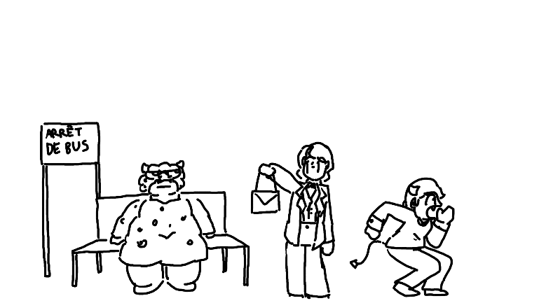
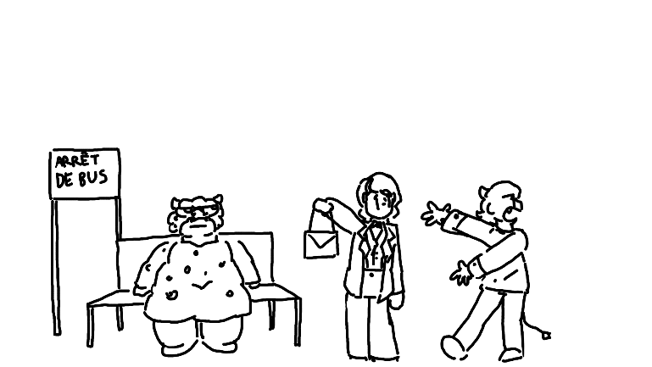
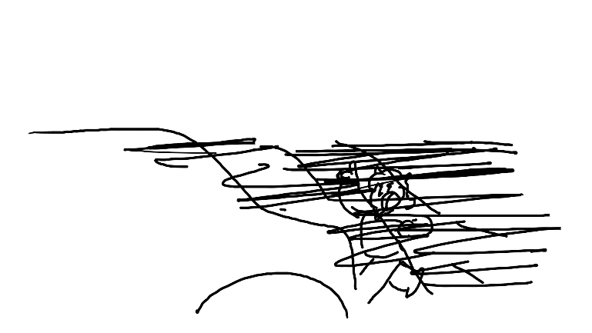

“Well… thank you for letting us pretend to steal your purse,” said Felix, going back to pick up the top hat that he dropped on his way over there.
She crossed her arms. “Whatever. Looks like it’s time for Plan B.”

After the Tiny Bus Naps

Maple did indeed sleep on the bus, but it wasn’t a good sleep. She kept having flashbacks to the time she blind elves snatched her. She occasionally rubbed her stomach, not going to be able to put behind her the fact that she was cut in half. She kept wondering how this trip was going to go from here if that’s what happened on the very first night. She probably dreamed something in the meantime, but it wasn’t much, and she immediately forgot it.
And then there was Enoki, curled up and dead asleep – even snoring just a bit. Maple could not fathom how on earth this girl was always so calm, and then she remembered it. Oh, yeah. She has lots of money, what could she possibly be afraid of?
She peeked out the window, trying to figure out where they were. It seemed like the hours spent pouring over a map were pointless. Then again, they were probably pointless anyway – she didn’t know where she was going, not really. She never felt passionate about anything other than leaving the providence.
Maple had about enough of Enoki’s sleeping and started poking her on the shoulder.
She sat up, stretching like a princess from a movie. “Uh huh?”
“We need a plan.”
“Hm?”
“I don’t know where we are, and we don’t have any of our supplies. We need to figure out what we’re doing, and fast.”
She rubbed her eyes, yawning. “Why not ask the lady behind us?”
“Enoki, you can’t just talk to people on the- “
“Hé!” she chirped, turning around.
The lady behind them smiled. “What do you need, honey?”
“We’re both a little lost, where are we again?”
“This bus is on the way to Montbéliard,” she answered. “Where are you two off to?”
“We don’t know,” answered Enoki, “So where are you going?”
Maple winced, trying to stay out of the conversation. She can’t believe that Enoki had worked up talking to a complete stranger about events that she was still trying to process, and to block out the noise, she did her best to figure out what exactly they needed to do to fix everything.

- Get this magic anklet off.

- Buy some new clothes – maybe a hair color change would be appropriate.

  - I want to choose something that won’t stand out too much but also won’t look like me. Purple? No. Dark brown? Maybe. We’ll see.

  - Oh… We’ll need to come up with fake names. That might be useful. What’s a good one for me? L-something would be fun… Lucretia? Hmm… I like that one.

- And then… ???

Enoki stood up. “It was very nice to meet you, Madame Green! Congratulations on your son’s wedding!!”
“You too, Maria! Stay safe, you hear?”
Maple noticed that everyone was standing up and getting off the bus. It was probably just as good of a time to get off as ever – the bus was inevitably going to loop back around anyway.
“Maria?” she whispered, “Is that your fake name?”
She giggled. “No, it’s my real name!”
“You mean Enoki isn’t your real name?”
Enoki gasped playfully. “It’s my nickname! You never knew that? What kinda name is Enoki? It’s a kinda mushroom!”
“How was I supposed to know that?”

Meanwhile, with Nim…

Officer Maurice LaPointe was silent for the car trip. Nim could not be more confused, maybe save for the fact that Maurice thought it was a good idea to bring the department’s incompetent loaf-of-bread dire wolf. Combining those two factors was the fact that Maurice had decided to roll down the window for Goawn, letting the flabby thing stick his face out the window. Nim thought it looked hilarious.
“You know,” he thought, “I wonder what that dog is thinking.”
So, he rolled down his own window and stuck his head out. He could see why it was fun – he looked like a fool, but it was definitely refreshing.
When he popped his head back in, Maurice was on his radio.
“You should be coming up on the bus,” said the voice on the radio, “Keep a low profile, we’ve already got some officers there.”
Nim sighed, having missed a chance to actually hear Maurice’s voice. Or maybe he didn’t talk. Maybe the person on the other side just knew what Maurice was thinking.
In front of the police car was a bus, pulled over. A few other cars were there, officer standing intimidatingly outside of the car.
“Nim,” said the voice from the radio, “We’ve had a talk and have selected you as the best possible person to go in and confront the pair. We don’t want to make either of them nervous.”
How long was his head out of the window?
He took a deep breath and stepped out of the vehicle. Then, walking over to the bus, he noticed that all eyes seemed to be on him. Creepy.
On the inside, however, he couldn’t find them.
“Bonjour? I’m.. looking for a Maple Tremblay and a- “ he then remembered that it might be best to keep Enoki’s disappearance on the downlow. “A… no one else, just Maple.”
Everyone just stared blankly back at him.
“Bon,” he sighed. “Did she pay you to be quiet about where she is, or…?”
More blank stares.
He made a few laps through the aisles, looking to make sure no one was hiding. Annoying. Apparently finding Maple was going to be harder than he at first anticipated.
At some point he just gave up and left the bus, immediately surrounded by questioning officers.
“Alright, alright, they’re not in there!” he ended up replying, “How are we supposed to find them now?”
One of the officers pulled out a radio. “We’re moving to plan B.”
“Plan B?”
“Running PSAs around town,” she replied. “We just got approval. We want to keep it on the down-low, so it’ll just be locally, but time is of the essence.”
He nodded. “I get that.” Then, he walked back to Maurice’s police car. “So… what now?”
Maurice pointed at a restaurant across the street.
Nim grinned. “I’m all for that.”

Mama Mia (here we go again)

From the entrance to the seating to getting their complimentary breadsticks, Enoki was squealing the entire time. Maple had ignored it for a while, excited that she got to order whatever she wanted off a real Italian restaurant menu but confused as to why Enoki was so excited.
“Hey, uh… You feeling alright?”
She leaned in and whispered. “I’ve always wanted to eat at a restaurant like this!!”
“But you’re rich, can’t you do whatever you want?”
She shook her head. “I had a security team escort me places, and we couldn’t go anywhere unless it was fancy or special enough. But we’re in the middle of the restaurant, ordering like normal people!!”
Maple thought about that for a moment. “You know… Growing up, I always wanted to go to a restaurant like this, but I never could because everything on the menu was way over budget. I mean, I could go for my birthday sometimes. Sometimes Aaron would save up enough for me to get to go on my birthday. But it wasn’t every year. I think that’s my favorite part of being in college, all the eating out. But this isn’t normal for you either, huh?”
“Nope!”
Maple raised an eyebrow. “Interesting.”
That’s when she noticed something on the restaurant television, though. Enoki’s face, followed by a short message.
“This is Maria Ramirez, a missing, very young, baby child. She is currently missing. If you have seen her, or know someone who has, please contact this number – 1 800 192 4509.”
When Maple turned back to Enoki, she had taken her cloth napkin and thrown it over her head. Her ears were still poking out the bottom, but most of her head was concealed.
“Child?” groaned Enoki, “How old do they think I am?”
Maple blinked. “How old do you think you look with a napkin on your head?”
The waiter returned with their drinks. “I- “
“I’m very ugly,” she explained, “And I am ashamed to show my face in public.”
He made a weird face. “You can’t be that ugly. You seem pretty cute to me.”
“You don’t understand! Do you see my ears? It is because… I am related to dumbo. Yes, that dumbo. I have the face of dumbo. It’s a curse.”
“So you’ve got a cute cartoon character face?”
“Yes. It’s hideous.”
He shrugged. “Alright…” he sighed, “But if you ever feel like giving me your number, just let me know. What can I get you two?”
They both ordered lasagna with a soda on the side, and the guy headed off back to the kitchen.
Maple blinked. “I don’t know what I just saw.”
“Don’t ask,” replied Enoki, “It’s better that way.”
That’s when she saw Nim go in through the front door. With an orc police officer.
She immediately ducked under the table, doing her best to keep her head away from the gum stuck to the surface. “Enoki,” she hissed, “Down here.”
Enoki popped under the table, lifting the napkin out from over her face but not taking it off.
“Bon, Nim’s going to recognize me.”
“Put a napkin on your head!”
“No! That’s stupid!”
“Quoi faire?”
“We need to escape. How are we going to get out of here?”
“Fire exit!”
Maple sighed. “Those make noise. Everyone would look directly at us.”
“Not unless there’s a real fire.”
“That’s way too far.”
“Even a little one?”
“I can’t make fire. I have this thing on my ankle, remember?”
“Hmm… How about… We pretend to be waitresses and escape through the employee’s exit?”
“Too long, too many things could go wrong.”
“Just walk out the front door with napkins on our heads?”
“No.”
“Escape through the air conditioning vent in the restroom, crawl our way to the outside, and then embrace freedom- “
The waiter from earlier stopped by and peeked under the table. “You, uh… You two chers doing fine down there?”
“We need to escape,” whispered Enoki, “Someone who knows mah’ friend Maple here, he’s out there and we don’t want him to find her.”
“I see,” he answered. “Well, you can come with me and I can take you both out the bad-date door.”
“You have a bad-date door?”
He chuckled. “This is an Italian restaurant, of course we have a bad-date door. Here- why don’t you both get up and hide your face with menus like normal hiding people?”
Maple popped up and grabbed a menu, hiding her face behind it. Then, Enoki did the same thing, taking off the napkin for half a second.
The waiter gasped a little. “You were on TV- “
“Shh! I’ll pay you a hundred bucks if you don’t tell anyone!” Out of her sleeve, she pulled four twenties and slipped them to him.
They started walking towards the back, face suspiciously obscured by menus, but… no, it didn’t seem to work for very long.
“Hey, uh, Maple?” she heard Nim say.
Yeah, it was over.
She tossed the menu to the table, and Enoki did the same. The whole restaurant, who had not cared at all that Enoki was in the store before the advertisement, was now staring to see what would happen next.
“Hey! We need to talk!”
“NO!” she shouted, grabbed Enoki’s wrist and darted towards the fire alarm door – it was the closest. The alarm immediately went off, as people got drenched with water from the sprinklers and loud sounds echoed through the building, equally disappointing everyone in the entire restaurant.
“AFTER THEM!” shouted Nim, who had Maurice right by his side.
Maple and Enoki burst through the door, immediately scanning the immediate vicinity. Enoki started running towards a random convertible jalopy, and not seeing much of a better option, Maple ran to the back tire, grabbing a spare key and then hopping into the driver’s side.
Nim was almost there, being marginally faster than Maurice, but it was too late. He leaped into the air, but as he did so, Maple had stared up the car, put it in gear, and slammed on the accelerator. Nim hit the back of the car and rolled off like a hot dog on a hot dog roller, hitting the concrete with a dull thud.
Maurice took note of the license plate number.
“WHOOP!” shouted Enoki, “This is so excit-‘
“SHUT UP!” replied Maple, frantically trying to merge into traffic. She did, once and once again, the two were on the road.
Enoki’s stomach growled. “I’m still hungry- you wanna get some drive through?”
“NOT NOW!”
“Hey, calm down, mademoiselle chaud.”

Coralie’s Père

“Hey, Felix, why are you always so nervous around my père?”
“N-No reason, none at all.”
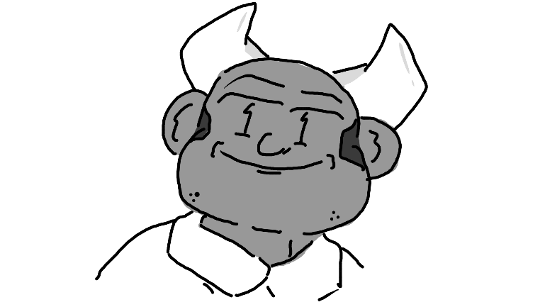
His station wagon was parked at the gas station, and Felix was once again within twenty feet of Coralie’s Père. He seemed unassuming – out of shape, bald head, goofy grin on his face all the time, but Felix knew that this Tiefling had seen things. He didn’t know much, just that he was involved with something in the military. Something that probably won’t be declassified until after Felix was dead.
Monsieur Lefebvre opened the passenger side door for his daughter, occasionally glaring at Felix, that smile still stretched across his face. “So,” he asked, “What do you think we should do with your car? Have you talked to the gas station owner about keeping your car here until we can get your grandpère’s tow truck?”
“Yep!” she replied, getting in. “I’m sorry that I made you come all the way out here.”
He shrugged. “It’s your car, this is a learning experience. I’m just glad I get to see you – it’s been months.” He glared at Felix through the window. “Has he been a gentleman?”
“Of course! A perfect gentleman.”
He started driving the car back onto the road. “Good, good. Won’t have to use the wood splitter on him this time, ho ho!”
Coralie laughed. Felix made a noise that faintly resembled laughing. M. Lefebvre laughed as to hide his thick, complete seriousness.
“So, you… you know Enoki Ramirez, oui? Amihan Ramirez’s daughter? Well, she and her roommate, they up and ran one day, but we spotted them, and we think there’s a decent chance that we could rescue them.”
“Imagine your parents being famous enough that everyone treats you like a child… I’m so glad you don’t have to live like that, Coralie. What I did for the military won’t be declassified for at least two more decades.”
Felix’s mind started racing.
“Do you think… Do you think we could get enough money from finding them to buy a new car for me? Or maybe just bribe them out of money to keep them secret?”
He grinned. “That’s my baby girl.”
“And maybe we can get something for Felix! He’s been super helpful!”
“Hmm, like what?” he looked at him through the rear-view mirror. “What would you like, Felix?”
He nearly choked on his breath. “I’d just like to make it through this trip alive, hehe.”
“Good choice! So, Coralie… I was listening to the police radios, as I usually do, and I caught wind of a missing person case involving two college-age females. Is that a lead you’re interested in following?”
Of course he listens to police radios, thought Felix.
“Çé bon!” replied Coralie. “So where do we head off to first?”

An Outdoor Shopping Centre

The two had decided to drive through and pick up some Chinese food. Maple parked the car in the middle of a busy parking lot, just in the shade of a tree so the sun wouldn’t be unbearable. They had begun to chow down, both enjoying their food for the most part.
“So now we’ve got the whole city – or country, I don’t know – trying to find you,” Maple pointed out. “And we stole a car. Now we’re legitimate criminals.”
“Hmmm… Let’s make a shopping list! Look at the shops!” Enoki went down the list, pointing at the different shops, “We’ve got a grocery store, a furniture store, a mattress store, a video rental store, a mattress store, a… another mattress store, and a tool store!”
That got Maple thinking. “What’d you say we swap out the license plates of this car? To stay off the radar.”
“Yeah, yeah!”
So, the two finished their food and wandered into the hardware store. Once again, Enoki acted like a kid in a candy store, immediately dashing out of Maple’s sight and to who-knows-where. At least Maple had an agenda. She found some magic pliers… they were expensive, but she was sure Enoki should be able to cover it, and besides, it was important to their safety. Then, she picked up a Philips-head screwdriver. Unable to think of anything else that she would need, she stopped by the front, where Enoki was already chatting it up with the guy behind the desk, holding a garden gnome.
“¿¿Cómo deb’ría llamarlo??” she asked.
The guy paused for a moment. “¿Por qué no le preguntas a tu amigo?”
“…What?” asked Maple, “In French, please.”
“We’re trying to name my gnome!”
“Uh… Monsieur Gnome?”
“That’s boring!” criticized Enoki, “But I love it!” Then, she turned to the cashier. “Sr. Gnome y todo lo que lleva, por favor.”
The moment they stepped outside, Maple leaned up against a pillar and began trying to remove the anklet. “I didn’t know you spoke Spanish.”
“I do! I speak French, Anglish, Spanish, Nipponese, and a little bit of Rizoy!”
“What’s Rizoy?”
She started moving around Monsieur Gnome and speaking in a deep voice, as if he were speaking. “It’s the Rizoy language, Maple, don’cha know? Like, the country? Rizalanio? Southeast Asia?”
Maple raised her eyebrows and crossed her arms. “Is it your first language? Because you speak French like a native. I’m really impressed.”
She shook her head. “I’m not even good at it.”
“Why not? Isn’t that important if you’re a, um, citizen of Riz- er… that place?”
“Because it’s the only language my parents speak,” she said nonchalantly.
Maple finally popped the magic anklet off. What looked like a small ghost flew away, as the stone slowly lost its glow. She sparked a few flames off her fingers smiling before she gave a concerned face to Enoki. “That sounds like a can of worms.”
“It is.”
It was annoying that, without her backpack, she didn’t have any pockets. Without any other options, she stuck the anklet in the side of her skirt to keep it safe just in case it still had magic. “Do you want to talk about it?”
“Not right now,” she said quietly.
Maple took a moment to wait. Enoki hadn’t been this quiet for the entire trip. She nodded, understanding that this was something to return to in the future.
“Let’s go get that license plate taken care of.”
The two walked back to their car. A family had parked next to them and got out, just as they were coming back. Perfect, thought Maple. So, she got out the screwdriver and got to work, first taking care of the front, since the cars surrounding them should block off most of the view. She worked quickly; her attention was laser-focused.
“What should I do?” asked Enoki.
“Uh… Distract people if they get too close.”
Enoki stood on the other side with M. Gnome, waiting for something to come by.
Maple successfully changed out the front license plates without too much of an issue, and then proceeded to move to swap out the back ones.
A businessman started passing them, confused about what was going on.
Enoki quickly jumped in, standing like a superhero with M. Gnome held out.
“Monsieur Gnome says there’s nothing to see here!”
“I-…” said the confused businessman.
“Move along, says Monsieur Gnome!”
“You’re not- “
“MONSIEUR GNOME IS NOT HAPPY.”
“I think something is wrong with Monseiur Gnome,“ he whispered.
“MONSEIUR GNOME HEARD YOU AND IS NOT FLATTERED.”
Maple stood up, having screwed the last screw in. “Alright, Enoki, let’s hop back in.”
“But M. Gnome isn’t done yet…”
“Yes, yes he is.”

Next Stop, License Plates

“I was so nice to them,” sighed the waiter, “At least, I think I was, I even tried flirting with that one girl, and they steal my car?”
Nim shrugged. “You probably shouldn’t have left the spare key in an obvious spot.”
“Right, right… Just please keep me updated, my mom is going to be super mad if she’s gonna have to take me to work every day.”
“Are we set to go, Chief Maurice?”
He nodded, turned around, and began to exit, apparently with the expectation that Nim had better follow behind or he was going to get left behind.
When they hopped back in the car, at least Goawn was thrilled, immediately trying to climb into the front but being too fat to squeeze through the thin windowed-off area. With no other option, he had begun to aimlessly lick the back of the chair.
“So, what next?”
Maurice pulled a map out from the dashboard and handed it to Nim. Nim folded it out, and Maurice pointed at a spot near the center.
“We’re tracking a license plate?”
He nodded.
“Can’t we just call them?”
Maurice handed him the police intercom.
“Alrighty…” He pushed the button. “This is officer Nim McNeely of the Charlottesville Magic University; we’re needing to run a plate.” He then gave the details of the plate and answered a few questions. At that point, they hung up, and he realized that they’d have to wait a moment to get all the information back.
So, the two of them went back inside and ate Italian food.

Interrogation No. 1 (Maybe)

“You know,” pointed out M. Lefebvre, “Someday, they might encode police phone calls. I don’t have a staff anymore, but until then, I’ll have just a good a chance as anyone at figuring these things out.”
“Y-You had a staff?” asked Felix, trying to keep the conversation up. The silence was literally killing him.
“That’s where you met mom, oui?”
“Yes, I did! Now, we’re coming up on the main shopping center in Montbéliard – keep your eye out for the license plate we heard on the radio, and I’ll remind you if you forget, Felix.”
They pulled the car into the lot, cruising along at five kilometers an hour. The three had their noses right next to the glass, scanning for the license plate of the stolen vehicle. Much to their shock, it was only about five minutes before it came up.
“PÈRE! PÈREEEE, LOOK!”
“Hmm?”
“THERE IT IS! On… a minivan?”
“Beggars can’t be choosers when you’re a car thief. Let’s park and take a look.”
They found a nearby spot and parked the car. Climbing out, they walked over and began to inspect the vehicle. It didn’t look like it was stolen – all the windows were intact, the doors were locked, nothing was out of the ordinary on the inside.
“Are you sure we heard the plate, right?” suggested Felix.
“Felix, Felix, Felix…” sighed M. Lefebvre. “I don’t forget things like this. I never let myself forget things like this. This is correct. You could bet your everlasting soul on it.”
“E-Everlasting soul?”
“We’re Tieflings,” laughed Coralie, “We like to say funny things like that.”
“F-Funny things, sure, right, yes.”
“Can I help you?” asked a very shaggy orc, stepping up to the vehicle with his family not far behind.
“Yes,” began M. Lefebvre. “Is this car stolen?”
“No!” he answered, “What do you mean?”
“Are you sure?”
“I’m positive.”
M. Lefebvre used his interrogation face.

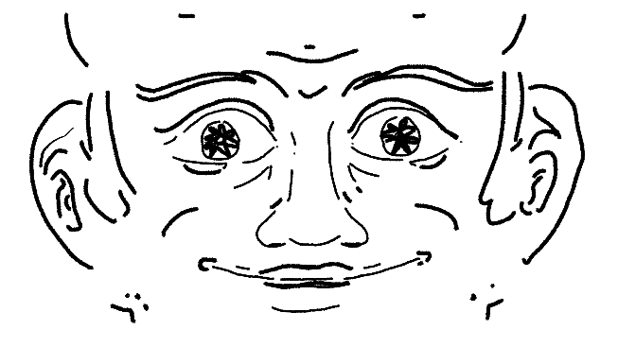

The orc stepped back. “I promise!!”
“Alright. Is this your license plate?”
He stared at it. “I… No, no it isn’t. We’re from Illinois. That says Carolina. I can prove it; I have my driver’s license- “
“No need,” interrupted M. Lefebvre. “We have reason to believe that a stolen car was here, and that the owners swapped out your license plates. You are going to want to inform the police before they pull you over and give you a ticket.”
“Oh… Thank you, sir.”
He stared into his eyes like, well, a demon. “What was your previous license plate number?”
“That’s confidential information.”
“I need it.”
“Uh- …like heck you need it, you’re not the police. Thank you for helping, but I’m not going to just give my personal information to- “

The orc shivered. “Bien! Fine! My license plate number was… uh… UIL-6…59, I think.”
“Good. Don’t tell the police.”
“Why not?”
He grinned again. “They’ll find it out eventually, but we want a head start.”
The orc got his family in the car as fast as was possible, and the three had to step out of the way to avoid being hit as he bolted out of the parking lot.
“Excellent. We’ll run your plate to be sure.” Then, he looked to Felix and Coralie. “Our work is done. Let’s go get a snack. I’ll call in a favor from some old friends and we’ll get this new plate tracked.”
Coralie lightly hit Felix on the shoulder, squealing. “Isn’t my père so heckin’ cool?”
“Hehe, yeah, he… um… he definitely is.”

Masters of Disguise

“I think we should go by a consignment shop,” commented Maple. “They’re not going to have the same number of cameras as an outlet store.”
“Because they kinda want people to steal the clothes anyway?”
“…Probably, yes.”
They pulled up outside a consignment shop, being sure to take the key with them, hiding their screwdriver in the glovebox. After stepping inside, they were immediately overwhelmed with the scent of mothballs and cheap perfume.
“I’ve always wanted to go to one of these!!” squealed Enoki, speaking just above a whisper.
Yeah, thought Maple, is there anywhere you haven’t always wanted to go to? But then again, that’s me too… Well, thunder my dog. Could you be a little less obnoxious about it, though? You’re rich, you get everything you want.
Maple headed over to the first rack that caught her eye and started going through the clothes. It was kind of relaxing, really. Slow-paced, picking out what she wanted. There was an arbitrary time limit – getting caught – but she wondered how much the people in the consignment shop even knew about the Enoki case. After all, there wasn’t a television in there.
She found a few outfits that she was fond of, but she was only going to limit herself to two – one was a turtleneck with skirt, tall socks, and lightly used sneakers. She thought it was so strange that the girls on her floor hated used shoes – but maybe she was just used to them at this point. The second one was a crop top, velvet jacket, and high-waisted jeans – she’d save that one for later.
After going to the changing room and making sure everything fit (and feeling pretty good about herself), she decided to pick up a used backpack and take everything to the front. Now to find Enoki.
“Hoi!” chirped Enoki.

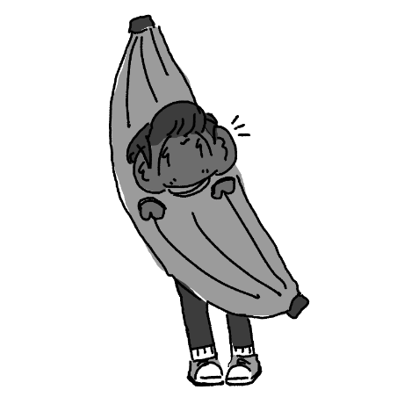
Maple turned around. Enoki was wearing a giant banana costume.
“What the- “
“I’m Bananoki!”
“I… see that. Did you pick out anything else?”
“Bananoki picked out two more outfits.”
“Do you seriously want me to call you ‘bananoki?’”
She nodded, which involved her entire body.
Maple sighed. “How do you expect me to respond when you act like this? I mean, seriously? Do you want me to laugh?”
Enoki ducked into one of the changing rooms, assumingly to take off the banana costume and bring out the outfits she picked out.
Turning around, Maple groaned.
“You two friends?” asked the lady behind the counter.
“Something like that, yeah,” she replied. “We’re roommates.”
“Charlottesville Magic? Ain’t nobody else uses uniforms like that.” She sighed. “You an elf?”
“Sometimes I wish I wasn’t an elf,” replied Maple.
She seemed confused. “But your ears…”
Maple felt her ears. “Yeah, they’re clipped.”
She shook her head. “What about her?”
“No, she’s just rich.”
The lady behind the counter smiled and nodded. “I see, I see. Y’know, my daughter’s half-elf, and we’re gonna see if her magic comes in soon. Maybe she’ll be able to go to that school on a scholarship.”
“It’s a good school,” answered Maple. “I’m not good at any of it, but it’s a good school.”
Enoki walked out. She was wearing a hoodie, brown skirt, leggings, and big, fluffy boots. In her arms was the banana outfit, another folded outfit, and her school uniform. She put it down on the countertop. “How does your daughter like long dresses?”
“In the winter she’s fine with ‘em,” answered the lady behind the desk.
“I wanna give my uniform to your daughter,” said Enoki, “’cos I know it’s expensive and I wanna help.”
She smiled. “Thank you, darling.”
Maple sighed. “You know what? Me too. For variety sake, not all of us like those long dresses.”
“Thank you both,” she said with a smile. “That’ll help when she gets old enough, as long as she fits, but I can sew, so let’s hope they can’t tell.”
The two walked out with their new outfits in their hands and dropped them off in the back of the car, under some of the seats. Maple pulled the convertible top over, just to make sure no one stole their new clothes.
“How does giving people stuff feel?” chirped Enoki.
Maple sighed. “Shut up.”
“Hmm?”
“I don’t… I don’t like to think about it.”
“Hm?”
Maple didn’t respond.
Enoki decided to wait for a moment, twiddling her thumbs, watching the outside of the car. It was a very pretty day that day, and the weather was just about perfect hoodie weather.
“I can’t do this,” she whispered through tears.
Enoki put a hand on her shoulder, a little confused but not wanting to seem calloused. “You can cry. C'est d'accord.”
Maple gripped the steering wheel and began to breathe slowly as tears fell down her face. Enoki just sat in silence as Maple stared out the window.
“Do you want to go back?”
“I can’t,” she whispered. “Not now. I stole a car.” Her face turned beet red, and fire sparks began to appear on the backs of her hands. “Aaron’s going to want to pay off whatever they make me pay in court, and then he’s going to lose his apartment and any chance at happiness he has left, and it’s going to be my fault. It’s all my fault, Enoki. I do nothing, nothing, but hurt him. When he figured out that I failed all my class… Enoki, he’s… it won’t be good. He’s given up his entire life. All of it. For me. I… I want to fake my own death.”
“Fake your death?”
“Yeah…” she said, drying up. “If he thinks I’m dead, then maybe he won’t worry about me anymore.”
Enoki wasn’t sure what to tell her.
“That’s next on the agenda,” she said, smiling a little, still shaking. “Faking my death. Pretending like I’m not here. Then we can just live out on the road and forget all about it, and he’ll forget all about me.”
“Maybe, um, something else should be on our agenda first.”
“What?”
“The blind elves on horses, they’re over there.”
Maple looked up, and just coming over the hill and darting around cars as if they were trees, were an entire band of blind elves.
“How do they-?”
Maple started the car. “Buckle your seat belt. You’ll need it.”

Part Two
or “Now We Have to Deal with the Consequences of Our Impulsive Decisions.”

Oh No, It’s Them Again

Maple growled, turning the car back on and revving it up. She backed up so fast that she clipped the car next to her, throwing it into full gear and trying to merge back onto the road. But the blind elves were swift – by the time she was there, a few of them were already in front of them.
So, she swerved and swiveled, hitting one of them with the back of the car.
“BUCKLE YOUR HECKING SEAT BELT!” shouted Maple.
“ALRIGHT!” chirped Enoki, who was a bit frightened but seemed to be excited.
She slammed on the accelerator and took off like a banshee. The horses pursued them, their speed for the most part matched. People in cars on the opposite lane stared. Some were stomped on by blind elves who thought it would be easier to just gallop their horses over their cars instead of getting into the other lane.
Maple kept an eye on the gas tank. It was riding right on ‘empty’. It should keep them going for a few dozen miles or so.
There were a few police officers on the side of the road as they drove on, noticing the situation and jumping into hot pursuit. Maple cursed under her breath – she did not want this situation to escalate, especially not like this.
“One… Two… Three… Six!” squealed Enoki, turned around to count the police cars. “We’ve got six cars on our tail!”
She kept the car at a constant seventy-five miles an hour. The speed limit was sixty, but – who cares about the speed limit when you’re being chased by a cult, particularly a cult of folks who ride really fast horses, honestly?
“ENOKI!”
“YEAH?”
“THROW THE ANKLET OUT THE WINDOW! THEY’RE PROBABLY TRACKING US OR SOMETHING!”
Enoki cranked the window down, grabbed the magic anklet, and threw it out. It landed somewhere in the ditch behind them – she couldn’t be sure where. Nonetheless, the horses kept chasing them. The horses had eyes, even if the riders did not.
“MAPLE!”
“WHAT?”
“IT DIDN’T WORK!”
She cursed again.
“HEY, I’VE GOT AN IDEA!! KEEP DRIVING!”
Enoki stood up and began to undo the convertible top from the car. Maple was going to ask her, but she was too busy focusing on the road. Once it was free, Enoki’s hair almost immediately blinded half of her vision. She didn’t do anything to try and stop it – it wasn’t worth it.
She picked up M. Gnome.
“EAT MONSIEUR GNOME, PUNKS!”
Enoki tossed her garden gnome, and it hit a rider square in the face. His horse toppled over, and he flew off, tumbling into the ditch.
“HA! ONE DOWN! MAPLE, GIMME MORE THINGS TO THROW!”
“SIT DOWN!”
Enoki sat down, buckling her seat belt again when she realized that the two were about to drive over an overpass.
Maple kept going, staring at the side. “Enoki, how lucky would you say you are, one out of ten?”
“Eleven.”
“You wanna bet your life on that?”
She thought for a moment. “Yeah.”
When they finally got to the overpass, Maple didn’t take the exit. Instead, she spun, taking the car back-first over the edge of the overpass. Both girls screamed at the top of their lungs as they free fell, the tip of the car pointed upwards, until finally-
WHAM!
They were on top of the bed of a car carrier trailer, facing backwards and quickly slipping off.
Maple stood on the brake with all her might, fumbling around for the emergency brake, pulling it with all her might.
By the time that the blind elves and police officers could hit the appropriate exit on the other side, or at least, the ones that could make it, the girls were already a blip on the horizon.
Enoki sighed in relief. “Yay, Autoroute!”
“Shush!” hissed Maple.
“Quoi faire?”
“I’m… trying to figure out what to do here.”
“Relax.”
“WHAT?”
She shrugged. “We’re just here for the ride. Don’t make any big movements and we should be good. See, look!”
Maple noticed that all the cars directly behind them had transferred to other lanes, so that if they were to suddenly fall off the cart, they at least wouldn’t have any head-on collisions.
So, she leaned back. “Alright. Let’s see where this goes then, bien?”

A Little Update

“Whoa, no way!!” squealed Coralie, almost putting her ear against the radio.
“I’m... impressed to say the least,” said Felix, “Jumping off a bridge and onto a car carrier? I need to listen to police radios more often.”
“Don’t,” said M. Lefebvre sternly. “It’s very illegal. This kind of equipment is expensive and only available on the black market.”
Felix didn’t want to ask him how he had a radio.
“So, they’re on the Autoroute, are they, hm? Coralie, remind me to call your Mère when I get to a phone, it looks like we might have to pull a slow burn on this chase and stay overnight somewhere.”
Felix frowned.
They pulled out onto the autoroute, the police radio still on. As they drove, M. Lefebvre kept adjusting it to stay relevant to where the girls were expected to be.
“So why do you think they did it?” asked Felix.
“Why do you think we’re doing this?” asked M. Lefebvre. “We’re all Laurentois, aren’t we? We don’t like being held back. They saw their opportunity, and they’re going to milk it for all it’s worth, and I think that’s a beautiful thing. The only reason we’re after them is because we have a car to pay off.”
“I’m curious what you’re thinking,” said Coralie with a suspicious but intrigued look in her eyes.
“If they’re smart,” he explained, “They’ll talk to me. I can keep them hidden. I have contacts.”
“They could probably stay in the Abyss and not be found,” chimed Coralie. “Oh! Felix! You’ve gotta come with us to this Abyss sometime!”
“Are you sure it’s... safe?”
M. Lefebvre chuckled. “We’re in a two-ton vehicle, how is that safe?”
“You didn’t answer my question.”
“Precisely.”
Felix decided to stop asking questions.

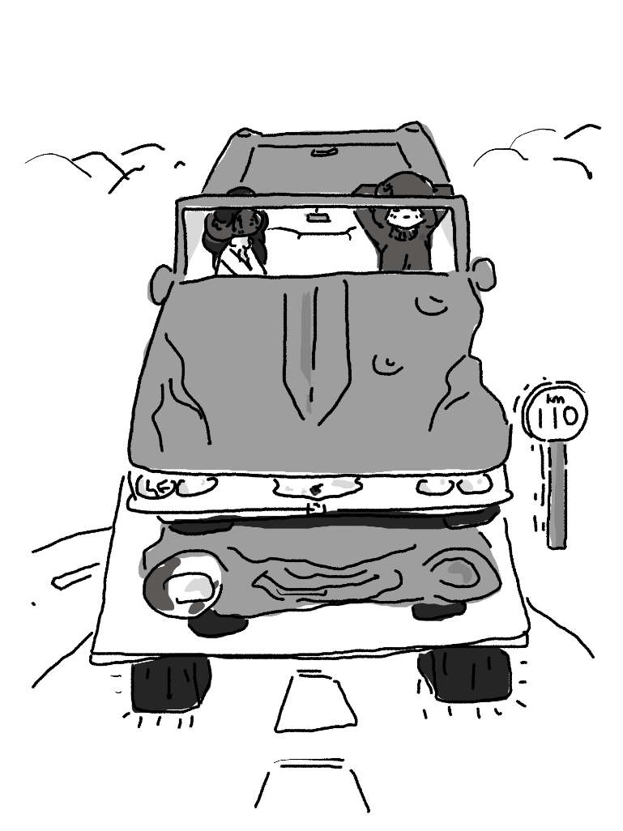
They Fall Off the Truck

“Enoki – you spend a lot of money, oui?”
“Uh huh?”
Maple scratched the bridge of her nose. “If you could appraise my life my life so far, how much do you think I’m worth as a person?”
“That’s…” she looked confused, “You don’t do that with people, silly.”
“But seriously – if I wanted to value myself with a dollar value, what do you think it’d be? I’m trying to add up my raw value per year, but I suck at math.”
“And you trust me with math?”
She laughed. “No.”
Enoki thought for a moment. “Five dollars a meal twice a day, ‘cos you don’t eat breakfast, times three-hundred and sixty-five is… one-thousand eight hundred and twenty-five, and you’ve been around for eighteen years and eleven months, ‘cos your birthday’s in a month… that’s… hmm… that by itself is thirty-four thousand, eight hundred and twenty-seven dollars…”
“Stop making up numbers.”
“I can do it on paper if you don’t believe me…”
“If that number’s accurate, I’m seriously impressed.”
“Why did you ask me?”
She thought for a moment. “I want to send someone a check.”
Enoki frowned. “That’s what we need to talk about. We’re on the back of a truck, and we’re gonna be for a bit, so I can listen.”
“Heck it, you’re right.” She slouched down a little more, letting out a sigh. “So, Aaron, oui? I keep talking about him, you know him, oui?”
“Uh huh?”
“He’s not perfect. He’s not. But I… I don’t know. I feel bad about how I treat him. Looking back on my circles in high school, they weren’t great, and I hated him for a long time, and… yeah, I really got mad at him when he pushed me to go to that stupid school. He knew I didn’t want to go.”
Enoki was quiet for a bit. “So why did you go?”
“I don’t know.” She laughed a little. “I guess I felt guilty about how I treated him and decided to treat him a little. But I didn’t care.”
“Yeah…” replied Enoki, nodding.
“I mean, you know, clearly I didn’t want to be there, we share a room, but…”
“You did start caring a few months ago,” she commented. “I saw you change a bit.”
“I watched some tapes,” she explained. “I realized that… well… I… loved him too. I was really lonely. And he still cared when nobody else did. So, I thought, maybe just this once, I’ll work really hard, and I mean really hard, and then I’ll get my grades up and make him proud.”
Enoki stared at her, face quiet, eagerly awaiting what she was going to do next.
“And so,” she said with a tinge of anger in her voice, “I figured that, if I left, he wouldn’t have to worry about me anymore. I won’t take anything from him if I’m not there.”
Enoki nodded. “I’m sorry for thinking this trip would be a good idea,” she whispered.
“No, you’re fine.”
“I’m not.”
Maple groaned. “Would you stop it? There’s no point now. We’re criminals. We can’t go back, now. We’re gonna keep swapping license plates until someone recognizes you and they send you back to college and put me in jail.”
“I’ll bail you out.”
“Don’t.” She rubbed the corner of her right eyes. “It’s free meals. Aaron won’t have to worry about me. I don’t have to get a degree or anything. I can just keep committing crimes and rot there for the rest of my life.” She hit the door with her palm. “When’s this truck gonna stop at a gas station so we can drive off?”
“Maple…”
“What?”
Enoki wasn’t sure what to say.
“Quit looking at me like that. You’re a princess, you get whatever you want, and everything goes right for you and everybody likes you. You know, I kind of hate you, you know that oui? So, stop looking at me like that.”
“Bon,” she whispered, looking down at her hands and trying to think of what to say. “What if… Aaron won’t be upset at you?”
“No, he won’t be, and that’s the problem.”
She nodded.
The truck pulled up into a gas station. The driver got out, walking inside as if nothing was off.
Enoki cranked down her window and yelled, “UH, EXCUSE ME?”
The driver turned around, staring at the two. He just stood there, thoroughly confused as to what was going on, unblinking.
“WE FELL OFF AN OVERPASS AND ONTO YOUR TRUCK,” explained Enoki, “MAY YOU PLEASE LET US DOWN?”
Confused, he started work on the lift, and the hydraulics keeping the second shelf on top slowly lowered the car down to the parking lot. It took some rocking, but the car eventually found traction and rolled off the top of the new, brand new car it had landed atop of.
The guy stared at the damage, unsure what to do about it. “I… er… my car…”
“Yeah…” commented Enoki, who had gotten out of the car and pretended to survey the damage. “We’re very sorry sir, that looks like it cost a lot of money… We were being chased by blind elves though, and we didn’t have a choice.”
“Let me see your insurance card. I’ve got some phone calls to make.”
Enoki ran back to the car. “Maple!” she hissed.
“What?”
“Where’s the insurance card?”
Maple popped open the glove box. “It’s right there, but…“
“Thank you!”
She handed it off to the man. “Here ya’ go!”
He looked it over. “So, you’re Daquarius Park?”
“Yessir!”
The man squinted his eyes. “It says here that you’re a Homme, but you… look a little more like a Femme to me.”
She sighed. “You know how they tell you to throw away expired allergy medicine? Well, the side effects are irreversible, I’m afraid.”
His face went pale. “I took expired allergy medicine this morning.”
“Are you married?”
“I’ve been married for twenty years.”
She patted him on the shoulder. “Better let your wife know before things get too awkward.”
“Right…” he handed the card back. “I-I’ll be right back.”
Maple parked the car over at one of the pumps. It had looked better – the back was severely beat up, but the tires were fine.
Enoki gave the card back to Maple. “I’m going to go buy some gas,” she said.
“Mind getting some clopes?”
She nodded. “I will.”
“Thanks.”
Enoki smiled, and then left to go inside.

They’re Not Eating Anymore

“You know?” sighed Nim, “I can’t seem to figure out why… Alright, this sounds self-focused, but why don’t you think she wanted me to go out with her more? I feel like I had all of the traits of an ideal boyfriend.”
Goawn barked from the backseat.
“See? Goawn agrees.”
“A report has just come in from the station,” said a voice from the radio. “The license plate number associated with Maria Ramirez has been swapped. We are now looking for the plate number 504-GF3.”
Nim frowned. He couldn’t think of any good mnemonics to help remember the new plate number.
“So, do you have any hobbies?”
“…”
“I mean, besides being a police officer. I hate to make small talk, but I think I’m burning out – I’ve been staring out of the window, looking for license plates for hours, and I feel drained. I think that maybe a little bit of a- “
POW!
The front tire blew, skewing the car off and to the right. Nim gripped his seat as Goawn slammed into the back of his chair like a giant sack of potatoes. As Officer Maurice was doing his best to get the car under control, however…
POW!
The back right tire went out, too. It took all of his strength to turn the wheels such that the car pulling over didn’t flip it over. They were now sitting in the ditch, the three of them quiet, defeated, and thoroughly annoyed.
“What the- “
Maurice got out of the car and walked around the front, assessing the damage. Nim did the same but froze when he figured out why the tires had been popped. There were two arrows sticking out of them, each with enormous spikes on the ends. Then, he got back in the car.
A figure came out of the woods, mounted on a dark steed. He was wearing overalls, had deep cheeks, and featured pale, purple skin surrounding the holes in his face where eyes should have been.
“I sense your motives, somewhat,” said the figure on the horse. “I sense that you are some kind of officer, are you not?”
No response came from Maurice, aside from him crossing his arms.
“Yes… You are in pursuit of the wealthy girl, too. We cannot have competition. Send word to your comrades and have them call off the pursuit, or we shall hunt you down.”
“Hey!” shouted Nim, “He, uh, doesn’t talk.”
The blind elf groaned. “Then you do it, for crying aloud! I need someone to talk, I’m blind.”
Nim rolled up his window and started ducking down, grabbing the intercom. “This is Officer Nim McNeely, we’re under a blind elf attack, please send reinforcements- “
Something hit the window. Looking up, he saw Maurice’s hand, gripping a new arrow that was about to hit the window, his elbow cancelling out the energy. Nim decided to stay where he was.
The elf laughed. “Good effort, orc. But you are no match for a blind elf. Our magicks and resilience are enough to- “
BANG.
“Alright!! Alright! I’ll leave!”
Maurice shook his head.
“Then I’ll cast a magic- “
ZAP.
The blind elf fell off the horse, having been hit by a taser. Once he was on the ground, Maurice handcuffed him and handcuffed the handcuffs to a loop on the side of the police car.
“What the-…” said the elf, dizzily, still woozy from the shock, “What are you doing?”
He opened the door for Nim.
“Good question,” laughed Nim, “Are we-?”
Maurice let Goawn out of the back, picked him up, and cast him over the back of the horse. The horse began to buck, but then Maurice grabbed it by the muzzle and stared into its eyes. The horse suddenly stopped fighting. Nim wasn’t sure what this ability was or why it happened, but he was a bit jealous.
“So are we going to- WHOA, HEY“
Maurice picked up Nim, setting him on the back of the horse. Then, he climbed on himself, surprisingly spry for an orc, fiercely grabbing the reins.
“You’re kidding me, aren’t you?”
Maurice was indeed not kidding.
The blind elf hissed. “I cast a spell of- “
Maurice tossed the taser at him, and it hit the elf in the gut, ending the spell.
Nim gripped onto Goawn. “Alright,” he said, sighing, “I guess this could have gone worse.”
And the group galloped off into the woods.

That Family Member Everyone Has

M. Lefebvre pulled over at a gas station for restroom breaks. The three got out and took care of business. The two Tieflings picked out backs of spicy chips, while Felix got a bottle of water. Something about the concept of not having to drink water more than once every few weeks or so disturbed Felix on a deep, personal level. He just couldn’t imagine how dry their mouths must have been.
When they weren’t looking, he snuck outside to the pay phone. He popped in a quarter, put the phone to his ear, and dialed his Mère.
“Bonjour?”
“Hey, mom, this is Felix.”
“Comment ça va? How are things, do you need help packing up?”
“No, I… Ça va, look, I’m stuck with M. Lefebvre and Coralie, and M. Lefebvre is making me super uncomfortable again.”
“I see. Where are you?”
“We’re in the one gas station in Montresor.”
“Should I call your uncle to come pick you up? He isn’t too far away from there.”
“Yes. Yes please.”
M. Lefebvre and Coralie left the station, noticing that Felix was by the phone almost immediately.
“Hey,” asked Coralie, “Everything bon?”
He laughed awkwardly, “I’m, uh, I think I’m gonna stay here at the gas station, I need to, uh...”
Coralie turned to her père. “Père.”
“Yes?”
“Why you make all of my guy friends so uncomfortable? It’s annoying!”
He crossed his arms, looking over at Felix, and then back to Coralie. “I care a lot about you, Lie.”
“I’m a freakin’ Tiefling! I could bite his head off if I wanted to! And besides, we’ve been friends for, what, ten years now? Just because you don’t know him doesn’t mean that I don’t! What on earth do I have to be afraid of?”
He smirked. “I also think it’s kind of funny.”
“Well stop. Please.”
He thought about it for a moment. “Alright. Human, you are welcome to join us in our quest if you want to, but if you’re too afraid to, then I understand.”
A car pulled up into the gas station. It was a hearse – a fully-sized, legitimate hearse. It pulled up right next to Felix, and a strange figure stepped out. He was wearing a cloak, a wide-brimmed hat, and a mask over his eyes that sort of looked like a bird. Nothing on his entire body was visible, as if he were afraid that the air was going to kill him. He strutted over to Felix, standing proudly.
“Now, hm, yes- If you do so not mind, I, your uncle, have arrived to retrieve you- “
Felix groaned. He was hoping that his mom had meant his other uncle.
“…He’s the one you called?” asked Coralie, confused. “Aren’t you the guy that’s on TV?”
“Why, yes!” he chortled. “I, indeed, am Dr. Pess T. Lance, the one and only, and I am quite tickled, quite humored, really, to know that my viewership is quite able to recollect my composure.”
Coralie walked over to Felix, whispering in his eyes. “I don’t know what you’re afraid of, he’s way scarier than my père.”
“Maybe to you,” he replied, thinking for a moment. But, with an eyebrow raise, he turned to his uncle. “Actually, I’m glad you came out here, but… I changed my mind; I’m going to stay here.”
“Truly? Bah- if you do so insist. I was forced to divert from my usual paths for an entire five minutes, quite a lot of time, unfortunately. But say, this little digression might not be so menial, so wasted, unless you... you haven’t happened to find a soul thus far with any extra limbs, say? Anyone who wouldn’t mind to, hm, spare an arm, per say? For my experimentation, of course. It is always for the purpose of scientific- “
“No,” groaned Felix. “Just stop.”
“Right, right, I forget, your feeble mind cannot rationalize the significance of my- oh, heavens, wait! Where are you three leaving to? I have not finished speaking yet! …Bah. Plebeians, the lot of them. They are not mentally capable of-”

Deciding on a Good Dinner

For Maple, it was nice to be back on the road again. It was also nice that, somehow, the undercarriage of their vehicle had not been totally destroyed. Now, the trunk was unusable, and the headlights were probably out, which meant it was only a matter of time before it got dark and they might get pulled over. Because of this, Maple was doing her best to intricately plan the next few steps. A single mistake, and they might both land in some serious hot water.
Of course, Enoki didn’t care.
“MALL,” she kept squeaking, “Can we go to a mall, huh? They’ve got lots of food and- I’ve always wanted to go!! Please, Maple? Please?”
“Enoki! This is a big deal. We have to be serious about this, you hear?”
“But doing fun stuff like this is why we ran away in the first place!”
“Who cares why we left in the first place?” She sighed. “We’ve got to keep our heads down.”
“I can put something on my head, and then they won’t know it’s me! I promise! But we’re- Oh! You take this exit up here and we can go to the mall!”
“What’s it with you and malls?” groaned Maple.
“Y’know! The people, the food, the glamour, the fun- I see it in advertisements on TV all the time! It always looked so fun!”
Maple sighed. “Look, if your parents made you call your security team every time you wanted to leave campus, couldn’t they have just let you go one time?” Much to Enoki’s delight, she took the exit.
“Nope,” she replied. “They always said no.”
“Why didn’t you just leave one day without telling anyone? Surely it wouldn’t be that hard, oui? Just for an afternoon?”
She giggled. “What are we doing right now, silly?”
“This is different, though.”
She shrugged. “Only way I could get away with it. I asked a gajillion times and they always said no.”
Maple looked confused. “I’ve known you for months, why did you never tell me this?”
“You never asked!”
“Oh, right.”
They pulled up into the parking lot, hiding within a pack of non-suspicious vehicles. Maple took a deep breath, giving Enoki a glare. “Look,” she sighed, “You know you don’t... look like most people here, oui?”
“There’s a lotta Hispanic people around- “
“No, you look Asian. And your ears, your hair, it’s all very distinct.”
She crossed her arms. “One, I’m very, very proud of my Rizay heritage, and two, it’s sad, but no one’s gonna tell I’m Rizay, I don’t think.”
“Maybe they’ll tell from your ears and the fact that, I don’t know, you’re the only person I know from anywhere whose mouth is higher up on their face than their eyes.”
Enoki crossed her arms. “But it’s cute!”
Maple sighed. “There’s a very, very large chance that we’re going to get caught, especially if they’re running ads on television. This is dangerous. We need a plan if we’re going to- “
Enoki got out of the car and started walking away, ignoring her.
“Hey! I’m being serio- “
“Lalala, lalalala, parle plus fort! Je peux pas t'attendre!” Speak louder – I can’t hear you!!
“ENOKI!” She groaned, slamming the door behind her.
When the two entered in through the lobby, Enoki did the same thing she did back at the Italian restaurant – go absolutely berserk without moving a muscle. Maple immediately scanned everyone else’s faces, doing her best to hide her own anxiety, desperately hoping that no one would put together that she looked like the girl from TV.
Enoki led the way, and Maple stayed close behind. There was a decent amount of people in the mall, it was probably close to its typical large crowd, and it was a little difficult for her to catch up.
“Hey, Maple!”
“What?”
“Tell me that I can’t eat dessert before I eat my real dinner!”
“Uh… quoi faire?”
“Just do it!”
“…You can’t eat dessert before-?”
“NO!” And at that, she turned, running into an ice cream parlor.
Maple sighed. “What are you, seven years old?”
Both of them got ice cream. Maple didn’t show it, but she enjoyed it much more than she would have liked to admit. It was kind of fun to pick out a flavor and toppings – especially when all of them looked so good. The ice cream they’d sometimes hand out at events back at the university was really the only ice cream she could recall having regular access to, so this was nice.
They sat down at one of the booths. Enoki took small bites of her marble bowl, covered with every single topping that she had access to.
Maple took a bite out of her butter pecan sugar cone. “Do you even enjoy ice cream like that?”
“Uh huh!”
“No, you don’t.” Another bite. “You seem like the type who thinks it’s cute to get all of the toppings, and then you can’t keep any of them down.”
She giggled. “Of course I’m not keeping any of ‘em down, silly, I’m lactose intolerant!”
Maple squinted her eyes.
“Doesn’t stop me!”
“Are you mocking me?”
“No! I’m really lactose intolerant! Tonight is not gonna be a fun night for ol’ Enoki’s tummy.”
“Keep your voice down!” hissed Maple. “People might hear your name! Didn’t we plan to go with codenames?”
“I can be Thing 1, and you be Thing 2.”
Maple groaned, taking out another bite. “I think I deserve Thing 1.”
“Do not!”
“I’m Type A, you’re Type B, so I don’t see why the ‘thing’ names should be in any other order.”
Enoki took another bite. “I say they should be sorted by how much of an ‘Enoki’ you are.”
“Isn’t your name Maria?”
“You are what you eat, and I eat a lot of mushrooms, and Enoki’s a kinda mushroom, so…”
The rest of their evening wasn’t all too bad. They got some cheap Italian food to make up for the Italian they never got to eat for lunch – just calzones and sodas. Then, they wasted the rest of the evening looking at and trying on clothes, exploring the music store and seeing what CDs they had on sale, and hanging out by the water fountains.
Maple put a bag down, sipping the rest of her lemonade almost completely gone. “How much money do we have left?”
Enoki had moved her money from the sleeve of her university uniform dress into a handbag, so she popped it open and sifted through. “We’ve got enough for… another week’a crazy spending. Then I go by the bank.”
“You can’t go by the bank. They’ll recognize you.” She sipped some more, staring at the tile wistfully. “We can’t keep living like this, but you know what? I haven’t relaxed this much in a long time. It feels pretty good.”
“There’s so many places I still wanna go!” she sighed, “The grocery store, the movies…”
“What do you rich people even do all day?”
She shrugged. “Stay in my house. School. Go on crazy vacations every once in a while. I got to see Nippon, Austria-Hungary, Iceland…”
“What did you think?”
“They’re really nice.”
“Just really nice? What could you possibly have to complain about? Those trips sound amazing.”
She started poking her fingers together, eyes staring at the ground. “I… just thought there’d be a little more every trip, that’s all, like, with my parents. We might eat a meal together during the trip with the translator, but that’s it.”
Maple sighed, shaking her head. “Spoiled upper class, I swear…” Then, she stood up. “I’m throwing away my cup. Guard my bags.”
“Bien!” chirped Enoki, her mind starting to wander again as she pondered how strangely similar this little outing was to all her world trips, at least in one way or another.

Sleep is For the Weak

Somehow, through some miracle of nature, Maple and Enoki had a decent time at the mall, and when they were ready to leave, they went out the front doors. No apprehension, no guards, no police cars, nothing.
“Y’know…” sighed Maple, “No. No, I don’t think that peanut butter goes with chocolate.”
“Aw, how come?”
“It sticks to the roof of your mouth, doesn’t it? It’s thick enough – why on earth would you want to make it thicker?”
She shrugged. “I just think it tastes good.”
Maple felt a little wary. “Hey, Enoki, hold my bags.”
“How come?”
Not too far away from their car, no – they were right in front of their car – were two individuals. She couldn’t tell what their age, gender, or heritage were, since they were wearing all black, but they were definitely doing something to their car.
“Hey!” she shouted, “What’re you doing?”
Someone grabbed her from behind, cupping a hand over both her and Enoki’s mouths.
“Shhh…” he whispered, chuckling under his breath, trying to take them off where they couldn’t be seen from the front of the mall.
He probably wouldn’t have done that if he had known who they were, though.
Maple instantly let her hands burst into flames. She threw them backwards at his chest, and he instantly let them go, yelping in pain. She let the light shine forward from her fingers like a flashlight, giving her face a terrifying brilliance.
“What the heck?!” she growled. “Who do you think I am, punk?”
“An elf…” he whimpered, trying to escape.
“DARN STRAIGHT!”
Then, she turned to the people in black clothes, who had stopped what they were doing and turned to look at her. They had guns pulled and started firing them in her direction. She pushed Enoki behind a car, hiding behind it herself until she could formulate a plan.
“Let’s just wait here,” whispered Enoki, calmly.
“And let them keep shooting??”
“They’re not gonna wanna waste bullets,” she replied. “Just wait ‘till they’re gone.”
A few more bullets came out, but sure enough, they stopped. The two girls hid under the car, just in case they happened to drive by and try to clip them. It was disgusting, Maple noticed that the air conditioner was dripping right onto her head, but when the crooks drove by in their car, they were undetected. Soon after, the burnt crook got into his own car and sped off, leaving the two alone.
Maple got out, cursing under her breath. Enoki did too, putting her hands on her hips.
“Who in the heck do they think they are?”
“Well,” pointed out Enoki, “We stole the car first.”
“Shut up!”
“Just pointing out the bright- “
“STOP! You understand? We’re going to have to walk a quarter mile to the nearest motel, in the dark, and then what? We have no car.”
Enoki stayed quiet.
Maple growled, burning a glowing spot into the asphalt below. After a few seconds of that, she got back up and started marching away.
They indeed walked in the dark for a quarter mile, down to the nearest motel building. The vacancy light was on, and it didn’t seem like it was unsafe – maybe not comfortable, but not unsafe, either. The whole walk, Maple was just fuming.
They stopped on the way at a convenience store, and Enoki bought Maple a pack of clopes and a small bag of peanut butter chocolate candy for herself. Then, the two entered the motel lobby, and Maple trudged up to the front.
“A room with two beds,” she said emotionlessly.
“Like, totally,” said the girl behind the desk with a bubbly facial expression, “That’ll be, like, 10 dollars.”
“Could you stop talking like that?” growled Maple, “It’s getting on my nerves.”
She put a hand on her hip. “Oh, like, me too. I was totally not like this, but this way uncool sorcerer put this, like, spell on me like a week ago because he was, like, mad that we had maximum occupancy. I, like, totally want to vomit every time I talk.”
Maple raised an eyebrow. “I see.”
Enoki nudged her in the arm. “Don’t you know a spell to help with that, huh?”
She looked embarrassed and angry. “I failed that class. No, I don’t.”
“C’mon, I saw you study for that one!”
“…”
“Just think about a spell, hm?”
Maple closed her eyes. She didn’t want to have to think about anything she learned in her incantation classes – too many bad memories. But, to fair, this poor girl needed her help.
“Alia… disputatio?”
The girl behind the desk blinked. “Well, I don’t rightly know how it changed my voice, but… Well burn my beans, y’all turned it to a Texas accent!”
“Let me try again,” said a frustrated Maple.
Enoki smiled a bit. “Hey, Maple, chill.”
“Enoki, I need to get this right.”
“You also need to calm down or you’ll mess this up, so…”
Maple sighed. “Fine. How about… Northmanni loqui?”
All of a sudden, her arms drooped, and the girl behind the desk sighed in relief. There were tears in her eyes. “Whoa… I feel… normal.” She laughed. “I haven’t been able to talk like this in weeks. You know what? Your room’s on me! Have a good night.”
The girl handed them a room key, and the two made their way to their room. Almost wordlessly, Enoki dropped off their bags, took out a fresh change of clothes, and went to take a shower. Maple took out a clope and went outside, making sure she had the room key with her.
She sat on a cheap bench, lighting the clope with her finger, staring out at the distant fast-food lights, stationed just above the trees, their silhouettes barely dancing in the wind. There was just about enough noise to let her know that the air was moving, but not much else.
It was nice to be alone with her thoughts.

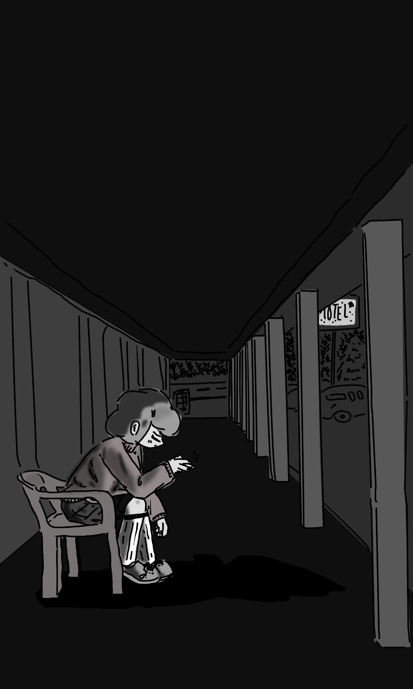
They didn’t have a car, now. She was covered in air conditioning fluid. And they weren’t sure where they were headed off to, anyway. Enoki’s money wasn’t going to last forever, and none of these things they were doing were fun – not really fun at least. Enoki’s sense of enjoyment made no sense at all. This whole
situation didn’t, couldn’t feel good. Not at all.
She felt a little like the clope – burnt at
The end and probably going to go
out soon.

Time to stop being alone with her thoughts.
She went into the motel, sat at the edge of one of the beds, and flicked on the television. It was set to one of those twenty-four-hour news channels, and she could see a sylph and a human behind the counter, talking.
“We’re going to be investing the politics of disarming terrorists,” the man said, “And to do this, we’ve brought in an expert on the subject, Dr. Pess T. Lance. Dr. Lance, thank you for joining us.”
The camera panned over to a man in a strange costume that reminded Maple a little of a bird. “Oh, right, of course, my apologizes, the pleasure is mine, truly, yes- I do say, regarding the process, the art of the- hm, dis-arm-ing, I do consider myself quite the expert, quite the expert indeed, hm.”
She changed the channel.
It was a soap opera about an orc family. She watched it, completely turning her brain off and just letting the sequences of events play out. She really didn’t want to think. She didn’t know who any of the characters were, and she didn’t particularly care to learn them.
“I’m done,” chimed Enoki, coming out in pajamas with her hair in a towel. “We’ve got a bathrobe in there, and it’s kinda soft, and you seemed really mad, so I saved it for you.”
Maple put out the clope in an ashtray and stood up. “Thanks.”
“Hey, and, uh… If you wanna talk, I’m here.”
She went over to the shower. “I don’t know if I want to talk to you.”
Enoki nodded, letting her go.
The shower was alright. The water pressure was decent, and the water was still warm. She must not have been in there too long. She got out and took Enoki up on her offer, stealing the bathrobe and putting it on top of some normal clothes she felt comfortable sleeping in – having dedicated sleeping clothes just felt wrong. When she left, she got into bed, groaning and staring up at the ceiling.
Enoki was in the next bed over, the one on the left, just like when they were back in the dorms. “Hey, Maple?”
“Yeah?”
“You’re thinkin’ about something and I wanna know what it is.”
“You don’t want to know.”
“I do, I’m your friend.”
“You’re not my friend - what on earth gave you the idea that you’re my friend? The fact that you feel obligated to be here?”
She was quiet for a bit, observing the popcorn ceiling. The heater was running, but just quietly enough that it wasn’t going to be too big of a deal.
“Hey, Maple?”
“Just talk – you don’t need to ask me every time.”
“Y’know when we were filling out forms for dorms, and you got to pick your roommate?”
“I didn’t pick you, Enoki.”
She smiled. “I know. You’re the only one who didn’t in the whole dorm.”
“Seriously?”
“Uh huh. Every single other person wanted to be my roommate cos they thought I’d buy them stuff. You were the only person who didn’t care who you stayed with, so I wanted to be your roommate.” She twiddled her thumbs a bit. “You left me alone all the time and we didn’t really talk back in the dorm, and you said you hate me a few times, and that was the most honest I think anyone’s ever been to be.”
“Really?”
“Everyone pretends like they like me but you.”
Maple was quiet for a bit. “I see.”
“So, I think like that, you’re the only friend I’ve ever had,” she admitted. “The only real one.”
Maple felt a deep bit in her stomach. She didn’t want to show anything, at least not know, but she felt a profound sense of guilt. As bad as the guilt that made her want to cut herself out of Aaron’s life. But she wasn’t quite sure why, or to what end, so she did nothing.
“If you do wanna talk, you can,” said Enoki, “I’m gonna turn off the lights and get some sleep though.”
“Goodnight, Enoki.”
“Goodnight, Maple.”
Click, click.

It’s Not as Cool as You’d Think

Nim thought that riding on the back of a blind elven horse, clutching a dire wolf while an orc took the reins, would be really cool. After a few hours, though, his butt was getting really tired. Tired enough that he was considering getting off and taking a taxi back to his house and giving up on the whole mission.
It was finally dark out, but they kept riding on the side of the road. Maurice was big, sweaty, and completely unphased. Nim thought that he must have not been right in the head – that, or he was so determined that he was more muscle than man- er, orc. But their eyes were out.
“Hey, Maurice?” asked Nim, “Can we just stay somewhere for the night and keep looking tomorrow?”
That’s when he noticed that one of the cars on the highway that they were keeping up with looked an awful lot like Maple and Enoki’s stolen car.

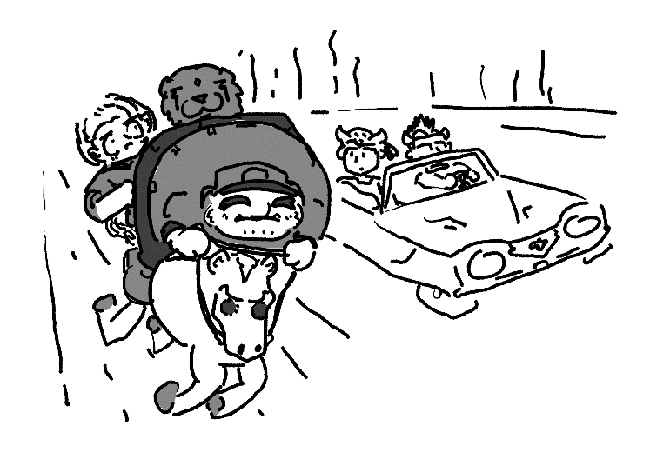
“Oh,” he said.
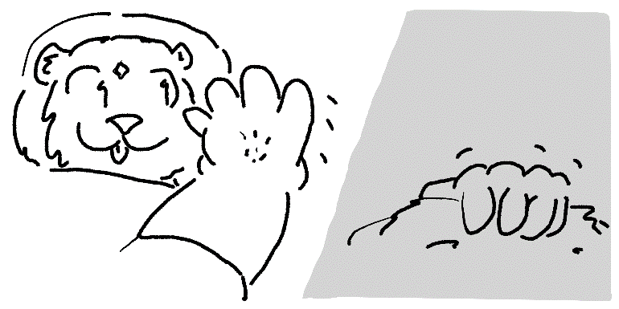

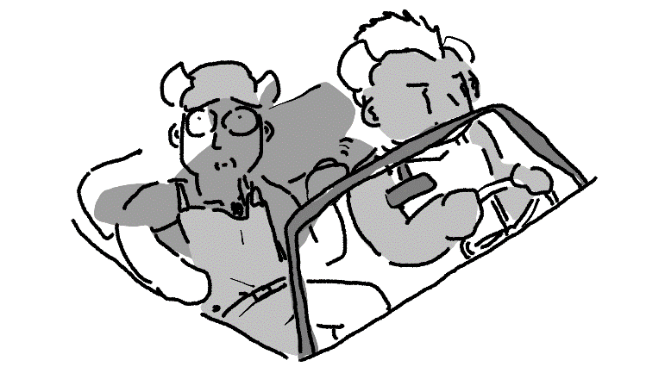
CRASH!
The wolf burst through the top of the open convertible, and the car almost immediately crashed on the side of the road.
Maurice stopped the horse, getting off. Nim tried to get off himself, but Maurice picked him up like a sack of flour and set him on the group, slapping the elven horse on the thigh to get it to scamper off into the woods.
“What on earth just happened??” demanded Nim.
Maurice unclipped his flashlight, shining it down onto the car. It was a little hard to tell that there were two men in all black on the ground scrambling to escape, since Goawn was spread across the majority of their bodies and pinning them where they were.
Nim walked up, pulling off their masks. Two Tieflings, mid-twenties, bloodshot eyes. That last detail was likely from the result of Goawn.
“Alright,” he asked, “Did either of yous see two lasses who were in possession of this vehicle?”
“Huh.. H-Huh.. I..” choked out one of them.
“Talk!”
“I did,” one of them coughed, “And she used fire abilities to burn my friend.. I think she was an elf.”
“Aren’t you Tieflings fireproof?”
“Yes- “
“Then why didn’t one of ye’ take over for that friend of yours? Didn’t ye’ consider that maybe you’d stolen a car from a fire elf?”
“There aren’t elves around here! This is Carolina!”
He shrugged. “It doesn’t matter. You’re obviously both under arrest for theft.”
Maurice punched a button on his belt, and a light started going off. Then, he crossed his arms, staring out at the road expectantly.
“Do you just have an alarm so you don’t have to talk to anyone else?” asked Nim, “Is that how determined ye’ are to stay quiet?”
Maurice nodded.
“Ah! So ye’ can communicate! Novel, ain’t it?”
When a police car finally showed up, the officers got out, handcuffed the perpetrators, and put them up in the back of the car.
“Yeah,” explained Nim, who had been briefly discussing their situation with an officer, “We had to dismount the police car after it broke down. I take it that it’ll be towed in the morning?”
“Yes,” answered the officer, “That’s a fair assumption. There isn’t a motel too far away from here, we can let you stay there for the night and have your vehicle ready for you by tomorrow.”
“We’d appreciate it,” replied Nim. “And I know that the poor guy who had his car stolen is going to appreciate it coming back to him, too.”
“More or less.”
A second police car was called to fit Nim, Goawn, and Maurice into the back. It dropped them off five minutes away at a local motel. It wasn’t too hard to get in and get a room key, and so after they did, they found their room and got in.
Nim got onto his bed, fully clothed, crossing his arms behind his head. “That was really cool, what you did back there.”
Maurice didn’t reply, but instead went into the bathroom to presumably take a shower.
Nim sighed. He thought he could hear the voice of Maple in the room just next door, but he knew that it was just his imagination playing tricks on him.
Goawn wanted to sleep in bed with him and proceeded to lay all of his flabby mass right on top, nearly crushing him.
“Go-awn… Get… Off…”
Goawn yawned, going to sleep.
Nim groaned, thinking, “Now I know why mère and père never got me a dog,”

Brief Break in The Narrative

“Hey! Felix! Wake up!” said Coralie, reaching back and shaking his knee.
He yawned, sitting up. “What?”
“It’s too late for you to drive safely, so your père and I drive back to his place and thought you could stay on the couch or something.”
Felix looked out the window and smiled a bit. He missed living on this street. It was definitely a nice change of pace.
He got out; his eyes were barely able to stay open. They went up to the front door, and Madame Lefebvre opened.
“Felix!” she said, throwing her arms open, “Com’ere, you!”
He smiled a little. “Hey, Mme. Lefebvre.”
“I haven’t seen you since you were twelve! You’ve gotten so big!”
He chuckled, awkwardly unsure how to reply.
“You know where the couch is.” Then, she turned to Coralie. “Your Père and I are going to be asleep. Now, you don’t pull any funny business if you want Felix to keep his arms and legs, bien?”
“Yeah, yeah, of course.”
“Good.”
Felix collapsed on the couch in their living room. He probably could have spent the time considering his day, his future situation, wondering if they were going to make any money off this, or if… No, he wasn’t even going to peruse his options, he was just going to go to sleep.

…

He slept like a rock for a solid six hours, woken up to the smell of breakfast. As much as he wanted to keep sleeping, he was a little concerned about what M. Lefebvre would do if he slept any later than anyone else.
Still in his suit, now especially wrinkled, he sat down. The whole family was taking breakfast sausage and dipping it into bowls of tabasco pepper sauce. Felix’s nostrils were burning. He figured that Coralie and her père couldn’t even taste it, but Coralie’s mom was human – eh, he figured, she was probably used to it at this point.
“So, Felix,” her père said between bites, “You’ve got some options. Coralie wants to go to the Abyss with me to get some tools. I can drop you off back at your house if you want.”
Felix got confused. “Can humans even survive in the Abyss…?”
“Carefully,” said Coralie.
“Are we sure we even want to keep doing this?” asked Felix, yawning, “I mean… This seems like a lot of effort…”
“I have had a long career in missing persons retrieval,” explained M. Lefebvre, “And I’d like to buy Coralie a new car.”
“And get a house add-on,” added her mom.
“Yes. We’d like an add-on.”
“Well, at some point I need to my things out of my dorm room. Coralie, you haven’t moved out yet either, have you?”
She shook her head. “When we’re rich, we can just pay someone to get it moved over, oui?”
Felix was a bit confused. “But we’ve got to move out before Sunday.”
“So, if we find them before Sunday… we can pay off someone. You wanna come along or not?”
Felix was confused. “May I go back to pack my own things and let you two go on this little adventure?”
Coralie’s eyes were wide. “Wait, really?”
“I’ll just get in the way,” he said nervously, eyeing M. Lefebvre. “You go find your fortune; I’ll take care of the bags.”
She crossed her arms. “But finding a fortune wouldn’t be any fun without you!”
M. Lefebvre stood up. “Felix, would you follow me for a moment?”
His eyes grew to the size of dinner plates.
“Felix?”
“Right, right, of course.”
Felix followed Coralie’s père into the other room, just far away enough from the dining area that, if they kept their voices low, they wouldn’t be heard. M. Lefebvre crossed his arms and kept a neutral facial expression spread, eyeing up his inferior silently.
“My daughter is going to be disappointed if you don’t come, and you know what she means to me.”
“Right, right, I’ll- “
“But at the same time, are you going to let her, or me, just tell you what to do, hm? What kind of man just lets people walk all over him?”
“I-I… right, then I won’t- “
“You’re not going to go then? What are you, a coward? Are you just too afraid of me?”
Felix groaned angrily. “Fine, what do you want me to do then?”
He squinted his eyes.
“Well?”
“First, I want you to talk to me respectfully.”
“Right. I’m sorry.”
He sighed. “No, you’re not.”
“I promise to you that I’m sorry.”
“Prove it next time.” He stepped forward. “You’re going to make a decision, Felix, and you’re going to stick with it. Here, or home. And whichever you choose, you’re going to be fine with the consequences that come along with it. A man doesn’t try to worm his way out of things because he’s afraid what people will think or because he’s afraid of the consequences. You’re going to make the right choice. Am I clear?”
Felix nodded.
“Well, what is it?”
“I’ll… go back. I’ll pack up Coralie’s stuff so that y’all don’t have to pay the fines.”
M. Lefebvre squinted his eyes. “Fine, coward.”
Felix crossed his arms.
Reaching into his pocket with a small smile, M. Lefebvre handed Felix a twenty. “That’s the spirit. It doesn’t matter if anyone calls you a coward, oui? Don’t tell them I’m paying you for this, bien?”

A Slight Change of Pace

Maple wasn’t sure if she had a good night sleep or not. The motel bed was about the same quality as her dorm bed – it actually smelled a little better, if she were to be completely honest with herself.
The time was eight o’clock or so – she was hoping she could sleep in a little longer, but that wasn’t happening. The motel television was on, and Enoki was sitting at the foot of her bed, her eyes as bright as her smile, which was as bright as the Saturday morning cartoons.
“Could you, uh, turn that down?” groaned Maple, a little tempted to throw something at the television.
“You’re up!” she chirped, turning off the TV. “We need to get a move on! I’ve got a ride for us!”
“You’ve… You’ve got a ride?”
“Yeah! An old friend!”
Maple raised an eyebrow. “I thought you didn’t have friends.”
She thought for a moment. “I guess I don’t know what else ta’ call her now, hmm… Anyway, let’s get some breakfast and go!”
“How long will it be before we have to go?”
She looked up at the clock. “Uh… An hour!”
Maple got up and changed into one of the outfits she got from the mall the previous day – acid-washed jeans, a tank top, and a cardigan. She had picked up a bottle of spray-on temporary hair color and decided to apply it, as well as heavy purple eyeshadow. She still looked like herself, but she could pass as someone else if you weren’t looking straight at her from the front. Enoki put her hair in a ponytail, sporting a baseball cap, white turtleneck, and overalls.
Maple put her hand on the door handle. “How do you feel, En?”
“Ready as a rabbit!”
“Aren’t you going to do something about your ears?”
“I could… tie ‘em in a bow!”
Maple stared for a few seconds. “How? That’s not how ears work.”
“I could… chop ‘em off!”
One eye twitched a bit. “Enoki, do I have to tell how morbid, and frankly impractical that- “
“WHAT?!”
Maple crossed her arms. “If you let me finish what I was saying, then you would know.”
Enoki nodded. “Oh, I know, I was just doing some I-don’t-have-ears practice.”
Maple sighed. “Fine.” Then, turning back around, she opened the door handle, and-
Maurice, Nim, and Goawn were directly outside, facing away from them, talking about something. They didn’t seem to see her, but whether they did or not didn’t matter to her. She had no idea how long it was open – her heart stopped, and time did, too.
Maple instantly but quietly closed the door, hissing. “Enoki.”
“Uh huh?”
“The police are right outside the door.”
“What are they talkin’ about?”
Maple leaned in, her hair crunching from the dye as she put her ear right next to the door.
“…They… um… It’s just one of them talking, I think… It’s Nim, he’s talking about… something… regarding a… uh… dog making him lose circulation… in his arm, I think.”
“Oh.”
Suddenly, there was a knock on the door.
“Maple? Maple Tremblay? You in there?”
It was Nim Mc-Freakin-Neely.
“Crud…” She took a deep breath. “Enoki, I’m going to do something a little crazy. I’m going to go full guns-out, and- “
“Maple?”
“What?”
“Are you hyping yourself into something you don’t wanna do?”
She sighed. “I might be.” Then, she turned to look at her, noticing that they weren’t alone. “Where’d that rabbit come from?”
“Oh, him?” She looked down at the rabbit she was cradling in her arm. “Oh- My sleeve. Always gotta have a rabbit up your sleeve, that’s what we magicians gotta do.”
Knock, knock, knock.
“Can I see him?”
She shook her head. “He doesn’t like people.”
“Can you let him out the front door and get the dog to chase him?”
She squinted her eyes. “I wanna gonna offer him as a peace offering, and that’s a little morbid, but.. he’s a fast booger, he should be fine…”
“Look, I don’t want to kill a rabbit either, but we don’t have that many options.”
She shrugged. “He’ll be ok. I’ll just pull him back outta my sleeve when he’s in danger.”
Maple blinked. “Do you magicians have any sort of limit or… uh… logic behind what exactly you can do and can’t do?”
She lifted her chin presumptuously. “Can’t tell mah’ tricks!”
“…Fair enough. Let me know when you’re ready.”
Enoki raced over, getting down near the ground. Maple kept the chain lock closed but unlocked the main door.
Three…
Two…
One…!
Maple opened the door, and Enoki let her rabbit out. Almost instantly, a dog tugged Nim off his feet, barking like a maniac and dragging him along the sidewalk and away from view of the door.
Maurice put his hand directly in the doorway.
“Hey!” shouted Maple, “I’m a fire warlock! I’ll burn your hand!”
He seemed unphased, and then quickly produced a gun from his holster.
Alrighty, then.
In a swift knife-handed motion, he popped the dinky little chain lock right off the door.
CRUD.
He kicked the door open, knocking Maple up and against the wall. She hit her head loud enough to make her dizzy and disoriented, barely able to stand up. She tried to light her hands on fire, but it was uncoordinated and didn’t do much other than singe the carpet.
“HEY, PUT ME DOWN YOU BIG- “
Maple got up as Maurice was walking out of the door, Enoki in stow under his arm. She was doing her best to get out, but it wasn’t doing much.
What kind of powers do magicians have?
Is there anything she can do?
There better be, but if not…
She stumbled outside, head throbbing.
Enoki was being handcuffed and locked inside the back of the police car. Maurice closed the door, holding a gun up at her, face sullen.
“It’ll be alright, Maple,” she thought, “Stay cool. It’s like that guy back when I was a kid with the shotgun. Just find a way around it, that’s all…”
BANG.
There was a gunshot behind Maurice, causing him to turn around. Sure enough – there was a Mònn d'Plonj, a dragon girl, driving up in a sportscar with a pistol out the window.
Maple saw it as an opportunity. She started screaming, waving her hands together into strange shapes, a ball of fire forming. She launched it at Maurice, slim enough that it shouldn’t hit the car, but he must have figured that it was coming, because it was only an instant before he was in the driver’s seat and hitting the road.
“HEY!” shouted Nim, sprinting back with Goawn, “WHAT THE HECK IS GOING ON?”
“BUZZ OFF!” shouted Maple, turning to the car. “Who the heck are you?”
“I’m Enoki’s old nanny!” she shouted, slamming on the break. “You’re Maple, I take it?”
“Yeah!”
“Get in!”
“WAIT! I CAN HELP!” he finally ran up to Maple, nearly collapsing from lack of oxygen.
Maple thought for a moment, before flaring up her hand. “I will not hesitate to skin you and turn you into a football if you even give me a hint that you’re involved in this, bien?”
“No! It’s a coincidence, I swear! I had no idea you were here! B-But I know that guy, I can help!”
“You know him?” asked the dragon girl.
Maple groaned. “He’s a friend.”
“Get in the back!” she shouted.
Maple scrambled into the front shotgun seat, while Nim and Goawn piled into the back seats. The girl hit the accelerator, and in a moment, they were on the highway, hitting speeds that Maple had never even fathomed were possible from a car, before, and in a moment, they were fresh on the tail of the police car.
“WELL, THIS IS FUN!” shouted the nanny passive-aggressively.
Maple was too deadest on the car in front to make a proper reply, but she somewhat agreed with every fiber in her being.

Part Three
or “Hey, look! There’s the plot we were looking for!”

And Back to Felix For A Bit!

Twenty dollars.
M. Lefebvre paid him twenty dollars to get Coralie’s room packed up and her stuff dropped off at his house for them to pick up later. At least they both didn’t live too far from campus, otherwise this would have been a disaster in the planning stage.
To be fair, he would have probably done it for free, but then there was the whole awkwardness that she was a girl. Going through a girl’s stuff wasn’t something he wanted to be caught doing from a kilometer anyway by anyone on campus, so he had to be thoughtful.
Going downstairs to the lobby, he caught a group of students playing an imported fighting game on the machine Enoki donated to the residence building. One of the girls just lost a match and stood up to cool down.
He walked up to her. “Hey, you got a moment?”
“Yeah, what?” she said, a bit short.
“You doing a tournament?”
“And losing at it. Aren’t you a fan?”
He shrugged. “Yeah, I play all the time.”
“You have?”
“Yeah – ask any of the regulars. I’m a big fan of this game. Are you out for the time being?”
“I am.”
“I’ll keep your place if you want – I was busy trying to get Coralie Lefebvre’s room packed up for her, she had to leave early.”
“The Tiefling?”
“That’s the one. Room 305. Say – how would you feel about packing it for me in the meantime? I mean, me being a dude and all, it’s a little weird. It’s almost done – just clothes and stuff are left, I think.”
“And you keep my place and play a few rounds?”
“Between you and me, I’ll try and get you up a few notches and then hand it back.”
“Thanks, Felix,” she sighed, “I’ll be back.”
Felix stepped up to one of the guys near the console who seemed to be keeping score. “Hey, you mind if I stepped in for her? Just to keep her spot on the roster.”
One of the guys thought for a moment. “I’m not sure that’s fair.”
“I’m just keeping her spot – she’s cleaning out a room for a girl who suddenly had to leave campus, and she’s betting on me doing that for her.”
He groaned. “Could you check this kind of stuff through me first before you all go galumphing? …Fine. Get a controller when it’s your turn.”
Felix stood behind the couch, watching the game and softly patting the twenty-dollar bill in his pocket to congratulate himself.

Portal to The Abyss

Coralie and her Père took the toll road off and down into the abyss port. It was designed for cars, big enough to fit a few dozen through at a time. It had a few guard booths near the front, but all in all wasn’t an inherently assuming structure from the outside. It definitely wasn’t as flashy as an airport or even a train station.
She smiled.
“What are you smiling about?”
“Thinking of seeing gramps and maw-maw. I can’t think about anything else when we drive up.”
“Yeah, me either,” he said with a smile. “That, and the food.”
The customs guards waited for him to roll down his window before speaking. “You have domestic or foreign passports?”
He handed the guard two passports. “Domestic.”
“Would you like to claim anything before you enter the portal?”
“Of course! Ten million dollars. Where can I pick it up?”
“Sir, we have Pères come through every day, I’ve heard that joke many, many times before. Please choose a new joke next time.”
He gave a slightly creepy smile. “No.”

The guard looked a bit nervous. “Alright. You’re good to go.”
“Good.”
As they drove, they came across a very large, very portal body of water. It was perpendicular to the ground, standing upright like a mirror. He passed through it, and in a moment, they were in the abyss.
It looked just like the Laurentides, but there wasn’t a sky. Everything was dead, some of the red turf was on fire, and most of the lighting came from strange glowing growths on the walls of the cave-like environment. But it had roads, cars, and a half-decent abyss port.
They drove on for a bit. The building style was a little different, but other than that, it was equally as livable – at least for Tieflings. They didn’t see too many humans, orcs, elves, sylphs, or fairies in here. It felt a little weird, but homey for Coralie – she was surrounded by so many people all the time, none of them Tieflings, so it was always a unique to see so many people like her, even if she was only half-Tiefling.
M. Lefebvre pulled up to a lock shop. It had a big neon key out in front, right above the door, and while Coralie thought it was hokey, at least it was easily identifiable from a distance.
The two went inside. A heavier Tiefling with a beard and a polo shirt was behind the desk, playing a portable video game console, but quickly put it down when he saw the two. “Hey! Customers! I forget that we get those sometimes!”
M. Lefebvre leaned against the desk. “So… I’m in need of some magic assistance.”
He grinned. “A man of class. But magicians can’t tell their tricks, you know that. It’s a magician rule.”
“I don’t need to know the how. I need to know if you’ve got any ways that I can locate a magician. Do they put off any kind of aura?”
He thought for a moment. “Well, we do tend to congregate to certain places. Lock shops, for example. We like unlocking things. We also like casinos, theatres, really anywhere we can easily demonstrate our tricks conveniently with an audience.”
“I see. Very well – do you have any other advice you could give me?”
He smirked. “I do, for a price.”
“How much?”
“We’ll see when you’re ready to check out.” He slammed a deck of cards on the deck. “This is a phlub deck. Specifically designed to prevent magic tricks from working correctly. It uses magic, ironically enough. But yes – you give it to them to do a card trick, they’ll ask, ‘is this your card?’…” He looked dead serious, “…and it will never be your card.”
“That’s evil,” said a chuckling Coralie.
“It’s the only way to keep a magician at bay,” he explained, “I’ve heard of magicians dying of dehydration before they give up the trick. But it’s the only way, like I said. Handcuffs don’t work, we’ll just get right out of them.”
“No. The best magicians can even avoid bullets. We just bite them. Not me, heavens – but some of us, can. They’re gods amongst us.”
“Very well,” he said, backing up. “I’ll take two sets of these cards, please.”
After the cards were bought, the two left the store and hopped back into the car. He started driving back towards the gate.
“Hey, père?’
“Yeah?”
“Why’d we come to the Abyss if we were just going to go to some locksmith? Don’t they have those all over the place in the Laurentides?”
He smirked. “I was craving some hot sauce.”
Coralie’s face lit up. “Oooh! Thank you!!”
He chuckled. “I’m so proud of you, you know that, oui?”

Return of The Weird Uncle

“If I’m going to be completely honest,” admitted Coralie, “I feel a little guilty about picking on Felix, but I’ve done it for so long that I don’t know how to stop.”
“I see,” her Père replied, his eyes fixated unabashedly towards the road.
“I... Hey, where are we going, anyway?”
“You haven’t heard the police radio?”
She was confused. “The radio’s off, père.”
He chuckled. “Oh. Right.” He leaned in, turning it back on. “I keep forgetting you have your Mère’s hearing. I’m working off the assumption that any car chase within two-hundred miles is our suspect, and I caught wind of one about fifteen minutes from here.”
Coralie frumped, leaning up against the window. “I know he doesn’t want to come, but it’s just not the same without him.”
“We haven’t had bonding time in months, can’t we just enjoy the moment without some boy being here?”
“It just didn’t feel like a good enough goodbye,” she sighed. “We kind of just gave him some money and made him do chores.”
“Wait, how do you know that?”
She smirked. “Mère’s hearing isn’t that bad, you know.” She sighed. “Eh… Who am I kidding, he probably got someone else to do them. But it’s not a good bookend, you know? I wanna close the book, but it’s stuck open.”
He thought about it for a moment. “Well, the car I’m chasing seems to be going the direction of the school, again. That’s good for him. If we stop, you can call the school and see if anyone knows what he’s up to.”
She smiled. “Thanks, père.”
He grinned, eager to change the subject. “So, tell me a little more about that project they had you do in arcane mechanics!”
She looked a little nervous. “I… um...”
“What is it?”
“I… changed my major.”
He frowned. “What do you mean?”
“I’m not going with a magic major. I’m getting an electrical engineering degree.”
“But that’s the whole point of going to a magic school,” he said, shortly. “You need to get a magic degree.”
“Père, it’s a cool degree! You can die! Power supplies can kill you if you’re not careful, and it’s playing with electricity! It feels just like magic!”
He shook his head slowly.
“I’ve got a magical scholarship, and it’s not too far from the house, isn’t that good enough?”
“Think about it – is that something you really want to be for the rest of my life?”
“I mean, it seems fun to me.” She shrugged. “And the people are a lot nicer. Everyone in all the arcane classes knows they’re paid to be there, so they don’t do any work.”
“Let me guess, Felix is an electrical engineer?”
“Computer scientist.”
“They’re the same thing, oui?”
“No, not quite.”
“They sound close enough.”
“Can we talk about something else?”
“No, I want to talk about this. Coralie, you know that it’s from my generosity that you’re even able to get this opportunity, so you need to consult your Mère and I when you make big choices, like- “
Coralie let her eyes wander. He knew that when he got onto these sorts of subjects, he wouldn’t stop talking, no matter how quiet he was at every other moment. She couldn’t quite figure out why they got along so well on adventures, but the moment she calmed down for a half a second, he’d get upset.
“Do you understand?”
“I do.”
“And are you going to change back?”
She thought. “What happens if I say no?”
“Then we stop paying for your college,” he said, gruff. “You’re a big girl, you can take care of yourself if you really feel like you’re going to live like an electrical engineer for the rest of your life.”
“I might,” she said. “I can take out loans. They make good money- “
“I’m changing the subject,” she said, interrupting her.
She sighed. “Père, I think...”
“Think what?”
“Think those are the cars we’re chasing.”
His razor-sharp focus must have been weak for a moment because it caught him off guard. He put the car in a higher gear and let his foot slam onto the gas pedal, speeding up to just barely legal and knocking Coralie back into her seat as he pursued the suggestion of a car chase in the horizon.
“CORALIE!”
“YES?”
He lowered his voice a bit, “I’m going to need you to cause a bit of a diversion! In the glovebox, you’ll find a small pistol!”
“Thunder my dog?!”
“Trust me!”
She popped it open, grabbing a pistol.
“We need the police officer off the road so we can pull over the car in front,” he explained. “Roll down the window and give it a pop!”
Her heart rate went through the roof, but she did what she was told – sure enough, there was a loaded pistol in the glove box. She rolled down her window, peeking out, trying to aim it.
“Aim a little higher than the wheels!”
She pulled the trigger, missing just a little, ricocheting off the car. However, the kick was bad enough that it knocked the gun right out of her hand.
“Shoot again!”
“I dropped the gun!”
He groaned. “Grab the one under your seat!”
She leaned down, picking it up. “How many guns do you have in here??”
“Shoot again!”
She leaned out, doing her best to adjust her position relative to where it was last time. And sure enough – BANG! It was a hit! The police car veered off to the side of the road, its back tire holding it back just long enough for M. Lefebvre to get an edge on.
He drove way above the speed limit, backing up right next to the vehicle.
“Père – I don’t know if this is them, that doesn’t look like Maple or Enoki driving.”
“It’s probably a kidnapping! Take out the tire!”
She held her breath, firing again. The back tire went out, and the car went down, nearly spinning out of control until it landed in the ditch on the side of the road.
M. Lefebvre pulled over, grabbing his own firearm and nearly leaping out of the car. Both he and his daughter kept their weapons, slowly approaching the unusual vehicle.
“Ready… Ready...”
None other than Felix’s uncle, Dr. Lance, stepped out of the driver’s seat with his hands in the air. He was still dressed in his ridiculous leather bird-like suit, not even his eyes able to be seen. “Please, gentleman and lady, I implore you, I beg of you.. My life is more valuable than the outage of my left turn signal light! If you have any kindness in your hearts, hm, any tinge of humanity to speak of, to say, I plea, do not kill me over my mild infringement- “
“Where is Enoki Ramirez?” demanded M. Lefebvre, his voice loud and gruff. He grabbed him by the cloak, holding him slightly off the ground. “Where??”
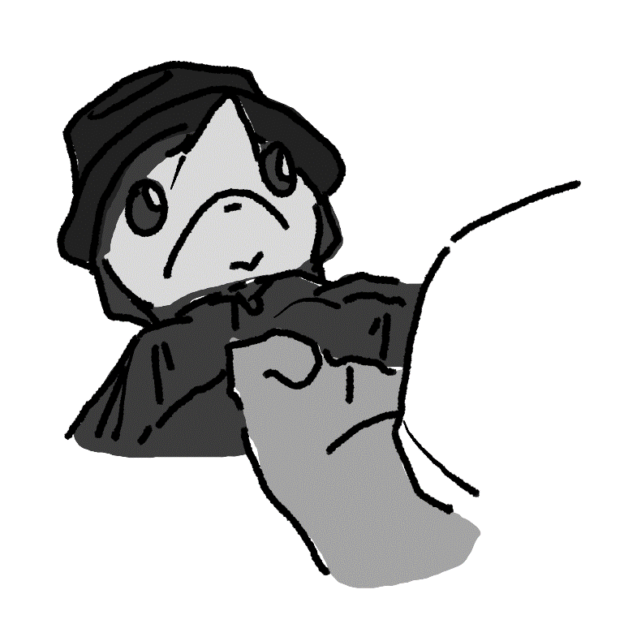

He was confused. “I beg your pardon.”
M. Lefebvre aimed his gun. “Open your trunk!”
“I...” he was lost for words, “I… do not believe that is quite necessary, hm...”
“OPEN THE TRUNK!”
“Yes, yes, quite right, one moment...”
Dr. Lance hobbled to the trunk, nervously trying to pick the key in the lock. After five attempts, he finally popped the trunk, under the supervision of both Lefebvres. And as it turned out… No, neither Maple nor Enoki were back there, but dozens upon dozens of stuffed bears were.
“I promise they are for naught but dismemberment studies!” He said, lifting his arms, “It is indeed no hobby of mine to collect these one-in-a-kind, hm, stuffed creatures, although that is quite wise in today’s climate, I assure that I merely am dissecting them to study the various medical sciences required to operate on- “
“OPEN THE BACK DOORS!”
Confused, Dr. Lance opened the back doors, letting the two take a look inside. Surely enough, there were no girls back there.
“I… I guess my judgment was wrong,” mumbled M. Lefebvre. “We need to get out. I apologize for damaging your car.”
“Oh, no problem, no problem at all, I tend to stock up on gauze for, hm, various reasons,” he mumbled, continuing with something under his breath that neither of them could hear.
“Père-“ started Coralie, quickly noticing three police cars that had appeared from both ends.
“Well, that makes things difficult,” he sighed. And for the first time, at least for many years, Coralie thought that she saw her Père afraid.

Mademoiselle Thibodaux

Maple was turned around in the car, her eyes burning into Nim in the backseat. The dragon girl was having a good enough time chasing the police car, so Maple didn’t have to think about it for a moment.
“Hey,” she hissed.
“H-Hey?” he asked, terrified.
“Do you like fried chicken?”
“A-As a matter of fact, yes- “
“Enough to be one?”
“W-What are you implying?”
The tips of her hair were glowing. “You better explain everything in the next thirty seconds, or I’m going to start burning it out of you, understand?”
He nodded like crazy. “Yeah, yeah, of course. I… That was Maurice LaPointe. The guy we’re chasing? He’s the head of the university police department – I saw you and Enoki heading out on a bus, and I- “
“You wanted to turn us in for the bounty, was that it?”
“N-No, I- “
“Then what?”
His face flushed. “I-I, uh… I…”
“SPEAK.”
“You don’t have a phone number, okay? A-And I wanted to, uh… Before you left, I… Well, that and I thought something was a little off, so I wanted to get the police car to chase you down, so…”
She burned holes into him. “You are a complete and utter idiot, you know that oui?” She turned around in her seat, letting out a heavy sigh. “You put both of us in danger, you know that oui? And now I’m going to go to prison for kidnapping…”
“N-No that wasn’t the idea at all- “
“OF COURSE IT WASN’T! You didn’t think through ANY OF THIS, did you?”
“How was I supposed to?”
“WITH YOUR BRAIN, if you had one. Look, don’t talk to me.” She bit her lip, punching the dashboard, her hands hot enough to leave a small dent in the plastic. “Hey… Do you have an air conditioner?”
“Nope,” replied their driver, “It’s broken-“
“Isn’t this a sportscar??”
“It broke and I have no reason to fix it, bien?” she snapped back, “I’m a lizard, I like the heat!”
At that moment, cool air started blowing out of the vents and towards the two of them, almost instantly.
“That’s odd…” she mumbled, fiddling with the controls, “They’re just working suddenly. Guess you guys’re lucky.”
Maple laughed angrily, staring out the window.
Nim tried to push Goawn off him, but Goawn was already starting to fall asleep again. There came a point where he gave up – making too much noise might attract Maple’s attention again, after all.
The car in front kept going, but their driver was right on his tail. She tailgated him, keeping as close as possible. She even considered honking to lift Enoki’s spirits, but she opted not to.
She could feel the car running out of gas. It had been bounding on empty for thirty minutes at this point, and slowly the car was losing control. The steering wheel locked up, the power braking stopped, but she pressed on, even as the car in front was slowly, slowly getting the better of them.
“Why are we slowing down??” demanded Maple.
“Out of gas,” hissed the driver.
They pulled up into a gas station, the driver having to put all her weight down on the brake to get them in. Sighing thankfully, she got out of the car and began to pump it as fast as possible.
Maple leaned against her chair, closing her eyes and sighing.
“Enoki’s a magician, and she’s super lucky,” reminded Nim, “Any locks, she’ll find a way out of them, I know it.”
“Hey, Nim?”
“Yeah?”
“Shut up.”
“Right. Sorry.”

Speaking of Magicians…

Enoki didn’t particularly enjoy the handcuffs, which had been sized correctly and did not slip off like the hand bindings the blind elves had used. She’d actually have to try a little to get out of these. There was an itch right between her shoulder blades and she couldn’t do much about it. She tried arching her back lightly to scratch it on the seat, but it just made it worse.
“Y’know, this isn’t particularly comfortable,” she said nonchalantly, frumping a little.
Maurice was busy driving like a bat out of Hades.
She felt ignored. So, being a magician, and using a lock pick she kept hidden in her hairband, she escaped the handcuffs, scratched her back, and then moved to the front seat.
When Maurice noticed, she was adjusting the air conditioner.
He slammed on the breaks, throwing her against the glove box, since she didn’t particularly feel like wearing a seat belt.
“Ow…”
At gunpoint, he pulled her back up into her seat and threw another pair of handcuffs on her.
Enoki frowned. “Y’could’a just asked nicely, y’know.” She climbed to the back, frowning, buckling her seatbelt again.
He kept driving, one arm up, holding the firearm.
Enoki stared out the window. She didn’t recognize any of her surroundings, but she had been memorizing their turns and street passes. Left, skip, skip, skip, left, skip, right, skip, right, skip, right, left…
It took nearly an hour before they finally stopped. They had pulled into the middle of a field, and the car jittered like mad as it was decidedly not designed for off-road usage. He pulled the car to a halt, letting Enoki out of the car before blind-folding her. He led her by the hands through an area, though she couldn’t be quite sure what sort of area. It felt like a forest, again – they were near the Blue Ridge mountains, there were lots of woods – but she couldn’t be certain.
He heard him undo a hatch. She was led down a ladder underground, where the air was much colder. He turned on a light, let her walk for a bit, and then finally removed her blindfold and handcuffs, keeping her at gunpoint to keep her where she was.
Enoki opened her eyes, unsure what to expect but certainly not expecting this. They seemed to be in a trailer home, moved underground, with dirt up against the windows and a ladder and hatch leading out the top. The master bedroom on the far side had its wall torn down and replaced with steel bars, fitted with a small bathroom in the corner. The living room and kitchen area were fully furnished, with the notable addition of a folding chair, lots of beer, a shotgun, and a pile of top hats. A stack of newspapers sat on one of the couches, and Maurice sat in the folding chair, staring at her with a gruff expression.
She folded her arms. “So what’m I supposed to do now?”
Maurice grabbed one of the newspapers and handed it through the bars. She took it and read from the top. It was an obituary.

JUNE 21, 1994 –

Bertrand de Ponteix, a human from the Carolina area, age 18, was found dead after driving a motorcycle into a lake. According to his friends, he was under the impression that if he had enough head start, he would be fast enough to… Ironically, he did not drown, but instead died of overexposure to gasoline fumes, as according to his friends, he believed that breathing fumes would grant one the ability to…

She skipped down a bit.

…Belle LaPointe, an orc from the Carolina area, age 36, was declared dead after being missing for two months. She was involved in a disappearing magic trick by the famous magician G.W. Winthrop. Winthrop refuses to reveal the secret behind his trick… surviving her are her husband, Maurice LaPointe…

She finished skimming, looking up to Maurice. “Is this your wife?”
He nodded.
She frowned. “Do you think I’ll bring her back?”
Once again, he nodded.
Enoki pondered this for a bit. “I-I don’t know why you didn’t find another magician, I’m not the best one in Carolina, surely- “
He didn’t seem to express anything.
“I’ll, uh… I-I’ll think of something, just… give me a moment, bien?”

Back to School

Felix took one last look at the university, starting his car. He was only going to be gone for a few months, but he knew it’d feel like a lifetime. It was so nice to finally get his own place and find something he felt good at, away from home. And he didn’t have to give up on Coralie, even if she was a little… sharp, and not in the intelligence way (she was smart, but that’s beside the point). She was nice to be around but hurt like a cactus if you weren’t careful. He hoped she was doing well, and he was wondering if they’d give up on this whole stupid treasure hunt by the time he got to her house to deliver her things.
HONK, HONK, HONK.
Confused, he turned around. There was a car in his way, missing one of its back tires. He almost immediately recognized it. It was his uncle again. And he was directly in the path of him driving away.
Felix, in an effort to avoid him, started repeatedly driving backwards for a few centimeters, putting the car in forward, driving forwards for a few centimeters, rinse and repeat.
“MASTER FELIX!” he shouted, “YOUR FRIENDS ARE IN GRAVE DANGER- “
“SHUT UP!” replied Felix, rolling down the window just a bit, “I LIKE MY ARMS, THANK YOU VERY MUCH!”
“THE TIEFLINGS! THEY WERE ARRESTED!”
He stopped, popping his head out the window. “Excuse me?”
“They shot my tire, believing me to be the one who kidnapped the foreign mistress, the wealthy one, you see, when indeed I was not the one to do so, and now they are apprehended by the authorities, and they desire you to visit!”
He froze. “...to visit?”
“Indeed!”
“Why on earth should I believe you?”
“For it is the truth!”
“And the arm pestilence is also the truth?”
“Indeed – they are both true!”
“Move so I can get out, please!”
Dr. Lance put his vehicle into park. “I shan't move until you join me in this quest to visit them, then I shall return to allow you safe passage returning to your home!”
Felix successfully got the car turned enough that, driving over the curb, he was able to pull out and around his uncle’s car, which was in no position to turn around.
“Please hold, Master Felix!!” Dr. Lance tried to turn the car around, but he did it too hard, and it leaned down and got stuck on the divot where the tire should have been. “I IMPLORE YOU TO- “
But he was already driving away.

They Lost Him… So What Now?

The half-dragon got back in the car and immediately extended a smirk and a hand to Maple. “The name’s Delphine Thibodeaux. I was Enoki’s nanny for a few years. I can’t remember if we established that or not.”
Maple shook her hand. “Maple Tremblay.”
“And who’s the lucky lad in the back?” she asked, turning to him and raising an eyebrow.
He leaned in. “Nim McNeely.”
She offered to shake his hand, and he accepted. “And the… dire wolf?”
“That’s Goawn,” explained Nim. “He’s not all there in the head, ye’ don’t need te’ worry about him.”
She nodded. “Maple, Nim, you two friends?”
“Maybe,” replied Maple, “We’ll see about that.”
Delphine hissed, climbing back into the air. “Spicy. Now, Nim, if you don’t mind, please don’t use wind magic on us again. I’m cold-blooded – it makes my reaction times slower.”
“What?” asked Maple.
Nim blushed, chuckling. “I… sent some wind through the air conditioner. Ya’ looked to me a bit warm, so I thought I’d be a help.”
Delphine started the car and immediately took to the road. She leaned back, her face a bit somber. Maple tried to read her, as well as the road, just in case the car appeared again. It had begun to dawn on her that she was in the car of a glorified stranger – someone Enoki knew, but a stranger, nonetheless. When it came to who she trusted the most, she had just as much backing as Nim.
“Drive faster,” commanded Maple, noticing that they were only a few ticks over the speed limit.
“I’m at the leeway,” she replied, “That’s not a good idea.”
Maple groaned. “SPEED UP! You still have a chance of finding that car!”
“No. I don’t want to get pulled over. And I know how folks like that think. He took advantage and took another route. They’re not there.”
Maple growled, gripping her seat handle.
“But there’s a thing you gotta know about my homegirl,” started Delphine, her eyes a bit squinted. “How well do you know her?”
“I don’t know,” answered Maple, her voice still teemed with anger.
“Can I tell you both a story?”
The car went silent.
“Right... Well, I’ll do it anyway. She was three years old. I wasn’t her nanny, someone else was – she got a new nanny every few years, but she had escaped the Mexican summer home she stayed in, had wandered across the yard, and was nearly to oncoming traffic. The security team nearly offed themselves in shame, racing after her, only to discover that she was standing in the middle of the road. And you know what happened?”
Maple and Nim were now interested, staring in interest. “What happened?” whispered Nim.
She laughed a little. “Nothing. Three car accidents around her, but not a scratch on her head. Was it unlucky that no one stopped her from going into traffic, or lucky that she just never got hit? I can’t tell you, but it seems like the girl oozes good luck. It just grows on her like hair. And besides, she’s a magician, who in their right mind kidnaps a magician? Don’t they know they’re magicians? I’m just here to pick y’all up and get her when she’s already out and ready to go.”
Maple thought for a moment. “No. That’s not right. We’ve been unlucky this whole trip.”
“How so?”
“We got our car stolen, that’s why she called you,” explained Maple. “Did she tell you our plan?”
Delphine winked. “Yes, but they were probably tracing your license plate, and I how else would I have shown up to save the day?”
Maple thought for a moment silently.
“And about the plan. She woke up bright and early for some reason. Luckily for her, I was already driving – this was supposed to be a vacation. The whole staff at the salon couldn’t get me to leave, and here I am, still working. But I gave Enoki my word – I’d be there for her if she ever needed me, and here I am.”
“Yeah,” answered Maple, “She got up and put on those bête Saturday Morning cartoons. She’s way too old for that.”
Delphine squinted even harder. “Are you sure we’re talking about the same Enoki? My Enoki wouldn’t be caught dead watching cartoons.”
“I hate to intrude,” said Nim, leaning in, “I really do, but where are we going? Do we have any kind of plan?”
“You tell us!” groaned Maple.
“I swear, I had no idea he would do that!” replied Nim, “I was just along for the ride, I thought we were going to find you both and check on you, I didn’t think he was going to abandon me and outright kidnap her!”
“Oh yeah? And the bounty had nothing to do with it?”
“I mean...” He chuckled, “I was aware that there’s a bounty of course, but that’s not why- “
“Well, then why did you do it?” Her eyes were burning, but just as much from curiosity as they were from confusion. “Maurice didn’t tell you that he’d just run off with Enoki if he had the chance?”
“He didn’t talk!” he laughed, “He never said a single word to me the entire time!”
“Go back- why did you come along? Aren’t we all supposed to be packing and heading out?”
He blushed a bit. “I… Well, I...”
Delphine was grinning, peeking in on him through the rear-view mirror. “Just spit it out already!”
He took a deep breath. “I wanted to, y’know, play another match of that fighting game with you before you left? And I went to you guys’ room, and you had up and left, so I figured you weren’t interested, but when I saw you with Enoki getting on the bus, I thought, ‘Hey, that might be something’, so- “
“So, you got the POLICE involved??”
He chuckled. “Looking back on it, it was a pretty overkill idea, but… I mean, it worked…? And I mean, I am on the police team…”
She groaned. “That… is the most stupid thing I think I’ve ever heard.”
He grinned. “The absolute stupidest.”
“And now Enoki is kidnapped by a rogue police officer who’s taking her to who-knows-where, and it’s all your fault.”
Nim’s grin immediately disappeared. “Right… Sorry, I’ll keep my eye out.”
“And so is everyone in the entire freakin’ Laurentides by now,” added Delphine. “I started seeing them on television – there are ‘Enoki Missing’ ads every five minutes, now. We’re not the only ones, you know. Somebody else is definitely going to find her before we do, so keep your eyes right.”
Maple turned to the window. “But could you both at least be a little more anxious? I hate being the only one in here who seems to be reacting to this like a normal person!”
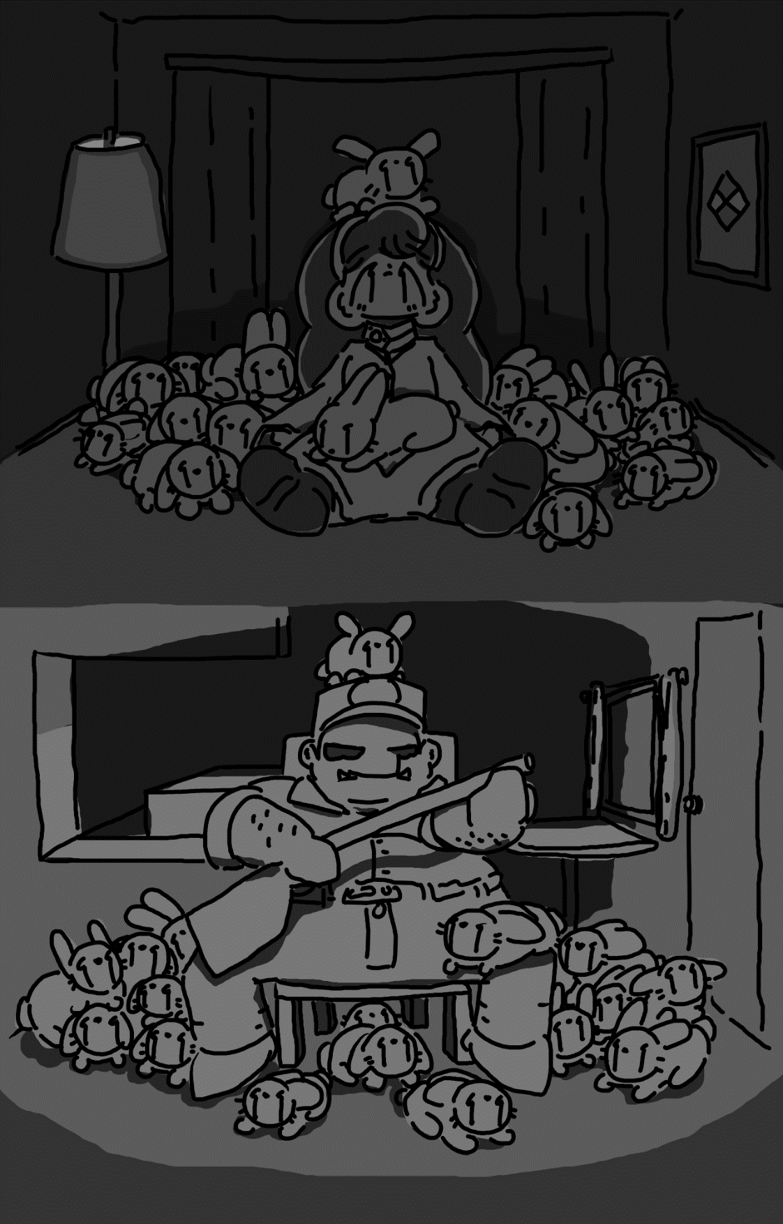

It’s Getting A Bit Full…

Enoki didn’t quite expect to be here, but here she was – underground, an angry arc with a shotgun on the other side of prison bars, surrounded by lots and lots of felt hats and lots and lots of rabbits.
She sat on the floor, so many rabbits spread across the ground, crawling over her and nibbling on the hem of her skirt that she wasn’t quite sure how to respond.
“I mean,” she said, “I don’t know what to tell you.. I’m just a student. Rabbits are all I do. And..” She showed him how big her sleeve was. “I don’t even think she’d fit through.”
He just stared back, blankly.
Enoki squinted, trying to figure out if she could even see his eyes. “Do you talk?”
He didn’t do anything.
“Then can we talk about this?”
Maurice looked down and to the side a bit.
“I’ve got an idea.” She picked up a rabbit and started petting it. “How ‘bout we have a conversation about this. I can’t help you any other way.”
He continued pondering, putting down his gun.
Enoki sighed. “I know you’re obviously an action guy, and I know the world is all about action – I haven’t even got a chance to breathe for the past, like, day and a half!” She thought for a moment. “Why me? There’s gotta be at least another magician at the school… I haven’t met any others but there’s gotta be one, oui?”
He shook his head ‘no’.
She scratched her chin. “Actually, now that I’m thinking about it, how’d you know I was magician to begin with? I don’t tell everybody.”
Maurice picked up one of the white rabbits.
“Was it that rabbit I let lose outside the…? Hmm.” She thought for a moment. “Maybe I shouldn’ta done that… So… You weren’t even gonna do this if I hadn’t had done that?”
He nodded ‘yes’.
“Do you not like magicians?”
‘Yes’ again.
“I… think I understand. I’ve been a magician my whole life, and there’s nothin’ I can do about it, and I know we’re a bit weird and scary, but we’re not all bad, y’know. I mean, we can make bunnies outta thin air, so that’s gotta count for something.”
He ignored her.
“I’m not just a magician, though, y’know,” she pointed out. “So if you’re mad at magicians, you’re not mad at most’a me, oui?” She scratched one of the rabbits behind the ears. “I’ll tell you what. You tell my parents you’re here, and they’ll pay you a bunch of money, and then you can go move somewhere nice on the beach in Mexico and make some new happy memories, oui?”
His disposition didn’t change much, but Enoki figured from his body language that he was suspicious.
“I don’t think I could ever understand, though,” she replied. “Y’know, me, I haven’t really had anyone in my life for very long, long enough to care about very much. My parents don’t even know we speak the same language, isn’t that funny? They think we’ve gotta get a translator who knows Rizoy and French. I mean, I’d like it if they tried a little, like, even if they said something way wrong, just… a little effort would be nice. You don’t mind it if I keep talking, d’you?”
He shook his head ‘no’.
She smiled. “Well, I’m just about done anyway. All I’m saying is that I don’t know what’d do about this.” She looked at the rabbit she was holding. “I don’t have’ta go home again, but if it makes you happy, then I don’t really have a choice, do I?”
He snorted.
“Do you wanna say something?”
He nodded.
“Can you not talk?”
He didn’t reply.
Enoki frowned. “Well…. Oh! You got a phonebook?”
Confused, Maurice stood up. Walking over to the countertop across the trailer from her, he reached into a drawer and found a phonebook, holding it up.
“Yeah, now just rip it up and toss the pieces over to me, bon?”
As if it were toilet paper, he shredded the phone book and tossed the shards off to Enoki. She made quick work of the strips, stuffing them all into her sleeve.
Maurice was very confused.
That’s when Enoki dumped out all of the strips onto the floor, ruffling through them a bit until the majority of them were visible.
“Now, I’ll just read through the bits that fell on the floor! Hmm… So, ‘Maurice LaPointe... is… a fan… of… cartoons… that are designed… for little girls…’”
Maurice’s eyebrows furled.
“He might… deny it… but it is true.”
He cocked his shotgun.
“Enoki… is just reading… phone book… clippings… please do not… shoot… her… for telling the truth, I… am just… a magic trick.” She looked up, seeing the shotgun and squeaking. “HEY! I’M JUST READING FROM THE PHONEBOOK CLIPPINGS, I SWEAR!”
He walked over to her, staring down at the shards of phone book disapprovingly.
“If… you let… Enoki… go, then… you won’t… die… a fiery… death.”
Maurice took a deep breath.
“You have ten seconds… to let her… go… or you will definitely die in a horrible way… so, here we go… ten… nine… eight…”
In a rush, Maurice frantically climbed up the ladder to open up the top of the mobile home.
“Seven… six… five…”
Pulling his keys from his belt, he feverishly flipped through his keyring, but there were far too many unlabeled keys for the time remaining.
“Four… three…”
In one swift blow, he punched through the steel bars, grabbed Enoki by the collar of her blouse, dragged her over to gate, and tossed her right out the entrance.
Enoki flew through the air for a little bit before she landed in the gentle arms of a nearby tree. She blinked a few times before discovering that the tree that she was launched into had a large hole in it, one that happened to be Enoki-sized, so she figured it wouldn’t be a bad idea to hide in it.

He Was Gonna Do It Anyway...

Felix just didn’t want to ride with his uncle for thirty minutes until they got to the local holding station, which probably wouldn’t let them in anyway. But he thought he’d pop in anyway.
He waited a few minutes before making his way through the line to the front.
“How can I help,” said the half-dead woman behind the counter with as much energy as a sock in middle of a baseball field.
“Yes, I’m here to see if I need to pay bail for a friend of mine. I’m not sure what I’m doing, so- “
“What’s the name?” she interrupted.
“Uh… Coralie Lefebvre.”
“How’s that spelled?”
“C-o-r-a-l-i-e L-e-f-e-b-v-r-e.”
She seemed suspicious. “That’s a real name?”
“I asked the same thing when I met her.”
She did some typing on her computer, leaning in to get a closer look. “No… It doesn’t look like we’ve got any ‘Lefebevver’ people.”
“L-e-f-e-b-v-r-e?”
“Yes dear, Lefe-beaver.”
“It’s like Leu-fairve.”
“It sounds like a Tiefling name.”
“She, um, is a Tiefling.”
The woman looked even more disappointed. “No, we don’t have any. NEXT!”
Felix stole all of her pens and hoped she wouldn’t notice until the worst possible moment.

What Actually Happened

Coralie could not understand how her Père could run for nearly thirty minutes without stopping to take a breath. Even for Tieflings – that was a big deal. She was gripping her knees, gasping for air, surrounded by trees and far too sweaty for her own personal comfort.
“Why’d.. we.. stop?” she huffed, confused.
M. Lefebvre broke a reed in half, blowing into it to check. “Take this for breathing,” he instructed, tossing it to her with a hushed voice. Then, spotting a nearby pond, he leaped in, hiding in some reeds.
“PÈRE-“ she was about to call out, catching herself. Then, scared as a cockroach in the middle of a well-lit room, she leaned in after him, breathing through the reed.
About a minute later, she could hear the officers stop by. They searched for a while, making lots and lots of noise. Coralie couldn’t help but worry about her père, though – she knew he’d been through crazy stuff in his mystery job, but a minute underwater for a full Tiefling felt like a minute under lava for a human.
After a little while, they were gone. She waited for him to get out first. Then she followed, remembering just how much she hated getting wet and how heavy it made her clothes feel.
M. Lefebvre was covered in green, unhealthy-looking rashes. His eyes were swollen and he was shaking like a stalk of wheat, but his facial expression was just as composed as ever.
“Your face..” said Coralie, softly.
“I’m fine,” he whispered, “We’re safe. They’re off our tails.”
“You need to go to a hospital, and, uh..”
“No, first we’re going to find a pay phone and cancel the house extension payment.”
She raised her eyebrows. “You already took out a loan on that extension?”
“I did.”
She hissed a little in sympathy.
“It’s fine. Apparently, we all make… mistakes. All of us.”
“Are you sure? It looks like it’s clearly not fine.”

If Only Phone Calls Were Cheaper

Delphine had stopped at a convenience store to let Nim use a pay phone. He was perched on top of the booth, weightlessly holding the cord phone to his ear, sharing codes and occasionally speaking in Anglish, a language which Maple didn’t know a word of. She knew he was trying to work on their behalf, and this was a call straight to the police station, but… she couldn’t help but distrust him a little bit, still.
“Hey,” said Delphine with a poke to Maple’s arm, “How ‘bout we go in and get some clopes?”
She nodded. “Yeah. I could do that.”
The two went in and purchased a box of clopes each. Then, as soon as they entered, they exited and walked to the side of the building.
Delphine was about to pull out her lighter, but Maple stopped her, snapping, and producing a little flame on the end of her finger.
“Oh… Merci,” she replied.
“Pas de quoi.”
Delphine took a deep puff. “So, where’d you come from? Phillipa or one of those provinces from up north?”
“I’m from South Louisiana,” she answered. “But I’ve moved around a lot.”
“Me too. Grew up in the bayou.” She chuckled. “Didn’t have a lot. Lived in one of those cheap, used trailers. We’d get about ten minutes of hot water a day, and being d’plonj...”
“Say, what does cold water do?”
“One day, I went to check on Père and was just frozen. Just sitting there in the shower, moving like a snail. Mère had to get some hot water boiled on the stove to warm him back up.”
“How long it’d take?”
“It wasn’t fast, I’ll… just say that.” She took another puff. “So what’s an elf like you doing this far south? Don’t you like it better up there?”
She thought for a moment. “I don’t know what I’m doing here, you know. My brother doesn’t know. Or at least he doesn’t tell me. I don’t think we’re related at all, really. But I pass as a human.” She pointed out her ears. “Clipped as a baby.”
Delphine winced. “Ow.”
Maple nodded. “Yes, ow.”
“I got my wings clipped as a baby, too.”
“That’s got to have hurt worse.”
Delphine shrugged. “I was a baby.”
Maple took a puff. “I wonder how he’s doing. I hope he’s stopped looking for me.”
“Bad situation?”
“He was hard on me,” she answered. “Almost making me work hard. It’s why I left the school like I did. Maybe he’ll find someone else to control.”
Maple immediately felt guilty the moment the words left her mouth – that didn’t sound like Aaron, he wasn’t manipulative, or at least, she didn’t think so. But for some reason, it felt like the right thing to say.
“You did a good thing by leaving like that,” she answered. “I had a boyfriend a few years back who was like that. Wouldn’t let me go anywhere without being all like ‘who’re you talking to?’ and ‘that better not be another gator’, things like that. I dumped him.”
Maple took another puff. “I kind of miss him, though.”
“Don’t. You’re a bigger person than that, Maple, bien? Find you and be you for you, and only you, oui?”
“You’re right.”
“And if I ever see him, I’ll give him the two-four, got it? Girls gotta help girls.”
“-I can handle myself,” she interjected, giving her a sharp look. “I’m fine. Thank you for your help, but I’m fine.”
Delphine wasn’t convinced. “For now, maybe.”
“Hey- “ chimed in Nim, suddenly appearing next to the two.
They jumped, Maple nearly taking his face off with an inopportune blast of fire.
“HEY!” he replied, “Chill!” At that moment, Goawn had rolled up behind him, yawning a little. Having to move any distance at all surely made the chubby pooch a little tired.
She groaned. “I do fire, Nim, how am I supposed to chill??”
“That is a fair point,” he replied, clearing his throat. “I’ve filled them in on the complete situation, and now there is an investigation planned. The police force, we aren’t particularly happy with how busy we’ve had to be lately. There are two Tieflings on the loose, too. A man and a girl about our age. Very dangerous. We need to keep on the lookout for- “
Right at that moment, Coralie and her father stepped out from the trees behind the gas station and directly into Nim’s line of sight. He got tunnel vision, immediately climbing atop a trash can to stare down at them.
“Hold on,” said Delphine quietly, “I’ve got this.” She stepped up to the two, her arms crossed. “My name’s Delphine, excuse my friend here, we heard news about two extremely dangerous criminals and he’s a bit paranoid.”
Coralie nodded. “We’ll be on the lookout.”
Maple noticed Delphine and M. Lefebvre winking at each other, even if just a moment.
“There’s an emergency room down the road,” mentioned Delphine. “Would you like me to take you? Those water burns look pretty bad.”
“I would appreciate it,” replied M. Lefebvre.
Nim and Maple glared at Delphine as if she just let a mass murderer into a grocery store and told him to ‘have fun’. Goawn would have been glaring, but he was unable to look at any one thing with both of his eyes at the same time.
Effectively abandoning them, Maple found herself alone at the gas station with nothing but Nim, this strange Tiefling girl, and a clope. The girl was sopping wet and eying her, as if they had met before.
“Hey… Have I… seen you?” she asked, “You’re not a student at CMU, are you?”
Maple and Nim both looked at each other. “Yeah,” replied Maple, “We’re both students there. We lived in East Hall.”
“Me too!” she chirped, “I was third floor!”
“Second floor,” replied Maple.
“First floor,” added Nim.
They stood awkwardly for a moment.
“Why’re you wanted then?” asked Nim, “What on earth did you do?”
She looked a bit uncomfortable, giggling anxiously. “My père and I have a penchant for getting into trouble, y’know? And… Well, we… I shot a police tire so we could try and pull over the car it was chasing.”
“How come?” asked Nim, leaning in a little, his eyes going into investigation mode.
“We’re trying to find Enoki Ramirez,” she replied.
“Where is she?” demanded Maple, stepping up. “She just got kidnapped by a police officer from the school – we think he’s holding her ransom. Big, green orc man. Have you seen one?”
She shook her head. “No. How do you… How do you know she got kidnapped? You’re not…” Her eyes widened. “Hold up, are you her roommate? The one she ran away with?”
“Yes,” groaned Maple. “And that’s all I am to anyone.”
She put out a hand. “Coralie Lefebvre.”
Maple shook it. “Maple, and that’s Nim.”
Coralie turned to Nim, putting out a hand. He just stared at it, like a cat. “Yes,” he said, still staring, “It’s very nice to meet you.”
“Sylphs,” sighed Coralie under her breath.
“Hey, don’t ‘sylphs’ him,” snapped Maple. “He won’t complain about it, but that’s rude.”
She crossed her arms. “You’re a human – what do you know about what’s rude?”
Maple’s hands caught on fire.
Coralie’s eyes widened. “I, uh.. I’m sorry, elf?”
“It doesn’t matter. So, what exactly do you and your père want with Enoki, hm? Let me guess – it’s the money, oui?”
She grimaced. “I just want to do something fun to end the school semester off, oui? I mean, the money is nice, but it was sort of a… quest, you know? Something fun to see if you can do it.”
“Hey, you wanna know why we ran away to begin with, hm?” Maple stepped up, squinting her eyes. “To get away from people breathing down our necks, bon? So we’d appreciate it if you’d harass someone else with your little ‘quest’ obsession.”
“It sounds to me,” chimed in Nim, who the two had almost forgot was there, “Like the two of you came out here for the same reason.”
“Look,” defended Coralie, “My father is frightening, and ninety-percent of the time he can get whatever he wants just from a look.” She lowered her voice. “He scans police radios, and can hear the components on the inside, so he knows what they’re saying even when his radio is off. He can go underwater for minutes at a time. He’s terrifying.”
Maple’s hand caught on fire, and she held it up aggressively. “Is this a threat?”
“No, no, no!” Coralie laughed, “Firstly, I’m fireproof, and secondly, I’m sure we can help you! Once my père cancels that loan he took out and gets back, we can help you find Enoki! And not for the money!”
Maple stepped back. “And you’re sure that your father can get anything?”
“Positive!”
“Alright, prove it.”
Suddenly, a van pulled into the parking lot and bolted towards them, and the three turned to look. It stopped a few meters away, with Delphine in the driver’s seat and M. Lefebvre in the passenger side seat, cream all over his skin.
Delphine rolled down the window and stuck her head out. “Hop in!”
Coraline crossed her arms and gave Maple a smug look. “See? New van.”
Maple sighed. “I’m so confused…”

Don’t Eat Those, Please

Enoki was alone in the woods. Maurice was still underground, trying to capture and release the rabbits, but she was under no obligation to stay – and had no intention of doing so.
That was easy, she thought. Maybe a little too easy. She tried to move as quickly as she could.
Grrrr…
Her stomach growled.
She knew she couldn’t be too far away from a restaurant, but there was still so much wooded space to walk through. She was thirsty, too – and if Maple were here, maybe they’d be able to get a drink without getting some weird bacterial something.
But hey, not too far away were some mushrooms. She smiled, stepping over to them. She tried to remember back to her guide on what mushrooms were safe to eat and which ones weren’t. While she couldn’t quite remember, she knew that she was a naturally lucky person – surely these wouldn’t kill her or anything, right?
So, she picked a few and popped them in her mouth. They didn’t quite taste right, but she figured that it was because they were raw. She swallowed, and having enjoyed her snack, went on with her walk.
Finally, she left the forest and arrived on the side of a road. Just across the street were restaurants, gas stations, and a few retail shops. They were all stretching and shrinking, but she didn’t think anything of it.
Having no fear of the road, she ran out and across the highway without a problem, tripping right as she left the road and landing face-first in the grass. The grass was a little weird, too – it was shimmering and twisting, changing colors. It also felt super soft. She started rubbing her cheek on the grass to feel its texture, giggling.
That’s when she decided to get up and try rubbing her face on other things. She ran up the hill, only tripping once or twice. She got to a pharmacy, a brick building whose texture was shimmering like an ocean. She put her cheek up to the wall and felt it lap up at her, like waves on an ocean. And if it was this fascinating outside the building, she wanted to know what it’d feel like inside.
She ran in through the main entrance, immediately overwhelmed by the sheer number of things jumping, moving, dancing around the store. So, of course, she needed to talk about it. She ran up to the front counter, giggling the whole time, nearly tripping as she got there.
“J-Je suis désolé, I-I’m sorry,” she said, her speech slurred, “I almost tripped.”
“Almost?” asked the cashier.
“It’dth just, I love your store,” she said, rubbing her cheek against the countertop, “Ib’th as smooth as chocolathes!” Which didn’t make much sense to even Enoki, but it seemed right to say.
The cashier picked up an intercom handset. “Security, we have an incident at station one.”
Enoki began crying tears of joy. “Didth I say how much I just love everyone? Everyone… Y-You’re all so beautiful, I feel s-so happy right now, I couldt’h just melt.” And then, she slumped down, laying on the floor, “It’s like it’s all made of love…”
She just laid on the floor, watching all the pretty colors go by. A few people had shown up, and she couldn’t help but just stare at their faces as they twisted and shimmered. They were talking, but she wasn’t particularly listening.
At some point, she was picked up and taken outside. Her stomach was just about to give way, but she didn’t care – the sun was much brighter than usual, and the sky was absolutely dancing with joy.
“Do you have any allergies?” she thought she heard someone say.
She replied by vomiting on the floor. “I-I’m allergic t-to sardines, they make me vomit ‘cuz they’re nasty.”
“That’s… not an allergy,” mumbled the ambulance nurse.
“B-But what is an allergy?” said Enoki, slurred. “It’s where you eat somethin’ and you get a bad reaction, oui? W-Well I always had to eat ‘em and they made me…” She heaved again. “That! T-That’s what they made me do- “

Alone with Her Thoughts

Enoki didn’t think that her hospital bed was particularly uncomfortable. She didn’t like the way her mouth tasted, though, and her head stung, especially her right temple – it was just throbbing away without a care in the world. But the gown was nice, and the bed was soft. The mid-afternoon lighting was good enough.
She checked her wrist. There was a little hospital bracelet, but no handcuffs. She could get up and walk away if she wanted to, most likely. They’d try to track her down and pull her back, but that was her life, anyway. Trying to be pulled back, seemingly successfully, over and over again. No matter how many times she’d try to run away as a kid, they’d find her and put her right back in her house.
This whole trip was a waste of time, wasn’t it?
Her left hand hurt a bit. She took a look at it. There was a little hole – they must have run an IV in to keep her fluids normal and healthy.
Enoki picked up her wristband and read it. “Maria Ramirez.” So, they knew who she was. It was only a matter of time before a representative of her parents would show up.
She frowned, sighing and laying back down, staring up at the ceiling. She started humming some song she learned back in high school just to give her mind something to chew on. She cringed, thinking of all the things that happened when she first learned the song. The friends she thought she had. The way she dressed. What she thought was important. She wasn’t sure if she thought of the song because she had seen Delphine for a split second that morning, or if it was because she felt absolutely miserable, but it was one of the two.
Maple must have seen her, though. Maybe they got in the car and were off to save her, wherever she was. They probably were – she knew they were behind her during Maurice’s car ride. She wondered where they were now, if anywhere.
She knew exactly what Maple felt like, though. Wanting to pay off her older brother for her worth and then leaving. She wanted to be honest with herself and just leave. Enoki knew what she was – she was a cute little button that needed someone to sew her on to something, and once she was there, she wouldn’t have a say in where she went. Moments like these were like when buttons had fallen off, and it was only a matter of time before she got sewed back on or replaced with a different, more reliable one and then was thrown away.
She wanted to be thrown away, really, that was what it was. She tried so many things, too – she thought back to when she was fourteen and tried to be goth to frighten all her classmates into respecting her – wearing spikes and fish netting, snarling at everyone, listening to heavy metal a little too loudly over her headphones so everyone could hear her. It just didn’t help that her cheeks were a little too plush, her frown just a little too lovable, far too many dimples, and she knew it. She wanted to be anything other than cute, but the harder she tried, the more endearing everyone thought she was, and the less anyone took her seriously.
So, she gave up. If she was going to be cute, then she was going to be so candy-coated and childlike that they’d have to give her a little more respect. And she was good at it – the cheesy way she said everything, the frilly dresses, squeaking at all the girls and flirting with all the boys. It definitely toned down when she got to college, but her senior year of high school, it worked. No one wanted anything to do with her (aside from a few boys that she wasn’t particularly interested in), and some annoyed teachers constantly telling her to act her age.
Women my age get to drive to the store without permission, she’d think. Women my age get to date whoever they want without a board’s permission. Kids my age are allowed to work a job to earn their own money.
And here she was – nineteen years old, a year and a half of college under her belt. She had finally made a real friend for a little while and was coming to terms with the fact that, well…
She was crying.
She didn’t know how long she had been crying, but her eyes were already sore. Perhaps she was just thinking too hard to notice, but…
Maple was the first real friend she had in years, and there was a good chance she’d never see her again. Not if her parents decided to ship her to Rizalanio after this whole mess and give her private tutoring so she could be a good heiress and take over the family fortune.
She could walk in front of cars and not get hit, but no matter how far she walked away from the house, she’d get pulled back into it.
So, she waited. There really wasn’t anything else to do in the meantime.

Part Four
or “I guess that things could have been worse, at least everyone will probably have learned something, right?”
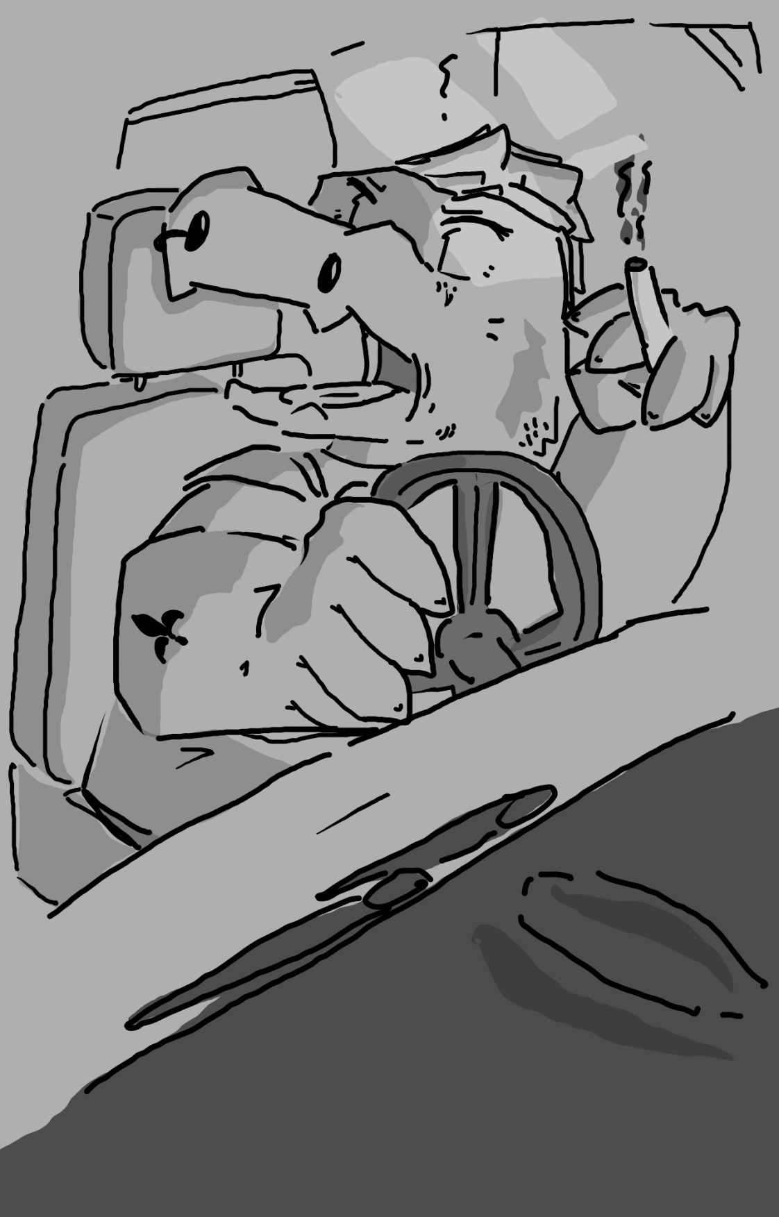

Is It Coming Together Yet?

“SO!” shouted Delphine, taking out the clope from her mouth with one hand as she drove with the other, “I feel like we’ve got some clarifying to do for everybody, bien?”
Everyone was quiet, leaning in, as the three in the backseats were more than a little confused.
“Hey, Coralie, oui? Your père and I used to work together,” she replied. “I mean- not exactly; he was on Enoki’s security team.”
“You what?” asked Coralie, squinting her eyes.
He chuckled. “They only wanted to best, and they paid a fortune.”
“Then why aren’t we filthy rich??” she demanded, crossing her arms.
“Getting back on topic,” continued Delphine, “We figured we’d finally find Enoki, let her get found by her parents, rescue her, and then sue the pants off her parents because that’s what her parents wanna do – kidnap her.”
Maple blinked a few times. “You people are delusional. All of you.”
Delphine chuckled. “Just the opposite. We sue them in a court, take a few cool million dollars, Enoki gets to stay in the Laurentides and her parents and their house get a restraining order put on them, and just like that… She’s free of her parents, gets a fortune, and we all profit, and if anyone’s lucky enough to do it, it’s Enoki. Albeit her parent’s luck doesn’t get in the way, of course.”
Maple squinted her eyes. “I thought you said good luck and bad luck were the same thing.”
“That’s where I come in,” chimed in a raspy-throated M. Lefebvre. “I know them in and out. If anyone’s capable of handling this operation, it’s me.”
“And I can bite through steel,” pointed out Coralie.
“This idea? Foolish,” groaned Nim, “I’m not going to- “
“I’m in,” interrupted Maple. “I’ve got nothing to lose. We need to find Enoki, and Enoki needs to be in a good place. I’ll do whatever it takes.”
“-not do it,” finished Nim. “I’m not going to not do it. Just because an idea is foolish doesn’t mean I’m not interested, of course.”
Goawn barked.
“-And we could prob’bly use him for somethin’,” sighed Nim, petting him. “You big oaf, you.”
“So, what first?” growled Coralie, slapping her hands together.
“That,” laughed Delphine, “Would be dinner. Who’s in the mood for some boudin?”

And Then Someone Walked In

Enoki was busy eating her hospital food when a nurse walked in, followed up by two men in suits and black sunglasses, carrying black suitcases.
“Honey,” started the nurse, “These men have come to getcha’ in contact with your parents and take you home.”
“But isn’t that against your contract?” asked Enoki, “I mean… I’m an adult, so… I never gave consent to have people come and take me anywhere.”
The nurse walked out and did a terrible job of hiding the money shoved into her back pocket. Enoki took a cynical look and sighed, staring at her bagel.
One of the men came over, opened up his suitcase, and revealed a phone. It rang almost immediately, and Enoki picked up the line.
She could hear a couple murmuring in Rizoy in the background. They sounded a little too much like her for her to be comfortable.
“Bonjour, is this Maria?” asked a voice in French, speaking with just a hint of a Rizoy accent, “This is M. and Mme. Ramirez’s personal French translator, and I’ve come to speak to you on behalf of them.”
Enoki bit her bagel.
“They’re asking how you feel after your accident in the woods.”
Enoki bit her bagel again.
“They say they only have a ten-minute window and want to check on how you’re feeling.”
“…”
“Is the phone working? Maria, can you hear me?”
One of the men looked down at Enoki, but it was hard to tell from behind the sunglasses. “Mademoiselle Ramirez, it’s imperative that you make this call.”
Enoki passive-aggressively spread butter across the remainder of her bagel. It was very slow, very slow, and she made direct eye contact with the suited men the entire time.
The suited man groaned. “Can’t you even stop for a moment to- “
Crunch.
There was now an extra bite in the bagel.
A few seconds of silence went by.
The translator cleared his throat. “Your parents are now concerned that your accident made you unable to speak.”
CRUNCH.
The bagel was gone.
It was mashed potatoes time.
“She can speak,” said one of the suited men, “She’s just choosing not to.”
“Your parents just informed that if you don’t speak,” the translator said, “You are going to be grounded for a month.”
“No me importa,” she groaned.
“In French, please,” sighed the translator. “Your parents do not want to speak Spanish.”
Enoki took a moment to think through whether or not she really wanted to continue.
“Maria?”
She bit her lip. “Bakit hindi ka makapagsalita ng Pranses minsan?” Why can’t you speak French sometimes?
The room went silent for a moment.
“Maria, dayong,” said her father directly, “hindi mo sinabi sa amin na maaari kang magsalita ng Rizoy.” Maria, sweetie, we never knew you could speak Rizoy.
Enoki reached over and hit the ‘end call’ button, grabbing a big spoonful of her mashed potatoes and shoving them into her mouth.

And It Tasted Very Good

Maple sipped her milkshake, doing her best to do so quickly before she melted it. “So, Nim, you remember that time they tried doing residence hall games?”
“Of course,” he replied with a smile, perched atop his seat like a crow, eating a single fry at a time. “I don’t think you were able to keep a water balloon in your hands for… what, was it five seconds?”
“Four,” she sighed. “I feel the same way about this milkshake, I think I’ve just about completely melted it.”
“Oh, here, let me help with that.” His eyes rolled back for just a second, and a chill breeze blew over her hands. “Let me know if that helps at all.”
“Thanks,” she said with a smile. “You know… I wonder… If- I mean, when we get Enoki back, do you think she’ll keep all that stuff she left in the lobby?
“I hope so. Thursdays were always fun.”
“Yeah… So, I have a question.”
“Yes.”
“It’s a little strange.”
He chuckled. “I’m fine with anything.”
“You wanted to go out for coffee for, like, five Saturday nights in a row, and you had to cancel every single time. What were you doing on Saturday nights that always made so busy?”
He looked around the table. “I’m… not… sure this is a good thing to talk about around the table, right when everyone is eating. Maybe later?”
Maple was a bit confused. “Alright. I’ll ask then.”
“You not going to eat your food?”
“Not hungry,” she replied, staring over at the television screen.
On the front was another one of those Enoki advertisements. Once again, they were using ten-year-old photos of her, which didn’t look all too different, but for someone so wealthy, didn’t they have a wax sculpture or hand-painted portrait something to go off of? Or maybe her parents hand-picked the photograph and didn’t know she was any older. One of the two.
But then, it was interrupted by a newscaster. “Bonsour, Carolina. We have just gotten reports that Maria de Ramirez y Panganiban, daughter of famed Ramirez International Trade owner and CEO Amihan Ramirez, has been discovered. She was found in a manic state in the Louhans parish and hospitalized.”
Everyone was dead quiet.
“She has a really long name…” whispered Nim.
“HOWEVER, this was quickly resolved, as it was discovered it was due to some bad mushrooms she ate in the forest.”
Maple hit the table. “Thunder my dog… Darn you and your darn mushrooms, Enoki.”
“She’s made a full recovery and will be flown back home to Rizalanio sometime over the next week. Now, the question becomes – will she be the one to receive the bounty for technically turning herself in, or is she ineligible? Stay tuned.”
“Thanks for the incredibly specific details, TV guy,” sighed Coralie.
“You’re welcome,” said the announcer with a chuckle, “And for those who didn’t quite hear, I was speaking to my co-host, not to anyone in the audience.”
Coralie looked up, staring in horror. “That guy… That guy is so creepy.”
“Excuse me?” asked her father, an equally horrifying smile on his face.
She was immediately defensive. “No, I wasn’t commented on a boy or anything, it was just the announcer on the television, please,” she cleared her throat, “please don’t kill anyone.”
He shrugged, “Alright.”
“Now we know where she is,” began Delphine, clearing the center of the table from its paper trash. “So that means she’s going to the Charlottesville International Airport, oui? Now we’ve got a destination. If we’re going to get her back, we’ve got a spot. We’ve got something. We’ve just got to find and hijack their private jet, that’s all.”
“How will we know it’s theirs?” asked Maple.
Delphine laughed. “You think they’re flying commercial? There’s gonna be a tiny little private plane. So, we find that, retrieve Enoki, and make out like a bunch of heathens until she’s able to bring this before a court.”
“And on the way we explain the court part?” asked Nim.
“Yes. On the way.”
“Thanks for the boudin,” chirped Delphine, standing up, “But we’re probably a solid forty-five minutes from the airport.”
“Hold on, we’re what?”
She looked confused. “Forty-five minutes?”
Maple stood up abruptly. “You’re telling me that Enoki and I travelled for days and we only managed to get an hour away from the university?”
She thought for a moment. “I suppose so.”
“But we drove for a lot longer than that!”
“It’s a possibility,” sighed Nim, “That… you drove in a large circle.”
“Large circle, my butt.” She kicked a nearby pillar as hard as she could.
Nim and Coralie started snickering.
“What?!” she demanded.
“Nothing, it’s just… We’re children, I guess,” sighed Coralie, “It’s just those particular choice of words together is… nothing.”
She groaned. “Let’s just get in the car.”

Well, She Definitely Tries

Another knock rang out on Enoki’s door. She hoped it would be the nurses, and… no, no it wasn’t. The same suited men came back, suitcases in hand.
“We’ve just gotten confirmation to go ahead and transport you to the airport,” one of them said, opening up a suitcase with clothes in it. “You are encouraged to change back into the clothes you arrived here in.”
She crossed her arms. “And if I don’t want to?”
“Then you will be forced to purchase those scrums from the hospital.”
“I don’t know, which way is more inconvenient for everybody?”
They looked at each other, and then at the suitcase, and then at each other, and then finally at her, again. “Uh… the clothes in the suitcase?” tried one of the agents, “I don’t know, we don’t particularly care.”
“Bien,” she huffed, getting out of bed and grabbing the clothes, “Have it your way.”
Once she was in the bathroom, she locked the door. Then, she planned her escape. There was a vent on the ceiling. Perfect. She had seen plenty of movies where people went through the ventilation ducts places, and worst case scenario, she just hide in there and they forget about her.
First things first, she turned the shower on to hide the sound a little bit.
“MADEMOISELLE RAMIREZ,” said one of the men, knocking on the door, “WE DON’T QUITE HAVE TIME FOR A SHOWER.”
“I ALREADY STARTED SO I GOTTA FINISH!” she shouted, going through her clothes. Did they have her hair band? No, no, no… HA! Voilà! She picked it up, unfolded it, and checked. Tools were still there. She put the hair band on but left the rest of the clothes behind. Far too heavy.
She climbed atop the toilet tank, reaching up, just barely touching the ceiling tiles. Perfect – they were the easy, breakaway kind. She started jumping over and over again, punching away at it until it became loose.
“MADEMOISELLE RAMIREZ, ARE YOU SURE THAT EVERYTHING IS FINE? THOSE AREN’T NORMAL SHOWERING NOISES.”
“YEAH!” she replied, “I’M JUST SPECIAL!”
Finally, she had enough leeway to grab onto the edge of the wall. She climbed up, throwing herself just enough to grab onto some metal piping. It was difficult, and there were lots of groans and grunts, but she managed to pull herself up enough that her legs were wrapped around the metal piping, too.
She sighed in relief, trying to get the tile back in place with her foot. All those years of wearing heavy velvet dresses all year paid off, she supposed.
It was darker than night up there, aside from the occasional beeping. The pipe was for the toilets on the floor directly above hers, which was great, because the one right next to her was hot water and almost immediately was uncomfortable to climb next to, but climb is exactly what she did – occasionally letting down on the roofing to relax, she tried shimmying as far as she could.
Five or so minutes had gone by, and now she was… somewhere that wasn’t her room, she wasn’t really sure. Well, time to relax again. Except this time, the ceiling paneling wasn’t doing too well. It snapped, causing her to lose her grip and fall. She screamed as she burst through the ceiling, landing rather uncomfortably on a pile of scrubs.
She peeked up out of the scrubs, and a hospital worker was staring at her like she was an alien.
“Just keep walking,” she whispered, “Or more of us are gonna fall out.”
The worker just walked, face pale as a ghost.

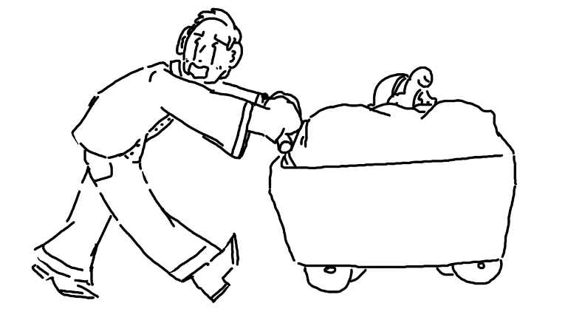
Enoki tried to orient herself so that she could see out of the linens. All she needed was a good exit sign. No, no, no, no… So many signs… Until finally...
“Wait!” she whispered, “This is my stop!”
The worker stopped, erring on the side of not asking any questions at all for any reason.
So, she jumped out, casually walking towards the exit, wondering if it wasn’t a fire exit. It wasn’t, but it wouldn’t matter – had Maple been in the area, she could have easy justified needing a fire exit. She pushed the door open, strutting as quickly as possible without losing her elegance away from the hospital.
At least until her security team outside discovered her.
It was a grand total of ten seconds before ten individuals had surrounded her, no more than a few meters away from one of her father’s limousines, highly, highly recommending that she take a ride in the limousine.
“Well… shoot,” thought Enoki.

The Rain Probably Isn’t Helping

“Oi, Maple?”
Her elbow was getting a bit cold, having been leaned against the van window for the past ten minutes. She had been staring out and watching the rain, feeling a whirlwind of things that she had trouble putting words against. What she was aware of was that, whether it was the boudin or her state of mind, her stomach wasn’t all too happy. “Yes?”
Nim was sitting there, cross-legged. “How’re you feeling?”
She laughed a bit. “Can’t you ever sit down like everyone else?”
He stopped, thinking about how to answer it.
Coralie leaned in from the row behind them, giving Maple a strange look. “Uh… How much do you know about sylphs?”
“Hold on, is that a sylph thing?”
Coralie nodded. “Of course it is, how on earth did you not know that?”
“We- “ interjected Nim, “Uh, We… There are cultural reasons why Oned Sylphs don’t sit like the Dyaithrin folk.”
Maple nodded. “I’m a wood elf though, I didn’t settle here like the humans.”
“Most of the wood elves from the nort’ don’t sit like that either,” he pointed out, “But I wouldn’t have known you were an elf unless you let me know, you carry yourself like a human.”
Maple blushed some. “Oh.. I apologize.”
“It’s fine,” he brushed off, “I know you well enough to not get mad.”
She slowly exhaled. “Look, I’m… Oui, the way I treated you right after the whole Enoki incident, that was a combination of stress and me being really, really confused. I shouldn’t have been as mad as I was at you for as long as I was.”
Nim closed one eye. “You never answered my question, did you?”
“How I’m feeling?”
“Aye.”
“Now? Guilty.”
He put out a hand. “I’m going to stop you, we can explore that a little later, aye? You looked a little sick earlier, was that guilt?”
She laughed. “No, I think it was the boudin.”
He chuckled back. “You remember that question you asked me back in the restaurant?”
“Yeah. Why’d you always cancel?”
Nim crossed his arms. “Same reason.”
“Because you ate boudin?”
He rolled his eyes.
“Because you got sick?”
Nim blushed a bit, which was impossible to hide with his unnaturally pale skin.
She smiled a bit. “I guess I’m not really sure what you’re trying to say by that. Do I make you sick? Like boudin?”
“N-No, that’s not what I’m trying to, uh, say..” He took a breath, “I mean, I like boudin, I’m happy eating it if it makes me feel sick, so..”
Maple shook her head. “You’re really mangling these analogies, but I think I get what you’re trying to say.” She smirked a bit.
“And you know who I’ve got?” exclaimed Coralie in a high-pitched voice, squeezing Goawn’s face, “THIS big boy! Who’s a big boy, huh? Is it you? Quoi ça dit, bougre?”
Goawn barked happily but didn’t make much of an effort to move much other than his tail.
“PÈRE,” said Coralie from the back, “AFTER THIS IS ALL OVER, I WANT A DOG.”
He took a moment to reply. “We’ll talk about it.”

Just for Context...

Enoki was in her scrubs, sitting in her jet plane seat. The entire private jet was essentially organized and ready for her, one suited man and two suited women as to not intimidate her too much. The seat was soft and cushy, though her scrubs contrasted extremely hard from the scenery around her.
She had been sitting there for ten minutes, crossing her arms. She just didn’t walk to talk to anybody. The others had noticed and mostly kept to themselves, occasionally chatting at the on-flight bar on the other side of the plane.
“Mademoiselle Ramirez,” asked one of the kinder-sounding women, “Would you like to try a drink at the bar to ease your anxieties?”
“I can’t,” she grumbled, “I’m too young.”
The woman paused for a moment. “You’re a Rizalanio national, the drinking age is eighteen.”
Enoki grinned.
“What is it, Mademoiselle Ramirez?”
“It’s a surprise for my parents.”
She was given a glare, hidden poorly behind a smile. “So, when is this thing taking off?”
“Oh. We’re having some issues with the pilot, and- “
“No, no… What’s really happening?”
She took a moment to think of how to word the message. “The hired pilot thought it would take longer to locate you, and so he went to a bar and was arrested for driving while being intoxicated. We went to the local police station, but the entire station was out of pens. Apparently, some boy came up to the front, asked if they had any Tieflings in jail, and then stole all of their pens.”
She nodded. “Now I see why you guys’re all worried about the flight.”
The woman took a deep breath. “I’m paid by your parents to not reply to statements like that.”
Enoki shrugged. “I don’t blame you.”

Bakery Is A Lucrative Business

The van was parked not too far off from the plane that was clearly the only private jet to take off that day. Of course – it was at a safe distance, no one should mistake them, but that safe distance included a barbed wire fence, security cameras, and a half mile’s worth of runway.
“Lefebvre, it’s your time to shine,” mumbled Delphine. “What do we do now?”
“Any of you good with computers?” he asked, turning around.
Everyone stared back at him, blankly.
“Alright, fair enough. We’re going to have to pretend like we belong on the flight, and it’s not going to be easy. We have no badges, no uniforms, no contacts, nothing. None of the current guards would even recognize me.”
“I could just make a run for it,” suggested Maple. “Guns blazing. I’m wearing a disguise and I’m poor – they wouldn’t even know it was me, and even if they did, no one would care.”
“No, that’s a bad idea,” he replied.
Maple frowned.
“How about this,” pitched Coralie, “We make a distraction so big, so unable to avoid that all the guards have to deal with it, and then we run in and deal with the plane?”
Her father thought about it for a moment. “What sort of distraction are you thinking? I don’t want any unnecessarily legal trouble coming from this.”
“Do you have any contacts?” asked Delphine. “Any at all?”
“Well… I might have one.”

…

“Yes, this is the Ramirez. What sort of order are you asking us to authorize again?”
Coralie was on the other end. “We’re with Lovlies’ Bakery, and we got an order from one Enoki Ramirez to deliver two wedding-sized cakes to her hospital room. We received notice that she’s checked out – would it be possible to have these delivered?”
“Uh… One moment.” He put the phone down. “Maria ordered two jumbo cakes.”
The other guard groaned. “What are we supposed to do with ‘em? Put ‘em in chilled storage?”
“That’s not a bad idea, actually.”
“I’m suspicious… You know Maria.”
“Yeah. She’s a pain in the butt.”
“I think we should have a word with her.”
He put the phone to his ear. “We’re going to have a word with Mademoiselle Ramirez and get back with you. Once we’re verified, we’ll get back with you.”
“Oh- Before I forget, remember, the flavors are Maple Bacon and Pumpker-Nim-cle. Not pumpernickel, there is a distinction. She’ll get upset if you tell her the wrong thing.”
“Al…right.” He handed the phone off. “Hold this. I’ll climb up and have a word.”
The guard climbed up into the body of the plane, where he saw Enoki with her back to everyone else, crossing her arms. He walked up, standing at attention. “Mademoiselle Ramirez, we need your authorization for a delivery.”
“Hm?” she asked, turning around, confused.
“It’s from a ‘Lovelies Bakery’. A Maple Bacon and Pumpernickel wedding cake. They say you ordered them at the hospital.”
She thought for a moment. “Oh… Yeah, yeah, those are mine.” Realizing she looked excited, she immediately frowned, turning around. “But I’m still mad at all you guys.”
He groaned. “I’m just doing my job, ma’am,” turning around and leaving the plane. “Spoiled rich brat,” he thought.
After fifteen minutes of tense waiting, the pilot or any valid pilot for that matter hadn’t shown up. The guards on the outside were getting a little impatient, worried about what the Ramirez family back in Rizalanio would be thinking.
But at least there was some development. A happy bakery truck appeared, making its way through the barbed wire fence gate and down towards the private jet. One of the guards decided to go check it out and deliver the cakes into cold storage, taking a firearm and a domineering stance with him.
Coralie was driving the vehicle, wearing a cute paper hat, white blouse, and decorative apron. She rolled down the window to speak to the agent, a smile on her face.
“So,” asked the guard, “You’re the deliverers from the bakery?”
“That we are!”
He thought for a moment. “Forgive me for asking, but… you’re a Tiefling. Why would Tieflings go into bakery? Don’t Tieflings hate sugar?”
“Well,” she said with a forced giggle, “There’s a lot of money in the bakery business, you know. It’s crazy! In fact, I probably make more money that you do as a security guard.”
“Really?”
“Yeah! You should consider quitting your job and joining us.”
“…”
“…”
“…”
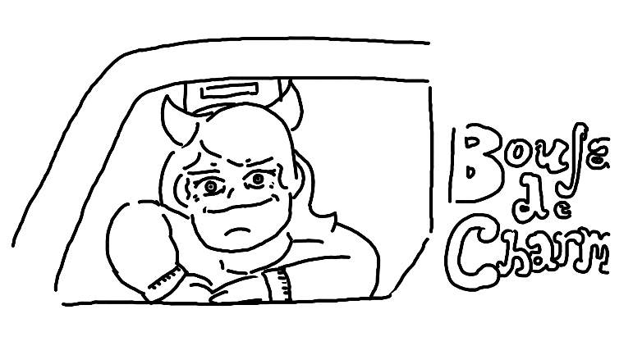
“…Get in the van.”
The van drove down to the jet, and the back opened. Coralie and Delphine got out and went around back, grabbing dollies to help carry the roughly people-sized cakes. The guard got out too, immediately handing his firearm and badge to the next guard.
“Jacques, what are you doing?”
“It’s over,” he replied, “It’s over! Man, you should’ve heard how much they’re paying me – I’ve always wanted to be a baker, and this is my opportunity. Have a good life, Sam.”
“B-But, wait, what?”
He slipped back into the van. “This is my life now, Sam. I hope to see you again one day.”
Sam looked to Coralie and Delphine.
“What can I say?” said Coralie, “We make really good cakes. Do you want to try some?”
“No, I… I think I’m good,” he said, mildly disturbed.
They loaded the cakes into the plane, storing them in a large freezer near the back. It was full of beverages, fine meats, and other assorted delectable. It was a tight fit to be sure, but it was a successful fit, nonetheless.
“Alright, how much’ll it be?” asked one of the guards.
“Together? Approximately one-thousand.”
He laughed. “One-thousand?”
“Look, I had to deprive two different couples from their wedding cakes just to make Mademoiselle Ramirez happy. Besides, doesn’t this family burn money like this all the time?”
“…They do…”
“Excellent.” She produced a notepad. “If you could just sign here, we’ll be perfect!”
Suddenly, another passenger boarded the plane. He looked a little rough, but his uniform suggested that, yeah, this was a pilot. “Hey… I’m sorry I was late, they had to import pens from the fire department. The police department was all out of pens. They say some random kid stole them all?”
“Finally, we were getting super impatient.”
“Ex-squeeze me, boys,” said Coralie, getting out, “Oh- and enjoy your cakes, Miss Enoki!”
Enoki turned around, immediately noticing that she called her ‘Enoki’. “Oh, I- bye!! I will!”
“Enoki?” asked the pilot, “Who’s Enoki?”
“That’s, uh.. What I ordered the cakes under,” she answered, standing up, “I wanted to be inconspicuous, y’know?”
“Why are you wearing scrubs?”
“You don’t want to know,” whispered one of the guards, “It’s a long story.”
“Right… Well, let’s go ahead and make this flight, shall we?”

Well, This Is Crate

Maple definitely did not like being a cake. It was dark, cramped, and difficult to breathe. There was probably enough oxygen in there to keep her alive for a little while, but she was just about ready to burst out and kill something.
But she waited.
And waited.
The floor began to rumble a bit. The plane must be on its way to takeoff…
In an instant, she poked a hole through the cardboard and cake with a fiery finger, blowing on it to keep smoke from backing up into her cavity. Light and air shone through. She was facing towards some crates of food, and it wasn’t terribly bright, so she figured she could probably slip out a bit and get a better view of the room.
Taking a fiery flat hand and slicing her way through the cake, she slipped out, getting more cake in her hair and on her clothes than she was comfortable with.
“Nim?” she hissed, trying to put the fire on the edges of the cake out.
Cleanly and swiftly, he cut through the cake, extending an arm towards hers. A gust of wind from seemingly nowhere swept past her fire and put it out.
She blinked. “You’ve got no cake on you.”
“Aye,” he replied.
“Lucky,” she groaned, “We’re in… a cooler, how do we get out?”
“I can burn my way out, but it’s going to get really hot in here – aren’t these walls made of metal?”
“I’ll cool it down.”
“Thanks.”
She knelt down next to the door, rubbing her hands together as they began to glow. Putting a concerted effort into it, she began to push into the steel as if it were clay. Nim closed his eyes, focusing on siphoning as much air towards the ceiling as possible, fanning the cooler air around the room. Nonetheless, it was very, very hot, and some of the hair color that Maple had used was starting to drip off her bangs.
Finally, she pushed her way through the door. Immediately in front of her was the bar, two guards and an attendant standing right there.
“WHAT THE- “ started one of the guards, pointing his gun at her.
She grabbed the barrel and twisted it to the left, causing to fire a rubber bullet towards the wall. It immediately began to ricochet, hitting him in the head and knocking him out.
In a moment, she leaped towards the other man, trying to take him down in close range, her hands fiery and ready to cause damage. “HANG ON, ENOKI!” She shouted, “I’VE GOT- “
Clink!
Maple immediately felt weak, and her hands lost their fire. She landed on the ground, her hair splatting black hair color on the floor like a wet mop. She turned her head to get a look at her ankle, and the flight attendant had slapped an anti-magical anklet around it, just like how the blind elves had done.
“Great,” she huffed, trying to get up, at least until she was handcuffed by the disgruntled guard.
Nim had finally made his way out of the room after the edges of the steel were cool enough, stumbling in and staring like a deer in the headlights. The guard pointed his rubber bullet gun at him, no words needing to be exchanged.
“Aye,” said Nim, putting his hands up, “So, as it turns out, we were in the cake.”
Enoki was almost immediately there. “MAPLE! …Nim? OY!” she clapped, “I want them to be let go! They’re guests, not attackers!”
“Miss Ramirez, with all due respect,” said the guard, “We answer to your parents first and foremost, and they have violated serious crimes against your parents’ property. We will be taking these two criminals into custody when we land.”

A Really, Really Long Flight

So, Maple and Nim were now next to each other, both handcuffed to an unoccupied shelf in the now non-functioning freezer, the anklet on Maple keeping her from doing anything about it. She picked at it as much as she could with her other foot, but it wasn’t coming off, at least not anytime soon.
“How long is the flight from here to Rizalanio?” asked Nim, whispering.
“I don’t know, but it’s… Oh… Oh no…”
“What?”
“Enoki, she… We were having a talk about it one time, and she said it was… thirty hours.”
“Thirty hours.”
“Yeah.”
He was quiet for a little while. “Surely they’re going to give us some food or let us use the water closet on board.”
“Enoki’s out there,” sighed Maple, “She’ll do her best, I know she will.”
Nim bit his lip. “I know this isn’t quite the best time to say this, but I suppose this is a good time to have that first, y’know…”
Maple couldn’t help but chuckle a little at the ridiculousness of the situation. “First actual, legitimate date?”
“Yes, yes, that.”
“Don’t you get sick on me, Nim.”
“I won’t, I’m fine.”
“Promise me.”
He nodded. “I… promise.”
“Good. So, you’re a police officer, oui?”
“I work for the university, yes.”
“Don’t be jerks like those guys outside, oui?”
He chuckled. “Right, right.”
“So,” she started, breaking out into laughing again, “I’m sorry, I just can’t get over the absurdity of this all – this, everything about this is surreal.”
“I ‘tink it’s the universe,” he replied, “We needed to finally meet up, and it was just about done with us not doing anything about it.”
“You mean you not doing anything about it?”
“Yes. Mostly me.”
“Entirely.”
“Mostly.” He cleared his throat. “With that said, I suppose I should ask, so… What hobbies do you have? Besides video games and partying.”
She laughed. “We’ve known each other for, what, two months and you don’t know these things?”
“We just played video games sometimes! I never got around to asking these kinds of questions!”
Maple thought for a moment. “Fair. I’m a little bit of a tomboy, I guess. I like driving. I play guitar sometimes.”
“Oh, really? Guitar?”
“What about it?”
“Nothing! I’d like to hear you play sometime!”
“Any suggestions?”
He shook his head. “I listen to Anglish music, you probably don’t know too many of those.”
“No, I don’t, I’m sorry.”
Nim chuckled. “And clearly you like driving, I was there when you pulled that crazy stunt with the overpass.”
Maple thought for a moment. “Right. I forgot you were there.” She chuckled. “You were chasing me, duh.”
“That car that you stole, was it a standard?”
“It was, yes.”
“I drive an automatic,” he admitted, “I have no idea how to drive a standard.”
“Oh. I could teach you sometime. Given that we’re not rotting in jail in some foreign country when this is all over. Nim, do we need to take a break from talking? Your face is turning very red, are you going to be sick?”
He shook his head. “I think I’ll be fine.”
Maple. “Boys, I swear.”
“It’s mostly you, I think,” he answered, “I mean, you’re the kind of person that makes boys like me a little queasy to talk to.”
“I don’t… get it, I guess,” she said, getting to think, quietly. “I mean, with how poisonous I am to everything, you’d think that everyone would learn by now.” She let out a breath, quietly. “If I’m going to be honest, it’s probably for the best that Enoki goes back to her parents and doesn’t spend any more time around me.”
“What do you mean?”
“Nothing.”
Nim gave her a completely flat facial expression. “We’re going to be chained to a shelf for a day and a half. We might as well talk about these things.”
“Can we talk about your hobbies, first?”
“Sure. I like baseball, I was in boy scouts growing up, and I’m a big fan of calligraphy.”
“Calligraphy?”
“You ever seen Oned Sylph calligraphy? I’ll have to show you some time, it looks good with poetry – but now that we’re done, let’s talk about what on earth you were talking about earlier.”
She sat quietly for a moment. “You don’t want to hear it.”
“Yes, I do!”
“No, no you don’t, because you’ll hate me.”
“Try me.”
She took a deep breath, resolving herself to her fate. “Alright. So here is a little about who I am.”

Maple Tremblay

“My older brother Aaron was abandoned by his parents at some point. I don’t know when – he doesn’t talk about them very often. And he doesn’t know how they ended up with me, but it can’t be for any good reason, but he left before I was old enough to remember anything. He was seven, and I was only a toddler. I remember a little of those days – he’d beg on the street for money, and then we’d go and look for loose change. I had little fingers and could grab quarters out of grates and underneath newspaper dispensers. There was a bakery that would sometimes let us have warm baguettes, and we would always be free to have the cold jambalaya and beans that the local restaurants would throw out. One time, one of the restaurants offered to let us stay in the kitchen to sleep. I remember it being magical… it was the first time I ever slept in a room like that. It was too quiet; I had trouble sleeping. It didn’t happen again, though – my older brother overheard them talking about splitting us up, that I must have been an elf and needed to go up to Phillipa with the other wood elves, and so he snuck us out in the middle of the night.”
“Things did change a little later. I was seven, he was twelve, and he got a job at a local restaurant. He worked under the strict condition that I would not be sent anywhere else, and after months and months of working, he was able to buy a car. He kept working there, and we’d sleep in the car. I went to school regularly, I went in a bit late, I started kindergarten at six, but I went. Aaron had been trying to teach me to read – he had a late start too, but he worked hard. I skipped fifth grade and went straight to sixth, which was nice.”
“Aaron was almost so… well, I can’t say enough nice things. I mean, for someone who dropped out of school at twelve and worked his tail off for me, you’ve got to give him some respect, oui? Things… dropped off in junior high. I lost a lot of close friends that year, and he was there, but I blamed him for it. I made the objectively right decision, and it looked like it backfired and made me lose all my friends, so I was mad at him. Really mad. I wanted to have a normal life, but I also didn’t want him to have to keep working just for me, so, I… I… well, I put myself in the system. I stayed with a foster family for a few years. They were cool and all – I didn’t really connect very well. My foster parents were great. I wish I kept in touch. Their other daughter was a pain in the neck. I left when I was seventeen, got a job, and lived on my own. I really, really started missing Aaron, though, but… no, I… I just couldn’t talk to him. I’d done way too much, you know? So, I started dating some meathead and let him move in; he was looking for a place, too. But you know what? Aaron reached out to me. He found out where I was and gave me a phone call, so I went and met up with him. There were tears. It was awkward, and… he was heartbroken, but he wouldn’t show it. But we kept meeting. I broke up with Paul - the meathead - and I moved everything into his apartment, and we tried to patch things up. He brought up the scholarship to go to the university, how I could get this amazing job and really make something of myself. And, I didn’t want to go, but I felt so guilty that I couldn’t say no. And I don’t really think I fit the whole time, I’m just not good enough for this kind of stuff, because I’m a dumpster fire of a person who hurts everyone around me and can’t take anything seriously.”
“And you know, it figures that Enoki was the person that I was roommates with. I literally can’t think of a more exact opposite, and you know? I think… she annoyed me so much because she’s the kind of person I wish I could be, but I’m never going to be. I wish I could just be a kid again, for once. Where I could be around Aaron without hating myself or feeling like I need to deserve it.”
“So, you know what I did when I realized I couldn’t salvage this semester? I ran away. Enoki had her own reasons, and I had mine. I wanted to… I don’t know, pay off Aaron or something for the time I wasted and let him move onto something else. Or someone else. He’s been in and out of relationships, but they’ve never lasted. He probably hates himself just as much as I do. He’s probably looking for me right now. I hope he’s given up. I hope he gets his high school diploma and moves on with his life, and I hope I rot in some prison in Rizalanio for the rest of my life. And you know what? I don’t blame you if you hate me, too.”

The rest of the flight

“Your dinner, Mademoiselle Ramirez,” said the flight attendant, placing a silver dish before her. She pulled open the lid to reveal a delicious set of Adobo chicken prepared with soy sauce and Lumpia spring rolls. “We apologize for the lateness. Would you like some tea to go along with it?”
“I know they’re prisoners, but…” sighed Enoki, “But… may I go give ‘em their dinner? I just wanna see ‘em for a bit; they’re my friends.”
She thought for a moment. “I don’t see the harm in that. We’ve warmed up rice for them, you may take it to them.”
Enoki grinned, standing up. She raced to the back, grabbed the tray, and peeked her head through the burned hole and into the freezer. “Beep-boop, you both in there?”
Although their hands were tied to the bottom rung of a shelf, Maple and Nim were passionately kissing. Enoki exhaled loudly, and the two slowly and sleepily stopped.
“Enoki!” chirped Maple with a smile, “It’s so good to see you again! You have no idea.”
“Yeah,” she replied with a smile, “Maple… are you actually smiling?”
“We need to get back to the Laurentides,” she whispered. “As fast as possible. We met some other folks, and Delphine- “
“Miss Ramirez, no speaking to the prisoners is permitted,” barked a guard.
She nodded, setting the trays on the inside of the door. “The, er, guard will let you go for a bit to eat, please behave, bon?”
“Bon,” replied Maple.
“Oy, Enoki,” said Nim.
Enoki grinned. “See? What did I tell you?”
“Excuse me?” asked Maple.
“Oh, nothing,” mumbled Nim. “Let’s eat.”

Plans Change with Half A Team

The airport security guard didn’t have all too much to do – stare at some screen for hours at a time, read books, get paid a decent amount. No one bothered her, and nothing happened.
Well, until she got a knock on the door.
She stretched and got up, opening the door in the back. A twenty-something year old Tiefling stood there in a decently-fitting uniform that was just slightly large on her. A morbidly obese dire wolf stood, or more accurately bobbled, off to the side, his wall-eyed stare pointed nowhere in particular.
“And who might you be?” she asked.
“Oh, right,” she replied. “I’m the new security intern. This was the uniform they had on hand, so my badge isn’t quite in yet.”
“Oh… I didn’t know we were doing that.”
“It’s a new thing. We also finally have a real dire wolf!”
The guard squinted at Goawn. “If you wanna call it that.”
Goawn barked his approval.
She shrugged. “I don’t pay attention anyway. Have a seat, we don’t do anything interesting in here.” Then, in a huff, she returned to her seat and immediately returned to reading her book.
Coralie took a seat across from her. “So… Frank, the, uh, Sylph guard- “
“Yeah, I know Frank.”
“He said you were a magician?”
She smirked. “Yeah, what of it?”
“Well,” chuckled Coralie, pulling out a deck of cards, “I’ve always wanted to learn a trick or two, but I’ve never been able to figure any of them out.”
The woman put down her book. “Listen here, it’s cute that you want to be a magician, but what we do is really magic. You’re not going to be able to figure it out.”
“I thought some of it was just tricks of the eye?”
“I can’t tell my tricks.”
“Well… I bet I could try and do a simple trick!”
She nodded. “Try me.”
Coralie shuffled the deck badly, dropping cards a few times. Then, she tried to spread them out. “Pick a card.” The guard did so. “You know it? Good. Now, put it back into the deck.” Coralie then closed her eyes, shifting the cards around until finally, she thought it was long enough. “Alright, is it… the three of spades?”
She shook her head. “No, ma’am. Now, you wanna see a real magician do the trick?”
“Yes, please!” she chirped, handing her the cards and sitting up straight, putting her hands in her lap like a schoolgirl.
The guard shuffled the cards like an employee at a Las Vegas casino. Then, she spread the cards. “Alright, pick a card.” Coralie did so. “You got the card? Now, watch this.” The woman then began to play with the cards as if she were a dolphin playing with an inflated ball – flinging them around the air like a master. “Right, so… is this your card?”
Coralie shook her head, confused. “No, no it isn’t.”
“Oh… R-Right, how about… this one?”
“That’s not it either.”
“Are you sure?”
“Absolutely.”
She then began to get very nervous, trying other cards. “Hold on, let me try this trick on myself, I-I… I think I may have made a mistake somewhere…”
“That’s fine.” She then stood up, walking over to the phone and dialing a number. She whispered, “Alright, we’re a go. Security’s down.”
The guard, continuing the trick, stared at her in confusion. “What did you say?”
“Nothing – Goawn, c’mere, boy!”
Goawn barked.
“Wait, come back-!”
Coralie and Goawn left the room.
“Alright, sit.”
Goawn laid down by the door, an impenetrable barrier against any who would have wished to enter or exit.
“You’re such a good boy!! Now, you stay here, bien?”
“Woof!”
After running for a bit, she ended up in Terminal B. That’s where she spotted Delphine, dressed in her normal clothes, reading a magazine. They made eye contact, and Delphine smirked a bit. She was handcuffed to M. Lefebvre, who was dressed in sunglasses and a police officer’s uniform.
She wondered how long it would be before the tied-up, nearly naked officers in the janitor’s closet would take before they were found. Probably a little while, though.
Before anyone else boarded the plane, they went up to the front, M. Lefebvre flashed his badge, and they went through. The guy at the ticket check turned around, about to say something, but Delphine turned around and growled, so that seemed like enough.
In a few minutes, Coralie, her father, and Delphine had been seated at the back of the plane. They were all a bit anxious, but they had made it this far – and the seats were pretty comfortable.
“Where’s the layover, again?” asked Coralie.
“Phillipa,” replied her father.
Delphine growled. “I hate cold places.”
“We’re Tieflings,” sighed M. Lefebvre, “We understand.”
Coralie nodded. “And what are we doing there, again?”
“I have connections,” answered her father. “Just wait. It’ll be fun.”

Vous Voilà

It was hard not to stare out the window with a smile. She couldn’t dare let her parents know but being stuck in traffic was a treat. Especially the traffic of Vibora, Rizalanio’s capital city. The thirty-hour flight had been a nightmare but being able to see the lazy early afternoon sun over the magical city warmed her heart.
“Don’t go to sleep,” said the limousine driver in fairly good French, “I know it’s night for you, but you won’t be able to make it through the day if you sleep.”
“Y’know,” she said, “It’s twelve hours apart? So, it’s the same time back home, but the AM and PM are different.”
No reply. Nobody cared – they weren’t being paid enough to care.
She had gotten tired and changed back into her velvet dress during the flight. She had kept her Rizalanio sun brooch hidden in her hair band, just in case, but she decided to put it back on. She debated taking it back off right before she got home.
The drive took them out of the city and into a more rural area. It wasn’t long before they came across a small city, or at least, it looked like one – it was a massive mansion complex that spread out like a palace, comprised of dozens of buildings with manicured lawns and high, stone walls. She smiled, hit with a rush of nostalgia from the glimpses she had of the place as a little girl. She forgot about why she was here and just tried to enjoy being here again.
She wanted to love this place. With everything in her, she wanted to love this place. But she told herself no – she couldn’t.
“Your parents will be there to greet you,” she was told, “Just go through the front door and they should be there.”
Her stomach was so in knots that she felt nauseous, but she knew what she needed to do. She needed to get them to work out the situation with Nim and Maple, who she was told were still stuck in the airport security. She needed to tell them that she couldn’t stand for this behavior anymore – she was an adult; she could handle life on her own. And she didn’t need them. She barely knew them. They didn’t even know she spoke their language until yesterday. Any feelings otherwise she desperately tried to shove in a container that was a bit too small.
They pulled up. She expected not to see anyone until she went inside, but as she glanced out the window, there they were – both of them, her mother and her father, smiling just a bit.
She was confused, and actually a bit scared.
Her father opened the door for her. She forgot she was wearing the brooch and crept up to the exit.
“Mais la,” her father said with a smile and in very poor French, “Vous voilà!” You’re here!
She didn’t realize she was crying until she caught herself unable to speak.

…
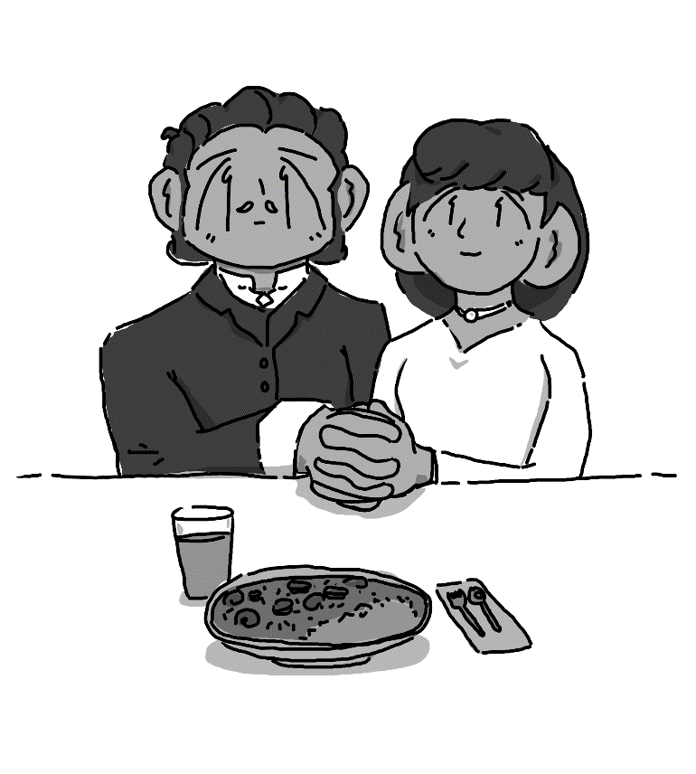

They sat close at the end of a long table. At first, she was a bit surprised when they put a bowl of gumbo in front of her, but she tried it. It was alright – it wasn’t as good as some of the local restaurants in Charlottesville, but better than the university cafeteria.
“How long have you been able to speak Rizoy?” asked her mother in perfect French.

“A few years,” she admitted, “I wanted to learn.”
“And you pretended like you didn’t know any?”
“Yes.”
Her father laughed. “We’re so much alike.”
“Maybe,” she mumbled, slowly drinking some of the gumbo.
“So,” he said, clearing his throat, “About your passport. Why didn’t you tell us that you applied for dual citizenship?”
She felt a prick in her stomach. “I don’t know who you are. I wouldn’t even be talking to you if I didn’t run away, huh?”
“What do you mean?”
“I didn’t apply for dual citizenship,” she mumbled.
“Then why are you registered as having a Laurentois passport?”
She stared at her gumbo, mumbling.
“Speak louder.”
“I revoked my Rizoy citizenship.”
Both of her parents were grave, and her mother let go of her shoulders. Enoki continued drinking her gumbo, not making eye contact.
“I see,” whispered her father, “So, you fancy yourself a Laurentois, do you?”
“Rizay-Laurentois,” she answered. “The Laurentides are my home, I don’t know any other one.”
“Dayong,” sighed her father, “I… Give me a moment.” He stood up, leaving the room, leaving her along with her mother.
Her mother looked at her with a stern face, but not quite raising her voice yet. “Maria, who do you think you are? This – here – this is your home; how dare you betray us like this? Your father – he spent fifteen years in Nippon, does he act like he’s Nipponese?”
“I spent my whole life in Carolina,” she replied. “I dream in French. All my friends have and have always been Cajun or Oned. I don’t know anyone here. I don’t know you.” Her eyes looked tired. “I see you and père in my dreams sometimes, but your faces change so much in-between visits that sometimes I forget.”
“I understand,” she replied, “You look different too, dayong.”
“I’m a grown woman, now. I’m nineteen years old. I have a life. I have a home. I wanted to be your daughter, but not like this.”
She bit her lip. “You have no love for us, or for your homeland. I see.”
“Hindi iyan totoo. That’s not true, I…” She winced. “You have no love for me, so I… don’t see what I’m doing here.”
Her mother slowly stood up. “I understand. You have two options, I see. Either we can start over, you stay home from college, or you leave the family, and we have nothing to do with you from now on, and you pay us back everything we have given you.” She slowly let air out of her nose, trying to stay calm. “If you want to be a Ramirez y Panganiban, you may return with your criminal friends, but you will have no wealth, no name, no family.”
Enoki wanted to reply, but she had started to choke up on herself.
“Well?” asked her father, returning to the room, “You have a minute to decide.”
“I-I… I…”
“Fifty seconds.”
She sat there, eating her gumbo. Forty seconds. Thirty seconds. Twenty seconds… A minute passed, and she was silent as a gravestone.
Her mother took away her bowl. “One of the home servants will lead you to your room.”

Stuck in The Airport

The airport security office was small, cramped, and not unlike the freezer from the plane. There was a guard, some cameras, and a holding cell. Maple and Nim were both in there, thoroughly worn out. There was a single bunk, and Maple was half-asleep on it, while Nim was on the other side, trying to do some exercises to keep his muscles from atrophying.
“Hey, uh, excuse me?” asked Maple, sitting up, “Do you speak French?”
The Tiefling guard looked at them in confusion.”
“Hablo español?”
He nodded. “Si.”
“Great,” she sighed, “’Cos I don’t.”
“So, uh,” chuckled Maple, “Did I tell you what happened last time I got one of these things on my ankle?”
“No, I don’t think so?”
“Enoki cut me in half and used my top half like a flamethrower,” she admitted. “She’s a magician, she can do stuff like that. You know, it’d be nice if she were back here to get us out of this cell instead of… wherever her parents want her, I don’t know.”
“I think she’s keeping us here to make it easier to get out. I mean, I don’t think another thirty-hour flight would be a very fun time.”
“Better than this,” she mused, “But you’re here.”
“No, no, don’t stop complaining,” laughed Nim, “It’s not like you, you’re scaring me.”
She closed her eyes. “Let me know if anything changes, bien?”
“Aye, I promise” he replied, wondering how the others were doing.

The Other Plane

It wasn’t visible in the horizon, which was a neat feature but wasn’t essential. A strange, black triangle zipped through the air, the city of Vibora coming up soon on the horizon.
“Alright,” shouted M. Lefebvre, “Everyone still feeling good? How about you, Monsieur de le Cruz?”
Four people stood near the back, wearing plastic clothes over their normal ones, goggles, parachute backpacks, and grins. Well, all except for their lawyer, M. de le Cruz, who was so green in the face that he looked like a cactus with facial hair.
“Coralie, you ready?”
She was holding Delphine’s hands, ready to pull her parachute cord when the time came. “Ready!”
“Alright,” began M. Lefebvre, “We’re going to go on the count of three. Three- “
He pushed the eject button.
Coralie had never been skydiving, but she absolutely adored it. That drop feeling to her was what sugar must have felt like to humans, and she just couldn’t get enough of it. On the other hand, because of the cold, Delphine froze up, so Coralie pulled her parachute before pulling her own.
The lawyer was screaming like a baby, eyes closed and arms tight around his briefcase. Everyone had their chutes pulled and was slowly drifting towards the bush.
After about a minute, they landed. A loud crashing noise echoed through the forest a distance away, which the group figured was the craft.
“S-Single use planes,” said Delphine, finally warming up enough to talk, “I l-love them.”
“Hey, if the Soviets could get to the moon with ‘em, I see no reason to not use them for travel,” said M. Lefebvre. “That’s one favor spent, thirty-something left…”
M. de la Cruz started heaving. “I’m… n-never doing that again!”
“I am,” grinned Delphine.
“It’s alright,” replied Lefebvre, clapping him on the back and making him heave harder, “We’ll be flying back first-class thanks to you. Now – off to the courthouse!”
They tossed their flight suits in the forest, and after a twenty-minute walk, were in downtown Vibora. Coralie was immediately amazed – she had never seen buildings so tall, or so much Rizoy on everything. The road in front of her was five-lines and stacked, twisting on itself like a rope. She could smell something delicious in the air, but she couldn’t quite identify what it was.
M. Lefebvre smiled. “I haven’t been here in a decade. Let’s explore downtown and get something to eat and somewhere to stay, oui? And Cruz… you’re absolutely positive that you got them to free a court case tomorrow morning?”
He nodded. “Absolutely. The Ramirez family is far too important to wait any longer than necessary.”
“Excellent.” He grinned. “I went ahead and took out far more pesos than I probably should have, so we’re going to be eating very well, tonight.”

A Little Bland, I Guess

Maple stared down at the rice, which now was her fifth bowl of rice in a row. At least it made her less hungry, and at least she wasn’t the only one – Nim had to eat it, too.
“I could kill for a shower and a change of clothes,” she sighed, taking a bite.
“Yeah,” he replied. “And maybe some seasoning.”
“What do you mean about a shower?” she laughed, “You’re a sylph, you’re clean all the time.”
“Just because I look clean, doesn’t mean I feel clean,” he sighed. “A nice, long bath would hit the spot. I haven’t had one in years, but it’d be nice.”
“At least you’re not covered in melted hair color.”
He laughed. “Look, I’ve got some on me. Now, you have it much worse.”
She was quiet for a little bit. “Do you really think I should have a talk with Aaron?”
“Maple, we’ve already had this talk.”
“Yeah, but…”
“But?”
“…”
“I know you’re nervous, but it’ll happen. When we’re out of here, obviously. Look, it can’t be any worse than what Enoki’s going through right now with her parents.”
“It’s backwards, but…”
“Still, just as awkward.”
She rested her head on his shoulder. “Bien.”

Things Escalate Very Fast

Knock, Knock, Knock.
Enoki had been sitting in her temporary room, gently petting a rabbit she had produced from her sleeve. As for the room itself, it was quaint, decorated in a classical Spanish style, with-
KNOCK, KNOCK, KNOCK.
She put the rabbit down and opened the front door. It was one of the house servants, who looked a little more anxious than he did when he led her up to the room.
After being lead downstairs, she caught her parents arguing in Rizoy. They were holding something in their hands, which Enoki couldn’t quite figure out.
“EXPLAIN THIS!” hissed her father, nearly throwing the paper at her before remembering that paper doesn’t travel like that.
“What?”
“Court Summons!” he stretched it out. “We’re being sued to the tune of twenty million dollars!”
“Isn’t that how much we make every day?”
“I’m upset on the principle,” he groaned. “I built this empire, my empire on keeping petty lawsuits like this at bay!”
Enoki scrunched her face in confusion. “I don’t know what this has to do with me, though.”
“Look at the signers! Lefebvre and that nanny you had a few years back. Del… Della…”
“Lady Delphine Thibodeaux,” finished Enoki.
“Right! Her!”
“And this one at the bottom? Maria de Ramirez Panganiban. Dayong, are you suing us? What on earth good is going to come out of this? Why do you want to destroy my reputation?”
She crossed her arms. “I… uh… I’ll stay out of your life and take the lawsuit down, but I need the twenty million. I can’t finish my degree or start a company without that much money.”
Her parents were absolutely furious but didn’t make a sound. Enoki just stood there, tense, but firm.
“Alright,” he said. “I believe I have a case for you. I don’t have time for… this… so I’ll send in my best lawyer, and I’ll win. But in case I lose, you get to go ‘home’ with twenty million dollars. If I win, you never get to come back, and you stay on the streets of Vibora until you’re deported back to your precious Laurentides. Am I clear?”
She nodded slowly, mulling this over as a pit began to grow in the pit of her stomach. “Only if you let me do something, first.”

It’s About Time

Maple and Nim were just about to die of boredom, their minds slowly turning to goo. The fluorescent bulbs weren’t getting any more inconsistent in their flickering, and the smell of socks and mold had just about given way to blissful nothingness.
And then the door opened.
Led by one guard, Enoki stepped in, beaming towards the two gracefully, her hands folded in front of her.
“ENOKI!!” shouted Maple and Nim at the same time.
She slipped a note to and exchanged with the guard, who promptly let the two out. They immediately ran over and hugged her, which she at first winced at before hugging back just as hard.
“You guys stink,” she whispered.
“Yeah, yeah, I know,” sighed Maple.
Enoki smiled at the guard. “We’re good now. I should be safe. Oh- If you wouldn’t mind taking that anklet off my friend, though.”
The guard pulled out a wicked-looking knife, leaning down and slicing her anklet completely off. Maple immediately sparked the tips of her fingers, a wicked grin filling her face.
“So, what are you guys hungry for?”
“Anything,” groaned Nim, “Literally anything but plain white rice.”
“Aw, you’re in Rizalanio and they don’t even give you good Rizoy food? That’s a shame! They got some good stuff here.”
The three of them left the airport. Enoki called a taxi, and they started to take off towards where they could find a good Laurentois restaurant – much to Nim’s disappointment, but Maple was insistent.
Enoki paid the driver in cash, and they went inside a little street corner diner. It was decorated on the inside with all sorts of Laurentois bric-a-brac – pieces from a swamp boat, maple leaves, posters from different Laurentois films, etc…
“It’s so weird, here,” mumbled Maple, “The street, it looks like I thought Mexico was supposed to look like. But it’s so… normal. And nobody speaks French – is that normal? Like, it looks almost just like home, but no one speaks French.”
She nodded. “Yeah. I’ll translate if you guys keep me alive.”
Nim gave her a thumbs-up. “Cool.”
They ordered their food, or, they ordered through Enoki, and then they sort of sat there, unsure what to do. There was so much weighing on all of their minds that they didn’t even know where to start for a long time.
“We can stay at a hotel,” said Enoki, finally breaking the silence. “Then we’ll win the court case tomorrow and go home.”
“I still don’t get why you’re so sure you’re gonna win,” sighed Maple, “Unless, of course, Lefebvre decided to fly all the way over here to- “
“GUYS!”
The three turned to the door of the restaurant, and there stood Coralie, her father, Delphine, and Cruz. Enoki squeaked like a rubber duck, immediately running and embracing Delphine as hard as she could. Coralie immediately ran over to embrace Nim and Maple at the same time, overwhelmingly happy, and M. Lefebvre and Cruz stood awkwardly in the doorway.
“Sit with us! Grab chairs!” chirped Nim, pulling two tables together.
“We were going to eat somewhere nicer,” laughed Lefebvre, “But Lady Delphine here refuses to eat anything at all except Laurentois food, and this is the only restaurant close to the airport.”
“I’m a gourmet, I have high standards,” she said under her breath.
So, the seven sat at a large table and began to catch up. Even though, yes, she knew they were expected some sort of money cut tomorrow, Enoki had never anticipated to sit at a table with so many people who cared about her – or least, she knew that Maple, Nim, and Delphine cared. That was enough. She didn’t need everyone at the table to love her. The gumbo they gave her was even worse than the gumbo she got at her parent’s house, but she didn’t care.
“Hey,” said Maple peering over, “You haven’t said much – you’ve just been smiling the whole time, so, uh, what are you thinking?”
Enoki nodded. “Nothing, nothing.”

Stuck in A Room, Planning

“And you said you signed it when you were seventeen, did you?”
Enoki nodded. “Yep.”
“Alright… That’s too young for a legally binding contract to work. I’m adding that to this case. I’ll get a draft written up to that bakery to cover their side… The most we’ll get off with the door is a fine…”
“Hey, hey, hey, c’me and my friends go to the pool? I heard this hotel’s got a pool.”
Cruz sighed. “I need to finish the paperwork so I can prepare for the case tomorrow, as soon as possible.”
Enoki frowned. “I wanna go buy a cute swimsuit with mah’ friends and go to the pool. I’ve never gone to a pool with friends.”
“Hey,” said Maple, walking up, “I get it, but we’re not here to play – we need to focus. This is a big deal.”
“I’m lucky, and I dunno what else I could do here,” she replied, blinking with both impatient and a lack of understanding. “I should be fine, oui?”
Delphine walked up to her with a sympathetic face, arms crossed. “Look, I get it – I don’t wanna be in a hotel room with six other people, but both of your parents are just as lucky as you are. There is a good chance they’re going to bribe the courtroom and the press. They don’t wanna lose face like this – not when their only daughter has the chance of making a big fool out of them and possibly endangering their empire.”
“But it’s not just me! We’ve got two lucky people here!”
Delphine scrunched her face. “…Who?”
“Maple!”
Maple laughed, confused and looking around the room to read everyone’s faces. Nim raised an eyebrow. Everyone was looking at each other, trying to figure out what exactly Enoki was implying.
“Look, Enoki, here’s the thing. Mind if we talk outside for a bit?”
“Yeah!”
Maple nodded to Enoki, and then to Nim, leading the way out into the hallway. Enoki followed, folding her hands in front of her, her head to the side a bit, like a confused puppy.
Once they were out, Maple closed the door and looked both ways, making sure no one was watching. Then, she began.
“Enoki?”
“Uh huh?”
She smiled. “I want to first, uh, apologize. I had a terrible attitude to you, and… a lot of that was me being jealous. I couldn’t tell if your, well, everything, if that was authentic or not, and I wished I were less of a soulless rock, bien? So, all that about me hating you, that’s not true.”
Enoki giggled. “You tried’a hijack my plane and went all this way to Rizalanio, I’dda think you didn’t hate me all too much.”
Maple smiled, nodding. “Yeah, but, I do have one pet peeve I want to resolve. This whole… Well… Lack of commitment to how you’re presenting yourself. I can’t decide if I’m ever supposed to take you seriously. Like back with the blind elves, oui? Didn’t we talk about this already?”
She nodded slowly, no smile.
“Good. Don’t say things like ‘oh, we’re going to win this court case because I feel cute and think I’m gonna say something nice about Maple’, bien? It’s not nice. Don’t do that, oui?”
Enoki thought for a moment, looking down. “You always seemed lucky to me.”
“What on earth are you talking about? I… Right, I haven’t told you anything. Well, I guess I’ll start. I’ve had an awful life, but you already know that, so what were you getting at, huh?”
She began touching her pointer fingers together, staring at the tips. “We’re both here, oui?”
“Yeah?”
“The daughter of the richest Rizoy and an orphaned wood elf, huh?”
“And?”
“We go to the same school and have the same friends, oui?”
“…”
“How’re our lives that much different, now?”
Maple thought for a moment. “I… guess I see what you’re saying, but I don’t think it matters. I’ve lived in a car, and how about you?”
“You have family who cares about you. I didn’t meet Delphine until I was fifteen, and then she only could stay for a few years.”
“You can buy whatever you want, though! What am I supposed to do if I’m hungry? What am I supposed to do when my scholarships run out and I can’t eat campus food or sneak fruit out, huh?”
“But why are we here? I’m stuck doing what my parents want me to, I can’t go anywhere or do anything without their permission, so I don’t have many options either.”
Maple started raising her voice. “But you can do crazy stuff, right? Like what I heard from Cruz - dropping your citizenship halfway through the semester? How on earth is a normal person supposed to do stuff like that?”
Enoki started tearing up. “I-I didn’t want to.”
“Wait, why not?”
It took her a moment for her to think about what she wanted to say. “Maple, what’re you?”
“What kind of question is that?”
“Y’know, heritage?”
She shrugged. “I don’t know, I… guess I’m a wood elf. I was raised by a human. I don’t know why I need to tell you this again, you already know this.”
“You ever wonder what life’d be like if you tried to connect with the other wood elves up in Phillipa?”
Maple thought for a moment. “Yeah, I’ve wondered. I don’t speak the language, for one. I’m not familiar with their lifestyle. Nim’s a Sylph, he’d have a better time fitting in than I would. My ears aren’t even pointy.”
Enoki smiled and nodded. “Now you know how I feel.”
“You wish you were a wood elf?”
“About this place! I…” She frowned. “All I know is the Laurentides, I don’t know this place, I don’t know my parents. Look, I wanna be proud of this place. I want to be a real Rizay, you know? But I can’t. I haven’t spent, like, any time here at all.” She crossed her arms. “Everything I learned about this place I learned from a book or from a teacher. I don’t even speak Rizoy without a French accent.” She frowned. “So, who does that make me?”
“Maria?”
She raised her eyes a bit. “Yeah?”
“Why do you call yourself Enoki again?”
“One of my nannies, she was Nipponese, she said I was tall and thin like an enoki mushroom, and I like mushrooms, so it stuck.” She poked herself in the belly. “Not thin anymore, I’m a little tubbier, now, so I’m Button?”
“Button?”
“It’s a kinda mushroom.”
She shook her head. “Look. We’ve both had a lot of trash to deal with, bien? And- getting back to the point, if I’m lucky, then what on earth does being lucky mean, then? Doesn’t that suggest that everyone is lucky?”
Enoki grinned. “It’s like magicians. Are we real magic? Are we fake magic? Maybe both? Nobody knows!”
Maple rolled her eyes. “This is why magicians frustrate me.”
“So… If we don’t wanna leave the hotel,” She tagged Maple. “Last one to the pool’s gotta pay a fine!!”
“Wait, are you going in your dress??”
“Uh huh!”
“Wait- NO!”

I’m Sorry, I Have to Write This

Maple chased Enoki down the hallway and into the stairwell. She was a bit shocked and out of breath – this girl in a thick, velvet dress was outrunning her, no matter how little that made sense.
“Hey! STOP! That’ll take forever to dry!”
Enoki ignored her all the way, continuing to run, even after Maple had given up catching her breath. She kept trying though, and finally, she was off in the pool area.
Right as she entered, Enoki was right there at the edge of the pool, towards the deep end side. She jumped right in, dropping like a stone. Maple ran up to the edge, peering in. It was only a few moments, but she started to flail around.
So Maple waited at the edge for her to stop.
But she didn’t, at least not for a while.
There was a family on the other side of the pool who was watching the two with some degree of fear, with this poor girl drowning in the pool and a foreigner crouching at the edge, watching her.
“Stop flailing, stop flailing…”
At some point, Enoki gave up, in which Maple immediately dove in, grabbed her, and pulled her up to the surface. Enoki gasped for air, frantically grabbing at the side of the pool, while Maple folded her arms on the side, squinting her eyes.
“You dumb-butt, what were you thinking?”
“I… thought…” Gasp, gasp. “It would be fun…”
“How much does that weigh?”
“…A lot…”
Maple climbed out. “And how long do suppose that’s going to take to dry?”
“A… long time…”
“And you think it might be ruined by tomorrow?”
“Uh-huh! That may or may not have been the plan, so now we could go to the store and maybe buy swimsuits and hang out in the pool- “
“Enoki! Gosh, what the heck?”
Nim entered the room, looking down at the two in the pool in confusion. Maple couldn’t help but think his confused face was absolutely hilarious compared to the chaos that just ensued and found herself trying to stifle laughter to no avail.
“Oy,” he started, “We’re going to the store to pick up some toiletries and a change of clothes, would either of ye care to join us?”
Maple looked over at Enoki and kept laughing, as her face was partly confused and partly excited. “Seriously,” she said, climbing out, “Just wait ten seconds for things to happen, bien?”

…

As everyone was headed off to sleep, Maple found herself back down at the pool smoking a clope. She let her feet hang in the water, staring up at the towel rack, wondering how tomorrow was going to go. Enoki would be fine though, she knew that for sure. Anything she touched went well, confused identity or not.
“Hey, Maple?”
Maple cringed just as hard as she did any time she heard that familiar chirp. “What?”
“I’m nervous about tomorrow.”
She chuckled. “If you’re worried about tomorrow, then I guess I have no reason to feel safe about anything, huh?”
“No, I mean…” She was wearing her pajamas, so she grabbed a towel and laid it out, sitting atop, “Y’know. I’m scared.”
“Well stop it, bien?”
“I don’t wanna stop it.”
“That’s not how life works, Enoki. It might be for you, but it’s not for anyone else, alright? You just have to… go with it.”
“Like with you and your brother?”
Maple’s eyes narrowed. “You don’t know anything about my brother.”
Enoki lifted her hands. “You just kept talking about ‘Aaron’ all the time and I wanted to ask Nim cos, you know, you’re going steady, I thought he’d know.”
“Ah… Right, then.”
“What’s your background, then?”
Maple huffed from her clope, considering pulling a new one from the package. “My older brother and I were homeless for a long time, and he thought the world of me, and I treated him like trash. I promised I’d do better on my schoolwork to make him proud, but I failed my classes and would rather run away with my least favorite person on the planet than face him.”
Enoki giggled. “But we’re friends now!”
“Probably. Look, can I be honest?”
“Yeah!”
“We’re probably not going to be friends for long after this whole incident. I know you’re just in this because you’re confused and have the resources to pull this off, and I’m just in this because I’m desperate, but when it comes down to it, we’re just different kinds of people. Everyone wants to be you; nobody wants to be me.”
“That’s not true!”
Maple chuckled. “No. You just want this moment because you’ve got this perfect life in your head, right? You want the scrappy token side friend so you don’t look like such a self-focused rich kid. It’s not your fault. But I can’t be here, alright? I can’t be that for you. You don’t know who I am. I couldn’t tell you who I was because you wouldn’t care long enough to listen.”
She crossed her arms. “Yes, I would!”
“No, you’d go wall-eyed, get distracted, and start running off to who-knows-where, probably winning the lottery along the way.”
Enoki went very quiet.
“What?”
“I- “
“Spit it out.”
“I… mean, well, you’re special to us, Maple. You’re special to me, and Nim, and Aaron- “
“You’re a child, Enoki.” She put out her clope in the pool water. “We’ll see how well that luck works out for you tomorrow, bien? I need some alone time to process.”
Enoki sat there, nothing to say, as Maple got up. She left the room, disappeared into an elevator, and intentionally chose the wrong floor. She’d wait a few minutes for Enoki to get off her trail, sneak back into the room, and get some rest to herself.

Obligatory Dream Sequence

Maple woke up in a dream as a ten-year-old girl again, asleep in the passenger’s side seat of her and Aaron’s car. She had a blanket on and was staring at the window mechanism, shivering a bit but used to it as this point. She liked to keep one of her fingers on fire and then wrapped up in her other hand, just enough to keep her warm but not enough to set anything on fire.
She turned over and saw Aaron asleep as he always used to be, a wool blanket pulled up to his chin behind the steering wheel. The car was pulled into the parking lot of a shopping center, far away enough from the building that no one would car. She watched him innocently, wondering what he was dreaming about.
He yawned a bit, peeking his eyes open. “Hey, Maple?”
“Hm?”
“Go to sleep.”
She yawned. “I can’t.”
“What’s on your mind?”
“Nothing.”
“You sure? I know you too well, you look like something’s on your mind.”
“I don’t wanna keep you up.”
He snorted. “I’m not sleeping until you’re sleeping, you know that well enough.”
Maple thought over her words for a bit. “I don’t know what to do about Enoki.”
Aaron nodded. “What about her?”
“I’m just jealous. I wish I had nice things like her. And she doesn’t deserve it. But I want friends.”
“Hey, Maple?”
“Yeah?”
“Why do you think I give you everything that I give you? Do you think you deserve it?”
Maple thought long and hard. “No.”
“So why do I?”
“I don’t know.”
He laughed a bit. “Because I love you.”
She was quiet. “So, the universe just loves her more than it loves me?”
“No, that’s not what I’m saying-“
“It sure sounds like it.”
He sighed.
“I’m scared.”
“I get that.”
She stayed quiet for a few moments, thinking to herself about her day and what she wanted to do with it. She could feel the innocence draining from her heart like fluid from an air conditioner.
“It’s really hard to love people when you have a lot of money,” he said, “but it’s not impossible. She’s just as scared and lonely as you are. It doesn’t matter where you’ve come from or who you are – people are more important than that, oui?”
“…”
“You can’t argue with me either because I’m not the real Aaron, I’m just a figment of your subconscious.”
She frowned. “Great. You ruined the moment.”
“No, you ruined the moment.”
“ARG!” she rolled over, “Just go back to sleep so I can wake up and deal with that stupid court case.”
He laughed. “Alright. Oh, by the way. I miss you.”
“No, you don’t, you don’t want me back.”
“How come?”
“Because I’ve treated you like garbage our whole lives? You’ve got absolutely no reason to trust me.”
He rolled his eyes. “Since when has me caring about you had anything to do with trusting you? You’re my sister, that’s not changing.”
She was quiet and her eyes were damp.
“Aren’t you my sister no matter what or something like that? Didn’t you put that in your letter?”
“Yeah…”
“Goodnight, Maple.”
“Goodnight.”

The Day of Reckoning

It was finally the day of reckoning. It had been a day of quick breakfast/lunch at a small café across the street, courtroom practice in the hotel room, and waiting in the courthouse lobby for the other cases to pass through. It was M. Cruz’s opinion that an early seat would be best – and surely enough it was, just about all the booths open.
Of course, Enoki’s parents were there, too.
Maple couldn’t help but stare a bit. M. Ramirez was especially surreal. Looking at him was looking at an older, male version of Enoki - a much angrier, much more frustrated one at that. His eyes wouldn’t seem to leave M. Lefebvre’s, though, a detail that Maple could only begin to ponder.
“Well,” whispered Enoki, “This is it, isn’t it?”
“Hm?”
“I guess I’m not gonna be the same person after this, am I?”
“We’ll see.”
M. Cruz went up to his spot, gesturing for Enoki to join him in a way that suggested they had practiced this many times, which they had. She remembered and went up to the booth.
Nim poked Maple’s hand. “Hey, you.”
She smiled, taking his. “Bonjour.”
“Relax.”
“Fine.”
The moment an audience was allowed into the room, they flooded in. Dozens of news reporters, rich elite, the whole nine yards. Cruz visibly winced, but he kept his hands on his notes.
The judge said something in Spanish that Maple couldn’t quite make out, but everyone rose, so she did to. Oh, she realized, I’m probably not going to understand any of this.
The procedures went on for about fifteen minutes in Spanish. The Ramirez’ lawyer would shout, then Cruz would shout, and on and on. Maple tried to at least read the facial expressions, but both Enoki and her parents were so even-tempered through the whole case that she had no idea where to even begin.
Or, at least she did until Delphine was called up as a defendant.
“Your honor,” she began, almost immediately interrupted by a court translator. “I would like to just-…“ Once again, an interruption. “All I’d like to say-… Hey, could you please wait for me to be done before- I didn’t want that translated, that was for, I- Your honor, may Mademoiselle Ramirez- May she translate instead?”
The judge approved.
Delphine gave a huge sigh of relief. “And Enoki, so help me, if you the same thing-… Seriously, stop.”
Enoki giggled, nodded.
“Your honor, I can confirm that I nannied for Mademoiselle Maria Ramirez from April 3rd, 1992 to December 12th, 1994. I acted as her sole legal guardian and was expected to act as her physical and emotional support. I was compensated and given a budget. During this period, no physical contact ever came between M. and Mme. Ramirez and Maria. This is, in fact, the first time we have ever met in-person.”
“Who is her current caregiver?” asked the judge.
Delphine blinked a few times. “Excuse me?”
“Who is her caregiver?”
“…She’s nineteen years old.”
“Oh, right, of course, it’s easy to forget.”
Enoki frowned somewhat.
Maple groaned, leaning into Nim to whisper. “She’s older than me, you know.”
“She what?”
“Yeah, she’s nineteen.”
“Wait… How old are you?”
Maple gave him a certain look. “Eighteen.”
“Oh.”
“How old did you think I was?”
He winced. “Twenty?”
Coralie jabbed Nim with her elbow and shushed him, glaring at both.
The judge inexplicably sent Delphine back to the booth, and then continued to speak in Spanish with her parents. Maple watched, trying to meter what was going on through Enoki’s facial expressions. She seemed to be incredibly neutral. Her eyes always looked sad, so when she wasn’t smiling, Maple had no idea how she really felt.
It went on for another hour. The jury was getting restless, but Maple was getting close to being angry. There was a lot of indecipherable anger shouted around, mostly between the lawyers.
To be honest with herself, she wasn’t sure what to make of it all. It was a little surreal, the whole situation – reflecting on it, it felt like a month ago that she had been ready to pack up and move back in with Aaron.
It may as well have been a year.
Cruz slammed his hands on his desk. “You know what?!” he exclaimed in French, “If we’re going to play that way, then that is what we’re going to do – Fine, maybe you’re going to ignore all of my hard evidence. Maybe you’re going to ignore all these sound, reasonable arguments because you’re too busy lining your pockets with dirty money and patting yourselves on the back, but do you know what? You know what? I’m done. Fine. If you want to have her, then I’m not paid enough for this. Heck, when can I get some of that cash that the jury’s going to get, huh?” Then, he turned to M. Lefebvre. “Getting here? Yeah, that was bad enough. I’m not a good enough lawyer to logic my way out of people who won’t listen.” Then, he turned an exasperated look to her parents. “And you? You take your six-year-old daughter back to her crib, and you put the rest of them in prison, and I’ll be at home with a bottle of tequila forgetting that this ever happened. Adios.” And with that, he left the courtroom.
No one knew what to do for about thirty seconds.
The judge hit his gavel, and everyone stood up, except for Enoki, who was trying to hide her face from everyone.
“Hey… Enoki?” asked Maple, walking up to her.
She ran past her, holding her face in her hands.

Where Do We Go from Here?

It was difficult to pass through all the people – it was claustrophobic, like being shoved into a tube sock and being unable to breathe. She tried to stay calm so no one would try to restrain her, her hands over her eyes, and she jumped every time one of them stood a little too close. She expected a hand to stop her.
In the hallway, more journalists and people waiting on their case sat, making the environment stuffy but not quite impenetrable. They immediately looked when they saw her, but no one stopped her as she walked back and down a hallway.
The quieter and quieter it became, the easier it was for her to think, but she wasn’t quite ready to think. It was too bright. Another hallway, another turn, and she caught a janitor walking away from a closet, the door not quite closed. Lucky enough. So she opened it up, climbed in, and closed the door.
There were probably security cameras. There had to have been. There were probably people following her, not that she was listening closely enough to notice.
She took her time, found a janitor’s closet to crawl into, and cried again. She wasn’t loud – she didn’t have to be. All she wanted was for the ‘alright’ feeling to kick in again so she could make a good decision.
But… who was she kidding? She hadn’t made a good decision in her entire life, had she? She had made a lot of almost good decisions. Getting attached to each one of her nannies before they were replaced. Finally choosing a roommate that treated her like a real person. Taking a road trip and living like everyone else. And all the good things behind them had to have been taken before she really had a chance to enjoy or even let them flavor her life. The only thing she had going for herself – luck – wasn’t even relevant. Her parents had twice as much, and they weren’t budging.
She guessed that it didn’t even really matter what she had done. Getting a new citizenship. Having a friendly talk with her parents. Bringing all these people with power and personal connections to do something about it. Everything in there was a joke – her parents must have paid everyone in there. They were probably paying off the journalists, anyway. It didn’t matter if the lawsuit was last minute and instant, they had the resources to-
Knock, Knock, Knock.
“…”
The door opened. It was her parents. She glared at them, eyes wet, trying to burn through them.
“Maria,” said her father, kneeling down, “Maybe we should have another talk, just us, bien?”
She couldn’t talk even if she wanted to.
“I didn’t want it to have to be like this. I didn’t want this lawsuit. Please understand you put us in an awkward situation – we can’t lose this case, or it would put the family reputation in jeopardy. Just… let us win, and be kind about it, would you? Then we can work something else out, but a lawsuit is the wrong decision. It will make us all look bad.”
“B-Bantay-salakayis.”
Her father’s face tightened.
She looked up to him in as much seriousness as her face could produce. “S-So that’s all I am to y-you? I l-look good, right?”
“I’m unsure what you’re saying.”
“Y-You know the family blessing? T-That we’re always lucky?”
“Of course.”
She sniffed. “It’s a lie, and I-I don’t wanna be a Ramirez anymore…” She stood up. “I wanna k-know this place, and know you, you know? B-But it’s too late, I’m n-not your daughter anymore, I could have been but now I-I’m someone else.”
“Maria- “
“Enoki,” she corrected, “I’m Enoki. I d-don’t know who ‘Maria’ is, bien? M-My passport says ‘Enoki’ on it, doesn’t it?”
“It sounds like you don’t even want to give us a chanc- “
Enoki’s tears had mostly dried up. “I am almost twenty years old! I’m as old as you were when you both were married, right? Am I right?”
“Yes.”
“L-Let me go. Please. Please let me and my friends go home, already.”
“You know we can’t do that immediately; we have to keep face for- “
“Well, you’ve got a bête face.”
He frowned. “We have the same face.”
“Then I have a bête face, too! We all have bête faces, and I wish I had a different face, bien? You take me home and I’m gonna… I’ll… I… I don’t know what I’ll do, but I’ll do something.”
“HEY!” shouted a voice behind her parents.
They turned around.
Maple was standing there, hands flaming at the tips, but her eyes were fierier. “You,” she said, “You let her go, bien?”
Her parents turned around, Enoki’s mother looking down the hallway. Maple turned, and caught a bodyguard with a rifle, pointed up and directly at her.
Maple smirked. “What, do you think a gun is going to scare me?” Her hands began to flare up a bit more. “I melt guns. You’re going to let Enoki free to go back with us right now, or you’re going to be really difficult to clean out of the carpet, am I clear?”
Enoki jumped up. “Maple, I-I’ve got this.”
“This is your friend?” asked her father.
Enoki nodded.
“And if what if we rewarded her? You look poor,” he commented, turning to her. “What if we paid you, say, one million Laurentois dollars, you and your friends? Surely your friend, ah… Enoki here would prefer to have you be well off, oui? Then we can settle this?”
“With all due respect,” she replied, “I’ve lived on garbage; I’m not selling out my friend for a million dollars.”
He smiled. “Noble. Return to the courtroom, we’ll be there shortly.”
“No!” shouted Maple, “I’m here.”
The bodyguard kept his rifle lifted.
“Put that down!” shouted Maple, “I’m not doing anything!”
“HEY!” shouted Nim from across the hallway, “WHAT AR- “
“STAY BACK!” shouted Maple.
Another bodyguard came up from behind, trying to snap Maple’s hands into handcuffs. She turned around, and in a bout of fury, melted part of the handcuffs.
The next few minutes flew by as if they lasted a hundred years.
BANG!
Enoki jumped out from the closet and past her parents, so hard that she hit her head against the wall and collapsed, curled up. It was only a moment before everyone realized that the first bodyguard had fired towards Maple, and Maple wasn’t hit.
The bullet was in Enoki.
Everyone was quiet, while Maple’s skin began to literally glow with licks of flames. She slowly and smoothly turned to Enoki’s parents, licking her teeth. “I’m going to burn this entire building down.”
“You wouldn’t- “
Maple screamed. Flames leapt out of her, lapping up and against the hallway. They licked towards her parents, who had begun to run like scared insects, desperately beating out their burning clothes and hair. Maple couldn’t put her arms down, screaming as she sparked in flame.
And then, she nearly collapsed too. The walls burning around her, she knelt to Enoki, shoving her head into her shoulder, no tears coming, just a dull, numb feeling.
“Maple…” whispered Enoki, “I-I swallowed the bullet…”
Maple snapped up, confused.
She got up, not a single bullet wound. If it weren’t for the horrible look on her face, she would seem completely fine.
“Did you-?”
Enoki nodded. “I swallowed it.”
“You… Swallowed it?”
A vicious storm of wind blew through the hallway. Maple got knocked over onto her back, grabbing onto the carpeting with her fingernails. The winds kept blowing, though, preventing her from getting a good look at what exactly was causing them.
Then, with a snap, the fire alarms turned on. Water started spraying from the ceiling, soaking her instantly.
She got up, pulling Enoki to her feet. The two peered down the hallway to see Nim, his hands at the ready, circles under his eyes, breathing like he just got out of a marathon. A bunch of people were standing behind them.
“How on earth did you do that?” asked Maple.
She grinned, sick. “Can’t tell mah’ tricks.”
“I hate you.”
“Hee-hee…”
“Come on,” she sighed with a small smile, “Let’s keep going.”

Wet and Unhappy

The case had continued, despite the minor fire damage in one hallway and a brief security scare. Maple sat drenched and emotionally exhausted on the front row, a magic anklet on to keep her from doing anything fire related. Enoki stood in the front, nearly tipped over from exhaustion, the same as her parents on the other side of the booth.
There were, of course, more discussions. It didn’t seem to get far, as Cruz hadn’t been seen for the past thirty minutes and Enoki wasn’t speaking in sentences longer than a few seconds. Her father had been doing most of the speaking, with her visibly shaken mother writing something down on a sheet of paper – it couldn’t quite be read.
The judge swung his gavel. Both Enoki and her parents started tearing up again. Maple leaned in, confused.
“Hey, Coralie,” whispered Maple, “You speak Spanish?”
“No, why’d you think I did?”
“You looked so invested.”
“Because this is interesting! Why aren’t you invested?”
“I meant- oh, nevermind.”
Enoki turned around with an open smile, shaking a little in the hands. She ran towards the front row, unsure who she wanted to hug first and settling on all of them.
“Wait, what happened?” asked Nim.
“I’m getting sent home,” she squealed, “I’m going home!!”
“That’s so good to hear!” chirped Coralie.
“It had better be,” said M. Lefebvre quietly. “We need to get out of this country as fast as we can. I don’t know how many favors I’ll have left by the time this is over.”
Enoki’s mother stepped over, handing Enoki a small note. She smiled and nodded, watching her take it and peek at the inside. “Save it,” she instructed, turning back around. Neither she nor her husband looked at the group after that.

A Bit Surreal

Maple wasn’t sure what to think of the plane trip back. All seven of them were there, taking up two rows of an international flight, but nothing was out of the ordinary. It was a regular flight, and everyone was shockingly relaxed. Save for Maple, of course – this was her first typical commercial flight, and she was on edge for the first hour.
“Hey,” said Enoki, “We just did this, it’s not too bad, y’know.”
“I think you understand,” she replied, “That with the sheer amount of chaos we’ve been through over the past week that it’s reasonable for me to be wary, right?”
Enoki nodded. “Well, yeah.”
“Good.”
“Hey, is Nim asleep?”
Maple smiled, rubbing the top of his hand with her thumb. “Yeah. He had to use a lot of power today.”
“Should I read this now or wait for him to wake up to read it?
“Read it!” said Coralie.
Delphine, who was apparently listening, lifted a hand. “I think this note is for Enoki and Enoki alone, for now. Maybe she should read it first and decide.”
Enoki thought for a moment. “I… I guess you’re right. I’ll give it a peek.”

Madame Ramirez’s Letter

To my daughter, Maria,

It wasn’t long ago that I was your age. Some days I forget that it’s been many years, and I still dream of it. I graduated from the same university that you are now attending, with honors. It was there I met your father.
Neither of us had money. Your father’s father was a magician. In our culture, magicians are seen as evil spirits, and he would often use his tricks asa young boy to steal food. It was through these same tricks that your father found his way into a business, and then with enough money to study in the Laurentides, and then finally with enough money to begin an empire.
We took many shortcuts and cheated many people. We sought what we wanted. We went on many adventures. It was only us and the world, and we could do what we wished.
I do not know what you did when you escaped, but as I considered what I wanted to say in response, it was to my shame that I realized your behaviors were the same as ours. The thought of having a daughter frightened us. In a strange way, we did not want you to become like us, but by doing so, we have put a spirit in you that is just like ours.
We have decided to let you go. It would not be a happy occasion for you to stay, like we believed it would. We are no longer together, and it is with a heavy heart that your father and I admit our failure. We do not like to be wrong, nor do we like for others to see wrong in us. We only hope that you do not cause further pain to others.
It is too late for us to repent. Go and enjoy your new family, your new name, your new culture. You may never be a little girl to us, but you are a proud young woman, whom I hope will never make the mistakes we have made upon ourselves and upon you. I have seen a dark path in the eyes of your friends, but I understand that it could not be any darker than the voids within your father’s eyes and my own.
With the expectation that you will use this with care and wisdom, we are giving you a gift of ten million Laurentois dollars. Never forget where you have come from, and we hope that one day you will come to see this place as home under different circumstances. But be warned – you tread thin ice, and you are in danger of being lost.
Inaasahan namin ang isang hinaharap kung saan maaari naming simulan ang aming relasyon sa unang pagkakataon, dayong.

~ Chesa Ramirez

Stopped on The Way

Everyone got off the plane, but Coralie was especially vigilant. She kept looking over the people towards the back, past the gate, and Maple could not figure out why.
“What are you- “
Coralie lifted a finger. “Let me know if you see a big, fat dire wolf, bon?”
“Oh… Fine.”
Nim laughed. “He’s probably still at the door.”
Coralie chuckled. “Hey, about that!”
Not all too far off was a door marked ‘off limits’, seemingly leading to an area that was under construction, but it wasn’t sure. What was sure was that there was a big, fat dire wolf in a safety vest too small for him, peacefully asleep in front of the doorway.
“Honey,” said M. Lefebvre, putting a hand on his daughter’s shoulder, “We’re not taking him home, don’t even ask.”
“He’s happy here,” pointed out Nim, “Trust me – at the station, he was doing the same thing anyway.”
She sighed. “Fine. As long as he’s happy.”
They left without as much as a hitch, but the guards on duty seemed to be different guards than the ones from their heist. Maple had more than a few questions, at least going off what she knew of their actions from their plan in the van, but she wondered how many favors M. Lefebvre actually had to spend now that it was all over.
Back in the van, they all felt a strong, overwhelming sense of lethargy – especially Delphine, who was driving with a mellow grin on her face.
“So,” she said, “You sure you want to sleep on the couch? Enoki?”
“Hm?”
“You sure you’re fine with the couch?”
Enoki nodded. “Uh-huh, I like couches.”
“It’s not what you’re used to,” she explained, “But it’s enough. I think you’ll like it.”
She giggled. “It can’t be any worse than those dorms.”
“True,” said Maple with a smile, “I lived in a car and for the most part it was more comfortable.”
They stopped by the Lefebvre’s house. Coralie and her father look a deep breath and got out, both with wobbly legs and thorough exhaustion all over their faces.
“Hey,” asked Enoki, moving up to the passenger’s side seat, “Bien?”
M. Lefebvre nodded. “Going to work tomorrow.”
Enoki frowned. “I know how you are with money, but… thank you both. Thank you both for everything.” She opened an envelope and handed them ten one-thousand bills. “I hope this goes towards something wonderful for both of you.”
Coralie ran up and gave Enoki a hug. “See you next semester?”
“Yeah,” she said, hugging back, “You too.”
M. Lefebvre saluted, taking the money. And then, within a moment, the two were back in their house without as much as a second glance.
Enoki got back in the car.
“Where to next?” asked Delphine.
“I’m going back to campus,” said Nim. “I need t’ pack my bags and take a train. How about you, Maple?”
She thought. “You know, I’m only thirty minutes away. My older brother’s house. But- “
“But?”
Maple sighed. “Well, you know…”
“You don’t want to have that conversation, do you?”
She shook her head no.
“Well, are we going or not?” asked Delphine, curtly, “Because I’m wasting gasoline.”
“…We’ll go,” she replied. “Take me.”
So, she took off.
Maple sat up straight. “So you live an hour away, Delphine?”
“Yes, yes.”
“So, I’m thirty minutes and you’re an hour from campus?”
Enoki turned around. “Oh, oh, oh- so you can visit me during the break?”
Maple smiled. “Yeah, that’s the plan.”
“Lucky,” chuckled Nim.
She became quiet.
“Oh,” apologized Nim, “I didn’t think that- “
“HA!” shouted Maple, “Looks like I really am the luckiest out of all of us!”
“Hey!” replied Enoki, “I’m lucky too!”
“Girls, girls, we’re all lucky, bien?” laughed Delphine, “Now can you sit down and let me focus on driving?”

And It Happens

“This is it?” asked Delphine.
Maple was a bit frozen, staring at the outside of the apartment. It had always been such a relief just a year ago, but now it was like trying to walk into a brick wall – her legs just didn’t want to move.
“Just go on!” chirped Enoki, “We’ll be here ‘till you get inside!”
She turned around again, taking in a deep breath. “Thank you both for taking me, and I’ll- “
Enoki got out and gave her a hug. “I’ll miss ya, y’know. I’ll miss you a lot.”
“We’re thirty minutes away.”
“Still!”
Maple smiled, hugging her back. “I’ll miss you too, Enoki. Looking forward to rooming with you again in a month or two.”
“Well go on!! T'es paré?” Are you ready?
“No.”
Enoki sighed. “I wouldn’t have bet for anything else. You’ve got this.”
“Thank you for driving me, Delphine.”
She nodded. “No problem.”
Maple gave Enoki one last nervous hug, before stepping back and waving. Enoki got back into the van, watching her with a quiet smile, leaving her to do the rest.
She walked up to the front door, opened the screen, and gave the wooden front a knock. Then, a few tense seconds went by as she waited there, fists clenched, running through her head over and over again about what she wanted to say.
And then Aaron opened the door, and the two locked eyes for about ten seconds.
“Hey, Aaron.”
“Who is it?” asked a Sylph woman, not far away.
Aaron smiled, getting out of the way. “This is Maple – you remember, we’ve talked about her.”
She nodded. “Right, right.”
“Well, come in!”
Maple awkwardly stepped in, taking off her backpack and leaving it by the door. The house was nice, just as she remembered it, with the addition of a few extra pieces of furniture and plenty of evidence that another person was living there.
“This is Alys,” introduced Aaron.
Maple smiled and nodded her head. “It’s very nice to meet you. Are you and Aaron…?”
They both grinned. “Yeah,” replied Aaron.
“We’ve been dating for about two months now,” she said, “But you already knew that.”
“I… knew that?”
“Didn’t you read any of the letters?”
Maple turned to Aaron. “You wrote back?”
“Feel free to sit down on the couch,” replied Aaron, “We have a lot to catch up about. Do you want a glass of water?”
“No, but thank you.”
Maple sat down on the couch, trying her best to think through how to approach this situation. Something was a bit off about everything – it didn’t quite feel like home, and she wasn’t quite sure if she enjoyed Alys being here. Something about the way the Sylph was watching her made her feel like she was waiting for a moment to pounce, and she wasn’t sure why.
Aaron sat down. “So… You never got any of my letters back? What was your box number?”
“…1667?”
He groaned, laughing. “I thought it was 1776! My bad, my bad, some random person got a bunch of letters meant for you. That’s awkward. I’m so, so sorry.”
She smiled, shaking her head. “It’s fine, I get it. Why didn’t you try and figure out why I wasn’t replying to- “
Aaron took a deep breath.
Oh, she thought to herself, he probably wasn’t expecting me to actually reply.
“So,” he asked, changing the subject slightly, “How was your semester?”
Maple took in and let out a few breaths, slowly, trying to remember she had been rehearsing to herself in the car. “I’m sorry. I wasted it. I wasted it all. I went in thinking I didn’t belong. I wasn’t like all those other people. They’re smart, talented, beautiful, they belong around other people. I’m some trash girl who doesn’t know how to be a human or an elf. So, I didn’t try – I tried to party my way through until halfway through, when I sent my first letter, and I tried, I really, really tried… But I’ve failed all my classes, and there’s no way they’re going to renew my scholarship.”
Aaron leaned in. “Are you sure? Maybe you could try reapplying, there’s lots of cultural heritage scholarships you can try applying for- “
“I can’t do it,” she said, tearing up, “I’m just not a good fit for college. I can’t, I… I can’t do it. Look, I ran away with Enoki because I didn’t want you to have to worry about me anymore. I wanted to go earn a bunch of money and write you a check to make up for all the trouble I’ve cost you my whole life, and then I- “
Aaron had gotten up and walked over to her, picking her up onto her feet and giving her a hug. “Hey, you know what?”
“…”
“Vous êtes ici.” You’re here. “You came back, bien? We’ll go out and get some food, oui? Whatever you want.”
“Hey, honey,” said Alys, poking him on the shoulder, “We don’t really have that in our budget for this month, we can’t eat out.”
“We’re going to anyway,” he said with a smile on his face, shaking a little, “I’m just… I’m just really happy that she’s still alive.”
“Do we have to spend money on her, though?”
Maple felt embarrassed. “Look, I’m flattered, but you don’t have to give me- “
Aaron raised his hand. “I’ll spend it. It’s my own money and my own treat. And we’ve got you for, what, another month?”
“I’m not sure I’ll be able to go back.”
He smiled. “You’re lucky. You’ll be able to. I know it. It won’t be easy. You might even need to take out a loan or two. But Maple… You didn’t do well because you didn’t let yourself. You’re never a burden to me, not ever. But we’ll talk about it later, oui? We’ll go- “
She burst into tears, not quite able to take it in anymore. Aaron gave her another hug, sighing, tearing up a bit himself. He gave her a small kiss on the forehead. “We’ll go get something to eat and not worry about it, bien?”
“B-Bien…” she barely squeaked out.
And so they went.

Fin
Merci pour la lecture! – Thank you for reading!

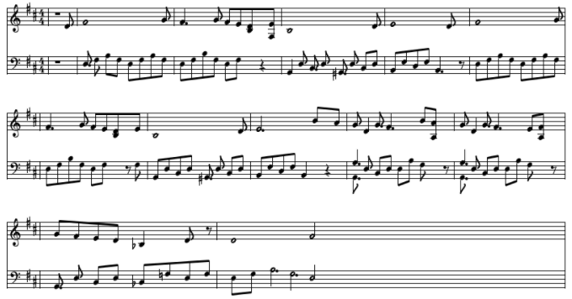
Maple’s Theme

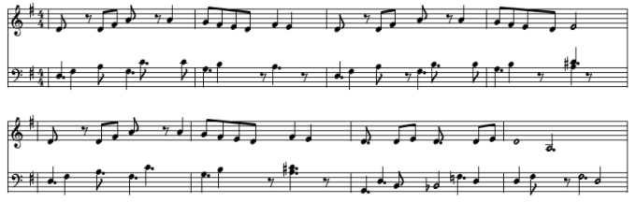
Enoki’s Theme

