DATA STRATEGY · COMMERCIAL STRATEGY · AI
Anatomy of a Wrong Quote
Why your data strategy is your commercial strategy — and what AI is about to do to it
Jerome Potvin (Jay) | Director, Commercial Strategy, Innovair Solutions | October 2026
AUTOPSY REPORT
Victim One quote (triplex: heat pump, 12 baseboards, 12 thermostats)
Time of death 10:40 a.m., after three hours
Cause logged in CRM "Lost on price"
Actual cause Four of six data links broken
Witnesses None. Nobody reported it.

IN 30 SECONDS
- Many quotes "lost on price" actually die elsewhere: when the links between customer, contract, product and supplier break.
- Culture outweighs budget in governance failure: 60% vs 40% (Gartner).
- In Canada, a breach costs C$7.11M, a record (IBM). Fewer businesses hit, but a recovery bill that doubled in two years (StatCan).
- AI doesn't fix the lost quote. It industrializes it. At the end: 8 lessons and an interactive tool to check your own.

4 / 6  links broken behind a sale "lost on price"  THE ARTICLE'S CASE | C$7.11M  average cost of a breach in Canada, a record  IBM 2026 | 60 / 40  culture outweighs budget in governance failure  GARTNER 2026 | ×6.8  odds of success with excellent change management  PROSCI
EXHIBIT 1 — THE SCENE

7:40 a.m., at the counter
A contractor calls. He is renovating a triplex and needs a price by noon: a cold-climate heat pump, twelve baseboard heaters and a dozen connected thermostats. The kind of order every distributor wants.
The inside sales rep opens the system and the morning starts to slip. The heater appears under two part numbers, at two different prices. The contractor's negotiated price isn't in the ERP; it lives in a spreadsheet on the sales manager's laptop. Thermostat compatibility is buried in a supplier PDF. To finish from home, the rep emails the price file to his personal inbox. Fourth broken link: the file has just left the company.
Three hours later the quote goes out. At the wrong price. The contractor buys elsewhere. In the CRM: "lost on price." Nobody writes down what actually happened: the company lost a sale because its own records couldn't agree with each other.
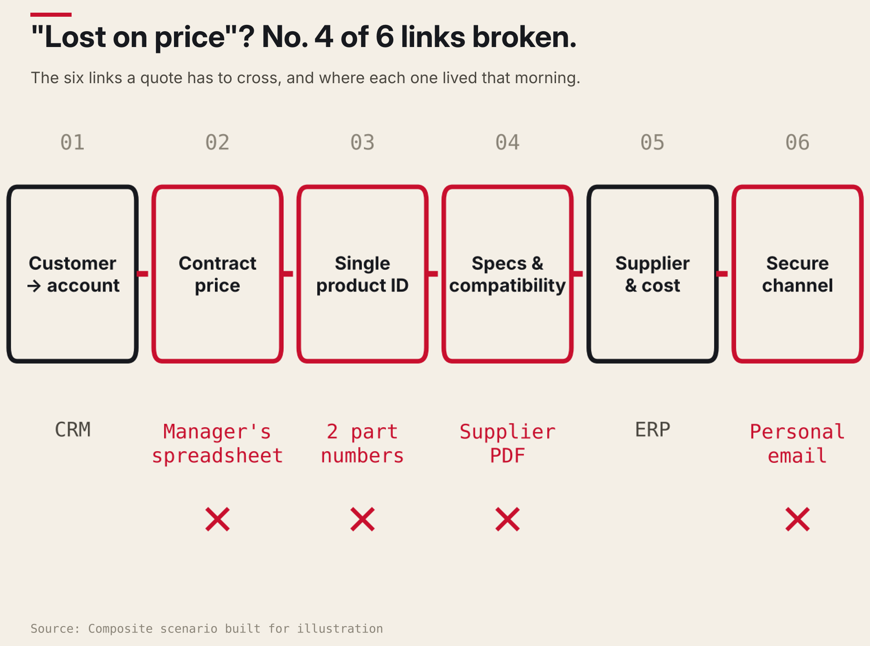
Figure 1. Lost on price? No: four of six links broken. A composite scenario, but anyone who has worked a supply-house counter will recognize every step.
EXHIBIT 2 — THE WRONG SUSPECT

It was never an IT problem
Ask most executives who owns the data strategy and they'll point to IT. Look again at the lost quote. The failure wasn't technical. It was a pricing failure, a customer-relationship failure and a speed-to-quote failure. Commercial outcomes.
A data strategy is not an appendix to commercial strategy. It is what makes commercial strategy executable.
Gartner reported in April 2026 that organizations with the most mature AI-ready data capabilities achieve up to 65% greater business outcomes, and that those with successful AI initiatives invest up to four times more in their data foundations. Yet in another Gartner survey of 504 leaders, only 22% of organizations had defined, tracked and communicated business impact metrics for most of their data use cases.
Most companies invest in data without being able to say which commercial number it moves. The loss at the counter was real, but no report will ever attribute it to data.
EXHIBIT 3 — THE WEAPON

A price is not a field. It's a relationship.
No single record was catastrophically wrong. The heater existed, the contract price existed, the compatibility information existed. What was broken were the links between them. A price is this customer, under this contract, buying this product, from this supplier, at this cost, today. Master data management (MDM) is the discipline of keeping those relationships true.
Its reputation is poor: Gartner figures cited by Dataversity (2025) put the share of MDM programs that miss their business objectives at 75%. My reading: MDM fails when it's run as a cleansing project rather than as a map of how the business actually makes money. Start from the quote, the contract and the order; trace which records each one touches. The priorities write themselves.
EXHIBIT 4 — THE NAMELESS SUSPECT

Who decides which price is right?
Two prices for the same heater. Which one was right? Purchasing created one record, a supplier price update created the other, and nobody had the authority to retire either. The data wasn't only wrong. It was ownerless.
Data governance is decision rights plus accountability: who may create, change, approve and retire each kind of data, and who answers for its quality. Back in 2024, Gartner predicted that 80% of governance initiatives would fail by 2027 for lack of a real or manufactured crisis. And per a 2025 Gartner survey, only 26% of programs build culture and communication into their strategy.
Role | Who | What they do
Executive sponsor | A leadership team member | Declares data part of the commercial plan and settles trade-offs.
Domain owners | Customer · Product · Price · Supplier | Decide when two records disagree. One name per domain.
Stewards | Reps, buyers | Spot and fix problems closest to the counter.
Monthly review | 30 minutes | A few quality numbers against the commercial KPI they support.

In Quebec, section 3.1 of Law 25 makes the person with the highest authority in the business its privacy officer by default. That same accountability can anchor the whole governance model.
EXHIBIT 5 — THE BREAK-IN

The spreadsheet that left the building
The personal email felt like initiative. It was a breach waiting to happen: a company without a data strategy doesn't know where its sensitive data lives, so it can't protect it. Per IBM, a breach in Canada now costs a record C$7.11M on average, and C$8.89M in the industrial sector.
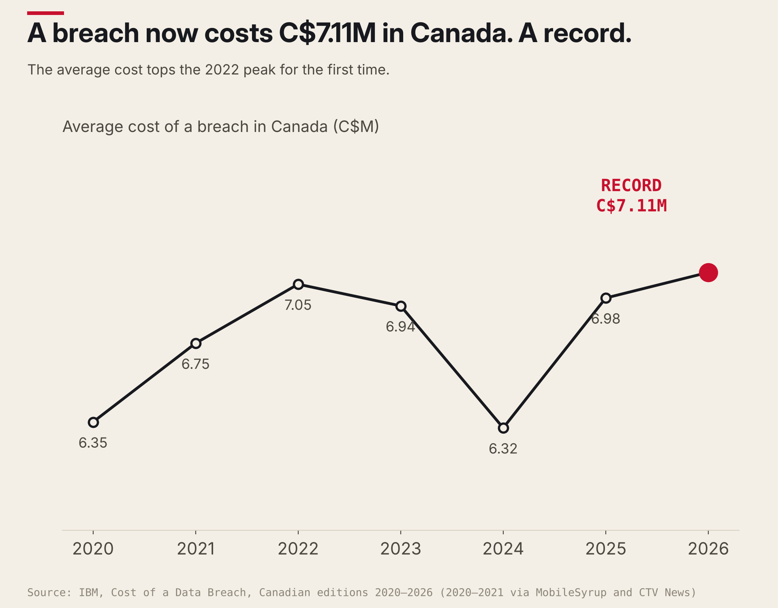
Figure 2. The average cost of a breach in Canada peaks in 2026. 2020–2021 values from media coverage of IBM reports.
For a distributor, the key number: supply-chain compromise has become the largest factor increasing breach costs in Canada, at roughly C$367,899 per incident.
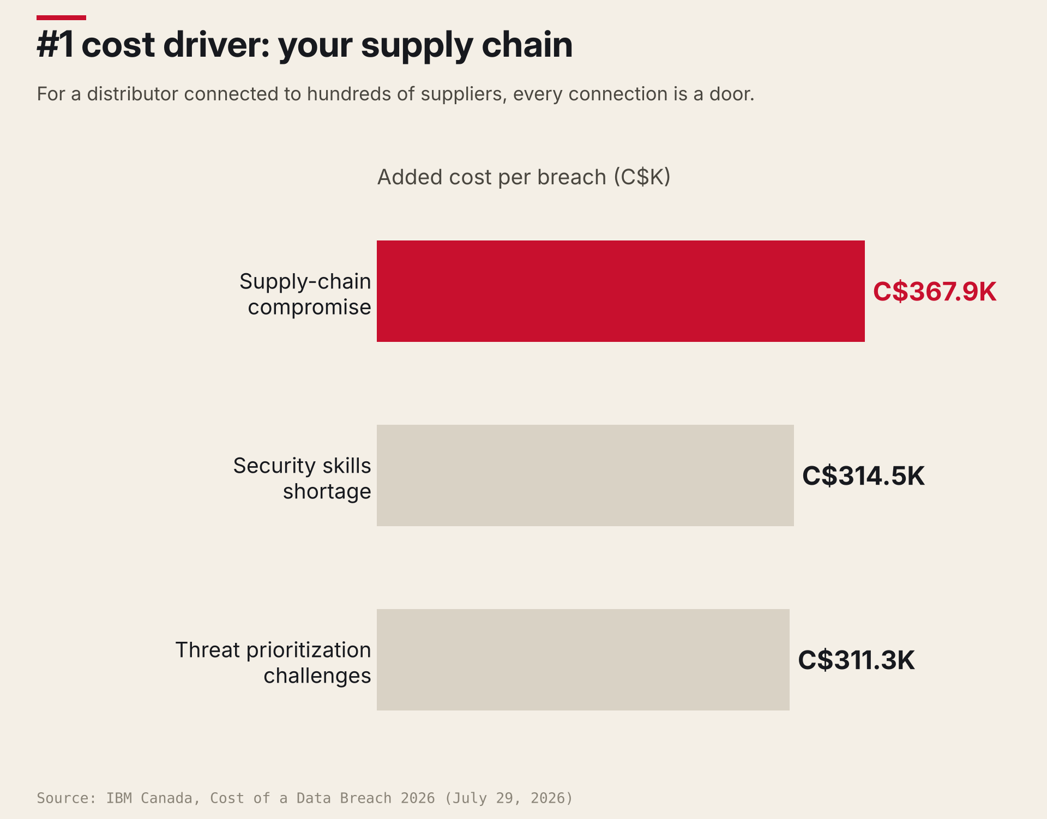
Figure 3. For a business connected to hundreds of suppliers, every connection is a door.
And the paradox almost nobody notices: per Statistics Canada, the share of businesses hit by a cyber incident fell, from 18% in 2021 to 16% in 2023, but their recovery spending doubled, from about $600M to $1.2B. Fewer incidents, far more expensive. Exactly the profile of an ever more connected economy.
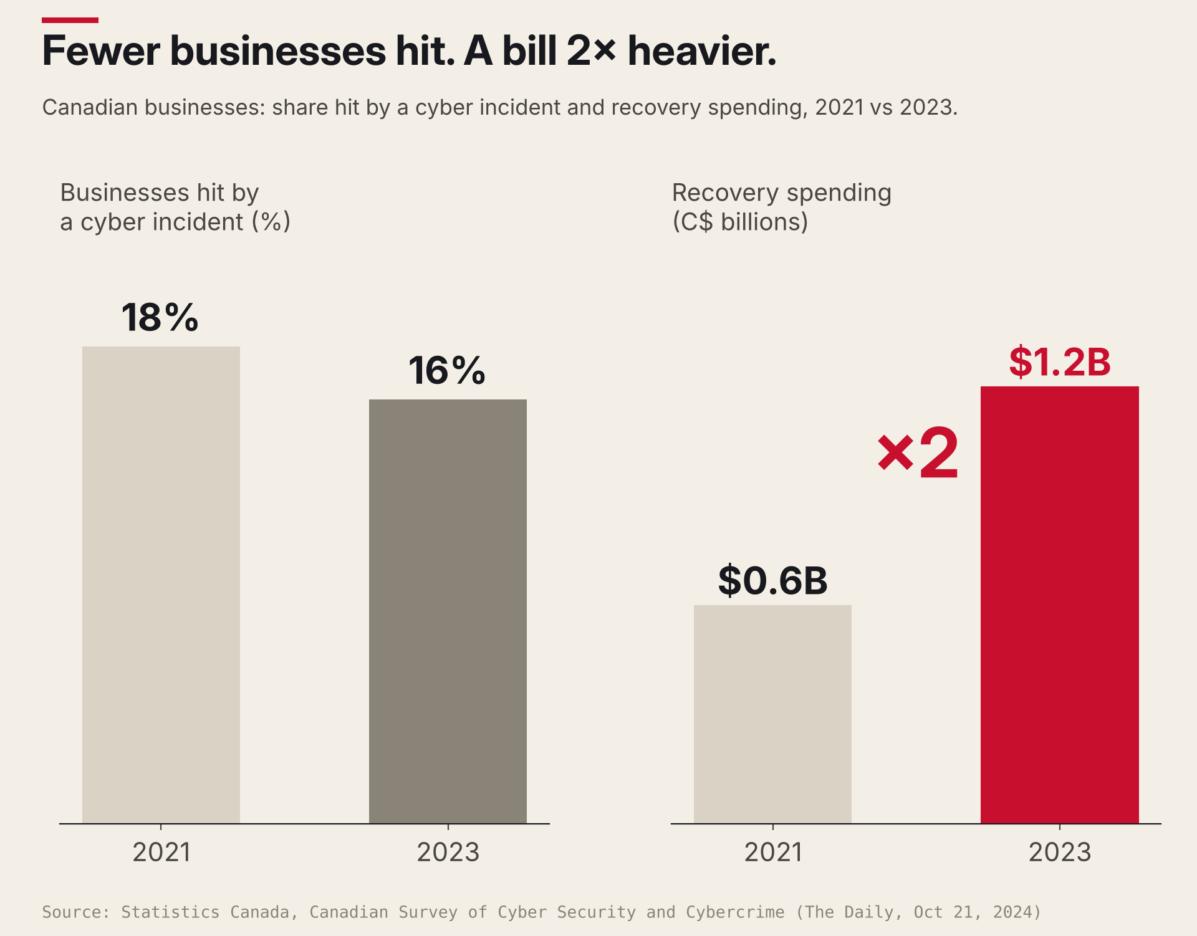
Figure 4. Fewer businesses hit, a bill twice as heavy.
EXHIBIT 6 — THE MOTIVE

The system nobody used
The company buys a platform, cleans the catalog, loads the contract prices. Six months later, reps still keep their spreadsheets, because they trust them more. On September 21, 2026, Gartner predicted that by 2027, 60% of organizations that ignore the cultural challenges of governance will fail to govern AI. Its March 2026 survey of 223 leaders: cultural resistance outweighs funding as the cause of failure, 60% vs 40%.
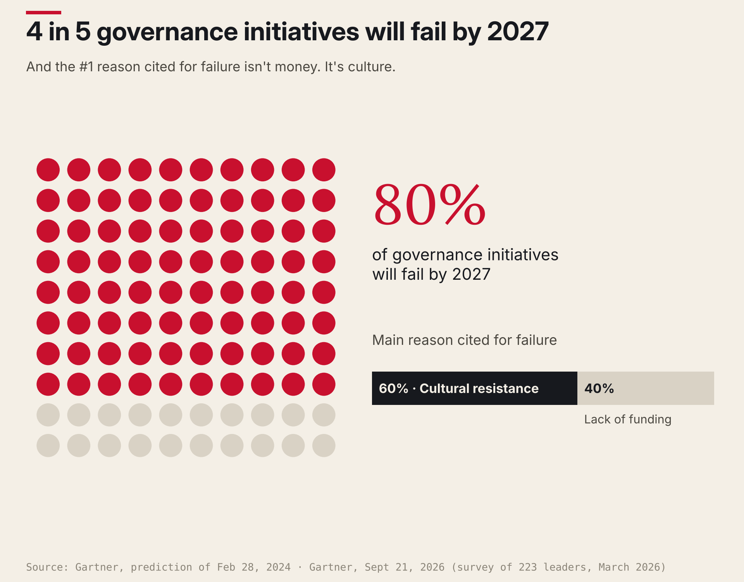
Figure 5. Four in five governance initiatives set to fail; culture, more than money, is the cause.
Prosci reaches the same conclusion: 88% of projects with excellent change management meet their objectives, versus 13% with poor change management. And 79% with extremely effective sponsors, versus 27% with extremely ineffective ones.
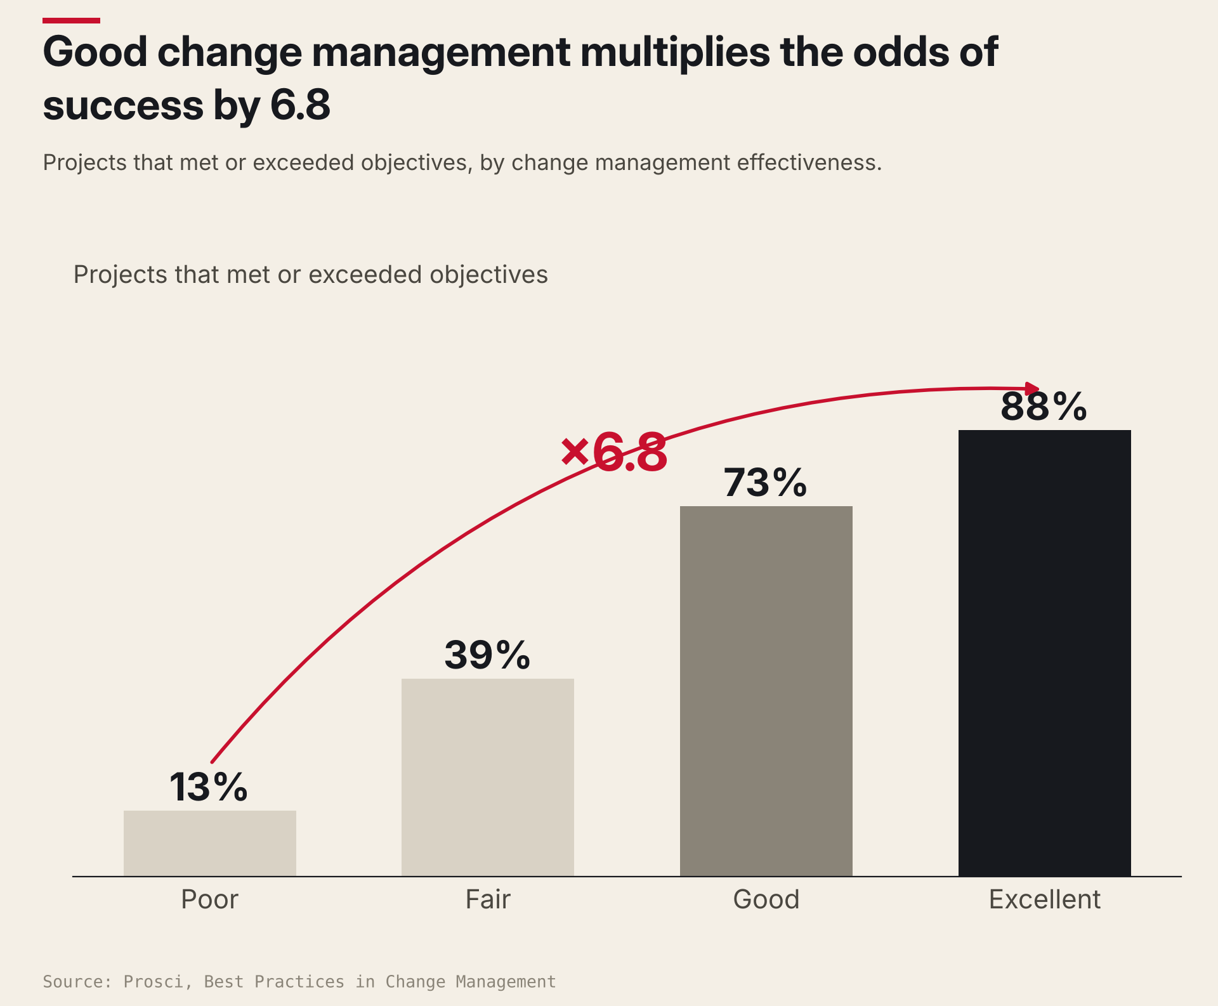
Figure 6. Change management multiplies the odds of success by 6.8.
EXHIBIT 7 — THE CONTEXT

The world is making data a condition of trade
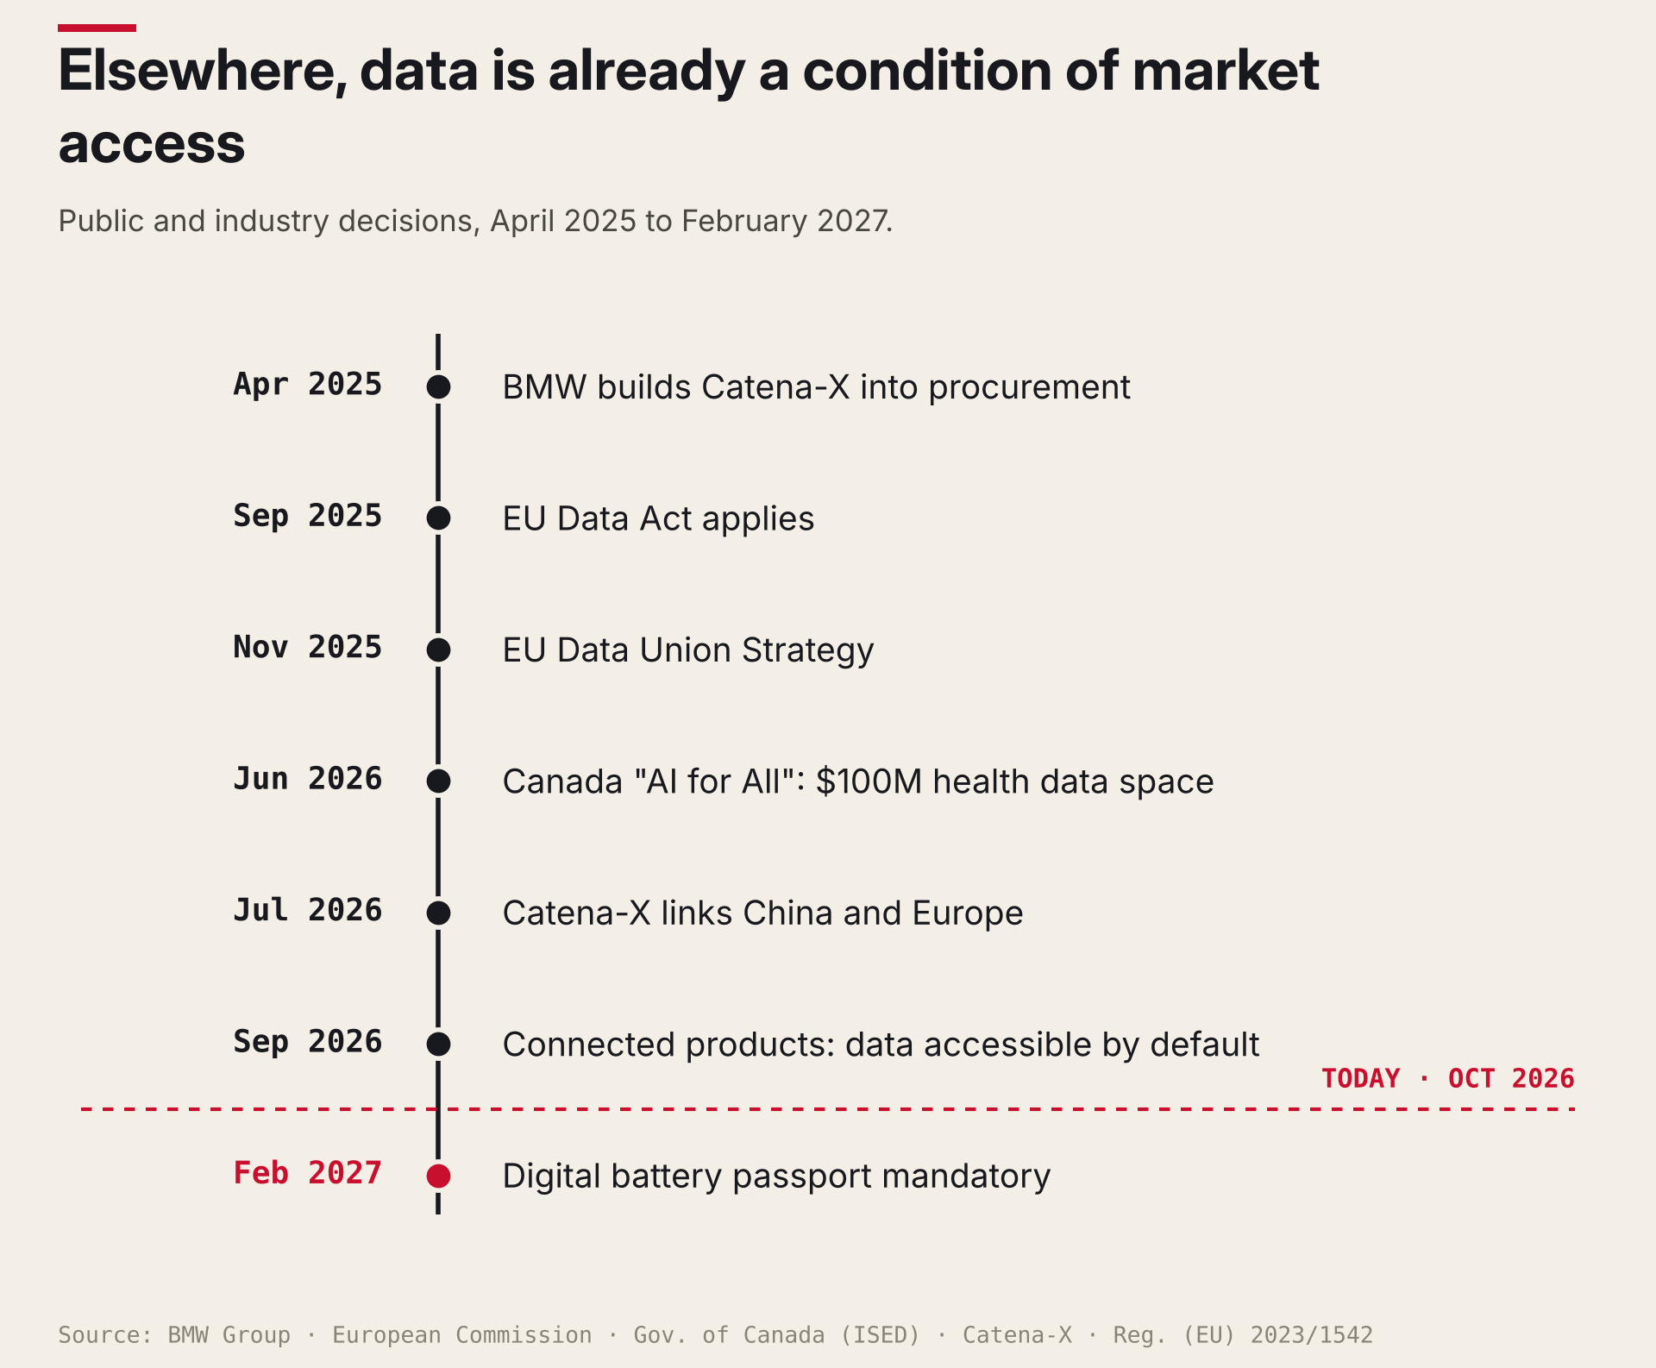
Figure 7. Under two years of decisions turning data into a condition of market access. Sources: European Commission, BMW Group, Catena-X, Gov. of Canada, Reg. (EU) 2023/1542.
In Europe, the Data Act has applied since September 12, 2025 and, since September 12, 2026, new connected products must make their data accessible by default. For anyone selling connected thermostats or heat pumps into Europe, data architecture is now a product specification. On November 19, 2025, the Commission added its Data Union Strategy.
In automotive, Catena-X registration has been part of BMW's procurement process since April 2025; over 1,000 companies now exchange data through it (Sept 21, 2026), and since July 2026 the network has linked China and Europe, starting with digital battery passports, mandatory in the EU from February 18, 2027. In Canada, the "AI for All" strategy (June 8, 2026) commits $100M to a health data space. In distribution, the deadline will likely come from a large customer. Not a law.
EXHIBIT 8 — THE REPEAT OFFENSE

Now put an AI assistant on the counter
Same morning, with an AI assistant. It answers in four seconds instead of three hours. It finds the duplicate heater, picks one of the two prices with total confidence, misses the contract price hidden in the spreadsheet, and sends a wrong quote faster than any human could.
AI doesn't fix the lost quote. It industrializes it.
On a clean foundation, though, AI pays: Gartner predicts it will speed time to value of governance and MDM programs by 40% by 2027, and in Canada, organizations that deployed it extensively in security pay C$5.5M per breach versus C$8.91M (IBM).
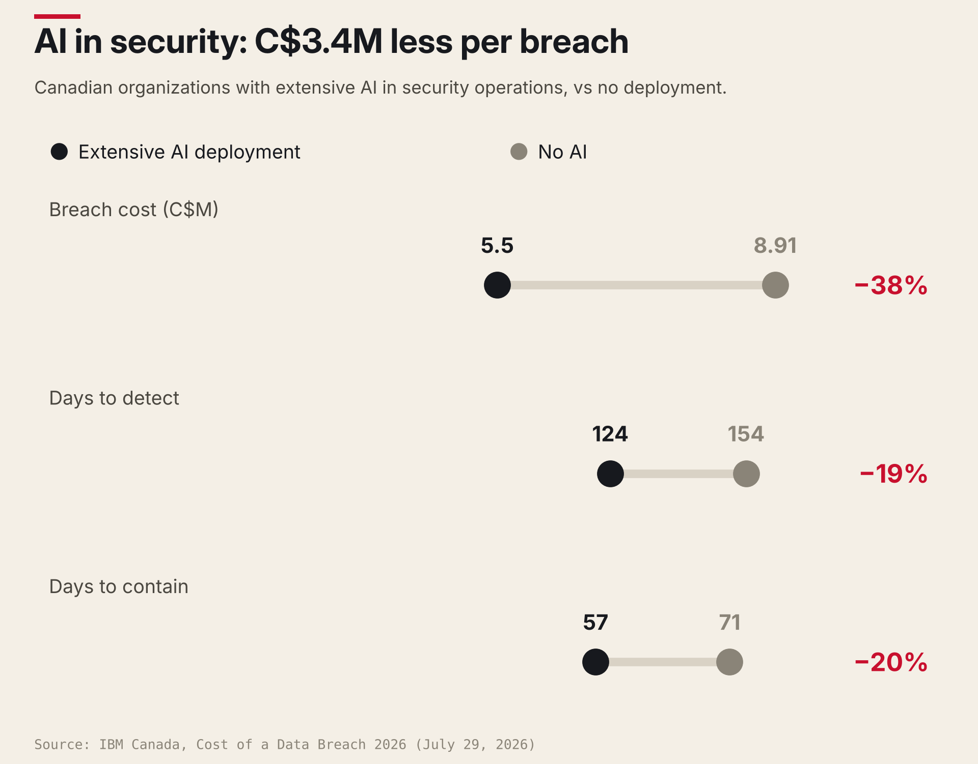
Figure 8. On a clean foundation, AI makes security cheaper and faster.
The headwind: per analyses of IBM's 2026 report (Baker Donelson), shadow AI is involved in 43% of AI-related incidents, at US$5.39M on average, and 92% of affected organizations lacked adequate AI access controls. The price file no longer leaves by email. It gets pasted into a chatbot.
The question isn't "should we adopt AI?" It's "what will it amplify?"
EXHIBIT 9 — THE DAMAGE

The price of doing nothing
A lost sale, three hours of a skilled rep, an exposed file in a country where a breach costs over C$7M, and the most expensive item: eroding trust, as customers learn your quotes need double-checking. Gartner says governance fails for lack of a crisis. But the lost quote IS a crisis. It arrives in installments, one call at a time, too small to notice.
THE VERDICT

Lessons learned
Eight lessons from the autopsy, the global examples and the research.
01 Start from a transaction, not an inventory. A quote, a renewal, an order: fix only what that moment depends on.
02 Links matter more than records. Connecting customer, contract, product and supplier changes the answer at the counter. Cleaning one by one doesn't.
03 Governance means decisions, not documents. Every critical domain has an owner who decides and a steward who spots the problem first.
04 Security comes free. Knowing where data lives and who owns it makes it useful and defensible. One program, not two budgets.
05 Culture beats budget. 60% vs 40% (Gartner). The day the rep drops his spreadsheet, you've won.
06 Set the deadline, or a customer will. In Europe: regulation. In automotive: BMW's procurement. In distribution: likely a large customer.
07 Sequence decides whether AI helps or hurts. Clean foundation: AI multiplies good answers. Broken one: wrong quotes at machine speed.
08 Measure one number. Name the commercial figure you'll move and record it first. Otherwise even a success looks like a cost.
THE PLAN

How to build it, starting Monday
- Pick 2 or 3 commercial objectives leadership already cares about: quote turnaround, contract-price accuracy, stockouts.
- Trace the relationships each depends on: customer → contract → product → supplier. That's your master-data scope.
- Light governance: a sponsor, an owner per critical domain, stewards from the front line.
- Inventory data where it actually lives, spreadsheets and inboxes included. In Quebec, Law 25 obligations (policies, privacy impact assessments, incident register) give you a head start.
- Fix only the fields your objectives depend on.
- Make reps co-designers: the records they trust least become their scoreboard.
- Measure one commercial number before you start, then add AI where the foundation is ready.
None of these steps requires a large platform purchase. They require an executive who decides that data is part of the commercial plan.
THE TOOL

The Quote Trace
Before Monday, one hour is enough to know where you stand and test all eight lessons. Sit down with your best inside rep, pull 5 recent quotes that were lost, late or corrected after sending, and score each of the six links. 0 = broken or outside the system · 1 = exists, fixed by hand · 2 = linked, trusted, used without checking. If nobody knows who decides when a link is wrong, untick "owner": an ownerless link loses a point.
# | Link to trace | The question to ask | Score | Where does it live? | Who decides?
1 | Customer → account | Is there one record for this customer, with the right terms? | 0 · 1 · 2
2 | Account → contract price | Did the negotiated price come up automatically? | 0 · 1 · 2
3 | Product → single identity | Did the product appear once, under one number? | 0 · 1 · 2
4 | Product → specs & compatibility | Were specs and compatibility on the record, not in a PDF? | 0 · 1 · 2
5 | Product → supplier & cost | Was cost current and linked to the right supplier? | 0 · 1 · 2
6 | Quote → secure channel | Was the quote built without a file leaving the system or going into an unapproved AI tool? | 0 · 1 · 2

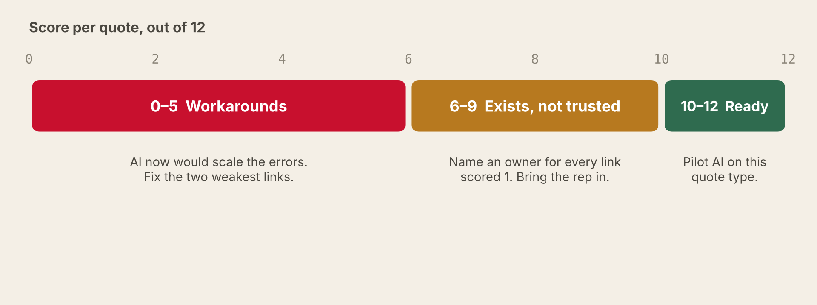
Reading the result: score per quote, out of 12. In the article's case, the quote scores 4: workarounds.
Why it works. In one sitting, the Quote Trace produces every building block of a data strategy:
- Master-data priorities: the links that break most often.
- A security inventory: where each link lives.
- A governance model: who decides.
- Change champions: the reps who spot the problems.
- The commercial KPI: quote time and accuracy.
- An honest answer on AI readiness.
Instead of debating "data quality" in the abstract, leadership looks at five real quotes and five real lost dollars.
EPILOGUE

7:40 a.m., one year later
The same contractor calls again. One heater, one part number. The negotiated price comes up on its own, because the contract is linked to the account. Compatibility is on the record. An AI assistant drafts the quote in ninety seconds, and the rep trusts it, because the records underneath are true. No file leaves the building. Nobody thinks about data strategy. That's the point.

Your first move: pull your last five lost quotes, sit down with your best rep and run the Trace. Some of them weren't lost on price.

And you: how many of your "lost on price" deals actually died of a broken link? I read every comment.
EVIDENCE

Sources and notes
The counter scenario is a composite. Sources accessed and re-verified September 22 to October 5, 2026. Shadow-AI figures come from secondary analyses of IBM's 2026 report; the 75% MDM figure is attributed to Gartner by Dataversity. The 2020–2021 points of the breach-cost chart rely on media coverage (MobileSyrup, CTV News) of IBM's reports. The Quote Trace is a conversation tool designed by the author, not a validated instrument.
1. Gartner, Organizations with successful AI initiatives invest up to four times more in D&A foundations (Apr 16, 2026)
2. Gartner, One-third of CDAOs cite measuring D&A and AI impact as top challenge (Feb 20, 2025)
3. Dataversity, Common master data management (MDM) pitfalls (2025)
4. Gartner, 80% of D&A governance initiatives will fail by 2027 (Feb 28, 2024)
5. IIoT World, Data governance fails without culture change (Gartner 2025 survey)
6. LégisQuébec, P-39.1, art. 3.1 (Loi 25 / Law 25)
7. IBM Canada, Cost of a Data Breach 2026 (July 29, 2026)
8. IBM Canada, Cost of a Data Breach 2025 (July 30, 2025)
9. IBM Canada, Cost of a Data Breach 2023
10. MobileSyrup, Average cost of data breaches rises in Canada: IBM (July 29, 2020)
11. CTV News, Cost of data breaches in Canada hit new record in 2021: IBM
12. Statistique Canada / Statistics Canada, Le Quotidien / The Daily (Oct 21, 2024)
13. Statistics Canada, Computer Security Day every day (Nov 27, 2025)
14. Gartner, 60% of organizations that ignore data governance culture challenges will fail to govern AI by 2027 (Sept 21, 2026)
15. Prosci, The correlation between change management and project success
16. Prosci, Change management executive sponsor program
17. European Commission, Data Act
18. Heuking, Data Act: access by design becomes mandatory as of 12 September (2026)
19. European Commission, Data Union Strategy: Unlocking data for AI (Nov 19, 2025)
20. BMW Group, Catena-X connects digital supply chains (Dec 11, 2025)
21. Catena-X, Network grows by more than a factor of five to over 1,000 companies (Sept 21, 2026)
22. Catena-X, World's first cross-border automotive data ecosystem between China and Europe (July 22, 2026)
23. Regulation (EU) 2023/1542 on batteries, art. 77 (battery passport)
24. Government of Canada (ISED), Canada's National AI Strategy: AI for All (June 8, 2026)
25. Baker Donelson, Ten takeaways from IBM's 2026 Cost of a Data Breach report

