Lab Semantic Data Web


Outlier Detection on Financial RDF Data
Mentor
Christiane Engels

Group students
Zuhair Almhithawi, Nayef Roqaya, Berivan Ekmez
Lab Project Report
Summer semester / 2016

Table of Contents
1 Introduction: 4
1.1 Motivation: 4
1.2 Project Purpose: 4
1.3 Definitions: 5
1.3.1 What is an outlier/anomaly? 5
1.3.2 Anomaly detection in data-mining 5
1.3.3 Outliers in financial data: 5
2 Project Time plan: 6
3 System Requirements: 7
3.1 Functional requirements: 7
3.2 Technical Requirements: 7
3.2.1 Fuseki: 7
3.2.2 Apache Jena: 8
3.2.3 Rapid miner: Error! Bookmark not defined.
3.3 Use case: 8
3.4 Non- functional requirements: 9
4 System architecture: 10
4.1 Subpopulation: 14
4.1.1 Pre-subpopulation: 15
4.1.2 Subpopulation : 15
4.1.3 Affect pruning on subpopulation – histogram: 17
4.2 Outlier detection 19
4.2.1 K-means algorithm for outlier detection: 20
4.2.2 Chauvenet’s Criterion 22
4.3 Semantic Web role: 23
4.3.1 RDF data model: 23
4.4 User Input and Interface: 30
4.5 Results in each level: 32
4.6 Property Name and constraint: 32
4.7 Choose a bin(bucket) to apply outlier detection: 33
5 Comparison of Outlier Detection Methods: 35
5.1 Comparing Example by our system: 35
5.2 Clarification example depending on Rapid Minder: 44
5.2.1 Nearest Neighbor Based: Local Outlier Factor (LOF) 44
5.2.2 Statistical Based: Histogram Based Outlier Score (HBOS): 44
6 Conclusion: 53
7 Reference: 54

Figure 1 :Use case Diagram Level 0 8
Figure 2:Use case Level 1 9
Figure 3: System Architecture 10
Figure 4 : System Architecture 11
Figure 5 : DFD diagram of system components 13
Figure 6: Observation structure 14
Figure 7: Triple structure 14
Figure 8: Structure constraint 15
Figure 9 : Sub population - process 17
Figure 10: Pruning - subpopulation 18
Figure 11: Lattice after pruning 19
Figure 12: K-means clusters 21
Figure 13 : Key terms and relationships in The RDF Data Cube Vocabulary 24
Figure 14:Example SPARQL query on how to generate location area information 30
Figure 15: User Interface 31
Figure 16: Subpopulation Results 32
Figure 17 : Details of results sub population 33
Figure 18: A Google Map shows outliers found in a number of cities. 34
Figure 19: Example illustrates how to build restful client 34
Figure 20: Percentage of outlier values 38
Figure 21:Agreement degree 41
Figure 22:Inersection of outlier results 43
Figure 23:Data sample 45
Figure 24 : Result outlier in Rapidminer 46
Figure 25:outlier in Rapidminer 47
Figure 26: Data Sample 48
Figure 27: result outlier in Rapidminer 49
Figure 28:results outlier in Rapidminer 50

Introduction:

Motivation:

The World Wide Web has enabled the creation of a global information space comprising linked documents. Linked Data provides a publishing paradigm in which not only documents, but also data, can be a first class citizen of the Web, thereby enabling the extension of the Web with a global data space based on open standards[1].

We use the Linked Open Data Cloud for retrieving additional information on e.g. demographics or economics to enrich the data sets at hand before analyzing them. The project aims to detect outliers on financial data and to compare the results. Certain data mining methods such as Chauvenet and K-means can be applied to these separate datasets (Financial data) to efficiently detect anomalies/outliers and these datasets were enriched from external sources like DBPedia to have accurate findings.

Project Purpose:
Applying different methods to detect outliers and anomalies in financial RDF data and compare the results.

Definitions:

What is an outlier/anomaly?

An anomaly is something that deviates from what is standard, normal, or expected [2].

Anomaly detection in data-mining

In data mining, anomaly detection (outlier detection) is the identification of items, events or observations, which do not conform to an expected pattern or other items in a dataset [3].

Outliers in financial data:
One aspect of analyzing financial data is finding unusual values,i.e. outliers or anomalies.
These may indicate:
- errors in the data
- irregular behavior (corruption, fraud, . . . )
- regions of special interest that e.g. require more subsidies or a better
handling of those

Project Time plan:

Figure1:Time plan

System Requirements:

Functional requirements:

ID | Name | Comments
FRQ - 1 | The user shall import his/her RDF datasets | Datasets may be in XML/RDF format
FRQ - 2 | The system shall Link local datasets to external dataset cloud | External dataset will be chosen manually the user in financial field
FRQ –3 | The system shall provide reports on analyzed data | Reports may include:  - Comparison for DM methods  - Results visualization  - Explanations

Technical Requirements:
- User interface: cross browser interface that runs on most web browsers (e.g. IE, Chrome, Firefox, Safari)
- The system shall be implemented using Java SE environment
- Front end languages and technologies: HTML5/CSS3, JavaScript, JQuery library, AngularJS, Google Maps API
- Restful API for web services
- Tools to be used: Fuseki, Rapid miner and Apache Jena

FUSEKI:
Fuseki is an HTTP interface to RDF data. It supports SPARQL for querying and updating. The project is a sub-project of Jena and is developed as servlet. Fuseki can also be run stand-alone server as it ships preconfigured with the Jetty web server.

Apache Jena:
A free and open source Java framework for building Semantic Web and Linked Data applications (Jena.apache.org, 2016).

Use case:
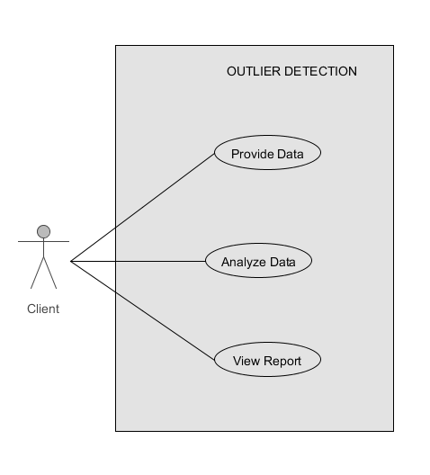
Figure 1 :Use case Diagram Level 0
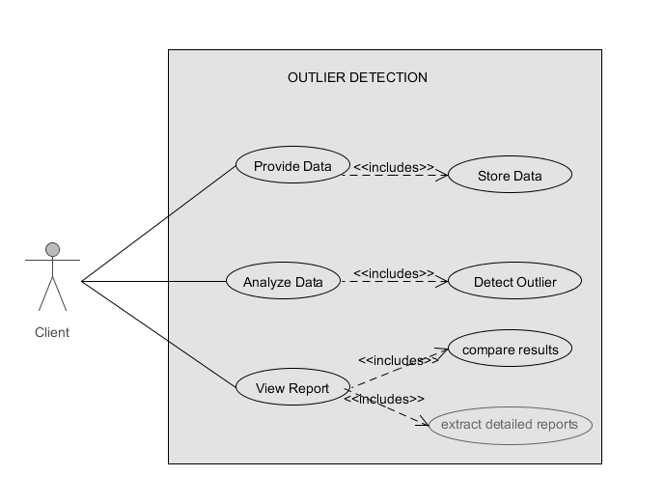
Figure 2:Use case Level 1

Non- functional requirements:

ID | Name | Comments
NRQ - 1 | Usability | The system must provide an intuitive and easy-to-use interface.
NRQ - 2 | Capacity | The ability of the system to handle transactional volumes is a very important characteristic for the system
NRQ – 3 | Performance | The system should consider the processed transactions per second and response time to user input and performance of the implemented DM methods
NRQ – 4 | Open source | Source code made available with a license in which the copyright holder provides the rights to study, change, and distribute the software to anyone and for any purpose.
NRQ – 5 | Quality | Quality of the outlier and detection methods for giving precise result.

System architecture:
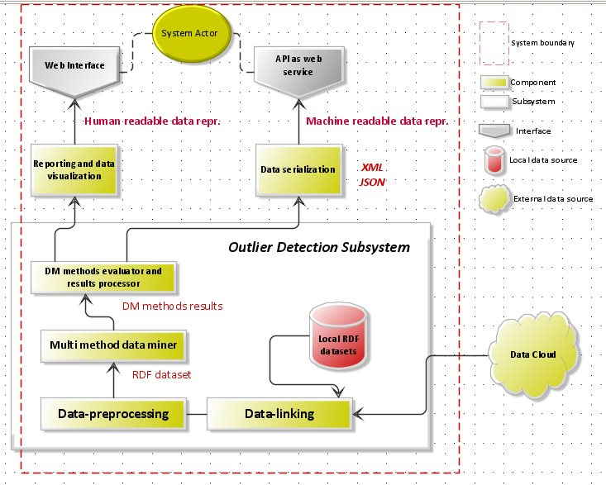
Figure 3: System Architecture

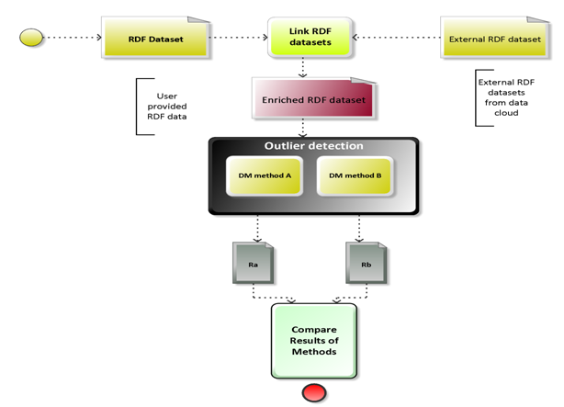
Figure 4 : System Architecture

Component ID | CP-DL
Component Name | Data-linking module
Component core functionality | Links a local RDF dataset to a DBpedia and enrich it with additional predicate-value pairs
Dependencies | Apache Jena Framework, DBpedia HTTP Endpoint
Input | Local RDF Dataset
Output | Enriched local RDF Dataset

Component ID | CP-DP
Component Name | Data-preprocessing module
Component core functionality | Applying sub-population on an RDF Dataset
Dependencies | ---
Input | RDF Dataset
Output | Sub datasets from the input dataset

Component ID | CP-MMD
Component Name | Multi-method Data Mining Module
Component core functionality | Applies multiple data mining methods on sub-population RDF dataset
Dependencies | -----
Input | RDF Dataset
Output | List of outliers

Component ID | CP-ENP
Component Name | DM methods evaluating and results processing module
Component core functionality | Compares applied DM methods and processes the resulted output from component CP-MMD
Dependencies | Component CP-MMD
Input | Output of component CP-MMD
Output | Statistical comparison

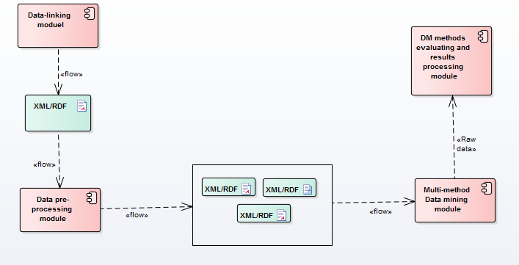
Module

Figure 5 : DFD diagram of system components

Subpopulation:
A subset of a population that shares one or more additional properties is called a subpopulation. For example, if the population is all German people, a subpopulation is all German males; if the population is all Ph.D. students in the world, a subpopulation is all Ph.D. in Germany. By contrast, a sample is a subset of a population that is not chosen to share any additional property. Before starting subpopulation, there are some concepts that have to be clear because this concept will play a vital role to have a correct subpopulation. In the RDF file, we have many triples that are attached to every observations .Each triple is formed by subject, predicate, and object. For instance, (Germany - located in - Europe = S:P:O).Located in is a property and Europe is a value of this property then located in = Europe is a constraint .

Figure 6: Observation structure

Figure 7: Triple structure

Figure 8: Structure constraint

There are three different types of constraints:
- Class constraints: A class constraint on class C applied to an instance set limits it to instances which belong to this class.
- Property constraints: A property constraint p limits the instances to those connected to an arbitrary object (instance or data value) by means of p.
- Property value constraints: A property value constraint is defined by a property p and a value v which can be either an instance or a data value. It limits the instances to those which are connected to a value v by means of p, and we are using only this approach.

Pre-subpopulation:
- Use parser to extract the triples from data set file (for instance file.ttl).
- Format these triples in this formula: “S: P: O”.

Subpopulation 1 :
- The root node includes all triples (instances) that are retrieved from the RDF parser.
- For the set of instances in the root node, we start to compute a histogram which represents the distribution of values in the subpopulation.
- Starting with the root node, this approach manages a queue of all not yet extended nodes and thus extends the lattice in a breadth-first-manner.
- When processing a node from this queue, we create its child nodes, each having an additional constraint compared to the parent node.
- The additional constraints are those from the set of possible constraints which are not yet used in the parent node.
- If a node for the resulting set of constraints already exists in the lattice, we do not consider the new node further.
- We determine the instances which adhere to this new set of constraints and compute the histogram of the value distribution [4].
- In each step of subpopulation ( each level ) , we have to make correlation lattice and finding the sharing bins between the paths in the lattice.
- We prune subpopulations which only contain a low number of instances or maybe no instances at all, we consider the instance reduction ratio. For instance, the change ratio in the number of instances of the new node compared to its parent node. If the additional constraint leads to a reduction of less than 1%, our approach prunes the node. Too low KL divergence and for not reducing the instance set further, we prune the node. Additionally if the number of instances in the bin is low , we prune the bin from lattice .
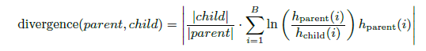
File.ttl

Constraint 2
Analysis triples to get the constraints
Constraint 1
Constraint 2........

RDF Parser
Level 1
Level 2
Bin 3

Constraint 3

Constraint 2
Constraint 1
Path from root to current node:
constaint3 – constraint 2
Repository

Bin 2

Bin 1
Constraint 1
Constraint 2

Constraint 3

Constraint 1
Constraint 3

Figure 9 : Sub population - process

- It is so important to analysis the triples and concludes the values of each property especially the properties that have many different values in a data set .For instance (budget Phase= approved, budget Phase = draft ...Etc).
- Each property with its values gives constraint and value of recursive levels related to a number of properties with considering the repeating in a list of properties and constraints.
- Number of levels in subpopulation is increasing gradually then the bins that are created by subpopulation will be increased, but the rule of pruning sometimes decrease the number of the bins.

Affect pruning on subpopulation – histogram:

Number of the bins in each level will increase when we move from one level to another.

Before pruning:
Constraint 2
Constraint 2
Constraint 3
Pruning childe
No reducing
e.g. 75 instances
e.g. 3 instances
Pruning childe
KLV is too low
Constraint 1
Level1
e.g. 25 instances
e.g. 24 instances
Constraint3
Repository
Bin1
Bin2

Bin

Constraint 1
Constraint3
e.g. 100 instances
Level2
Share Bin

Constraint2

Constraints 2

1 instance

2
Number of instance is too low

3
1

Figure 10: Pruning - subpopulation

Before pruning we can note from the graph above many important points:
Some vertices in the lattice have the same constraint (property=value) but these constraints has a different sequence.

- For each pair parent-child, we calculate the KLV value and not reducing rule between the parent and child.

After pruning:
Repository
Bin1
Bin2

Bin3

Constraint3
Level1
Level2

Constraint2

Prune

Figure 11: Lattice after pruning

We can note that the number of bins in the second level was decreased as result to apply pruning rules between the parent bins in the leve1 and children bins in the level 2 .

Outlier detection

After finishing subpopulation stage, we perform outlier detection on all non-pruned nodes of the lattice and store the resulting outliers together with the set of constraints which led to the corresponding instance set. Values may not only be detected as outliers when they are wrong but also if they are natural outliers in the considered dataset.

We chose k-means method and Chauvenet method because each method relate to different types of approach. K-means is a clustering method that is sensitive to noise and outliers comparing with Chauvenet is a mathematical method that depends on statistical approach. That will give us a chance to compare two different methods that have different approaches.

K-means algorithm for outlier detection:

An outlier is an object that differs from most other objects significantly. Therefore it can be considered as an anomaly. For outlier detection, only the distance to the appropriate centroid of the normal cluster is calculated. If the distance between an object and the centroid is larger than a predefined threshold dmax, the object is treated as an outlier.

In cluster analysis, a fundamental problem is to determine the best estimate of the number of clusters, which has a deterministic effect on the clustering results. However, a limitation in current applications is that no convincingly acceptable solution to the best-number-of clusters problem is available due to high complexity of real datasets [5].

Unfortunately, the researchers did not follow a specific way to solve specifying number of clusters in k-means algorithm. Some of them suggested following test results of algorithm for different number of cluster then choosing the best result and others suggest analyzing the data then deciding the number of clusters. For instance, if we want to cluster population in low, medium and high category, the number of cluster has to be K but this approach is not precise and cannot be applied for all cases [6].

K-Means clustering intends to partition n objects into k clusters in which each object belongs to the cluster with the nearest mean. This method produces exactly k different clusters of greatest possible distinction. The best number of clusters k leading to the greatest separation (distance) is not known as a priori and must be computed from the data. The Algorithm includes these steps :
- Clusters the data into k groups where k is predefined.
- Select k points at random as cluster centers.
- Assign objects to their closest cluster center according to the Euclidean distance function.
- Calculate the centric or mean of all objects in each cluster.
- Repeat steps 2, 3 and 4 until the same points are assigned to each cluster in consecutive rounds.

K-Means is relatively an efficient method. However, we need to specify the number of clusters, in advance and the final results are sensitive to initialization and often terminates at a local optimum. Unfortunately there is no global theoretical method to find the optimal number of clusters. A practical approach is to compare the outcomes of multiple runs with different k and choose the best one based on a predefined criterion. In general, a large k probably decreases the error but increases the risk of over fitting.
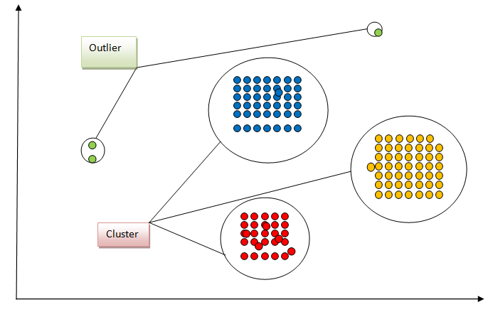

Figure 12: K-means clusters

Cons of K-means algorithm:

4) K value not known precisely and that affect the results of outlier if the user did not apply the cluster for different k value and choose the best results.
5) Sensitive to outliers and noise
6) Sensitive to initial points and local optimal, and there is no unique solution for a certain K value that play role in specifying outlier values[7].

Pros of K-means algorithm:

1) Practical, works well even some assumptions are broken especially with a big data set that have different values
2) Simple, easy to implement;
3) Easy to interpret the clustering results and that help in finding the correct outlier cluster
4) Fast and efficient in terms of computational cost, typically O (K*n*d);

Chauvenet’s Criterion

The idea behind Chauvenet's criterion is to find a probability band, centered on the mean of a normal distribution that should reasonably contain all n samples of a data set. By doing this, any data points from the n samples that lie outside this probability band can be considered to be outliers, removed from the data set, and a new mean and standard deviation based on the remaining values and new sample size can be calculated.
This identification of the outliers will be achieved by finding the number of standard deviations that correspond to the bounds of the probability band around the mean (D_{max}) and comparing that value to the absolute value of the difference between the suspected outliers and the mean divided by the sample standard deviation.
Steps Chauvenet’s Criterion:

- Step 1: Calculate the sample mean
- Step 2: Find the sample standard deviation.
- Step 3: We start by calculating the mean and standard deviation of the sample, 𝑥̅ and S. We then calculate the standardized deviation from the mean for all data values as:
τi = |Xi – x̄|/ s
- Step 4: Compare the values you got in Step 4 with a table of Chauvenet’s criterion values to see if you can reject each data point.

Properties Chauvenet’s Criterion:

A long established method based on probability theory that is widely used in government, universities and industry for outlier detection. It has the disadvantage that it assumes that data are from a normal distribution - always a very questionable assumption! If this is assumed, then outliers are identified based on the mean and standard deviation of the data.

Semantic Web role:
The subpopulation method can be applied on many types of constrains and by choosing the right constrains on which the subpopulation is applied, we can have more consistent outcomes of it. In our RDF dataset we have financial data about observations recorded in certain location and that location might be a city or even a country. By deploying liked data principles we can fetch additional information (that will be finally considered as constraints) for the observation location (like area and population) and then we apply the subpopulation method on these new constraints. As locations (city or country) have many properties in common like: area and population, we can apply the subpopulation method based on these properties and that will give us more consistent grouping of our samples which are the observations that were recorded in certain locations.

RDF data model:

The Data Cube Vocabulary overview:

Data Cube Vocabulary represents datasets as data cubes, i.e. collections of data that comprises of observed values (observations), associated dimensions, and metadata. The DCV provides a set of classes and properties for representing the data cubes in RDF and publishing them according to the linked data principles (see Berners-Lee, 2006).

Figure 13 : Key terms and relationships in The RDF Data Cube Vocabulary
source: (Cyganiak & Reynolds, 2014)

For every dataset (qb:DataSet) a definition of its structure (qb:DataStructureDefinition) needs to be developed. This structure is made of specifications of its components properties (qb:ComponentProperty). There are 3 types of components properties:
- Measures (qb:MeasureProperty) – measure properties specify the types of the observed values in the dataset.
- Dimensions (qb:DimensionProperty) – dimension properties specify dimensions used in the dataset to organize the observed values in a multidimensional space.
- Attributes (qb:AttributeProperty) – attribute properties specify additional attributes of the observed values, such as currency or accuracy.

Datasets using the DCV are made of observations (qb:Observation). An observation might be seen as a record of measures (one or more observed values) and the respective values of the specified dimensions and attributes. By selecting specific values of one or more dimensions, a view on the data called slice (qb:Slice) can be defined.

Observations, DataSet, and Data Structure Definition :

The RDF Data Cube Vocabulary builds upon an abstract cube model, i.e. a multidimensional space where measured values are indexed by multiple dimensions.
Using an excerpt of the total general government expenditure expressed as percentage of GDP published by Eurostat (2015) as an example.

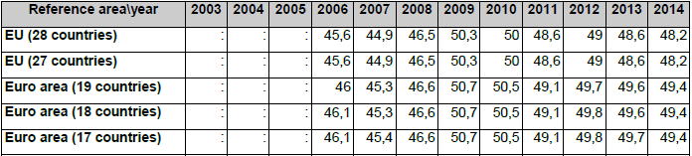

Total general government expenditure (% of GDP, excerpt)
source: excerpt from (Eurostat, 2015b)

The total general government expenditure expressed as percentage of GDP is the measured phenomenon, as illustrated in Table 1, which is indexed by two dimensions: reference area and year. The total government expenditure in EU28 in 2010 represents a single observation. The collection of observations forms a dataset, i.e. a data cube.
The following example shows a data structure definition for the dataset described in the table above .
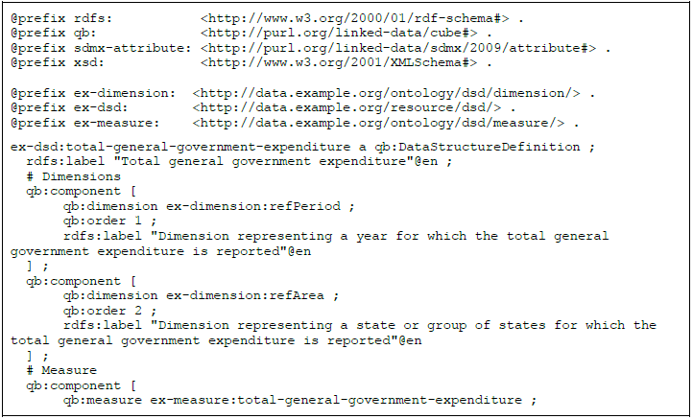

Dimensions, Measures and Attributes:

Data structure definition of a dataset represented using DCV is made of specifications of its components (qb:ComponentSpecification). There are 3 types of components: measures, dimensions, and attributes. The DCV provides specific classes to represent these components: qb:MeasureProperty, qb:DimensionProperty, qb:AttributeProperty. Component specification thus links data structure definition with instances of these classes that can be shared among multiple data structure definitions.
Measures (qb:MeasureProperty) represent types of the measured phenomenon, such as population of a given area or the total general government expenditure expressed as percentage of GDP, as illustrated in Table above .
In the following example, we provide RDF representation of these components.
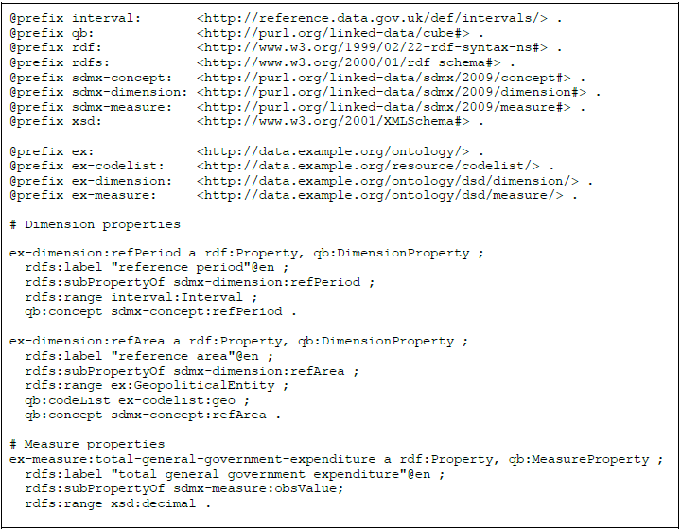
Example 3: Vocabulary for the data structure definition of the dataset described in Table 1

Code lists:
Possible values of dimensions are limited to items of the used code lists.
Code list can be defined as “a predefined list from which some statistical coded concepts take their values. The DCV implements an approach to the definition of code lists via qb:HierarchicalCodeList – see

Data Linking Module:
We use DBPedia as an external data repository to enrich our local dataset uploaded by the user.
By using special SPARQL queries we fetch following information:
- Area and population values for both location (usually a city) and the country where this city is located.
- Latitude and longitude values for the location
- GDP per capita value for the country
Each and every observation in the provided RDF dataset must be linked to a location (usually a city) so that that location can be used to retrieve the formerly mentioned information from DBPedia endpoint.
<http://data.openbudgets.eu/resource/dataset/example-budget-cities/observation/1a> a qb:Observation ;
http://data.openbudgets.eu/ontology/dsd/dimension/organization
http://dbpedia.org/resource/Paris;
<http://data.openbudgets.eu/ontology/dsd/measure/amount> 14881;

Enrichment stage steps:

- we go through all locations we have to fetch the relevant country, geo-spatial, area and population information
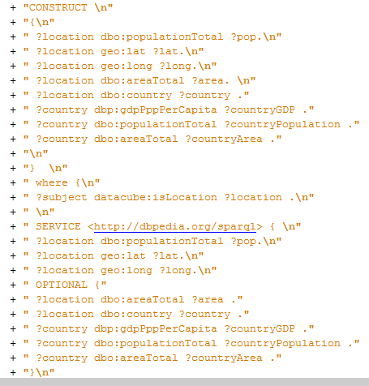
- we go through all observations we have and according to its location we attach the country and geo-spatial information again to the observation 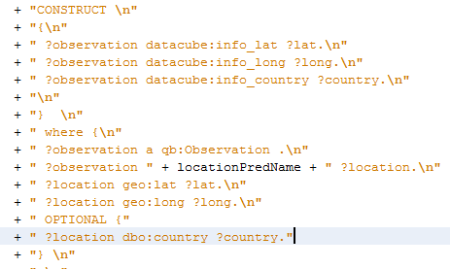
In our example the “locationPredName" is HTTP://DATA.OPENBUDGETS.EU/ONTOLOGY/DSD/DIMENSION/ORGANIZATION
- Finally we again go through all observations and attach the GDP, area and population information for both country and location.
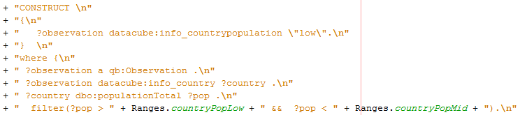
Example SPARQL query on how to generate county population information
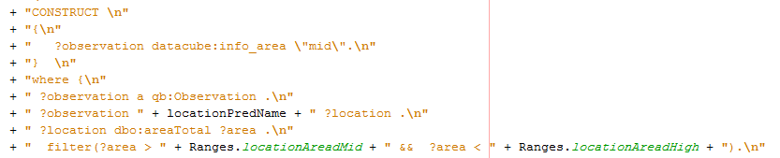
Figure 14:Example SPARQL query on how to generate location area information

By the end of these steps the dataset is ready to go through the subpopulation stage.

User Input and Interface:

The user is required to input different information to start a new session. During creating the session the system goes through enrichment and preprocessing (subpopulation) and then the user can select which sample groups to find outliers for.
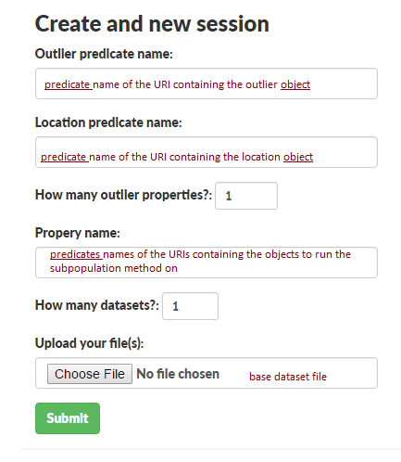
Figure 15: User Interface

After the session is created the user should keep the shown session ID to view the session again without going through the above-mentioned stages.

Results in each level:
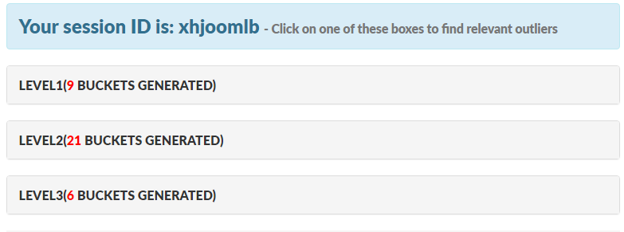
Figure 16: Subpopulation Results

By pressing certain level the user can view the different buckets that we generated for each level and choose one bucket to apply one of the two used outlier detection methods.

Property Name and constraint:
For the property that are used in subpopulation , we used three property and the user can choose any property and apply subpopulation for any number of property .
- info_population.
- info_countryarea
- budgetPhase
Depending on this property, the system analysis the data set automatically to find the constraint depending on these properties and its values.

For example:
- info_population=high , info_population=mid if it is available in data set , info_population=low if it is available in data set
- info_countryarea=mid…. Etc.
- budgetPhase=approved…. Etc.

Choose a bin(bucket) to apply outlier detection:

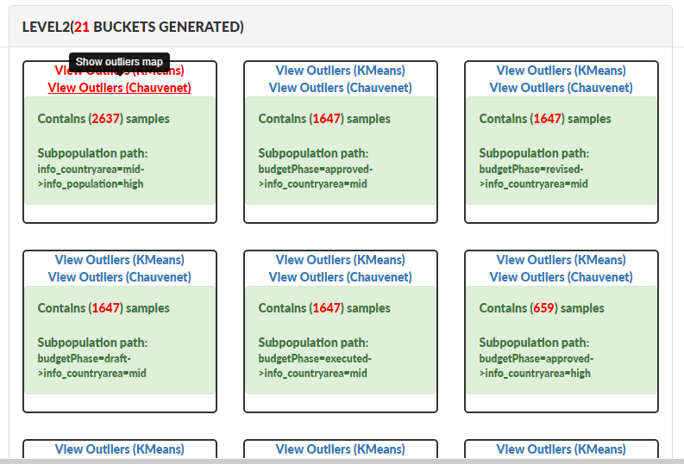
Figure 17 : Details of results sub population
Visualization of the results:
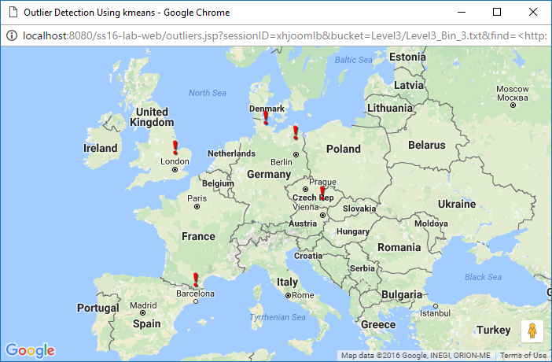

Figure 18: A Google Map shows outliers found in a number of cities.

After the outlier results are found, a cache entry is created for that specific outlier results based on the applied method, session ID and bucket name so that these results can be lately retrieved directly from the cache in both web interface and restful interface.

Restful Service Interface:

The system also provides a web service that can be used to retrieve the results of a previously cached outlier method in a certain session for a certain bucket, therefor the user is required to provide three pieces of information using the PUT method, and then can use the GET method to retrieve the results in a JSON format.
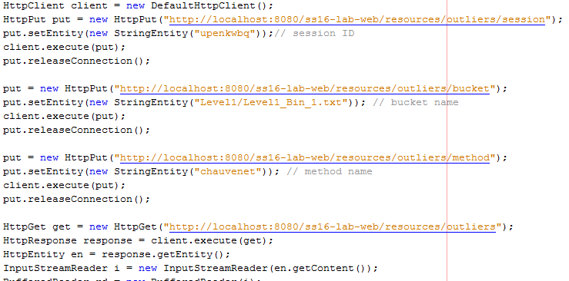

Figure 19: Example illustrates how to build restful client

Comparison of Outlier Detection Methods:

Since different outlier detection algorithms are based on disjoints sets of assumption, a direct comparison between them is not always possible. In many cases, the data structure and the outlier generating mechanism on which the study is based dictate which method will outperform the others. There are few works that compare different classes of outlier detection methods. In particular, the methods depend on: whether or not the data set is multivariate normal, the dimension of the data set, the type of the outliers, the proportion of outliers in the dataset.

Comparing Example by our system:

The project can process any data set dynamically and this point is one of the strongest points that support the project. Our data set that is used in testing the project and comparing the result is “Budget-EU.ttl”. The statistics in the tables below are generated automatically inside the project folder in the statistics folder and include all information that we used to analysis and compare the results.

There are three criteria for comparing the result:
  - Comparing number of outliers in each bin in each level for each method.
In these criteria, we will calculate the number of all observations that are specified by K-means method as an outlier and compare it with a number of all observations that are specified by Chauvenet method.

 | Number of instances (samples) in each bin | Outliers found by K-means | Outliers found by Chauvenet
Level 1
Bin 1.1 | 5273 | 15 | 26
Bin 1.2 | 5265 | 9 | 9
Bin1.3 | 6585 | 14 | 29
Bin1.4 | 2633 | 5 | 5
Bin1.5 | 1317 | 1 | 1
Bin1.6 | 2964 | 2 | 6
Bin1.7 | 2964 | 11 | 12
Bin1.8 | 2964 | 8 | 9
Bin1.9 | 2964 | 7 | 10
Level 2
Bin2.1 | 2637 | 13 | 20
Bin2.2 | 1317 | 2 | 1
Bin2.3 | 1319 | 2 | 5
Bin2.4 | 1319 | 8 | 9
Bin2.5 | 1319 | 3 | 5
Bin2.6 | 3949 | 6 | 6
Bin2.7 | 1317 | 1 | 1
Bin2.8 | 1317 | 423 | 0
Bin2.9 | 1317 | 5 | 5
Bin2.10 | 1647 | 2 | 6
Bin2.11 | 1647 | 6 | 7
Bin2.12 | 1647 | 8 | 9
Bin2.13 | 1647 | 12 | 8
Bin2.14 | 659 | 190 | 0
Bin2.15 | 659 | 4 | 4
Bin2.16 | 659 | 199 | 0
Bin2.17 | 659 | 1 | 1
Bin2.18 | 330 | 88 | 0
Bin2.19 | 330 | 1 | 1
Bin2.20 | 330 | 105 | 0
Bin2.21 | 330 | 84 | 0
Level 3
B3.1 | 660 | 2 | 4
B3.2 | 660 | 8 | 8
B3.3 | 660 | 3 | 4
B3.4 | 330 | 102 | 0
B3.5 | 330 | 106 | 0
B3.6 | 330 | 71 | 0
Sum | 62254 | 1527 | 211
Results |  | 1527 | 211
Chauvenet maximum number of found outliers in a bin(bucket) |  | 29
Chauvenet minimum number of found outliers in a bin(bucket) |  | 0
Kmeans maximum number of found outliers in a bin(bucket) |  | 423
Kmeans minimum number of found outliers in a bin(bucket) |  | 1

Figure 20: Percentage of outlier values
Using “Budget-Eu” data set in as input to a project will give about 3% outliers for k-means method comparing with Chauvenet method that gave only 0.3 % outliers. Depending on this comparison we can conclude that k-means algorithm is more sensitive to outlier compared to Chauvenet method but that does not mean k-means is better than Chauvenet because each algorithm follows specific process and special rules .As a result, we can conclude following points related to K-means:

- Strong sensitivity to outliers and noise
- Doesn't work well with non-circular cluster shape - number of cluster and initial seed value need to be specified beforehand
- Low capability to pass the local optimum.
- K-means is the simplest to implement and to run

- Scale the degree of agreement by calculates Min, Max.
We followed a special scale in the measure of the degree of agreement between the results of outlier in each method. This scale range is between [0,1] display the different degree of agreement .

0
1

The degree of agreement is the number of the shared outliers between both methods divided by the maximum number of found outliers by each method.

For instance:
Method A gave 4 outliers values: Value _A= 4.
Method B gave 4 outliers values: Value_B =4.
The number of shared outliers: Value_C
Maximum value when comparing value_A and value_B : Value_D
e.g. status 1:
If number of shared outliers between both methods is 4, that means there is a full matching (agreement) in the results
e.g. status 2:
If number of shared outliers between both methods is 0, that means there is no matching in the results

$$\frac{Value_C}{Value_D}= \frac{4}{4}=1 full agreement$$

$$\frac{Value_C}{Value_D}= \frac{0}{4}=0 full disagreement$$

 | Number of instances (samples) in each bin | Degree of agreement | Notes
Level 1
Bin 1.1 | 5273 | 0
Bin 1.2 | 5265 | 1
Bin1.3 | 6585 | 0
Bin1.4 | 2633 | 1
Bin1.5 | 1317 | 1
Bin1.6 | 2964 | 0
Bin1.7 | 2964 | 0
Bin1.8 | 2964 | 0
Bin1.9 | 2964 | 0
Level 2
Bin2.1 | 2637 | 0
Bin2.2 | 1317 | 1
Bin2.3 | 1319 | 0
Bin2.4 | 1319 | 0
Bin2.5 | 1319 | 0
Bin2.6 | 3949 | 1
Bin2.7 | 1317 | 1
Bin2.8 | 1317 | 0
Bin2.9 | 1317 | 1
Bin2.10 | 1647 | 0
Bin2.11 | 1647 | 0
Bin2.12 | 1647 | 0
Bin2.13 | 1647 | 0
Bin2.14 | 659 | 0
Bin2.15 | 659 | 1
Bin2.16 | 659 | 0
Bin2.17 | 659 | 1
Bin2.18 | 330 | 0
Bin2.19 | 330 | 1
Bin2.20 | 330 | 0
Bin2.21 | 330 | 0
Level 3
B3.1 | 660 | 0
B3.2 | 660 | 1
B3.3 | 660 | 0
B3.4 | 330 | 0
B3.5 | 330 | 0
B3.6 | 330 | 0
Results
Agreement value = 1 | 11
Disagreement value = 0 | 25

Figure 21:Agreement degree

We can conclude from the graph that the agreement between these two methods ( k-means and Chauvenet ) is bad and that reflect the differences in strategy of the work between these methods .

Compare the states where outlier results from K-means are a subset of outlier’s results from Chauvenet .additionally, states where outlier results from K- Chauvenet are a subset of outlier’s results from K-means.

 | Number of instances in each bin (samples ) | Chauvenet subset of Kmeans | Kmeans subset of Chauvenet
Level 1
Bin 1.1 | 5273 | false | false
Bin 1.2 | 5265 | false | false
Bin1.3 | 6585 | false | false
Bin1.4 | 2633 | false | false
Bin1.5 | 1317 | false | false
Bin1.6 | 2964 | false | false
Bin1.7 | 2964 | false | false
Bin1.8 | 2964 | false | false
Bin1.9 | 2964 | false | false
Level 2
Bin2.1 | 2637 | false | false
Bin2.2 | 1317 | false | false
Bin2.3 | 1319 | false | false
Bin2.4 | 1319 | false | false
Bin2.5 | 1319 | false | true
Bin2.6 | 3949 | false | false
Bin2.7 | 1317 | false | false
Bin2.8 | 1317 | false | false
Bin2.9 | 1317 | false | false
Bin2.10 | 1647 | false | false
Bin2.11 | 1647 | false | false
Bin2.12 | 1647 | false | false
Bin2.13 | 1647 | false | false
Bin2.14 | 659 | false | false
Bin2.15 | 659 | false | false
Bin2.16 | 659 | false | false
Bin2.17 | 659 | false | false
Bin2.18 | 330 | false | false
Bin2.19 | 330 | false | false
Bin2.20 | 330 | false | false
Bin2.21 | 330 | False | false
Level 3
B3.1 | 660 | false | false
B3.2 | 660 | false | false
B3.3 | 660 | false | true
B3.4 | 330 | false | false
B3.5 | 330 | false | false
B3.6 | 330 | false | false
No intersection |  | 34 cases
Chauvenet subset of Kmeans |  | 0 cases
Kmeans subset of Chauvenet |  | 2 cases

• No intersection status means that there is no shared outliers between the k-means method and Chauvenet method. According to our results, there are 34 cases.
• Chauvenet subset of Kmeans means the outliers that we got from Chauvenet is subset of outliers that we got from k-means. According to our results, there no case of that.
• Kmeans subset of Chauvenet means the outliers that we got from Kmeans is part of an outlier that we got from Chauvenet. According to our results, there are 2 cases.
• The average of agreement depending on all result from our data set is approximately 0.30%.

Figure 22:Inersection of outlier results

Clarification example depending on Rapid Minder:
We use in rapid miner the same samples of example that are used in the project.

Nearest Neighbor Based: Local Outlier Factor (LOF)
The LOF anomaly detection calculates the anomaly score according to the local outlier factor algorithm proposed by Breunig[10]. There are several steps in the calculation of the LOF. The initial step involves getting the nearest neighbors set. The definition states that the k-distance(p) has at least k neighbors with distinct spatial coordinates that have a distance less than or equal it and at most k-1 of such neighbors with distance strictly less than it. The reachability distance (reach-dist(p,o)) is the maximum of the distance between point p and o and the k-distance(o). The local reachability is the inverse of the average reachability distance over the nearest neighborhood set. Finally the LOF is calculated as the average of the ratio of the local reachability density over the neighborhood set. The values of the LOF oscillates with the change in the size of the neighborhood. Thus a range is defined for the size of the neighborhood. The maximum LOF over that range is taken as the final LOF score. A normal instance has an outlier value of approximately 1, while outliers have values greater than 1. The operator is also able to read and write a model containing the k nearest neighbors set.

Statistical Based: Histogram Based Outlier Score (HBOS):
Calculates an outlier score by creating an histogram with a fixed or a dynamic binwidth.
This method calculates a separate univariate histogram for every column in the Example Set. There are two modes, one with a static and one with a dynamic bandwidth[11]. In the static mode every bin has the same binwidth equally distributed over the value range. In the dynamic mode the binwidth can vary, but you can specify a minimum number of examples contained in a bin. The parameter number of bins sets the total number of bins used for either mode. The binwidth / minimum number values per bin is then calculated automatically. In the dynamic mode it is possible that there are less bins then specified if some bins contain more than the minimum number of values. To compute the outlier score, the histograms are normalized to one in height first. Then, the score is inverted, so that anomalies have a high score and normal examples a low score.

We choose some bins from all level of the results and applied diffrent outlier methods in Rapidminer as follow :
Example 1:
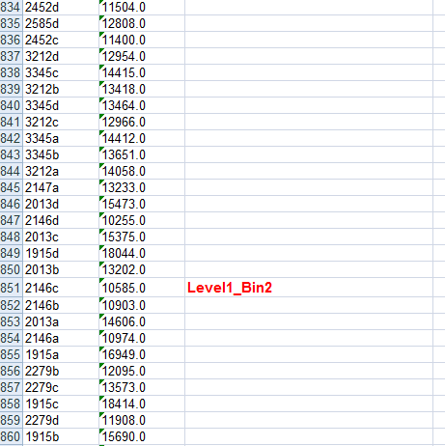
Observation Name
Amount value

Figure 23:Data sample

Outliers by Nearest Neighbor Based: Local Outlier Factor (LOF):
Criteria : Outliers have values greater than 1

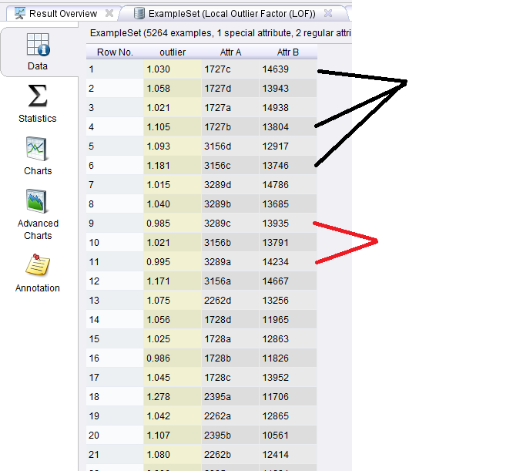
Outliers
Normal
Observation Name
Amount value

Figure 24 : Result outlier in Rapidminer

Outliers byStatistical Based: Histogram Based Outlier Score (HBOS):
Criteria: anomalies have a high score and normal examples a low score
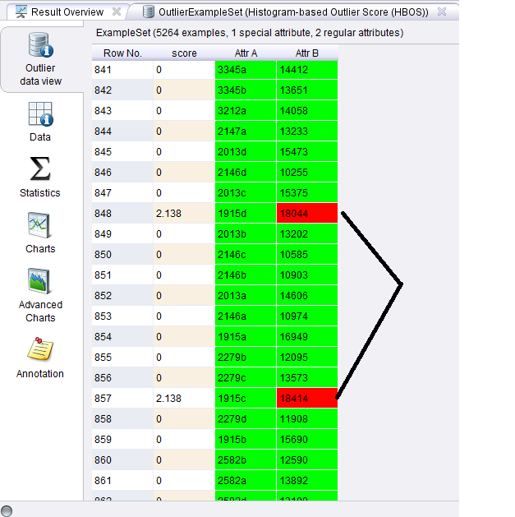
Observation Name
Amount value
Outliers

Figure 25:outlier in Rapidminer

Example 2 :

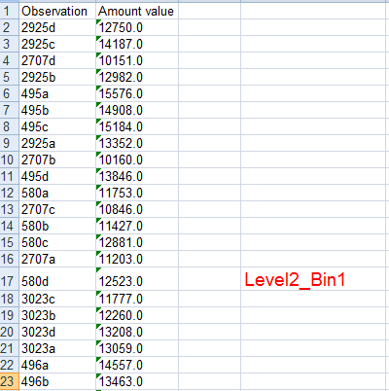
Observation Name
Amount value

Figure 26: Data Sample

Outliers by Nearest Neighbor Based: Local Outlier Factor (LOF):
Criteria : Outliers have values greater than 1

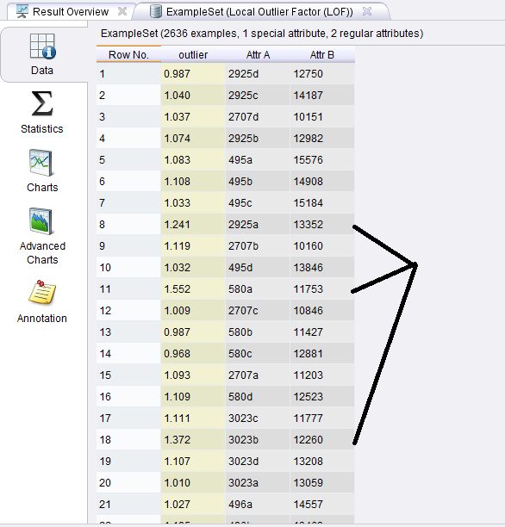
Outliers
Observation Name
Amount value

Figure 27: result outlier in Rapidminer

Outliers by Statistical Based: Histogram Based Outlier Score (HBOS):
Criteria: anomalies have a high score and normal examples a low score
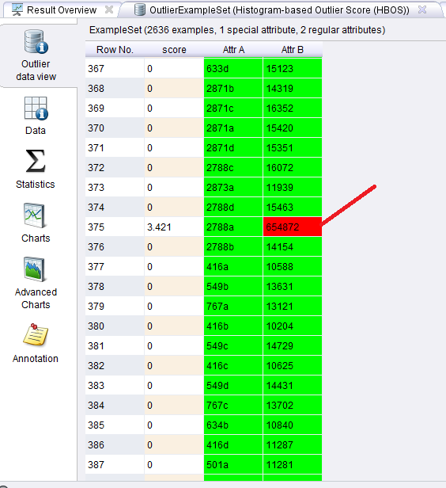
Outlier
Observation Name
Amount value

Figure 28:results outlier in Rapidminer

Comparing outlier methods in Rapidminer
Local Outlier Factor (LOF) | Histogram Based Outlier Score (HBOS)
- Outliers have values greater than 1. | - anomalies have a high score and normal examples a low score
- LOF is able to identify outliers in a data set that would not be outliers in another area of the data set. | - The histogram based outlier detection approach is typically applied when the data has a single feature.
- It has experimentally been shown to work very well in numerous setups, often outperforming the competitors | - Histogram based detection methods are simple to implement and hence are quite popular in domain such as intrusion detection
- LOF family of methods can be easily generalized and then applied to various other problems, such as detecting outliers in geographic data | - Frequency (relative amount) of samples in a bin is used as density estimation
- Local outlier detection reconsidered: a generalized view on locality with applications to spatial, video, and network outlier detection | - Assumes independence of features similar to Naive Bayes

We can not that each method follows special process and depends on different assumption to specify the outliers in data set and that make us sure about idea that clear different outlier methods are not necessary the same outlier values, sometimes we can have matched in outlier value or outer result by methods are subset of outlier results other method .

Comparing outlier methods in Rapidminer
Local Outlier Factor (LOF) | Histogram Based Outlier Score (HBOS)
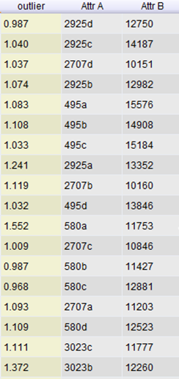 | 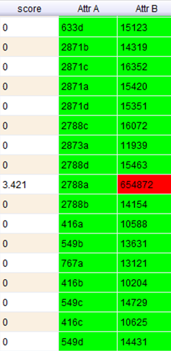
- LoF gave use outlier score for each value then we make negotiation choose the outlier depending on the criteria “Outliers have values greater than 1”.
- HBOS use the score and clearly, we get the outlier depending on the criteria anomalies have a high score and normal examples a low score.

Conclusion:

Most real-world data sets contain outliers that have unusually large or small values when compared to others in the data set. Outliers may cause a negative effect on data analyses, or may provide useful information about data when we look into an unusual response to a given study.There are some important points that have to be considered :
- Different method are based on different assumptions to model outliers.
- Different models consider outlier at different resolutions.
Basically , a key question arises as to how the effectiveness of an outlier detection algorithm should be evaluated. Unfortunately, this is often a difficult task, because outliers, by definition, are rare. This means that the ground-truth about which data points are outliers, is often not available. This is especially true for unsupervised algorithms, because if the ground-truth were indeed available, it could have been used to create a more effective supervised algorithm. For instance, In the unsupervised scenario (without ground-truth), it is often the case, that no realistic quantitative methods can be used in order to judge the effectiveness of the underlying algorithms in a rigorous way. Therefore, much of the research literature uses case studies in order to provide an intuitive and qualitative evaluation of the underlying outliers in unsupervised scenarios. In some cases, the data sets may be adapted from imbalanced classification problems, and the rare labels may be used as surrogates for the ground truth outliers.on the other hand, if the algorithm declares too many data points as outliers, then it will lead to too many false positives. This tradeoff can be measured in terms of precision. In most practical real-life settings, samples of the outlie r generating mechanism are non-existent.Depending on our comparison between many different outlier methods in the project , we can be sure basically that different method are based on different assumptions to model outliers and different models consider outlier at different resolutions.

Reference:

[1]. Heath, T. and Bizer, C. (2011). Linked Data: Evolving the Web into a Global Data Space.Synthesis Lectures on the Semantic Web: Theory and Technology, 1(1), pp.1-136.

[2]. Techniques for Anomaly Detection in Network Flows. (2016). [online] Available at: http://cahsi.cs.utep.edu/cahsifiles/Files/PostersFinal/TechniquesAnomalyDetectionNetwork.pdf [Accessed 14 Oct. 2016].

[3]. Chandola, Varun and Banerjee, Arindam and Kumar, Vipin: "Anomaly detection: A survey", ACM computing surveys (CSUR), 2009.

[4]. Detecting Errors in Numerical Linked Data using Cross-Checked Outlier Detection. (2016). [online] Mannheim, Germany: Daniel Fleischhacker, Heiko Paulheim, Volha Bryl, Johanna Volker?, and Christian Bizer. Available at: http://www.heikopaulheim.com/docs/iswc_2014.pdf [Accessed 14 Oct. 2016].

[5]. Yan, M. (2005). Methods of Determining the Number of Clusters in a Data Set and a New Clustering Criterion. Keying Ye, Chair Samantha Bates Prins Eric P. Smith Dan Spitzner. Faculty of the Virginia Polytechnic Institute and State University.

[6].Selection of K in K-means clustering. (2016). [online] Cardiff University, Cardiff, UK. Available at: https://www.ee.columbia.edu/~dpwe/papers/PhamDN05-kmeans.pdf [Accessed 14 Oct. 2016].

[7].Clustering and information visualization. (2016). [online] University of Helsinki. Available at: https://www.cs.helsinki.fi/bioinformatiikka/mbi/courses/06-07/itb/slides/clustering.pdf [Accessed 14 Oct. 2016].

[8]. Heath, T. and Bizer, C. (2011) ‘Linked data: Evolving the web into a global data space’, Linked Data Evolving the Web into a Global Data Space, 1(1), pp. 1–136, page 7.

[9].Melo, A., Theobald, M., Volker, J.: Correlation-based re_nement of rules with numerical attributes. In: Proc. of the 27th International Florida Arti_cial Intelligence
Research Society Conference (2014).

[10]. Chandola, V., Banerjee, A., Kumar, V.: Anomaly detection: A survey. ACM Comput.Surv. (2009).

[11]. Euzenat, J., Shvaiko, P.: Ontology Matching, Second Edition. Springer (2013).

[12]. Hautamaki,V.Cherednichenko, S.,Karkkainen, I.,Kinnunen, T.,and Franti, P.2005. Improving K-Means by Outlier Removal. In: SCIA 2005, pp.978-987.

[13]. Murugavel, P., and Punithavalli, M. 2011. Improved Hybrid Clustering and Distance-based Technique for Outlier Removal, International Journal on Computer Science and Engineering (IJCSE).

[14]. J. R. Taylor, “An Introduction to Error Analysis,” 1st Ed., University Science Books, CA, 1982.

[15]. Breunig, M., Kriegel, H., Ng, R. and Sander, J. (2000). LOF. ACM SIGMOD Record, 29(2), pp.93-104.

[16]. Mennatallah Amer and Markus Goldstein. Nearest-neighbor and clustering based anomaly detection algorithms for rapidminer. In Proc. of the 3rd RCOMM 2012.

[17]. Yan, M. (2005). Methods of Determining the Number of Clusters in a Data Set and a New Clustering Criterion. Keying Ye, Chair Samantha Bates Prins Eric P. Smith Dan Spitzner. Faculty of the Virginia Polytechnic Institute and State University.

[18].Allen R., Tommasi D. (eds.) (2001): Managing public expenditure: a reference book for transition countries. http://www1.worldbank.org/publicsector/pe/oecdpemhandbook.pdf .

[19].Berners-Lee, T. (2006): Linked Data - Design Issues, http://www.w3.org/DesignIssues/LinkedData.html .

[20].Brickley D., Guha R. (2014): RDF Schema 1.1, http://www.w3.org/TR/rdf-schema/ .

[21].Cyganiak R, Reynolds D. (2014): The RDF Data Cube Vocabulary, http://www.w3.org/TR/vocab-data-cube/

[22].Eurostat (2015a): Gross domestic product at market prices, http://ec.europa.eu/eurostat/tgm/table.do?tab=table&init=1&language=en&pcode=tec00001&plugin=1 .
[23].Eurostat (2015b): Total general government expenditure, http://ec.europa.eu/eurostat/tgm/table.do?tab=table&plugin=1&language=en&pcode=tec00023.

[24].Eurostat (2015c): Real GDP growth rate – volume, http://ec.europa.eu/eurostat/tgm/table.do?tab=table&init=1&language=en&pcode=tec00115&plugin=1

[25].Selection of K in K-means clustering. (2016). [online] Cardiff University, Cardiff, UK. Available at: https://www.ee.columbia.edu/~dpwe/papers/PhamDN05-kmeans.pdf [Accessed 14 Oct. 2016].

[26]. Clustering and information visualization. (2016). [online] University of Helsinki. Available at: https://www.cs.helsinki.fi/bioinformatiikka/mbi/courses/06-07/itb/slides/clustering.pdf [Accessed 14 Oct. 2016].

http://www.szabadsolyom.hu/go/doc/dictionary-of-modern-fuseki-korean-style.pdf
http://www.heikopaulheim.com/docs/iswc_2014.pdf
https://www.usna.edu/Users/mecheng/ratcliff/EM375/handouts/Statistics/06-OutlierElimination.pdf
(Cyganiak & Reynolds, 2014).For a detailed description of the Data Cube Vocabulary please refer to the User documentation for DCV at: http://openbudgets.eu/assets/deliverables/D1.4.pdf Footer: https://stats.oecd.org/glossary/detail.asp?ID=3371
http://www.dbs.ifi.lmu.de/Publikationen/Papers/LOF.pdf
http://www.dfki.de/KI2012/PosterDemoTrack/ki2012pd13.pdf

