Semantic Approach to modelling a Consumer Electronics Enterprise Documentation

**Developed by**

Shirin Ameri

Shiva Shokuhi

Eliza Koshtoyan

Yi Chen

**Mentor**

Michael Galkin

September 2015

Contents

1 Introduction 10

1.1 Purpose 10

1.2 Project Scope 10

1.3 Modelling Tools 10

1.4 Documentation structure 11

2 Enterprise Architecture 11

2.1 Framework ToGAF 11

2.2 Layers 12

2.3 Component 13

2.4 Organizational Structure Diagram 14

2.5 Business Processes 15

2.5.1 Finance Department 16

Description 17

Process Elements 17

**2.5.1.1** Resolve Conflicts 17

**2.5.1.2** Procurement Process 17

**2.5.1.3** Payment Process 18

**2.5.1.4** Salary Procedure 18

**2.5.1.5** Report Process 18

2.5.2 Legal Department 19

Description 20

Process Elements 20

**2.5.2.1** Customer Complaint Process 20

**2.5.2.2** Locations Contract Preparations Process 20

**2.5.2.3** Lawsuit Process 20

**2.5.2.4** License Process 20

2.5.3 Sales Department 21

Description 21

Process Elements 22

**2.5.3.1** Sales Process (through CRM) 22

**2.5.3.2** Online Sales Process 22

**2.5.3.3** Offline Sales Process 23

**2.5.3.4** After Sale Customer Support Process 23

2.5.4 HR Department 24

Description 25

Process Elements 25

**2.5.4.1**  Employee Evaluation Process 25

**2.5.4.2** Job leave Process 25

**2.5.4.3** Vacation request Process 25

**2.5.4.4** Job advertise Process 25

**2.5.4.5** Recruitment Process 25

**2.5.4.6** Salary report Process 26

2.5.5 Logistics Department 27

Description 28

Process Elements 28

**2.5.5.1** Purchasing Components Process from Suppliers 28

**2.5.5.2** Warehouse Process 28

**2.5.5.3** Order Process 28

**2.5.5.4**  Delivery Procedure 28

2.5.6 Manufacturing Department 29

Description 30

Process Elements 30

**2.5.6.1** Production process 30

**2.5.6.2** Shop floor process 30

**2.5.6.3** Quality Process 31

**2.5.6.4** design and technical support 31

2.5.7 Marketing Department 32

Description 33

Process Elements 33

**2.5.7.1** Analysis Process 33

**2.5.7.2** Strategy Making Process 33

**2.5.7.3** Advertising & Lead Generating Process (through CRM) 33

**2.5.7.4**  After Sale Marketing(through CRM) 34

2.5.8 Real Estate Department 35

Description 35

Process Elements 35

**2.5.8.1** Determine Availability of Appropriate Locations 35

**2.5.8.2** Strategic Development & Decision Making 35

**2.5.8.3** Purchasing Company Equipment Process 36

2.6 Application Architecture 37

2.6.1 Overview of Application Layer 37

**2.6.1.1** Application landscape 37

**2.6.1.2** Interfaces between applications 38

**2.6.1.3** Functionality of an application 38

**2.6.1.4** Process overview 39

2.7 Data Architecture 40

2.7.1 Overview of Data Architecture 40

**2.7.1.1** Enterprise Resource Planning(ERP) 41

**2.7.1.2** E-commerce 42

**2.7.1.3** Financial Application 43

**2.7.1.4** Customer Relationship Management(CRM) 44

**2.7.1.5** Master Data Management(MDM) 45

2.8 Technology Architecture 45

2.8.1 Overview of Technology Layer 45

**2.8.1.1** Infrastructure services 45

**2.8.1.1** Infrastructure landscape 46

3 User manual 47

3.1 Enterprise Architecture Overview 47

3.2 BPMN Notation Guide 48

3.2.1 Events 48

3.2.2 Activities 48

3.2.3 Artifacts 49

3.2.4 Swimlanes 50

3.2.5 Connectors 50

3.2.6 Gateways 51

3.3 Archimate Notation Guide 52

3.3.1 Business Layer Concepts 52

3.3.2 Application Layer Components 54

3.3.3 Technology Layer Concepts 55

4 Reference 57

Figures

Figure 1: TOGAF Framework 8

Figure 2: Correspondence between TOGAF and Archimate layers 9

Figure 3: Framework Components 10

Figure 4 Organizational Structure 11

Figure 5: Finance Dept. Business Processes 13

Figure 6: Legal Dept. Business Processes 16

Figure 7: Sales Dept. Business Processes 18

Figure 8: HR Dept. Business Processes 21

Figure 9: Logistics Dept. Business Processes 24

Figure 10: Manufacturing Dept. Business Processes 26

Figure 11: Marketing Dept. Business Processes 29

Figure 12: Real Estate Dept. Business Processes 32

Figure 13: Example of an application landscape organized along usage of front-office and back-office 34

Figure 14: Application interface using application function, application service and connected application component. 35

Figure 15: CRM Function 36

Figure 16: CRM Process Overview 36

Figure 17: Data Architecture Model 37

Figure 18: ERP Data Model 38

Figure 19: E-Commerce Input and Output Data Model 39

Figure 20: Financial Application Data Model 40

Figure 21: CRM Data Model 40

Figure 22: MDM Data Exchange Model 41

Figure 23: Example of infrastructure services 42

igure 24: Example of an infrastructure landscape 43

Figure 25: Scenario Specification 44

1. Introduction
   1. Purpose

The aim of this document is to provide detail information about the enterprise architecture modelling. It will make models and contents available to a wider audience – not just expert in modelling and in using EA, but also the domain experts who need the information in the model. Instead of helping the audience to understand the modelling language, convert the model into something more understandable and thus help them to use the models easier.

* 1. Project Scope

The aims of the project are:

1. **Develop comprehensive enterprise architecture for:**

* Organizational structure
* Functional structure
* Models of business processes
* Application Architecture
* Data Architecture
* Technology Architecture

1. **Develop the ontology of the enterprise**
   1. Modelling Tools

Archimate: Archimate is an open-standard enterprise architecture language based on the IEEE 1471 standard, providing a common language for describing the construction and operation of business processes, organizational structures, information flows, IT systems and technical infrastructure. It enables Enterprise Architects to clearly describe, analyse and visualize the relationships among business domains.

BPMN (Business Process Model and Notation): BPMN is a standard for specifying business processes in a business process model. It provides a graphical notation based on a flowcharting technique. The BPMN specification also provides a mapping between the graphics of the notation and the underlying constructs of execution languages

* 1. Documentation structure

This documentation will have following parts:

Chapter one is the introduction, describes the main purpose of the document and the project purpose.

Chapter two is technical system documentation, explains the structure of the project and the details of enterprise architecture models.

Chapter three is a user manual, describes the enterprise system that is implemented and gives the description of BPMN and Archimate notations.

1. Enterprise Architecture
   1. Framework ToGAF

TOGAF (The Open Group Architecture Framework) is an architecture framework, provides the methods and tools for assisting in the acceptance, production, use, and maintenance of enterprise architecture. It is based on an iterative process model supported by best practices and a re-usable set of existing architecture assets.

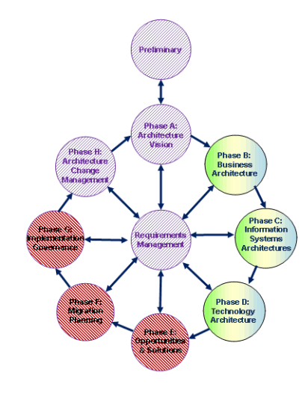

Figure 1: TOGAF Framework

Using an architecture framework will ensure more complete coverage of the designed solution, speed up and simplify architecture development and make sure that the architecture selected allows for future growth in response to the needs of the business.

* 1. Layers

Archimate architectural models have a layered and service-oriented look based on specializations of the core concepts. The higher layers make use of services that are provided by the lower layers.

Archimate defines three main layers:

The ***Business layer*** is about business processes, services, functions and events of business units. This layer provides products and services to external customers, which are realized in the organization by business processes performed by business actors and roles.

The ***Application layer*** is about software applications that support the components in the business with application services.

The ***Technology layer*** deals with the hardware and communication infrastructure to support the Application Layer. This layer offers infrastructural services needed to run applications, realized by computer and communication hardware and system software.

The structure of the core Archimate language closely corresponds with the three main architectures as addressed in the TOGAF. This correspondence would suggest a fairly easy mapping between TOGAF views and the Archimate viewpoints.

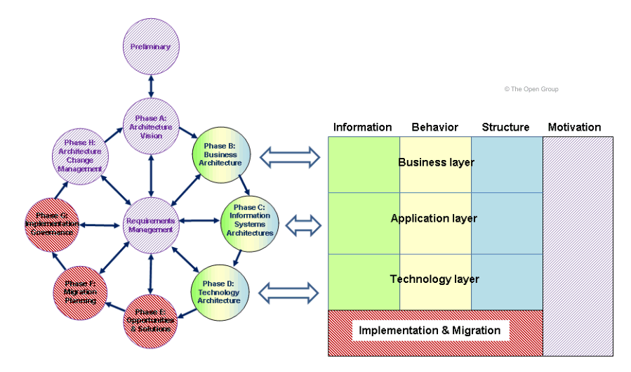

Figure 2: Correspondence between TOGAF and Archimate layers

* 1. Component

The layers of the Archimate framework can be organized into nine parts, as illustrated in Figure 3.

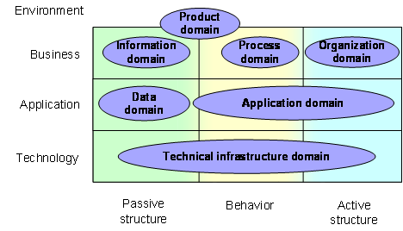

Figure 3: Framework Components

The classification of the concepts is based on conceptual domains or aspects and layers. These aspects do not have a strict boundary. They often link the different aspects and layers play a central role in a coherent architectural description. For example, running somewhat ahead of the later conceptual discussions, business functions and business roles serve as intermediary concepts between “purely behavioural” concepts and “purely structural” concepts.

Besides the three core aspects shown in Figure 3 (passive structure, behaviour, and active structure), which are mainly operational, there are still many other important aspects. Some aspects may cross different conceptual domains. For example: Goals, Security, Governance, Costs, Performance, Timing, Planning and Evolution.

* 1. Organizational Structure Diagram

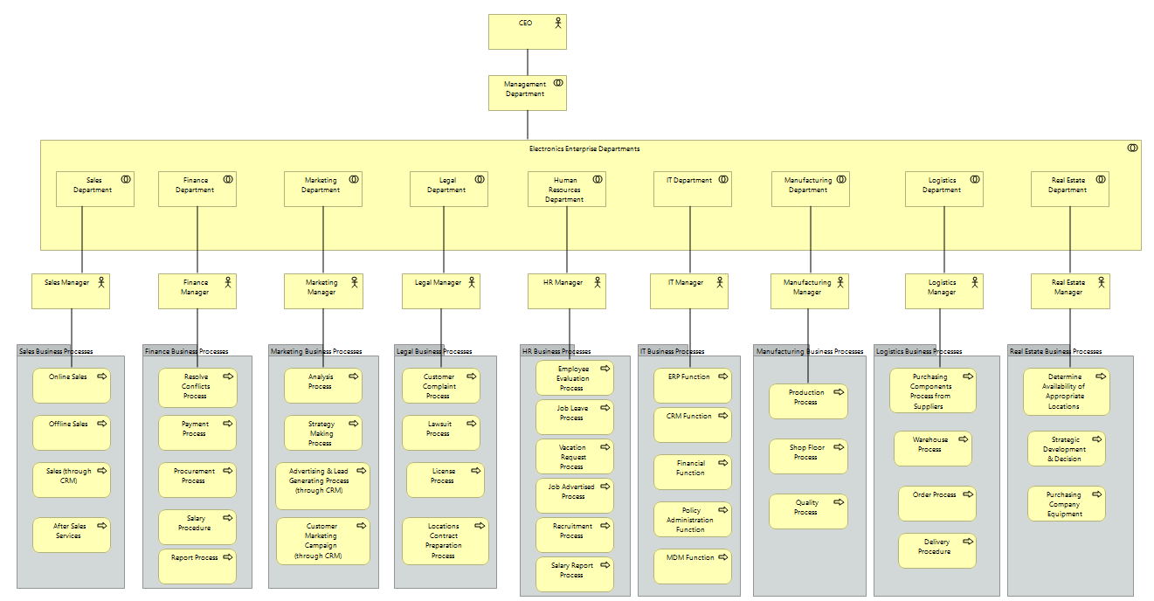

Figure 4 Organizational Structure

The organizational structure diagram shows the structure of the enterprise. It determines how the roles, functions and responsibilities are assigned and coordinated. Different functions go into separate departments that report to department managers, who then report to someone higher level. The diagram depends on the enterprise’s objectives and strategy. It can be used to depict the whole structure of the enterprise or broken down by department. The top layer has the most of the decision making power and has tight control over departments.

In the enterprise, there are nine departments: Sales Department, Finance Department, Marketing Department, Legal Department, Human Resources Department, IT Department, Manufacturing Department, Logistics Department and Real Estate Department.

Sales Department has the processes of Online Sales, Offline Sales, Sales (through CRM) and After Sales Services.

Finance Department has the processes of Resolve Conflicts Process, Payment Process, Procurement Process, Salary Procedure and Report Process.

Marketing Department has the processes of Analysis Process, Strategy Making Process, Advertising & Lead Generating Process (through CRM) and Customer Marketing Campaign (through CRM).

Legal Department has the processes of Customer Complaint Process, Lawsuit Process, License Process and Locations Contract Preparation Process.

Human Resources Department has the processes of Employee Evaluation Process, Job Leave Process, Vacation Request Process, Job Advertised Process, Recruitment Process and Salary Report Process.

IT Department has the functions of ERP Function, CRM Function, Financial Function, Policy Administration Function and MDM Function.

Manufacturing Department has the processes of Production Process, Shop Floor Process and Quality Process.

Logistics Department has the processes of Purchasing Components Process from Suppliers, Warehouse Process, Order Process and Delivery Procedure.

Real Estate Department has the processes of Determine Availability of Appropriate Locations, Strategic Development & Decision Making and Purchasing Company Equipment Process.

For each process we implement in BPMN, the next section shows the detail procedures.

* 1. Business Processes

The business layer is implemented by Business processes using BPMN tool. The following parts will show the BPMN diagrams and describe each process correspond to different departments.

* + 1. 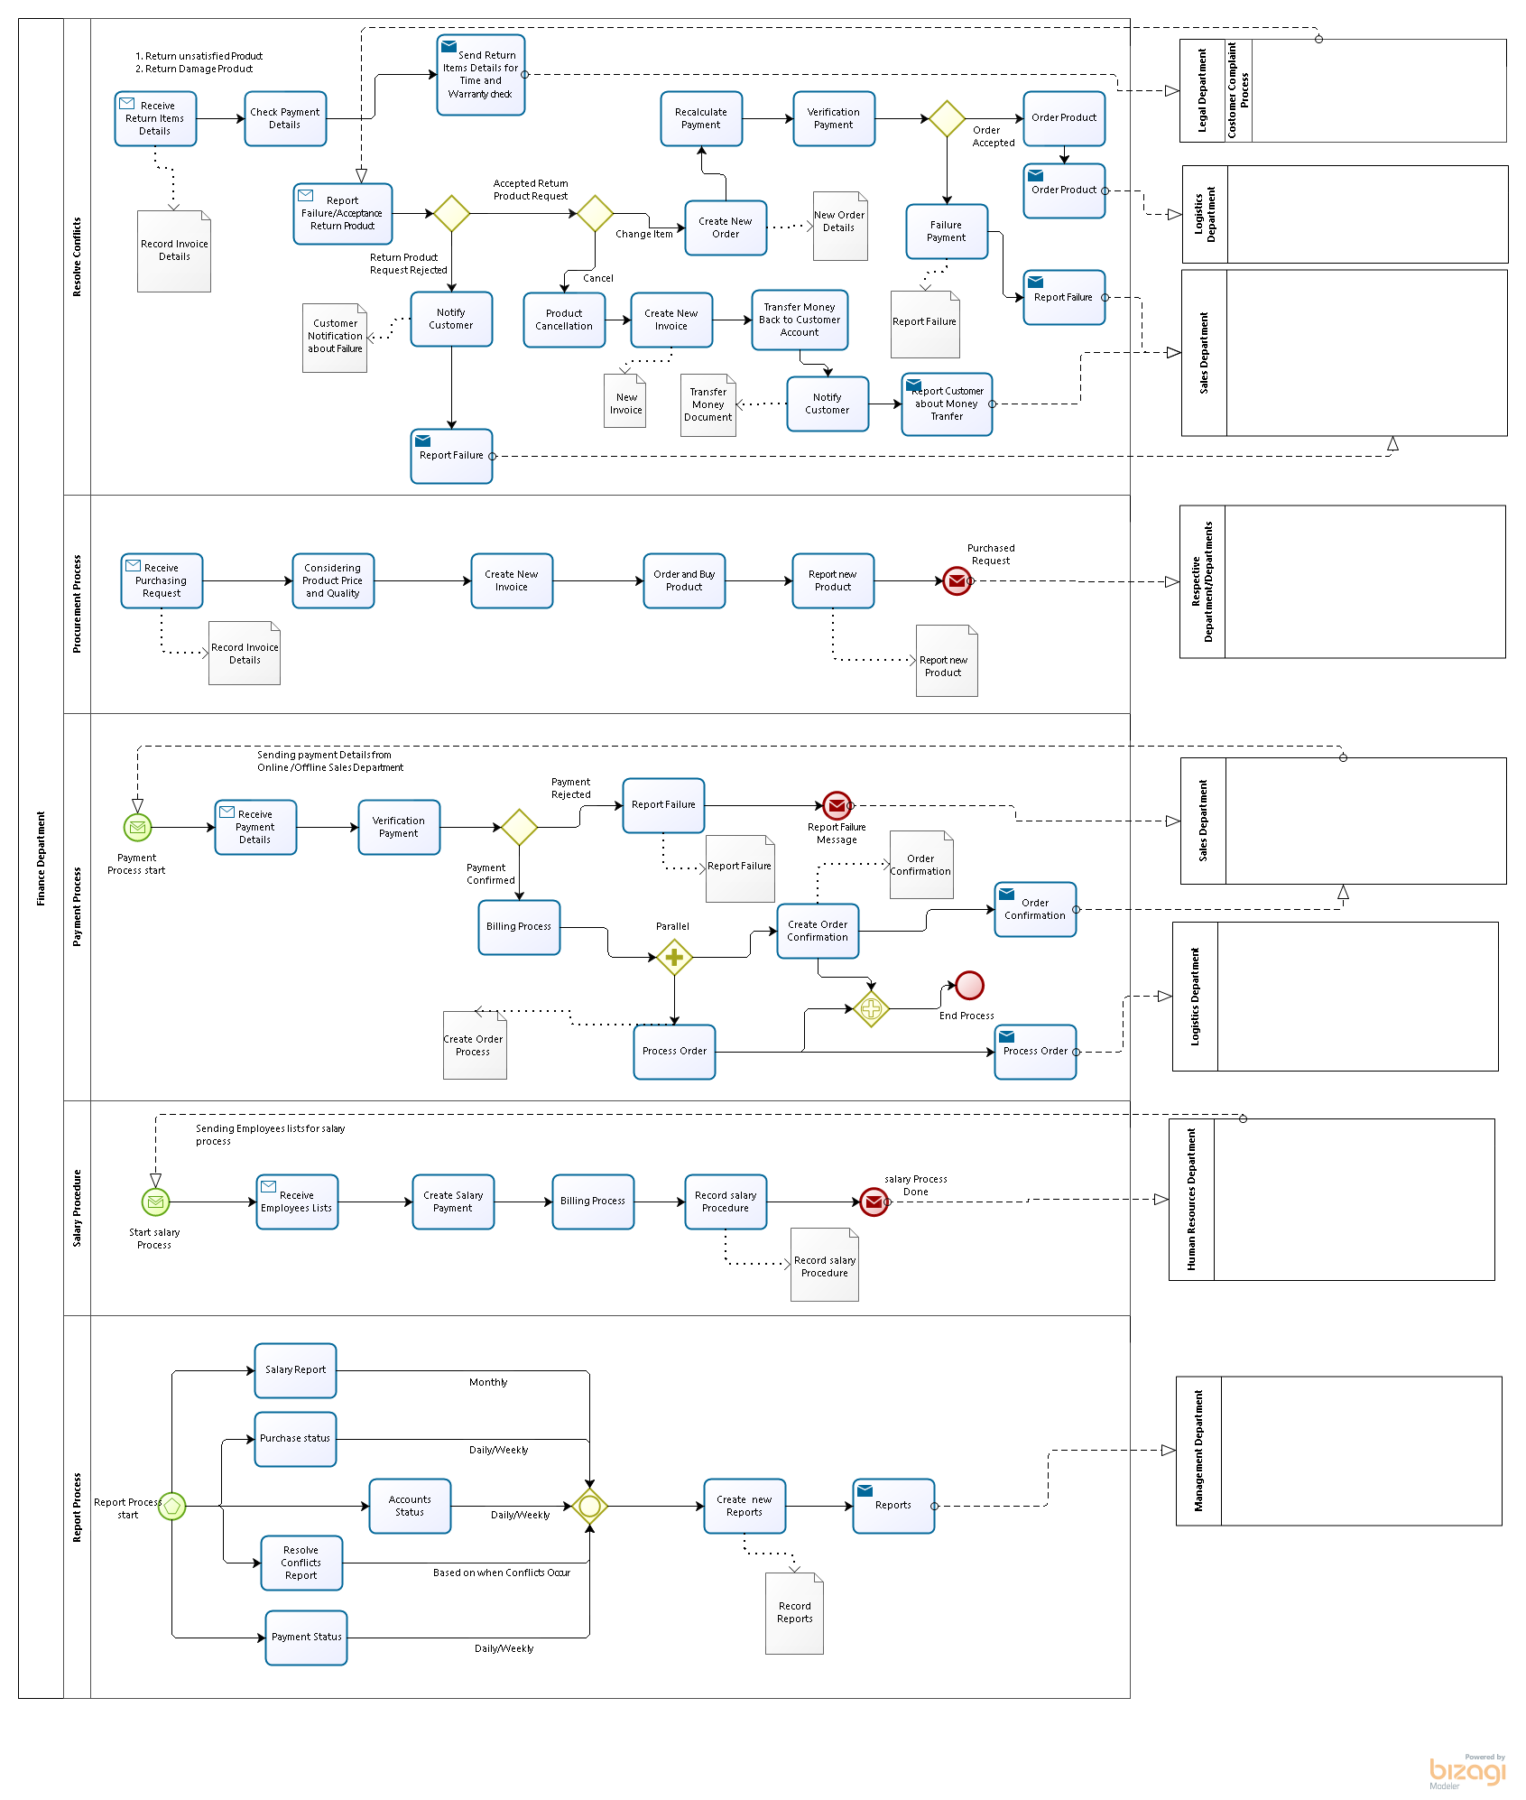Finance Department

Figure 5: Finance Dept. Business Processes

Description

The activities expected from a Finance Department cover a wide range from basic bookkeeping to providing information to assisting managers in making strategic decisions. At the base level, the finance department will be responsible for all the day to day transactional accounting for the business.  This will include the tracking of all transactions and the management of any government reporting.

The finance department is also responsible for management of the organization’s cash flow and ensuring there are enough funds available to meet the day to day payments.  This area also encompasses the credit and collections policies for the company’s customers, to ensure the organization is paid on time, and that there is a payment policy for the company’s suppliers.  In most organizations there will be some form of forecast prepared on a regular basis to systematically calculate the ongoing cash needs.

Where there are cash needs beyond the day to day working capital, the finance department is responsible for advising and sourcing longer term financing.

Looking forward, the finance department will work with managers to prepare the organization’s budgets and forecasts, and to report back on the progress against these throughout the year.  This information can be used to plan staffing levels, asset purchases and expansions and cash needs, before they become necessary

Finally, the finance department should be called upon to provide information to assist managers in making key strategic decisions, such as which markets or projects to pursue or the payback periods for large capital purchases.  The finance department can often contribute an objective perspective based on special financial assessment techniques.

Process Elements

* + - 1. Resolve Conflicts

**Description**

Resolve Conflicts is the process of handling conflict issues such as return unsatisfied or damaged products. And based on the company policy it tried to resolve the conflict and considers as a vital situation to provide some new offer for customer in order to get their satisfactory.

* + - 1. Procurement Process

**Description**

Procurement Process is one of the financial procedures to keep an efficient record of all items that have been bought or purchased and also price and quality of requested product are considered as important factors to have an effect on the final decision to order.

* + - 1. Payment Process

**Description**

Payment Process validations verified billing information and confirmed the invoice amount is transferred to the company`s account. Based on this confirmation, next step would be to notify customer about successful payment and also send customer`s request to logistics department for packaging and delivery process.

* + - 1. Salary Procedure

**Description**

Salary Procedure is responsible for calculating the wages and salaries of employees and organizing the collection of income tax and national insurance for the Inland Revenue.

* + - 1. Report Process

**Description**

Report Process provides reporting of historic financial information. This process generally includes ongoing financial information such as salary report, purchase and payment status for managers in order to inform and enable them to make better decision.

* + 1. Legal Department

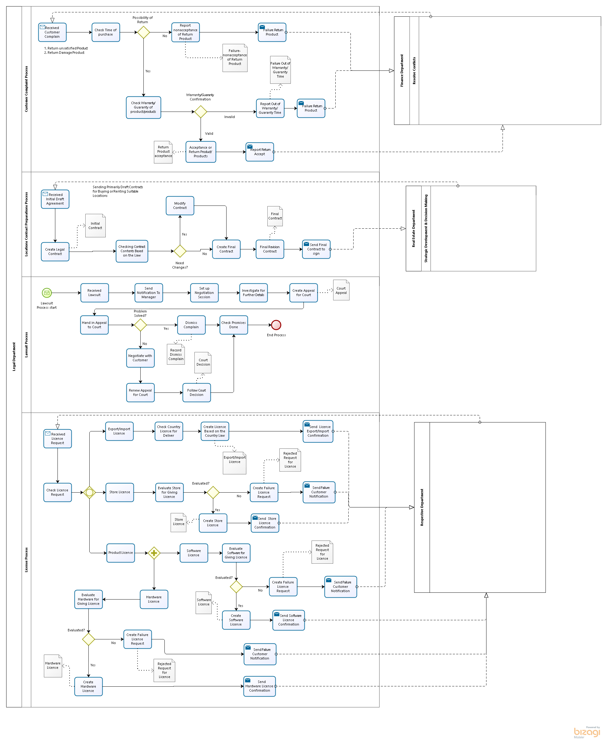

Figure 6: Legal Dept. Business Processes

Description

The legal department of a business handles legal issues that may come up in the course of business, ranging from drafting waiver forms for employees to handling lawsuits from angry customers. Many large companies have this type of department; ensuring that they have quick access to legal knowledge when they need it. Customers can often find themselves interacting with the department, especially when they file complaints or indicate that they believe a business is not operating within the law.

Process Elements

* + - 1. Customer Complaint Process

**Description**

Customer Complaint Process will become involved in [customer complaints](http://www.wisegeek.com/how-do-i-handle-customer-complaints.htm), ensuring that the responses to these complaints are drafted in a professional style that also covers the company's bases legally. This Process is responsible for return of unsatisfied or damaged products in order to confirm or reject them based on given Warranty/Guaranty.

* + - 1. Locations Contract Preparations Process

**Description**

Locations Contract Preparation Process manages final contract based on initial agreement between company and landowner.

* + - 1. Lawsuit Process

**Description**

Lawsuit Process provides responses to complaints which the company is [sued](http://www.wisegeek.com/what-should-i-do-if-im-being-sued.htm), either from within or from the outside; the process will represent the company in the suit. It also occasionally handles checking promises to ensure about satisfaction.

* + - 1. License Process

**Description**

License Process handles the filing of location, hardware and software license. This process authorizes other companies or customers based on company`s right to use their products. And also it provides export/import license for transferring products internationally based on destination`s laws.

* + 1. Sales Department

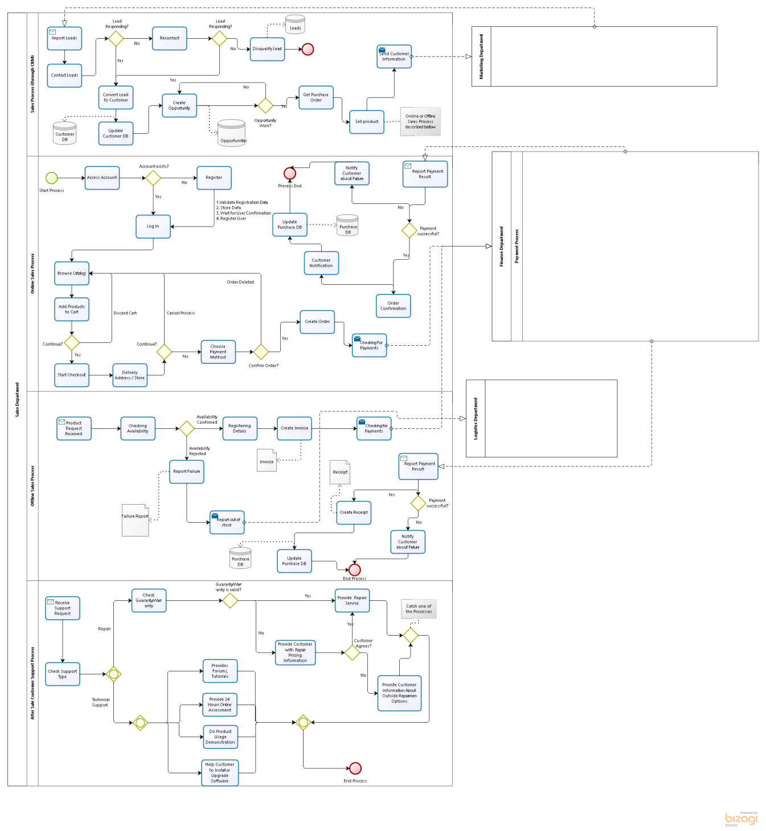

Figure 7: Sales Dept. Business Processes

Description

Sale is a transaction between two parties, buyer and seller, where the buyer receives goods (tangible or intangible) or services from sellers in exchange for money.

 Sales Manager along with the Sales Department is responsible for administration functions, operational performance reporting, streamlining processes and systems wherever possible, and advising senior management on maximizing business relationships and creating an environment where customer service can flourish.

In the Sale Department of our Electronics Enterprise we have described the following business processes:

* General Sale Process (using CRM),
* Online Sale Process
* Offline Sale Process
* After Sale Customer Support Services.

Process Elements

* + - 1. Sales Process (through CRM)

**Description**

This sub-process is responsible for generating and qualifying leads which were previously generated in Marketing Department. Main functions here are:

* Contact Leads
* Convert Leads to Customers
* Create Opportunities
* Get Purchase Request

This process is based on CRM system.

* + - 1. Online Sales Process

**Description**

This sub-process is describing all possible actions in online sales, like:

* Browse Catalogs
* Check Product Details
* Add/delete Products to/from Card
* Create Order
* Payment

This process is organized using E- Commerce system.

* + - 1. Offline Sales Process

**Description**

This sub-process demonstrates main activities of Offline Sales through the following functions:

* Receive Product Request
* Check Availability
* Register Purchase
* Create Invoice
* Payment
* Create Receipt

Central ERP system is used here.

* + - 1. After Sale Customer Support Process

**Description**

This sub-process in mainly responsible for after Sale Customer support services like Repairing or Technical Support.

* + 1. HR Department

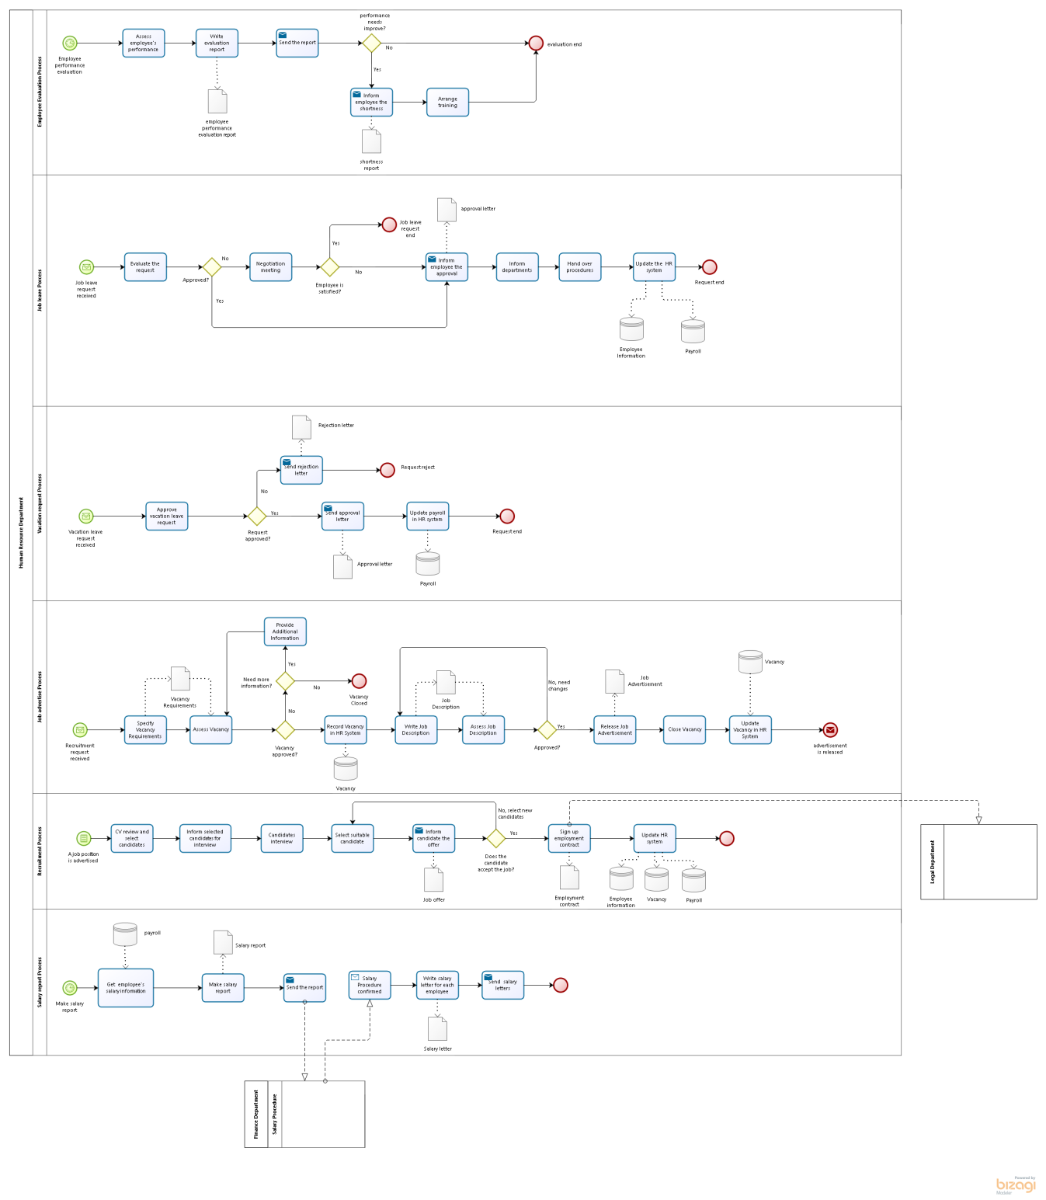

Figure 8: HR Dept. Business Processes

Description

The Human Resource Department is concerned with the issues of managing people in the company. To ensure the company employs the right balance of staff in terms of skills and experience. It is concerned with employee hiring, evaluation, training and development, managing payroll and providing opportunities for employees to enhance their performance and achieve the enterprise's business goals.

Process Elements

* + - 1.  Employee Evaluation Process

**Description**

 Employee Evaluation Process will evaluate employee's performance to ensure the company employs the right balance of staff in terms of skills and experience. It will deliver a report and provides training and development opportunities for employees.

* + - 1. Job leave Process

**Description**

Job leave Process handles the employee's leaving request, provides a negotiation meeting between employee and the company, and ensures the hand over process.

* + - 1. Vacation request Process

**Description**

Vacation request Process deals with the request, send rejection or approval letters and records in HR systems.

* + - 1. Job advertise Process

**Description**

Job advertise Process specifies the vacancy position, makes the job description and records in HR system, finally release job advertisements and notifies recruitment process can start.

* + - 1. Recruitment Process

**Description**

Recruitment Process will select suitable candidate for a vacancy position, send the contract to Legal Department update HR system.

* + - 1. Salary report Process

**Description**

Salary report Process responses for calculating the employees' salaries and give the salary letter, and also send the report to Finance Department.

* + 1. Logistics Department

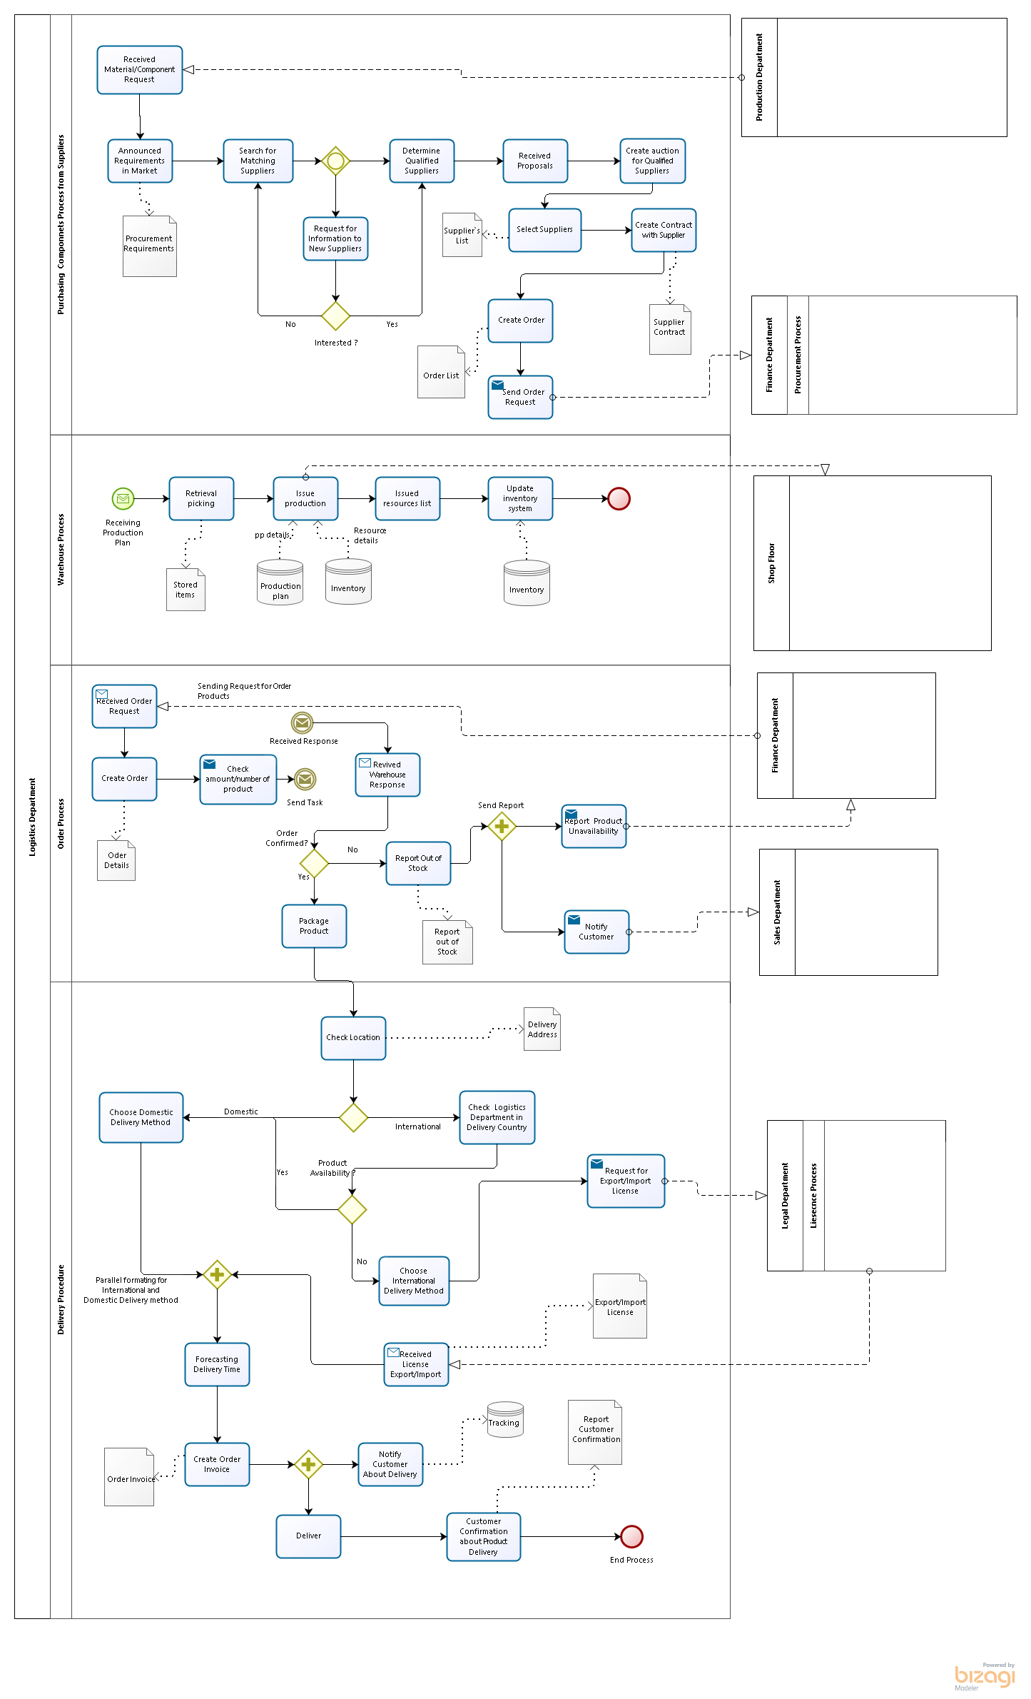

Figure 9: Logistics Dept. Business Processes

Description

The Logistics Department has the responsibilities of ensuring that the entire process of logistics is maintained and developed in the same with the goals of the business at an economical cost. The tasks of the department include purchasing, storage, distribution, warehousing, movement of products from one place to another, tracking and delivery. It includes a complete process of planning, managing, controlling and coordination to make sure that the products reach the right place, at the right time, for the right cost and in a right condition.

Process Elements

* + - 1. Purchasing Components Process from Suppliers

**Description**

Purchasing Components Process from Suppliers is responsible for searching suitable suppliers based on the request from Production Department. And create contract and order with suppliers. Finally send the order request to Finance Department.

* + - 1. Warehouse Process

**Description**

Warehouse Process ensures the items in warehouse are right before and after the issuance which is related with Shop Floor, and update the inventory system.

* + - 1. Order Process

**Description**

Order Process deals with the order products request. It will check the warehouse, if confirms the order then package product and deliver otherwise inform the unavailability.

* + - 1.  Delivery Procedure

**Description**

Delivery Procedure deals with deliver products both domestic and international. Make sure the export/import license is prepared and inform customer about tracking.

* + 1. Manufacturing Department

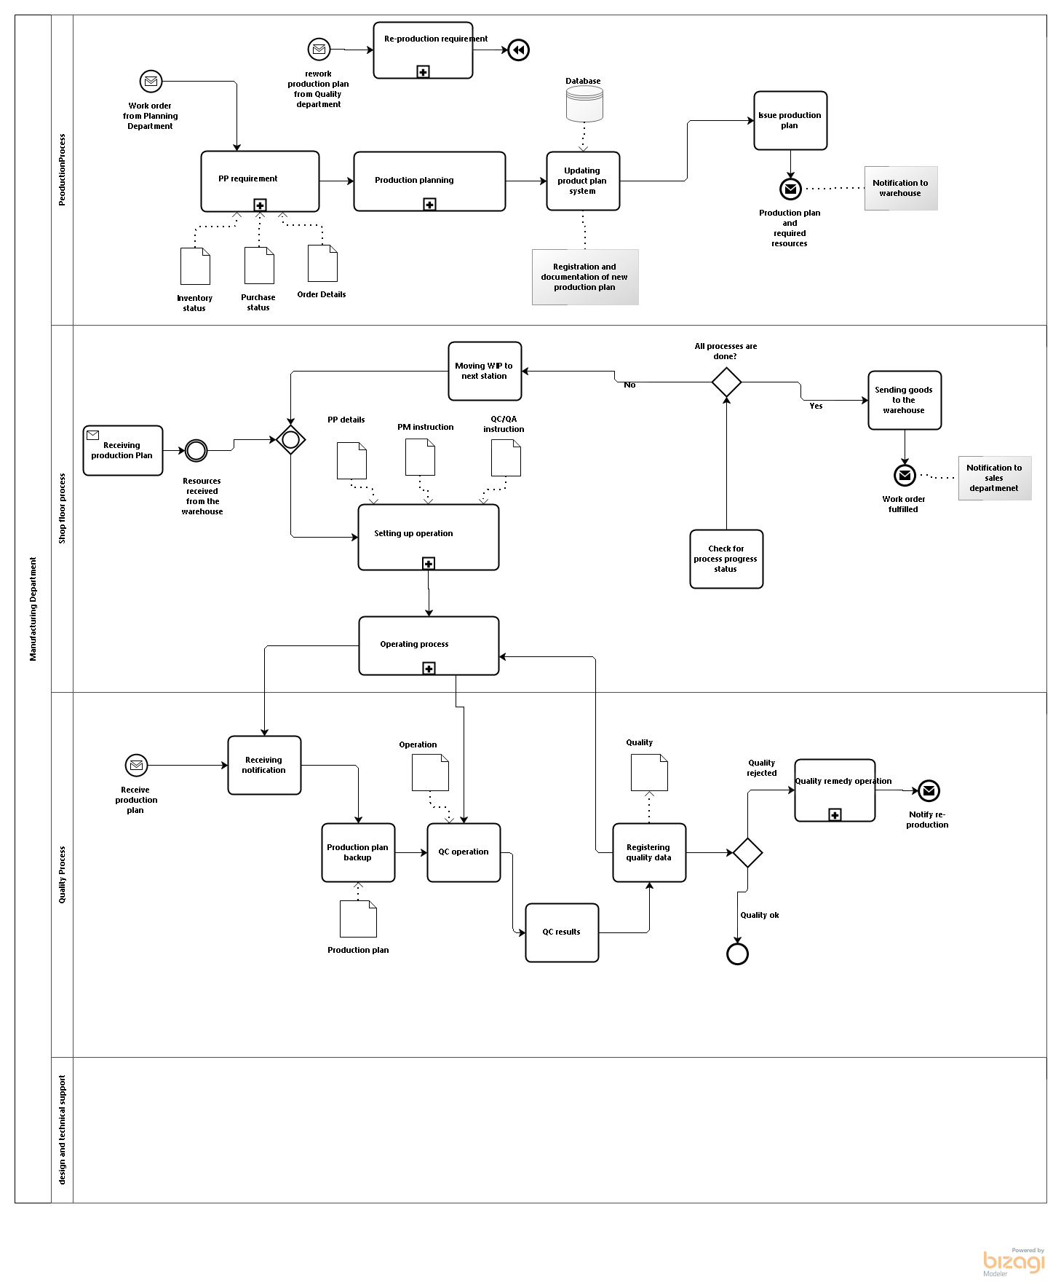

Figure 10: Manufacturing Dept. Business Processes

Description

Manufacturing is the functional area responsible for turning inputs into finished outputs through a series of production processes. The Production Manager is responsible for making sure that raw materials are provided and made into finished goods effectively. He or she must make sure that work is carried out smoothly, and must supervise procedures for making work more efficient and more enjoyable. In a manufacturing company the production function may be split into five sub-functions.

Process Elements

* + - 1. Production process

**Description**

The production department is the functional area and is responsible for turning inputs into finished outputs through a series of production processes. The production processes are the various stages of production that turn raw materials into finished goods. Although businesses such as bank, insurance companies and internet service providers do not supply physical goods that can be seen or held, they do have to organize their resources to meet customers’ demands as completely as possible.   
The main function of production is to turn inputs (raw materials) into outputs (finished goods). Outputs refer to a finished product or service and inputs are the materials that are needed to manufacture certain goods. When a business completes this process they are able to achieve customer satisfaction by producing products that are ready to be used and fit for purpose.

Production BPM Diagram represents how the work order is fulfilled as responding to the received customer order. Production is triggered by Work order “Start” event message from planning department. “Embedded” sub-process of PP requirement followed by Production planning “Embedded” sub-process leads to the Updating production plan system task. Through registration into the system the production plan is sent to Shop floor, Quality Dept. and Warehouse by Issue production plan “Send” task terminating with a “Message” end event.

* + - 1. Shop floor process

**Description**

Shop floor process is a process to produce parts, items and final products through production operation. Production plan is received in Shop floor and after a while upon “Receive” required resources task event from Warehouse the operation process will be setup with “Embedded” sub-process. Operating process sub-process with “Multi-instance parallel loop” is made on items in a defined size of lots inside the allocated production routings followed by “User” task of Check for process progress status to check for any other remaining operating process required to be performed onto the items in lots. This is shown by All processes are done “Data-based exclusive decision” gateway with a Yes control flow meaning the operation process is ended and followed by Sending goods to warehouse “Send” task and “Message” end event of Work order fulfilled.

* + - 1. Quality Process

**Description**

It's the job of the QC Process to make sure that what comes out of Production actually works.  In company that manufactures stuff, they will devise tests that every product (or a sample from a production batch) has to pass before it is shipped.  In a software company, QC usually works with the developers to find bugs (although many companies are letting their customers take on the QC task).

Quality department which is concurrently performed with updating production plans task.

* + - 1. design and technical support

**Description**

The design and technical support department is responsible for researching new products or modifications to existing ones, estimating costs for producing in different quantities and by using different methods. It will also be responsible for the design and testing of new product processes and product types, together with the development of prototypes through to the final product. The technical support department may also be responsible for work study and suggestions as to how working practices can be improved.

* + 1. Marketing Department

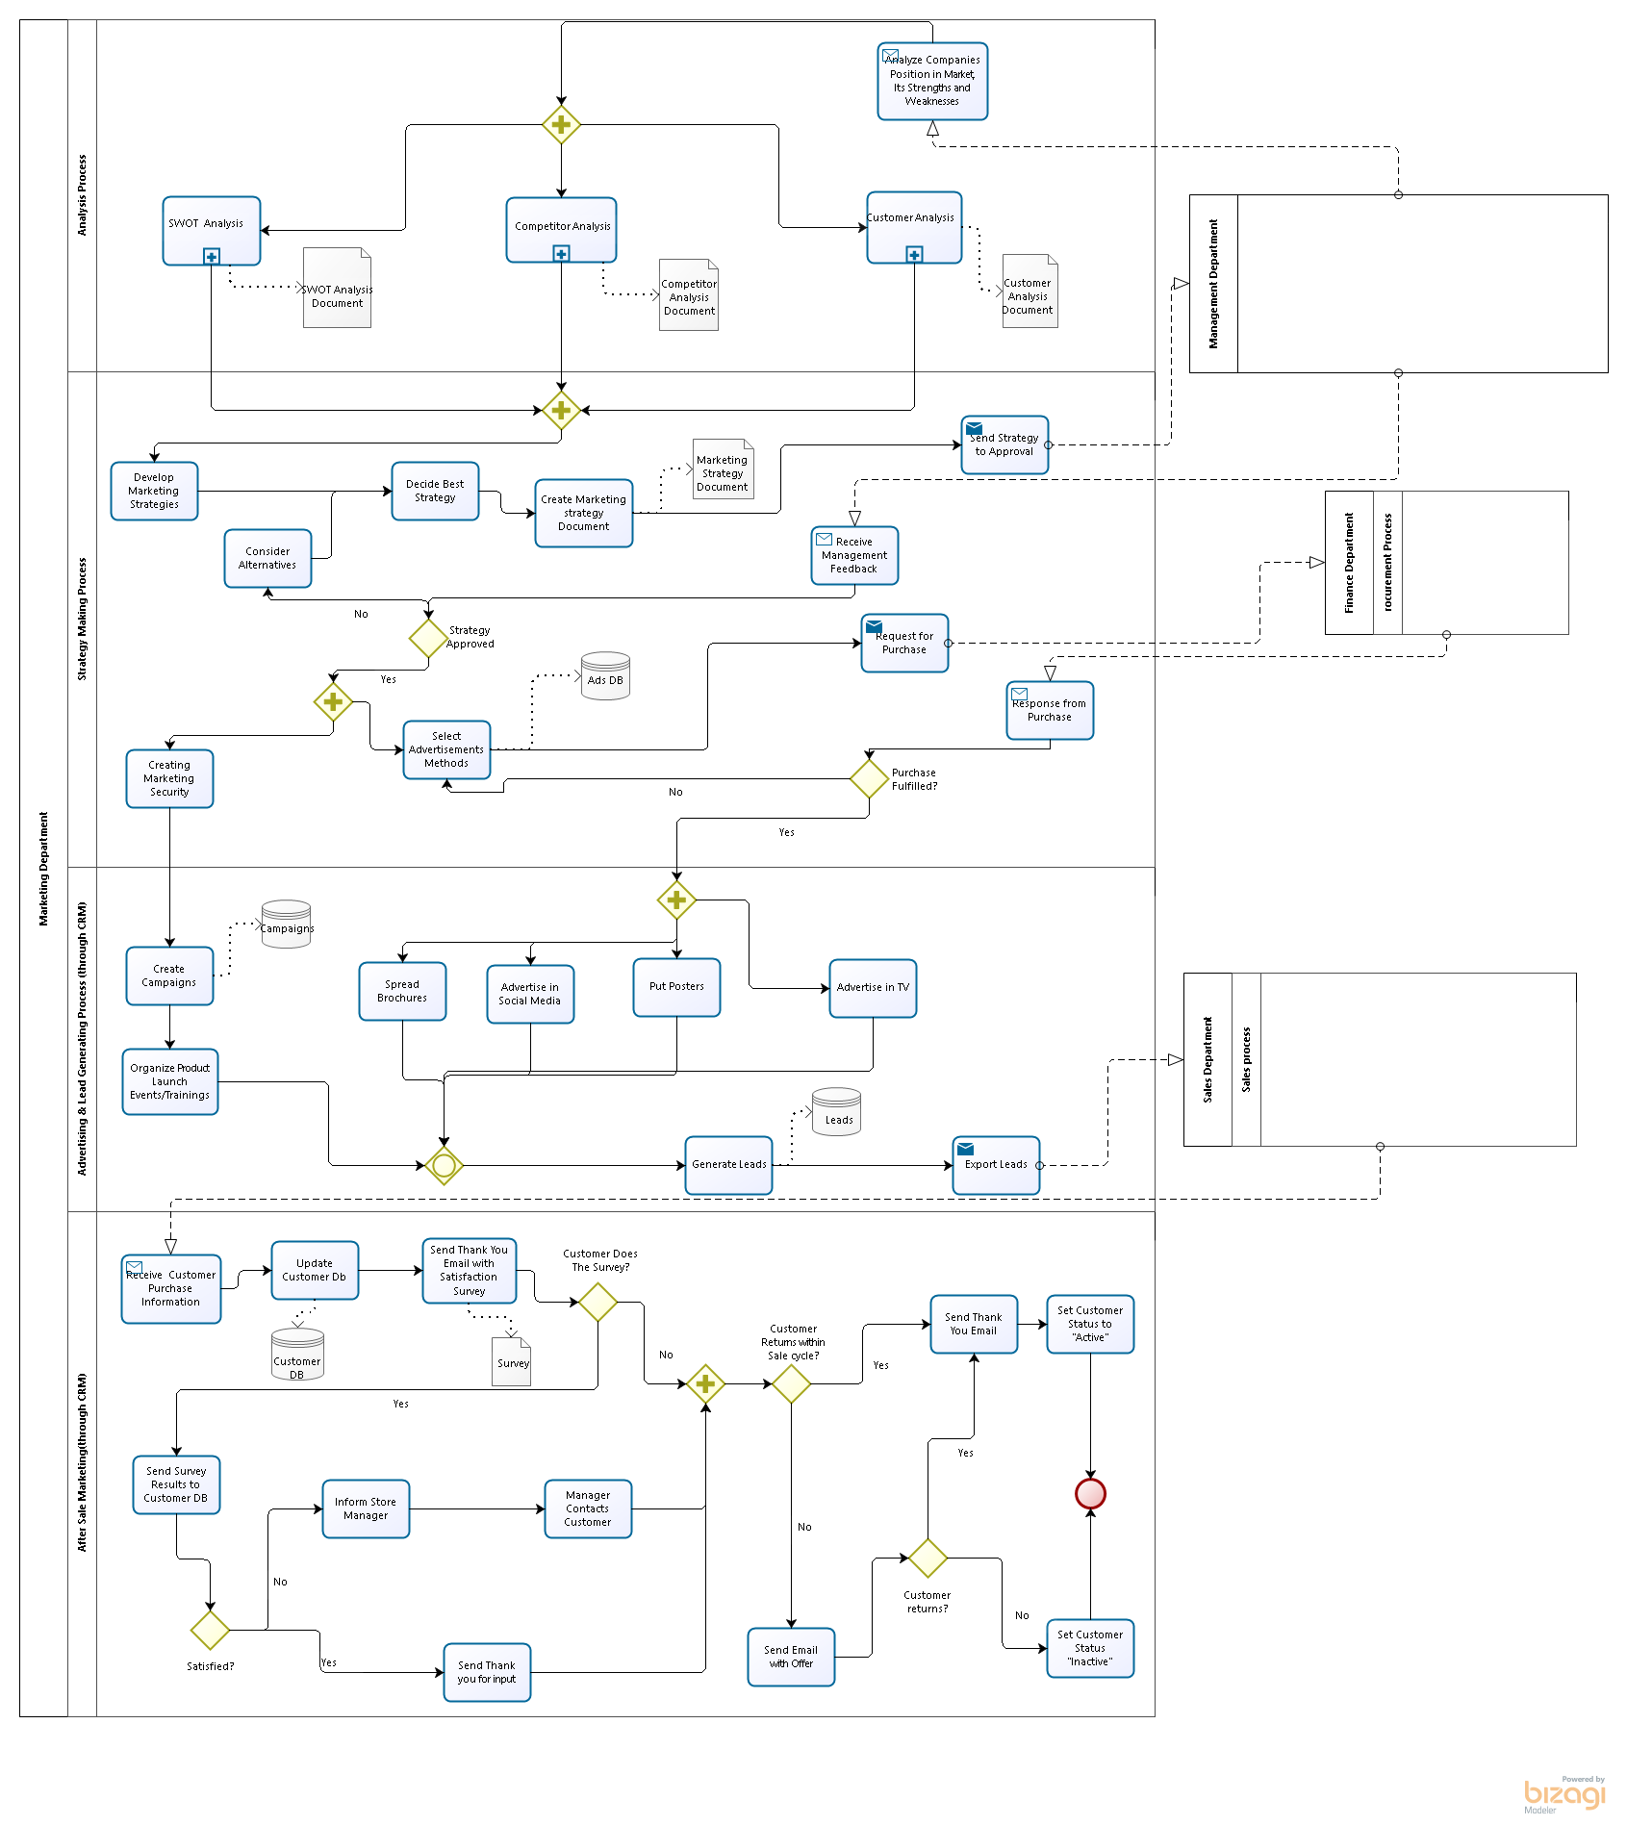

Figure 11: Marketing Dept. Business Processes

Description

Marketing is about communicating the value of a product, service or brand to customers or consumers for the purpose of promoting or selling that product, service, or brand.

In our Electronics Enterprise following business processes are described in Marketing Department:

* Analysis Process
* Strategy Marking Process
* Advertising & Lead generating Process (using CRM)
* After Sale marketing Process (using CRM).

Process Elements

* + - 1. Analysis Process

**Description**

Analysis sub-process is the first step in Marketing Strategy. It identifies:

* Customers and their Requirements
* Competitors in Market
* Enterprises Strengths and Weaknesses
  + - 1. Strategy Making Process

**Description**

This sub-process in mainly responsible for creating marketing strategy and business plan based on analysis results coming from previous sub- process. The main actions here are:

* Develop Marketing Strategies
* Select Best One
* Ask Upper Management to Approve
* Choose Alternative Strategy in case of not Approved
* Perform Strategy (e.g. select advertisement methods)
  + - 1. Advertising & Lead Generating Process (through CRM)

**Description**

This sub-process describes the actions how to get customers and their interest.  Main activities here are:

* Create campaigns
* Spread brochures
* Advertise in TV and Social Media
* Put posters

 Based on the above mentioned activities marketing department generate leads, which can be later converted to customers in Sales Process.

* + - 1.  After Sale Marketing(through CRM)

**Description**

This sub-process is responsible for keeping customer relationships after Sale and getting their feedback about products. It includes such activities as:

* Send Emails and Survey to Customers
* Get Feedback
* Check Customers Purchase Frequency
* Re-contact Customer and Send New Offers

This process in based on CRM system.

* + 1. Real Estate Department

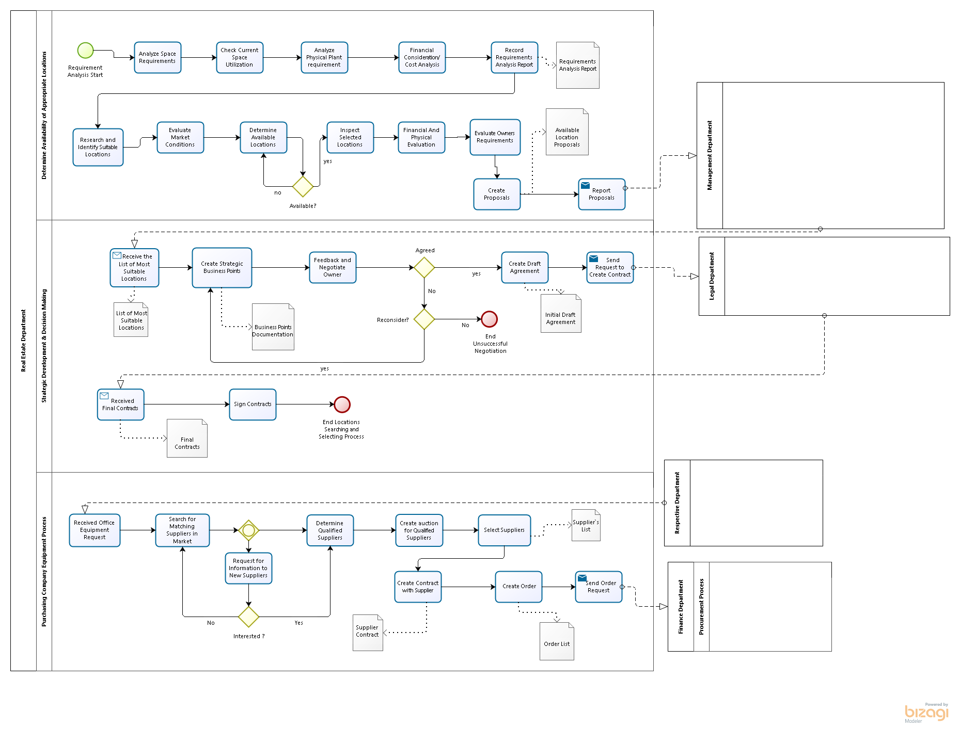

Figure 12: Real Estate Dept. Business Processes

Description

The Real Estate Department performs property management and development services for the company. It is responsible for selecting location and office equipment purchasing.

Process Elements

* + - 1. Determine Availability of Appropriate Locations

**Description**

The process is response for looking a suitable location. It will analyze requirements, cost, market conditions, and finally generate a proposal.

* + - 1. Strategic Development & Decision Making

**Description**

This process will analyze locations based on business strategies and select suitable one. After that together with Legal Department deal with signing contracts.

* + - 1. Purchasing Company Equipment Process

**Description**

Purchasing Company Equipment Process is responsible for searching suitable suppliers for office equipment based on the request from respective department. And create contract and order with suppliers. Finally send the order request to Finance Department.

* 1. Application Architecture
     1. Overview of Application Layer

In this section, application layer is described:

1. Application landscape
2. Interfaces between applications
3. Functionality of an application
4. Process overview
   * + 1. Application landscape

An overview of applications is often visualized in an application landscape. This is done to provide an overview of the relationships between applications. This will often produce a large number of connecting lines and actually no overview at all. This kind of overview often only shows how complex the application landscape is.

It is important to keep overviews readable. Apply a rule of maximum 10 to 15 applications per overview. If there are more, it is recommended to use a general model containing only a major grouping and a detailed model per group. Choose a viewpoint that is important for the stakeholder you are addressing. The format will always be an Application structure viewpoint. A classification can be done via process, organization, data, and type of functionality or infrastructure. Group applications per area of interest and only connect the areas. With an increasing number of applications it will give more of an overview if relationships are visualized in a matrix.

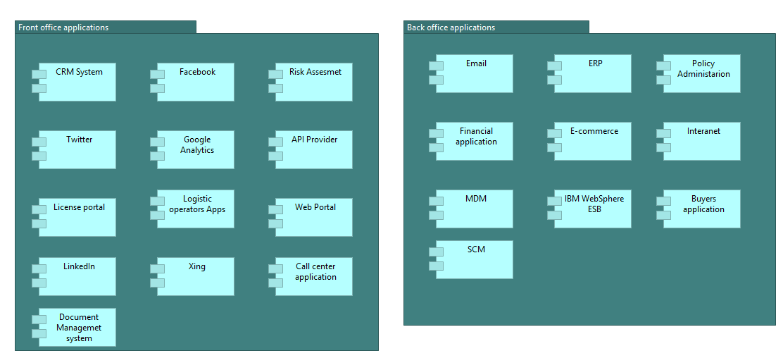Below an example is shown of an application landscape organized along application type and also the application landscape according to usage pattern by front-office and back-office.

Figure 13: Example of an application landscape organized along usage of front-office and back-office

For an overview of all relationships you need multiple views. Use a matrix for this purpose. A tool can be very valuable in this case to register information and produce a relationship matrix.

**Alternatives:** The alternative is the large ‘view’ with all applications and the many lines. This is only usable to express how complex the landscape is and does not give much additional added value.

**Relationships with other good practices:** There is an important relationship with ‘Interfaces between applications’.

* + - 1. Interfaces between applications

It is desirable to visualize interfaces between applications. An application is modeled as an application component with corresponding application functions. An interface between applications is modeled via an application service. The application service delivers data by means of an access relationship with a data object. In the example model application Payment function realizes an application service that is used Payment Interface.

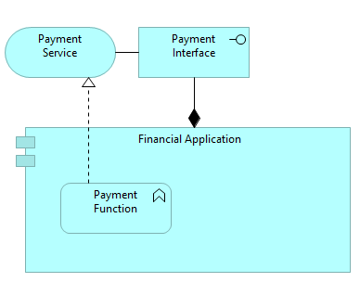

Figure 14: Application interface using application function, application service and connected application component.

* + - 1. Functionality of an application

This section is about the functionality of each application which is used in the IT architecture. It describes different functions which that specific application should cover over the whole architecture. In the figure 15, CRM functionality is illustrated. It indicates 3 different groups, Security and Reliability, Integration and User-Related Functions. Each group is responsible to meet the mentioned functions and fulfilled the functionality.

In addition, it is possible to define sub-group in a group in order to categorize functionalities like User-Related Functions, which 3 sub-groups are defined to describe that specific functionalities.

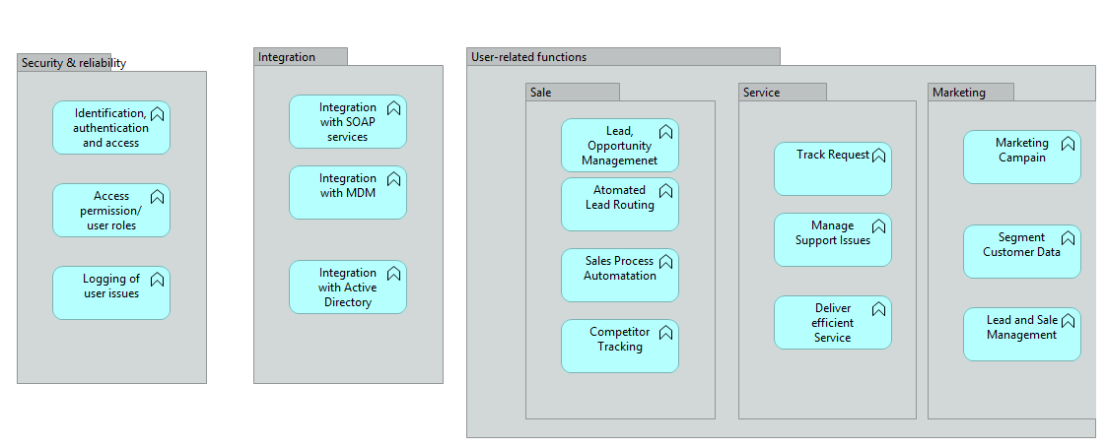

Figure 15: CRM Function

* + - 1. Process overview

In previous section, it is mentioned for each application, some specific functionalities are described in order to be integrated. In this part, it will be shown the integration between 2 different layers. When some components are used in application layer, they need to communicate with other components in technology layer, so it is necessary these layers are integrated with each other and synchronized to avoid ambiguity. In figure 16, there is CRM process overview which can be seen CRM applications and how they process data and work with each other and also how CRM applications are connected to CRM server in order to use database, application and web services from server in technology layer.

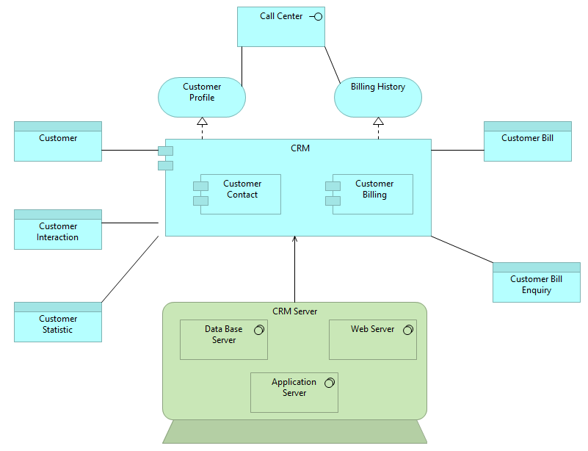

Figure 16: CRM Process Overview

* 1. Data Architecture
     1. Overview of Data Architecture

**Data architecture** is composed of models, policies, rules or standards that govern which data is collected, and how it is stored, arranged, integrated, and put to use in data systems and in organizations (Wikipedia).

In our Electronics Enterprise there are 5 main applications to automate and organize business processes. These are: **Enterprise Resource Planning (ERP)**, **Electronic Commerce** (**E-commerce)**, **Financial Application, Customer Relationship Management (CRM)** and **Master Data Management (MDM).** In the following sub-chapters we will describe each system in details including their purpose, their functionality domains and also data flow within and between these systems.

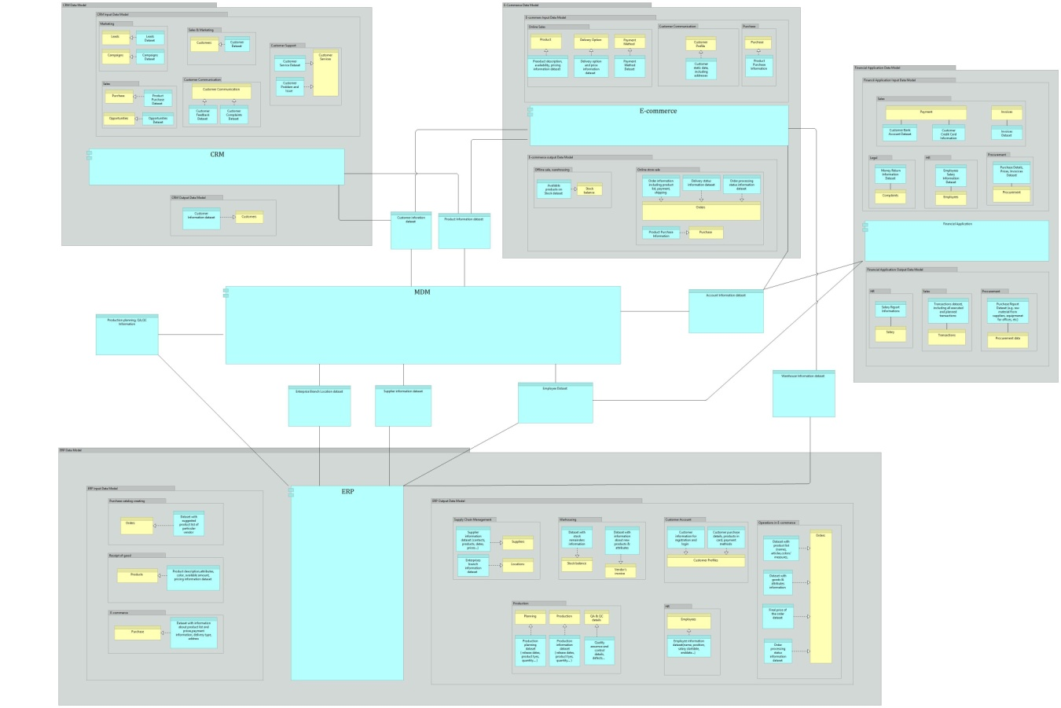

Figure 17: Data Architecture Model

* + - 1. Enterprise Resource Planning(ERP)

**Enterprise resource planning** (**ERP**) is business management software—typically a suite of integrated applications—that a company can use to collect, store, manage and interpret data from many business activities. (Wikipedia)

ERP system is a central part in our Electronics Enterprise. It automates business activities from such departments as Manufacturing, Logistics, and HR etc. ERP stores and manages data from following business processes:

* Production and Manufacturing
* Supply Chain Management
* E-commerce
* Warehousing & Inventory management
* HR Management
* Shipping and Delivery

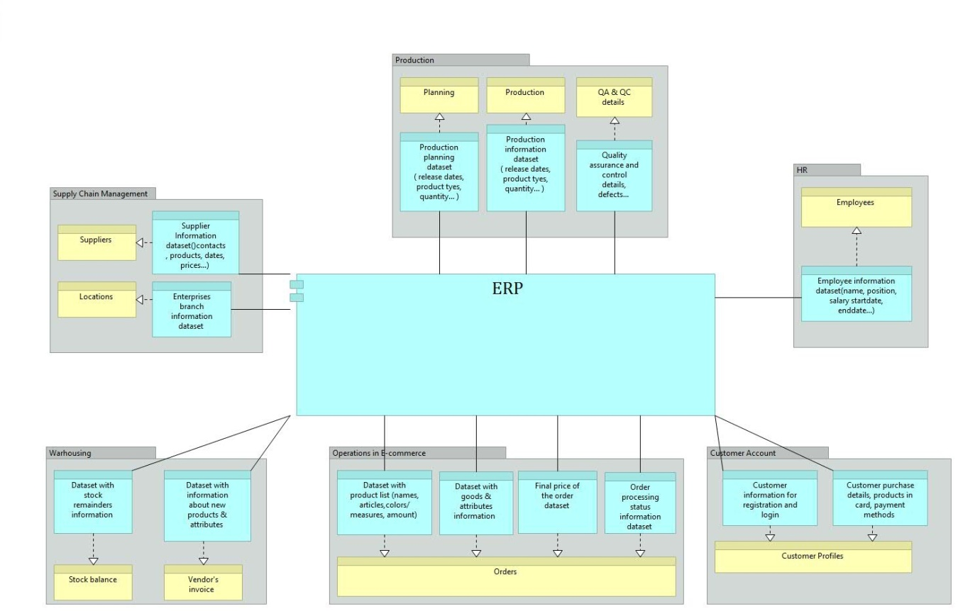

Figure 18: ERP Data Model

­­­­­­­­

* + - 1. E-commerce

**E-commerce** or electronic **commerce**, is trading in products or services using computer networks, such as the Internet. It includes online shopping websites, online marketplaces, etc.

In our enterprise it is used for organizing all virtual sales activities. E-commerce is responsible mainly for online sales business process as well as it keeps track on orders, product list, and availability of products, delivery and payment methods. Another important part of E-commerce is storing customer account data and their purchase history.

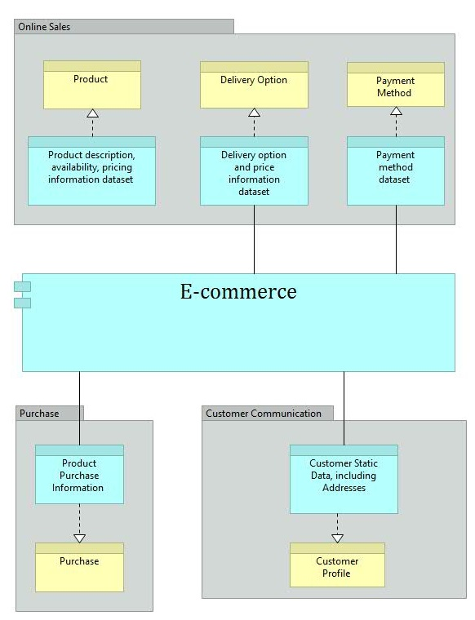 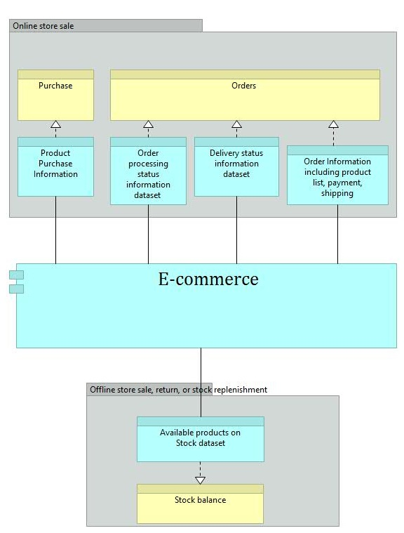

Figure 19: E-Commerce Input and Output Data Model

­­­­­­

* + - 1. Financial Application

For managing all financial activities within and out of enterprise Financial Application system is used. Its main functions are storing banking account details of customers (for sales), of suppliers (for procurement), of employees (for salary distribution). This application stores also all invoices, payment and salary reports, customer complaints and money return issues, etc. It keeps track of all transactions providing safe money transfer and delivery.

­­ 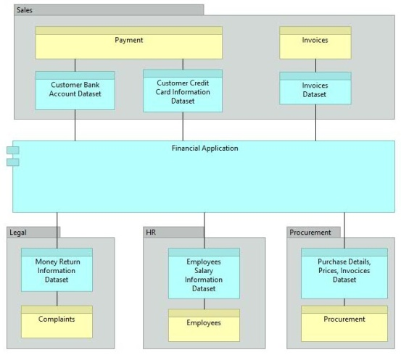

Figure 20: Financial Application Data Model

* + - 1. Customer Relationship Management(CRM)

**Customer relationship management** (**CRM**) system focuses mainly on communication between enterprise and its current and potential customers. It is widely used in Sales, Marketing and Customer Services.

In **Marketing** CRM helps to organize such processes as launching new products, advertising them by various means, organizing different campaigns, generating leads, organize surveys between customers. In **Sales** CRM is used to create new customers or convert leads to customers, propose, win or lose different sales opportunities, sell products, keep track of customers’ returns. Third important part of CRM is to provide customer with support **services** thus helping with technical and repair problems, managing customers’ issues.

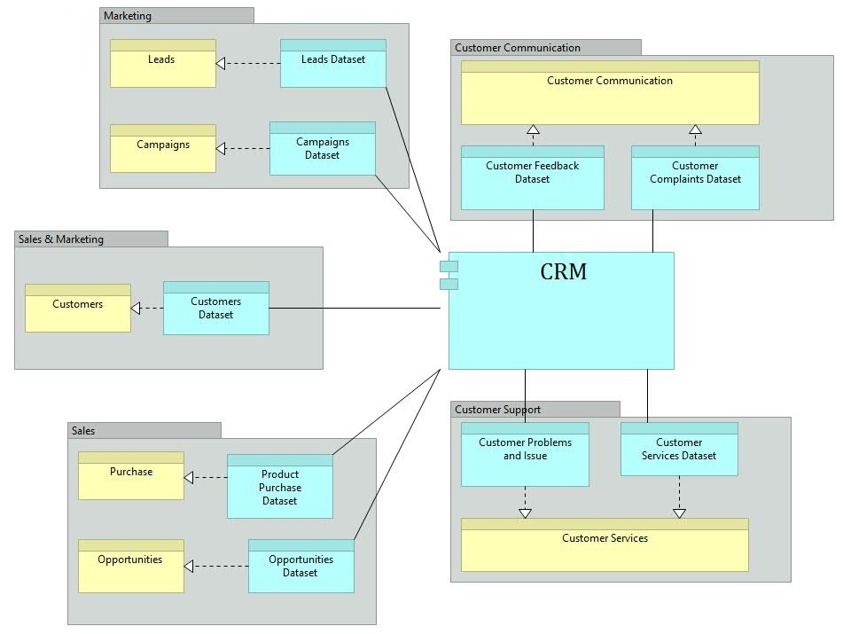

Figure 21: CRM Data Model

* + - 1. Master Data Management(MDM)

**Master data management** (MDM) system is used to consistently define and manage the critical data of an organization or enterprise. It provides a single point of reference for all applications used in enterprise to put and receive data, thus keeping it consistent.

Master Data in Customer Electronics Enterprise includes following datasets: **Customers Products, Accounts, Production, Employees, Warehouse, Suppliers, and Locations.**

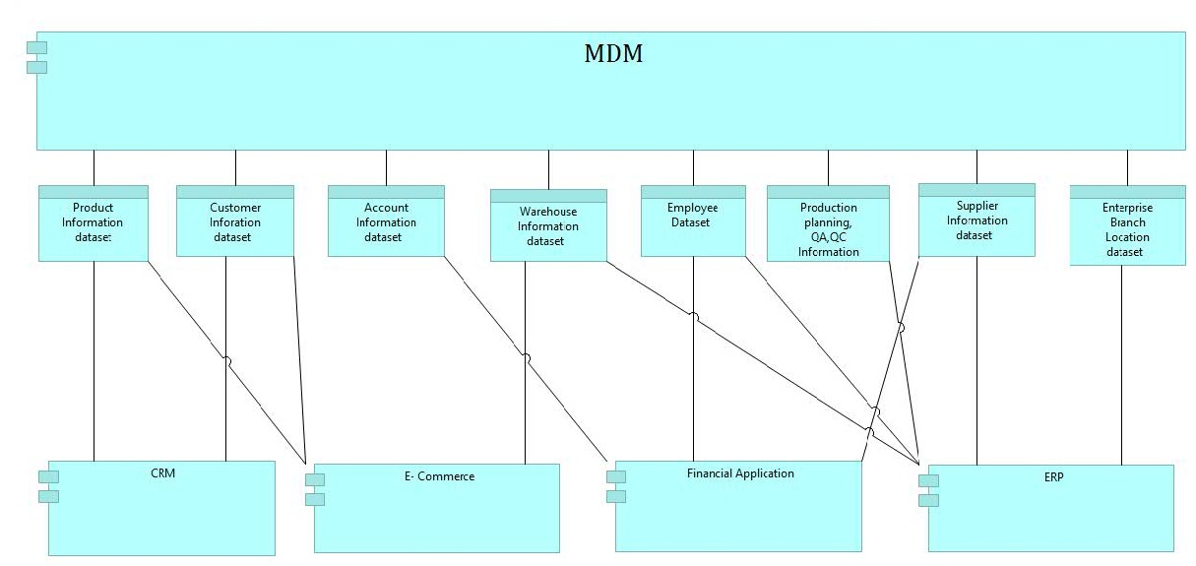

Figure 22: MDM Data Exchange Model

* 1. Technology Architecture
     1. Overview of Technology Layer

In this section, technology layer is described:

1. Infrastructure services
2. Infrastructure landscape
   * + 1. Infrastructure services

From maintenance point of view the infrastructure layer often requires a lot of detailed information: which systems exist and how are these connected to each other?

The step in describing meaningful services for the environment is not commonplace: how one starts with modeling services on the infrastructure layer and which types of services must be distinguished?

Describe those services on the infrastructure layer that supports applications. It is recommended to distinguish processing services, storage services and communication services. When modeling the infrastructure layer it is essential to use abstraction of internal details, for example implementation details. Domain specific languages are better suited for this.

Use the viewpoint ‘Infrastructure usage’ from the ArchiMate book (Lankhorst et al., 2005, p. 187). This viewpoint allows visualizing how applications are supported by software and hardware infrastructure.

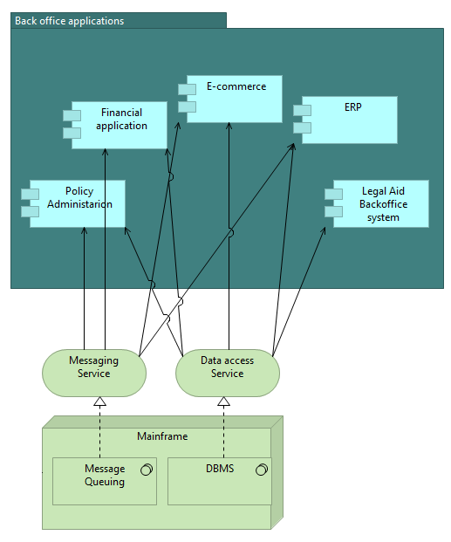

Figure 23: Example of infrastructure services

Apply the definition as described in ArchiMate (Lankhorst et al., 2005): an infrastructure service is a visible unit of functionality, delivered by one or more nodes, exposed via well-defined interfaces and meaningful for the environment.

* + - 1. Infrastructure landscape

Enterprise architecture is used to register the essentials of architecture domains and visualize the relationships between those domains; on infrastructure level implementation specific details are often important.

When modeling an infrastructure landscape it is essential to maintain distance (or objectivity) from the stakeholder and their corresponding concerns. In most enterprise architecture initiatives the goal of modeling an infrastructure landscape is to visualize the most important elements (hardware and software) of the infrastructure, how these are connected to networks and what their geographical location is (such as main office and regional offices).

Limit an ArchiMate infrastructure landscape to the most important physical systems and networks and specific essential supporting software like operating systems, database management systems and middleware.

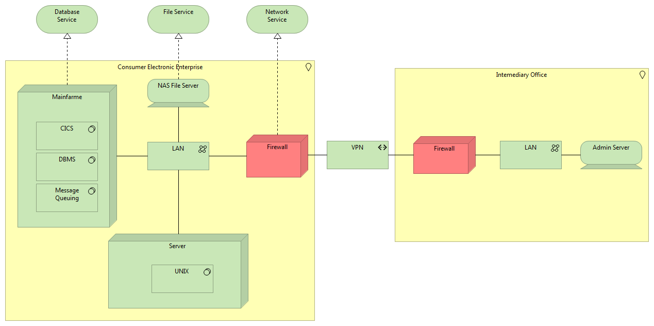Figure 24: Example of an infrastructure landscape

Use the Infrastructure viewpoint from the ArchiMate book (Lankhorst et al., 2005, p. 186). This viewpoint gives the possibility to show which essential hardware and software determine the infrastructure landscape and how this is connected via networks (VPN). It is recommended to group infrastructure elements in this viewpoint based on geographical location and make these groups explicit.

1. User manual
   1. Enterprise Architecture Overview

The idea behind the project is to comprehensively describe the architecture of a Consumer Electronics Enterprise, e.g. its functional structure, organizational structure, business processes, supply chains, logistics, money flows and information flows.



Figure 25: Scenario Specification

The whole models are separated into three parts: business processes, application architecture and data architecture. The modelling tool used for business processes is BPMN, for application and data architecture we used Archimate.

* 1. BPMN Notation Guide
     1. Events

|  |  |  |
| --- | --- | --- |
| Notation | Element | Description |
|  | Start Event | Indicates a process will start. |
|  | Intermediate Event | Indicates something that occurs during the process, between Start and End. |
|  | End Event | Indicates a process will end. |

* + 1. Activities

|  |  |  |
| --- | --- | --- |
| Notation | Element | Description |
|  | Task | Is a simple activity which is used when the work performed within the process |
|  | Sub-process | Indicates something that occurs during the process, between Start and End. |

* + 1. Artifacts

|  |  |  |
| --- | --- | --- |
| Notation | Element | Description |
|  | Annotation | Annotation is a mechanism for a modeller to provide additional information for the reader of a BPMN Diagram. |
|  | Group | The group object is an artifact that provides a visual mechanism to group elements of a diagram informally. |
|  | Data Object | Provides information about how documents, data, and other objects are used and updated during the Process. It can be used to represent many different types of objects, both electronic and physical |
|  | Data Store | Provides a mechanism for Activities to retrieve or update stored information that will persist beyond the scope of the Process. |

* + 1. Swimlanes

|  |  |  |
| --- | --- | --- |
| Notation | Element | Description |
|  | Pool | Represents a Participant in the Process. |
|  | Lane | A Lane is a sub-partition with in a Pool. |
|  | Milestone | A milestone is a subpartion within a Process. |

* + 1. Connectors

|  |  |  |
| --- | --- | --- |
| Notation | Element | Description |
|  | Sequence Flow | A Sequence Flow is used to show the order that activities will be performed in a Process. Each Flow has only one source and only one target. |
|  | Association | An Association is used to associate information and Artifacts with Flow Objects. Also used to show the activities used to compensate for an activity. |
|  | Message Flow | A Message Flow is used to show the flow of messages between two entities that are prepared to send and receive them. Two separate Pools in the Diagram will represent the two entities. |

* + 1. Gateways

|  |  |  |
| --- | --- | --- |
| Notation | Element | Description |
|  | Exclusive Gateway | When splitting, it routes the sequence flow to exactly one of the outgoing branches. When merging, it awaits |
|  | Inclusive Gateway | When splitting, one or more branches are activated. All active incoming branches must complete before merging. |
|  | Parallel Gateway | When used to split the sequence flow, all outgoing branches are activated simultaneously. When merging parallel branches it waits for all incoming branches to complete before triggering the outgoing flow. |
|  | Event-based Gateway | Is always followed by catching events or receive tasks. Sequence flow is routed to the subsequent event/task which happens first. |
|  | Exclusive Event-based Gateway | Each occurrence of a subsequent event starts a new process instance. |
|  | Parallel Event-based Gateway | The occurrence of all subsequent events starts a new process instance. |
|  | Complex Gateway | Complex merging and branching behaviour that is not captured by other gateways. |

* 1. Archimate Notation Guide
     1. Business Layer Concepts

|  |  |  |
| --- | --- | --- |
| Notation | Concept | Description |
|  | Business Actor | An organizational entity that is capable of performing behaviour. |
|  | Business Role | The responsibility for performing specific behaviour, to which an actor can be assigned. |
|  | Business Collaboration | An aggregate of two or more business roles that work together to perform collective behaviour. |
|  | Business Interface | A point of access where a business service is made available to the environment. |
|  | Business Function | A behaviour element that groups behaviour based on a chosen set of criteria. |
|  | Business process | A behaviour element that groups behaviour based on an ordering of activities. It is intended to produce a defined set of products or business services. |
|  | Business event | Something that happens (internally or externally) and influences behaviour. |
|  | Business interaction | A behaviour element that describes the behaviour of business collaboration. |
|  | Product | A coherent collection of services, accompanied by a contract/set of agreements, which is offered as a whole to (internal or external) customers. |
|  | Contract | A formal or informal specification of agreement that specifies the rights and obligations associated with a product. |
|  | Business service | A service that fulfills a business need for a customer (internal or external to the organization). |
|  | Value | The relative worth, utility, or importance of a business service or product. |
|  | Meaning | The knowledge or expertise present in a business object or its representation, given a particular context. |
|  | Representation | A perceptible form of the information carried by a business object. |
|  | Business object | A passive element that has relevance from a business perspective. |
|  | Location | A conceptual point or extent in space. |

* + 1. Application Layer Components

|  |  |  |
| --- | --- | --- |
| Notation | Concept | Description |
|  | Application component | A modular, deployable, and replaceable part of a software system that encapsulates its behavior and data and exposes these through a set of interfaces. |
|  | Application collaboration | An aggregate of two or more application components that work together to perform collective behavior. |
|  | Application interface | A point of access where an application service is made available to a user or another application component. |
|  | Application service | A service that exposes automated behavior. |
|  | Application function | A behavior element that groups automated behavior that can be performed by an application component. |
|  | Application interaction | A behavior element that describes the behaviour of application collaboration. |
|  | Data Object | A passive element suitable for automated processing. |

* + 1. Technology Layer Concepts

|  |  |  |
| --- | --- | --- |
| Notation | Concept | Description |
|  | Artifact | A physical piece of data that is used or produced in a software development process, or by deployment and operation of a system. |
|  | Infrastructure interface | A point of access where infrastructure services offered by a node can be accessed by other nodes and application components. |
|  | Node | A computational resource upon which artifacts may be stored or deployed for execution. |
|  | Communication path | A link between two or more nodes, through which these nodes can exchange data. |
|  | Infrastructure function | A behaviour element that groups infrastructural behaviour that can be performed by a node. |
|  | System software | A software environment for specific types of components and objects that are deployed on it in the form of artifacts. |
|  | Network | A communication medium between two or more devices. |
|  | Infrastructure service | An externally visible unit of functionality, provided by one or more nodes, exposed through well-defined interfaces, and meaningful to the environment. |
|  | Device | A hardware resource upon which artifacts may be stored or deployed for execution. |

1. Reference
2. http://pubs.opengroup.org/architecture/togaf9-doc/arch/index.html
3. https://en.wikipedia.org/wiki/Enterprise_architecture
4. https://en.wikipedia.org/wiki/Business_Process_Model_and_Notation
5. http://pubs.opengroup.org/architecture/archimate-doc/ts_archimate/chap3.html
6. https://www.bizagi.com/docs/BPMN_Quick_Reference_Guide_ENG.pdf
7. http://pubs.opengroup.org/architecture/archimate2-doc/chap03.html#_Toc371945176
8. http://pubs.opengroup.org/architecture/archimate2-doc/chap04.html#_Toc371945178
9. http://pubs.opengroup.org/architecture/archimate2-doc/chap05.html#_Toc371945204