**Purpose**

The results of the requirements elicitation and the analysis activities are documented in the Requirements Analysis Document (RAD). This document completely describes the system in terms of functional and nonfunctional requirements and serves as a contractual basis between the client and the developers.

**Audience**

The audience for the RAD includes the client, the end users, the project manager, and the developers.

**Table of Contents**

1. Introduction 3

1.1 Purpose of the system 3

1.2 Scope of the system 3

1.3 Objectives and success criteria of the project 3

1.4 Definitions, acronyms, and abbreviations 3

1.5 References 3

1.6 Overview 3

2. Current system 3

3. Proposed system 3

3.1 Overview 3

3.2 Functional requirements 3

3.3 Nonfunctional requirements 3

3.3.1 Usability 4

3.3.2 Reliability 4

3.3.3 Performance 4

3.3.4 Supportability 4

3.3.5 Implementation Requirements 4

3.3.6 Interface Requirements 4

3.3.7 Packaging Requirements 4

3.3.8 Legal Requirements 4

3.4 System models 4

3.4.1 Scenarios 4

3.4.2 Use case model 4

3.4.3 Object model 4

3.4.4 Dynamic model 4

3.4.5 User interface 4

4. Glossary 4

**Document History**

|  |  |  |  |
| --- | --- | --- | --- |
| Rev. | Author | Date | Changes |
|  | Patrick Rank |  |  |
|  | Rico Finkbeiner |  |  |
|  | Simone Domenici |  |  |
|  | Jonas Hitter |  |  |
|  | Caroline Stallknecht | 16.07.2022 |  |

# Introduction

*The purpose of the Introduction is to provide a brief overview of the function of the system and the reasons for its development, its scope, and references to the development context. The introduction also includes the objectives and success criteria of the project.*

## Purpose of the system

## Scope of the system

## Objectives and success criteria of the project

## Definitions, acronyms, and abbreviations

## References

## Overview

# Current system

*The current system is an operating system. It is a program, which it needs in order to function and run all of the functionalities described in the following.*

# Proposed system

*The third section documents the requirements elicitation and the analysis model of the new system.*

## Overview

*The overview presents a functional overview of the system.*

## Functional requirements

*The following functional requirements (FR) were addressed in the project.*

* *FR1: Search for restaurants: The user can search for restaurants on a list and on a map that displays up to 50 restaurants.*
* *FR2: See restaurants details: The user can see pictures, ratings and comments of the restaurant as well as opening times and a link to the website.*
* *FR3: Filter search results: He can filter the results by the restaurant type, the prize category, by distance around a certain location, by the average rating and by free time slots for reservations for specified dates and number of visitors.*
* *FR4: Reserve table: A user can see the times when he can reserve a table in the chosen restaurant. After clicking on the time, the user sees an overview of all tables in the restaurant. He can choose the exact table the free one in the overview and thus reserve the table for the specified number of visitors.*
* *FR5: Save calendar event: When the user reserves a table, an event in the local calendar is created for the reservation.*
* *FR6: Confirm reservation: A user is reminded about a reservation one day before the actual date of the reservation and must confirm it until latest 12 hours before the actual date. If the user does not confirm, his reservation is cancelled automatically.*
* *FR7: Cancel reservation: A user can cancel his reservation at any time up to two twelve hours before the actual date of the reservation. After the confirmation (see FR5), the user cannot cancel the reservation anymore.*

## Nonfunctional requirements

*Nonfunctional requirements (NFR) describe user-level requirements that are not directly related to functionality. This includes usability, reliability, performance, supportability, implementation, interface, operational, packaging, and legal requirements. The section list all these non-functional requirements and additionally presents the dependencies between them.*

### Usability

*The following NFR regarding usability was addressed:*

*The system should be intuitive to use, and the user interface should be easy to understand. Simple interactions should be completed in less than three clicks. Complex interactions should be completed in less than six clicks.*

### Reliability

*No specific NFRs were addressed in this section.*

### Performance

*No specific NFRs were addressed in this section.*

### Supportability

*No specific NFRs were addressed in this section.*

### Implementation Requirements

*The following NFR regarding usability was addressed:*

*Conformance to guidelines: The design of the system should conform to the typical usability guidelines such as Nielsen’s usability heuristics.*

### Interface Requirements

*The following NFR regarding usability was addressed:*

*A server subsystem with a couple of services must be used in the system.*

### Packaging Requirements

*No specific NFRs were addressed in this section.*

### Legal Requirements

*No specific NFRs were addressed in this section.*

## System models

*The System models include scenarios, use cases, object model, and dynamic models for the system. This section should contain the complete functional specification, including mock-ups, paper-based prototypes or storyboards illustrating the user interface of the system and navigational paths representing the sequence of screens.*

### Scenarios

### Use case model

*A use-case model is a model that show the interaction of different users with the system to solve a problem.  As such, it describes the goals of the users, the interactions between the users and the system, and the required behavior of the system in satisfying these goals. In the following case there is only one user and the main focus are the functionalities.*

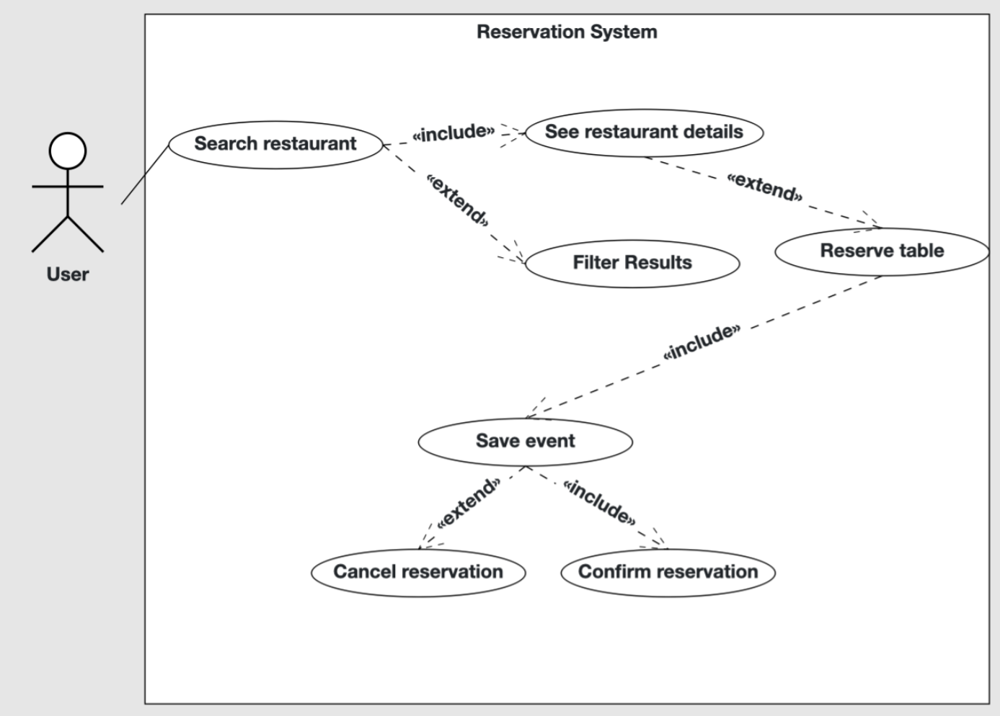

### Object model

*An object model is a logical interface that shows classes, their relationships as well as interactions between them. It enables the creation of an architectural software or system model prior to development or programming. In the following the object model for the reservation system is shown.*

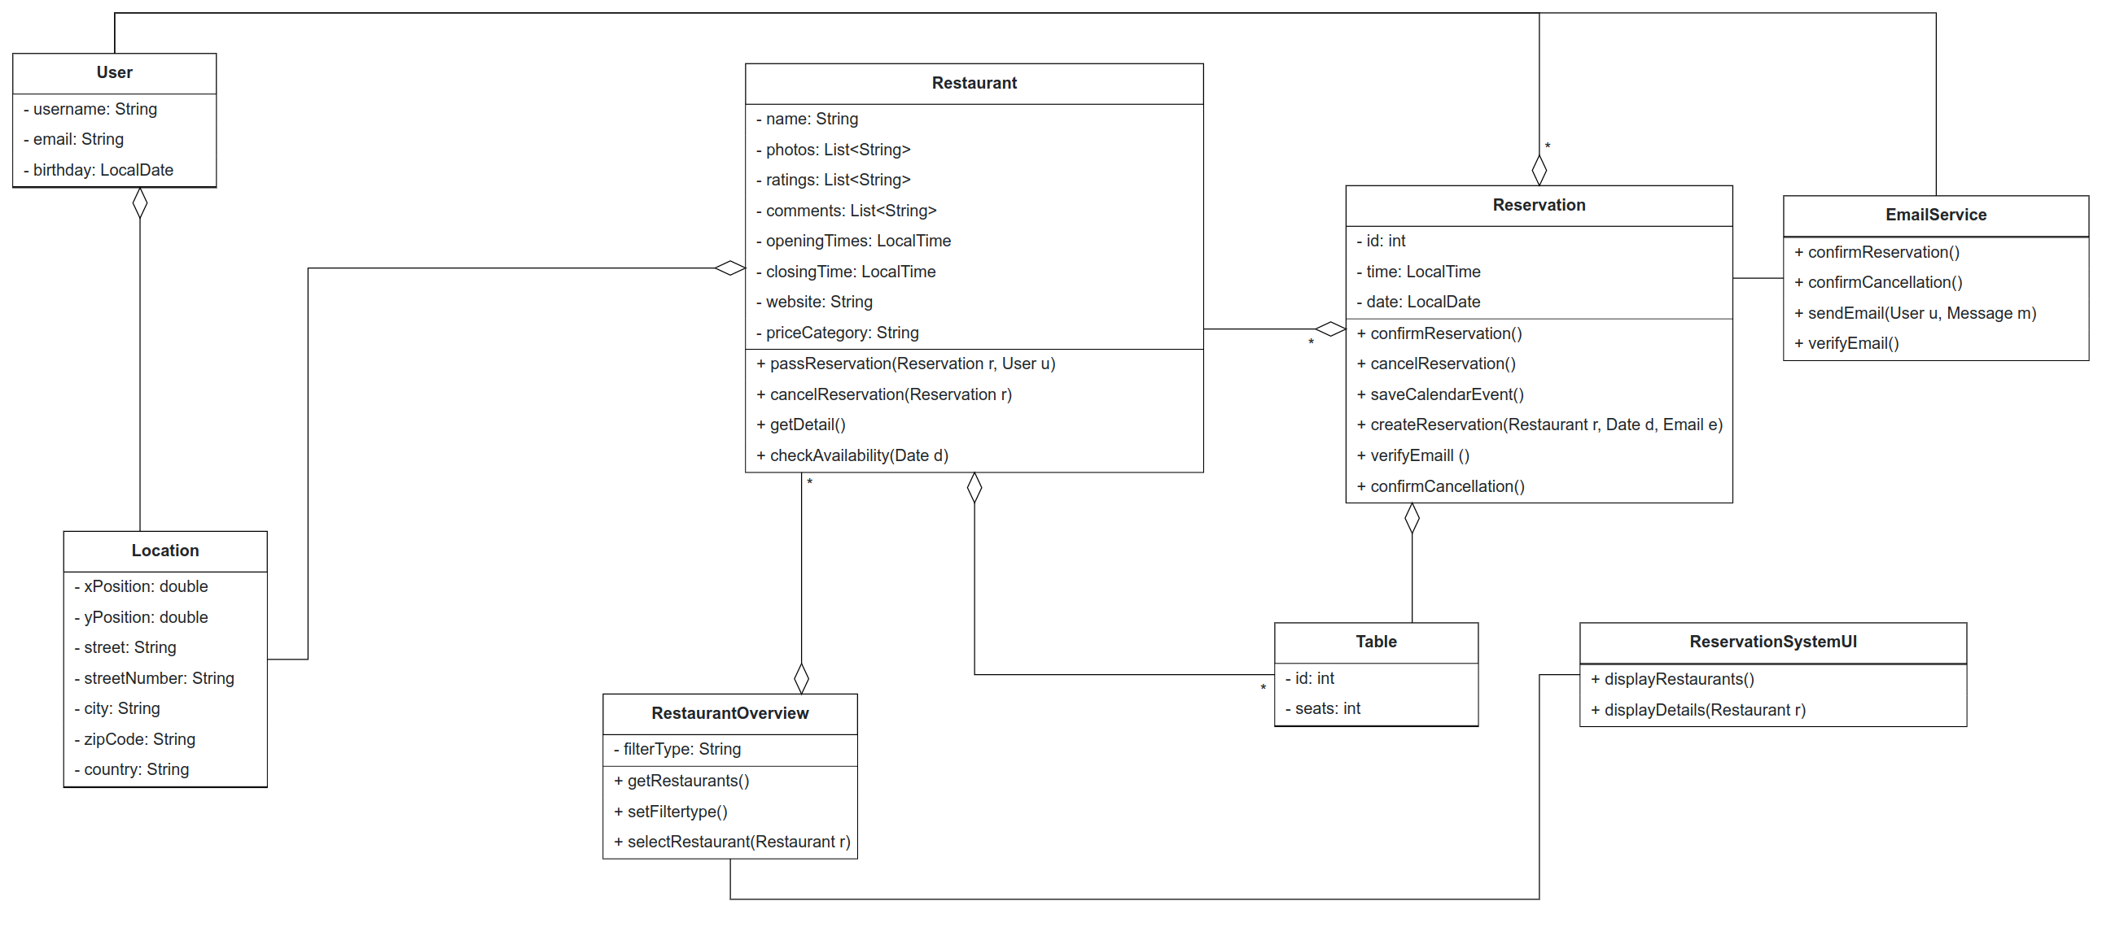

### Dynamic model

*The dynamic model represents the time–dependent aspects as events of a system. It shows the flow of events and messages that happen between the objects.*

*In the first diagram the user makes a reservation and the basic flow of events is shown.*

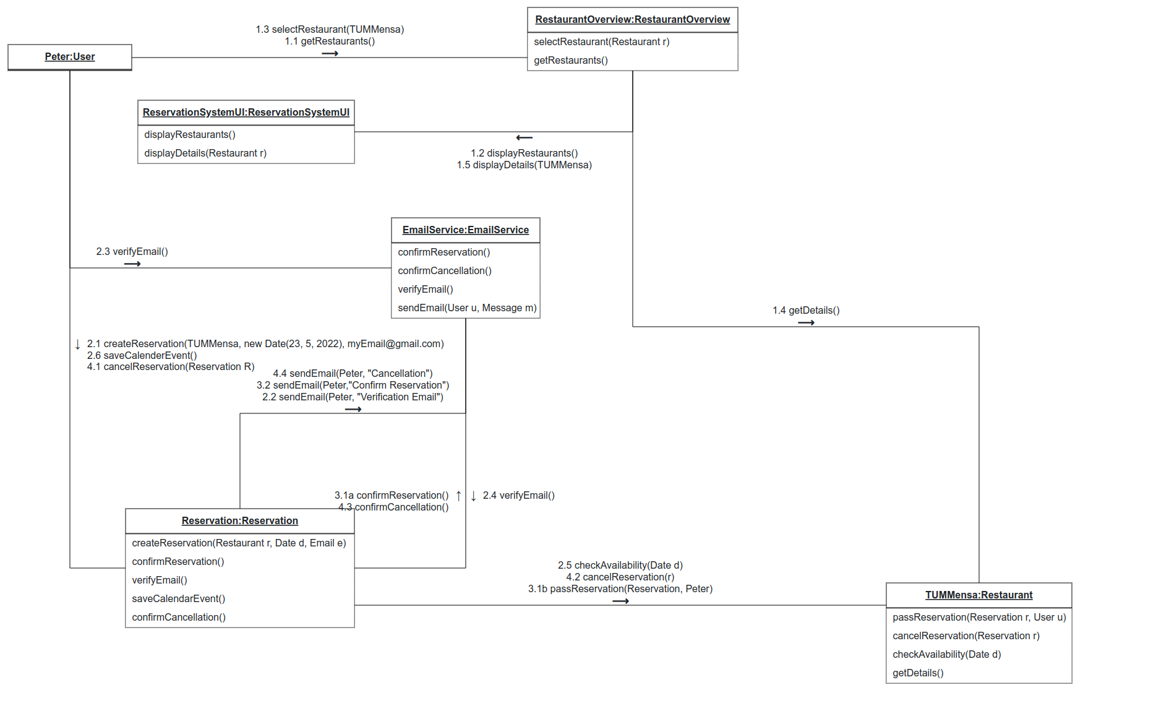

*In the second diagram the user Peter makes a reservation at TUM Mensa. In advance he specifically searched for the TUM Mensa, displayed its details and made a reservation for a specific date. Also the clear distinction between client and server is shown.*

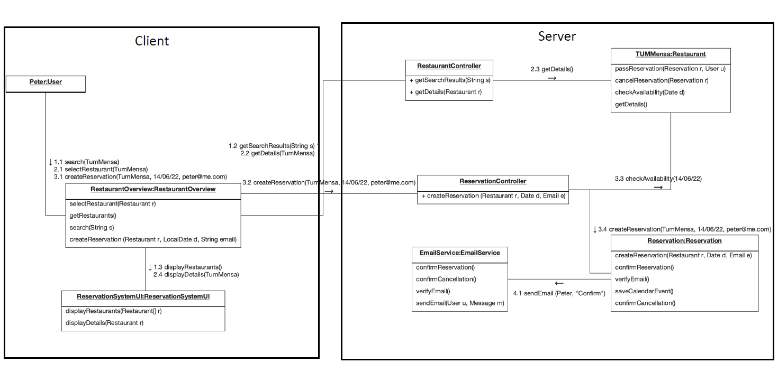

### User interface

# Glossary

*A glossary of important terms used in the project and in the system model ensures consistency in the specification and a common understanding of terms used by the client.*