Task 2.3 Unravelling coral-symbiont biodiversity in threatened tropical coral reefs
This task investigates coral holobiont biodiversity across tropical reef systems exposed to contrasted local (e.g. sedimentation, turbidity) and global (ocean warming) stressors. By combining host genetics, microbial community profiling and symbiont diversity analyses, this task aims to identify general patterns of holobiont variability, resilience and sensitivity to environmental change. Comparative and experimental approaches are used to assess the stability, plasticity and fidelity of coral–symbiont associations under stress.

Subtask 2.3.1: Corals (Pocillopora meandrina and Porites rus) and their holobionts biodiversity, facing local (turbidity) and global (coral bleaching) stress.
The Subtask initially planned to focus on Pocillopora meandrina, Porites lobata and Millepora platyphila. However, colonies of P. lobata and M. platyphila were not found at one of the two study sites, so other species present at both sites were selected instead; the coral holobionts analysed are therefore Porites rus and Pocillopora meandrina (Cnidaria, Anthozoa, Scleractinia). Porites rus is a massive, long-lived species generally considered tolerant to environmental stress and frequently found in turbid or variable reef environments, whereas Pocillopora meandrina is a fast-growing branching coral, ecologically important for reef structure but more sensitive to thermal stress. These contrasting life-history strategies are mirrored in the results reported below, where the thermally sensitive Pocillopora shows a symbiont response to acute heat stress that the stress-tolerant Porites does not.
Reef-building corals are holobionts whose bacterial and Symbiodiniaceae partners are both implicated in acclimatisation to environmental change, yet the two are rarely tracked in the same animals under the same perturbation, so it is unclear whether they respond on the same axis. Here we address a local stressor (turbidity) and a global one (thermal bleaching stress) together, using a reciprocal transplantation between two bays of contrasting water quality in Mo'orea — Opunohu, turbid and land-influenced, and Tiahura, comparatively pristine — followed by an acute heat challenge, to separate the effects of colony provenance from those of the environment actually experienced. Our objectives are fourfold: (i) to determine whether coral bacterial community composition is set by the bay a colony came from or by the bay its fragments now occupy; (ii) to test whether specific bacterial partners, in particular Endozoicomonas, are acquired from the surrounding environment rather than inherited from the parent colony; (iii) to establish whether an acute thermal challenge restructures either partner community; and (iv) to compare the bacterial and Symbiodiniaceae responses directly within the same host fragments, distinguishing shifts in mean community composition from changes in among-individual variability.

Methods
Five colonies per species were sampled in each bay and fragmented for reciprocal transplantation between Opunohu and Tiahura, giving four origin→destination paths per host from 20 parent colonies in total. Fragments were sampled as mother-colony genotypes (day 0), at 2 weeks, at 4 months, immediately before an acute heat challenge (day 121) and immediately after it (day 122), alongside free-living (0.2 µm) and particle-bound (3 µm) seawater and sediment references, giving 187 libraries of which 157 passed quality filtering. Replication is not balanced across the design: all 18 Pocillopora 2-week libraries failed at sequencing, and every Porites fragment held at Tiahura died after the 2-week timepoint, so origin and destination are fully crossed only in Pocillopora from 4 months onward and all later Porites fragments sat in Opunohu. Environmental conditions (temperature, salinity, photosynthetically active radiation, rainfall) were logged in both bays and remain to be integrated.
DNA and RNA were extracted from coral tissue using standardised protocols. Bacterial and archaeal communities were characterised by amplicon sequencing of the 16S rRNA V4–V5 region (primers 515F/926R); primers were removed with cutadapt, host reads depleted against the Porites rus assembly GCA_964035705.1 with bowtie2, and ASVs inferred with DADA2 from forward reads only (reverse-read quality was insufficient; truncQ = 3, maxEE = 2), with taxonomy assigned from SILVA nr99 v138.2. Chimera removal left 1,795,938 reads (76.0% of input) in 15,067 ASVs; removal of chloroplast, mitochondrial and eukaryotic sequences left 14,075 prokaryotic ASVs at a median depth of 10,214 reads, aligned with MAFFT and placed on a midpoint-rooted FastTree2 phylogeny. Symbiodiniaceae diversity was assessed by ITS2 metabarcoding of the same fragments (135 samples) processed with SymPortal (Hume et al. 2019); because each sample carries essentially one ITS2 type profile (mean 1.1–1.4 detected), all symbiont statistics use the post-MED sequence layer — clade-C UniFrac distances and Bray–Curtis on post-MED abundances — with type profiles used for description only. Community structure was tested by PERMANOVA (vegan::adonis2, 999 permutations) under a split-plot permutation design, whole colonies permuted for the between-colony term (origin) and samples permuted within colony for destination and timepoint, with dispersion homogeneity checked by betadisper. Differential abundance between bays was tested on one value per colony to avoid pseudoreplication, with Benjamini–Hochberg correction across all taxa tested. Bioinformatic processing follows harmonised pipelines developed within BIOcean5D, to be released on GitHub upon publication.

Main Results
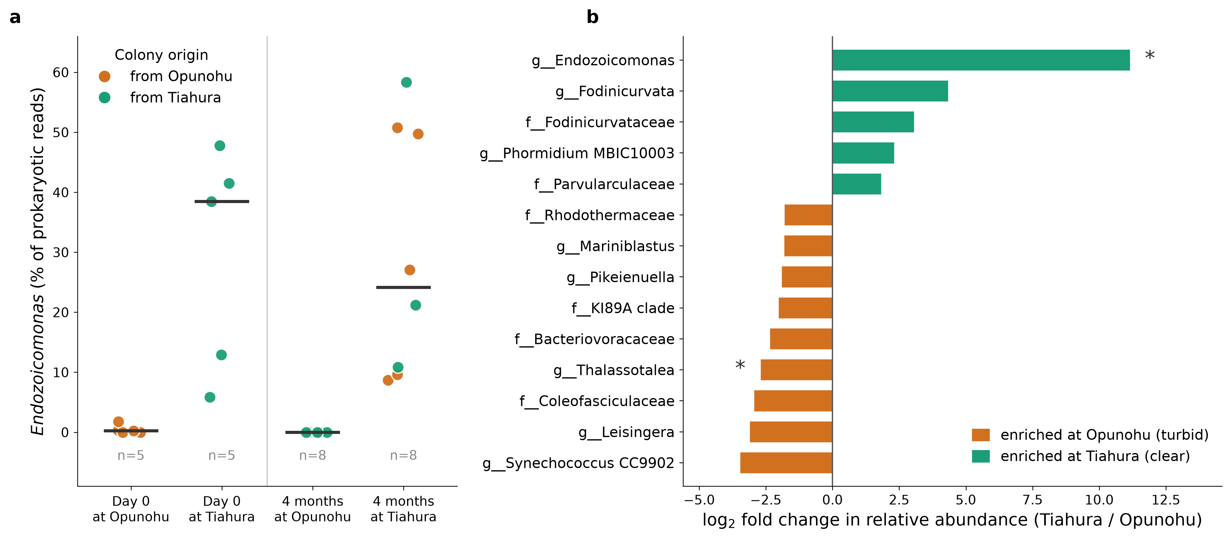
Figure 1: Bacterial response to the turbidity contrast in Pocillopora meandrina. (a) Endozoicomonas relative abundance per colony (fragments averaged within colony; bars are medians), coloured by the bay the colony came from and positioned by the bay its fragments occupied. At day 0 the genus tracks provenance; after four months it is absent from every fragment at Opunohu and present in every fragment at Tiahura, irrespective of origin. (b) Taxa differing in relative abundance between bays across all post-transplant timepoints, tested at colony level with Benjamini–Hochberg correction across 245 taxa. Bars show log2 fold change; asterisks mark FDR < 0.05 and every taxon shown passes FDR < 0.10.
Compartment is the dominant axis of bacterial community structure, with host or medium explaining 10.8% (Sørensen) to 23.6% (weighted UniFrac) of variation (p = 0.001 in all four metrics), although dispersion is heterogeneous across compartments (F = 10.74, p = 0.001) so part of this reflects unequal spread. Within corals, the bay a fragment occupied outweighs the bay it came from: across the balanced Pocillopora heat-shock window (n = 40, 10 colonies) destination explains 4.6–7.3% of variation (p = 0.001) and 8.05% of weighted UniFrac (F = 3.19, p = 0.011), against 4.6% for origin (F = 1.83, p = 0.009), and time in the field outweighs provenance in both hosts (Pocillopora 6.6–8.1%, p ≤ 0.003; Porites 10.2–19.4%, p = 0.001).
The taxon-level pattern is considerably stronger than any fitted model (Fig. 1a). At day 0 Endozoicomonas separates by provenance — Tiahura colonies 10/10 positive at a mean of 18.2% of reads, Opunohu colonies 3/10 at 0.35% — but by 4 months every Opunohu-origin colony moved to Tiahura had gained the genus (6.0–23.7%, from near zero) and every Tiahura-origin colony moved to Opunohu had lost it entirely (zero reads; Mann–Whitney p = 0.0075, Fisher on presence p = 0.0079 within each origin). Across all timepoints 35 of 35 fragments at Tiahura carry the genus against 2 of 33 at Opunohu. Corals from the impacted bay therefore acquire Endozoicomonas when placed in the pristine one, rather than merely losing it when moved the other way — consistent with environmental acquisition of a genus usually described as a vertically associated coral symbiont (Neave et al. 2016).
Across the wider community, testing every taxon at colony level with correction for multiple comparisons identifies Endozoicomonas and its family Endozoicomonadaceae as the clearest bacterial markers of the turbidity contrast (FDR = 0.018; present in 1 of 10 colonies at Opunohu against 10 of 10 at Tiahura), alongside Thalassotalea (Colwelliaceae), which is enriched at Opunohu (FDR = 0.047; Fig. 1b). A further 24 taxa reach FDR < 0.10, predominantly Opunohu-enriched and dominated by heterotrophic and particle-associated lineages (Marinobacter, Oleiphilus, Cognatishimia, Leisingera, Bdellovibrionota, Verrucomicrobiota, Chloroflexota), consistent with a more particle-rich, land-influenced water column, while Flavobacteriaceae and Flavobacteriales are elevated at Opunohu at nominal significance (p = 0.043 and 0.021).
Against this environmental responsiveness, the acute heat challenge produced no detectable change in the bacterial community of either host: Pre-HS versus Post-HS is non-significant on every metric in Pocillopora (Bray–Curtis R² = 0.026, p = 0.290; weighted UniFrac 2.47%, p = 0.420) and in Porites (weighted UniFrac R² = 5.24%, p = 0.734), with a flat destination × heat-shock interaction (p ≥ 0.712) and homogeneous dispersion (timepoint F = 1.33, p = 0.267), so this is a genuine null rather than a power artefact. Over the experiment as a whole communities are replaced rather than depleted, with Baselga partitioning giving total Sørensen dissimilarity of 0.943 (Pocillopora) and 0.952 (Porites) of which 98.0% and 98.5% is pure species turnover, and no alpha-diversity measure responds to provenance or timeline in either host (all p ≥ 0.27).
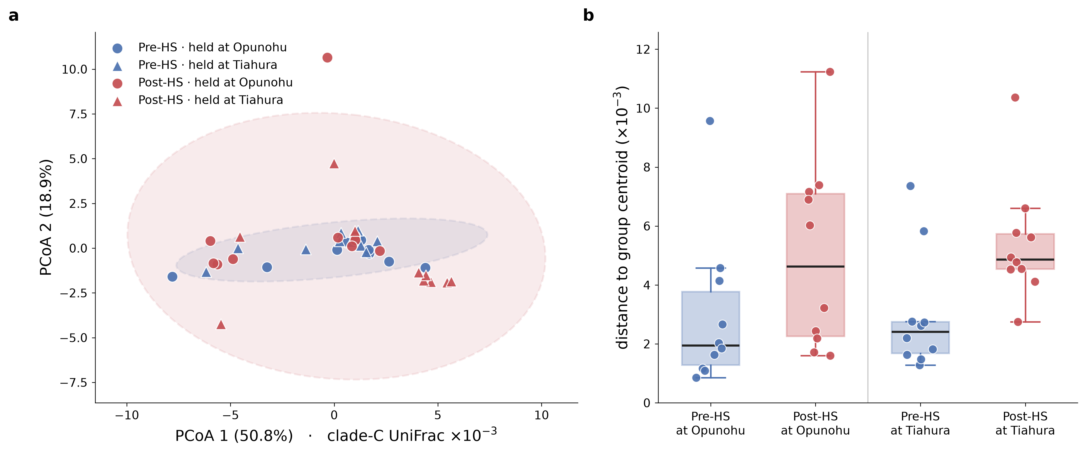
Figure 2: Symbiodiniaceae response to the acute heat challenge in Pocillopora meandrina. (a) Principal coordinates of clade-C UniFrac distances across the heat-shock window, with 95% ellipses by timepoint and symbols marking the bay each fragment occupied; the Post-HS ellipse is markedly wider while the centroids coincide. (b) Distance to group centroid, shown separately for fragments held at each bay; dispersion rises after the heat challenge in both.
The symbiont community behaved in the opposite way (Fig. 2). Host identity explains 72.5% of clade-C UniFrac variation (p = 0.001), with Pocillopora carrying C1/C42-type profiles and Porites the C15 lineage; both hosts are essentially pure Cladocopium (97.3% and 98.9% of post-MED reads) and Durusdinium is absent (0.000% and 0.004%), so no thermotolerant symbiont is available to shuffle towards. Neither origin (p = 0.587) nor destination (p = 0.208) shifted the symbiont community of Pocillopora over four months in the opposite bay. The heat challenge did not move the mean community either (p = 0.568 UniFrac, 0.065 Bray–Curtis), but it increased among-fragment variability approximately 1.75-fold (UniFrac F = 8.19, p = 0.005; Bray–Curtis F = 8.61, p = 0.003) — variance rising while the mean holds still, the diagnostic signature of the Anna Karenina principle (Zaneveld et al. 2017). The effect is robust: the median dispersion ratio (2.30) exceeds the mean so it is not outlier-driven, colony-blocked permutation gives p = 0.003, a paired test across the 20 colony × destination pairs carrying both timepoints gives 16 of 20 increasing (p = 0.0042), and although Post-HS libraries are shallower (median 39,213 versus 48,336 reads, p = 0.017) depth does not predict distance-to-centroid (ρ = −0.106, p = 0.515). Porites showed no such increase (ratio 1.24, p = 0.482), matching its reputation as the more stress-tolerant of the two species. Notably, the framework was formulated for bacterial microbiomes, yet here the bacterial community of the same fragments did not destabilise while the obligate, host-selected symbiont did — the two partners responded on orthogonal axes, bacteria tracking the environment and ignoring the thermal challenge, symbionts ignoring the environment and becoming erratic under it.
Three limitations bound these conclusions. The thermal-stress interpretation rests on treatment rather than measured physiology — no bleaching score, photochemical yield or symbiont density has been incorporated, and the Pocillopora heat-shock metatranscriptomes that would establish whether these fragments were physiologically stressed are sequenced but not yet quantified. The environmental-tracking analysis comparing fragments to local versus origin-bay reference communities uses out-transplants only, and because every group proves closer to the Tiahura environmental pool regardless of location, it cannot yet distinguish genuine tracking from coral microbiomes simply sitting nearer that pool; the discriminating back-transplant controls are in the dataset but were not included, and six of twelve sediment samples were lost at sequencing. Finally, the Porites heat-shock window (n = 18) lies entirely at Opunohu, so that host contributes no destination contrast after 2 weeks and its null results are low-powered. All sequencing data and metadata are curated within the BIOcean5D data infrastructure and will be deposited in public repositories (e.g. ENA) upon project completion.

