US Army Enterprise Army Data Framework
Data Warehouse Description

Project Number: AV-1 51

Prepared by:

Office of the Army Chief Information Officer

Architecture, Operations, Networks and Space Mission

Army Net-Centric Data Strategy Branch

Arlington, VA 22202

and

CECOM Life Cycle Management Command

Software Engineering Center

Fort Monmouth, NJ 07703-5207

Revision History

Revision | Date | Description of Change
1.0 | 04/22/09 | Original Release

Table of Contents
Executive Summary v
1. Introduction 1
1.1. Background Information 1
1.2. Diversity of Views 1
1.3. Audience 1
1.4. Reference Documents 1
1.5. Document Overview 2
2. Purpose, Scope, and Objectives 2
2.1. Purpose 2
2.2. Scope 2
2.3. Objectives 3
3. Definition and Scope 3
3.1. Definition of Data Warehouse 3
3.1.1. Purpose of a Data Warehouse 3
3.1.2. Characteristics of a Data Warehouse 4
3.2. Domain Models, Architectures, and Diagrams 4
3.3. Persistent Data Warehouse 6
3.3.1. Persistent Data Warehouse Description 6
3.3.2. Persistent Data Warehouse Flow 9
3.3.3. Persistent Data Warehouse Use Cases 9
3.4. Virtual Data Warehouse 10
3.4.1. Virtual Data Warehouse Description 10
3.4.2. Virtual Data Warehouse Use Cases 12
3.5. Master Data 13
4. DSRA-Related Features 13
4.1. DSRA Overview 13
4.2. Mapping to DSRA Components 14
4.2.1. Data Set Transformation Domain Model 14
4.2.2. DSRA Bricks and Patterns 16
4.2.3. Mapping of Data Warehouse Features to Bricks 18
5. Summary and Future Direction 20

Figures
Figure 1 – Army Data Warehouse Framework Areas 5
Figure 2 – Army Data Warehouse Framework Detail 7
Figure 3 – Virtual Data Warehouse Framework Detail 11
Figure 4 – Data Set Transformation Domain Model 14
Figure 5 – Data Set Transformation Domain Model to Data Warehouse Framework Mapping 15
Figure 6 – Typical Virtual Data Warehouse Architecture 24
Figure 7 – Physical versus Virtual Data Warehouse Decision Tree 25
Figure 8 – Data Service versus Direct Data Access Decision Tree 26

Tables
Table 1: Data Set Transformation Domain Model to Data Warehouse Mapping Description 16
Table 2: Description of DSRA Bricks 17

Appendices
Appendix A Definitions 21
Appendix B List of Acronyms 22
Appendix C Background Subjects 23

Executive Summary
The Army Enterprise CIO-G6 established a Chief Data Officer (CDO) to initiate data-centric initiatives to document the existing data sources, to establish/increase data-sharing opportunities, and to reduce redundant data sets. The Army Data Framework provides the guiding principles and standards in developing sound, cost-effective, scalable, enterprise-wide data-sharing architecture.
Data warehouse technology is one candidate data-sharing architecture that may be employed within the Army Enterprise. Data warehouse capabilities, organization, and applications are presented as a framework for data warehouse design and implementation. Components of the Data Strategy Reference Architecture (DSRA) are identified and mapped to the framework. The DSRA components are part of a reusable componentized architecture; thus, the mapping of DSRA components to the framework establishes a standard technology design basis for the data warehouse.
.

Introduction
This document presents the Army Data Framework for Data Warehouses (ADF–DW).

Background Information
Currently, enterprises are driven by, and rely heavily upon, Information Technology (IT). There is a tremendous need within these enterprises to share data from different source systems among applications, and reduce data redundancy within the enterprise. Integrating the disparate source data is difficult enough, but enterprises are faced with an ever-increasing volume of data, which makes the task even more challenging.
The Army is one of these information technology-driven enterprises. The Army Chief Information Officer (CIO) has been commissioned to implement an Army Net-Centric Data Strategy. This strategy is to provide guidance in achieving interoperability within the AE.
In FY 2009, the CIO-G6 established a Chief Data Officer (CDO) to initiate data-centric initiatives to document the existing data sources, to establish/increase data sharing opportunities, and to reduce redundant data sets. The Enterprise Army Data Framework (Reference 5) outlines the overarching architecture and life-cycle phases as a guide for implementing policies, guidelines, and procedures to assist in the implementation of the net-centric data environment of the CDO.
The purpose of the ADF is to provide the guiding principles and standards in developing sound, cost-effective, scalable, enterprise-wide data architecture. The data architecture brings data together which currently resides in various technology islands and silos into an integrated environment, leading to more effective information sharing, building trust, and enhancing visibility of data to the user community.
The ADF is a generic framework that is specialized in subsidiary “Subject Matter” documents that provide addition functional and technical details about a particular application of the ADF. One such subject matter is the DW . This document is an ADF subsidiary that focuses on the DW subject matter.

Diversity of Views
There are two views of a data warehouse pertinent to this document. One is a data warehouse as a persistent storage mechanism for the stored data; the second is as a data warehouse as an integrated virtual view across the set of input data sources. These two views are important and relevant and will be maintained throughout this document.

Audience
The intended audience for this document is as follows
- Army Data Officers
- Army Data Stewards
- Program Managers (PM) for DW s
- Data warehouse solution architects
These individuals are responsible for aligning and integrating the data resources of the Army with the net-centric system development and operational objectives of the Army/Department of Defense (DoD).

Reference Documents
The following documents directly support the objectives and content of this document:
- Blalock, James, and O’Malley, Jan. ARMY NET-CENTRIC DATA STRATEGY DATA REFERENCE MODEL A WHITE PAPER. US Army CIO G-6, CECOM. Version 1.1, June 2008.
- US Army Enterprise Data Strategies Reference Architectures (DSRA) Part 3: Information Architecture. US Army CIO G-6, CECOM. Version 0.1, 25 January 2009.
- US Army Enterprise Service Oriented Architecture Technical Reference Model. US Army CIO G-6, CECOM. Version 0.9, 16 January 2009.
- Data Warehouse Tool Evaluation Industry Standard Selection Criteria. Office of the Army Chief Information Officer Architecture, Operations, Networks and Space Mission Army Net-Centric Data Strategy Branch, CECOM Life Cycle Management Command, March 2009.
- US Army Enterprise Army Data Framework (ADF): Implementation Guide from Enterprise Architecture to System Implementation. Office of the Army Chief Information Officer Architecture, Operations, Networks and Space Mission Army Net-Centric Data Strategy Branch, CECOM Life Cycle Management Command. Project 0153, April, 2009.

Document Overview
There are two primary parts to the description of the ADF-DW presented in this document. The first part is the definition and scope of a data warehouse, presented in Section 3. The definitions and scope describe the components, boundaries, and functions of a data warehouse.
The second part is the mapping of ADF-DW to components of the DSRA (Reference 2), presented in Section 4. This section explains how components of the DSRA may be used to compose the functionality of a data warehouse.

Purpose, Scope, and Objectives

Purpose
The purpose of this document is to present and explain the ADF-DW. It is a “blueprint” document that specifies what elements are required in the ADF-DW and what properties/behaviors those elements must possess.
The purpose of the ADF-DW is to provide the guiding principles and standards in developing a sound, cost-effective, scalable, enterprise-wide data warehouse solution. The data warehouse brings data that currently resides in various technology islands and silos into an integrated environment, leading to more effective information sharing, building trust, and enhancing visibility of data to the user community

Scope
The scope of this document is the description of the ADF-DW. The scope includes:
- Structural architecture governance pertaining to the data warehouse, data sources, users, and their relationships
- Architectural models of the ADF-DW
- Data warehouse Use Cases
The scope of this document does not include:
- Requirements of, or for, supporting technology, e.g., the Enterprise Service Bus (ESB) , the Army Enterprise (AE) Service Oriented Architecture (SOA) Foundation (AE SOAF), or the Army Data Service Layer (ADSL) other than for the purpose of stating assumptions about the functionality of the technology vis-à-vis the ADF-DW
- The content of policies and procedures associated with the development, deployment, or operation of a data warehouse based upon the ADF-DW other than for the purpose of stating assumptions about the relationships between the ADF-DW, data warehouse, and policies/procedures
- The “How Tos”, i.e., the procedures/processes for using this document to create a data warehouse based upon the ADF-DW
The scope of the ADF-DW includes:
- The database that houses the data warehouse data
- The relationship to the data sources, i.e., providers that feed the data warehouse, including transformation, cleansing, and integration
- The relationship to user/consumer agents and applications.
The scope of the ADF-DW does not include:
- Specification of a physical integrated data environment
- Service architectures, e.g., SOA, and service definitions.

Objectives
The objective of this document is to present the ADF-DW clearly, concisely, and completely.
The objective of the ADF-DW is to provide governance and guidance that instills a consistent and uniform design structure within the Army data warehouse solution initiatives.

Definition and Scope
A shared data resource is a mechanism for combining data from two or more data sources or “providers” and providing access to the data to one or more consumers, i.e., people or applications. There are many kinds and configurations of shared data resources; they exhibit different operating/behavioral characteristics and serve different purposes. A common distinction that breaks shared data resources down into two high-level categories is the relationship between the data providers and data consumers. If the data providers are also the data consumers and the providers/consumers use the shared data resources as a collaborative data-sharing workspace, the shared data resource is a data repository. If the data providers and data consumers are disjoint sets of agents, and the shared data resource is used for data summarization, recording, analysis, and reporting, the shared data resource is a data warehouse.
This document focuses on the definition and architecture of data warehouses. Data repositories are not considered in further detail.

Definition of Data Warehouse
A data warehouse is a database that collects and stores integrated sets of transactional data from multiple operational systems. It is intended to enable an organization to flexibly analyze and discover new information important to operations of the organization. It is designed for the purpose of query and analysis rather than transaction processing or shared data storage.
The environment in which a data warehouse is deployed may include, Extraction, Transformation and Loading (ETL) solution, an Online Analytical Processing (OLAP) engine, client analysis tools and other applications that manage the process of gathering and delivering data to the business users for intelligent business decision making.
The functionality of a data warehouse complements the functionality of existing operational systems; thus, it is designed and used differently. Operational systems are designed to support typical day-to-day transactional operations. The data warehouse is design to support flexible analytical processing of integrated and nonvolatile data.

Purpose of a Data Warehouse
Data warehouses are developed for various reasons. The most frequently cited reasons for developing a data warehouse are:
- Single Source for Information
A data warehouse integrates information from several source systems, thus, enabling consumers to retrieve information expeditiously from a single point of reference
- Data Consistency and Quality
Data may be stored in inconsistent formats in databases across the organization, and data may conflict; loading this data into a data warehouse provides a uniform and consistent format and enables data conflicts to be detected and corrected more easily
- Separation of Analysis/Reporting and Production Data
Reporting and analysis functions involve complex queries that normally access many database tables and command a great deal of system resources, which can slow down database query response time significantly; separation of analysis/reporting data from production data of operational systems prevents reporting/analysis functions from impacting operational systems
- Rapid Response Time
A data warehouse is architected to handle high, unexpected loads and complex queries that demands a high degree of flexibility and quick response time
- Adaptive and Flexible Source Information
A DW must have the capability to adapt quickly to changing requirements
- Decision Support Foundation
A DW must be the single source for consistent, quality data coupled with a rapid response time to enable faster and more informed decision-making.
Performance of a data warehouse can be greatly enhanced by populating subject matter data marts for data mining and reporting purposes.

Characteristics of a Data Warehouse
The data warehouse has the following characteristics
- Subject-oriented: The data in a data warehouse focuses on one, or a small set of, purpose(s). For example, to analyze sales data, i.e., a purpose, the data warehouse will contain data pertaining to sales: regions, amount, purchasers, and sellers (data that supports the purpose). It enables the organization to answer questions such as “Which product had the highest sales during last year?” through use of Business Intelligence (BI) techniques and tools that leverage the data warehouse.
- Integrated: The data warehouse, transforms and combines data from disparate sources into a consistent format. It assists organization in resolving problems, e.g., naming conflicts and inconsistencies among units of measure, thereby performing data integration.
- Read-Only: The data in the data warehouse does not often change and therefore meets the requirement for true analysis on what has already occurred.
- Unidirectional or “One-way”: The information flow moves in one direction from the component data source providers to the data warehouse and from the data warehouse to consumers. Consumers do not make updates to the data warehouse, nor does the data warehouse initiate updates to the original data sources.

Domain Models, Architectures, and Diagrams
The Army Data Framework for data warehouses architecture consists of six major functional areas of interest:
- Data Capture
- Data Providers/Sources
- Data Warehousing
- Analysis
- User Access
- The AE Infrastructure Support Services.
These six areas are depicted in Figure 1. This diagram illustrates the relative adjacency of the area functionality and, from left-to-right, the general flow of information from sources to consumers.

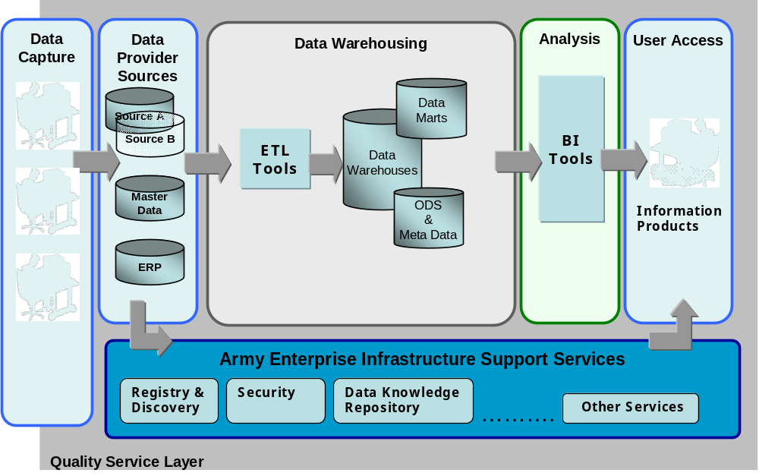
Figure 1 – Army Data Warehouse Framework Areas
Data Capture is the point-of-origin for data, the point at which data enters the information systems. Data Providers/Source are the local databases that store and manage the captured data and make it available (e.g., through web services) to external users. The Data Warehousing area is a hub that obtains data from many data sources; analyzes, cleans, integrates and stores the data; then makes the data available to end users and analysis tools. All of these areas are supported by an AE Infrastructure Support System that provides security, registries/repositories, message transport, and a variety of other services.
These areas of the diagram will be explained in further detail in the Sections 3.3, Persistent Data Warehouse, and 3.4, Virtual Data Warehouse.
The DWs can be categorized based on behavioral characteristics. As mentioned in Section 1.2, two distinctions are made here:
- Persistent Data Warehouse
- Virtual Data Warehouse.
A persistent data warehouse is best suited to meet the following business requirements:
- Users/consumers perform ad hoc, multidimensional data analysis
- Complex/comprehensive data cleansing, data transformation and/or data integration is required on input/ingested data
- Data volumes are extremely high.
A virtual data warehouse is best suited to meet the following business requirements:
- Users/Consumers require real-time, most up-to-date data
- Legal restriction prohibit data replication
- Cost limitations prohibit development, maintenance, and operation of a persistent data store.
The frameworks and characteristics of persistent and virtual data warehouses are presented in the following sections. Figure 1 and the characteristics described above apply to both persistent and virtual data warehouses.

Persistent Data Warehouse
A persistent data warehouse, as the name implies, has persistent data storage, i.e., a database, at its core. Data from the sources/providers is refined through a series of processes and integrated with/added to the data warehouse database.

Persistent Data Warehouse Description
In addition to the general data warehouse characteristics described above, a persistent data warehouse has the following additional characteristics:
- Persistency: Data is stored in the data warehouse database; the database is physically separate from, and managed separately from, the source data.
- Progression: The data in the data warehouse grows over time due to its capability of storing large amounts of data, enabling organization the discovery of trends through analytics.
Figure 2 expands on Figure 1 and presents a framework of a persistent data warehouse. It provides a more detailed picture of what is “in” each area described in Figure 1. Note that the single Data Warehousing area of Figure 1 is decomposed into three areas – Data Ingest, ETL, and Data Storage – in Figure 2.
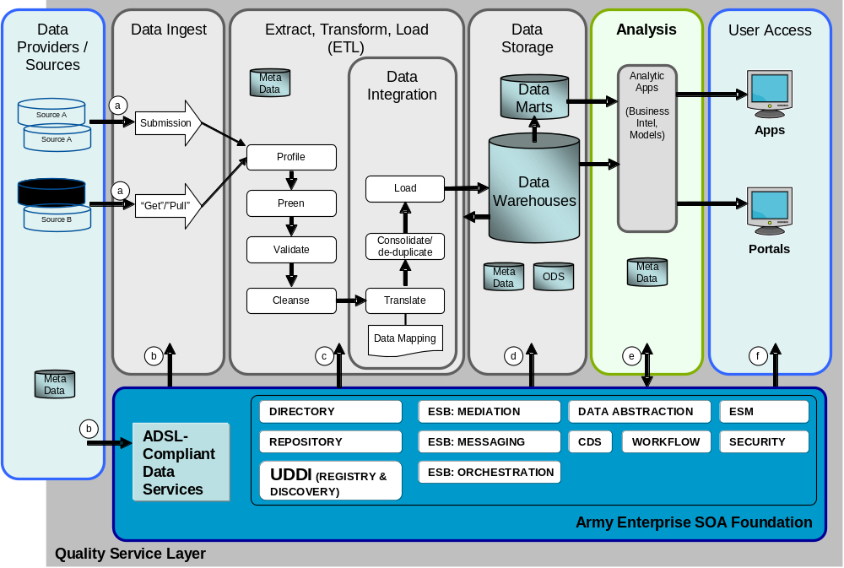
Figure 2 – Army Data Warehouse Framework Detail
The persistent data warehouse framework (Figure 2) consists of the following elements (the Data Capture area illustrated in Figure 1 is assumed and omitted in Figure 2):
- Providers/Data Sources: Network resources that provide data to the data warehouse.
- Data Ingest: The acquisition of data from a data source. Acquisition could be through a feed, a submission by a provider, or a “get” or “pull” action of the data warehouse. This is the “E” part of “ETL”. Data may be acquired through ADSL-Compliant Data Services or directly from the data sources via data source Application Programming Interfaces (API). The extracted data may be stored in the staging area.
- Extract, Transform, and Load (ETL): A variety of functions are part of the overall ETL function. These functions are all data quality functions, but do not constitute a complete/comprehensive data quality solution. The functions include:
- Profile: a process that analyzes the data for inconsistencies and patterns that can be used to characterize, and thus correct, data coming from a particular data source; the results of profiling are used in the cleansing process
- “Preen”: a process that changes incoming data to clean it up and turn it into a regular and processable form, e.g., make alphabetic casing uniform or eliminating white space; the incoming data is still in its native format. Preen does not change the information represented by the data.
- Validate: a process that validates the data against a schema or other business rules to ensure that it meets the structural and data integrity requirements specified for the data
- Cleanse: a process that changes the data based on the profiling analysis results; the data remains in its native form
- Translate: a process that converts the incoming data into a neutral form compatible with the internal format of the data warehouse
- Consolidate/de-duplicate: a process that removes any redundant data; this action is necessary when data about the same thing, e.g., person, organization, or vehicle, is received from multiple sources
- Load: All of the above processes may read data from the Operational Data Stores (ODS) to perform the function, e.g., de-duplicate, the read function is indicated by the arrow from the data warehouse to the ETL area box; the data results from the collection of processes is then loaded into the data warehouse
For additional detailed information on ETL please refer the to Data Warehouse Tool Evaluation Document, Section 3 (Reference 4).
- Data Integration: This is not typically viewed as a data quality function, but data quality principles and evaluations are necessary during the integration process. Consolidation/de-duplication, for example, is really a data quality action. For additional detailed information on Data integration and functional capabilities please refer to the Data Warehouse Tool Evaluation Document Section 4 (Reference 4).
- Data Mapping: Specification of data translation rules. The schema necessary for data mapping and the Extensible Stylesheet Language Transformations (XSLT) necessary for data transformation may be obtained from the Army Schema Repository.
- Data Storage: The storage facility for data, including perhaps the storage area network and the database, but may include many databases; it may include Data Marts and ODS
- Analysis: Data analysis applications that are designed to use the data warehouse directly; for additional detailed information on BI and functional capabilities please refer to Data Warehouse Tool Evaluation Document Section 11 (Reference 4).
- User Access: User applications and agents that access the data warehouse or services offered by the data warehouse
- Quality Services: The ETL processes are data quality operations, but data quality services exist at many points through the data warehouse environment. For additional detailed information on Data Quality functional capabilities please refer to the Data Warehouse Tool Evaluation Document Section 10.2 (Reference 4).
- AE SOA Foundation: The AE SOAF provides the technology and basic services for the interoperation of the data warehouse environment with applications outside of that environment. The data environment does not reside or depend on the AE SOAF. See the Army Enterprise Service Oriented Architecture (SOA) Technical Reference Manual (TRM) (Reference 3.)
- ADSL-Compliant Data Services: The ADSL-compliant web services providing, for example, data access to data sources. Services may be used by the data warehouse to obtain data from the data sources, or by users/consumers to obtain data from the data warehouse. The ADSL Data Services run on the AE SOAF infrastructure.
The ADSL/AE SOAF component of the framework provides services for things like data access, transformation, message delivery, and security. The AE SOAF is infrastructure and does not have data of interest to the general end-user. It is a platform for the implementation of the SOA data strategy.
The processing of incoming data through to the data warehouse must be traced to establish the pedigree of data within the data warehouse.

Persistent Data Warehouse Flow
The processing of incoming data through to the data warehouse must be traced to establish the pedigree of data within the data warehouse. The flows illustrated in Figure 2 enumerated possible paths for data flows so that data movement can be traced.
Some of the data flow arrows in Figure 2 are labeled with (a), (b), etc., markers. These flows require some additional explanation:
- Data enters the Data Ingest staging area in two ways: Externally, directly from remote sources and Internally via the AE SOAF. There are two patterns for data entering externally:, Submission,and Get/pull. In this diagram, SOA services used in method (ii) are intended to be web services located on remote source systems in remote data centers.
- Data services hosted on the AE SOAF can be used for data warehouse ingestion as well. In this case, two patterns are used: submissions and get/pull. It is intended that these data services are ADSL-compliant and on the AE SOAF infrastructure. This allows for transformation into common enterprise schema prior to data warehouse ingestion.
- This data flow is intended for Master Data Management (MDM) data set connectivity from the AE SOAF to ETL processing in which a standard is used and maintained separately from the data sets ingested. This can be used for cleansing and normalization as well as other processes.
- This data flow depicts MDM data or other data sources exposed for combinations into Data Marts, Materialized Views and other data warehouses. In some cases, data marts may merge historic data warehouse information with real-time data from the SOAF to present a complete view of the data.
(e) and (f) are data flows into two other sub-domains (analysis and user access) and are not part of the data warehouse flow interactions:
- This data flow reflects the fact that analysis reports maybe be delivered as information services in the AE SOAF (outgoing), or MDM detail data or other data sources may be required for enterprise reports by BI tools (incoming).
- Data and Information services are available via SOAF for portals and applications.

Persistent Data Warehouse Use Cases
A persistent data warehouse has functional characteristics as described above and additional, detailed functional characteristics as described by the Use Cases in this section. The use, or application, of a data warehouse may reflect one of several usage patterns or Use Cases. Each of these Use Cases entails certain functional or design characteristics that further specialize the behavior of the data warehouse.
The following Use Cases for a persistent data warehouse are described below:
- Longitudinal Studies
- Authoritative Data Consolidation
- Scheduled Snapshot
Persistent DWs are most appropriate in applications where query flexibility and responsiveness are the primary usage drivers. Also, persistent data warehouse enable better data quality assurance because of the time available to perform quality evaluations.

Longitudinal Studies
A DW that is intended for longitudinal studies is designed for statistical analysis, is normalized to a high-degree, and includes metadata like date and time of creation and creating process/application/individual. The structure of the data must flexibly support a large variety of ad hoc queries and reports.

Authoritative Data Consolidation
A DQ that is intended for consolidation of Authoritative Data must ensure the quality, timeliness, and consumer availability of the data. This has less impact on the design of the data warehouse database than it does on the ETL function: data cleansing, integration, and conflict resolution are the most import features of an AD DW.

Scheduled Snapshot
The “Scheduled Snapshot” DW is a derivative of the “need to know now” DW, which is essentially a “need to know once a month” snapshot of some information. The time/performance requirements of the “Schedule Snapshot” DW are far less rigorous than the “need to know now” DW. A monthly bank statement is a kind of “scheduled snapshot”.

Virtual Data Warehouse
A virtual DW enables consumers to access source databases directly via a single integrated view. To the consumer, the DW “looks” like a single integrated database and queries are submitted to the data warehouse as if it were a single database. This approach provides the most current operational data to consumers in near-real time. It also provides query flexibility as well as the minimum amount of redundant data that must be loaded and maintained.
The benefits of virtual data warehouse over a traditional data warehouse that it presents data to users that is as fresh as the source data it draws from. The drawback is that it while it works well with canned queries, ad hoc queries would require complex query decomposition and redirection.
For additional details on the data virtualization please refer to Appendix C.1 Data Virtualization Overview

Virtual Data Warehouse Description
In addition to the general data warehouse characteristics described above, a virtual data warehouse has the following characteristics:
- Non-persistent: Data is viewed virtually from the database and is not persistent.
- Dependent: It relies on the creation of an independent metadata definition of the corporate data
- Raw: Access only data in its raw form unless data across middleware is used to populate OLAP database directly.
Figure 3 expands on Figure 1 and presents a framework of a virtual data warehouse. Figure 3 provides a more detailed picture of what is “in” each area described in Figure 1. Note that the Data Warehousing Area of Figure 1 is decomposed into two areas in Figure 3: Data Ingest and Query/Response Processing.
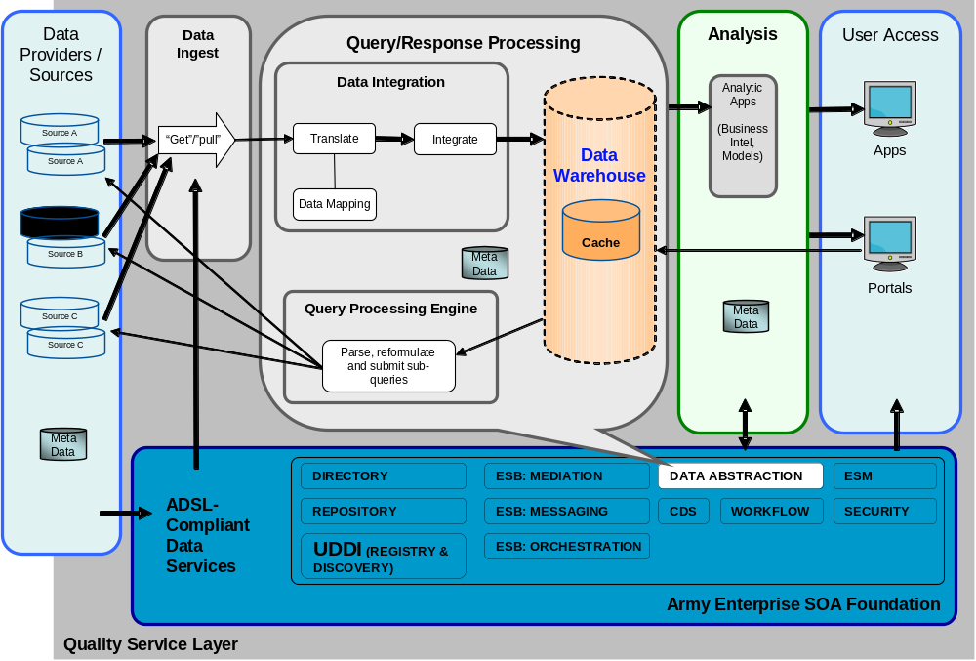
Figure 3 – Virtual Data Warehouse Framework Detail
The virtual DW framework as shown in Figure 3 consists of the following elements:
- Providers/Data Sources: Network resources that provide data to the data warehouse.
- Data Ingest: The acquisition of data from a data source. A virtual data warehouse may use ADSL but is more likely to use direct access connections for performance reasons.
- Data Integration: There are no explicit ETL operations in a virtual data warehouse. Due to performance requirements, there is not enough time for the processing steps that are performed before data is loaded into a persistent data warehouse. The raw data obtained from the data sources is transformed to a neutral format, i.e., the “view” of the virtual data warehouse, and combined for presentation/delivery to the user.
- Data Mapping: Specification of data translation rules. The schema necessary for data mapping and the XSLTs necessary for data transformation may be obtained from the Schema Repository.
- Data Warehouse: This is the view, i.e., schema, of the virtual data warehouse. The data governed by this view is transient and exists only for the lifecycle of the query.
- Cache: To expedite queries, some source data may be cached in the data warehouse, e.g., what data is cached, the frequency of refresh/update, and the version control procedures must be established based on the kind/frequency of queries received.
- Query Processing Engine: Data requested by users/consumers may be spread across several data sources. The query processing engine breaks down consumer requests into component queries and submits the sub-queries to the respective data sources.
- Analysis - Analytic Applications/Business Intelligence: Data analysis applications that are designed to use and use the data warehouse directly.
- User Access: User applications and agents that access the data warehouse or services offered by the data warehouse.
- AE SOAF: The combination of ADSL-compliant data services and AE SOAF provides the technology platform and SOA services that support access to the data in the data warehouse and for some data ingest functions.

Virtual Data Warehouse Use Cases
A virtual data warehouse has functional characteristics as described above and additional, detailed functional characteristics as described by the Use Cases in this section.. The use, or application, of a DW may reflect one of several usage patterns or Use Cases. Each of these Use Cases entails certain functional or design characteristics that further specialize the behavior of the data warehouse..
The following Use Cases for a virtual data warehouse are described below:
- Need to know – now!
- Holistic Data View
- Virtual Data Mart
- Virtual Data Source
Virtual data warehouses are most appropriate in applications where the timeliness, i.e., “freshness”, of the data is the primary usage driver. Both performance and flexibility are compromised by the requirement to pull data from the data sources in response to each query. Data quality concessions may also be necessary because the time required for quality evaluations adds to the overall system response time.

Need to Know – now!
A “Need to know – now!” virtual DW provides a near-real-time information on wide-spanning but narrowly focused status questions. Inventory levels or resource readiness, for example, are important examples of the kind of information provided by a “need to know now” data warehouse. There are no time dimensions to this kind of data warehouse since the information is intended to be “real time” or as current as possible.

Holistic Data View
This Use Case, also known as the schema extension pattern, uses data virtualization to create a holistic complete view of business activity by combining the latest most up to date operational transactional activity in one or more operational systems with detailed corresponding historical data from DWs and data marts.

Virtual Data Mart
This Use Case uses data virtualization to create one or more virtual data marts on top of a BI system thereby providing multiple summarized views of detailed historical data in a data warehouse. Different groups of users can then run ad hoc reports and analyses on these virtual data marts without interfering with the analytical activity of the other groups.

Virtual Data Source
This Use Case uses virtual views of federated data to create virtual data source components for use in ETL processing. The purpose of this pattern is twofold. First, to protect ETL workflows from structural changes to operational data sources. Second, to create re-usable virtual data source “components” for accessing disintegrated master and transactional data. The virtual data source pattern effectively is just the data associated with a customer, or a product for example, ETL workflows can be built for customer data, product data, asset data, order data etc. This helps ETL designers to create ETL jobs dedicated to a particular type of data, e.g., the customer ETL job, the product ETL job, and the orders ETL job. Simplistic design of data consolidation workflows dedicated to a type of data allows these jobs to be reused if the same data is needed elsewhere, e.g. customer data needed in two different data marts. It also guarantees that the same data is made available again and again via the same virtual view.

Master Data
Master Data are used by DWs in the ETL process. There are two forms of master data of importance to data warehouses: catalogue data and lookup reference data. Catalogues are data sets that contain descriptions of persistent objects and are relatively static, except for additions representing newly acquired objects or new versions/models of existing objects, e.g., equipment detail data. Lookup reference data are data sets that change very seldom like a fact table, e.g., state code look up tables, fact tables like gender, and unit of measures. Master Data are managed for the AE and specifically by the MDM program. The architecture goal of the Army is to have all of the MDM data sets exposed/available via a web service in the SOAF.
A full explanation of the MDM program will be provided in the yet-to-be-published MDM topic area documentation. Only a brief explanation of Master Data is provided here to describe its relationship to and use in data warehouses.
Master Data are used in two ways when data is input to a data warehouse. They may be loaded with other data sets through the normal data ingestion process and ETL processing; this approach is used when it is critical to synchronize values of the reference data with the other data sets being loaded. The second way Master Data can be used in a data warehouse is as a current baseline point for validation. In this case, the MDM data set is not ingested through the main ETL process, but rather is loaded directly from the MDM repository, via data services through the SOAF, into the data warehouse.
In both cases, the MDM data set can be used as an input to data cleansing or other ETL processing, e.g., sequence value replacement in preparation for integration processes, or workflow processing based upon values.

DSRA-Related Features
The DSRA provide a technical roadmap for transforming data systems, i.e., data repositories/data access, into an enterprise system that meets DoD Net-Centric system operational goals. It is a set of componentized architectures, terminology, and guidance for data system architecture specification.
The DSRA components are used to specify the components of a data warehouse. The functionality of a data warehouse is abstractly described in Section 3. This section describes how elements of DSRA are used to fulfill the DW functionality described above.

DSRA Overview
The DSRA was developed with the Gartner Bricks and Patterns methodology and was designed to meet several usage objectives:
- to produce a component-based architecture in a shorter development cycle
- to employ agile methods so that the architecture can adapt to business and technical changes over time
- to document the process so that the work process could be maintained and updated with ease
- to provide implementation guidance such that implementations would fit in to the enterprise architecture, interoperability would be increased, and the goals of netcentricity would be achieved.
A “pattern” is a set of interactions between information technology components that is typical in the sense that different “real” processes may be based on the same pattern. A “brick” is a logical set of capabilities that may be used as component in different patterns.
The DSRA is a comprehensive architecture based upon the Data Reference Model (DRM). (Reference 1). The DSRA is presented in 5 parts:
- Part 1: Overview, Methodology, and Common Vocabulary. Presents the overview of the DSRA. Describes how the Gartner methodology was applied. Contains the terminology that is used throughout the 6 parts.
- Part 2: Business Architecture. Presents the business architecture as a set of bricks and patterns. Logically, the business architecture motivates the information architecture and both motivate the technology architecture.
- Part 3: Information Architecture. Presents the information architecture as a set of bricks and patterns. See 2.5 below on distinguishing information and technology architectures.
- Part 4: Technology Architecture. Presents the technology architecture as a set of bricks and patterns/
- Part 5: Repeatable Process. Describes how the documents were developed and how they should be maintained in light of business and technology changes.
The bricks and patterns used to specify the data warehouse are drawn from the DSRA Information Architecture.

Mapping to DSRA Components

Data Set Transformation Domain Model
Figure 2 and Figure 3 present the functionality of the data warehouse as a logical process flow. The actual system architecture is not a sequence flow, but a set of distinct services and components that interact over an enterprise service bus, as illustrated in Figure 4.
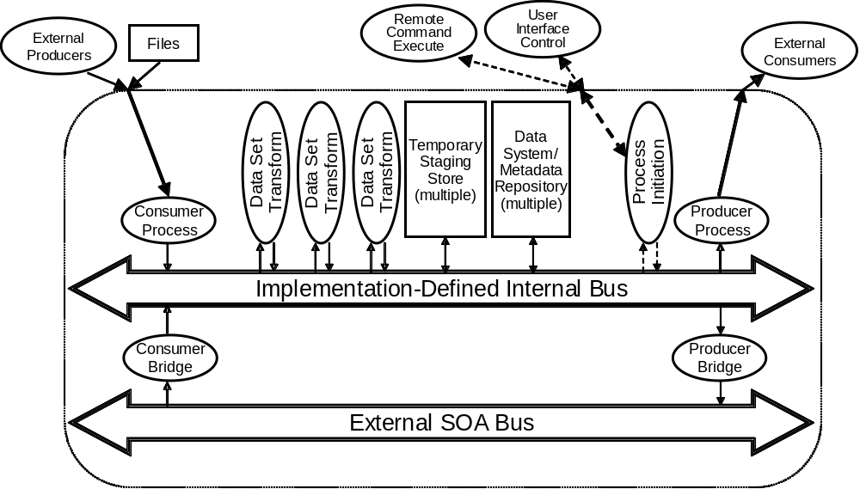
Figure 4 – Data Set Transformation Domain Model
The Data Set Transformation Domain Model illustrates the relationships between system-level components and processes. Each process (oval icon) in Figure 4 corresponds to a process (round corner box) in Figure 2. The implementation-defined internal bus is the local service bus (i.e., within an enterprise) and the external service bus is the network outside the enterprise. The “process initiation” process is a process that launches a particular workflow, e.g., “poll these data sources, retrieve updates, and load the new data”.
The Data Set Transformation Domain Model establishes the context for illustrating and understanding the relationships among several patterns and bricks.
The relationship between the Data Set Transformation Domain Model (Figure 4) and the Data Warehouse Framework (Figure 2) is illustrated in Figure 5.

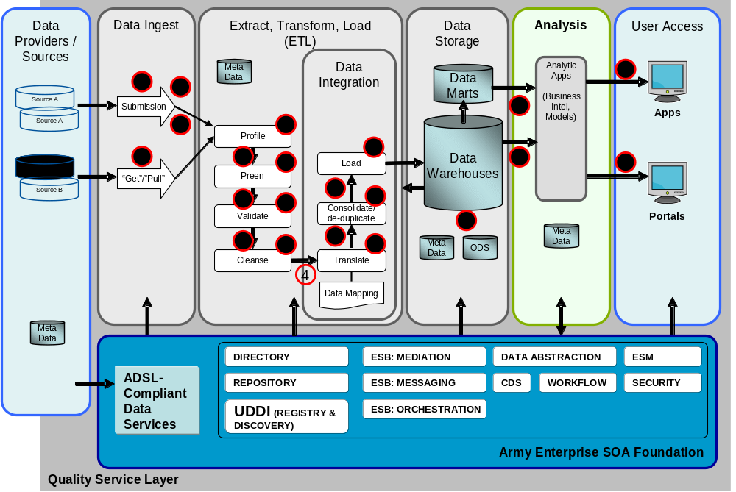
Figure 5 – Data Set Transformation Domain Model to Data Warehouse Framework Mapping

Table 1: Data Set Transformation Domain Model to Data Warehouse Mapping Description
 | Data Warehouse Framework element |  | Data Set Transformation Domain Model
(1) | Data ingest processes: Submission, “get”/”pull” | maps to | Consumer Process, Consumer Bridge
(2) | Flow of ingested data to initial ETL process | maps to | Internal Bus to Data Set Transformation Process
(3) | ETL Processes | maps to | Data Set Transformation Process
(4) | Flow of data between processes | maps to | Dataflow via internal bus, staging area, internal bus, and to next Data Set Transformation Process
(5) | Data Warehouse | maps to | Data System Repositories, Metadata Repositories
(6) | User/Application Access to Data Warehouse data | maps to | Producer Process, Producer Bridge

DSRA Bricks and Patterns
The DSRA Bricks and Patterns that are applicable to the Data Warehouse Framework are described in this section. The mapping of bricks and patterns to Data Warehouse Framework elements is presented in section 4.2.3.
There are three DSRA patterns applicable to the DW Framework:
- Access Data
- Access Metadata
- Data Set Transformation
Access Data
“Access Data” is one of the most fundamental operational patterns in information systems. Data is obtained (consumed) from a data set through an API, or other interface, by user, i.e., consumer, applications, or it is added (produced) to a data set through an API by a user, i.e., producer, application. (Access includes all Create-Read-Update-Delete (CRUD) functionality.)
Access Data has three primary features:
- Raw data transfer: transferring data via as read/write;
- Raw data navigation: changing positions for subsequent read/write;
- Raw data access paradigm: the approach used to access data, such as sequential access versus random access, and file versus stream.
The Access Data pattern uses two bricks:
- Data Systems (e.g., Relational Database Management System (RDBMS), files, data-at-rest);
- Format Specs, Message Standards.
A Data System is the data set plus API, or other interface. Format specifications and message standards specify the structure of the data accessed.
For additional details please refer to Section 3.1.1.1 from Data Strategies Reference Architectures (DSRA) Part 3: Information Architecture. (Reference 2)
Access Metadata
The Access Metadata pattern is a specialization of the Access Data pattern. It is access of metadata (data that describes other data) by a user application, typically in conjunction with Access Data to validate or control the operations on the accessed data. Metadata may be directly attached to a data source or stored in a separate data repository attached to the data source
Access Metadata has three primary features:
- Standardized descriptive data attributes, e.g., names and property values
- Metadata search: discovering descriptive data based on criteria
- Navigating through metadata: exploring relationships among descriptions.
The Access Metadata pattern uses two bricks:
- Data Description
- Object Discovery Support
For additional details please refer to Section 3.4.1.2 of Data Strategies Reference Architectures (DSRA) Part 3: Information Architecture. (Reference 2)
Data Set Transformation
Data Set Transformation is the process of transforming data from an input form to an output form. There are many kinds of transformations that an input data set(s) might undergo: translation, cleansing, or de-duplication.
The Data Set Transformation Pattern uses nine variation of the Data Set Transformation brick:
- Data Set Transformation Process Producer/Consumer Stream/File
- Data Set Transformation Process for Data Profiling
- Data Set Transformation Process for Data Preening
- Data Set Transformation Process for Data Validation
- Data Set Transformation Process for Data Cleaning
- Data Set Transformation Process for Data Translation
- Data Set Transformation Process for Data De-Duplication
- Data Set Transformation Process for Data Consolidation
- Data Set Transformation Process Initiation
The following DSRA bricks are applicable to the DW Framework:
Table 2: Description of DSRA Bricks
Brick | Description
Data Systems (data repository) | The data storage containing the data that is accessed.
Format Specifications, Message Standards | The specification, e.g., a schema, that governs the format/structure of data accessed and exchanged. The specification may be an accepted/authorized standard.
Data Description | The description or descriptive attributes that serve as metadata for a data set.
Object Discovery Support | A service that enables and supports search for data.
Metadata Repository | The data repository containing the descriptive data about data sets.
Data Set Transformation Process Producer/Consumer Stream/File | Data set transformation of Provider, Consumer or both. As a provider, the data is retrieved from multiple sources and transformed according to the rules for which it has been configured. As a consumer, the transformed data is consumed. The provider/ consumer may use a streaming mode for data transfer (get/pull) or random access
Data Set Transformation Process for Data Profiling | Data is analyzed and profiled to compile statistics and generated changes/corrected needed.
Data Set Transformation Process for Data Preening | Data set is syntactically transformed without changing its meaning and structure.
Data Set Transformation Process for Data Validation | Data is validated against schema and/or business rules to ensuring data quality and accuracy
Data Set Transformation Process for Data Cleaning | Data is corrected and reformatted according to business rules.
Data Set Transformation Process for Data Translation | The data set is translated from the source format, e.g., schema, to a target format.
Data Set Transformation Process for Data De-Duplication | The duplicate records from the data set are detected and deleted.
Data Set Transformation Process for Data Consolidation | The data set is consolidated to eliminate redundancy and ensure connectedness of data
Data Set Transformation Process Initiation | A process that initiates and manages the execution of data processing actions on a data set.

Mapping of Data Warehouse Features to Bricks
The areas and functional features of the data warehouse are filled by the bricks and patterns as described below.
Data Ingest
- Submission, “Get”/”Pull” ⇒ Data Set Transformation Consumer/Producer Stream/File (Brick)
- Access Data (Pattern)
- Access Meta data (Pattern)
The data from various sources is ingested through various paradigms such as submission or “get” and “pull” actions executed against the data systems or providers. The metadata repository containing the information about this data is also accessed.
Extract, Transform, Load
- Data Set Transformation (Pattern)
The ingested data set is transformed and loaded
- Profile ⇒ Data Set Transformation Data Profiling
The data is analyzed to compile statistics, detect errors, and identifying data patterns. The result of the analysis is used in the data cleansing process.
- Preen ⇒ Data Set Transformation Data Preening
The data set is transformed through preening where data set is formatted with steps such as adjusting the casing of alphas, removing trailing/leading white space without actually changing the information represented by the data.
- Profile and Validate ⇒ Data Set Transformation Process for Data Validation
The data set is analyzed and processed through data profiling, the resulting data profile helps to make the discovery of the data set and it further assists in setting the business rule for validation and data quality assessment; the data quality assessment sets the stage for identifying the types of data issues.
- Cleanse ⇒ Data Set Transformation Process for Data Cleaning
The bad quality data set is cleansed through various techniques as per the data quality issue.
- Translate ⇒ Data Set Transformation Process for Data Translation
The cleansed data is translated from one physical format into another.
- De-Duplicate ⇒ Data Set Transformation Process for Data De-duplication
The duplicate or redundant information is identified accordingly those records are deleted.
- Consolidate ⇒ Data Set Transformation Process for Data
The data sets are combined into a consistent format; consolidate and de-duplicate are typical performed at the same time.
- Integrate ⇒ Data Set Transformation Process for Data Integration
The data sets from various sources are integrated into an ODS-based on the volume and Data warehouse requirements.
Data Storage
- Data Warehouse ⇒ Data/Metadata Repository
The data is transformed into a data warehouse repository and used for historical storage and smart business decision making.
- Data Mart ⇒ Data Set Transformation Consumer/Producer Stream/File
Data marts are created based on business needs/operations or key business functions i.e. inventory, finance, etc.
Analysis
- Business Intelligence ⇒ Data Set Transformation Scripting
The data stored in the data warehouse is retrieved to fulfill BI capabilities i.e. predictive analysis, reporting etc.
- Web Service ⇒ Data Set Transformation Consumer/Producer Stream/File

User Access
- Web Service ⇒ Data Set Transformation Consumer/Producer Stream/File
The user access, i.e. portals, application systems access the data sets.

Summary and Future Direction
This document presented the Army Data Framework for Data Warehouses. The components and features of data warehouse technology were identified and defined, and the various applications of data warehouse technology was described. These descriptions are intended to be used within data sharing implementation efforts to guide the design and use of data warehouse technology.
The Data Strategies Reference Architecture (DSRA) defines a generalized componentized architecture for the constructive design and specification of information-sharing architectures. The components are defined in terms of Gartner Bricks and Patterns methodology. Bricks and patterns from DSRA were identified and mapped to the functional elements of the data warehouse framework . The use of the DSRA bricks and patterns is an example of reusable technology design components that furthers the Army’s objective of a common information technology operating architecture.
This document is one volume in a series of planned volumes within the broader Army Data Framework initiative. Other candidate volumes identified at the time of publication of this document include the following:
- Army Data Framework (Introduction to complete ADF)
- ADF-Applications (Data Capture, A guide to purchasing applications.)
- ADF-Repositories
- ADF-Data Warehouses (this document)
- ADF-Master Data Management Repositories
- ADF-ERP
- ADF-Data Services (Army Data Services Layer – ADSL)
- ADF-IT Infrastructure (Asset Management, AE SOA-F, and APC)
- ADF-Analysis
- ADF-Metadata Management
- ADF-Enterprise Security
- ADF-APC (A guide to operations in an APC)
- Definitions
Architecture (Information System) | The fundamental organization of a system embodied in its components, their relationships to each other and to the environment and the principles guiding its design and evolution. (ISO 42010)  An architecture description is comprised of a set of views. Each view is based on a viewpoint; a viewpoint is a collection of principles, rules, and methods for constructing and analyzing a view.
Data source | A repository, database, file, or interface from which data is available.
Dataset | A database, file, or message payload that has a bounded, finite, physical extent, and location, and within which identifiers and type names are unique. A dataset is or may be governed by a schema, i.e., it has a predictable and formally specifiable structure.
Data architecture | The structural definition of the relationships between data sources and the data within the data sources.  The data architecture is one subsystem within a comprehensive system architecture.
Data warehouse | A data warehouse is a database that collects and stores integrated sets of historical data from multiple operational systems, such as transactional systems. It is intended to enable an organization to flexibly analyze and discover new information important to operations of the organization. It is designed for the purpose of query and analysis rather than transaction processing or shared data storage.

- List of Acronyms

Acronym Definition
AE Army Enterprise
ADF Army Data Framework
ADSL Army Data Services Layer
API Application Programming Interfaces
APC Area Processing Center
BI Business Intelligence
CDO Chief Data Officer
CIO Chief Information Officer
CRUD Create-Read-Update-Delete
DoD Department of Defense
DRM Data Reference Model
DSRA Data Strategies Reference Architectures
DW Data Warehouses
ERP Enterprise Resource Planning
ESB Enterprise Service Bus
ETL Extract, Transform and Load
IT Information Technology
MDM Master Data Management
ODS Operational Data Stores
OLAP Online Analytical Processing
PM Program Manager
RDBMS Relational Database Management System
REST Representational State Transfer
RSS Real Simple Syndication
SOA Service Oriented Architecture
SOAF Service Oriented Architecture Foundation
SOAP Simple Object Access Protocol
TRM Technical Reference Manual
XSLT Extensible Stylesheet Language Transformations
- Background Subjects
  - Data Virtualization Overview
Data Virtualization is a way to integrate data from multiple disparate data sources. However, instead of copying data from numerous data sources and duplicating this data in a new, persistent data source such as data warehouse or a data mart, Data Virtualization tools access the data from across numerous “systems of record” only as and when requested by a consuming application. The systems of record are databases or other data sources, e.g., as flat files, web services, packaged applications, message queues, etc., in which the data were created and are maintained. Data Virtualization tools act as data brokers. The idea is to not create duplicative data sources, but to access data from the systems of record.
Data Virtualization techniques define logical data “views” that aggregate data from numerous systems of record “on demand”. A consuming application leverages these logical views of data in much the same way that an application would access a physical database. However, when the consuming application requests/queries data via data virtualization tools and techniques, the data virtualization layer orchestrates a query in the background across the multiple systems of record. Each system of record processes applicable pieces of the query, and provides data to the virtualization layer. The virtualization layer performs transformations on the query response provided by each system of record in order to reconcile differences in data formats. After transforming the data into a consistent format, the data virtualization tool aggregates each query result set from across all of the systems of record and presents the resultant data set to the consuming application. From the perspective of the consuming application, this resultant data set looks like a single physical database, i.e., a physical view. However, the data are actually extracted from numerous disparate data sources upon the request of a consuming application, and are aggregated together, i.e., a logical view, to resolve a specific consuming application query. This aggregated query result is not persistent. It simply exists long enough to satisfy the data request from a consuming application. The data resulting from these queries is the current snapshot of the data from across numerous systems of record instead of query responses derived from the last warehouse build, often built the night before.
A good Data Virtualization solution also incorporates query optimization techniques to reduce unneeded data as early as possible, caching techniques to assist with slower data sources, and clustering for high availability; all with the overarching goal of delivering the most current data as quickly as possible. The Data Virtualization solution must also be able to deliver such data to a client in a number of different formats, whether they be relational, using ODBC, JDBC, ADO.Net, etc. or hierarchical, i.e., Simple Object Access Protocol (SOAP), Representational State Transfer (REST), Real Simply Syndication (RSS), etc.
A typical Data Virtualization architecture, which was derived from a Gartner architecture slide, appears in Figure 6.
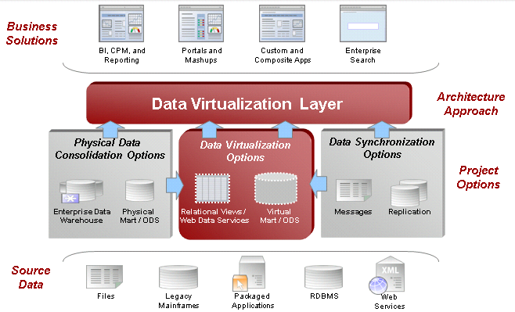
Figure 6 – Typical Virtual Data Warehouse Architecture

  - Best Practices: When to Use Physical vs. Virtual Data Warehouse
This section summarizes when it is appropriate to use a physical data warehouse and when it is better to use a virtual data warehouse.
    - Virtual/Physical Data Warehouse Decision Tree
Use a physical Data Warehouse if:
- The client application is performing multi-dimensional analysis
- Complex data cleansing or transformations is required
- Data volumes are extremely high.
Use a virtual Data Warehouse if:
- The data requirements are not completely known at design time
- Data sources may be added over the lifetime of the client application
- Legal restrictions prohibit data replication
- Lifetime costs are lower and a physical ODS is not required.
Figure 7 illustrates a decision tree for determine whether a physical or virtual data warehouse best meets the requirements.
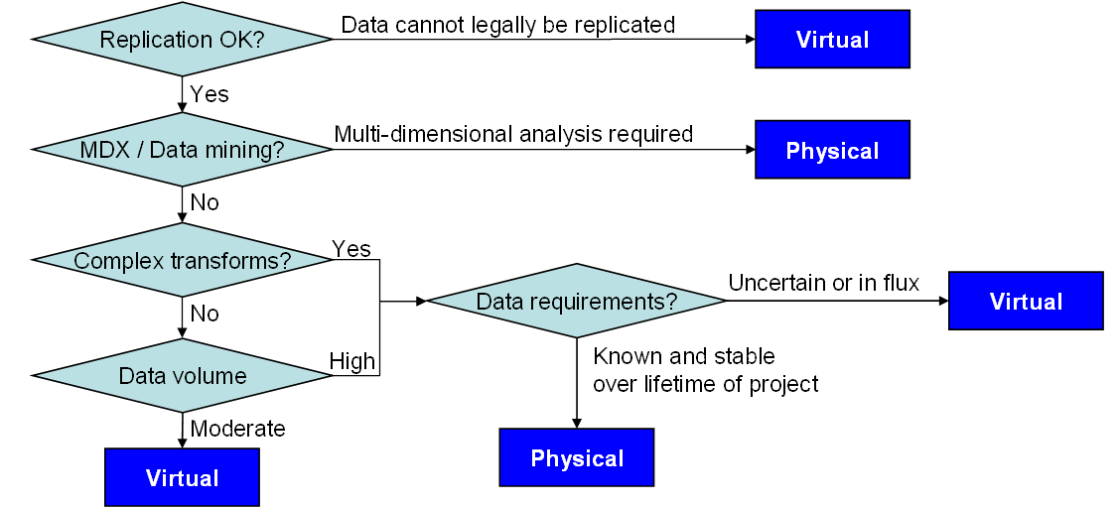
Figure 7 – Physical versus Virtual Data Warehouse Decision Tree
    - Data Service/Data Access
Use data services if:
- The data must be federated from multiple sources
- Data transformation is required
- Semantic mapping is required
- Robust data caching is required
- A “single view” of the truth is important
Access database directly if:
- All data is in a single data source
- The data is in the necessary form and the semantic mapping is simple
- The risk of different development teams writing disparate queries is small
Figure 8 illustrates a decision tree to determine whether a data service or direct database access best meets requirements.
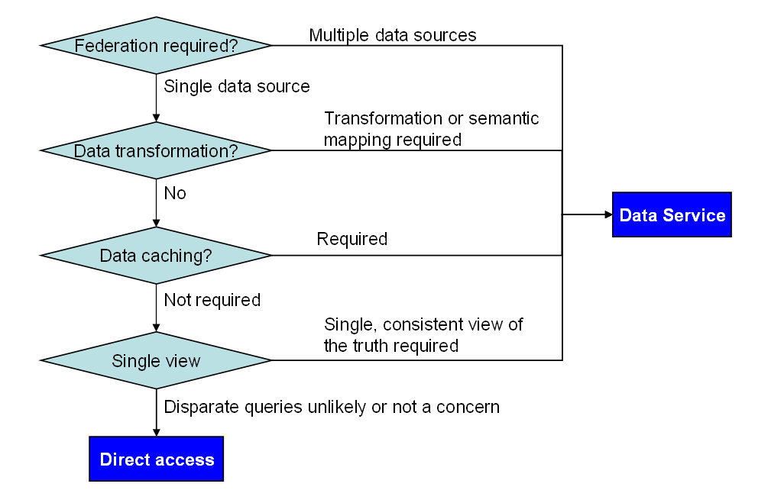
Figure 8 – Data Service versus Direct Data Access Decision Tree

