# Node

node –v

# NPM

npm –v

npm init

npm install lite-server –-save

npm install lite-server –save-dev

cls && npm start

# GIT

<https://git-scm.com/>

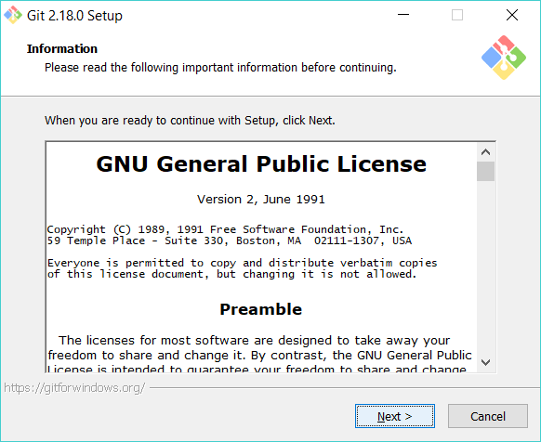

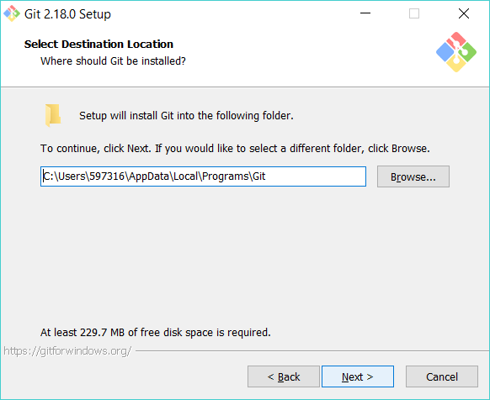

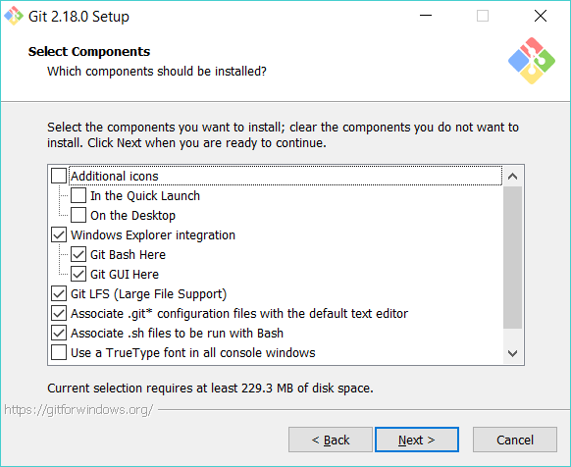

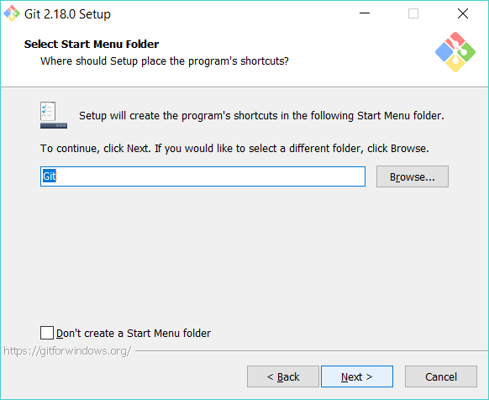

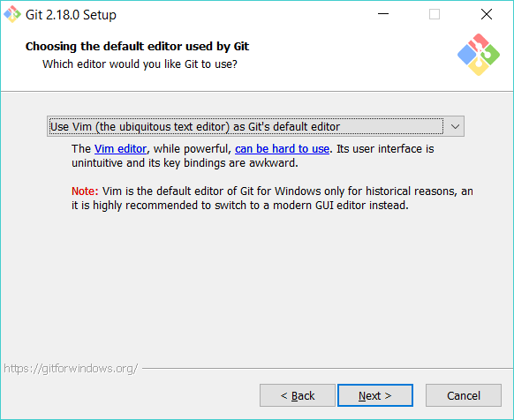

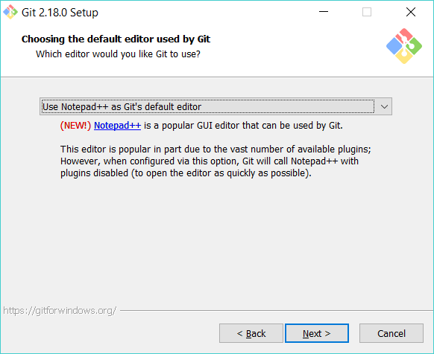

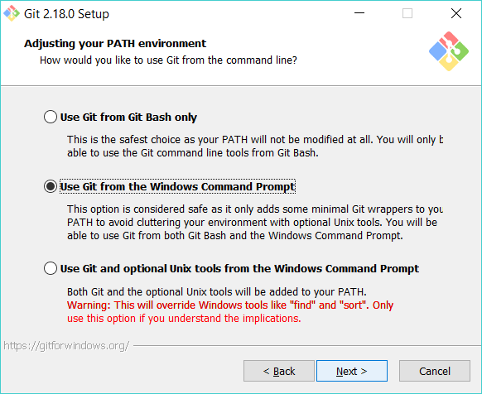

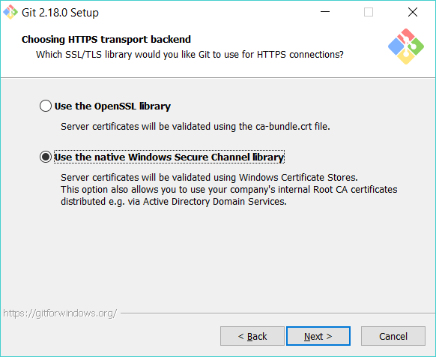

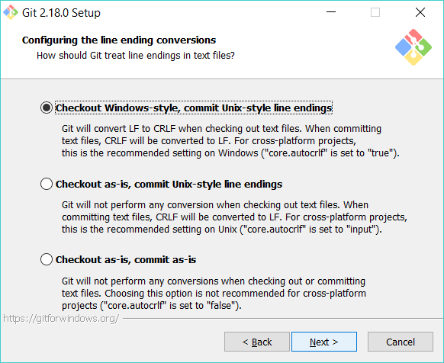

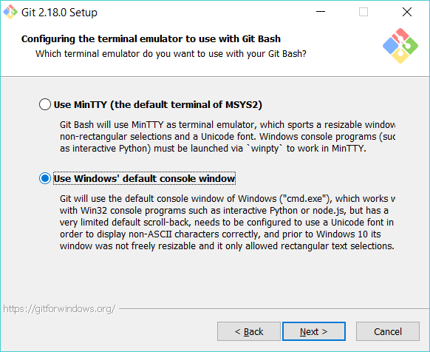

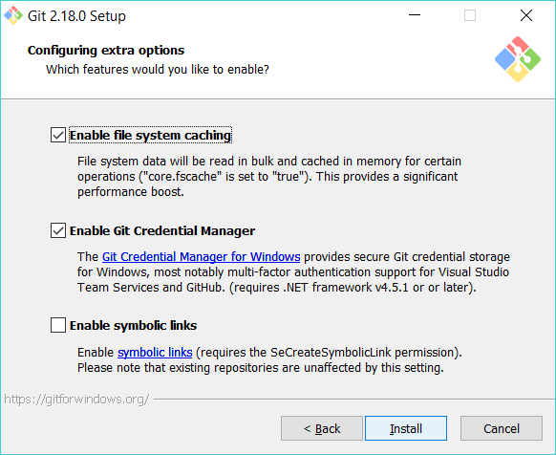

git init

cls && git log --oneline & git status

git add .

git commit –m “<description>”

git push [EJBelford] <R0b0t12Bad>

git push www.github.com//EJBelford/<project>

# Angular

ng g c <component_name> --module app

ng g service services/<service name>

# MongoDB

mongod.exe –config “C:\Program Files\MongoDB\Server\3.6\mongod.cfg” --install

net start MongoDB

net stop MongoDB