***Brooklyn:***

**Program Website:**

http://www.brooklynlandmarkelementary.org/

**Address:**

Brooklyn Landmark Elementary School

251 MacDougal Street

Brooklyn, NY 11233

**School Type:** K- 5, public

**Status:** Start-up

**Free and Reduced Lunch Rate:** 100%

**Summary:**

This program presently does not have a garden program, although they are seeking assistance from the Brooklyn Botanic Garden to establish raised beds. Volunteers and staff have gardening experience with youth and have been involved in planting in their home environments. Brooklyn Landmark Elementary School hopes to establish a garden program to provide students and families with hands-on learning experiences growing their own food.

**Photo:**

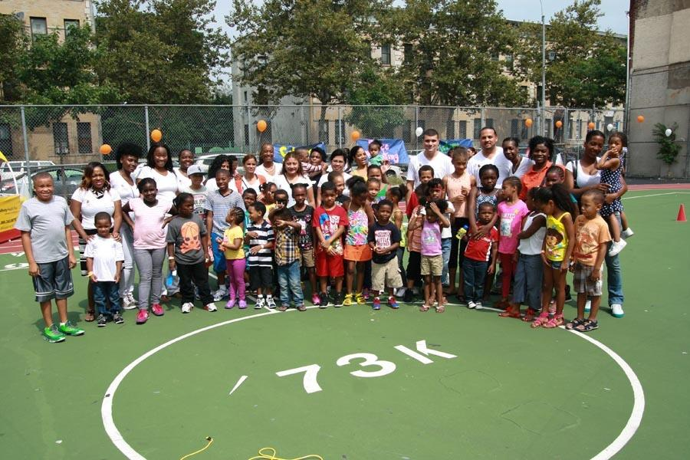

**Program Website:**

http://schools.nyc.gov/SchoolPortals/32/K274/default.htm

**Address:**

PS 274

800 Bushwick Ave

Brooklyn, NY 11221

**School Type:** K-5, public

**Status:** Start-up

**Free and Reduced Lunch Rate:** 98%

**Summary:**

This school plans to build three raised beds in between the main building and annex school that teachers and students will have access to during the school day. Security is a concern, so the area chosen will not be accessible to the public during outside of school hours. The primary use of the garden is to give students and parents the opportunity to grow fruits and vegetables, strengthening the school’s healthy child initiative. The program has also expressed an interest in installing rain barrels. Teachers would like to rotate students from all grade levels to work in the garden weekly and to organize the garden so that each grade level including pre-k will have an opportunity to be responsible for the school garden.

**Photos:**

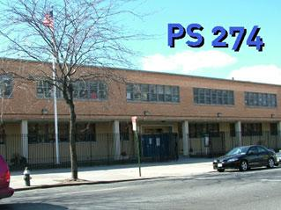

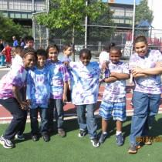

***Bronx:***

**Program Website:**

http://schools.nyc.gov/SchoolPortals/32/K274/default.htm

**Address:**

P.S./I.S. 218 Rafael Hernandez Dual Language Magnet School

1220 Gerard Ave,

Bronx, New York 10452

**School Type:** K-8, magnet school

**Status:** Start-up

**Free and Reduced Lunch Rate:** 95%

**Summary:**

The school is looking to install 6 raised beds to grow vegetables, flower and herbs in a 20 ft x 30 ft. backyard covered area next to our school. The program installed four small raised beds during the 2011/2012 academic year. They would like to expand their program, hoping to work with Cornell to hold classes in food and nutrition education. P.S./I.S. 218 is a title one school with a high rate of obesity. They hope in involve parents to help families serve healthier food in the home environment.

**Garden Plan:** 