**PyNeb Handbook**

C. Morisset, V. Luridiana, G. Delgado-Inglada. Updated 08/09/2014

A) Introduction 2

References 2

Discussion group 2

B) Installation 2

1. Requirements 2

2. Installing the code with pip 3

3. Installing the code from tar 3

C) First steps using PyNeb 4

D) The Atom class 5

1. Description 5

2. Print and plot atomic properties 5

3. Use of Atom to compute populations and emissivities 8

4. Physical conditions determined from line ratios 9

5. Ionic abundance determination 10

6. Creating a dictionary of Atom objects 10

7. The atomic data 10

Predefined sets of atomic data 11

Creating new atomic data files 11

Plotting atomic data 14

E) Recombination lines: the RecAtom class 16

F) The extinction class: RedCorr() 17

G) The EmissionLine class 19

H) The Observation class: reading and dealing with observations 20

1. Reading observation from a file 20

2. Extinction correction 21

3. Adding observations and lines 21

4. Getting line intensities 22

5. Using Observation to determine ionic abundances 22

I) Exploring line intensities with the EmisGrid class 22

1. The EmisGrid class 22

2. Instantiating various EmisGrid Objects with getEmisGridDict 23

J) The Diagnostics class 24

1. Determination of temperature and density 24

2. Diagnostic diagram combining various atoms 25

K) Determination of elemental abundances using ICFs 27

L) The logging facility 27

M) References 28

N) How it works 28

1. getPopulations 28

2. getEmissivity 29

1. Introduction

PyNeb is a package for the analysis of emission lines, which evolved from the IRAF package **nebular** (Shaw and Dufour 1995; Shaw et al 1998). Please note that the name of the code and the tarball are CapitalCase (PyNeb, *PyNeb-<version-number>*), whereas the module and directories are all lowercase (*pyneb*, *pynebcore.py*, etc).

PyNeb is a library rather than a code. This means that to use it, one has to write a python script or enter an interactive python session to call PyNeb classes and/or functions. In the following we'll provide some examples on how to use the different classes and functions.

In this manual, python commands are identified by this style:

print('this is a python command')

Outputs of python commands will start on the first column:

this is a python command

The (Linux) shell commands use this style:

echo I m on Linux

* + 1. References

Whenever you use PyNeb for calculations that lead to a published paper, you are kindly asked to cite the code as:

Luridiana, V., Morisset, C., & Shaw, R. A. 2012: *PyNeb: a new software for the analysis of emission lines*, IAU Symposium, 283, 422-423

This paper is accessible [HERE](http://adsabs.harvard.edu/abs/2012IAUS..283..422L).

* + 1. Discussion group

There is a discussion group where you can post your requests, help other users, share your problems (PyNeb-related only :) ) at the following URL:

<https://groups.google.com/forum/#!forum/pyneb>

The email address to send messages to the group (the best way to get a quick answer to a problem) is [pyneb@googlegroups.com](mailto:pyneb@googlegroups.com)

1. Installation
   1. Requirements

To run PyNeb, you must have python v. 2.6 or above installed (but ***not*** python v. 3.n, which is a different python branch), plus the *matplotlib* , *numpy* and *scipy* libraries. Numpy minimum version is 1.5.1.

To know which your default python version is, enter from the command line:

python --version

To know whether you have *numpy* and *matplotlib* installed, enter python by typing either *python* or *ipython* (preferred), then type:

import matplotlib

import numpy

You'll access the version number this way:

print(matplotlib.__version__)

print(numpy.__version__)

* 1. Installing the code with pip

This is the easiest way to install or upgrade PyNeb. You'll need **pip** installed; get it here:

<http://pypi.python.org/pypi/pip> and install it using:

sudo easy_install pip

or following the instructions on the pip web page. Once pip is installed, enter from the command line:

pip install –user pyneb

to install PyNeb and:

pip install –upgrade –user pyneb

for any upgrade. Uninstall PyNeb is easy as well:

pip uninstall pyneb

PyNeb's webpage at [www.iac.es/proyecto/PyNeb](http://www.iac.es/proyecto/PyNeb) contains a Troubleshooting page to address most frequent installation problems.

* 1. Installing the code from tar

Download the PyNeb package from the pypi site. Unpack the PyNeb tarball in the directory of your choice, enter the directory PyNeb-<version-number>, which is PyNeb's root directory and contains the following:

* *setup.py* (a file)
* *pyneb* (a directory)
* *PKG-INFO* and *README.txt* (information files)

*setup.py* is the package installer. To install the package, enter:

python setup.py install --user

Once the package is installed, simply enter your favorite python interface (e.g., *python* or *ipython*) and start using PyNeb by inputting:

import pyneb as pn

(the "as pn" bit simply establishes a nickname for pyneb). Enjoy!

You can know which version of PyNeb you are using by:

print(pn.__version__)

or, in ipython:

pn.__version__

1. First steps using PyNeb

A sketch of the organization of PyNeb can help to understand which class plays which role:

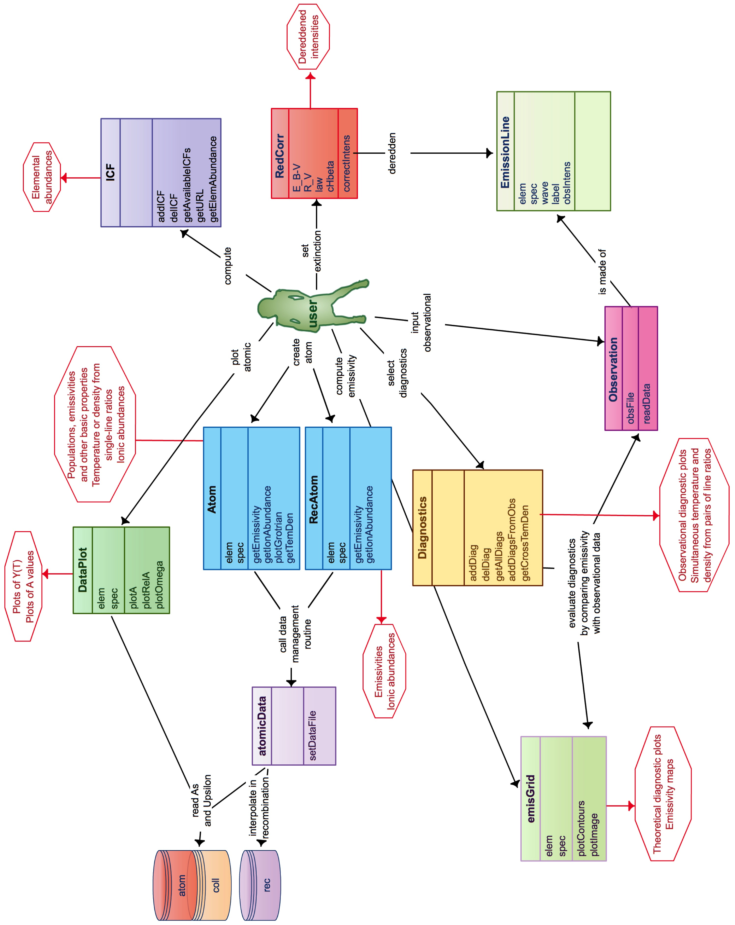

The main classes are Atom, RecAtom, EmisGrid, Observations, and Diagnostics. Some classes use other classes, for example Atom is used in almost all the other classes. In the following a detailed description of each class is given, and the exhaustive list of all the methods of all the classes is available from the reference manual.

PyNeb uses the Object Oriented (OO) method of programming to define most of its features, but the scripts written as PyNeb wrappers need not be OO; they may follow the more classical functional or structured programming style.

1. How atoms are represented: the Atom and RecAtom classes

PyNeb distinguishes between atoms emitting collisionally-excited lines (called here "collisionalatoms") and atoms emitting recombination lines ("recombination atoms"). Both are represented as n-level systems and share the same basic syntax, but they are encoded in different classes and their internal representation is different in either case, as detailed in the following sections.

* 1. The Atom class

The critical features of the physical atom relevant for our scope are encapsulated, for the collisional case, in the Atom data structure. Atom contains the way atomic data are read and managed to compute, for example, line emissivities and to determine diagnostics from line ratios, as well as ionic and total abundances.

In the following, we will always assume that the PyNeb package has been imported under the alias “pn”:

import pyneb as pn

Instantiation of the Atom class to create an Atom object is done by specifying an ion.

O3 = pn.Atom('O', 3)

This command tells the code to create an O++ ion (corresponding to the [O III] spectrum, hence the "3") model by reading the [O III] atomic data. You can create (instantiate) as many atoms as you need, or even create atoms for the same ion using different atomic data. You can check the feature of a particular Atom object by printing it:

print(O3)

Atom O3 from o_iii_atom_SZ00-WFD96.dat and o_iii_coll_AK99.dat

(As will be explained in this Section, the data are stored in two kinds of files, the *atom* files and the *coll* files.) The Atom object contains methods (functions) to explore it; for example you can display the ion's intrinsic properties:

O3.name

O3.spec

O3.gs

or the value of the data you are using, such as the energy of the fourth level in eV:

O3.getEnergy(4, unit='eV')

The complete inventory of features and methods of the Atom class can be displayed by entering:

O3.

(with the dot) followed by the TAB key (only from an ipython session). The methods can be either public or private and are described in the PyNeb Reference Manual. The private methods have names starting with underscore “_”. They are not supposed to be used by “standard” users.

As always, use the “?” from within an ipython session, or the __doc__ method in any python session, or consult the User Reference Manual, to gain access to the different options of the methods:

O3. getEnergy?

print(O3. getEnergy.__doc__)

* 1. Print and plot atomic properties

You can use the following methods to obtained line emissivities:

O3.printIonic()

Some arguments can be passed to the method to obtain more information:

O3.printIonic(tem=10000., den=1e3, printA=True, printPop=True, printCrit=True)

the result of the latter being the following:

elem = O

spec = 3

temperature = 10000.0 K

density = 1000.0 cm-3

Level Populations Critical densities

Level 1: 3.150E-01 0.000E+00

Level 2: 4.888E-01 5.173E+02

Level 3: 1.961E-01 3.629E+03

Level 4: 4.252E-05 7.146E+05

Level 5: 2.933E-09 2.751E+07

Level 6: 2.407E-12 3.991E+10

2.620E-05

88.33m

(2-->1)

2.879E-22

3.170E-11 9.760E-05

32.65m 51.80m

(3-->1) (3-->2)

3.781E-28 7.337E-22

2.410E-06 6.791E-03 2.046E-02

4931.23A 4958.91A 5006.84A

(4-->1) (4-->2) (4-->3)

4.127E-25 1.156E-21 3.451E-21

0.000E+00 2.150E-01 6.340E-04 1.710E+00

2314.87A 2320.95A 2331.40A 4363.21A

(5-->1) (5-->2) (5-->3) (5-->4)

0.000E+00 5.396E-24 1.584E-26 2.283E-23

0.000E+00 2.200E+02 5.480E+02 4.740E-03 0.000E+00

1657.69A 1660.81A 1666.15A 2496.03A 5833.01A

(6-->1) (6-->2) (6-->3) (6-->4) (6-->5)

0.000E+00 6.334E-24 1.573E-23 9.078E-29 0.000E+00

# H-beta volume emissivity:

1.237E-25 N(H+) * N(e-) (erg/s)

Each block corresponds to a transition; the four lines contain the transition probability (in s-1); the wavelength of the corresponding emission line (in Angstrom or microns); the two levels of the transition; and the emissivity of the line.

You can plot the line emissivities using the following command:

O3.plotEmiss(tem_min=1000, tem_max=30000, ionic_abund=1.0, den=1e3, style='-', legend_loc=4, temLog=False, plot_total=False, plot_only_total=False, legend=True, total_color='black', total_label='TOTAL')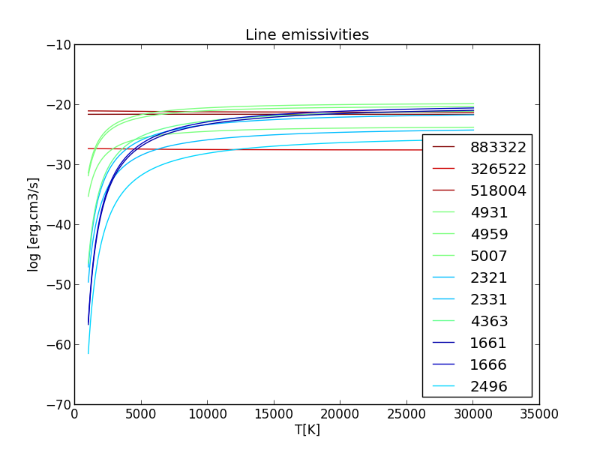

You can use the capacity of matplotlib plotting tools to zoom, crop, move the figure as you need.

A Grotrian diagram of the ion (i.e., a plot of the energy levels and transition wavelengths) can be obtained using:

O3.plotGrotrian(tem=1e4, den=1e2, thresh_int=1e-3, unit = *'eV'*)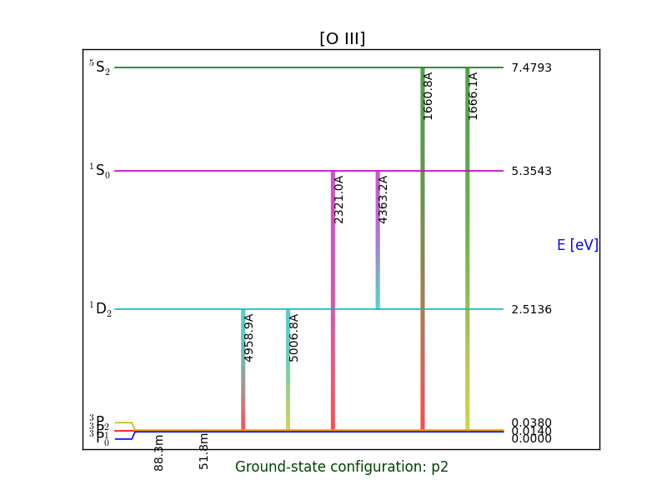

which can be tailored in various ways, zoomed in or saved into a file.

The atomic data are accessible using the following commands:

O3.getA()

O3.getOmegaArray()

O3.getOmega(tem=1e4)

As always, use the “?” from within an ipython session, or the __doc__ method in any python session, or consult the User Reference Manual, to gain access to the different options of the methods:

O3.getOmega?

print(O3.getOmega.__doc__)

* 1. Use of Atom to compute populations and emissivities

Individual methods are used to access the populations, emissivities, etc:

O3.getEnergy(4, unit='eV')

O3.getStatWeight(level=4)

O3.getPopulations(tem=1e4, den=1e2)

O3.getCritDensity(tem=12000)

O3.getEmissivity(tem=1e4, den=1e2, wave=5007)

O3.getIonAbundance(int_ratio=100, tem=1.5e4, den=100., wave=5007)

The wavelengths should be entered with enough precision to avoid confusion with nearby lines. In case of doubt, enter:

O3.printTransition(5007)

to check if the transition selected by the code actually correponds to the one you intended. **O3.getTransition** is an abridged version which only returns the tuple of levels rather than an extended output, and is therefore apt to be used in scripts.

In addition to the wavelength, a transition can also be specified through its defining levels, as in:

O3.getIonAbundance(int_ratio=100, tem=1.5e4, den=100., lev_i = 4, lev_j=3)

In the case of getEmissivity method, tem and den can be arrays. In such a case, if they have different dimensions N and M, the function will return an array of NxM emissivities corresponding to all tem-den combinations; if both arrays have the same dimension, you can obtain the emissivities of either the NxN array of tem-den combinations as in the previous case, or of the 1D, N-length array obtained pairing tem and den element by element. This is controlled by the “product” parameter:

O3.getEmissivity([10000, 12000], [100, 500], 4, 2, product=True)

array([[ 1.14345463e-21, 1.15206397e-21], [ 1.74604704e-21, 1.75668558e-21]])

O3.getEmissivity([10000, 12000], [100, 500], 4, 2, product=False)

array([ 1.14345463e-21, 1.75668558e-21])

* 1. Physical conditions determined from line ratios

The Atom object also contains a method to compute the electron temperature or density given a line ratio:

O3.getTemDen(int_ratio=150., den=100., wave1=5007, wave2=4363)

The keyword *tem* (or *den*) specifies the supplied value of the temperature (or density). Which quantity is computed (temperature or density) is determined by which quantity is provided to the method: if “den” is given, then “tem” is computed, and viceversa.

If the intensity ratio is a simple ratio of two transitions, you can:

- either give the wavelengths of the two transitions involved:

O3.getTemDen(0.02, den=1.e4, wave1=4363, wave2=5007)

- or give the four levels that define the two transitions, in the following order: (upper level of numerator) (lower level of numerator) (upper level of denominator) (lower level of denominator); e. g.:

O3.getTemDen(0.02, den=1.e4, lev_i1=5, lev_j1=4, lev_i2=4, lev_j2=3)

In the general case of an intensity ratio formed by any number of transitions, an algebraic expression must be supplied as the argument of the keyword *to_eval*:

O3.getTemDen(0.02, den=1.e4, to_eval="I(5, 4) / (I(4, 3) + I(4, 2))" )

N2.getTemDen(150., den=100., to_eval = "(L(6584) + L(6548)) / L(5755)")

The “to_eval” argument admits either I(i, j) or L(wavelength) to identify the transitions involved in the diagnostic. Both can be mixed in the same string. If you do not know what transition corresponds to a given wavelength, use **O3.printTransition** to find it.

The parameters tem or den, as well as the line ratio, may be arrays (1D or 2D, as in the case of observations obtained from IFUs), in which case the result will have the same shape. Some restrictions can be set to the domain explored by the method when looking for the solution; see the documentation for more details.

O3.getTemDen([0.02, 0.04], den=[1.e4, 1.1e4], to_eval="I(5, 4) / (I(4, 3) + I(4, 2))")

O3.getTemDen([0.02, 0.04], den=1.e4, to_eval="I(5, 4) / (I(4, 3) + I(4, 2))")

Notice that if you want to simultaneously determine both temperature and density combining two diagnostics (from two different atoms), you need to use the getCrossTemDen method of the Diagnostic class, described here XXXX_ADD_LINK.

* 1. Ionic abundance determination

The ionic abundance is obtained from the intensity of a line normalized to Hbeta=100.

O3.getIonAbundance(int_ratio=100, tem=1.5e4, den=100., wave=5007)

See HERE XXXX_ADD_LINK for a determination using the Observation object.

* 1. Creating a dictionary of Atom objects

You can define all the atoms at once and put them in a dictionary by creating each atom at a time through the commands:

O3 = pn.Atom('O', '3')

O2 = pn.Atom('O', '2')

N2 = pn.Atom('N', '2')

or rather use one of the following shortcuts:

atoms = pn.getAtomDict() # a method always requires parenthesis, even without argument

atoms = pn.getAtomDict(elem_list=['C', 'N', 'O']) # all the ions with spectra from 1 to 6 are created

atoms = pn.getAtomDict(atom_list=['O2', 'O3', 'Ar3'])

which create a dictionary whose keys are the conventional atom names <element><spectrum> and the corresponding entries the atoms themselves; e. g.:

atoms['N2'] # N II atom

atoms['N2'].getEmissivity(tem=1e4, den=1e2, wave=6584) # example of use

This can be useful if you need to loop on a list of atoms, to plot atomic data for example. To see what atoms have been created (which is limited by the data included in the selected atomic data set), enter:

atoms.keys()

If you want to be able to access them directly rather than through a dictionary, input from the command line:

for key in atoms.keys():

vars()[key]=atoms[key]

and then you will be able to do the following:

N2.elem

* 1. The atomic data

Since, for a given ion, there can be different calculations of atomic data with slightly (or not so slightly!) different results, more than one version of the data can exist for a given ion. The data are stored in and read from different types of files depending on the mechanism of line formation:

* In the case of recombination data, a single xxx_rec_XYZ.fits file contains the line emissivities, in a 2D temperature-density dependent table.
* In the case of collisionally excited lines, the data are organized in different way depending on the file format:
  + The only data format admitted was, originally, fits (extension: .fits). Fits atomic data for a given ion are organized in two files (xxx here represents the ion [e.g., "o_iii" for O III] and XYZ is the acronym of the source paper(s)):
    - the *xxx_atom_XYZ.fits* file, containing the energies, the statistical weights and the transitions probabilities (the Einstein coefficients Aij)
    - the *xxx_coll_XYZ.fits* file, containing the temperature-dependent collision strengths.
  + Fits file are being gradually replaced by plain ascii tables (extension .dat), which are organized as follows:
    - xxx_levels.dat contain the energy levels and statistical weights. These file are downloaded from NIST and the source papers are encoded within the file and translated by PyNeb into an explicit bibliographic reference.
    - *xxx_atom_XYZ.dat contain* the transitions probabilities
    - *xxx_coll_XYZ.fits* contain the temperature-dependent collision strengths

Each of these file contains information for a finite number of levels N. Specifically, the energy levels and the statistical weights are arrays with N elements (one value per level), while the transition probability tables are triangular *N*N* matrices with zeros on the main diagonal (transition probabilities are different from zero only for *(j -> i)* transitions with *j > i)*.

This number is a feature of the particular atomic calculation, not an intrinsic feature of the physical atom, so that an Atom object created within PyNeb will have a number of levels *NLevels* equal to the number of levels of all the data used (or the minimum of them if either of the *atom*, *coll* or levels is different).

You can print the name of the atomic data used for a given ion with:

O3.atomFile

O3.collFile

As the files can be found in different directories, you may also find useful to print the directories:

O3.atomPath

O3.collPath

A set of data files for a given group of ions is called a data set. The default data set (or the adopted data set, if a different one has been set) can be displayed with the command:

pn.atomicData.getDataFile()

while the data files set for a particular ion can be displayed by providing an argument to the above; e.g. for [SIV]:

pn.atomicData.getDataFile('S4')

The complete inventory of data available for a given ion can be displayed with the command:

pn.atomicData.getAllAvailableFiles('S3')

This method looks for any “s_iii_*” file in a set of paths including the PyNeb package atomic data directory and the current directory (the one from where the python session is running); additional paths can be added with the following command:

pn.atomicData.addDataFilePath(“user_directory”)

If both a .dat and a .fits version of the same data are found, the .fits files are ignored, but you can force PyNeb to include them by running the command:

pn.atomicData.includeFitsPath()

If you want to change the atomic data used for a given ion, use the following command to point to an existing data file:

pn.atomicData.setDataFile('s_iii_coll_HRS12.fits')

If you want to change several data files, it may be worth defining a dictionary with all your preferred atomic data files within your script:

DataFileDict = {'H1': {'rec': 'h_i_rec_SH95.fits'},

'N1': {'atom': 'n_i_atom_KS86-WFD96.fits', 'coll': 'n_i_coll_PA76-DMR76.fits'},

'N2': {'atom': 'n_ii_atom_WFD96.fits', 'coll': 'n_ii_coll_LB94.fits'},

'O2': {'atom': 'o_ii_atom_Z82.fits', 'coll': 'o_ii_coll_P06.fits'},

'O3': {'atom': 'o_iii_atom_WFD96SZ00.fits', 'coll': 'o_iii_coll_AK99.fits'},

'Ne3': {'atom': 'ne_iii_atom_M83-KS86.fits', 'coll': 'ne_iii_coll_McLB00.fits'}} pn.atomicData.setDataFileDict(DataFileDict)

Predefined sets of atomic data

Predefined atomic data dictionaries are provided by PyNeb. One of them is the default data set, whose identifying label is given by:

pn.atomicData.defaultDict

To display the complete list of the existing predefined dictionaries, enter:

pn.atomicData.getAllPredefinedDict()

To use a predefined data set, enter for example the following:

pn.atomicData.setDataFileDict("IRAF_09")

To revert to the default set:

pn.atomicData.resetDataFileDict()

You can have a look at the other methods of pn.atomicData in the Reference Manual.

* + 1. Creating new atomic data files

The following is an example of a file for a 6-level atom fits file of O III, containing the energies, the statistical weights, and the matrix of transition probabilities:

Energy Stat_Weight Aij

1/Ang none 1/s 1/s 1/s 1/s 1/s 1/s 1/s

0. 4 0.00e+00 0.00e+00 0.00e+00 0.00e+00 0.00e+00 0.00e+00 0.00e+00

0.00026818 6 3.06e-05 0.00e+00 0.00e+00 0.00e+00 0.00e+00 0.00e+00 0.00e+00

0.00026838 4 0.000178 1.3e-07 0.00e+00 0.00e+00 0.00e+00 0.00e+00 0.00e+00

0.0004048 4 0.0522 0.0991 0.0534 0.00e+00 0.00e+00 0.00e+00 0.00e+00

0.00040482 2 0.0212 0.0519 0.0867 1.41e-10 0.00e+00 0.00e+00 0.00e+00

0.00119837 6 8.61e+08 0.00e+00 0.00e+00 0.00e+00 0.00e+00 0.00e+00 0.00e+00

0.0012 4 8.65e+08 0.00e+00 0.00e+00 0.00e+00 0.00e+00 0.00e+00 0.00e+00

0.00120082 2 8.67e+08 0.00e+00 0.00e+00 0.00e+00 0.00e+00 0.00e+00 0.00e+00

*** O II energy and Aij data

*** SOURCE1 'Bowen, 1960, ApJ, 132, 1'

*** NOTE1 'Energy values for levels 2 and 3'

*** SOURCE2 'Kaufman & Sugar, 1986, JPCRD, 15, 330'

*** NOTE2 'Energy values for levels 4 and 5'

*** SOURCE3 'Fawcett, 1975, ADNDT, 16, 135'

*** NOTE3 'Energy values for levels 6, 7 and 8'

*** SOURCE4 'Wiese, Fuhr & Deters, 1996, JPCRF, Monograph 7, 396'

*** NOTE4 'A-values from level 5 or lower'

*** SOURCE5 'Unknown'

*** NOTE5 'A-values from level 6 or upper'

Since the energies are stored in Angstrom^{-1}, the wavelength of any transition can be simply calculated as the inverse of the energy difference between the corresponding levels. (A note of caution: in some of the older fits files, many energies had been computed as the inverse of observed wavelengths, which in most cases were in the air; in such cases, the energy listed are not true energies but rather "energies in 1/Ang in the air”, which might lead to misidentification in the case of closely spaced lines; the new ascii files are free from this bug.)

The effective collision strengths are a function of electron temperature (a collective property of the electron distribution) and are obtained as the average over a Maxwellian distribution of the collision strengths, which depend on the energy. (Note: in this document, we will often refer to the effective collision strengths as *collision strengths* for short, although this is not strictly correct.) They are usually published for a handful of T values and must be interpolated to get the collision strength at the desired values. As a result, there is a whole 1-D array of collision strengths, with one element for each tabulated temperature value, for each transition *j -> i*  with *j > i*. The existence of this 3rd dimension prevents the data from being simply stored in a matrix as transition probabilities are. Instead, each transition is presented in a line, as in the following example:

0 0 3.699 3.778 3.903 4.000 4.204 4.301

1 3 0.54439998 0.5456 0.54799998 0.55000001 0.5564 0.56040001

1 2 0.81660002 0.81840003 0.82200003 0.82499999 0.83459997 0.84060001

1 5 0.13510001 0.1358 0.1371 0.1382 0.14139999 0.1435

1 4 0.2701 0.27149999 0.27410001 0.27649999 0.28290001 0.28690001

2 3 1.22000003 1.20799994 1.18599999 1.16799998 1.12800002 1.11199999

3 5 0.322 0.3238 0.3276 0.3321 0.34760001 0.35839999

3 4 0.47799999 0.4806 0.48640001 0.49309999 0.51599997 0.53200001

2 5 0.34599999 0.3479 0.35210001 0.35690001 0.37349999 0.38510001

2 4 0.85600001 0.86070001 0.87099999 0.88300002 0.92409998 0.95270002

4 5 0.28 0.28200001 0.28400001 0.287 0.29499999 0.30000001

1 6 1.14199996 1.15600002 1.18400002 1.21099997 1.29149997 1.34350002

1 7 0.76130003 0.77069998 0.78930002 0.80729997 0.861 0.89569998

1 8 0.38069999 0.38530001 0.39469999 0.40369999 0.4305 0.44780001

2 6 0. 0. 0. 0. 0. 0.

2 7 0. 0. 0. 0. 0. 0.

2 8 0. 0. 0. 0. 0. 0.

3 6 0. 0. 0. 0. 0. 0.

3 7 0. 0. 0. 0. 0. 0.

3 8 0. 0. 0. 0. 0. 0.

4 6 0. 0. 0. 0. 0. 0.

4 7 0. 0. 0. 0. 0. 0.

4 8 0. 0. 0. 0. 0. 0.

5 6 0. 0. 0. 0. 0. 0.

5 7 0. 0. 0. 0. 0. 0.

5 8 0. 0. 0. 0. 0. 0.

6 7 0. 0. 0. 0. 0. 0.

6 8 0. 0. 0. 0. 0. 0.

7 8 0. 0. 0. 0. 0. 0.

*** OII collision strength data

*** SOURCE1 'Pradhan, 1976, MNRAS, 177, 31'

*** NOTE1 'Collision strengths for transitions 3-2 and 5-4'

*** SOURCE2 'McLaughlin & Bell, 1993, ApJ, 408, 753'

*** NOTE2 'All other collision strengths'

The first row of the data (0 0 …) is the array of electron temperatures for which the collision strengths are tabulated (in log10(K) or K/10000, depending on the particular data set).

From experience with **nebular**, it was decided that a suitable interpolating function for collision strengths is the Chebyshev polynomial. By default, each transition is described by a Chebyshev polynomial of order *n* that interpolates the tabulated values. The default value for the Chebyshev order is the number of temperature values, but other order can be specified when calling pn.writeColl.

If, for some reason, a Chebyshev interpolation is not desired, the data can also be interpolated linearly, when the instantiation of the corresponding Atom is done.

Notice the use of SOURCE and NOTE keyword to store the references of the data. It is very important to document those keywords and to give a name to the file that reflects the sources of the data. When an Atom object is built, this information is stored and can be retrieved through:

O3.printSources()

* + 1. Plotting atomic data

**DataPlot** is a class to produce plots of the atomic data provided. The module must be initialized by specifying which data sets are to be plotted; it allows plotting the transition probabilities (either as an absolute value or relative to a reference set: **A** and **relA** respectively) and the collision strengths (**Omega**).

You must first create an instantiation of DataPlot for a given atom:

dp_O3 = pn.DataPlot('O', 3)

dp_S3 = pn.DataPlot('S', 3)

Then you can plot the different As and Omegas :

dp_S3.plotA() # transition probabilities plot

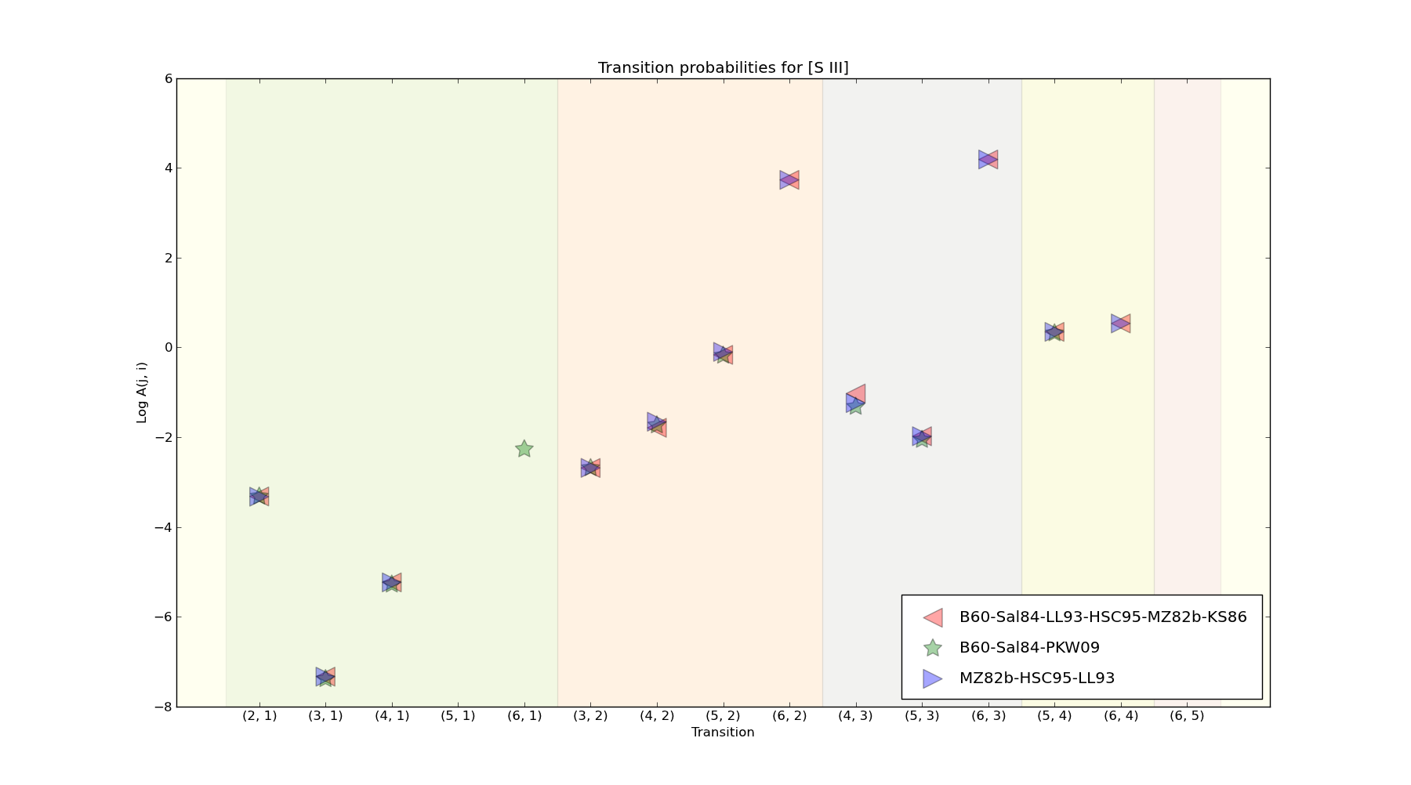

dp_S3.plotRelA() # relative transition probabilities plot

dp_S3.plotRelA(ref_data = ‘B60-Sal84-PKW09’) # defining relative to which ref

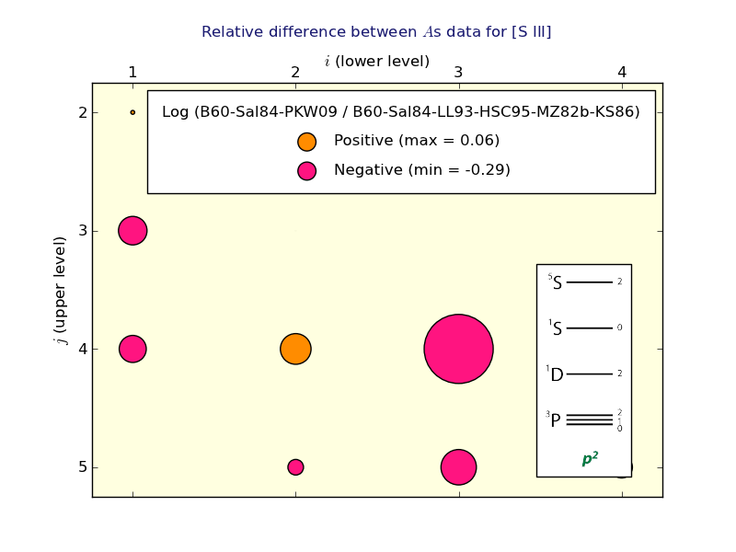

dp_O3.plotOmega() # collision strength plot

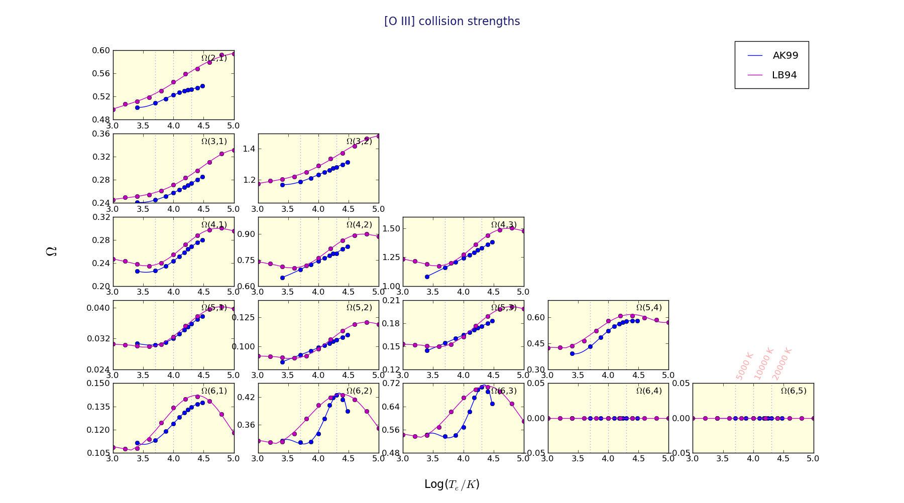

1. Recombination lines: the RecAtom class

This object is similar to the Atom one, but some methods differ due to the particularities of the recombination spectrum. It is instantiated like this:

H1 = pn.RecAtom('H', 1)

The data are read from a fits file defined in the pn.atomicData.getDataFile('H1', 'rec') file and interpolated in tem, den. The ions for which recombination lines are available are listed with the command:

pn.atomicData.getAllAtoms(coll=False, rec=True)

You can list all the available data files for a given ion by:

pn.atomicData.getAllAvailableFiles('H1')

The emissivities are obtained by:

Hbeta = H1.getEmissivity(tem=1e4, den=1e3, lev_i=4, lev_j=2)

There are two ways in which the lines are identified in the data file, depending on whether the atom is an hydrogenoid or not. In the first case, the transition can be specified either as a pair of levels lev_i, lev_j or as a label (labels are descriptive of level pairs):

H1.getEmissivity([1e4, 1.2e4], [1e3, 1e2], lev_i = 4, lev_j = 2)

H1.getEmissivity([1e4, 1.2e4], [1e3, 1e2], label='4_2', product=False)

In the second case, the transition can be specified either as a wavelength or as a label (labels are descriptive of wavelengths):

He1.getEmissivity(1e4, 1e2, wave=4471.0)

He1.getEmissivity(1e4, 1e2, label='4471.0')

In either case, enter <atom>.labels to display the valid labels.

As an example application, you can easily generate a 2D table of H alpha/ H Beta as a function of Te and Ne:

tem = np.linspace(5000, 20000, 100)

den = np.logspace(2, 6, 100)

im_Hab = (H1.getEmissivity(tem, den, label='3_2') /

H1.getEmissivity(tem, den, label='4_2'))

By default, H1 emissivities are computed under case B; to compute Case A emissivities, the atomic data file must be changed:

pn.atomicData.getAllAvailableFiles('H1')

['h_i_rec_SH95-caseA.fits', 'h_i_rec_SH95.fits']

pn.atomicData.setDataFile('h_i_rec_SH95-caseA.fits')

H1_A = pn.RecAtom('H', 1)

im_casAonB = (H1_A.getEmissivity(tem, den, label='4_2')/H1.getEmissivity(tem, den, label='4_2'))

1. The extinction class: RedCorr()

The class RedCorr manages the extinction (reddening) correction. It can compute the logarithmic extinction at Hbeta by comparing an observed ratio to a theoretical one (usually Halpha/Hbeta, but any other ratio can be used). The object is also able to compute the correction to be applied to any intensity, given the wavelength of the line.

Various extinction laws are included in the class, and any user-defined function can also be implemented. The available extinction laws can be listed by entering (here no need to instantiate an object):

pn.RedCorr().printLaws()

Less detailed output is obtained with:

pn.RedCorr().getLaws()

To apply an extinction correction, you have to define an RedCorr object:

rc = pn.RedCorr(E_BV = 1.2, R_V = 3.2, law = 'Fitz 99')

The parameters can also be defined after the instantiation:

rc = pn.RedCorr()

rc.E_BV = 1.34

rc.law = 'S 79 H 83'

cHbeta and E(B-V) are related through:

E(B-V) = 0.61 * cHbeta + 0.024 * cHbeta ** 2.

so that, once one of the two parameters is defined, the other is also automatically defined; to output its value, enter:

rc.cHbeta

The reddening of a given spectrum is determined by using the ratio of two observed line intensities relative to the theoretical value, for example:

rc.setCorr(6.5 / 2.86, 6563., 4861.)

Once a law and cHbeta or E(B-V) are defined, the correction for any wavelength is obtained by:

corr = rc.getCorr(wave)

where wave can be a single wavelength or a list or array of wavelengths.

The correction relative to the Hbeta correction is given by:

corr = rc.getCorrHb(wave)

and relative to any other wavelength correction by:

corr = rc.getCorr(wave1, wave2)

The class includes a plotting tool to have a quick look at the different extinction laws:

rc.plot(laws = 'all')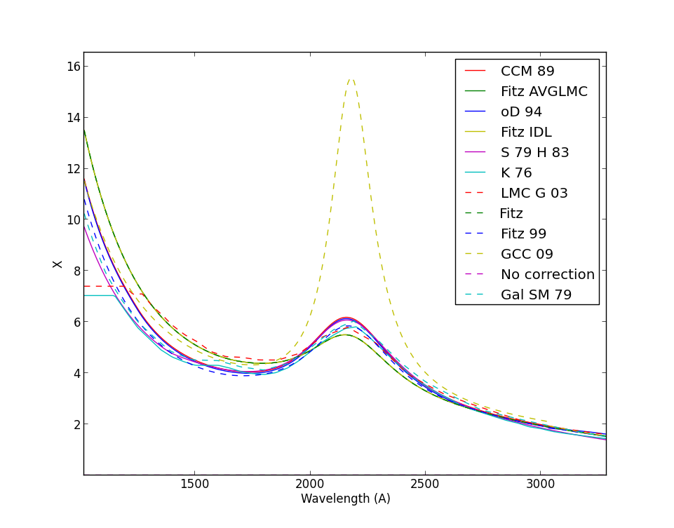

A user-defined method can also be used. User-defined methods must accept 2 parameters: the first is the wavelength (or wavelength array), in Angstrom, and the second is an optional parameter (which can also be a list). The method must return X(lambda) = A(lambda)/E_BV = RV.A(lambda)/AV. The correction is then: 10**(0.4*E_BV*X)

Here is an example of a user-defined function:

def my_X(wave, params = [5000., 1., 2., 3.]):

return params[1] * (wave/params[0]) + params[2] * (wave/params[0])**-1 + params[3] * (wave/params[0])**-2

rc.UserFunction = my_X

rc.UserParams = [6000., 0., 0., 1.]

rc.getCorr(5007)

1. The EmissionLine class

This is the class characterizing emission lines. An emission line is identified by an element and a spectrum (which identify the emitting ion), a wavelength in Angstrom, a blend flag, a label in the standard PyNeb format, an observed intensity, a reddening-corrected intensity, an expression describing how the intensity depends on the included wavelengths, an observational error and an error on the corrected intensity. Other programs determine one or more of these values.

To instantiate an Emission Line object, use the following:

line = pn.EmissionLine('O', 3, 5007, obsIntens=[1.4, 1.3])

line = pn.EmissionLine(label = 'O3_5007A', obsIntens=320, corrected=True )

obsIntens is a value, a list or a numpy array of values corresponding to the observed intensity of the given emission line.

To know how the label of a given line is exactly spelled, you can print the dictionary pn.LINE_LABEL_LIST:

pn.LINE_LABEL_LIST['O3']

It is possible to instantiate a line not contained in the pn.LINE_LABEL_LIST. In this case a warning is issued, but the code can still continue to run.

The observed intensity is stored in *line.obsIntens* and the extinction-corrected intensity is stored in *line.corrIntens*. line.corrIntens is set to 0.0 when the line is instantiated, unless the parameter corrected is set to True, in which case the observed value *obsIntens* is copied to the *corrIntens* value (the same applies for *corrError*, which is set to *obsError*).

The *corrIntens* value can also be computed using an instantiation of the pn.RedCorr class (see this Section):

redcorr = pn.RedCorr(E_BV = 0.87, law = 'Fitz 99')

line.correctIntens(redcorr) #redcorr is used to compute line.corrIntens

The line information is printed using:

line.printLine()

Line O3 O3_5007A evaluated as L(5007.0)

Observed intensity: 320.0

Observed error: 0.0

Corrected intensity: 320.0

Corrected error: 0.0

Most of the times, users will not need to define or manipulate EmissionLine objects, since most of the work on the EmissionLine objects will be performed from the Observation class (read data, extinction correction); see next section.

1. The Observation class: reading and dealing with observations
   1. Reading observation from a file

*pn.Observation* is the class characterizing observation records. An observation record is composed of an object identifier, the observed intensity of one or more emission lines, and, optionally, the dereddened line intensities and the identifier of the extinction law used, and the value of c(Hbeta).

Observations can be initialized by reading data files, which can be organized with different emission lines either in rows or columns (usually, in a survey of many objects with few emission lines emission lines change across columns; and in a high-resolution observation of a small sample of objects lines change across rows).

The following is an example of how to define an observation:

obs = pn.Observation() # define the Observation object 'obs'

obs.readData('smc_24.dat', fileFormat='lines_in_rows', err_default=0.05) # fill obs with data read from smc_24.dat

obs.extinction.law = 'CCM 89' # define the extinction law from Cardelli et al.

obs.correctData() # the dereddened data are computed

The data can be read by the *readData* method as above or directly while instantiating the object:

obs = pn.Observation('smc_24.dat', fileFormat='lines_in_rows', corrected=True)

The format of the data file from which the emission line intensities are read can be one of two kinds:

*- fileFormat='lines_in_rows'*:

LINE Cn1_5 Hb4 He2_86

O2_3726A 0.71752200 0.17224200 0.12817400

O2_3726Ae 0.05800000 0.09730000 0.07760000

O2_3729A 0.36053100 0.07933200 0.05474200

O2_3729Ae 0.05810000 0.09920000 0.07830000

Ne3_3869A 0.95247500 1.04331400 0.70986900

H1_4861A 1.00 1.00 1.00

*- fileFormat='lines_in_cols'* (this is the default):

NAME O2_3726A O2_3726Ae O2_3729A O2_3729Ae

NGC3132 0.93000 0.05000 0.17224200 0.10

IC418 1.28000 0.05000 0.09920000 0.05

M33 0.03100 0.080 0.03100 0.10

*- fileFormat='lines_in_rows_err_cols' (errors labeled “err”. Don’t name an observation “err”!)*

LINE TT err TT2 err TT3 err

cHbeta 1.2 0.0 1.5 0.2 1.1 0.2

O3_5007A 1.5 0.15 1.3 .2 1.1 0.1

H1_6563A 2.89 0.05 1.6 0.3 1.3 0.1

N2_6584A 1. 0.20 0.3 0.5 1.5 0.1

The labels “LINE” and “NAME” are mandatory to identify rows or columns that are not line intensities.

The delimiter between the columns is any sequence of spaces or TAB, but it can be changed using the *delimiter* parameter. The line names are defined by a label starting with the name of the atom (‘O2’), followed by an underscore, followed by a wavelength and ending with a unit (‘A’ or ‘m’). The list of all the lines managed by PyNeb, ordered by atoms, is obtained by entering:

for atom in pn.LINE_LABEL_LIST:

print(atom, pn.LINE_LABEL_LIST[atom])

The presence of a trailing “e” at the end of the label points to the error associated to the line. The error is considered to be relative to the intensity (i.e., 0.05 means 5% of the intensity), unless the parameter *errIsRelative* is set to False. A common value for all the errors can be defined by the parameter *err_default=0.10* (0.10 is the default value).

* 1. Extinction correction

Once the data have been read, they have to be corrected from extinction. An instantiation of RedCorr() is available inside the Observation object as *obs.extinction*.

If the data file contains “cHbeta” or “E(B-V)” alongside of line labels, the corresponding information on extinction is transmitted to the extinction correction object. Otherwise, the extinction parameters must be set manually; for example:

obs.extinction.E_BV = 0.34

obs.extinction.cHbeta = 1.2

An extinction law has to be specified in either case:

obs.extinction.law = 'Fitz 99'

To correct all the lines at once:

obs.correctData()

If you want the corrected line intensities to be normalized to a given wavelength, use the following:

obs.correctData(normWave=4861.)

The extinction correction can be determined by comparing the observed values to a theoretical ratio, as in the following:

obs.def_EBV(label1="H1_6563A", label2="H1_4861A", r_theo=2.85)

This only sets the amount of extinction; once this is done, you will need to call:

obs.correctData()

to actually apply the correction.

The lines included in the observation record (each line being an *EmissionLine* object) are stored in the *Observation.lines* list. They can be printed using:

obs.printIntens()

By default, this method prints out the corrected intensities. If one wishes to prints the observed intensities are obtained using the *returnObs=True* parameter.

The method getSortedLines returns the lines sorted in alphabetical order according to the emitting atoms (default) or the wavelength (using the *crit = 'wave'* parameter):

for line in obs.getSortedLines():

print(line, line.corrIntens)

The following method, which gives the list of all the atoms implied in the observed emission lines, will be useful later:

atomList = obs.getUniqueAtoms()

* 1. Adding observations and lines

Once an Observation object is instantiated, you can add a new observation (corresponding, e.g., to a new object or a new fiber) by using:

obs.addObs('test', obs_tab)

where ‘test’ is the name of the new observation. The new observation must have the same shape of obs, that is, it must contain obs.n_lines lines.

You can also add a new emission line by menas of:

obs.addLine(line)

* 1. Getting line intensities

You can extract the line intensities from an Observation object by, for example:

obs.getIntens(obsName='M1_32')

obs.getIntens()['Ar4_7262A']

* 1. Using Observation to determine ionic abundances

Once the electron temperature and density are determined, it is easy to obtain the ionic abundances from a set of emission lines included in an Observation object:

# Define a dictionary to hold all the Atom objects needed

all_atoms = pn.getAtomDict(atom_list=obs.getUniqueAtoms())

# define a dictionary to store the abundances

ab_dict = {}

# we use the following lines to determine the ionic abundances

ab_labels = ['N2_6583A', 'O2_3727A+', 'O3_5007A', 'S2_6716A',

'S3_9069A', 'Ar3_7136A', 'Ne3_3869A']

for line in obs.getSortedLines():

if line.label in ab_labels:

ab = all_atoms[line.atom].getIonAbundance(line.corrIntens, Te, Ne,

to_eval=line.to_eval, Hbeta=100)

ab_dict[line.atom] = ab

1. Exploring line intensities with the EmisGrid class
   1. The EmisGrid class

Most plots are obtained by operating on emission maps, which are grids of emissivities as a function of temperature and density generated by the EmisGrid class.

EmisGrid instantiates an atom and computes the emissivities of all its lines for the (tem, den) values of a regularly spaced grid (may be log or linear in the case of the density). Each line is represented in a 2D array (a grid), and there are as many arrays transitions in the atom. The results can be operated on, saved for a later use in a cPickle file, or restored.

The following command instantiates an [O III] atom and computes the emissivity of all its lines in a 30x30 grid:

O3_EG = pn.EmisGrid('O', 3, n_tem=30, n_den=30)

O3_EG.save('plot/O3_30by30.pypic')

O3_EG = pn.EmisGrid(restore_file='plot/O3_30by30.pypic') # Restored from a previous computation

The arguments are described in more details in the Reference Manual. Here is the list:

O3_EG = pn.EmisGrid(elem=None, spec=None, n_tem=100, n_den=100, tem_min=5000.,

tem_max=20000., den_min=10., den_max=1.e8, restore_file=None, atomObj=None)

The emissivity grid of a specific line can be obtained by means of:

O3_5007 = O3_EG.getGrid(wave=5007)

The emissivity grid of a combination of lines can also be computed:

O3_Te = O3_EG.getGrid(to_eval = 'L(4363)/L(5007)')

There are two plotting tools integrated in the EmisGrid object

O3_EG.plotImage(to_eval = 'L(4363)/L(5007)')

O3_EG.plotContours(to_eval = 'L(4363)/L(5007)')

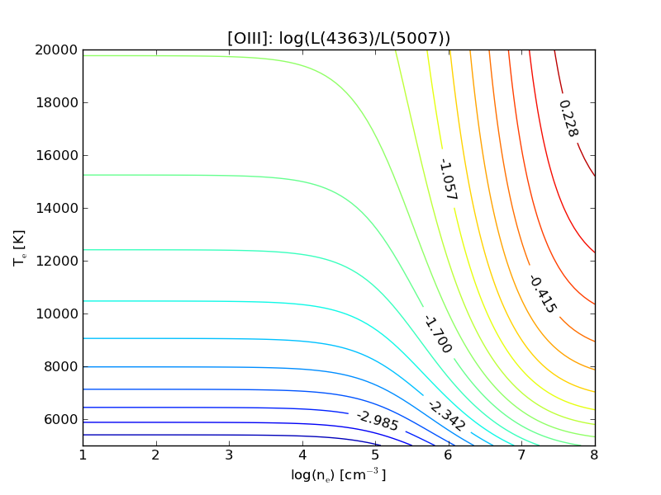

See the Reference Manual for more option and the Diagnostic Object for producing plots combining different atoms.

* 1. Instantiating various EmisGrid Objects with getEmisGridDict

It is quite common to have to instantiate various *EmisGrid* objects, especially if you want to make a diagnostic diagram. This can easily be done using the getEmisGridDict method, used for example as follows:

emisgrids = pn.getEmisGridDict(['C', 'N', 'O'], [2, 3])

This command generates a dictionary of emission grids for all the combinations of 'C', 'N', and 'O' with ionizations stages 2 and 3, that is 6 atoms. The resulting maps are saved in a directory defined by default when PyNeb is started, in the *pn.config.pypic_path* variable. It first tries to use the $HOME/.pypics directory; if it fails, it tries to use /tmp/pypic; if it fails too, the value is set to None and a user-defined value has to be provided by changing *pn.config.pypic_path* or using the *pypic_path* parameter when calling getEmisGridDict.

If a Diagnostic object is already available (see next Section), it can be used to determine the relevant atoms for which a grid must be computed or restored:

emisgrids = pn.getEmisGridDict(atomDict=diags.atomDict,

den_max=1e6, pypic_path='./pypics')

This EmisGrid dictionary will be very useful to plot the diagnostic diagrams with the Diagnostic object, described in the next section.

Two functions are available from the pn.utils.misc domain to manage the stored pypics files, adapting the following examples:

from pyneb.utils.misc import cleanPypicFiles, getPypicFiles

print('default dir for the pypics files is {}'.format(pn.config.pypic_path))

getPypicFiles()

cleanPypicFiles('emis_S2.pypic')

cleanPypicFiles(all_=True)

getPypicFiles()

1. The Diagnostics class

*Diagnostics* is the class used to evaluate temperatures and densities from line ratios. It is also the class that plots the diagnostic Te-Ne diagrams. The object is instantiated like this:

diags = pn.Diagnostics() # instantiate the Diagnostic class

An optional parameter *addAll=True* (default is False) lets the object loads all the available diagnostics. Most of the time this option is not used and the diagnostics are added manually as they are needed:

diags.addDiag([

'[NI] 5198/5200',

'[NII] 5755/6548',

'[OII] 3726/3729'])

Each diagnostic is defined by a label and is associated to a tuple containing 3 elements: the atom corresponding to the diagnostic lines, the algebraic definition of the line ratios and the algebraic definition of the error of the diagnostic depending on the error of each line involved. In the present case, the diagnostic is the ratios of two O3 lines, 4363/5007, and the error is the quadratic sum of the relative error of each line (E(lambda)): RMS(a, b) = sqrt(a**2 + b**2).

In the case of more lines, the error is obviously more complex and involves the error and the intensities of the lines, defined by E(lambda) and L(lambda) respectively:

“[SII] 4072+/6720+” : ('S2', '(L(4069)+L(4076))/(L(6716)+L(6731))', 'RMS([E(6716)*L(6716)/(L(6716)+L(6731)),E(6731)*L(6731)/(L(6716)+L(6731)),E(4069)*L(4069)/(L(4069)+L(4076)),E(4076)*L(4076)/(L(4069)+L(4076))])')

The user can also define its own diagnostics, for example using:

diags.addDiag('[OIII] 4363/4959', ('O3', 'L(4363)/L(4959)', 'RMS([E(4363),E(4959)])')

Notice that the diagnostics are defined so that they increase with the main parameter they trace: [OIII] 4363/5007 increases with the electron temperature.

The diagnostics contained in a *Diagnostic* object are listed by means of the *diags.getDiagLabels()* and *diags.getDiags()* methods. Once added to the Diagnostic object, they can be used either to compute Te and Ne via *getCrossTemDen* or to plot diagrams (see below). A diagnostic can be removed from the list with the *delDiag* method.

* 1. Determination of temperature and density

The *getCrossTemDen* method cross-converges the temperature and density derived from two sensitive line ratios (not necessarily from the same atom), by inputting the quantity derived with one line ratio into the other and then iterating. When the iteration process ends, the two diagnostics give self-consistent results. The first line ratio must be a temperature-sensitive one and the second a density-sensitive one. The temperature and density can be individual numbers as well as arrays (provided they are equal in shape).

diags=pn.Diagnostics>()

diags.getCrossTemDen('[NII] 5755/6548', '[SII] 6731/6716', 0.02, 1.0)

The observed ratio can be automatically extracted from an Observation object named *obs*:

Te, Ne = diags.getCrossTemDen('[NII] 5755/6548', '[SII] 6731/6716', obs=obs))

The complete list of the predefined diagnostics is stored in the *pn.diags* dictionary and can be listed with:

for diag in sort(pn.diags_dict.keys()):

print('”{0}” : {1}'.format(diag, pn.diags_dict[diag]))

...

“[OIII] 4363/5007” : ('O3', 'L(4363)/L(5007)', 'RMS([E(5007),E(4363)])')

...

* 1. Diagnostic diagram combining various atoms

The plotting tool included in the Diagnostic class requires an *EmisGrid* dictionary (as returned by *pn.getEmisGridDict*, see the previous section) and an Observation object (see here). The plot is obtained by:

diags.plot(emisgrids, obs)

which compares the Te, Ne loci defined by the diagnostics of diags that can be computed from the observation in obs.

If there is more than one spectrum in the *obs* object, the index of the observation to use is given by *i_obs*:

diags.plot(emisgrids, obs, i_obs = 4)

An example of use with 16 objects:

plt.figure(figsize=(30, 30))

for i, obs_name in enumerate(obs.names):

plt.subplot(4, 4, i+1)

diags.plot(emisgrids, obs, i_obs=i)

plt.title(obs_name)

plt.savefig('Diagnostics.pdf')

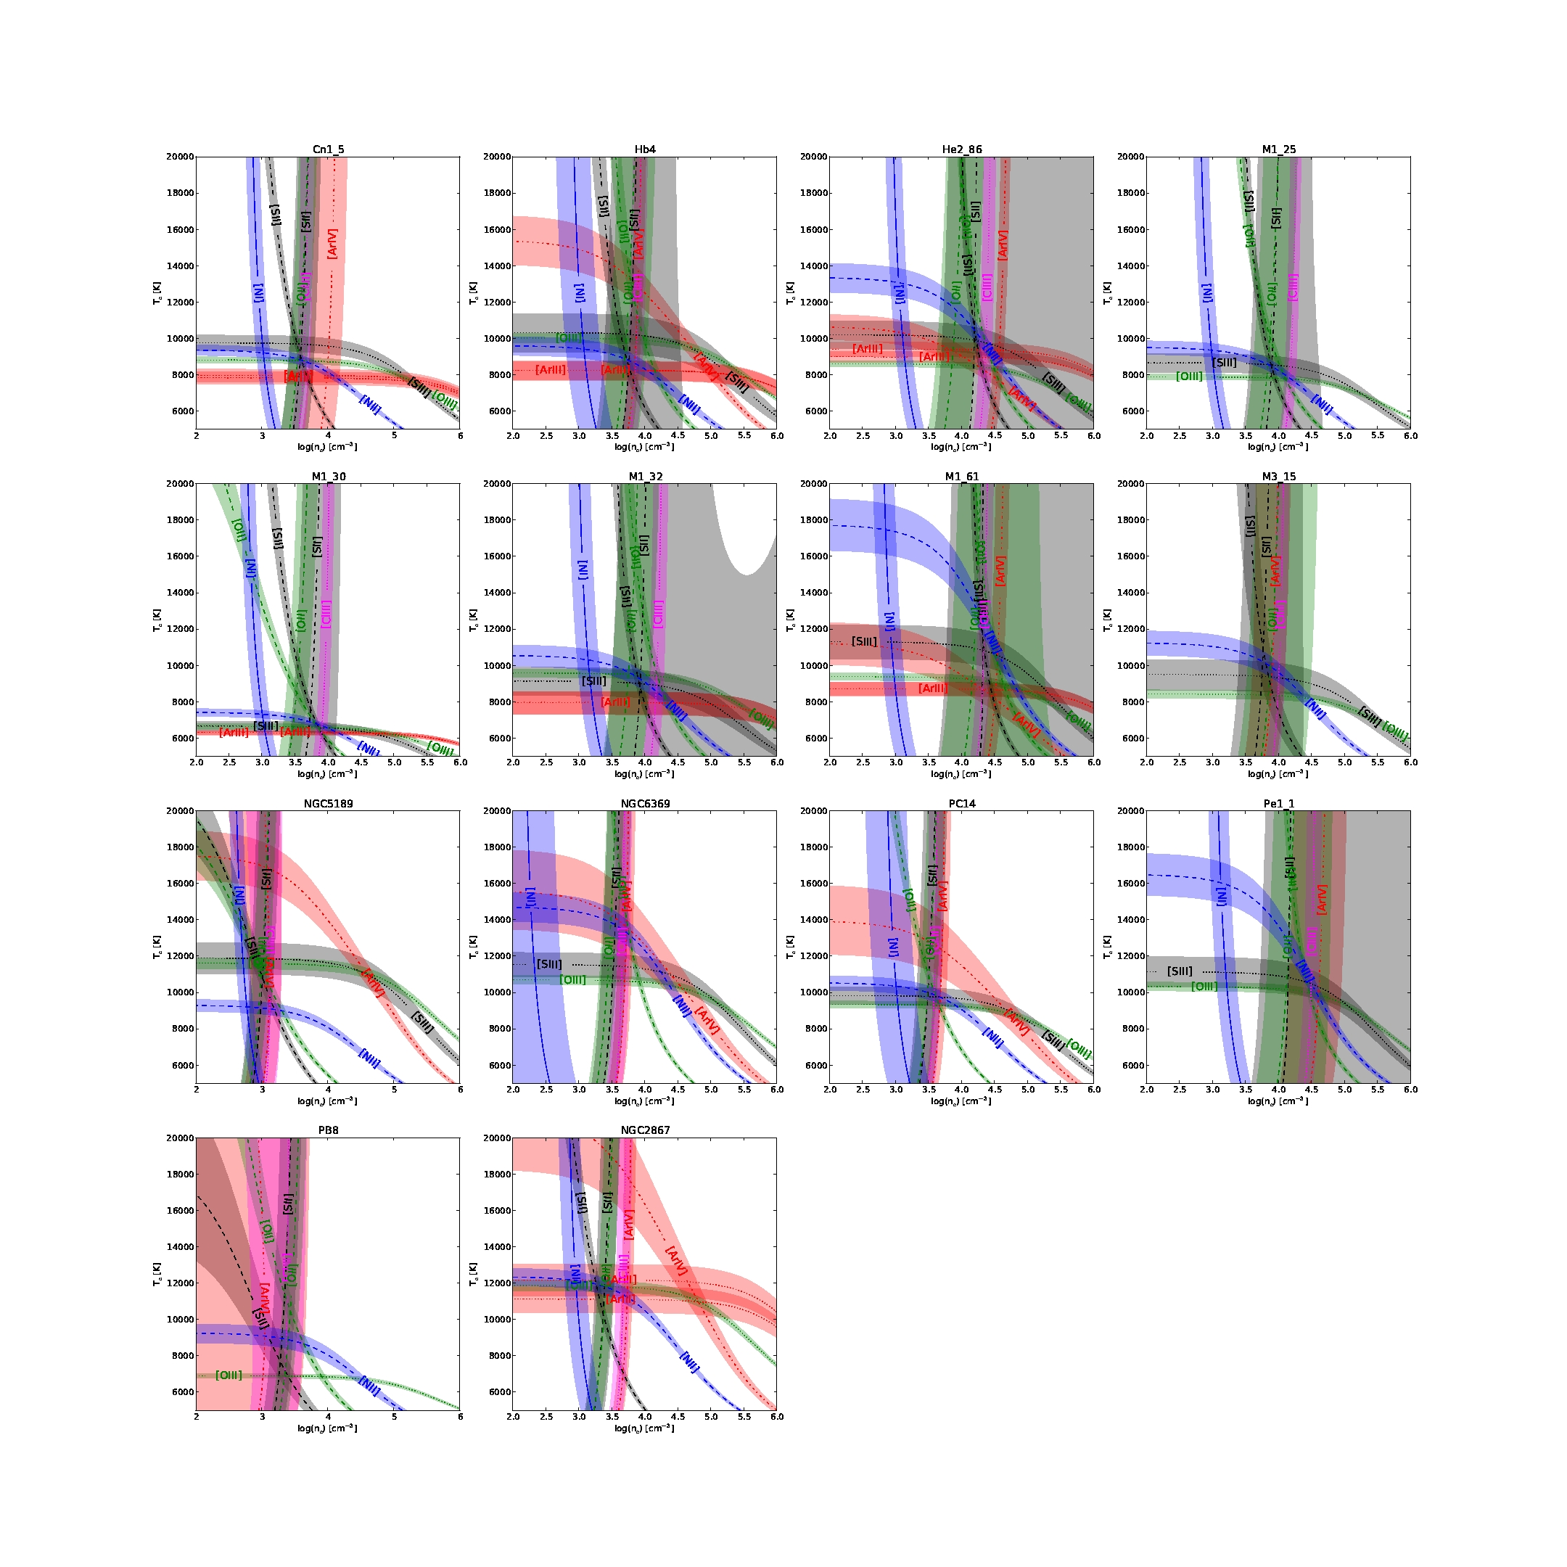

Data and plots from:

**Analysis of chemical abundances in planetary nebulae with [WC] central stars. I. Line intensities and physical conditions**

**García-Rojas, J., Peña, M., Morisset, C., Mesa-Delgado, A., & Ruiz, M. T.**

2012, *Astronomy and Astrophysics*, **538,** A54

The label used to identify the emission lines can be changed in the *diags* object, using for example:

diags.addClabel('[OIII] 5007/4363', '[OIII]na')

1. Determination of elemental abundances using ICFs

The determination of elemental abundances is complicated by the fact that some ions are not observed. To take this into account when computing the total abundances, it is necessary to use ionization correction factors (ICFs). The ICFs are expressions used to correct the abundance of observed ions for unseen ions to get the total elemental abundance of a given element:

X(elem) = X(ion) * icf,

where X(ion) may be the abundance of one single ion or the sum of several ions of the element. These expressions are generally obtained empirically or semiempirically, based on the results of photoionization models or a comparison between the ionization potentials of different ions. Most expressions have been devised for a specific kind of object (e.g., PNe, HII regions, etc) and should not be applied to objects of a different kind.

In PyNeb, an icf formula is identified by an element ("elem", e.g. "O"), which is the element of which the total abundance is seeked for; the ion or ions whose abundance is corrected ("atom", e.g. "O2+O3"); and the icf proper, which is an expression involving the abundances of other ions, assumed to be known ("icf", e.g. "1 + 0.5 * He3 / (He2 + He3)"). In addition, each icf expressions is identified by a label and holds the original reference and a brief comment specifying its intended field of application. The label is formed by an acronym of the paper and the equation number of the icf within the paper.

The following snippet illustrates how PyNeb manages icfs:

atom_abun = {'O2': 0.001, 'O3': 0.002, 'Ne3': 1.2e-5}

icf = pn.ICF()

icf.getAvailableICFs('Ne') # lists all the available recipes for Ne

elem_abun = icf.getElemAbundance(atom_abun, icf_list=['TPP77_15']) # Computes the Ne abundance with the TPP06 recipe

elem_abun = icf.getElemAbundance(elem_abun) # performs all the possible element abundance computations given the input ionic abundance set and available icf

The first line above defines a set of ionic abundances; the second defines an ICF object; the third lists the label of all the available recipes for Ne; in the fourth, a specific one is selected to compute the desired abundance; in the fifth line, all the possible element abundance computations given the present icf set are performed (these may include icfs not suitable for the object under study).

Additionally, PyNeb provides a series of single-line commands to explore the icf collection and its source papers; e.g.:

icf.getAvailableICFs()

icf.getExpression('KH01_4g') # returns the analytical expression of the icf identified by the label KH01_4g

icf.getReference('KH01_4g') # returns the bibliographic reference of the source paper

icf.getURL('KH01_4g') # returns the ADS URL of the source paper

PyNeb provides a large set of icfs compiled from the literature; each icf is stored together with the ref, the URL and a comment with further details. Further expressions will be added in the future, and a special function (addICF) allows to add customized expressions to the collection.

1. The logging facility

When importing PyNeb, a special object is instantiated to hold messages (error, warnings, normal messages and debug tools).  
This object is named *pn.log*. The object receives messages, writes them to the standard output (and eventually in a file) and also keeps them in memory. It can also stop the execution and raise an error when error message is sent to it. It also tracks which method in the code sends the message (the calling parameter), and the time at which is was sent.  
There is a level of verbosity, which can be changed at any moment (e.g. *pn.log_.level = 2*), that determines the kind of messages that will be printed to the standard output (commonly the screen).  
There are 5 types of messages this object can manage:

* debug: using *pn.log_.debug('This is the message', calling = 'Routine1')*; it is printed if *pn.log_level >= 4.*
* message: using *pn.log_.message('This is the message', calling = 'Routine1')*; it is printed if *pn.log_level >= 3.*
* warning: using *pn.log_warn('This is the warning', calling = 'Routine1')*; it is printed if *pn.log_level >= 2.*
* error: using *pn.log_error('This is the error', calling = 'Routine1')*; it is printed if *pn.log_level >= 1.* When error is called, an error is raised using exception *PyNebError*, unless the *exception* argument is given. This default behavior is altered by changing *pn.log_.no_exit* to False, in which case a *SystemExit*exception is raised (and the program stops).
* timer: using *pn.log_.timer('Ending the process', calling = 'Routine1', quiet = False)*. This method prints (if quiet = True) the message with the time spent since the last call of timer.

At any moment in a script file the verbosity can be changed either to see what's happening, or to avoid being annoyed by too many messages.

It is possible to store the messages in a file. The file is opened by *pn.log_.open_file('my_log.txt')*, and eventually closed by *pn.log_.close_file()*.  
Access to the messages is possible with *pn.log_.print_messages(), pn.log_.print_warnings() and pn.log_.print_errors().*

1. References

Shaw, R. A., Dufour, R. J. 1995, PASP, 107, 896

Shaw, R.A., de La Peña, M. D., Katsanis, R. M., & Williams, R. E. 1998, in ADASS VII, edited by R. Albrecht, R. N. Hook, & H. A. Bushouse, ASP Conf. Ser., 192

1. How it works
   1. getPopulations

The populations are found by solving the following linear system:

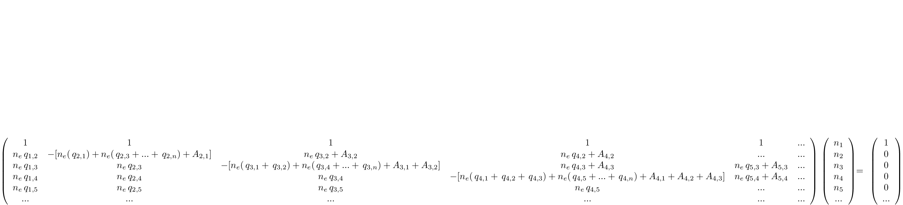

The logic underlying the method is that the matrix is filled and the system is solved for the population vector [n1, n2, ...], using the numpy linear algebra method *np.linalg.solve*. The implementation is slightly complicated by the fact that both tem and den can be 1-D arrays rather than individual values, so that an n_tem x n_den array of coefficient matrices is built. This is done as follows (consider that the elements of the coefficient matrix are combinations of the density den, the transition probability A, and the collisional rate q, and that q, but not A, depends on temperature):

▪ A 1-D vector of length n_tem is created whose elements are equal to 1 (tem_ones = np.ones(n_tem)); the same for den.

▪ The collisional rates for the whole temperature array are computed and stored in q (which is therefore defined as a 1-D array of n_tem elements): q = self.getCollRates(tem);

▪ A 3-D array is created by replicating the 2-D A(i, j) array n_tem times (Atem = np.outer(self.A, tem_ones).reshape(n_level, n_level, n_tem); the reshape is needed because np.outer really makes the outer products of vectors, not arrays, so one dimension is lost and must be restored.

▪ A 2-D array is built as the outer product of q and den (np.outer(np.swapaxes(q, 0, 1), den); swapaxes is needed to make the 2nd dimension of the fist array equal to the 1st dimension of the 2nd array so that the outer product can be carried out).

▪ A 2-D array is built as the outer product of A and the unitary vector of size = size(density) (np.outer(np.swapaxes(q, 0, 1), den_ones); swapaxes is to make the 2nd dimension of the fist array equal to the 1st dimension of the 2nd array so that the outer product can be carried out).

▪ These two are summed up, and then reshaped to be a (n_level, n_level, n_tem, n_den) array (the reshape is needed for the same reason as above: outer always returns a matrix, so the exceeding dimensions are "lost"). The result is stored in coeff_matrix.

▪ The slice of coeff_matrix corresponding to first index = 0 has been previously set to 1 (see docs/pop_array.pdf; this corresponds to the equation which conserves the total number of electron across levels) (coeff_array[0,:] = 1.).

▪ We have now one system for each density/temperature combination: a loop over tem and den solves each of these systems.

▪ The result is squeezed to get rid of any superfluous dimension, in case either tem or den are individual values and not arrays (np.squeeze(pop_result)).

* 1. getEmissivity

returns the emissivity at given temperature and density:

O3.getEmissivity(12000, 100, 4, 2) # (4, 2) transition

O3.getEmissivity(10000, 10000, wave=5007) # (4, 2) transition

O3.getEmissivity(12000, 100) # all transitions

This method computes the emissivity for a given transition or the whole transition array. The transition is selected by the argument *wave* (if given); if *wave* is not supplied, it is selected by the upper and lower levels (*lev_i* and *lev_j*); if neither is given, the whole array is computed:

How it works:

Since both *tem* and *den* can be vectors (of *n_tem* and *n_den* elements, respectively) rather than individual numbers, the computation is vectorial:

A 1-D vector of length *n_tem* is created whose elements are equal to 1 (*tem_ones = np.ones(n_tem)*); same for *den*.

The population array *populations* is created (which is in fact a population vector for each of the *n_tem* * *n_den* different combinations of temperature and density).

The emissivity array *resultArray* is initialized (an array of (*Nlevel * Nlevel * n_tem * n_den* different combinations of temperature and density).

A loop over *i* and *j* fills the array: for each *i, j* pair with *i > j* the product *A*DeltaE*n_i* is computed and divided by the density to give it as emissivity per unit densities (the division by density is in fact a division by a 2-D array: one holds the temperature dimension, the other the density dimension and magnitude; the array is reshaped to (*1, 1, n_tem, n_den*) because there is no outer product among arrays and the elements must be redistributed: see also getPopulations).

Finally, the *resultArray* is squeezed to get rid of any extra dimension (i.e., whether *tem* and/or *den* have only one element)