Configuración ADFS para integración en PLATEAWeb

RelyingParty

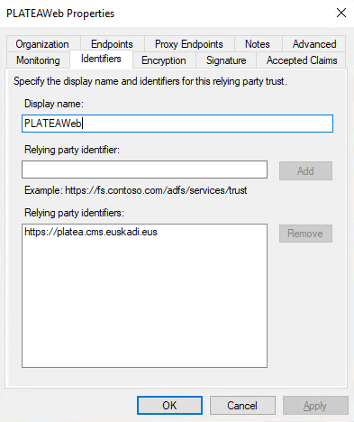

Assertion Consumer Service

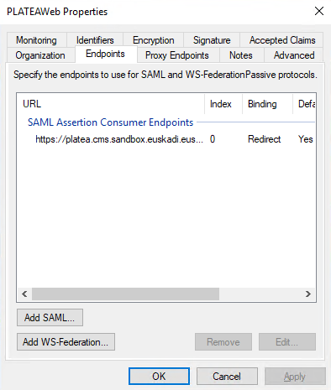 | 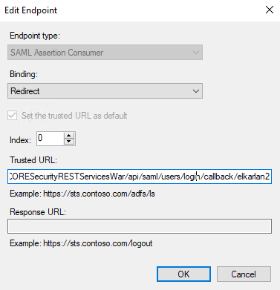

The [ACS=Assertion Consumer Service] are:
DEVELOP / SANDBOX | https://platea.cms.sandbox.euskadi.eus/  r01PLATEAWebCORESecurityRESTServicesWar/api/saml/users/login/callback/elkarlan2
PROD | https://platea.cms.euskadi.eus/  r01PLATEAWebCORESecurityRESTServicesWar/api/saml/users/login/callback/elkarlan
BATERA PROD | https://platea.cms.batera.euskadi.eus/  r01PLATEAWebCORESecurityRESTServicesWar/api/saml/users/login/callback/elkarlan

Config

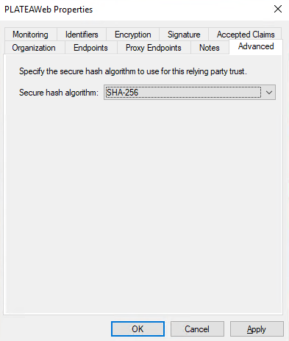

Assertions (claims)

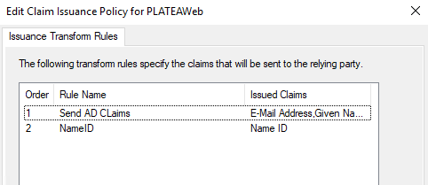 | 

