**Product Specifications**

**Team: Code Slayer**

**Elvis Jimenez – Team Lead**

**Luis Oropeza – SQA Representative**

**Nah Nguyen – SQA Representative**

**Akshay Patel – Secretary**

**Stephanie Reyes – Secretary**

Table of Contents:

Modification History………………………………..…………………………….3

Major Milestones………………………………………………………………….4

Abstract……………………………….……………………………………..…….5

Document References…………………………………...……………………..….6

Glossary………………………….………………………………………….…….7

Class Diagram…………………………………….………………………….…....8

Use Case Sequence Diagram……………………………………………………...9

Use case 1……………………………………………………………………....9

General Description……….……………………………………………...9-11

Sequence Diagram………………………………………………..………9-11

Use case 2…………………………………………………………………...…12

General Description………………………………………………....…...11-12

Sequence Diagram……………………………………………………….11-12

Use case 3…………………………………………………………………...…13

General Description………………………………………………....…...13-14

Sequence Diagram……………………………………………………….13-14

Use case 4…………………………………………………………………...…14

General Description………………………………………………....…...14-16

Sequence Diagram……………………………………………………….14-16

User Interface……………………………………………………………..……....17

Others………………………………..……………………………………………17

# Modification History

9/9/16 The product design layout has been developed.

9/16/16 The product design layout has been improved with features.

9/23/16 The coding has begun and a 5X5 board has been created

9/30/16 The product has the single or multiplayer feature

# Major Milestones

|  |  |
| --- | --- |
| **Date** | **Milestone** |
| 8/29/2016 | Code Slayer team is formed. |
| 9/2/2016 | First team meeting. |
| 9/9/2016 | Team work on Preliminary Requirements. Team focus on use cases and non-functional requirements. |
| 9/16/2016 | Team work on Preliminary Product Specification. Team focus on scenarios, class diagram, and sequence diagrams. |
| 9/23/2016 | Team work on Preliminary Software Project Plan. Team focus on risk management, schedule, and configuration control. |
| 9/30/2016 | Team review preliminary requirements, preliminary product specification and preliminary software project management plan. |
| 10/1/2016 | Team is coding remotely. |
| 10/2/2016 | Team collaborated through remotely through google docs |

# Abstract

This Project is a tic-tac-toe on a 5x5 grid. Two player playing, one of them being a computer or human. The winner is the player who is first to have 4 objects in a row, either horizontally, or vertically, or diagonally. When playing a user can either play as a guest or with a registered user name. The game keeps track of the history of each player or player. Upon user’s request the history of the players is shown. User may select the level of skill and who goes first.

# Document References

|  |  |
| --- | --- |
| **Document** | **Location** |
| Requirements | Google Drive |
| Product Specification | Google Drive |
| Software Project Management Plan | Google Drive |
| Test Plan | Google Drive |
| Modification History | Google Drive |

# Glossary

|  |  |
| --- | --- |
| **Term** | **Definition** |
| X | First Player |
| O | Second Player |
| 5x5 | Board Parameters |
| Connect 4 | Winner |
| Level | Difficulty in the single player mode |
| Multiplayer | Person against person |
|  |  |

|  |  |
| --- | --- |
| **Acronym** | **Meaning** |
| TTT | Tic-Tac-Toe |
| AI | Artificial Intelligence |
| GUI | Graphical User interface |
| SQA | Software Quality Assurance |
|  |  |
|  |  |
|  |  |
|  |  |

# Class Diagram

# 

# 

# 

# 

# 

# 

# 

# 

# 

# Use Case Sequence Diagram

## Use case 1:

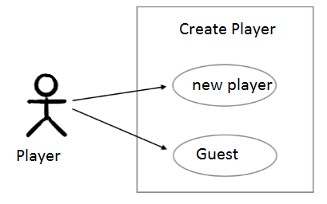

Figure 1. Use Case Diagram for Create Player.

### General Description

This enables for user to create a new player or sign in as a guest.

Use Case 1: Creating a player

|  |
| --- |
| **Brief Description**  Allows a new player to sign in with player name. |
| **Step-by-Step Description**   1. Player inputs name and signs in. 2. Player will be allowed to see the record of wins and losses. |

Use case 1: Player name already exist (anomaly 1)

|  |
| --- |
| **Brief Description**  Player username already exist. |
| **Step-by-Step Description**   1. Player uses name that already exist 2. Player will get a message that informs player that the username is already taken. |

Use case1: Player plays as a guest. (anomaly 2)

|  |
| --- |
| **Brief Description**  Player plays as a guest. |
| **Step-by-Step Description**   1. Player does not need a username and plays as a guest. 2. Guest player will not create a report of wins and losses. |

### Sequence Diagram

* + 1. 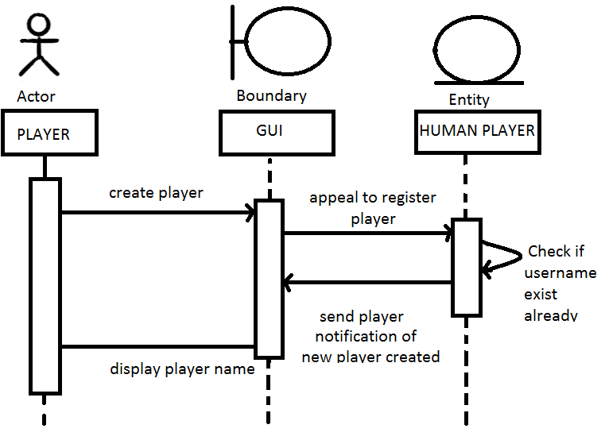

Figure 2. Sequence Diagram for creating a player.

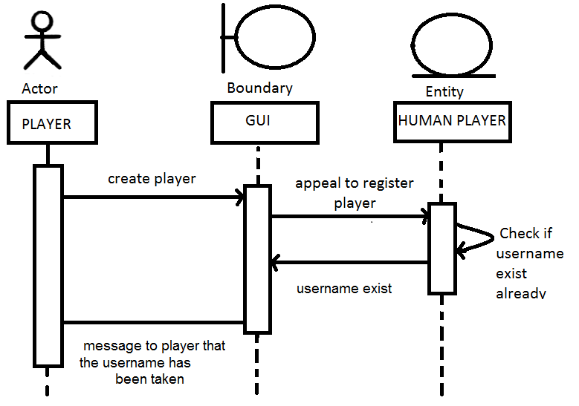

Figure 3. Sequence Diagram for creating player (Anomaly 1)

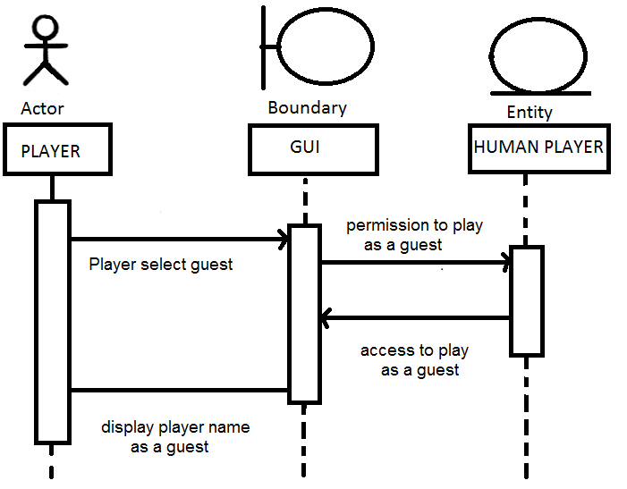

Figure3. Sequence Diagram for Create Player (Anomaly 2)

## Use case 2:

* + 1. 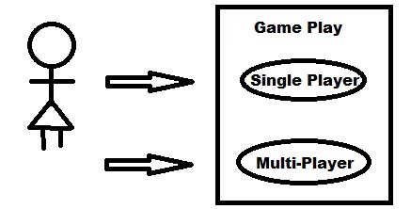

Figure 1. Use Case Diagram for Multiplayer.

Use Case 2: Creating players

|  |
| --- |
| **Brief Description**  Allows both new players to sign in with player name |
| **Step-by-Step Description**   1. Player input user name. |

Use case 2: Player name already exist

|  |
| --- |
| **Brief Description**  Player username already exist. |
| **Step-by-Step Description**   1. Player uses name that already exist 2. Player will get a message that informs player that the username is already taken. |

Use case 2: Player/s plays as a guest.

|  |
| --- |
| **Brief Description**  Player/s plays as a guest. |
| **Step-by-Step Description**   1. Player does not need a username and plays as a guest. 2. Player gets created as guest1, guest2...etc. 3. Player is notified that user account is deleted at the end of the game |

### General Description

* + - 1. This enables for users to create a new player or sign in as a guest.

### Sequence Diagram

* + - 1. 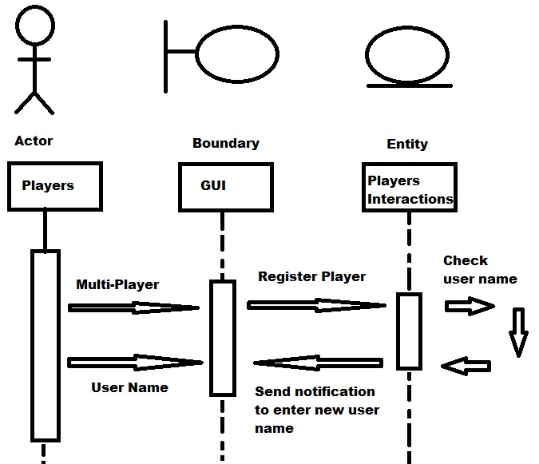

Figure 2. Sequence Diagram for creating two players.

# 

# *Use case 3:*

* 1. 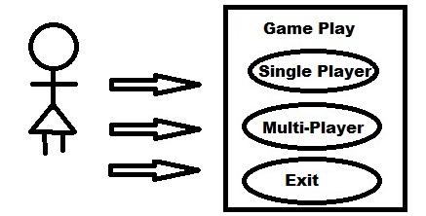

Figure 1. Use Case Diagram for not playing.

Use Case 3: Choosing to play

|  |
| --- |
| **Brief Description**  All player is allowed to not play the game |
| **Step-by-Step Description**   1. Player chooses to exit game. |

Use case 3: Prompt to confirm

|  |
| --- |
| **Brief Description**  A Prompt shows up to confirm to close game |
| **Step-by-Step Description**   1. Prompt to confirm to close game. 2. Game closes. |

### General Description

* + 1. This enables for user/s to choose not to play Tic-Tac-Toe

### Sequence Diagram

* + 1. 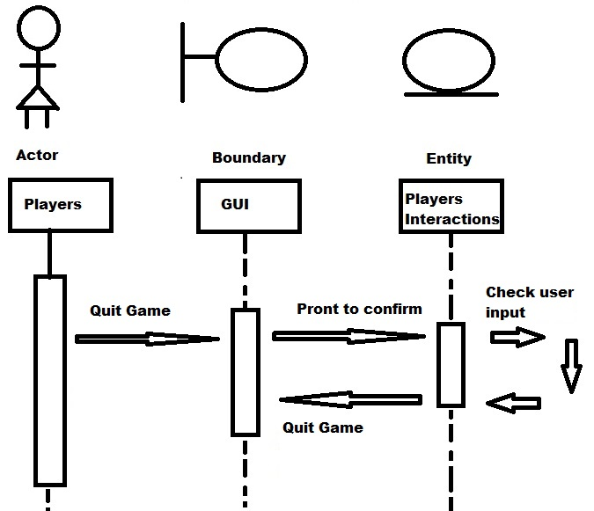

Figure 2. Sequence Diagram for Closing game.

# *Use case 4:*

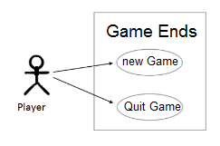

Figure 1. Use Case Diagram for Game Ends.

Use Case 4: End Game

|  |
| --- |
| **Brief Description**  User has the option to start a new game, quit game, or display score. |
| **Step-by-Step Description**   1. At the end of a match player/s get a prompt. 2. Player chose to quit game 3. Player chose to play again 4. Player chose to display score |

Use case 4: Player/s choose display score

|  |
| --- |
| **Brief Description**  Player chose to see score records. |
| **Step-by-Step Description**   1. Player chooses to see score. 2. Prompt displays user's score. |

Use case 4: Player/s choose Quit Game

|  |
| --- |
| **Brief Description**  Player chose to quit game. |
| **Step-by-Step Description**   1. Player chooses to quit 2. Gameplay goes to main screen |

Use case 4: Player/s choose New Game

|  |
| --- |
| **Brief Description**  Player/s get a prompt to choose to play with same credentials or new credentials |
| **Step-by-Step Description**   1. Player chooses New Game 2. Prompt to use same credentials or new credentials |

Use case 4: Player/s choose same credentials

|  |
| --- |
| **Brief Description**  GUI display a new game play with the same user information |
| **Step-by-Step Description**   1. Player chooses same credentials 2. New game with same user info is displayed |

Use case 4: Player/s choose new credentials

|  |
| --- |
| **Brief Description**  Player/s receive a prompt to enter new username and once completed a new game with the new user info is displayed |
| **Step-by-Step Description**   1. Player chooses new credentials 2. Prompt to enter new credentials 3. Verifies user name has not been already created 4. New game with new user info is displayed. |

### Sequence Diagram

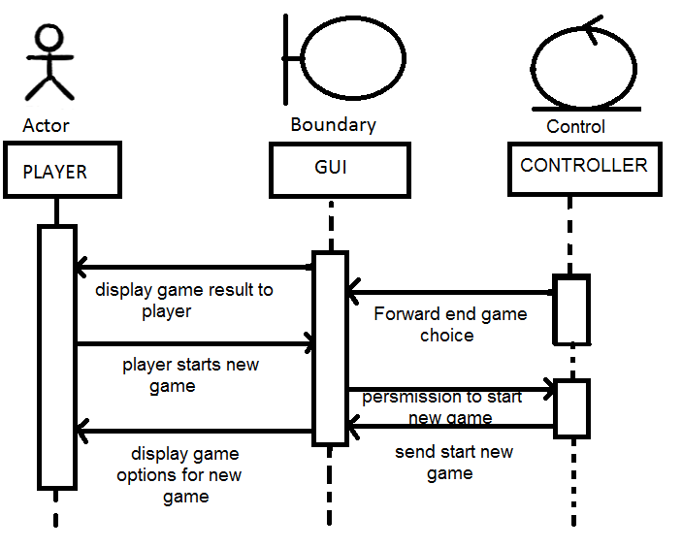

Figure 4. Sequence Diagram for Game Ends.

# 

# User Interface

# Others