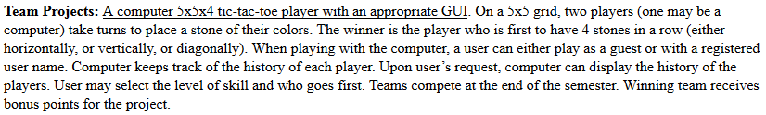

**Team Projects:** A computer 5x5x4 tic-tac-toe player with an appropriate GUI. On a 5x5 grid, two players (one may be a computer) take turns to place a stone of their colors. The winner is the player who is first to have 4 stones in a row (either horizontally, or vertically, or diagonally). When playing with the computer, a user can either play as a guest or with a registered user name. Computer keeps track of the history of each player. Upon user’s request, computer can display the history of the players. User may select the level of skill and who goes first. Teams compete at the end of the semester. Winning team receives bonus points for the project.

Use case 1: Create Player

Use case 2: Multiplayer

Use case 3: Level of Skill

Use case 4: Who goes first?

Use case 5: Game Over

Use case 6: Hisotry of Players

**Use Case Sequence Diagram**

***Use case 1:***

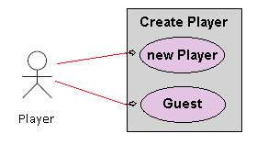

Figure 1. Use Case Diagram for Create Player.

### **General Description**

This enables for user to create a new player or sign in as a guest.

Use Case 1: Creating a player

|  |
| --- |
| **Brief Description**  Allows a new player to sign in with player name. |
| **Step-by-Step Description**   1. Player inputs name and signs in. 2. Player will be allow to see the record of wins and losses. |

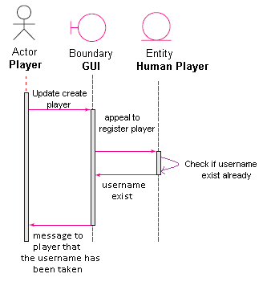

Use case 1: Player name already exist (anomaly 1)

|  |
| --- |
| **Brief Description**  Player username already exist. |
| **Step-by-Step Description**   1. Player uses name that already exist 2. Player will get a message that informs player that the username is already taken. |

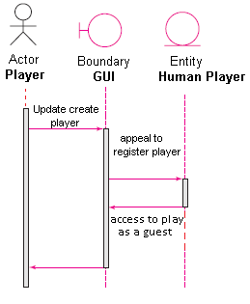

Use case1: Player plays as a guest. (Anomaly 2)

|  |
| --- |
| **Brief Description**  Player plays as a guest. |
| **Step-by-Step Description**   1. Player does not need a username and plays as a guest. 2. Guest player will not create a report of wins and losses. |

**Use Case Sequence Diagram**

***Use case 2:***

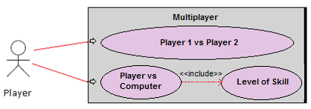

Figure 1. Use Case Diagram for Multiplayer

### **General Description**

This enables for user to play with another player or with computer.

Use Case 1: Playing multiplayer (normal)

|  |
| --- |
| **Brief Description**  Allows a user to choose to play with another player or with computer. |
| **Step-by-Step Description**   1. User selects Player 1 vs Player 2 2. Player 1 will choose to play as a registered username or guest. 3. Player 2 will choose to play as a registered username or guest. |

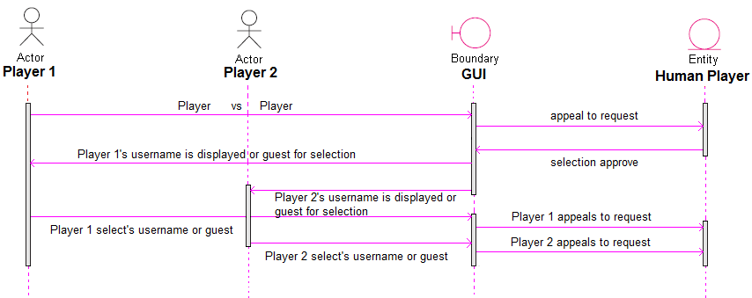

Figure 2. Use Case Diagram for Multiplayer (Normal)

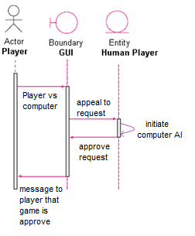

Use Case 2: Playing multiplayer (anomaly)

|  |
| --- |
| **Brief Description**  Allows user to play against the computer. |
| **Step-by-Step Description**   1. Player selects their username or guest. 2. Player chooses to play against computer. |

***Use case 3:***

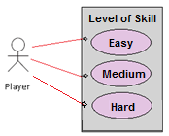

Figure 1. Use Case Diagram for level of skill

### **General Description**

This enables for user to choose level of skill

Use Case 1: Level of skill (normal)

|  |
| --- |
| **Brief Description**  Allows a user to choose level of skill. |
| **Step-by-Step Description**   1. If user chooses Player vs Computer then player chooses level of skill. 2. User has the option to choose easy, medium, and hard. |

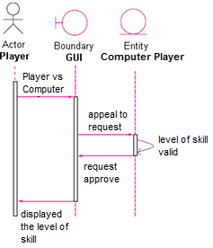

Figure 2. Use Case Diagram for level of skill (normal).

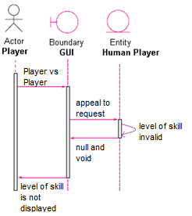

Figure 3. Use Case Diagram for level of skill (anomaly 1).

|  |
| --- |
| **Brief Description**  Level of skill is invalid |
| **Step-by-Step Description**   1. If user chooses Player 1 vs Player 2 then the level of skill will be invalid. |

***Use case 4:***

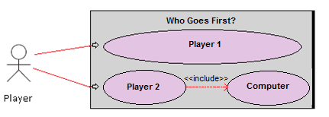

Figure 1. Use Case Diagram for who goes first.

### **General Description**

This enables for user to choose who goes first.

Use Case 1: Who goes first (normal)

|  |
| --- |
| **Brief Description**  Allows a user to choose who goes first. |
| **Step-by-Step Description**   1. If user chooses Player 1 then Player 1 goes first. 2. If user chooses Player 2 then Player 2 goes first. 3. If user chooses computer then computer goes first. |

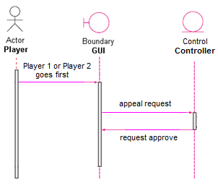

Figure 2. Use Case Diagram for who goes first.

***Use case 5:***

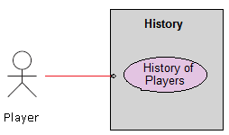

Figure 1. Use Case Diagram for History.

### **General Description**

This enables for user to display the history of players.

Use Case 1: Viewing a history of players.

|  |
| --- |
| **Brief Description**  Allows a player to view a history of players |
| **Step-by-Step Description**   1. Player chooses to view the history of players. 2. Player can view all players who have played the game. |

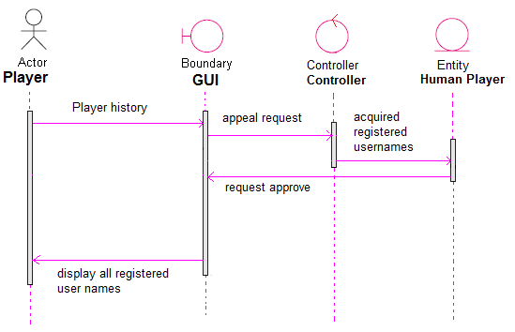

Figure 2. Use Case Diagram for History.

**Use Case Sequence Diagram**

***Use case 6:***

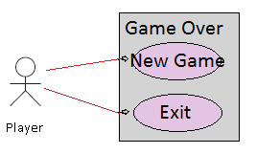

Figure 1. Use Case Diagram for Game Over

### **General Description**

This enables for user to start a new game or exit the game.

Use Case 1: Starting new game

|  |
| --- |
| **Brief Description**  Allows a player to start a new game. |
| **Step-by-Step Description**   1. Player clicks new game. 2. Player will start a new game. |

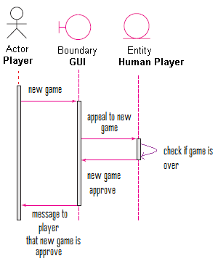

Use case 1: Player chooses new game (anomaly 1)

|  |
| --- |
| **Brief Description**  Player chooses new game. |
| **Step-by-Step Description**   1. Player chooses to start a new game. 2. Player will get a message that informs player that new game has begun. |

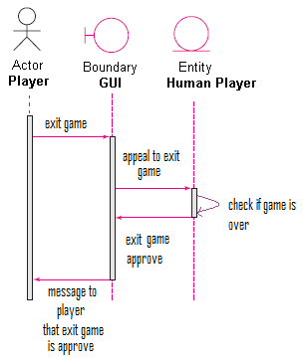

Use case1: Player chooses to exit game. (Anomaly 2)

|  |
| --- |
| **Brief Description**  Player exits game. |
| **Step-by-Step Description**   1. Player does not want to start a new game and exits game. 2. Player will not start a new game and the game will close down. |