**Product Specifications**

**Team: Code Slayer**

**Elvis Jimenez – Team Lead**

**Luis Oropeza – SQA Representative**

**Nah Nguyen – SQA Representative**

**Akshay Patel – Secretary**

**Stephanie Reyes – Secretary**

Table of Contents:

Modification History………………………………..…………………………….3

Major Milestones………………………………………………………………….4

Abstract……………………………….……………………………………..…….5

Document References…………………………………...……………………..….6

Glossary………………………….………………………………………….…….7

Class Diagram…………………………………….………………………….…....8

Use Case Sequence Diagram……………………………………………………...9

Use case 1……………………………………………………………………....9

General Description……….……………………………………………...9-11

Sequence Diagram………………………………………………..………9-11

Use case 2…………………………………………………………………...…12

General Description………………………………………………....…...11-12

Sequence Diagram……………………………………………………….11-12

Use case 3…………………………………………………………………...…13

General Description………………………………………………....…...13-14

Sequence Diagram……………………………………………………….13-14

Use case 4…………………………………………………………………...…14

General Description………………………………………………....…...14-16

Sequence Diagram……………………………………………………….14-16

User Interface……………………………………………………………..……....17

Others………………………………..……………………………………………17

# Modification History

9/9/16 The product design layout has been developed.

9/16/16 The product design layout has been improved with features.

9/23/16 The coding has begun and a 5X5 board has been created

9/30/16 The product has the single or multiplayer feature

# Major Milestones

|  |  |
| --- | --- |
| **Date** | **Milestone** |
| 8/29/2016 | Code Slayer team is formed. |
| 9/2/2016 | First team meeting. |
| 9/9/2016 | Team work on Preliminary Requirements. Team focus on use cases and non-functional requirements. |
| 9/16/2016 | Team work on Preliminary Product Specification. Team focus on scenarios, class diagram, and sequence diagrams. |
| 9/23/2016 | Team work on Preliminary Software Project Plan. Team focus on risk management, schedule, and configuration control. |
| 9/30/2016 | Team review preliminary requirements, preliminary product specification and preliminary software project management plan. |
| 10/1/2016 | Team is coding remotely. |
| 10/2/2016 | Team collaborated through remotely through google docs |

# Abstract

This Project is a tic-tac-toe on a 5x5 grid. Two player playing, one of them being a computer or human. The winner is the player who is first to have 4 objects in a row, either horizontally, or vertically, or diagonally. When playing a user can either play as a guest or with a registered user name. The game keeps track of the history of each player or player. Upon user’s request the history of the players is shown. User may select the level of skill and who goes first.

# Document References

|  |  |
| --- | --- |
| **Document** | **Location** |
| Requirements | Google Drive |
| Product Specification | Google Drive |
| Software Project Management Plan | Google Drive |
| Test Plan | Google Drive |
| Modification History | Google Drive |

# Glossary

|  |  |
| --- | --- |
| **Term** | **Definition** |
| X | First Player |
| O | Second Player |
| 5x5 | Board Parameters |
| Connect 4 | Winner |
| Level | Difficulty in the single player mode |
| Multiplayer | Person against person |
|  |  |

|  |  |
| --- | --- |
| **Acronym** | **Meaning** |
| TTT | Tic-Tac-Toe |
| AI | Artificial Intelligence |
| GUI | Graphical User interface |
| SQA | Software Quality Assurance |
|  |  |
|  |  |
|  |  |
|  |  |

# Class Diagram

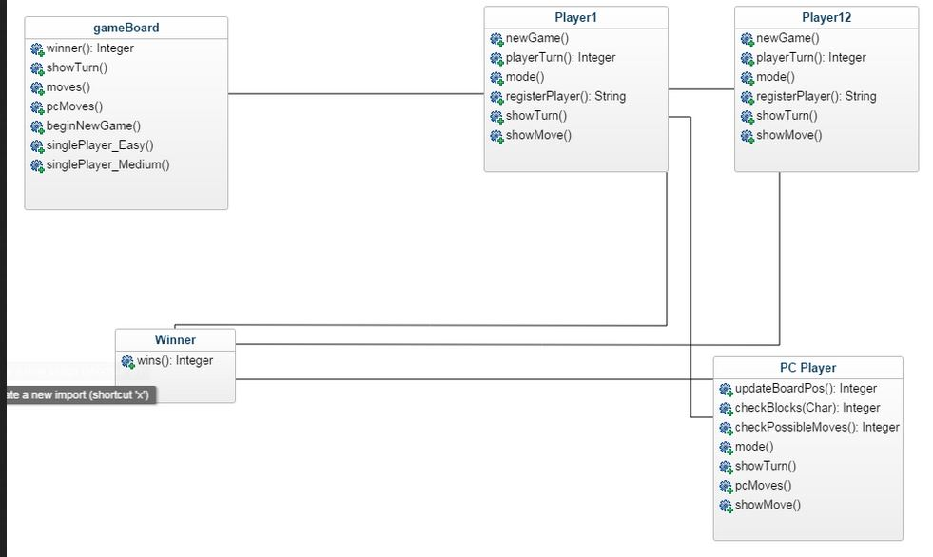

# 

# 

# 

# 

# 

# 

# 

# 

# 



**Use Case Sequence Diagram**

***Use case 1:***

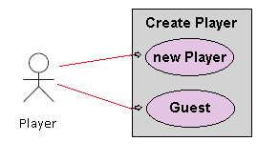

Figure 1. Use Case Diagram for Create Player.

### General Description

This enables for user to create a new player or sign in as a guest.

Use Case 1: Creating a player

|  |
| --- |
| **Brief Description**  Allows a new player to sign in with player name. |
| **Step-by-Step Description**   1. Player inputs name and signs in. 2. Player will be allow to see the record of wins and losses. |

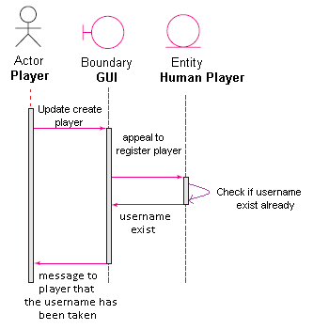

Use case 1: Player name already exist (anomaly 1)

|  |
| --- |
| **Brief Description**  Player username already exist. |
| **Step-by-Step Description**   1. Player uses name that already exist 2. Player will get a message that informs player that the username is already taken. |

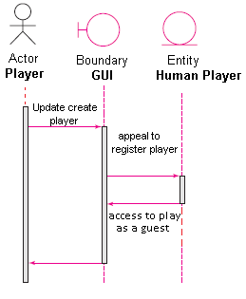

Use case1: Player plays as a guest. (Anomaly 2)

|  |
| --- |
| **Brief Description**  Player plays as a guest. |
| **Step-by-Step Description**   1. Player does not need a username and plays as a guest. 2. Guest player will not create a report of wins and losses. |



***Use case 2:***

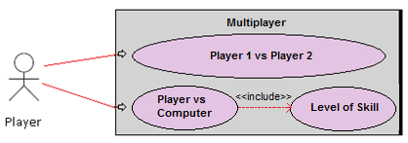

Figure 1. Use Case Diagram for Multiplayer

### General Description

This enables for user to play with another player or with computer.

Use Case 1: Playing multiplayer (normal)

|  |
| --- |
| **Brief Description**  Allows a user to choose to play with another player or with computer. |
| **Step-by-Step Description**   1. User selects Player 1 vs Player 2 2. Player 1 will choose to play as a registered username or guest. 3. Player 2 will choose to play as a registered username or guest. |

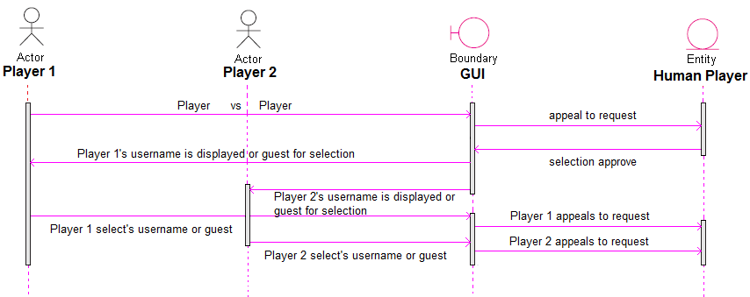

Figure 2. Use Case Diagram for Multiplayer (Normal)

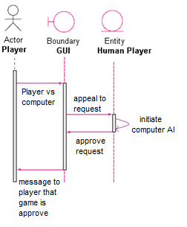

Use Case 2: Playing multiplayer (anomaly)

|  |
| --- |
| **Brief Description**  Allows user to play against the computer. |
| **Step-by-Step Description**   1. Player selects their username or guest. 2. Player chooses to play against computer. |

# 

***Use case 3:***

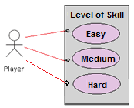

Figure 1. Use Case Diagram for level of skill

### General Description

This enables for user to choose level of skill

Use Case 1: Level of skill (normal)

|  |
| --- |
| **Brief Description**  Allows a user to choose level of skill. |
| **Step-by-Step Description**   1. If user chooses Player vs Computer then player chooses level of skill. 2. User has the option to choose easy, medium, and hard. |

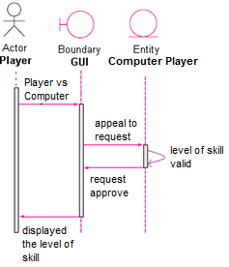

Figure 2. Use Case Diagram for level of skill (normal).

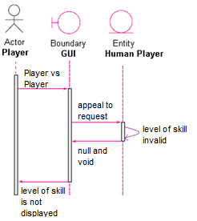

Figure 3. Use Case Diagram for level of skill (anomaly 1).

|  |
| --- |
| **Brief Description**  Level of skill is invalid |
| **Step-by-Step Description**   1. If user chooses Player 1 vs Player 2 then the level of skill will be invalid. |

***Use case 4:***

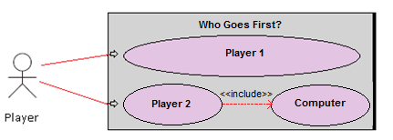

Figure 1. Use Case Diagram for who goes first.

### General Description

This enables for user to choose who goes first.

Use Case 1: Who goes first (normal)

|  |
| --- |
| **Brief Description**  Allows a user to choose who goes first. |
| **Step-by-Step Description**   1. If user chooses Player 1 then Player 1 goes first. 2. If user chooses Player 2 then Player 2 goes first. 3. If user chooses computer then computer goes first. |

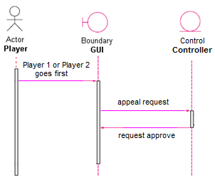

Figure 2. Use Case Diagram for who goes first.

***Use case 5:***

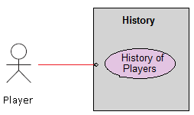

Figure 1. Use Case Diagram for History.

### General Description

This enables for user to display the history of players.

Use Case 1: Viewing a history of players.

|  |
| --- |
| **Brief Description**  Allows a player to view a history of players |
| **Step-by-Step Description**   1. Player chooses to view the history of players. 2. Player can view all players who have played the game. |

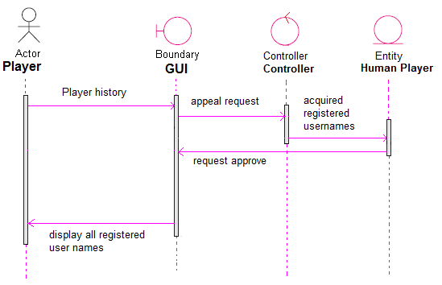

Figure 2. Use Case Diagram for History.

**Use Case Sequence Diagram**

***Use case 6:***

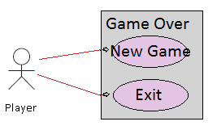

Figure 1. Use Case Diagram for Game Over

### General Description

This enables for user to start a new game or exit the game.

Use Case 1: Starting new game

|  |
| --- |
| **Brief Description**  Allows a player to start a new game. |
| **Step-by-Step Description**   1. Player clicks new game. 2. Player will start a new game. |

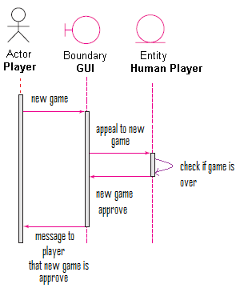

Use case 1: Player chooses new game (anomaly 1)

|  |
| --- |
| **Brief Description**  Player chooses new game. |
| **Step-by-Step Description**   1. Player chooses to start a new game. 2. Player will get a message that informs player that new game has begun. |

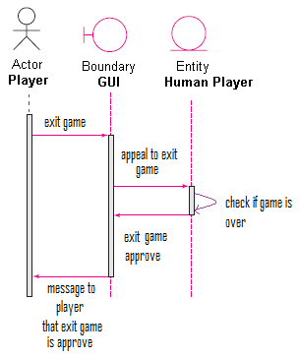

Use case1: Player chooses to exit game. (Anomaly 2)

|  |
| --- |
| **Brief Description**  Player exits game. |
| **Step-by-Step Description**   1. Player does not want to start a new game and exits game. 2. Player will not start a new game and the game will close down. |

# 

# User Interface

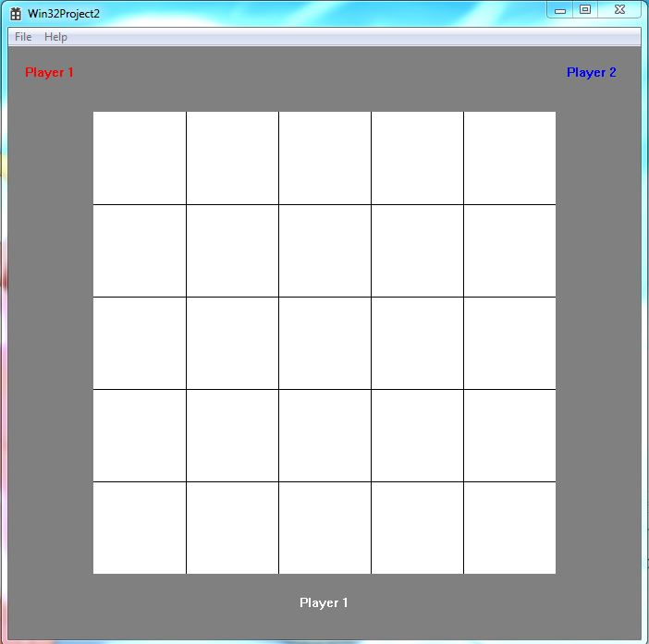

# Others