**TAWAG SA PAGSIMBA**

**Pastor:** Umari, O katawhan, ug simbahon tang Ginoo,

Uban ang pag-awit, ug paglipay ug pasalamat,

Kay ang Ginoo atong Dios, kay sya maayo,

Mahigugmaon, matinumanon sa kanunay.

Umari o katawhan.

**††HYMNO SA PAGDAYEG**

**“DAYGON ANG DIOS UG SIMBAHON”**

Daygon ang Dios ug simbahon, ug awitan ta S’ya karon,

Kay gamhanan kanunay, magpadayon S’ya atong Dios.

Duulon ta ang Ginoo, sa tingub pagadaygon S’ya;

Tingog ta ipalanog, pag-ila nga S’ya atong Dios.

Atong mga kasingkasing, hiusahon nato karon;

Sa pagbati Kaniya, haduul S’ya ang atong Dios.

Atong mga kinabuhi, gikan sa gamhanan nga Dios;

Gugma N’ya ang nagmugna, himayaon Sya, atong Dios.

O Amahan nga langitnon, among pag-ambahan karon;

Ginahalad Kanimo, ug kami dawata, O Dios. Amen.

**††PAG-AMPO**

**TUBAG AWIT** **“*Gloria Patri”***

**TAWAG SA PAGHINULSOL Salmo 32:3-5**

***HILOM NGA PAGSUGID SA SALA*** *(inubanan sa honi)*

**AWIT SA KALIPAY “BECAUSE HE LIVES”**

God sent His Son, they called Him Jesus,

He came to love, heal and forgive,

He bled and died to buy my pardon and empty grave

is there to prove my Savior lives.

***Because He lives, I can face tomorrow, because He lives, all fear is gone, because I know, He holds the future, and life is worth the living just because He lives. Amen.***

**PAHIBALO / PAGLAMANUHAY**

**PAG-AMPO ALANG SA IGLESIA**

**Tubag awit**  **“God Answers Prayer”**

God answers prayer in the morning

God answers payer at noon

God answers prayer in the evening

So keep your hearth in tune

**††PAGBASA SA BALAANG KASULATAN**

**Tubag awit** ***“Wonderful words of life”***

**Refrain:**

Beautiful words, wonderful words,

Wonderful words of life;

Beautiful words, wonderful words,

Wonderful words of life.

**MENSAHE SA AWIT**

**MENSAHE SA PULONG**

**ANG SAKRAMENTO SA BALAANG PANIHAPON**

**PULONG SA PAGHANDUM**

**PAG-APOD-APOD**

**HIMNO “AMAZING GRACE”**

Amazing grace, how sweet the sound

That saved a wretch li ke me  
I once was lost, but now I'm found Was blind, but now I see

'Twas grace that taught my heart to fear  
And grace, my fears relieved  
How precious did that grace appear The hour I first believed

Through many dangers, toils and snares

We have already come  
'Twas grace that brought us safe thus far

And grace will lead us home

When we've been there ten thousand years  
Bright shining as the sun  
We've no less days to sing God's praise  
Than when we first begun

**TAWAG SA PAGHALAD** **2 Corinto 9:10**

“..ang Dios, nga maoy naghatag ug binhi ngadto sa magpupugas ingon man sa pan aron kan-on, maghatag usab kaninyo sa binhi nga inyong gikinahanglan. Patubuon niya kini aron makaani kamo ug dako gikan sa inyong pagkamahinatagon.”

**††DOXOLOHIYA** *(English version)*

**††AMPO PAGPASALAMAT**  **PANGULO**

**††HIMNO SA PAGTUGYAN “TRUST AND OBEY”**

When we walk with the Lord, In the light of His Word,

what a glory He sheds on our way! While we do His goodwill,

He abides with us still, And with all who will trust and obey.

**Trust and obey, For there’s no other way**

**to be happy in Jesus, But to trust and obey.**

Not a shadow can rise, Not a cloud in the skies

But His smile quickly drives it away; Not a doubt nor a fear,

Not a sigh nor a tear, can abide while we trust and obey.

Not a burden we bear, Not a sorrow we share

But our toil He doth richly repay, Not a grief nor a loss,

Not a frown nor a cross, But is best if we trust and obey.

**††PANAPOS NGA PAG-AMPO**

**††PANALANGIN**

**Pastor:** Pamauli katawhan, panalangin kauban,

Ang Dios magabubo iyang grasya diha kaninyo,

Ug magabantay sya gayod, kay sya maayo,

Mahigugmaon, matinumanon sa kanunay.

Pamauli, katawhan. Amen. Amen

**TUBAG-AWIT “LIMA KA AMEN”**

**RECESSIONAL**

**\*\*\*\*\*\*\*\*\*\*\*\*\*\*\*\*\*\*\*\*\*\*\*\*\*\*\*\*\*\*\*\*\*\*\*\*\*\*\*\*\*\*\*\*\*\*\*\*\*\*\*\*\*\*\*\*\*\*\*\*\*\*\*\*\*\***

**Sunday school**

**Adult**

**CYF**

**Children**

**United Church of Christ in the Philippines**

**Lanao District Conference**

**Lanipao, Lala, Lanao Del Norte**

**July 7, 2024**

**TALAMDAN SA PAGSIMBA**

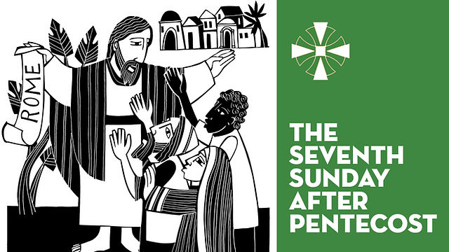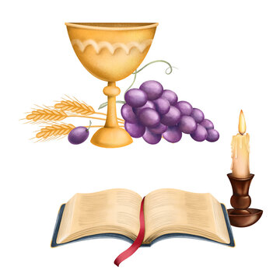7th Sunday after Pentecost

Communion Sunday

*******************************************************************

**WORSHIP LEADERS**

**Liturgist**  John Aeron Ybanez

**Bible Reader** Belsapit John Padilla

**Choir**  CYF

**Usher**  CYF

**Organist** Bro. Greg Federic Buhawe

**Resident Pastor** Rev. Juseph P. Goc-ong

*******************************************************************

**PASIUNANG AWIT *“Come now is the time to worship”***

**PAGDAGKOT SA KANDILA NI KRISTO**

**PROCESYONAL**