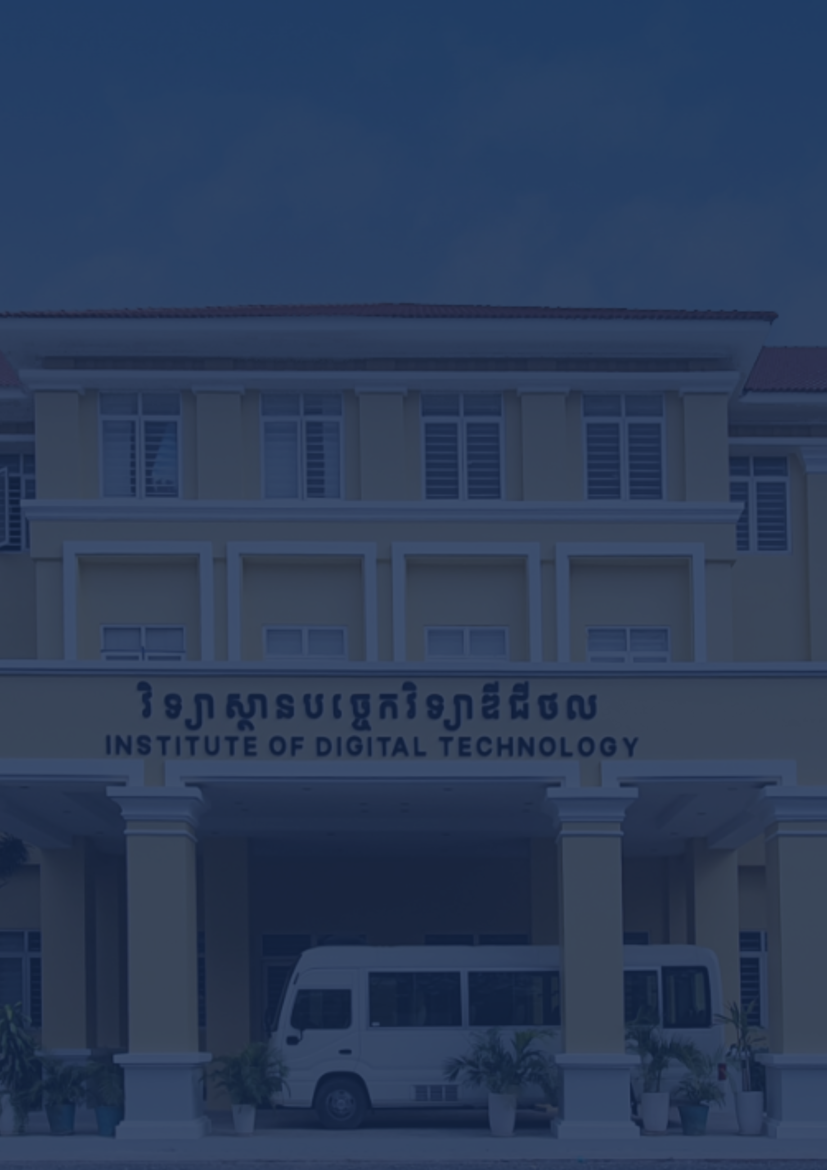

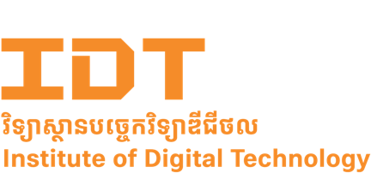

1st Internship report on
Khmer RAG Chatbot for Insurance
Department of Computer Science
Faculty of Digital Engineering
www.cadt.edu.kh
Date of Presentation: Month Day, Year

This report is submitted in partial fulfillment of the requirements for the Bachelor of Computer Science degree with a specialization in Data Science in
Submitted By:
Ms. PONH Sorphea
Under the supervision of:
Mr. SAM Lyheng
Under the advisory of:
Mr. POV Phannet
at




បណ្ឌិត្យសភាបច្ចេកវិទ្យាឌីជីថលកម្ពុជា
វិទ្យាស្ថានបច្ចេកវិទ្យាឌីជីថល
មហាវិទ្យាល័យ វិស្វកម្មឌីជីថល
ដេប៉ាតឺម៉ង់ វិទ្យាសាស្រ្តកុំព្យូទ័រ
គម្រោងសញ្ញាបត្របរិញ្ញាបត្រ
របស់និស្សិត ៖ កញ្ញា ប៉ូញ សោភា
កាលបរិច្ឆេទការពារនិក្ខេបបទ ៖ ថ្ងៃទី ខែ ឆ្នាំ ២០២៥
អនុញ្ញាតអោយការពារគម្រោង ៖
ប្រធានបណ្ឌិត្យសភាបច្ចេកវិទ្យាឌីជីថលកម្ពុជា____________
រាជធានីភ្នំពេញ ថ្ងៃទី ____ ខែ ________ ឆ្នាំ ______

ប្រធានបទ ៖ ប្រព័ន្ធជជែកឆ្លើយតប RAG ជាភាសាខ្មែរ ​សម្រាប់វិស័យធានារ៉ាប់រង
សហគ្រាស ៖​ ឯករាជ្យឌីជីថល
គ្រូដឹកនាំគម្រោង ៖ ​​​​​​​​​​​លោក ពៅ ផាន់ណែត
អ្នកទទួលខុសត្រូវក្នុងសហគ្រាស ៖ លោក សំ​ លីហេង
រាជធានីភ្នំពេញ
Cambodia Academy of Digital Technology
Institute of Digital Technology
Faculty of Digital Engineering
Department of Computer Science
INTERNSHIP REPORT OF
Ms. PONH Sorphea
Presentation Date: Month Date, Year
Internship Presentation Authorization

President:
Phnom Penh,

Topic : Khmer RAG Chatbot for Insurance
Establishment : EKÁREACH Digital
Advisor : Mr. POV Phannet
Supervisor : Mr. SAM Lyheng

PHNOM PENH

ACKNOWLEDGMENT
I would like to express my sincere gratitude to everyone who supported me throughout my internship and the completion of this report.
First, I would like to thank the Cambodia Academy of Digital Technology (CADT) for providing me the opportunity to participate in the internship program. The knowledge and skills I gained during my studies provided the foundation for this project. I would like to express my appreciation to H.E. Dr. SENG Sopheap, President of the Cambodia Academy of Digital Technology (CADT), for his commitment to developing digital education and creating opportunities for students to gain practical experience.
I am deeply grateful to my internship advisor, Mr. POV Phannet, for his guidance, encouragement, and valuable feedback throughout the project. His support helped me strengthen both my technical knowledge and problem-solving skills. His suggestions and advice were very helpful and valuable during the development of the Khmer Insurace Chatbot and the preparation of this report.
My sincere thanks also go to Mr. SAM Lyheng, my company supervisor at EKÁREACH Digital, for his continuous support and mentorship during the internship. Through his guidance, I gained valuable insights into professional working practices and the development of practical AI solutions. His experience and willingness to share knowledge greatly contributed to my learning and practical experience.
Finally, I would also acknowledge the team at EKÁREACH Digital for creating a welcoming and supportive working environment. Working with the team allowed me to learn only technical skills but also the importance of collaboration, communication, and professionalism in the workplace.
This internship has been a valuable learning experience that allowed me to apply academic knowledge to a real-world project. Through development of the Khmer Insurance RAG Chatbot, I gained practical experience in artificial intelligence, natural language processing, and information retrieval. I am grateful to everyone who contributed to making this experience meaningful and successful.

មូលន័យសង្ខេប
និក្ខេបបទនេះពិពណ៌នាអំពីការស្រាវជ្រាវ និងអភិវឌ្ឍប្រព័ន្ធជជែកឆ្លើយតបឆ្លាតវៃជាភាសាខ្មែរ សម្រាប់វិស័យធានារ៉ាប់រង ក្នុងអំឡុងពេលកម្មសិក្សានៅក្រុមហ៊ុន ឯករាជ្យ ឌីជីថល ។ គម្រោងនេះ មានគោលបំណងជួយប្រជាពលរដ្ឋកម្ពុជាឱ្យអាចទទួលបានព័ត៌មាន និងស្វែងយល់អំពីសេវាធានា រ៉ាប់រងបានកាន់តែងាយស្រួល ត្រឹមត្រូវ និងអាចទុកចិត្តបាន តាមរយៈការប្រើប្រាស់ បច្ចេកវិទ្យាបញ្ញា សិប្បនិម្មិត។ បច្ចុប្បន្ន ឯកសារធានារ៉ាប់រងជាច្រើនត្រូវបានសរសេរដោយប្រើប្រាស់ពាក្យបច្ចេកទេស ដែលមានលក្ខណៈស្មុគស្មាញធ្វើឱ្យអ្នកប្រើប្រាស់ទូទៅមានការលំបាកក្នុងការស្វែងយល់អំពី គោល នយោបាយ លក្ខខណ្ឌធានារ៉ាប់រង និងនីតិវិធីទាមទារសំណង។ លើសពីនេះ ប្រព័ន្ធបញ្ញាសិប្បនិម្មិត ទូទៅមួយចំនួនអាចផ្តល់ព័ត៌មានដែលមិនមានប្រភពយោងច្បាស់លាស់ ឬមានភាពមិនត្រឹមត្រូវ។ ដើម្បីដោះស្រាយបញ្ហាទាំងនេះ ប្រព័ន្ធឆ្លើយតបសំណួរត្រូវបានបង្កើតឡើងដោយប្រើប្រាស់បច្ចេកវិទ្យា Retrieval-Augmented Generation (RAG) ដែលអាចស្វែងរកព័ត៌មានពីឯកសារពិតប្រាកដមុន ពេលឆ្លើយតបទៅកាន់អ្នកប្រើប្រាស់។ ក្នុងការអនុវត្តគម្រោងនេះឯកសារធានារ៉ាប់រងត្រូវបានប្រមូល ពីប្រភពសាធារណៈ និងត្រូវបានដំណើរការតាមរយៈការបំលែងឯកសារ PDF ទៅជារូបភាព រួចទាញយកអត្ថបទពីរូបភាពតាមរយៈបច្ចេកវិទ្យា OCR និងសម្អាតទិន្នន័យឱ្យមានទម្រង់ត្រឹមត្រូវ។ ចុងក្រោយ ធ្វើការបែងចែកទិន្នន័យជាបំណែកៗរួចបំលែងទៅជាទិន្នន័យវ៉ិចទ័រដើម្បីឱ្យប្រព័ន្ធធ្វើការ ទាញយកទិន្នន័យទាំងនេះនៅពេលដែលអ្នកប្រើប្រាស់សួរសំណួរ។ ប្រព័ន្ធត្រូវបានអភិវឌ្ឍដោយប្រើ ភាសា Python និងបច្ចេកវិទ្យា Natural Language Processing (NLP), Large Language Model (LLM) និង Vector Database ដើម្បីគាំទ្រដល់ការស្វែងរក និងធ្វើការឆ្លើយតបប្រកបដោយ ប្រសិទ្ធភាព។ ជាលទ្ធផល ប្រព័ន្ធនេះអាច ឆ្លើយតបសំណួរទាក់ទងនឹងវិស័យធានារ៉ាប់រងជាភាសាខ្មែរ ដោយផ្អែកលើប្រភពព័ត៌មានដែលអាច ផ្ទៀងផ្ទាត់បាន។

ABSTRACT
This report presents the research and development of a Khmer-language intelligent chatbot for the insurance sector which was conducted during an internship at EKÁREACH Digital. The project purpose is to help Cambodian citizens access and understand insurance information more easily, accurately, and reliably through the use of artificial intelligence technologies. There are many insurance documents that were written using technical and complex terminology which make it difficult for general users to understand insurance policies, coverage conditions, and claims procedures. Additionally, some existing artificial intelligence systems may provide inaccurate information or generate responses without clear references. These limitations can reduce users' confidence in the information they receive, particularly in a domain where accuracy is essential. To address these challenges, a chatbot based on Retrieval-Augmented Generation (RAG) technology was developed. Unlike conventional AI chatbots, the system retrieves information from actual insurance documents before generating a response back to user. During the development process, insurance documents were collected from publicly available sources and processed through several stages. Initially, PDF documents were first converted into PNG images, after which text was extracted using Optical Character Recognition (OCR) technology. The extracted text was then cleaned and divided into smaller chunks. These chunks were eventually transformed into vector representations. This enables the system to retrieve relevant information whenever a user submits a question. The chatbot was developed using Python together with Natural Language Processing (NLP), Large Language Models (LLMs), and a vector database to support efficient information retrieval and response generation. As a result, the system is capable of answering insurance-related questions in the Khmer language based on information obtained from reliable and verifiable sources.

TABLE OF CONTENTS

ACKNOWLEDGMENT I
មូលន័យសង្ខេប II
ABSTRACT III
TABLE OF CONTENTS IV
LIST OF FIGURES VI
LIST OF TABLES VII
LIST OF ABBREVIATIONS VIII
I. INTRODUCTION 1
1.1. Presentation of Internship 1
1.1.1. Objective of Internship 2
1.1.2. Duration of Internship 2
1.2. Presentation of Organization 2
1.2.1. General Information of Company 3
1.2.2. Service of Company 3
1.2.3. Vision and Mission 4
1.2.4. Organization Chart 4
1.2.5. Address and contact 4
II. PRESENTATION OF THE PROJECT 5
2.1. General Presentation of Project 5
2.2. Problematic 6
2.3. Objectives 7
2.4. Planning of Project 7
III. LITERATURE REVIEW 8
3.1 Artificial Intelligence and Natural Language Processing 8
3.2 Large Language Models 9
3.3 Retrieval-Augmented Generation 9
3.4 Optical Character Recognition 9
3.5 Document Chunking Techniques 10
3.6 Embedding Models 10
3.7 Vector Databases and FAISS 10
3.8 Retrieval Evaluation Metrics 10
3.9 Local Language Models for RAG Systems 11
IV. PROJECT ANALYSIS AND CONCEPTS 11
4.1 Choice of Technology 11
4.1.1 Programming Language 11
4.1.2 Framework 12
4.1.3 Libraries 12
4.2 Dataset Analysis 13
4.3 Research Methodology 14
4.4 Chunking Strategy Analysis 15
4.5 Embedding Model Analysis 17
4.6 Vector Database Analysis 18
4.7 Local Language Model Analysis 19
4.8 System Architecture 21
V. DETAIL CONCEPT 22
5.1 Dataset Collection and Preparation 22
5.2 OCR Processing Implementation 23
5.3 Text Cleaning and Preprocessing 24
5.4 Recursive Chunking Implementation 25
5.5 Embedding Generation Using BGE-M3 26
5.6 FAISS Vector Database Construction 27
5.7 Retrieval Evaluation Implementation 28
5.8 Local Language Model Testing 29
5.9 Streamlit Chatbot Development 30
5.10 System Integration 31
VI. IMPLEMENTATION 32
6.1 Development Environment 32
6.2 Retrieval Performance Evaluation 32
6.3 Local Language Model Evaluation 32
6.4 Challenges Encountered 33
VII. CONCLUSION 34
7.1 Conclusion 34
7.2 Project Achievements 35
7.3 Limitations 36
7.4 Future Work 36
REFERENCES 38
APPENDICES 40

LIST OF FIGURES
Figure 1: EKÁREACH Digital Logo 3
Figure 2: Company Organization Chart 4
Figure 3: Python Logo 11
Figure 4: Streamlit Logo 12
Figure 5: Dataset Folder Structure 14
Figure 6: Research Methodology Workflow 15
Figure 7: Recursive Chunking Process 16
Figure 8: BGE-M3 Embedding Model 18
Figure 9: FAISS Retrieval Architecture 19
Figure 10: Khmer Insurance RAG System Architecture 22
Figure 11: OCR Processing Workflow 24
Figure 12: Sample OCR Output 24
Figure 13: Text Cleaning Workflow 24
Figure 14: Recursive Chunking Implementation 25
Figure 15: Example Generated Chunks 25
Figure 16: Embedding Generation Workflow 26
Figure 17: FAISS Index Construction Workflow 27
Figure 18: Retrieval Evaluation Workflow 28
Figure 19: : Streamlit Interface 30
Figure 20: Sample Chatbot Response 30
Figure 21: Final RAG Pipeline 31

LIST OF TABLES
Table 1: Project Planning 8
Table 2: Libraries Used in the Project 12
Table 3: Dataset Categories 13
Table 4: Chunk Sizes Evaluated 16
Table 5: Local Language Models Evaluation 20
Table 6: Dataset Statistics 23
Table 7: Chunking Configurations 26
Table 8: Vector Database Statistics 27
Table 9: Evaluation Configuration 29
Table 10: Retrieval Performance Comparison 29
Table 11: Local Language Model Evaluation 29
Table 15: Summary of Project Achievements 35

LIST OF ABBREVIATIONS
Abbreviation | Meaning
AI | Artificial Intelligence
API | Application Programming Interface
BGE-M3 | BAAI General Embedding Model Version 3
CADT | Cambodia Academy of Digital Technology
CPU | Central Processing Unit
FAISS | Facebook AI Similarity Search
GPU | Graphics Processing Unit
IRC | Insurance Regulator of Cambodia
JSON | JavaScript Object Notation
LLM | Large Language Model
MRR | Mean Reciprocal Rank
NLP | Natural Language Processing
OCR | Optical Character Recognition
PDF | Portable Document Format
PNG | Portable Network Graphics
RAG | Retrieval-Augmented Generation
TOP-K | Top K Retrieved Results
UI | User Interface
UTF-8 | Unicode Transformation Format – 8-bit
VRAM | Video Random Access Memory
VS Code | Visual Studio Code

INTRODUCTION
Internships facilitate the application of theoretical knowledge in practical settings while developing related skills. Completion of an internship is an integral part of the Bachelor of Computer Science study program offered by the Cambodia Academy of Digital Technology (CADT), which allows for the enhancement of technical skills prior to job search.
The report describes the activities and results achieved during an internship held at EKÁREACH Digital. During the internship, the focus was placed on creating a Khmer RAG chatbot, which can be used in the insurance industry, with the use of artificial intelligence and NLP techniques.

Presentation of Internship
At EKÁREACH Digital, the intern worked as an AI Engineer Intern. In the course of the internship, the task was to create a Khmer RAG chatbot that could be applied in the insurance industry.
Duties included gathering of insurance-related documents, performing OCR tasks, cleaning and preparing data from those documents, recursive chunking, generating embeddings through the BGE-M3 model, constructing the FAISS vector database, conducting a retrieval test and designing the interface of a chatbot.
The internship brought invaluable experience in the fields of artificial intelligence, natural language processing, information retrieval, and software development.

Objective of Internship
Internship was conducted to gain experience in developing artificial intelligence-based applications and explore the ways of utilizing modern technologies of artificial intelligence for solving current issues. In this case, it concerned the investigation of a Khmer Retrieval-Augmented Generation (RAG) Chatbot for the insurance industry aimed to facilitate the access to reliable insurance information for Cambodians. As part of the project, several stages were completed, such as collecting insurance documents, implementing OCR, pre-processing the text, chunking, generating embeddings, building vector database, conducting the retrieval evaluation and creating chatbot. Thus, skills in natural language processing, information retrieval, as well as application development with artificial intelligence were gained. Besides, experience was obtained in a professional environment, collaborating with advisors and supervisors and gaining insight into a solution development life cycle. In total, the internship will help the author to conduct further academic researches and develop expertise in the field of artificial intelligence and software engineering.

Duration of Internship
An internship lasted three months and was carried out at EKÁREACH Digital. Starting date is May 04, 2026 and ending date is July 31, 2026. Within the framework of this internship, the author served as AI Engineer Intern responsible for the creation of a Khmer Retrieval-Augmented Generation (RAG) Chatbot for the insurance sector. Working schedule consisted of 9 to 6 Monday through Friday. As a result of the internship, practical experience in artificial intelligence and software development was gained.

Presentation of Organization
EKÁREACH Digital is a technology-driven startup that provides intelligent, reliable and scalable digital solutions customized to each particular business. It specializes in creating smart systems that help businesses become more efficient and effective in their operation. Using modern technologies and strategic planning, EKÁREACH Digital creates solutions that ensure sustainable business development and add value to companies' assets.

General Information of Company

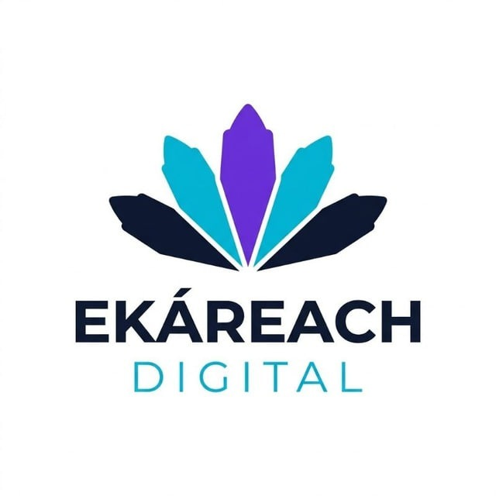
Figure 1: EKÁREACH Digital Logo
EKÁREACH Digital is a technology-based firm that is committed to providing innovative solutions to its business clients through technology. The firm understands the challenges of its clients and helps them realize areas where there could be operational gaps, developing solutions using innovative technology to help them perform better. Through innovations and strong relationships with its clients, EKÁREACH Digital wants to emerge as a trusted and leading technology partner to its clients who wish to do better in business operations through innovative approaches.

Service of Company
EKÁREACH Digital is a firm that provides its clients with intelligent and reliable digital solutions that can help improve the efficiency of business operations and simplify them at the same time. Working hand-in-hand with the clients, the firm tries to understand their challenges and provides solutions based on innovative technology. Some of the services provided by the firm include software development, automation of business processes, website development, system integration, data management solutions, technical consultancy, and support services.

Vision and Mission
EKÁREACH Digital's vision is to become a trusted and leading digital technology partner recognized for delivering smart, future-ready solutions that drive business transformation and innovation.
EKÁREACH Digital's mission is to provide innovative, reliable, and scalable digital solutions that empower businesses to improve efficiency, streamline operations, and achieve sustainable growth while responding to their evolving needs.

Organization Chart
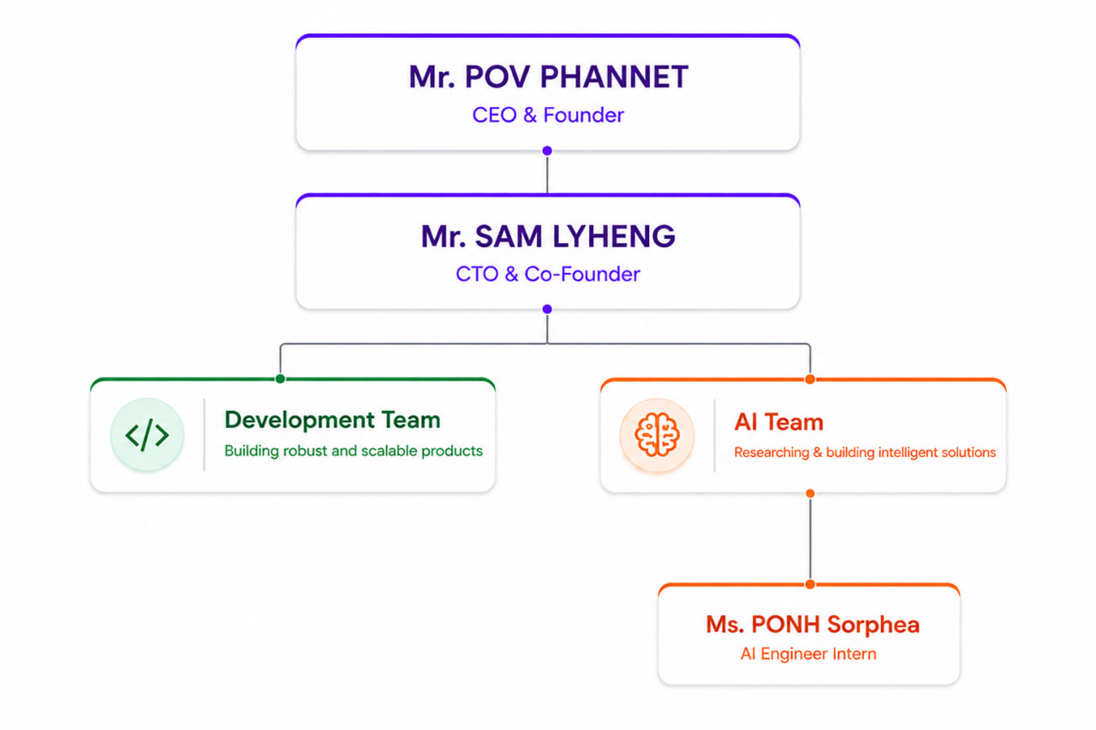
Figure 2: Company Organization Chart

Address and contact
- Head Office Address:
EKÁREACH Digital is located at Home No. 3A, Street N11, Phum Prek Ta Kong 1, Sangkat Chak Angrae Leu, Khan Meanchey, Phnom Penh, Kingdom of Cambodia.
- Contact:
➢ Email: samlyheng@gmail.com
➢ Telephone: (+855) 10 567 274
➢ Telegram: @lyheng_sam

PRESENTATION OF THE PROJECT
This chapter provides a description of the project of Khmer Insurance RAG Chatbot created during the internship at EKÁREACH Digital. Herein, the chapter covers information regarding the background of the project, problems solved, its main objectives, and planning performed within the duration of the internship. The project focuses on the use of artificial intelligence and Retrieval-Augmented Generation (RAG) technologies in order to improve accessibility to insurance information in Khmer.

General Presentation of Project
The internship project is called "Khmer Insurance RAG Chatbot". In particular, the purpose of the system lies in providing insurance information that is accurate and reliable to Khmer speakers via a chatbot. The system uses the Retrievall-Augmented Generation technology that means combining information retrieval with large language models. Thus, generated information is based on relevant information retrieved from the documents on insurance.
Overall, the project is aimed at helping users understand information related to insurance such as insurance products, policy terms, coverage conditions, exclusions, and claims procedure. The system retrieves necessary information from the insurance documents prior to generating answers in contrast to systems using only pre-trained AI knowledge.
The creation of the system was possible due to the utilization of a number of different technologies, namely, Python programming language, optical character recognition (OCR) technology, natural language processing (NLP), BGE-M3 embeddings, vector database FAISS, and Streamlit.

Problematic
The role of insurance is to provide protection and manage risks. However, the documents related to insurance policies can be very long and written in legal jargon. Such documents may hinder users' understanding of information about insurance policies and their conditions. Moreover, insurance-related questions may pose additional problems due to their specificity.
Besides, finding the required information about insurance can be difficult because it is spread out between many documents that may include both information from the regulator and from the insurance companies. Thus, looking through many documents for relevant information can take a lot of time. This factor makes it hard for people to obtain quick answers on a pressing matter.
Another issue concerns the development of general-purpose artificial intelligence systems, which can provide the necessary answers to questions but give information that is incorrect and lacks proper evidence. As a result, the answer cannot be considered fully trustworthy. The requirement for precise insurance information leads to the creation of a special document retrieval system.
Finally, there are not many applications for the insurance domain developed specifically for the Khmer language. Therefore, the creation of a reliable chatbot in the language in question may prove beneficial in developing other AI applications in Cambodia.

Objectives
The key objective of this project is the creation of a RAG chatbot using the Khmer language with application to the insurance industry. It is expected that the chatbot will facilitate the acquisition of insurance-related information through the provision of factual and dependable answers based on credible texts. The second objective of this project is the development of an RAG process involving various stages such as document collecting, OCR processing, text cleaning, document chunking, embedding generating, building vector database with FAISS, retrieval evaluating, and chatbot building. These steps are aimed at improving the efficiency of the retrieval process and the quality of generated answers. In addition, the project makes its contribution to the development of applications of artificial intelligence systems in the Khmer language.

Planning of Project
This project was implemented during a 12-week internship and included several stages. The initial stage of the project involved the conducting of the literature review, project planning, and collecting of insurance documents. After the documents were collected, the process of OCR processing, text cleaning, recursive chunking, embedding generation, and FAISS vector database building started. After that, the performance of retrieval was assessed, and the chatbot was built. Throughout the internship, weekly progress reports were written. Finally, in the last few weeks of the internship, the writing of the final reports and their presentation was done. The timeline of the project is described in Table 1 below.
Table 1: Project Planning
 | Month and Week
Tasks | May |  |  |  | June |  |  |  |  | July
Week | 1 | 2 | 3 | 4 | 5 | 6 | 7 | 8 | 9 |  | 10 | 11 | 12
Literature Review
Project Planning
Document Collection
OCR Research & Testing
OCR Processing
Text Cleaning
Recursive Chunking
Embedding
FAISS Construction
Retrieval Evaluation
Chatbot Development
Testing & Refinement
Weekly Report
Final Report
Presentation Preparation

LITERATURE REVIEW
This section provides an overview of the theories and technologies related to developing the proposed Khmer Insurance RAG Chatbot. It covers past studies and core technologies, including NLP, LLM, RAG, OCR, document chunking, embedding models, vector databases, and retrieval evaluation. All these technologies are vital to understand the proposed approach.

3.1 Artificial Intelligence and Natural Language Processing
One of the leading emerging technologies of the modern world of information systems is artificial intelligence (AI). The major area of application of AI is natural language processing (NLP), where it helps computers comprehend, process, and generate human language. NLP is applied in numerous computer programs, such as chatbots, search engines, machine translators, and question-answerers. With the help of recent advancements in NLP, intelligent systems can engage in natural language communication with users, providing pertinent information from vast document collections [19].

3.2 Large Language Models
A large language model (LLM) is a neural network that has been trained on an enormous body of text. It is capable of performing various operations with language, such as generating text, translating, summarizing, or answering questions. Today's LLMs, such as Qwen, Gemini, Llama, or SeaLLM, possess great language understanding abilities, but at times, they provide wrong information regarding questions that lie outside their boundaries of knowledge. This phenomenon is called hallucination [5].

3.3 Retrieval-Augmented Generation
Retrieval-Augmented Generation (RAG) technology combines information retrieval and language generation. Instead of basing responses to questions on the inner knowledge of a language model, RAG retrieves relevant documents and feeds this information to the model before generating an answer. Research has proven that RAG technology helps in enhancing question answers' accuracy and reducing the problem of hallucination [5] [9]. Given that some domains require very accurate information, such as legal, medical, and insurance services, many organizations adopt this approach.

3.4 Optical Character Recognition
Optical character recognition (OCR) is the technology of recognizing characters in scanned documents or PDF files and converting them into machine-readable text. OCR is crucial in digitalizing documentation because there is a lot of valuable information stored in scanned form. Various OCR software, such as Tesseract OCR and vision-language models, have already been designed [17]. OCR directly impacts how effective downstream tasks are performed, like retrieval or question-answering.

3.5 Document Chunking Techniques
Document chunking refers to a preprocessing approach which splits a document into smaller pieces before being embedded and retrieved. Several approaches to chunking have been introduced, such as fixed-sized chunking, recursive chunking, and semantic chunking. As for fixed-sized chunking, documents are divided into several parts with predefined sizes. Meanwhile, recursive chunking aims to preserve document structure by breaking down texts based on paragraphs, sentences, and even words [8]. It has been previously found that chunk size is crucial for the performance of retrievals. Therefore, choosing a proper chunking strategy is an important part of studying RAG architectures [1].

3.6 Embedding Models
Embedding models allow converting natural language to a series of numbers containing semantic information [14]. This conversion makes it possible to measure the similarity between query and documents. There are many state-of-the-art embedding models for multilingual retrieval. One of the most promising models is BGE-M3 which is capable of performing well in multiple languages and semantic search tasks [3].

3.7 Vector Databases and FAISS
The main purpose of vector databases is the storage and rapid search of embeddings in order to perform semantic searches. Unlike the traditional keyword-based retrieval, vector database provides users with a way to find similar texts based on their semantic representation using vector similarity computation. The FAISS (Facebook AI Similarity Search) library has become a popular tool for performing vector searches due to its great performance and efficiency. FAISS has been applied in many RAG systems because it allows retrieving relevant chunks [4].

3.8 Retrieval Evaluation Metrics
It is necessary to assess the performance of a retrieval model in order to determine its quality. Among popular evaluation metrics, there are such as Recall@K, Precision@K, Hit Rate, and Mean Reciprocal Rank (MRR). Recall stands for the percentage of relevant chunks, while precision refers to the quality of retrieved items. In addition, Hit Rate means whether a relevant document was found and MRR measures retrieval results' rankings. All mentioned metrics are widely used in information retrieval [1].

3.9 Local Language Models for RAG Systems
Several recent papers have addressed the possibility of using local models in order to reduce operating costs and improve data protection. Language models like Qwen and SeaLLM were tested on multilingual tasks. However, the performance of local models is influenced by hardware specifications, model size, response time, and quality of answers. Therefore, comparing language models becomes an essential task when creating a domain-specific chatbot system [2].

PROJECT ANALYSIS AND CONCEPTS
This chapter contains the analysis and design approaches applied during the development of the Khmer Insurance RAG Chatbot. This chapter talks about the technologies used, data sets chosen, methodology, and system architecture selected for the current work. The aim of the present discussion is the establishment of a functional Retrieval-Augmented Generation (RAG) system to provide the users with information related to insurance on the basis of reliable regulatory documents.

4.1 Choice of Technology
As part of the process of developing a chatbot system, there were multiple technologies chosen. The choice has been made considering their capabilities, effectiveness, implementation complexity, and compliance with the requirements of the research.

4.1.1 Programming Language
Python has been selected as the main programming language as it is characterized by numerous benefits in terms of the creation of artificial intelligence applications, including natural language processing, machine learning, data processing, and more.

Figure 3: Python Logo

4.1.2 Framework
Streamlit is used to develop the chatbot due to its capability of quickly developing web-based applications through the use of the Python programming language. The framework simplifies the integration of the retrieval systems and language models into the chatbot interface.

Figure 4: Streamlit Logo

4.1.3 Libraries
Several Python libraries were used throughout the project.
Table 2: Libraries Used in the Project
Library | Purpose
Pandas | Data processing and analysis
NumPy | Numerical computation
Sentence Transformers | Embedding generation
FAISS | Vector similarity search
Transformers | Language model integration
Streamlit | User interface development

4.2 Dataset Analysis
The dataset employed in this project is comprised of insurance-related regulatory documents obtained from freely available resources. Most of the documents were sourced from the Insurance Regulator of Cambodia (IRC), which serves as the main knowledge base of the Khmer Insurance RAG Chatbot.
For the purpose of document categorization and management, the documents in the dataset have been classified under four classes - Guidance, Laws, Prakas, and Sub-Decrees. Documents in the Guidance category are guidelines and recommendations regarding the practice of insurance. On the other hand, documents under the Laws category comprise of the laws that govern the conduct of insurance-related operations in Cambodia. Documents included in the Prakas and Sub-Decrees categories are ministerial regulations and directives respectively.
The total number of PDF documents in the dataset is approximately 49, with a total page count of about 799 pages. The classification of documents has been presented in Table 3 below.
Table 3: Dataset Categories
Category | Description
Guidance | Insurance guidelines and instructions
Laws | Insurance laws and regulations
Prakas | Ministerial regulations
Sub-Decrees | Government implementation regulations
A structured file system was used for supporting the document processing pipeline, which is divided based on where files such as sources documents, texts extracted from the sources, chunked documents, and test data sets will be placed.
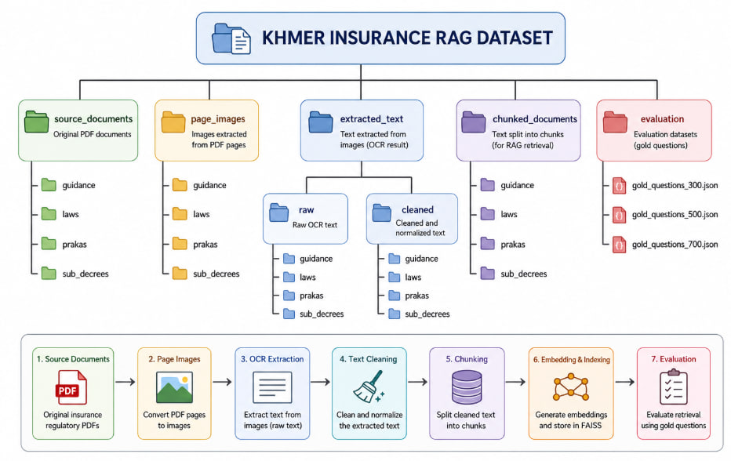
Figure 5: Dataset Folder Structure

4.3 Research Methodology
The project follows a Retrieval-Augmented Generation methodology consisting of multiple processing stages.
The workflow begins with document collection and OCR extraction. The extracted text is cleaned and preprocessed before being divided into smaller chunks. Embeddings are generated from each chunk and stored in a vector database. During retrieval, the most relevant chunks are retrieved and provided to a language model for answer generation.
This methodology helps improve response accuracy while reducing hallucination by grounding answers in trusted source documents.

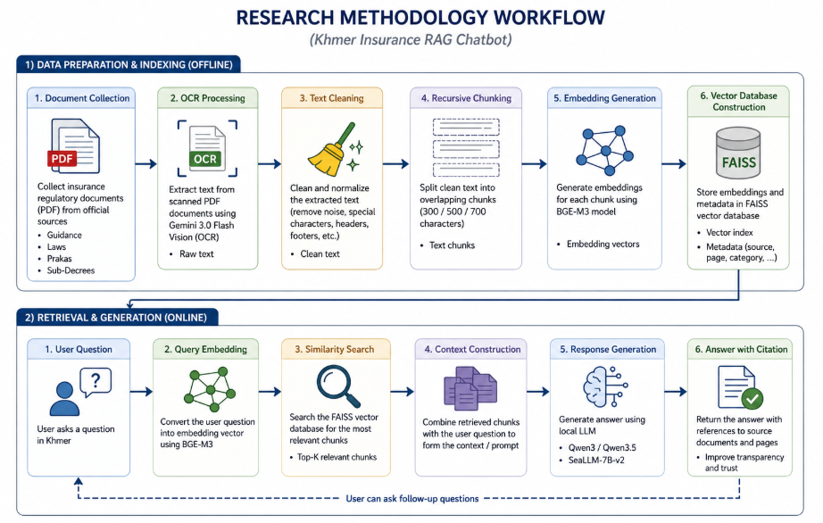
Figure 6: Research Methodology Workflow

4.4 Chunking Strategy Analysis
Document chunking plays a vital role in a Retrieval Augmented Generation (RAG) system since retrieval capability relies heavily on document chunking. Chunks that are too large tend to have redundant information that makes them less effective in terms of retrieval, while chunks that are too small could miss out on crucial information needed for response generation.
Recursive Chunking was chosen as the benchmark chunking strategy to find the right chunking strategy for Khmer insurance documents due to its ability to retain document structure through successive divisions. The order of chunking goes from paragraphs to lines, Khmer sentence markers (។), English sentence markers (.), words, and characters where necessary. This process of recursive chunking for the current study is shown in Figure 7.
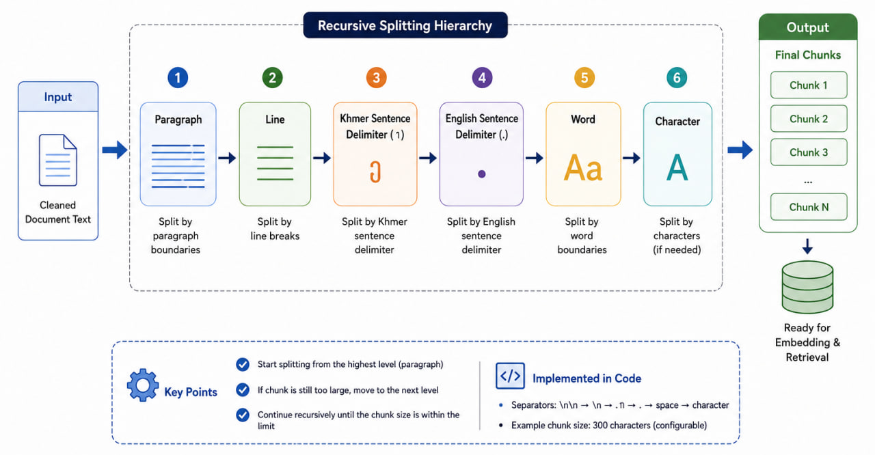
Figure 7: Recursive Chunking Process
As illustrated in Figure 8, the algorithm recursively splits text from high-level boundaries to low-level boundaries until the desired chunk size is achieved. In this way, it is easier to preserve semantics while keeping the chunk size reasonable.
In order to explore the effect of chunk size on the retrieval results, three different settings of chunk sizes are used. They are 300, 500, and 700 characters.
Table 4: Chunk Sizes Evaluated
Chunk Size | Description
300 | Smaller chunks with potentially higher retrieval precision
500 | Balanced chunk size between precision and context preservation
700 | Larger chunks containing more contextual information
Next, the effectiveness of retrieval of each chunk size combination was tested using various IR metrics. Results were analyzed to select the best chunk size for the development of the Khmer Insurance RAG Chatbot.

4.5 Embedding Model Analysis
Embedding models are key components of RAG systems since they help represent text using numbers with respect to their semantics. Unlike conventional keyword-based search techniques, where a keyword can only capture the surface-level information about the content, embedding models help in comprehending the contextual relation between terms and documents. Therefore, documents sharing similar meaning are easily detectable irrespective of their vocabulary and sentence structure.
For this project, we have used the BGE-M3 (BAAI General Embedding Model 3) embedding model for representing both the chunks from documents and user queries in vector forms. BGE-M3 is a multilingual embedding model that works on several languages and retrieval purposes. We opted for the BGE-M3 model due to its proven efficiency in semantic searches, multilinguality, and ability to handle Khmer and English texts prevalent in insurance regulations.
After chunking documents into smaller fragments, the generation of embeddings starts. Every chunk extracted using the chunking pipeline is translated to a high-dimensional vector with the help of the BGE-M3 model. Also, when a user asks a question, the model creates an embedding vector from the query. This way, all the documents and queries are represented in one vector space, thus allowing to compute the degree of their semantic similarity.
The embeddings that have been generated are saved in a FAISS vector database. The process of retrieval takes place in the vector space with the use of vector similarity comparison. That is, when a query comes, the model calculates the similarity of vectors to retrieve the closest chunks. Afterward, these chunks are provided as context to generate a response.
Choosing BGE-M3 helps improve the efficiency of the RAG Chatbot by ensuring better performance in semantically searching documents. Moreover, being multilingual, this model is perfect for the Khmer Insurance RAG Chatbot because the documents may contain some phrases in both English and Khmer languages. Hence, the embedding model can be considered a crucial part of the retrieval and generation of responses.
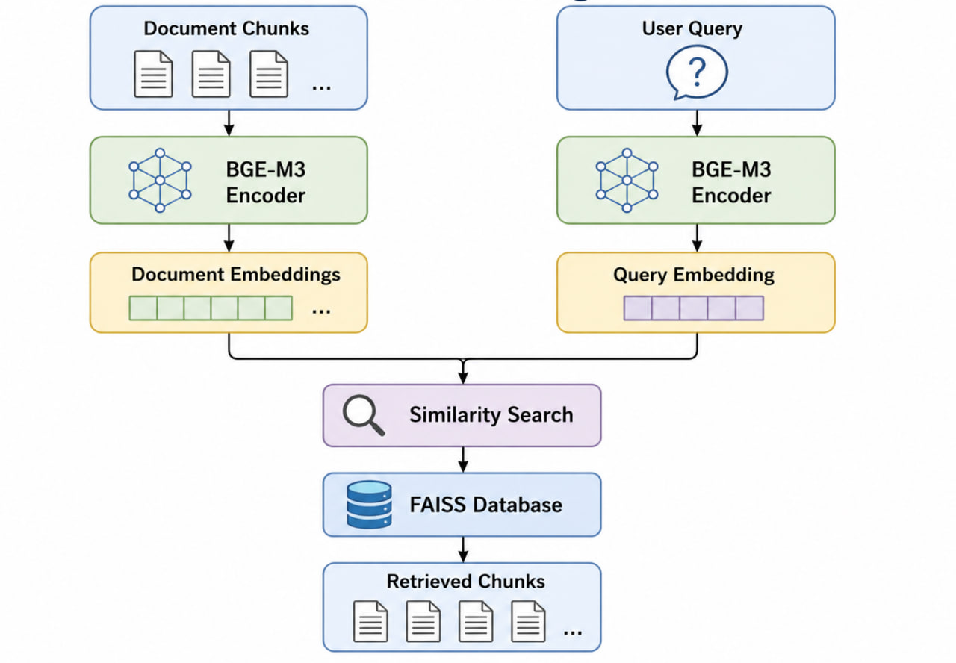
Figure 8: BGE-M3 Embedding Model

4.6 Vector Database Analysis
One crucial element in any Retrieval-Augmented Generation (RAG) architecture is the vector database since it allows the storage and subsequent retrieval of high-dimensional embedding vectors. Once a chunk of the document is converted into an embedding via the BGE-M3 model, the embedding will need to be saved in a suitable database that allows fast similarity search. Thus, the system can use the semantics of the document for searching relevant documents instead of doing exact matches with keywords.
For this project, we chose FAISS (Facebook AI Similarity Search) as the vector database solution. FAISS is an open-source software library created by Meta AI that is designed explicitly for fast similarity search and clustering of dense vectors.
These embedding vectors, along with their metadata, are stored in the FAISS database. Some types of data stored in metadata include document IDs, pages, categories, chunk sizes, and sources. The storage of this type of metadata will allow the chatbot not only to find chunks that fit into the request but also provide citation to support generated answers.
When the question comes from a user, its embedding vector is created through the use of the BGE-M3 embedding model. Next, the created embedding vector is compared to all existing document embeddings in the FAISS database using the technique of vector comparison. As a result, FAISS returns the documents most similar semantically to the user's request.
Finally, the retrieved chunks are sent to the language model in order to generate a relevant answer. With the help of semantic search rather than a simple search by keywords, the system can find relevant information regardless of the wording or the way it was expressed. Consequently, the vector database is of critical importance in the efficiency of the Khmer Insurance RAG Chatbot.
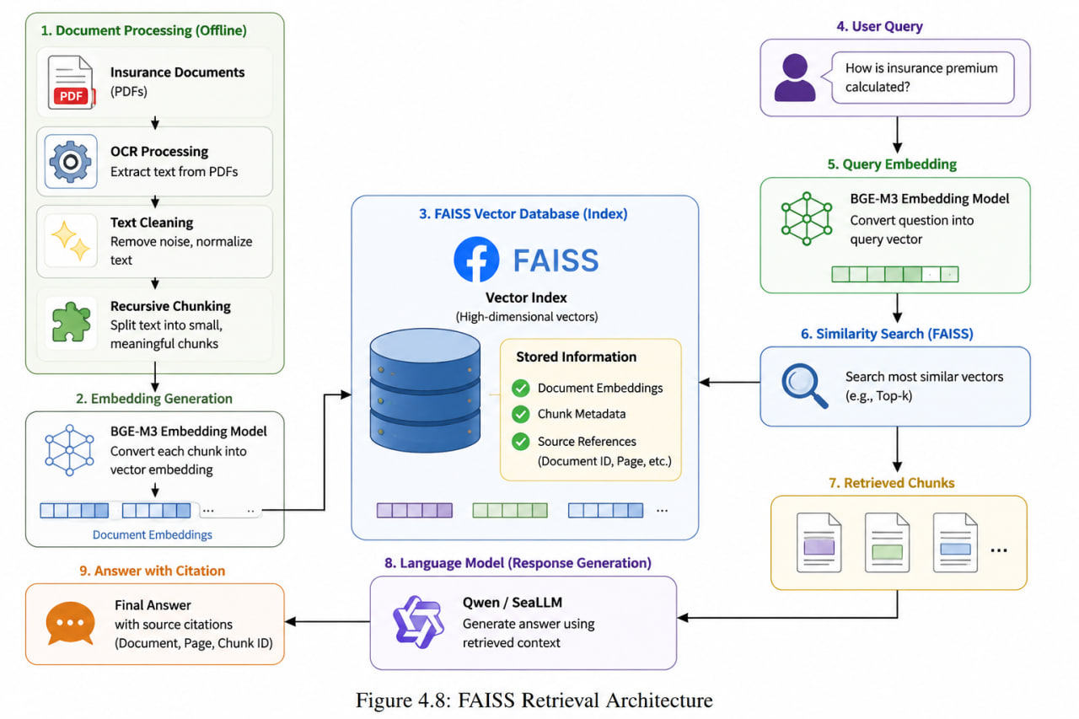
Figure 9: FAISS Retrieval Architecture

4.7 Local Language Model Analysis
The language model is in charge of producing responses to the answers obtained from the vector database. Since the target of this project was to create a chatbot that can be used locally, some open-source language models have been tested to see if they can be applied to the Khmer Insurance RAG Chatbot.
At first, tests were conducted on the Qwen model series, which include Qwen3-4B, Qwen3.5-4B, and Qwen3.5-9B. All the mentioned models were able to show great reasoning abilities and generate coherent answers using the retrieved insurance information. Nonetheless, the latter two models needed much computing power and were slower when generating responses on laptops with low hardware performance.
The latter issue made it necessary to look for other language models that could be used. One such model is called SeaLLM-7B-v2. It is worth noting that SeaLLM was designed specifically to perform well with Southeast Asian languages and multilingual tasks, which makes it a suitable option for the Khmer language.
In the evaluation process, three major criteria were considered: response quality, generation speed, and the requirements for hardware. The results of the experimentation conducted allowed drawing important conclusions related to the balance between the effectiveness of the model and its real-world implementation. Further analysis helped select the most feasible language model settings for the chatbot.
Table 5: Local Language Models Evaluation
Criteria | Qwen3-4B | Qwen3.5-4B | Qwen3.5-9B | SeaLLM-7B-v2
Parameters | 4B | 4B | 9B | 7B
Response Quality (1-5) | 4.1 | 4.3 | 4.7 | 4.4
Average Response Time | 45 sec | 60 sec | 180-300 sec | 20-30 sec
VRAM Requirement (4-bit) | ~4.5 GB | ~5.0 GB | ~9.5 GB | ~6.0 GB
Khmer Language Support (1-5) | 3.8 | 4.0 | 4.5 | 4.7
Multilingual Capability (1-5) | 4.0 | 4.3 | 4.6 | 4.7
Hardware Suitability (1-5) | 5.0 | 4.8 | 2.5 | 4.5
Overall Score (1-5) | 4.2 | 4.4 | 4.1 | 4.6
The comparative evaluation of the local language models evaluated within the scope of this project is presented in Table 5. Qwen3.5-9B performed the best in terms of the answer quality score and reasoning capabilities, but it demanded many more computing resources to perform, and its response time was much slower compared to other models on the existing hardware. On the contrary, SeaLLM-7B-v2 proved to be an optimal solution combining answer quality, multilingual capabilities, and relatively fast response times. Additionally, the model performed extremely well for queries in Khmer language.

4.8 System Architecture
The Retrieval-Augmented Generation chatbot built for the Khmer Insurance company utilizes an RAG-based architecture that integrates document retrieval algorithms along with large language models to deliver reliable and accurate answers backed up by credible sources. This type of architecture was used specifically to eliminate hallucinations and provide more trustworthy answers grounded in the documents used for generating them.
The input data for the chatbot consists of PDF files related to insurance regulatory documents collected online. Such files are then parsed using an OCR algorithm to produce machine-readable text that is further preprocessed and normalized. Lastly, the text undergoes recursive splitting to create small chunks of documents suitable for analysis.
After the split, the chunks of the documents are represented using vectors produced by the BGE-M3 model. These vectors are added to the FAISS vector database where they are used to retrieve chunks similar to the query. Thus, when a query arrives, its vector representation is created and compared to the document embeddings to find the most similar chunks.
The obtained chunks will be passed to the chosen language model, such as Qwen or SeaLLM, to provide context during the generation process. At last, the final output will be shown to the user, along with citation information to ensure transparency and enable users to cross-check the obtained information.
The proposed design will allow users to receive insurance-related information from the official regulatory authorities with increased accuracy, decreased chances of hallucinations, and enhanced credibility.
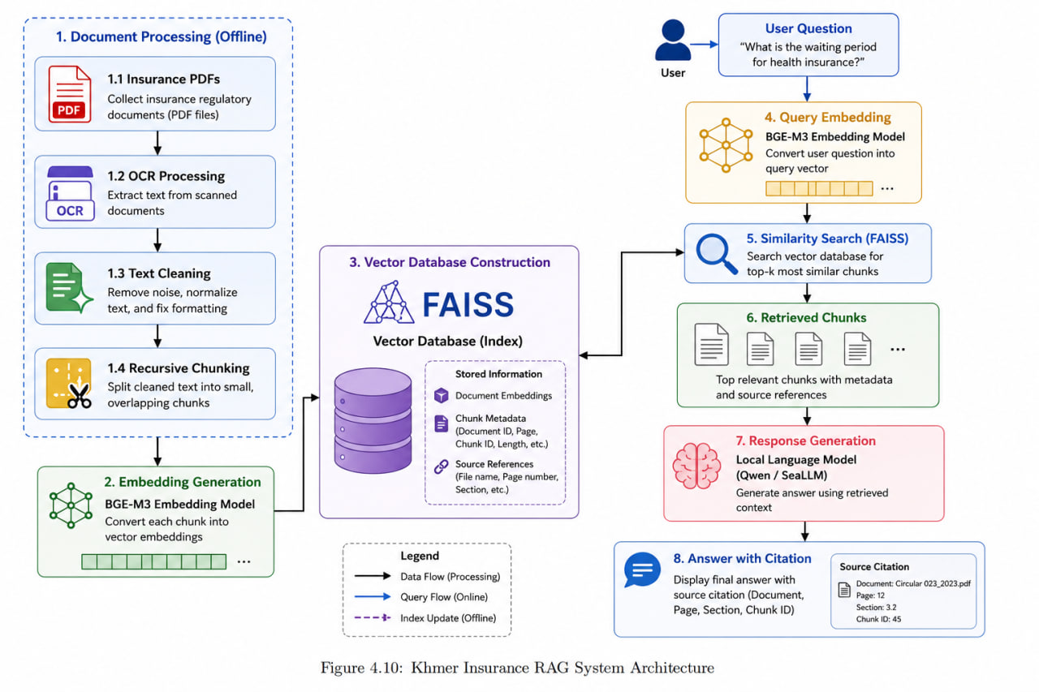
Figure 10: Khmer Insurance RAG System Architecture

DETAIL CONCEPT
This chapter discusses the detailed implementation of the Khmer Insurance RAG Chatbot. This section outlines the processes used during implementation including configurations of experiments and integration of the system through the course of the internship period. The intention behind this chapter is to illustrate the implementation of the techniques discussed in Chapter IV to create an entire retrieval-augmented generation system for Khmer insurance information retrieval.

5.1 Dataset Collection and Preparation
This process involved the extraction of relevant insurance regulation documents from publicly available sources. Information for this paper was sourced from the Insurance Regulator of Cambodia (IRC), which is the organization responsible for official documents pertaining to insurance regulation in Cambodia.
Approximately 49 PDF documents made up of about 799 pages have been gathered. Such documents have undergone thorough analysis and classification into four major categories including Guidance, Laws, Prakas, and Sub-Decrees. This has facilitated proper classification and eased processing procedures.
In order to effectively develop the project, a folder system was implemented. Folders were created for the following purposes including Source Documents, OCR Output, Clean Text, Chunks, Vector Databases, Evaluation Dataset, and Application Modules.
Table 6: Dataset Statistics
Category | Number of Documents
Guidance | 16
Laws | 04
Prakas | 25
Sub-Decrees | 04
Total | 49

5.2 OCR Processing Implementation
Once the datasets have been collected, an OCR pipeline has been created in order to extract machine-readable texts out of PDF documents. Given that a significant portion of the collected datasets are composed of scanned pages, the text cannot be directly extracted.
Tesseract OCR was initially tested because of its open-source nature as well as the possibility to recognize Khmer text. It turned out that the accuracy, character segmentation, and formatting preservation were lacking when Tesseract was used on Khmer insurance documents.
Therefore, Google Gemini OCR was chosen as a primary OCR tool in our implementation. The pipeline starts with converting PDF pages to image files using pdf2image library. Then each of the images goes through the Gemini Vision model and extracts the text data from it.
The text along with metadata such as document identifier, page number, and category are saved in JSON files, which makes further processing easier in the rest of the RAG pipeline.
Overall, the OCR pipeline has been able to process around 799 pages and extract texts for all datasets collected.
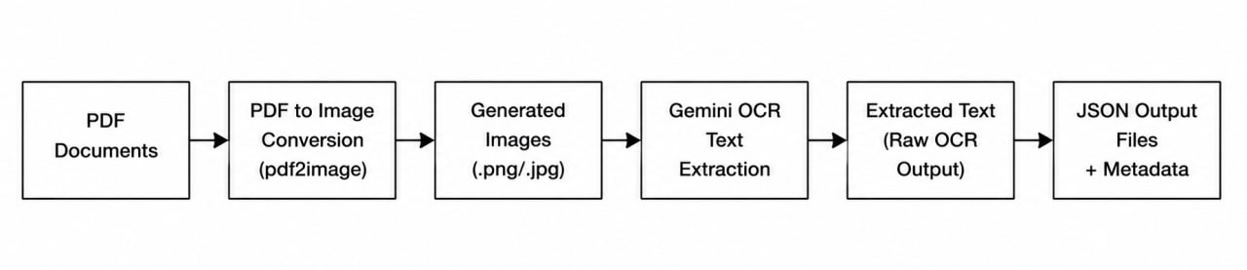
Figure 11: OCR Processing Workflow
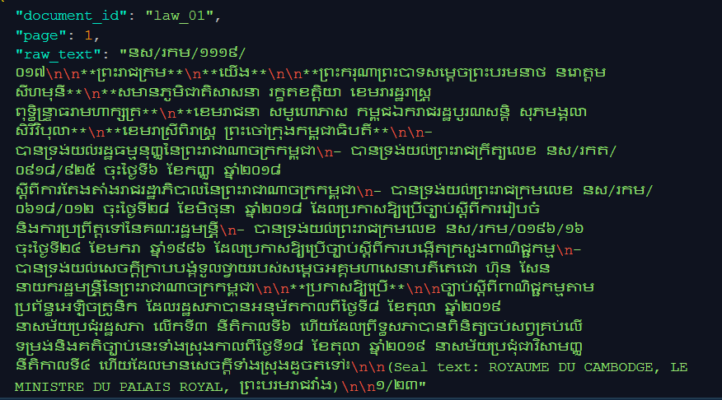
Figure 12: Sample OCR Output

5.3 Text Cleaning and Preprocessing
Some types of noises present in the OCR result included page numbers, formatting discrepancies, redundant spaces, OCR noises, and unrelated characters. Hence, a custom text cleaning pipeline was developed to enhance the quality of the data prior to the generation of chunks. The process included stripping away formatting noises, correcting whitespaces, rectifying structure issues, and retaining key insurance jargon as well as legal terms in the text. Emphasis was placed on retaining the meaning of regulation texts while ignoring any unimportant aspects. The cleaned text was then exported into JSON files and used in the document chunking step.
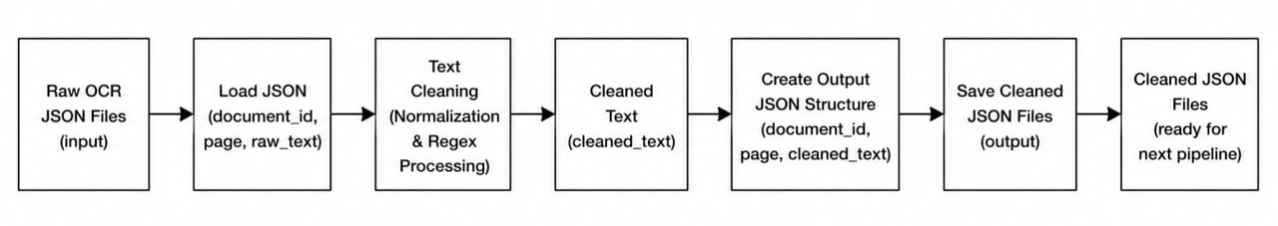
Figure 13: Text Cleaning Workflow

5.4 Recursive Chunking Implementation
The next step involved chunking to break down large documents into smaller chunks that would be easier to retrieve. Recursive Chunking was adopted since it retains document structures while forming chunks of an appropriate size.
The chunking hierarchy that was implemented includes:
- Paragraph
- Line
- Khmer Sentence Delimiter (។)
- English Sentence Delimiter (.)
- Word
- Character
There were three chunk sizes used while implementing the chunking process:
- 300 Characters
- 500 Characters
- 700 Characters
The following metadata for each chunk was recorded: document identifier, category, page number, chunk size, and chunking method. Metadata would facilitate the tracing of documents, retrieval of documents, and the generation of citations. The chunking process successfully converted all the cleaned documents into thousands of chunks.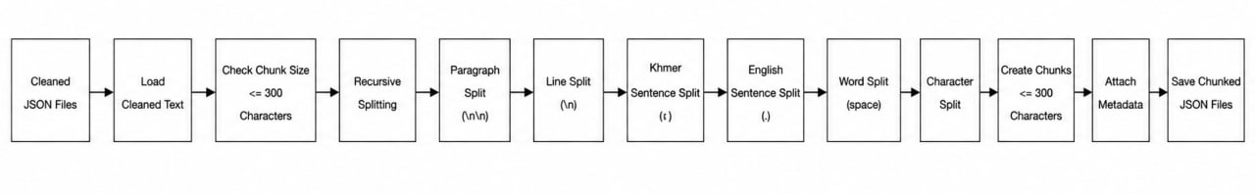
Figure 14: Recursive Chunking Implementation
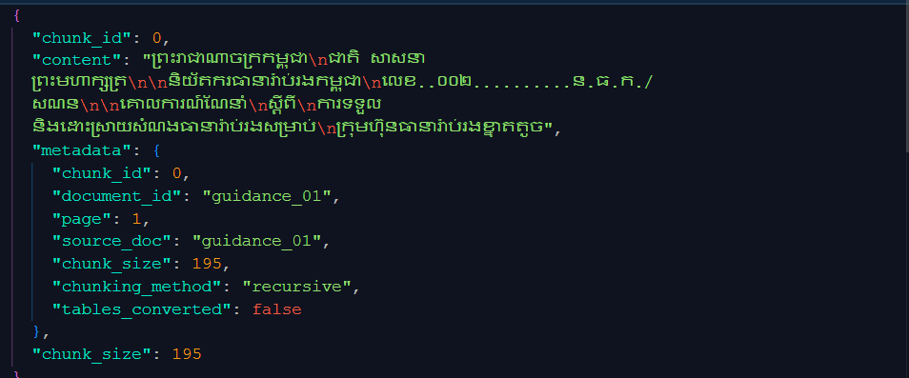
Figure 15: Example Generated Chunks
Table 7: Chunking Configurations
Chunk Size | Purpose
300 | Higher retrieval precision
500 | Balanced precision and context
700 | Greater contextual preservation

5.5 Embedding Generation Using BGE-M3
After the chunk generation step, the next step in the process entailed creating embeddings for all chunks of documents using the BGE-M3 embedding model. The rationale behind this was to convert information from textual form into vectors that will represent semantic meaning of content contained in the documents.
The implementation started by first collecting all created chunks from the previous step. Each chunk was then converted into vectors using the BGE-M3 embedding model. Embedding creation was carried out using the Sentence Transformer tool.
The BGE-M3 model was used because of its effectiveness in multilingual retrieval and support of Khmer and English languages. Since insurance documents are characterized by use of multiple languages in terminology, supporting multiple languages was a key criterion for selection of the model.
The embeddings created will be at the heart of retrieval operation. Using the same semantic space, it becomes easy to compute similarities between documents and user queries when carrying out retrieval operations.
Embeddings were then saved for indexation in the FAISS vector database.
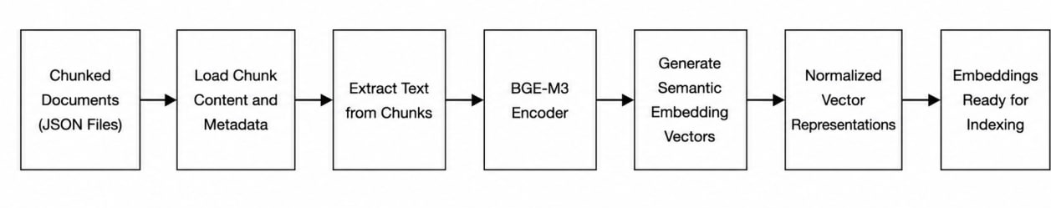
Figure 16: Embedding Generation Workflow

5.6 FAISS Vector Database Construction
Upon the completion of embedding generation, a vector database was created via FAISS (Facebook AI Similarity Search).
In this step, the objective was to facilitate the storage and retrieval of document embeddings upon interaction with users.
The steps included:
- Setting up of a FAISS index
- Creating and adding all generated embedding vectors to the index
Each embedding vector is attached to metadata which describes its corresponding document chunks.
The metadata consists of:
- Document ID
- Page Number
- Category
- Size of Chunk
- The source
The vector database was stored locally for the sake of faster retrievals. In the chatbot's operation, the FAISS index acts as the key retriever of document chunks based on vector similarity.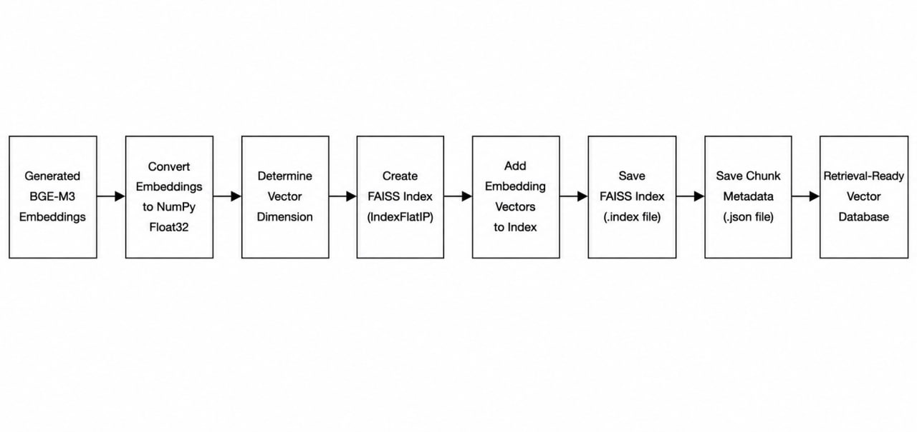
Figure 17: FAISS Index Construction Workflow
Table 8: Vector Database Statistics
Item | Value
Total Documents | 49
Total Pages | 799
Total Chunks | 6,740
Embedding Model | BGE-M3
Vector Database | FAISS
Retrieval Method | Top-K Similarity Search
Top-K Value | 5

5.7 Retrieval Evaluation Implementation
The retrieval evaluation was undertaken in order to test the effectiveness of the retrieval model. Because retrieval is very crucial for the performance of chatbots, an evaluation approach was set up to compare various chunking strategies.
Gold standard dataset consisting of questions manually created was used in the retrieval evaluation. The questions were paired with document sources for a comparative study on retrieval performance.
The test entailed inputting the questions into the retrieval model and capturing the outputs. Comparisons were made to evaluate the relevance of document sources to retrieve.
Three chunk sizes of 300, 500, and 700 characters were used in the experiment in order to find out which chunk size gave the most efficient result.
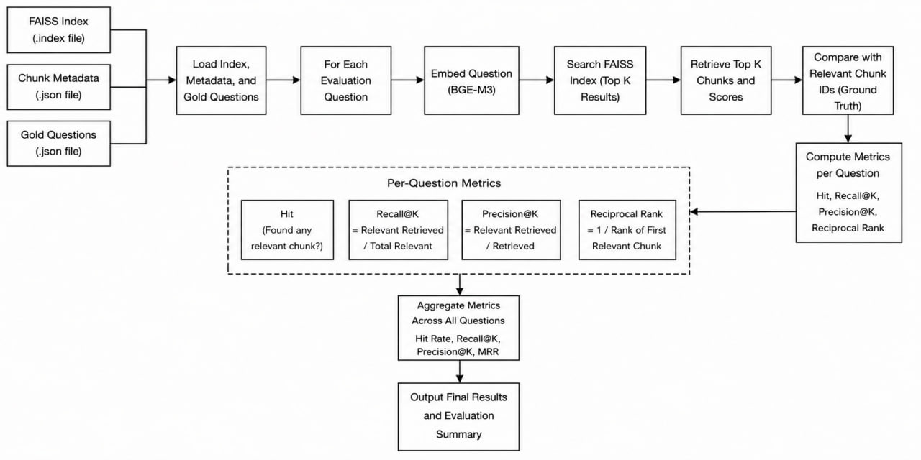
Figure 18: Retrieval Evaluation Workflow

Table 9: Evaluation Configuration
Parameter | Value
Evaluation Questions | 30
Chunk Sizes Tested | 300, 500, 700
Metrics | Hit Rate, Recall@5, Precision@5, MRR
Embedding Model | BGE-M3
Vector Database | FAISS

Table 10: Retrieval Performance Comparison
Chunk Size | Hit Rate | Recall@5 | Precision@5 | MRR
300 | 0.8333 | 0.8167 | 0.1733 | 0.6372
500 | 0.8333 | 0.7333 | 0.1667 | 0.6272
700 | 0.8000 | 0.8000 | 0.1600 | 0.6417

5.8 Local Language Model Testing
To provide assistance in generating responses, some local language models were considered in order to determine their compatibility with the Khmer Insurance RAG Chatbot.
Those include:
- Qwen3:4B
- Qwen3.5:4B
- Qwen3.5:9B
- SeaLLM-7B-v2
The assessment was performed based on the same retrieval outputs for each model. The assessment covered such aspects as response generation quality, inference speed, multilingual capabilities, hardware requirements, and practicality of implementation. During experiments, it was found that although larger Qwen models were superior in reasoning skills, they demanded far more computing power.
Table 11: Local Language Model Evaluation
Criteria | Qwen3-4B | Qwen3.5-4B | Qwen3.5-9B | SeaLLM-7B-v2
Parameters | 4B | 4B | 9B | 7B
Response Quality | 4.1 | 4.3 | 4.7 | 4.4
Response Time | 45 sec | 60 sec | 180-300 sec | 20-30 sec
Khmer Support | 3.8 | 4.0 | 4.5 | 4.7
Overall Score | 4.2 | 4.4 | 4.1 | 4.6

5.9 Streamlit Chatbot Development
A streamlit package was used to design the user interface of the chatbot. The purpose was to create a simple and interactive interface that would enable users to pose questions relating to insurance and have the questions answered using an RAG pipeline. In designing the user interface, four components were used namely question input area, retrieval, answer output area, and sources. Once a user poses a question, the question is automatically retrieved and responded to while showing the sources at the same time. Sources were added in all answers to enhance accountability and transparency.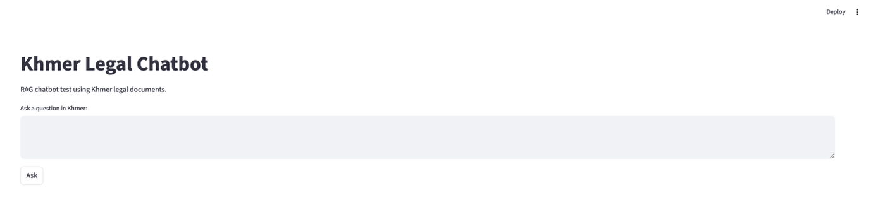
Figure 19: : Streamlit Interface
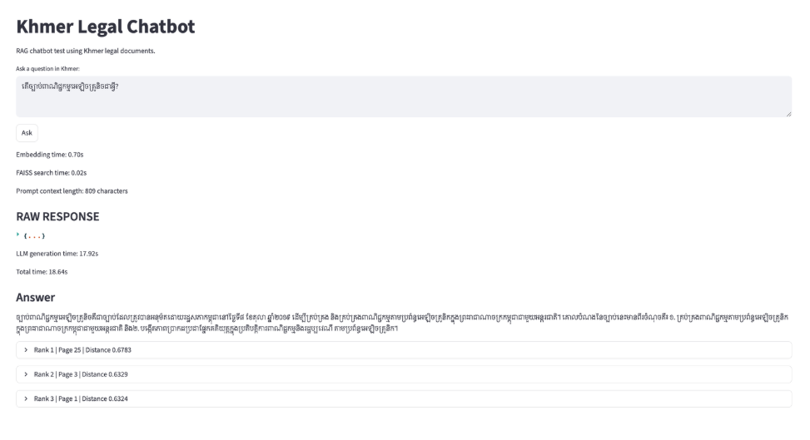
Figure 20: Sample Chatbot Response

5.10 System Integration
In the last step, all previously developed parts were consolidated into one comprehensive system called Retrieval-Augmented Generation.
The process starts with documents' collecting and extracting them through OCR. The obtained texts undergo cleaning and splitting in accordance with the recursive chunking pipeline. All chunks are encoded via BGE-M3 into embeddings, which are stored in the FAISS vector database.
Once the user poses a question, the query gets translated into a vector embedding and compared to the existing document embeddings. Top-relevant chunks are retrieved and used by the language model as context information to generate an answer. The answer itself is provided along with sources citing.
The consolidated project shows how all mentioned technologies can be combined for the purpose of reliable information retrieval in the field of insurance.
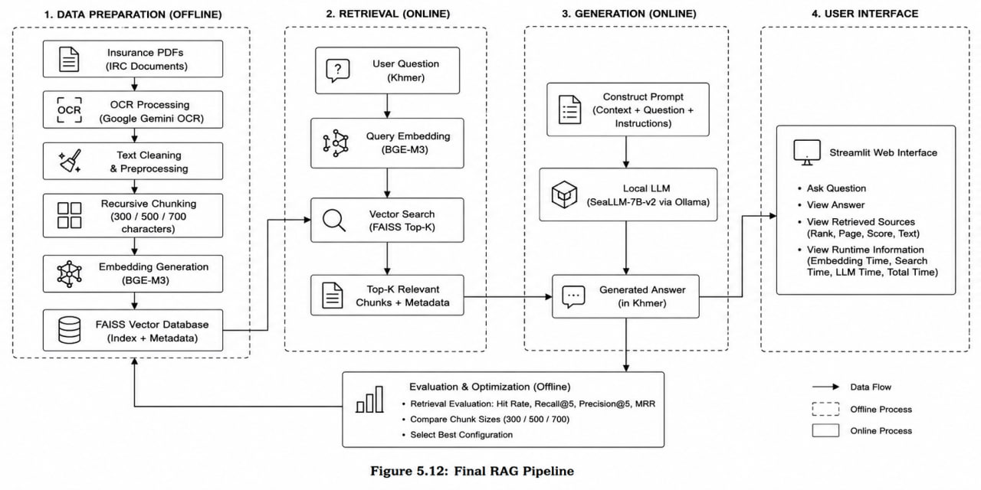
Figure 21: Final RAG Pipeline

IMPLEMENTATION
This chapter will discuss the experiment conducted on the Khmer Insurance RAG Chatbot, its performance, and analysis of its outcome. The purpose of this section is to determine how effective the chatbot performs and analyze its outcome.

6.1 Development Environment
The Khmer Insurance RAG Chatbot was developed by using Python programming language along with different open-source modules that assist in extracting embeddings, retrieving vectors, and developing a web application. The development process was conducted in a Windows-based system environment. Some of the modules used for developing the system include Google Gemini OCR, BGE-M3, FAISS, SeaLLM-7B-v2, and Streamlit.

6.2 Retrieval Performance Evaluation
The tests were carried out on 30 questions related to insurance that were manually designed. The purpose of the test was to determine how effective the retrieval function is in retrieving relevant document fragments from the vector space database. The findings shown in Table 10 reveal that the chunk size of 300 characters delivered the most effective retrieval performance of all the tested sizes. This is the reason why this size was chosen for the final chatbot design. The experiments revealed that the chunk size has considerable influence on retrieval performance. Large chunks facilitated better context preservation but sometimes contained noise.

6.3 Local Language Model Evaluation
Local language models were tested to assess which one is suitable for implementation into the chatbot system. Considering the testing results shown in Table 11, SeaLLM-7B-v2 became the most optimal in terms of quality of response, multilingual support, inference speed, and hardware costs. Despite the fact that bigger language models performed better when it came to reasoning, the high cost and long response time were not optimal for deployment. Therefore, SeaLLM-7B-v2 became the chosen language model for Khmer Insurance RAG Chatbot.

6.4 Challenges Encountered
Challenges emerged during the whole development process. First of all, there were issues related to the Google Gemini OCR scanning accuracy, when working with insurance documents. Even though OCR from Google has been used successfully in various tasks, there were some mistakes made when recognizing texts from low-quality images. Another issue was finding the right size for chunking. It has taken quite a few tests to reach the right compromise regarding precision of retrieving information and preserving context.
Hardware constraints have also played an important role in choosing a language model to use. More powerful language models performed better in reasoning tasks, however they required more computational resources and time.
6.5 Discussion
The analysis proves that it is possible to utilize the Retrieval-Augmented Generation approach in the area of insurance information retrieval in Khmer language. By combining OCR processing, recursive chunking, embedding vectors, FAISS retrieval, and local language model usage, it was possible to develop an application capable of producing responses that are based on official insurance documents.
The experiment showed that the chunk size plays a major role in retrieval effectiveness, while language model tests proved that response generation quality should be balanced with processing speed.
In summary, the developed solution has met all of the project goals and showed the opportunities of the Retrieval-Augmented Generation approach in the field of insurance information retrieval using the Khmer language. The project has created a solid foundation for future AI systems development in Cambodia.

CONCLUSION

7.1 Conclusion
The main focus of the internship was the design and evaluation of Khmer Insurance Retrieval-Augmented Generation (RAG) Chatbot based on AI and NLP techniques. The primary objective of the internship project was to enhance the availability of data regarding insurance by developing the RAG chatbot that would retrieve information from the legal documents and respond accurately in Khmer language.
The internship period resulted in successful design and implementation of the fully functional pipeline of RAG chatbot. The development of the chatbot began with collecting of 49 legal documents covering insurance regulations and including 799 pages of text, which were provided by the Insurance Regulator of Cambodia (IRC). Since all of those documents were originally in PDF format, their transformation into text form required the use of OCR technology based on Google Gemini tool.
The next step after conversion of all documents into text form was designing the pipeline for text cleaning.
A number of local language models have also been tested, namely Qwen3-4B, Qwen3.5-4B, Qwen3.5-9B, and SeaLLM-7B-v2. According to the metrics of response quality, multilingual capability, hardware requirements, and speed of inference, the final language model chosen for the chatbot was SeaLLM-7B-v2. This model offered an adequate balance between response quality and computational efficiency while supporting communication in the Khmer language.
The final system has been released via a web interface implemented using Streamlit, where the user is capable of inputting a question to get an answer produced by a chatbot based on the retrieved data from the insurance documents.
The developed project was successful in reaching its goals and showing the practical implementation of the Retrieval Augmentation technique for information search in the insurance industry based on the Khmer language. The work done during this internship gave me the opportunity to gain knowledge in several fields, such as artificial intelligence, information retrieval, programming, and system development.

7.2 Project Achievements

The main accomplishments of this project internship include:

Organization of 49 regulatory documents related to insurance.

Use of Google Gemini OCR for processing about 799 document pages.

Text cleaning and pre-processing procedures.

Application of Recursive Chunking method for dividing documents into segments.

Creation of semantic embeddings through use of the BGE-M3 model.

Building a FAISS vector database.

Similarity Search evaluation with different chunk sizes.

Trial and testing of various language models locally.

Use of Streamlit framework for developing a chatbot application.

Successful deployment of a full-fledged Khmer Insurance RAG Chatbot.

Table 12: Summary of Project Achievements
Achievement | Status
Document Collection | Completed
OCR Processing | Completed
Text Cleaning | Completed
Recursive Chunking | Completed
BGE-M3 Embedding Generation | Completed
FAISS Vector Database | Completed
Retrieval Evaluation | Completed
Local LLM Evaluation | Completed
Streamlit Chatbot Development | Completed
Final System Integration | Completed

7.3 Limitations
Despite the successful completion of all the tasks, there were certain limitations found in the development and assessment process.
First, the accuracy of the OCR results depends on the quality of scanned documents. Badly formatted documents, images, and documents with poor text resolution will negatively impact the extraction result. The errors in the OCR results will propagate through subsequent steps in the RAG pipeline affecting retrieval.
The second limitation of the system is related to the size of the evaluation set. The dataset included only a small set of manually created questions, which was enough for obtaining valuable insights about the system's performance.
The third limitation of the proposed solution is related to the fact that the chatbot uses only information extracted from the insurance documents collection. This means that the system won't be able to answer questions based on the information not available in the knowledge base.
Finally, hardware restrictions have limited the possible language model sizes used in the system.

7.4 Future Work
There are several ways in which the current system can be enhanced or extended in the scope of future research.
For example, it might be interesting to extend the corpus of documents by including more policies, company-related materials, FAQs, etc. The more extensive the corpus of documents is, the better answers it will be able to give.
The current system uses Recursive Chunking for organizing chunks within documents. In addition, future research might consider such chunking algorithms as Semantic Chunking and Hybrid Chunking. Their performance compared to that of the Recursive Chunking algorithm might be considered for further improvements.
In addition, it might be interesting to try out more embedding algorithms as well as alternative retrieval techniques. This might help to determine whether a higher level of retrieval performance can be reached using different techniques.
Finally, it is worth considering the development of a more extensive dataset for testing the developed system.
Future research could also include the evaluation of advanced language models for Khmer, and the exploration of methods to fine-tune models for improved results.
The chatbot could finally also be made available as a fully functional application, be it on the web or through a mobile app, thus opening up the use of such an application to the general public. More integration of new sources and updating of existing sources could help achieve this purpose.
Concluding, the Khmer Insurance RAG Chatbot presents an interesting opportunity for research and development in the future. It has shown that it is possible to improve the capabilities of traditional AI chatbots through the implementation of Retrieval-Augmented Generation.

REFERENCES
[1] Chhoun, S., Po, P., Ros, S., Cho, W.-S., & Khoeurn, S. (2026). Evaluation of Chunking Strategies for Effective Text Embedding in Low-Resource Language on Agricultural Documents. arXiv:2605.22203. Retrieved from https://arxiv.org/abs/2605.22203
[2] Ros, S., Pov, P., Chhor, R., Ly, K., Cho, W.-S., & Khoeurn, S. (2026). A Comparative Study of Language Models for Khmer Retrieval-Augmented Question Answering. arXiv:2605.22099. Retrieved from https://arxiv.org/abs/2605.22099
[3] BAAI. (2024). BGE-M3: Multi-lingual, Multi-Functionality, Multi-Granularity Embedding Model. Hugging Face. Retrieved from https://huggingface.co/BAAI/bge-m3
[4] Meta AI. (2024). FAISS Documentation. Retrieved from https://faiss.ai
[5] Gao, Y., Xiong, Y., Gao, X., Jia, K., Pan, J., Bi, Y., Wang, Y., & Wang, H. (2024). Retrieval-Augmented Generation for Large Language Models: A Survey. Retrieved from https://arxiv.org/abs/2312.10997
[6] Google. (2024). Gemini API Documentation. Retrieved from https://ai.google.dev
[7] Insurance Regulator of Cambodia (IRC). (2024). Insurance Laws, Regulations, Guidelines, and Regulatory Documents. Retrieved from https://www.irc.gov.kh
[8] LangChain. (2024). Recursive Character Text Splitter Documentation. Retrieved from https://python.langchain.com/docs/concepts/text_splitters
[9] Lewis, P., Perez, E., Piktus, A., Petroni, F., Karpukhin, V., Goyal, N., Küttler, H., Lewis, M., Yih, W. T., Rocktäschel, T., Riedel, S., & Kiela, D. (2020). Retrieval-Augmented Generation for Knowledge-Intensive NLP Tasks. Advances in Neural Information Processing Systems (NeurIPS 2020), 33, 9459–9474. Retrieved from https://arxiv.org/abs/2005.11401
[10] Microsoft. (2024). Visual Studio Code Documentation. Retrieved from https://code.visualstudio.com/docs
[11] Ollama. (2024). Ollama Documentation. Retrieved from https://ollama.com
[12] Python Software Foundation. (2024). Python Documentation. Retrieved from https://docs.python.org
[13] Qwen Team. (2024). Qwen Large Language Models. Hugging Face. Retrieved from https://huggingface.co/Qwen
[14] Reimers, N., & Gurevych, I. (2019). Sentence-BERT: Sentence Embeddings Using Siamese BERT-Networks. Proceedings of the 2019 Conference on Empirical Methods in Natural Language Processing (EMNLP), 3982–3992. Retrieved from https://arxiv.org/abs/1908.10084
[15] Sea AI Lab. (2024). SeaLLM: Large Language Models for Southeast Asian Languages. Hugging Face. Retrieved from https://huggingface.co/SeaLLMs
[16] Streamlit Inc. (2024). Streamlit Documentation. Retrieved from https://docs.streamlit.io
[17] Tesseract OCR Development Team. (2024). Tesseract OCR Documentation. Retrieved from https://tesseract-ocr.github.io
[18] Van Rossum, G., & Drake, F. L. (2009). Python 3 Reference Manual. Python Software Foundation. Retrieved from https://www.python.org
[19] Wolf, T., Debut, L., Sanh, V., Chaumond, J., Delangue, C., Moi, A., Cistac, P., Rault, T., Louf, R., Funtowicz, M., Davison, J., Shleifer, S., Platen, P., Ma, C., Jernite, Y., Neve, M., Tunstall, L., Brundage, M., & Rush, A. M. (2020). Transformers: State-of-the-Art Natural Language Processing. Proceedings of the 2020 Conference on Empirical Methods in Natural Language Processing: System Demonstrations, 38–45. Retrieved from https://arxiv.org/abs/1910.03771

APPENDICES

