Finite State Machine Engine
Developer Guide
Version 0.02 – 15/07/2011

File | 0000.doc
Author | DZ | Dimitris ZAVALIADIS | Analyst Programmer
 | NP | Nikos POUGOUNIAS | Analyst Programmer
Reviewer

Version history

Version | Date | Author | Contributors | Change Summary
0.01 | 01/05/11 | DZ |  | Document creation
0.02 | 13/07/11 | NP |  | Updated to new format and added examples.

Table of Contents
1 Introduction 4
1.1 Purpose 4
1.2 Scope 4
2 Technical Details 5
2.1 Domain Model 5
2.2 Flow 7
3 How to use 10
3.1 Instructions 10
3.2 Example 1 - A simple example 11
3.3 Example 2 - An order 12
4 Known Limitations and Future Work 15
4.1 Intrusiveness 15
4.2 Implications of Using the StateName enum 15
4.3 Branch Robustness 15

List of Figures
Figure 1 – FSM Engine Domain Model 6
Figure 2 – FSM Engine Sequence Diagram 9
Figure 3 – A simple state diagram 11
Figure 4 – The state diagram of an Order 12

Introduction

Purpose
FSM Engine is a Java API that allows you to define and execute simple state machines and workflows in your code. It helps in cases where the behaviour of an object needs to be changed at runtime depending on its state, eliminating the need for extensive use of if/else and switch statements which make your code unreadable and difficult to maintain. FSM Engine is inspired by Harel Statecharts and the State Design Pattern and has been originally developed by the Hellenic National Documentation Centre as part of internal software development projects.
The purpose of this document is to describe the concepts and techniques used by the FSM Engine and provide some examples that can help you get started with utilising FSM Engine in your own projects.

Scope
FSM Engine provides a set of reusable Java classes and interfaces that apply the abstract concepts of finite state machines (hence FSM) at the source code level. By extending and implementing those classes and interfaces in your application, you can systematically define how your system reacts to certain events avoiding at the same time cluttered case statements. This is achieved by specifying a set of valid states for an object along with possible transitions between states which are triggered by events. In addition, guard conditions can determine whether a transition should be executed or not and a set of possible actions can be associated with a given transition in order to be fired as a side effect of executing the transition.

Technical Details

Domain Model
The FSM Engine consists of a set of core interfaces and classes all of which are found under the gr.ekt.fsmengine.api.* package and described below:

gr.ekt.fsmengine.api.StateContext
Maintains a reference to the current state. It should be implemented by one or more client classes that can have different internal states and whose behavior changes depending on those states.

gr.ekt.fsmengine.api.State
Represents the different states of the state machine. Each possible state of a class implementing the StateContext interface should correspond to a concrete implementation of this interface.

gr.ekt.fsmengine.api.StateName
A Java enum acting as a bridge between StateContext and States. Within the classes that implement the StateContext interface, internal states are represented via a StateName enum rather than a State object. This is due to the fact that typically StateContext implementations will need to be persisted in a database and therefore representing States with a regular object would introduce unnecessary complexities (since the relationship between StateContexts and States would need to be mapped at the database level as well) as opposed to Java enums which can be easily persisted in a database as plain text.

gr.ekt.fsmengine.api.Event
Represents an external or internal event such as a button click or a date expiration that can change the State of an object, thus leading to a state Transition in the system. Usually, there is only one Transition corresponding to a given Event but it is also possible to accommodate more than one Transitions for an Event via Branches and GuardConditions (see below). An Event can also be characterised by an InteractionType. gr.ekt.fsmengine.api.InteractionType is a Java enum with three constants, namely POSITIVE, NEGATIVE and NEUTRAL. It is not coupled to any particular purpose, but the most common use case is for styling form controls in the front end, such as for coloring buttons that fire certain Events for example.

gr.ekt.fsmengine.api.Transition
Defines the transition from one state to another as a response of the state machine to an occurrence of a specific Event. A Transition can be guarded by a GuardCondition which determines whether the execution of the Transition should proceed or not. In addition, a Transition can be associated with one or more Actions to be performed once the Transition has been executed.

gr.ekt.fsmengine.api.GuardCondition
A GuardCondition is actually a Boolean expression that affects the behavior of the state machine by enabling Transitions only when it evaluates to true and disabling them when it evaluates to false. A GuardCondition can be associated with many Transitions but each Transition can have only one GuardCondition.

gr.ekt.fsmengine.api.Action
Defines an activity that is to be performed when executing a certain Transition. An Action can be associated with more than one Transitions and a Transition can have more than one Actions. Also note that an Action can well trigger an Event having as a result another Transition.

gr.ekt.fsmengine.api.Branch
Acts as a container of Transitions. It is used in cases where there is no one-to-one mapping between an Event and a Transition but instead there are more than one possible Transitions for a given Event. In principle, the Transitions contained in a Branch are mutually exclusive, meaning that only one Transition will be executed each time and this will be determined once the GuardConditions of all Transitions have been evaluated. Note however, that currently this behavior is not strictly enforced by the Engine and therefore care should be taken to avoid unexpected results.

gr.ekt.fsmengine.api.StateChanger
Its sole purpose is to define a common interface for Transitions and Branches so that they can be used interchangeably (i.e. both Transition and Branch interfaces extend this interface).
gr.ekt.fsmengine.api.FiniteStateMachine
An abstraction encapsulating the internal details of the state machine, presenting a single interface to the outside world. Implementation classes should be used as the main point where the lifecycle management of a StateContext takes place, whenever a triggering Event occurs.

The figure below depicts the main relationships between the aforementioned classes:

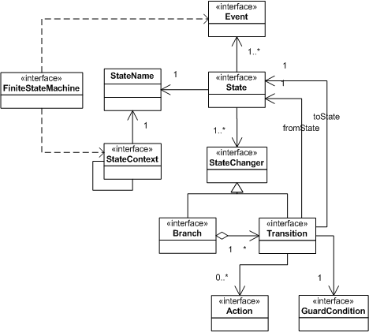
Figure 1 – FSM Engine Domain Model
Where required, either default implementation classes of the core interfaces (DefaultState, DefaultEvent, DefaultTransition, DefaultBranch, DefaultFsm, SpringFsm) or base abstract classes (AbstractAction, AbstractGuardCondition) are provided, that are necessary for implementing the basic logic of the state machine. Normally they should be used as is, but nevertheless if needed they are “open for extension and closed for modification” (thus following the open/closed principle). In addition, some utility implementation classes are provided under the gr.ekt.fsmengine.impl.* package which might come in handy e.g. for testing purposes:

gr.ekt.fsmengine.impl.AlwaysTrueCondition
A GuardCondition implementation (actually an AbstractGuardCondition extension) that always evaluates to true.

gr.ekt.fsmengine.impl.AlwaysFalseCondition
A GuardCondition implementation (actually an AbstractGuardCondition extension) that always evaluates to false.

gr.ekt.fsmengine.impl.NullAction
An Action implementation (actually an AbstractAction extension) that does nothing other than logging a dummy debug statement.

Flow
To give a better understanding of how the FSM Engine works, a step-by-step workflow is provided below:
- Everything starts within an implementation class of the FiniteStateMachine interface as described earlier. A client (e.g. a piece of code in your application) calls the FiniteStateMachine#processEvent(event, stateContext) method passing as parameters a certain Event and an instance of the client application class which implements the StateContext interface and whose states are managed by the FiniteStateMachine.
- The exact implementation of the FiniteStateMachine#processEvent() method might depend on the client application, but the behavior provided by the default implementation class that comes along with FSM Engine is as follows:
- Check whether the triggering Event is valid delegating to FiniteStateMachine#isValidEvent(). The default implementation of this method actually only checks whether the given Event is included in the list of specified Events for the State that the StateContext implementation class is currently in (by consulting the FiniteStateMachine#getValidEvents() method), but the client application could easily override this method in order to add other checks such as whether the user actually is authorised to trigger a given Event etc.
- If the triggering Event is indeed valid, find the equivalent State object that corresponds to the current StateContext#getStateName() and delegate the processing of the Event to the State object by calling the State#processEvent(event, stateContext) method, since the state-specific behavior is directly defined in the appropriate State implementation class (as per the State Design Pattern). If the Event is not valid, stop any further execution and inform the client accordingly throwing a proper runtime exception.
- The control is now transferred to an implementation class of the State interface which represents a specific state of the state machine as explained earlier. Each one of the different State instances is configured with a populated map property where Events are stored as keys and StateChangers (i.e. Transitions or Branches) as values. The default implementation of State#processEvent(event, stateContext) finds the StateChanger instance that corresponds to the passed Event and delegates further execution to a Transition (or Branch) instance by calling the StateChanger#execute(stateContext) method. If the StateChanger found happens to be a Branch instance, this Branch instance iterates over the list of possible Transitions that it holds and delegates execution to each one of them. However, as explained earlier, only one Transition instance actually proceeds further and this will depend on the configured GuardCondition for each Transition (i.e. only one of those Transitions should evaluate to true). The entire process remains transparent to the client code due to polymorphism magic.
- The control is now transferred to a Transition instance. The implementation of the DefaultTransition#execute() class/method provided along with the FSM Engine is the following:
- Check if there’s a GuardCondition implementation configured for this Transition. If so, evaluate the condition and if the result is true proceed to the next step (by delegating to DefaultTransition#proceed()) otherwise do nothing (just log a proper message).
- If the Transition is allowed to be executed after the GuardCondition has been evaluated, the DefaultTransition#proceed(stateContext) method changes the State (or the StateName to be precise) of the passed StateContext instance according to what has been configured for this specific Transition instance upon initialisation, i.e. according to the Transition#getToState() value. Note that it is also possible to configure internal Transitions, i.e. Transitions that do not lead to a change of State, by leaving the Transition#toState property null. This might be useful in cases for example where only some Transition Actions need to be performed (see below).
- Once the state transition (or the internal transition) has been executed, the configured Actions (if any) are executed as well by delegation to the DefaultTransition#executeActions() method. This method iterates over all the configured Action instances for a given Transition instance and executes them one by one by calling the Action#execute(stateContext) method. Note that this operation is atomic, meaning that if one of the Actions throws an exception for some reason while being executed, all of the previous Actions that might have been executed up to this point will be rolled back, provided that the Action#rollback() method has been properly overridden by the implementing class.
- Normally, at this point the state machine execution is completed and the control is handed over back to the client code, unless one or more of the Transition Actions trigger new Events, thus leading to nested state machine executions in which case the workflow starts again in step 1 above.

The sequence diagram below visually depicts the FSM Engine flow described so far:
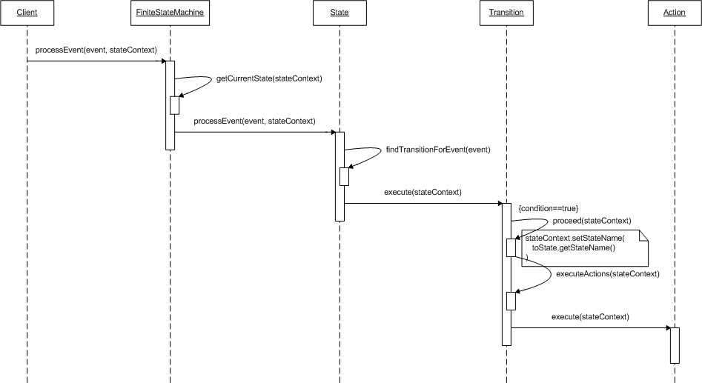
Figure 2 – FSM Engine Sequence Diagram

How to use

Instructions
In order to use the FSM Engine in your own project, the steps described below can be followed:
- Identify the classes in your application whose behavior changes depending on their state and therefore would better be managed by the FSM Engine.
- Populate the StateName enum with all the possible state names you envisage for each one of the classes selected in the previous step. Each state name is represented with an enum constant. So, for example, the state names for an Order class in an ecommerce application could be PENDING, PROCESSING, SHIPPED, CANCELLED, etc.
- Have those classes implement the StateContext interface:
- Add a property in your class for maintaining a reference to the current StateName.
- Provide proper accessors and mutators (i.e. implement the StateContext#getStateName() and StateContext#setStateName() methods) for the StateName property
- Initialise the StateName property assigning the StateName enum constant that corresponds to the initial state of your class
- Implement the StateContext#isDone() method by providing a proper Boolean expression which will evaluate to true when your class has reached the final state, that is, when the current StateName of your class equals to the StateName constant designated as the final state for this class.
- In case of nested states, implement the StateContext#getParent() method by providing a reference to the parent StateContext instance, otherwise return null.
- Create a State class for each one of the StateName enum constants either by extending the DefaultState class provided along with the FSM Engine or if this doesn’t fit your needs by directly implementing the State interface. In any case, getStateName() should return the corresponding StateName enum constant.
- Create an Event class for each one of the triggering events that you envisage for your domain’s state (or internal) transitions either by extending the DefaultEvent class provided with FSM Engine or by directly implementing the Event interface (not normally the case):
- Override (or implement) getName() to return a suitable Event name
- Optionally, override (or implement) getInteractionType() returning one of the available InteractionType constants (the default implementation uses InteractionType#NEUTRAL)
- Create a Transition class corresponding to each one of the possible transitions you envisage for your domain’s States either by extending the DefaultTransition class provided with the FSM Engine or by directly implementing the Transition interface:
- getFromState() should correspond to the State containing this Transition, otherwise an InvalidTransitionException will be thrown.
- getToState() should correspond to the desired result of the state transition, i.e. to the State which the current State should switch to if the Transition is executed successfully.
- Optionally, if the Transition is conditional, getGuardCondition() should be overridden to return a proper instance of the GuardCondition interface. This mean that you will need to create a GuardCondition class for each one of the applicable conditions in your Transitions, either by extending the AbstractGuardCondition class and implementing the execute(StateContext stateContext) abstract method or by directly implementing the GuardCondition interface.
- Optionally, getActions() can be overridden to return a list of Actions to be performed once the Transition has been executed. Again, if this is the case, you will need to create an Action class for each one of the applicable Actions in your Transitions, either by extending the AbstractAction class and implementing the execute(StateContext stateContext) abstract method or by directly implementing the Action interface. If you wish the execution of Actions to be an all or nothing operation, you will also have to override the Action#rollback(StateContext stateContext) method for all of your Actions providing a proper rollback routine.
- Once you have all of the required Events and Transitions in place, override State#getEventTransitionsMap() providing a map populated with all the valid Events for this State and their corresponding Transitions. If more than one Transitions are possible for a given Event, create a Branch class either by extending DefaultBranch and overriding the getPossibleTransitions() method or by directly implementing the Branch interface, and assign this Branch as the map value instead of a Transition.
- As long as all of the FSM Engine definitions and wirings are complete, you can bootstrap the state machine execution by calling FiniteStateMachine#processEvent(Event event, StateContext stateContext) and passing one of your concrete Event objects along with the StateContext object as parameters. If everything is wired correctly and no exceptions are thrown along the way, normally, upon completion of the state machine execution, the state (StateName to be precise) of the StateContext instance in question should have changed to a new one (provided that this is a state transition rather than an internal transition) and any defined Actions should have been executed. Depending on your requirements, you can either use one of the provided FiniteStateMachine implementations (currently only gr.ekt.fsmegine.api.SpringFsm is available) for this reason or provide your own implementation/extension.

Example 1 - A simple switch
Suppose a simple switch that can be either OFF or ON. The initial state is OFF. The event press moves the switch to ON.

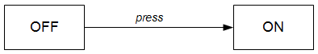
Figure 3 – The state diagram of a simple switch
The state diagram consists of the following elements:
States
- STATE_OFF
- STATE_ON
Event
- EVENT_PRESS
Transition
- From STATE_OFF to STATE_ON

Let’s define the above elements in Spring’s application context.

At first we declare the event.
<!-- Events -->
<bean id="eventPress" class="gr.ekt.fsmengine.api.DefaultEvent">
<property name="name" value="EVENT_PRESS"/>
</bean>
Then we declare the states.
<!-- States -->
<bean id="stateOff" class="gr.ekt.fsmengine.api.DefaultState">
<property name="stateName" value="STATE_OFF"/>
</bean>

<bean id="stateOn" class="gr.ekt.fsmengine.api.DefaultState">
<property name="stateName" value="STATE_ON"/>
</bean>
Finally, we declare the transition.
<!-- Transitions -->
<bean id="transition" class="gr.ekt.fsmengine.api.DefaultTransition">
<property name="fromState" ref="stateOff" />
<property name="toState" ref="stateOn" />
</bean>
At this point we should declare that the transition occurs when the press event arrives at the STATE_OFF. This is accomplished by adding the event transition map to the declaration of STATE_OFF.
<!-- States -->
<bean id="stateOff" class="gr.ekt.fsmengine.api.DefaultState">
<property name="stateName" value="STATE_OFF"/>
<property name="eventTransitionsMap">
<map>
<entry key-ref="eventPress" value-ref="transition"/>
</map>
</property>
</bean>
The complete declaration is under conf/context-example1.xml.

Run src/test/java/gr.ekt.fsmengine.example1.Run to see the execution flow.

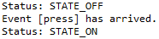
Figure 4 – Executing example 1

Example 2 - A simple action
Extending the previous example, an action will occur during the transition from STATE_OFF to STATE_ON.
For this reason we define an action:
public class TurnLightsOnAction extends AbstractAction {
@Override
public void execute(StateContext context) throws ActionException {
System.out.println("Action: Turned the lights on!");
}
}

<bean id="actionTurnLightsOn"
class=" gr.ekt.fsmengine.example2.TurnLightsOnAction" />

And we associate the action with the transition.
<!-- Transitions -->
<bean id="transition" class="gr.ekt.fsmengine.api.DefaultTransition">
<property name="fromState" ref="stateOff" />
<property name="toState" ref="stateOn" />
<property name="actions">
<list>
<ref bean="actionTurnLightsOn"/>
</list>
</property>
</bean>

The complete declaration is under conf/context-example2.xml.

Run src/test/java/gr.ekt.fsmengine.example2.Run to see the execution flow.

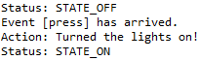
Figure 5 – Executing example 2

Example 3 - A toggle switch
Extending the previous example, when the event press arrives at STATE_ON, the state is moved back to STATE_OFF.

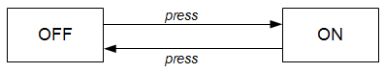
Figure 6 – The state diagram of a toggle switch
So we have a second transition from STATE_ON to STATE_OFF. For this transition we define a new action to be performed.
public class TurnLightsOffAction extends AbstractAction {
@Override
public void execute(StateContext context) throws ActionException {
System.out.println("Action: Turned the lights off!");
}
}

<bean id="actionTurnLightsOff"
class=" gr.ekt.fsmengine.example3.TurnLightsOffAction" />

<bean id="transitionB" class="gr.ekt.fsmengine.api.DefaultTransition">
<property name="fromState" ref="stateOn" />
<property name="toState" ref="stateOff" />
<property name="actions">
<list>
<ref bean="actionTurnLightsOff"/>
</list>
</property>
</bean>

The complete declaration is under conf/context-example3.xml.

Run src/test/java/gr.ekt.fsmengine.example3.Run to see the execution flow.

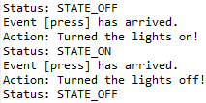
Figure 7 – Execution of example 3

Example 4 - A toggle switch (updated)
Extending the previous example, the two actions are merged into one.
TurnLightsOffAction + TurnLightsOnAction = TurnLightsAction
The new action decides whether to switch the lights on or off based on the current state.
public void execute(StateContext context) throws ActionException {
Switch powerSwitch = (Switch) stateContext;
if (powerSwitch.isOn()) {
System.out.println("Action: Turned the lights off!");
} else {
System.out.println("Action: Turned the lights on!");
}
}

This is possible because the action has access to the state context.
The complete declaration is under conf/context-example4.xml.
Run src/test/java/gr.ekt.fsmengine.example4.Run to see the execution flow.
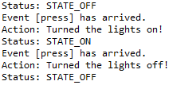
Figure 8 – Executing example 5

Example 5 - An order
In this more complex example we would like to monitor an Order.

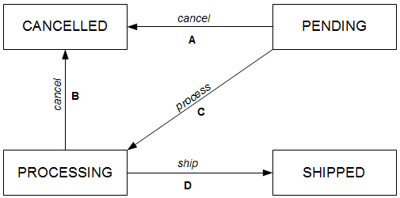
Figure 9 – The state diagram of an Order
The state diagram consists of the following elements:
States
- STATE_CANCELLED
- STATE_PROCESSING
- STATE_SHIPPED

Event
- EVENT_CANCEL
- EVENT_PROCESS
- EVENT_SHIP
Transition
- A: from STATE_PENDING to STATE_CANCELLED
- B: from STATE_PROCESSING to STATE_CANCELLED
- C: from STATE_PENDING to STATE_PROCESSING
- D: from STATE_PROCESSING to STATE_SHIPPED

The complete declaration is under conf/context-example5.xml.
Run src/test/java/gr.ekt.fsmengine.example5.Run to see the execution flow.

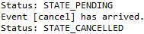
Figure 10 – An order that was immediately cancelled

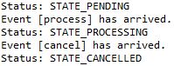
Figure 11 – A pending order that was finally cancelled

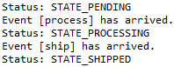
Figure 12 – An order that was shipped

Known Limitations and Future Work

Intrusiveness
With the current implementation, a client application needs quite a few changes in order to take advantage of the FSM Engine. In a future version, the API should be improved so that the FSM Engine becomes less intrusive and can be integrated into an existing application with the least changes possible in the client source code (e.g. by using Java annotations, aspect-oriented programming, metaprogramming if integrating with other languages running on the JVM such as Groovy, etc.).

Branch Robustness
Branches are used as containers of Transitions and implement the same interface with Transitions (StateChanger) so that they can be used interchangeably and transparently to the client code. Normally, only one of the Transitions contained in a Branch should be actually executed each time and this is determined by the GuardConditions configured for those Transitions. Currently however, this behavior cannot be enforced programmatically and therefore it is up to the client code to ensure that only one Transition is executed each time by having only one GuardCondition evaluating to true. In a future version this should be improved by at least providing a proper warning to the client if not entirely prohibiting it (if it is decided that there is no point providing this kind of flexibility, that is), thus preventing nasty surprises and making the Branch model more robust.

http://www.wisdom.weizmann.ac.il/~dharel/papers/Statecharts.pdf
http://en.wikipedia.org/wiki/State_pattern
http://www.ekt.gr/en/

