Tips for this project

A set of tips I learned while making this project, it is modified along the way, so it stays updated.

Scraping:

- The key to a clean project structure is to separate each set of operations in separate folders, each operation in a separate file, and each action in separate function.
- Think about using helper functions to treat possible exceptions instead of writing “if” statements manually inside the main function.
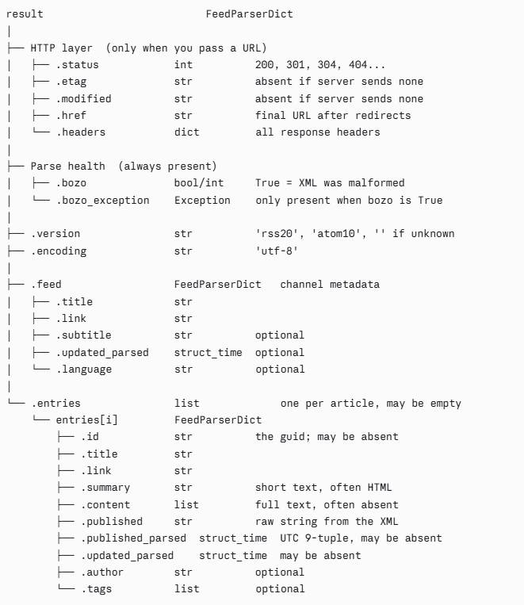
- In this project I used feedparser library and knowing the expected output helps a lot to know how to build the pipeline, the following schema is made with claude and it showcases when something shows what and why:

- The steps followed to scrape the news are:

- Writing Urls as values and the names as keys of the news websites in a json file.
- Coding a script that verifies the state of each website by using the Urls of the previous json file and storing the link as key and the state, etag, modified attribute as values.
- Coding a script that stores the content of each article, the shape and how the result looks can be changed depending on what we are looking for.

