**Step by Step Instructions to Download and Install ISIM**

Martín Cicowiez

This version: July 20, 2021

## 1. Software Requirements

In order to use ISIM, the user needs a PC running **Windows** with Excel 2010 or newer, and GAMS distribution 24.3 or newer with the PATH solver installed – along with a valid license file. In addition, notice that you will require administrative rights to install the software.

The last version of the GAMS software can be downloaded from <http://www.gams.com/download/>.

To install GAMS, run the installation file and follow the screen messages; also, note that

* depending on your version of Excel 2010 or newer select one of the following files -- users of Excel 2007 should install the 32 bits version of GAMS:
* 32 bits version (windows_x86_32.exe)
* 64 bits version (windows_x64_64.exe)
* the installation may require administrative privileges on your computer
* you will be asked for the GAMS license file (gamslice.txt) during the installation; browse the file system and find the license file gamslice.txt that you must have; for detailed instructions visit <http://support.gams.com/doku.php?id=02g5ku>

## 2. Downloading ISIM

Currently, there are two versions of ISIM, 32 and 64 bits. The user should install the one that matches his/her version of Excel 2010 or newer.

* To determine which version of Excel 2010 you have installed, open Excel 2010 and go to **File | Help**. The information can be found on the right-hand side of the screen below the “About Microsoft Excel” legend.
* to determine which version of Excel 2013 or newer you have installed, open Excel 2013 and go to File | Account | About Excel. The information can be found on the top of the screen.

(For additional details, see http://kb.jetreports.com/article/AA-00722/0/How-todetermine-whether-you-have-32-bits-or-64-bits-Excel.html.) Notice that what is relevant is the version of Office you are using, not the version of Windows. The ISIM installation files can be downloaded from

**32 bits**

<https://github.com/EL-BID/Open-IEEM/blob/main/IM-2021-07-20-Office32bits.zip>

**64 bits**

<https://github.com/EL-BID/Open-IEEM/blob/main/IM-2021-07-20-Office64bits.zip>

## 3. Installation

ISIM software is distributed as a zip file that contains a setup file. To install the software, (1) create a new folder (for example, C:\Temp), (2) unzip the file **IM-yyyy-mm-dd-Office32bits.zip** or **IM-yyyy-mm-dd-Office64bits.zip** into that folder, and (3) run the file setup.exe (see Figure 1 and Figure 2). In general, an Internet connection is required to automatically update some Windows and/or Office components.

Figure 1: ISIM installation file

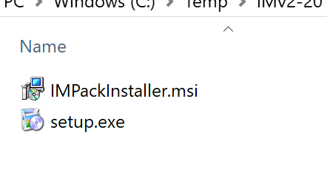

Figure 2: Starting ISIM Installation

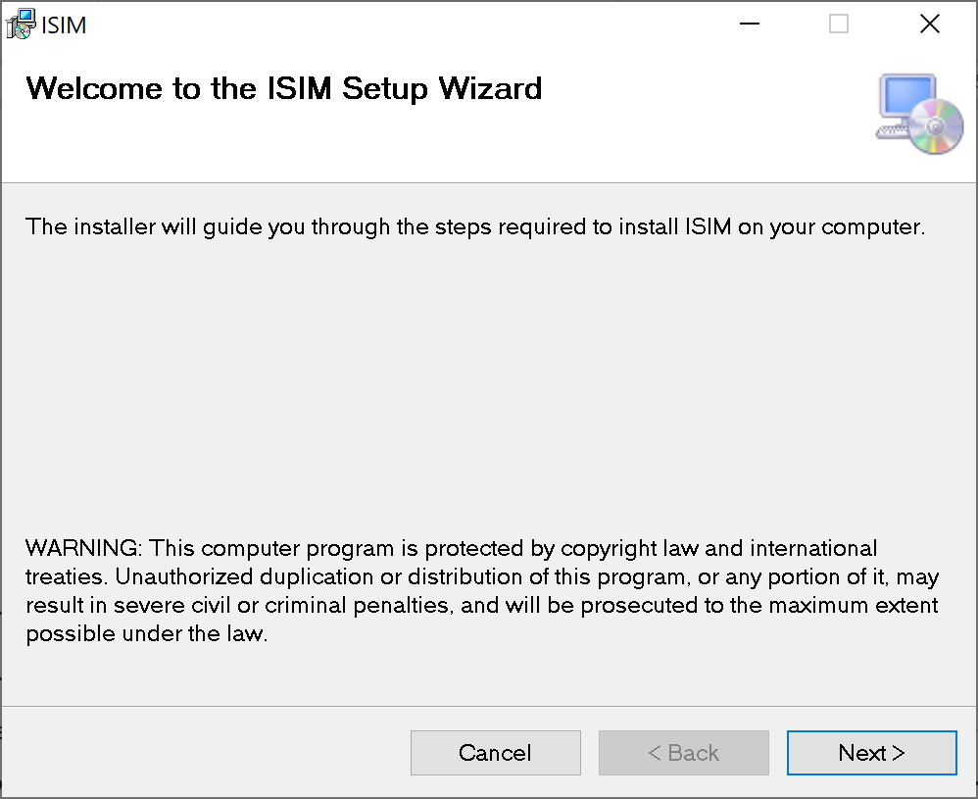

In case the installation process detects the presence of an older version of ISIM, the installer will stop and will ask the user to (a) repair ISIM, or (b) remove ISIM (see Figure 3). To install the new version, select the first option. To uninstall the software, the **Control Panel** | **Programs and Features** option in Windows can also be used.

Figure 2: message in case an existing version of ISIM is detected

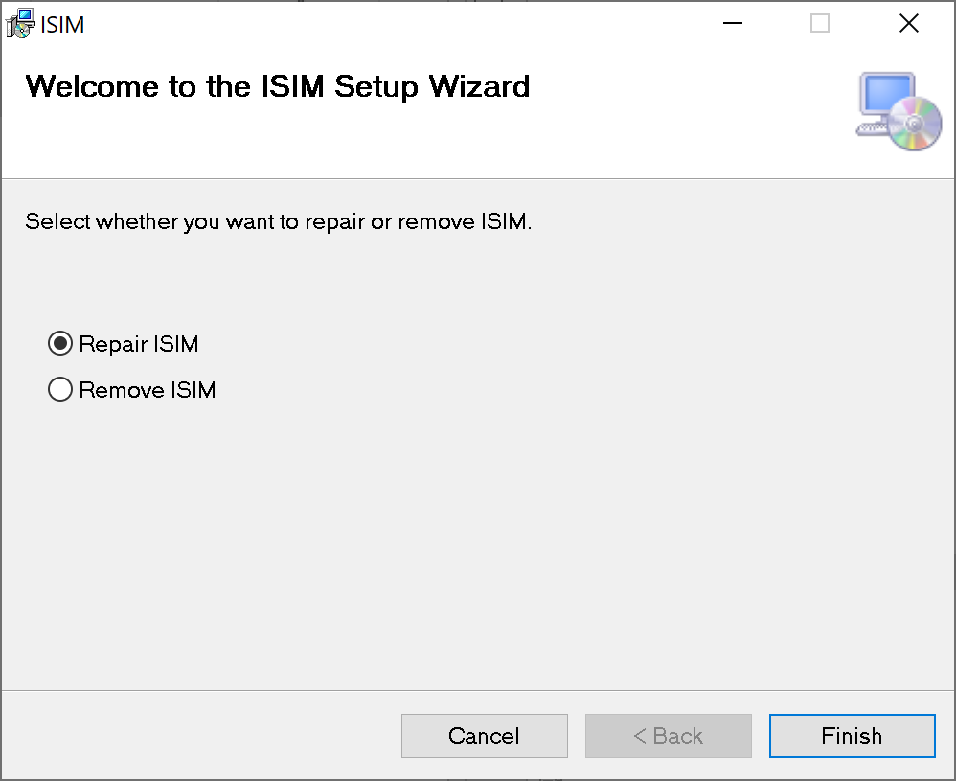

In case needed, the installation process will connect to the Internet to download the “Visual Studio Tools for the Office System 3.0 Runtime”, an Office component that is needed to execute Office add-ins or customizations. The user will be asked to restart Excel once ISIM in installed.

Once finished, an ISIM tab will be added to Excel 2010 or newer (see Figure 3). Please let us know if this is not the case.

Figure 3: the ISIM tab in Excel

