**Smart Home**

For

**AVR** Microcontroller

AT-mega 32

**Software Requirement Specification Document**

Table of Contents

1. Scope of Document .......................................................................... 2

2. Functional Overview.......................................................................... 2

2.1 Intended Audience…………………………………………………………………… 2

2.2 Product Scope………………………………………………………………………… 2

2.3 Overall Description………………………………………………………………….. 2

3. Requirement Specification................................................................ 3

3.1 Functional Requirements................................................................ 3

3.2 Non-functional requirements.......................................................... 4

4. State Machine.................................................................................. 4

5. Acceptance Criteria.......................................................................... 5

**Version: 1st**

# Scope of Document

The purpose of this document is to present a detailed description of the Smart Home System. It will explain the purpose and features of the system, interfaces, and what the system will do considering some constraints with how the system will react to them.

# Functional Overview

## 2.1 Intended Audience

Real estate owners

## 2.2 Product Scope

This software will be a Smart Home Control System that contains sub systems such as Fire Alarm System, Control system on LEDS, Window by servo motor and LCD and Smart light Control system. This system will be designed to maximize the comfortable living.

## 2.3 Overall Description

The control system has 1 active actor (owner) and 2 modes. First system control on led, window and lcd by send command by UART Communication protocol to controller by Bluetooth from owner’s mobile to turn on or off Ledes or send number to write on LCD or control on servo motor which control on window and the second system smart light control system which require threshold of brightness to turn on or off blue led to adjust it.

# Requirements Specification

## 3.1 Functional Requirements

|  |  |
| --- | --- |
| Use Case Name | Fire Alarm System |
| Trigger | Periodic invocation by system |
| Pre-Condition | All sensors are activated. |
| Post-Condition | Invoice owner with the state of the Process. |
| Basic Path | This use case should read temperature from temperature sensor if it low than 50 c will display “Fine” and update temperature on lcd. if the temperature increases to above 50 c with 10% hysteresis display ” Heat” and turn on alarm led present on “yellow led” and read smoke sensor if above 40% turn on fire led present on “red led” and turn on “buzzer “ and display “Fire”.  NOTE : The temp reversible with 10% hysteresis and smoke unreversible. |
| Alternative Path | None |
| Exception Path | None |

|  |  |
| --- | --- |
| Use Case Name | Wireless Control System using Bluetooth module |
| Trigger | Periodic invocation by system |
| Pre-Condition | None |
| Post-Condition | None |
| Basic Path | Receive specific commands from owner by UART communication protocol by through Bluetooth module to turn on or off 4 Ledes by send command like “LEDON 1#” or “LEDOFF 2#” to “LEDON 3#”  or Control on window by servo motor by send command like “SERVO 45#” the degree from 0 to 180.  or Display number on lcd by send command  “LCD 679#” |
| Alternative Path | None |
| Exception Path | None |

|  |  |
| --- | --- |
| Use Case Name | Smart Light Control System |
| Trigger | Owner turns on Smart Light Control Mode by button |
| Pre-Condition | LDR sensor activated and adjust threshold of brightness. |
| Post-Condition | None |
| Basic Path | Wait to Take threshold of brightness from user and compare it with the actual brightness to turn on or off blue led and can edit threshold by button |
| Alternative Path | None |
| Exception Path | None |

## 3.2 Nonfunctional Requirements

* The control system should be well-tested.
* The control system shall be reliable and robust.
* The control system shall be efficient and use minimal resources.

# State Machine

Fire Alarm System

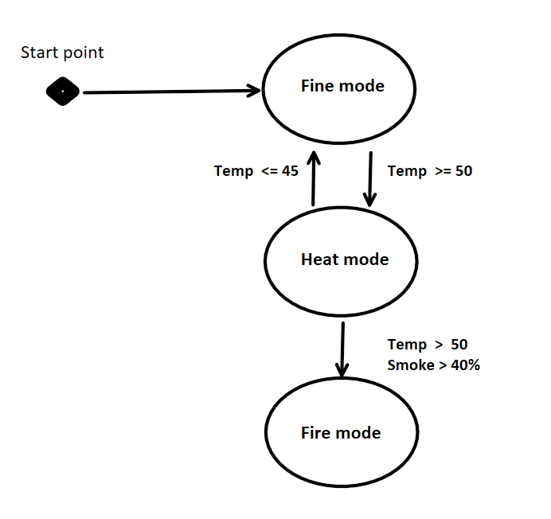

# Acceptance Criteria

The Smart Home control System shall be accepted when it meets the following criteria:

* The Program shall compile and run without errors and warnings.
* Each component shall pass the unit test.
* Each component shall pass the integration test.
* The Program shall pass all system tests.