|  |
| --- |
| [(4,8),(4,3),(4,3),(10,3),(13,3),(13,8),(13,8);(-1,5),(-4,11),(2,18),(2,18),(2,18),(8,6);(17,14),(9,9),(14,5),(17,14);(-13,-1),(-6,3),(2,-11),(-5,-15),(-9,-8),(-9,-8);(7,-14),(4,-17),(4,-17),(-1,-14),(-2,-9),(3,-6),(10,-7),(6,-11);(-7,12),(-6.5,13),(3,4),(3,4),(-8,10);(19,-8),(19,-8),(16,-3),(10,-4),(7,-8),(10,-11),(13,-8),(14,-12),(19,-8),(19,-8);(7,-4),(5,-5),(3,-6),(5,-1);(3,-6),(1,-2),(-1,-4)] |

|  |  |
| --- | --- |
| Operation | **output** |
| Number_Polygons | **9** |
| Total_Number_Points | **53** |
| Minimum_X | **-13** |
| Maximum_X | **19** |
| Minimum_Y | **-17** |
| Maximum_Y | **18** |
| Enclosing_Rectangle | **[(-13,18),(19,18),(19,-17),(-13,-17)]** |
| Total_Redundant_Points | **15** |
| Quit | **End program** |
| Polygon_Points 1 | **(4,8),(4,3),(13,3),(13,8)** |
| Polygon_Points 4 | **(-13,-1),(-6,3),(2,-11),(-5,-15)** |
| Polygon_Points 5 | **(7,-14),(4,-17),(-1,-14),(-2,-9),(3,-6),(10,-7),(6,-11)** |
| Polygon_Points 7 | **(19,-8),(16,-3),(10,-4),(7,-8),(10,-11),(13,-8),(14,-12)** |
| Point_Polygons (3,-6) | **5,8,9** |
| Point_Polygons (9,9) | **3** |
| Point_Polygons (-9,-8) | **4** |
| Point_Polygons (-91,-80) | **none** |
| List_Polygons_Points More 3 | **1,2,4,5,7** |
| List_Polygons_Points Less 7 | **1,2,3,4,6,8,9** |
| List_Polygons_Points Equal 7 | **5,7** |
| List_Points_Polygons More 3 | **none** |
| List_Points_Polygons More 2 | **(3,-6)** |
| List_Points_Polygons Less 3 | **(4,8),(4,3),(13,3),(13,8),(-1,5),(-4,11),(2,18),(8,6),(17,14),(9,9),(14,5),(-13,-1),(-6,3),(2,-11),(-5,-15),(7,-14),(4,-17),(-1,-14),(-2,-9),(10,-7),(6,-11),(-6.5,13),(3,4),(-8,10),(19,-8),(16,-3),(10,-4),(7,-8),(10,-11),(13,-8),(14,-12),(7,-4),(5,-1),(1,-2),(-1,-4)** |
| List_Points_Polygons Equal 3 | **(3,-6)** |
| Polygon_Perimeter 1 | **28** |
| Polygon_Perimeter 2 | **38.3995** |
| Polygon_Perimeter 6 | **28.9703** |
| Polygon_Perimeter 5 | **36.8938** |
| List_Triangles | **3,6,8,9** |
| List_Rectangles | **1,4** |
| List_Trapezoid | **2** |
| Inside_Rectangle (-4,-4),(12,-4),(12,-13),(-4,-13) | **none** |
| Inside_Rectangle(20,0),(20,20),(-9,20),(-9,0) | **1,2,3,6** |
| Inside_Rectangle (0,-11),(11,0),(0,11),(-11,0) | **9** |
| Inside_Rectangle (0,-9),(9,0),(0,9),(-9,0) | **8,9** |
| Inside_Circle (7,11),4 | **none** |
| Inside_Circle (7,5),10 | **1** |
| Inside_Circle (0,0),15 | **6,8,9** |
| Polygon_Area 1 | **45** |
| Polygon_Area 6 | **21** |
| Polygon_Area 4 | **130** |
| Polygon_Area 8 | **8** |
| Polygons_Area_Range 10,50 | **1,3,6** |
| Polygons_Enclosing_Point (5,7) | **1,2** |
| Polygons_Enclosing_Point (0,-10) | **4,5** |
| Polygons_Enclosing_Point (3,-6) | **5,8,9** |
| Polygons_Enclosing_Point (97,-60) | **none** |
| Polygons_Enclosing_Point (10,3) | **1** |
| Is_Intersecting 1,6 | **FALSE** |
| Is_Intersecting 1,3 | **TRUE** |
| Is_Intersecting 1,2 | **TRUE** |
| Is_Intersecting 2,3 | **FALSE** |
| Intersecting_Group 5,8,9 | **TRUE** |
| Intersecting_Group 4,5,7 | **FALSE** |
| Intersecting_Group 5,8,9,7,4 | **FALSE** |
| Intersecting_Group 5,8 | **TRUE** |
| Largest_Intersecting_Pair | **4,5** |
| Is_Connected 2,3 | **TRUE** |
| Is_Connected 4,7 | **TRUE** |
| Is_Connected 1,6 | **TRUE** |
| Is_Connected 1,9 | **FALSE** |
| Is_Connected 5,7 | **TRUE** |
| Is_Connected 5,6 | **FALSE** |
| Is_Connected_Group 4,5,7 | **TRUE** |
| Is_Connected_Group 4,5,7,8,9 | **TRUE** |
| Is_Connected_Group4,5,7,8,9,1 | **FALSE** |
| Is_Connected_Group 1,6,2,3 | **TRUE** |
| Is_Connected_Group 1,6,2,5 | **FALSE** |
| Maximum_Intersecting_Group | **5,9,8** |
| Maximum_Connected_Group | **4,5,7,8,9** |

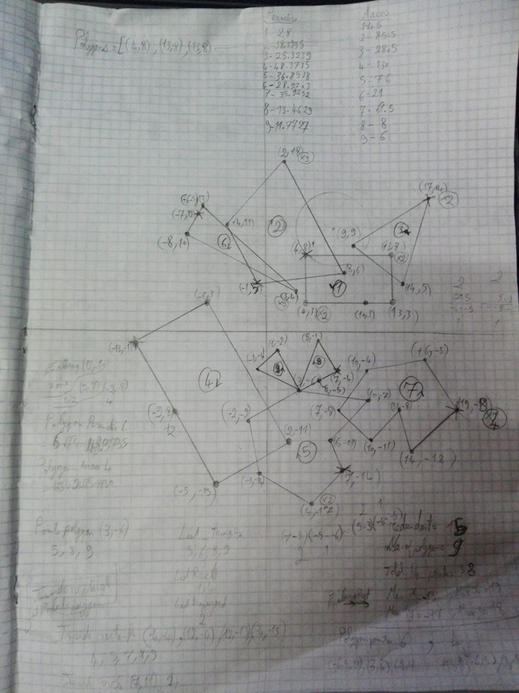

The drawing of the example

Another example

|  |
| --- |
| [(1,1),(2,2),(1,3),(0,2);(0,1),(3,3),(1,6),(-2,4);(2,3),(5,3),(4,8);(7,7),(6,8),(4,11),(3,10),(2,5),(3,3),(3,3),(5,5),(5,5),(7,7);(4,5),(7,8),(6,11),(3,8);(2,6),(5,8),(5,13),(1,11);(0,6),(2,10),(2,12),(-1,13),(-2,11),(-2,7);(-5,5),(-1,5),(-1,10),(-1,10),(-5,12);(-4,4),(-1,8),(-2,10),(-4,4);(-5,3),(-3,3),(-1,3),(-3,7),(-5,6);(-2,-1),(-4,-4),(-4,-7),(-2,-9),(-2,-4),(-2,-1);(-2,-7),(-4,-10),(-1,-12);(-1,-6),(-3,-6),(-2,-9),(1,-11),(3,-6),(0,-6),(-1,-6);(1,-9),(4,-2),(7,-5),(4,-11);(5,-5),(1,-3),(4,1),(7,2),(7,-6);(-1,1),(-2,2),(3,5),(4,4)] |

|  |  |
| --- | --- |
| Operation | **output** |
| Number_Polygons | **16** |
| Total_Number_Points | **78** |
| Minimum_X | **-5** |
| Maximum_X | **7** |
| Minimum_Y | **-12** |
| Maximum_Y | **13** |
| Enclosing_Rectangle | **[(-5,13),(7,13),(7,-12),(-5,-12)]** |
| Total_Redundant_Points | **13** |
| Quit | **End program** |
| Polygon_Points 16 | **(-1,1),(-2,2),(3,5),(4,4)** |
| Polygon_Points 4 | **(7,7),(6,8),(4,11),(3,10),(2,5),(3,3)** |
| Polygon_Points 13 | **(-3,-6),(-2,-9),(1,-11),(3,-6)** |
| Point_Polygons (3,3) | **2,4** |
| Point_Polygons (5,5) | **4** |
| List_Polygons_Points More 3 | **1,2,4,5,6,7,8,10,11,13,14,15,16** |
| List_Polygons_Points Less 6 | **1,2,3,5,6,8,9,10,11,12,13,14,15,16** |
| List_Points_Polygons More 2 | **none** |
| List_Points_Polygons Less 1 | **none** |
| List_Triangles | **3,9,12** |
| List_Rectangles | **1,2** |
| List_Trapezoid | **8,11** |
| Inside_Rectangle (9,2),(16,2),(16,-8),(9,-8) | **none** |
| Inside_Rectangle (-5,8),(6,8),(6,2),(-5,2)) | **3,10** |
| Inside_Rectangle (1,2),(1,9),(6,9),(6,2) | **3** |
| Inside_Rectangle (-5,3),(-5,13),(6,13),(6,3) | **3,6,7,8,9,10** |
| Inside_Circle (1,2),5 | **1,2,16** |
| Inside_Circle (0,-2),12 | **1,2,3,10,11,12,13,14,15,16** |
| Polygon_Area 3 | **7.5** |
| Polygon_Area 4 | **20.5** |
| Polygon_Area 16 | **8** |
| Polygon_Area 1 | **2** |
| Polygons_Area_Range 3,20 | **2,3,5,6,9,10,11,12,13,16** |
| Polygons_Enclosing_Point (-2,8) | **7,8,9** |
| Polygons_Enclosing_Point (-1,5) | **8** |
| Polygons_Enclosing_Point (4,8) | **3,4,5,6** |
| Polygons_Enclosing_Point (1,3) | **1,2,16** |
| Polygons_Enclosing_Point (-2,-3) | **11** |
| Polygons_Enclosing_Point (-2,-6) | **11,13** |
| Polygons_Enclosing_Point (-2,-7) | **11,12,13** |
| Polygons_Enclosing_Point (-1,-11) | **none** |
| Polygons_Enclosing_Point (1,6) | **2** |
| Polygons_Enclosing_Point (-1,3) | **2,10** |
| Polygons_Enclosing_Point (1,8) | **7** |
| Polygons_Enclosing_Point (7,-5) | **14,15** |
| Polygons_Enclosing_Point (-3,3) | **10** |
| Polygons_Enclosing_Point (5,-4) | **14,15** |
| Is_Intersecting 1,3 | **FALSE** |
| Is_Intersecting 1,2 | **TRUE** |
| Is_Intersecting 2,16 | **TRUE** |
| Is_Intersecting 1,15 | **FALSE** |
| Is_Intersecting 6,4 | **TRUE** |
| Is_Intersecting 7,10 | **FALSE** |
| Intersecting_Group 3,4,5,6 | **TRUE** |
| Intersecting_Group 6,7,8 | **FALSE** |
| Intersecting_Group 6,7 | **TRUE** |
| Intersecting_Group 7,8,9 | **TRUE** |
| Intersecting_Group 16,2,10 | **FALSE** |
| Intersecting_Group 11,12,13 | **TRUE** |

Drawing of this example:

