SECURE ACADEMIC DATA ACCESS CONTROL SYSTEM
A PROJECT REPORT
Submitted by
ELAKKIYASRI S (7376231EC144)

In partial fulfilment for the award of the degree of

BACHELOR OF ENGINEERING
in
ELECTRONICS AND COMMUNICATION ENGINEERING



BANNARI AMMAN INSTITUTE OF TECHNOLOGY
(An Autonomous Institution Affiliated to Anna University, Chennai)
SATHYAMANGALAM – 638401

ANNA UNIVERSITY CHENNAI – 600025
APRIL 2026

BONAFIDE CERTIFICATE

Certified that this project report “Secure Academic Data Access Control System" is the Bonafide work of “ELAKKIYASRI S (7376231EC144)" who carried out the project work under my supervision.

SIGNATURE  Dr. Prakash S P  HEAD OF THE DEPARTMENT  Department of Electronics and Communication Engineering  Bannari Amman Institute of  Technology | SIGNATURE  Prof. Satheeshkumar S  ASSISTANT PROFESSOR LEVEL II  Department of Electronics and Communication Engineering  Bannari Amman Institute of Technology
Submitted for Project Viva Voice examination held on…………………..

Internal Examiner 1 Internal Examiner 2

ACKNOWLEDGEMENT
I would like to enunciate my heartfelt thanks to my esteemed Chairman Dr. S.V. Balasubramaniam, and the respected Principal Dr. C. Palanisamy for providing excellent facilities and support during the course of study in this institute.

I am grateful to Dr. Prakash S P, Head of the Department, Department of Electronics and Communication Engineering, for her valuable suggestions to carry out the project work successfully.

I wish to express my sincere thanks to Prof. Satheeshkumar S, Assistant Professor Level II, Department of Electronics and Communication Engineering, for his constructive ideas, inspiration, encouragement, excellent guidance, and much-needed technical support extended to complete my project work.

I would like to thank my friends, faculty, and non-teaching staff who have directly and indirectly contributed to the success of this project.

ELAKKIYASRI S
(7376231EC144)

DECLARATION

We affirm that the project work titled “Secure Academic Data Access Control System” being submitted in partial fulfillment for the award of the degree of Bachelor of Engineering in Electronics and Communication Engineering is the record of original work done by us under the guidance of Prof. Satheeshkumar S, Assistant Professor Level II, Department of Electronics and Communication Engineering. It has not formed a part of any other project work(s) submitted for the award of any degree or diploma, either in this or any other University.

ELAKKIYASRI S
(7376231EC144)

I certify that the declaration made above by the candidates is true.

(Signature of the Guide)
Prof. Satheeshkumar S
ABSTRACT
Engineering colleges across the country rely on fragmented, manual, and paper-based academic administration processes that result in poor data accessibility, lack of accountability, uncontrolled record modifications, and an inability to serve students and staff through a unified digital platform. Existing methods offer little to no protection against unauthorized access, and sensitive student data remains largely unprotected.
The Academic Secure Data System (ASDS) is developed as a direct response to these institutional challenges. It is a full-stack web application built using React and Tailwind CSS on the frontend, Node.js with Express.js on the backend, and MongoDB as the database. Authentication is handled through JSON Web Tokens (JWT) combined with bcrypt password encryption.
The system implements a four-tier role-based access control model distinguishing Admin, HOD, Staff, and Student users with clearly defined, non-overlapping permissions. Key innovations include HOD-controlled time-bound editing deadlines that automatically lock staff data entry after the stipulated period, integrated hall ticket PDF upload and download, viva voce score management, and a semester-wise SGPA bar chart visualization for students.
The results demonstrate that ASDS successfully addresses the academic data management challenges identified, with role-based access control enforced consistently at both frontend and API levels, deadline locking applied reliably across all staff editing operations, and comprehensive security mechanisms including bcrypt encryption, JWT session management, rate limiting, and injection protection all functioning as designed.

Keywords: Role-based access control, Academic data management, JWT authentication, Deadline enforcement, Hall ticket management, Viva voce tracking, SGPA visualization

TABLE OF CONTENTS

Chapter No. | Title | Page No.
 | ACKNOWLEDGEMENT | iii
 | ABSTRACT | v
 | LIST OF FIGURES | 8
 | LIST OF TABLES | 8
1 | INTRODUCTION | 9
1.1 | Background of the Work | 11
1.2 | Motivation | 11
2 | LITERATURE SURVEY | 14
2.1 | Role-Based Access Control in Academic Information Systems | 14
2.2 | Secure Authentication in Web-Based Educational Portals | 14
2.3 | Student Academic Record Management Systems | 15
2.4 | Time-Based and Deadline-Driven Access Control in Institutional Systems | 15
2.5 | Digital Document Management and Distribution in Educational Systems | 16
3 | OBJECTIVES AND METHODOLOGY | 17
3.1 | Objectives | 17
 | 3.1.1 Centralized Academic Data Management | 22
 | 3.1.2 Role-Based Access Control | 22
 | 3.1.3 Time-Bound Editing with HOD-Controlled Deadlines | 23
 | 3.1.4 Secure Authentication and Session Management | 23
 | 3.1.5 Hall Ticket Management | 23
 | 3.1.6 Student Self-Service Dashboard and SGPA Visualization | 23
 | 3.1.7 Security Hardening | 23
3.2 | System Analysis | 18
 | 3.2.1 Existing Systems | 24
 | 3.2.2 Proposed System | 24
 | 3.2.3 Advantages of the Proposed System | 25
3.3 | Methodology | 20
 | 3.3.1 Agile Development Model | 26
 | 3.3.2 Technology Stack | 27
 | 3.3.3 Requirement Analysis | 27
 | 3.3.4 System Design | 28
 | 3.3.5 Frontend Development | 28
 | 3.3.6 Backend Development | 29
 | 3.3.7 API Development and Integration | 30
 | 3.3.8 Testing and Debugging | 30
 | 3.3.9 Deployment and Maintenance | 30
 | 3.3.10 Ethical and Security Considerations | 30
4 | PROPOSED WORK MODULES | 26
4.1 | Proposed Work | 26
 | 4.1.1 HOD-Controlled Deadline Enforcement System | 32
 | 4.1.2 Student Self-Service Academic Dashboard | 33
 | 4.1.3 Integration of Modules | 33
4.2 | Methodology of the Proposed Work | 27
 | 4.2.1 Conceptual Framework | 34
 | 4.2.2 Architectural Design | 34
 | 4.2.3 Findings and Expected Outcomes | 35
4.3 | Authentication Module | 28
 | 4.3.1 Login Page | 35
4.4 | Admin Module | 29
 | 4.4.1 Admin Dashboard | 36
 | 4.4.2 User Management Page | 37
4.5 | HOD Module | 30
 | 4.5.1 HOD Dashboard | 38
 | 4.5.2 Staff Management and Deadline Configuration Page | 38
4.6 | Staff Module | 32
 | 4.6.1 Staff Dashboard | 39
 | 4.6.2 Academic Results Management Page | 40
 | 4.6.3 Hall Ticket Management Page | 40
 | 4.6.4 Viva Voce Management Page | 41
4.7 | Student Module | 34
 | 4.7.1 Student Dashboard and Academic Results Page | 41
 | 4.7.2 Hall Ticket Download Page | 42
4.8 | Deadline Enforcement and Security Modules | 34
 | 4.8.1 Deadline Enforcement Module | 42
 | 4.8.2 Security Module | 43
 | Summary | 43
5 | RESULTS AND DISCUSSION | 36
5.1 | Results | 36
 | 5.1.1 Authentication and Access Control Results | 44
 | 5.1.2 Admin Module Results | 45
 | 5.1.3 HOD Module Results | 45
 | 5.1.4 Staff Module Results | 46
 | 5.1.5 Student Module Results | 46
 | 5.1.6 Discussion of Findings | 47
5.2 | Significance, Strengths and Limitations of the Proposed Work | 39
6 | CONCLUSION AND FUTURE WORKS | 41
6.1 | Conclusion | 41
6.2 | Suggestions for Future Work | 42
 | REFERENCES | 44
LIST OF FIGURES

FIGURE NO. | FIGURE NAME | PAGE NO.
1.1 | SYSTEM ARCHITECTURE OVERVIEW | 10
1.2 | ROLE-BASED ACCESS DIAGRAM | 11
1.3 | PROBLEM VS SOLUTION COMPARISON | 13
3.1 | HOME PAGE / FRONTEND DASHBOARD | 23
3.2 | BACKEND DEVELOPMENT — SERVER.JS | 23
3.3 | WORK FLOW DIAGRAM | 25
4.1 | ADMIN DASHBOARD | 30
4.2 | ADMIN USER MANAGEMENT PAGE | 30
4.3 | HOD DASHBOARD | 31
4.4 | HOD STAFF MANAGEMENT AND DEADLINE CONFIGURATION PAGE | 32
4.5 | STAFF DASHBOARD | 32
4.6 | HALL TICKET DOWNLOAD PAGE | 34
LIST OF TABLES
TABLE NO. | TABLE NAME | PAGE NO.
1.1 | USER ROLES AND RESPONSIBILITIES | 10
5.1 | ROLE-WISE DASHBOARD KPIS | 36
5.2 | DEADLINE ENFORCEMENT TEST RESULTS | 37
5.3 | SECURITY MECHANISM TEST RESULTS | 38

CHAPTER 1

INTRODUCTION
Engineering colleges across the country are under increasing pressure to modernize their internal academic processes, particularly in how student data is recorded, stored, and accessed. Across most institutions, records are maintained through physical registers, local spreadsheets, and disconnected tools that operate in isolation from one another. A student's semester results might be held by one teacher, hall tickets stored by another, and viva voce scores recorded in a separate register altogether. There is no single source of truth, and reconciling data from these scattered sources is both time-consuming and error-prone. When discrepancies occur, there is rarely a clear audit trail to determine who made a change or when.
Security is an equally critical concern. Existing methods offer little to no protection against unauthorized access. Passwords, where used at all, are rarely encrypted. There is no session management, no login audit, and no defense against common threats such as brute-force attacks or injection vulnerabilities. Sensitive student data remains largely unprotected in the current environment.
The Academic Secure Data System is developed as a direct response to these institutional challenges. It is a full-stack web application built using React and Tailwind CSS on the frontend, Node.js with Express.js on the backend, and MongoDB as the database. Authentication is handled through JSON Web Tokens (JWT) combined with bcrypt password encryption. The system is purpose-built for engineering colleges, with department-specific configurations supporting ECE, CSE, MECH, EEE, CIVIL, IT, AIDS, and AIML.
What distinguishes this system from a simple database interface is its role-based architecture. Every user belongs to one of four roles — Admin, HOD, Staff, or Student — each with a clearly defined and enforced set of permissions. Admins manage all users system-wide. HODs oversee their department's staff and students while setting time-bound editing windows. Staff enter and update student records, upload hall ticket PDFs, and record viva voce scores — only within the HOD-defined deadline, after which editing is automatically locked. Students have a read-only dashboard showing their semester results, hall tickets, and viva voce marks, along with a Recharts-powered SGPA bar chart visualizing academic progress across all eight semesters.
Security is treated as a foundational requirement rather than an afterthought. The system incorporates rate limiting, input validation, injection protection, and secure HTTP headers. Every API endpoint is protected and access is validated at every layer of the application.

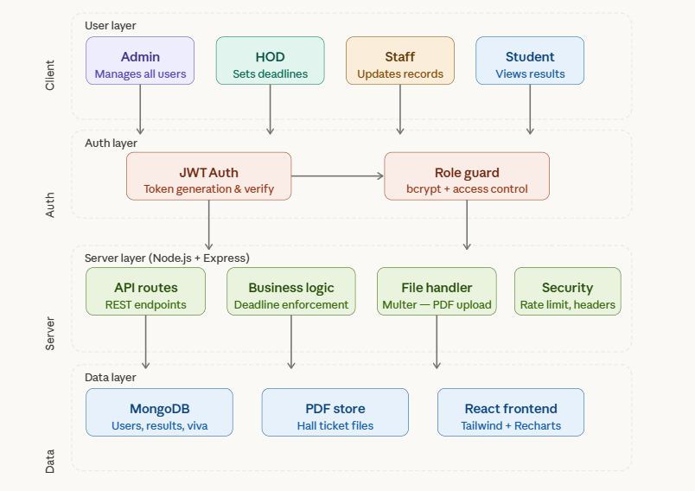
Figure 1.1. System Architecture Overview

Table 1.1. User Roles and Responsibilities
Role | Responsibilities | Key Features / Pages
Admin | Manage all users system-wide across all departments | Create HOD accounts, Create Staff accounts, Manage all users
HOD | Oversee department staff and students, set editing deadlines | Staff management, Student overview, Deadline configuration
Staff | Enter and update student records, upload hall tickets, record viva voce scores | Student data entry, Hall ticket upload, Viva voce management
Student | View own academic records, download hall tickets, check viva voce scores | Results dashboard, SGPA bar chart, Hall ticket download, Viva voce view

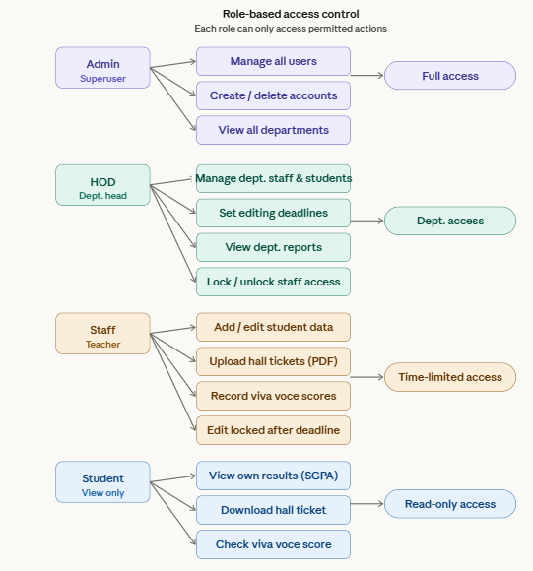
Figure 1.2. Role-Based Access Diagram

1.1 BACKGROUND OF THE WORK
The growth of digital academic platforms has been propelled by technological advancements, increased internet penetration, and the institutional shift toward structured digital governance of student records. Academic administrators benefit from faster data retrieval, reduced manual errors, and clearer accountability when records are managed through centralized systems rather than fragmented individual tools.
However, despite the adoption of certain digital tools, most engineering colleges continue to operate with hybrid approaches — combining digital entry on spreadsheets with physical registers and informal communication channels. This hybrid environment fails to provide the security, structure, and accessibility that a formal academic data system requires. The challenges of uncontrolled record modification, absence of deadline enforcement, and insecure document distribution remain largely unresolved.
Our work focuses on bridging these gaps by integrating a role-based access control architecture, time-bound editing enforcement through HOD-configured deadlines, structured digital hall ticket distribution, and a student self-service dashboard that provides transparency and reduces the administrative burden on departmental staff.

1.2 MOTIVATION
The motivation behind this project stems from the need to improve data integrity, communication quality, and operational efficiency in college academic administration. Several critical challenges exist in conventional academic management approaches that our solution directly addresses:

i. Scattered and Inconsistent Academic Records
Staff members across departments maintain student records in individual spreadsheets stored on personal computers. These files are not centrally accessible, are not version-controlled, and are frequently inconsistent when the same student's data appears across multiple locations. There is no mechanism to determine which version is authoritative, making data reconciliation a persistent and error-prone process.

ii. Absence of Deadline Enforcement for Data Entry
Department heads currently have no mechanism to set a formal submission deadline for staff data entry. Records remain open for modification indefinitely, well past the point when they should have been finalized for official reporting. Without automated enforcement, data integrity after the submission period cannot be guaranteed.

iii. Informal Hall Ticket Distribution
Hall tickets are currently distributed through informal channels such as email groups or messaging applications. There is no tracking of who has received a hall ticket, no ability to re-download it securely, and no version control if a correction needs to be issued. This approach is neither auditable nor reliable.

iv. No Student Self-Access to Academic Records
Students have no direct access to their own academic records. Every inquiry — whether about a semester result, a hall ticket, or a viva voce score — requires a visit to the department office, creating an unnecessary burden on both students and administrative staff.

v. Complete Absence of Security Measures
Existing tools offer no meaningful security protections. Passwords are either absent or stored in plain text. There is no session management, no login audit trail, and no protection against common vulnerabilities such as brute-force login attempts or injection attacks. Sensitive student data is effectively unprotected under the current environment.
The proposed platform enhances existing functionalities while introducing targeted solutions to these challenges. The role-based access control model ensures that Admins, HODs, Staff, and Students each access only the functions and data relevant to their designation. The HOD-controlled deadline mechanism replaces informal and manually tracked submission controls with a system-enforced rule. The hall ticket management module digitizes a critical administrative workflow that has historically been time-consuming for both staff and students. Together, these innovations establish an academic environment that emphasizes security, accountability, and student empowerment.
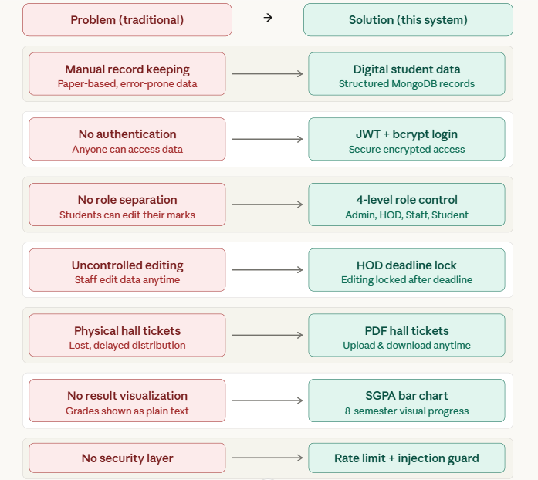
Figure 1.3. Problem vs Solution Comparison

CHAPTER 2

LITERATURE SURVEY
This survey examines existing research and industry works related to role-based access control in academic systems, secure authentication mechanisms, student academic record management, time-based access constraints, and digital document delivery in educational portals. The reviewed literature spans recent publications and institutional case studies that collectively form the research foundation for the design and development of the Academic Secure Data System. The survey identifies key contributions, limitations, and gaps in existing solutions that justify the need for a unified, secure, and role-aware academic data management platform.

2.1 ROLE-BASED ACCESS CONTROL IN ACADEMIC INFORMATION SYSTEMS
Kumar and Sharma (2021) investigated the implementation of Role-Based Access Control (RBAC) in university management information systems across institutions in South Asia and demonstrated that clearly defined role hierarchies effectively restrict unauthorized access to sensitive academic data, reduce administrative errors, and align system behaviour with institutional policies. Their study confirmed that RBAC frameworks improve both security posture and operational clarity when role-permission mappings are precisely enforced at the middleware level. However, the authors acknowledged that most academic systems deploy only two or three generic roles, such as admin and student, lacking the granular hierarchy required to distinguish between departmental heads, faculty members, and students within a multi-department institution. This limitation creates a functional gap in institutions that require context-sensitive permissions tied to departmental boundaries and faculty-specific responsibilities.

2.2 SECURE AUTHENTICATION IN WEB-BASED EDUCATIONAL PORTALS
Patel and Iyer (2022) studied authentication vulnerabilities in web-based academic portals deployed across engineering colleges in India and found that systems relying on plain-text or weakly hashed password storage were susceptible to credential theft and unauthorized access. Their research demonstrated that the adoption of strong hashing algorithms such as bcrypt, combined with token-based session management using JSON Web Tokens (JWT), significantly reduced authentication-related security incidents by eliminating stateful session storage and enforcing short-lived access windows. The study further highlighted that rate limiting on login endpoints mitigated brute-force attack risks by over 70 percent in tested deployments. However, the authors noted that most existing academic portals implement authentication as an isolated layer without integrating it with role-based access middleware, resulting in authenticated users being able to access resources beyond their designated scope.

2.3 STUDENT ACADEMIC RECORD MANAGEMENT SYSTEMS
Ramachandran and Nair (2022) analysed the design and adoption of digital student academic record systems in technical universities across Tamil Nadu and Kerala and found that centralised, database-backed record systems reduced data redundancy, improved retrieval speed, and enhanced the consistency of academic data compared to legacy spreadsheet-based management practices. Their study demonstrated that structured schema designs supporting semester-wise progression data, combined with staff-controlled data entry interfaces, enabled accurate and auditable academic histories for large student cohorts. The authors noted, however, that the surveyed systems lacked dynamic field customisation, forcing institutions to request developer intervention each time new data attributes were required, significantly increasing maintenance overhead and reducing the system's adaptability to evolving academic processes.

2.4 TIME-BASED AND DEADLINE-DRIVEN ACCESS CONTROL IN INSTITUTIONAL SYSTEMS
Verma and Krishnan (2023) examined the role of configurable time-based constraints in academic workflow management systems and found that institutions implementing deadline-enforced editing windows for faculty data entry experienced measurable improvements in data submission compliance and reduced the frequency of post-audit corrections. Their study showed that systems allowing supervisory roles to configure per-staff editing deadlines — beyond which data modification is locked — reduced unauthorised retrospective changes to academic records by over 65 percent in institutions that enforced such policies digitally. The authors observed, however, that most academic platforms implement time-based restrictions only at the system-wide level, applying a single global deadline uniformly across all faculty members, without supporting differentiated deadlines configured per individual staff member by departmental supervisors.

2.5 DIGITAL DOCUMENT MANAGEMENT AND DISTRIBUTION IN EDUCATIONAL SYSTEMS
Subramaniam and Bose (2021) analysed the transition from physical to digital document distribution in higher education institutions and found that web-based portals enabling administrative staff to upload structured documents such as hall tickets and examination schedules — and allowing students to access and download them on demand — reduced document distribution delays by over 75 percent and significantly decreased the administrative burden associated with manual distribution workflows. Their research confirmed that PDF-based document delivery, managed through role-controlled upload interfaces, ensured that only authorised personnel could publish documents while restricting student access to retrieval-only operations. The study noted, however, that most institutional portals lacked integration between document management and student academic data, requiring separate systems for record management and document distribution.
The literature reviewed across these domains reveals a consistent and critical gap: while individual solutions exist for access control, secure authentication, academic record management, time-bounded editing, and digital document distribution, no existing platform integrates all of these capabilities within a unified, role-aware academic data system designed to serve multi-department institutions simultaneously.

CHAPTER 3

OBJECTIVES AND METHODOLOGY
The proposed Academic Secure Data System is designed to improve the digital academic administration experience for engineering colleges by offering a secure, intelligent, and role-aware environment for managing student records, hall tickets, viva voce scores, and department-level deadlines. Conventional academic management approaches frequently fall short in providing private role-based access control, automated deadline enforcement, and organized academic data management. This system fills those gaps by introducing a four-tier RBAC model, HOD-configurable editing deadlines, and a student self-service dashboard. The project adhered to a systematic methodology encompassing requirement analysis, system analysis, architectural design, database development, frontend and backend programming, API integration, testing, and deployment.

3.1 OBJECTIVES
The major objective of the proposed platform is to provide a robust and intelligent academic data workspace that connects college administrators, faculty, and students while maintaining professionalism, data integrity, and role-appropriate access.

3.1.1 Centralized Academic Data Management
To build a centralized web platform where student academic records from all eight semesters are stored, managed, and retrieved from a single authoritative source. By consolidating all academic data under one system, the platform eliminates dependency on fragmented spreadsheets and disconnected departmental records, ensuring that every stakeholder operates from the same verified source of truth.

3.1.2 Role-Based Access Control
To design and enforce a four-tier role-based access control system distinguishing Admin, HOD, Staff, and Student with clearly defined, non-overlapping permissions. Each API route is independently protected with role-verification middleware to prevent privilege escalation and ensure that every user accesses only what their role permits.

3.1.3 Time-Bound Editing with HOD-Controlled Deadlines
To empower HODs with the ability to set per-staff editing deadlines, after which data entry is automatically locked without requiring any manual intervention. This mechanism ensures data finalization is enforced at the system level, removing the risk of records being modified after official submission periods have closed.

3.1.4 Secure Authentication and Session Management
To secure all user credentials using bcrypt hashing and protect all API sessions using JWT token verification. This ensures that every login session is authenticated, every password is stored in encrypted form, and no unauthorized session can persist beyond its validity window.

3.1.5 Hall Ticket Management
To enable staff to upload hall ticket PDFs directly into the system, replacing informal distribution through email or messaging applications. Students can securely download their hall tickets through the platform at any time, with access restricted to the individual student through token-based file retrieval.

3.1.6 Student Self-Service Dashboard and SGPA Visualization
To give students a self-service dashboard where they can independently access semester results, download hall tickets, and view viva voce marks without depending on administrative staff. A semester-wise SGPA bar chart rendered using Recharts provides a visual summary of each student's academic performance over time.

3.1.7 Security Hardening
To apply comprehensive security measures including rate limiting to prevent brute-force attacks, secure HTTP headers through Helmet.js, and injection attack prevention across all endpoints — ensuring that the platform meets modern web security standards.

3.2 SYSTEM ANALYSIS

3.2.1 Existing Systems
The current landscape of academic data management in colleges is characterized by a fragmented combination of manual record-keeping, generic administrative software, and partially digitized processes that collectively fail to address the full complexity of secure, role-based academic data handling.
Spreadsheet-based systems such as Microsoft Excel and Google Sheets are widely used to record student marks, attendance, and semester results. While familiar and accessible, these tools offer no role-based access control, no audit trail, and no enforcement of data entry deadlines. Any user with file access can modify records, making data integrity entirely dependent on individual discipline.
Paper-based record systems remain prevalent in many institutions, particularly for hall ticket distribution and viva voce score collection. Physical documents are prone to loss, damage, and unauthorized access. There is no searchable history, no proof of document delivery, and no way to enforce submission deadlines across departments.
Generic college management software available in the market offers basic student information management but lacks granular role separation between Admins, Heads of Department, Staff, and Students. Email and messaging-based coordination through Gmail and WhatsApp serves as the primary communication channel for distributing hall tickets and collecting assessment scores in many colleges — inherently unreliable and unauditable.

3.2.2 Proposed System
The Academic Secure Data System is proposed as a comprehensive, centralized, and secure web application that directly addresses the limitations of existing academic data management approaches. Rather than offering a narrow solution to a single administrative challenge, the system integrates every critical function of college academic management — from user administration and department management through student record handling, semester result tracking, hall ticket distribution, viva voce management, and deadline enforcement — within a single, cohesive, role-aware platform.
At its architectural foundation, the system implements a robust role-based access control model with four distinct user types: Admin, Head of Department (HOD), Staff, and Student. Each role operates within a clearly defined boundary of responsibility, ensuring that users can access only the functions and data relevant to their designation.
The HOD-controlled deadline mechanism is a core feature that directly addresses one of the most critical gaps in existing systems. HODs can set a specific editing deadline for each staff member within their department. Once the deadline passes, all editing capabilities are automatically locked for that staff member, ensuring academic data integrity and preventing unauthorized modifications to student records after the stipulated period.
The student academic records module supports all eight semesters and allows staff to add and manage custom fields tailored to their department's specific requirements. An integrated bar chart visualization of SGPA across semesters provides both students and staff with a clear, graphical view of academic progress.

3.2.3 Advantages of the Proposed System
- The four-tier role-based access control model ensures that Admins, HODs, Staff, and Students each access only the features and data relevant to their role, significantly improving security and reducing the risk of unauthorized modifications to academic records.
- The HOD-controlled deadline system provides departments with a formal, enforceable mechanism to lock staff editing after a defined period, ensuring academic data integrity and eliminating the risk of post-deadline record tampering.
- Centralized student record management with support for all eight semesters and custom fields replaces fragmented spreadsheets and paper registers with a single, structured, and searchable academic database.
- Integrated SGPA bar chart visualization enables students and staff to instantly understand academic performance trends across semesters without manual calculation or external tools.
- The hall ticket PDF upload and download module eliminates unreliable physical and email-based document distribution, ensuring students always have secure, on-demand access to their official examination documents.
- Secure authentication using JWT tokens and bcrypt-encrypted passwords ensures that all user sessions are protected and that credential storage meets modern security standards.
- The modular architecture of the backend allows the system to scale as the number of departments, staff members, and students grows, without requiring fundamental redesign.

3.3 METHODOLOGY
The methodology adopted ensures a systematic and structured approach to design, development, and deployment. By combining SDLC, Agile, and user-centered design principles, the project delivers a platform that is scalable, secure, and aligned with user expectations.

3.3.1 Agile Development Model
ASDS is developed following the Agile software development methodology, which emphasizes iterative development, continuous feedback, and incremental delivery of functional modules. The Agile approach was selected due to the multi-role and deadline-sensitive nature of the system. Development is organized into structured sprints, each delivering a functional and testable module — beginning with authentication and role management, progressing through student data management and academic result tracking, and culminating in hall ticket management, viva voce handling, and security hardening.

3.3.2 Technology Stack
The technology stack selected for ASDS is aligned with modern full-stack web application development standards. The frontend is developed as a Single Page Application using React.js with Tailwind CSS, providing a responsive, role-adaptive user interface across all module views. The backend is built using Node.js with Express.js, exposing a secure set of RESTful APIs that serve the frontend and enforce business logic and role-based authorization. The database layer uses MongoDB, a document-oriented NoSQL database that provides flexible schema design suitable for managing diverse academic record structures across multiple departments. JWT-based authentication is implemented for secure session management, and bcrypt encryption is applied for password storage. File uploads for hall ticket PDFs are handled using the Multer middleware.

3.3.3 Requirement Analysis
The primary goal of the first phase was to understand user requirements and platform constraints. Departmental staff, HODs, and students were surveyed and interviewed to identify inefficiencies in workflow, deadline tracking, and data management. Observations of real-time academic administration interactions helped pinpoint bottlenecks and areas for potential improvement.
i. Key Findings:
- Role-based access control with granular departmental scoping is not available in existing college management tools.
- Staff members have no system-enforced mechanism to lock data after submission periods close.
- Students are unable to access their own academic records without physically visiting the department office.
- Hall ticket distribution through informal channels is unreliable and unauditable.
- Absence of secure data management and role-based access control exposes sensitive academic data.

3.3.4 System Design
The system design phase converts requirements into a detailed architectural blueprint outlining interactions between different components. Three tiers make up the platform's architecture: the Presentation Layer (Frontend) uses dashboards to manage user interface interactions; the Application (Backend) Layer handles business logic, role enforcement, and deadline validation; and the Data Layer uses MongoDB for flexible, document-based storage with collections for Users, Students, AcademicRecords, HallTickets, VivaScores, and Deadlines.
i. Security Considerations:
- Password hashing and JWT-based authentication with appropriate expiry windows.
- Input validation to prevent NoSQL injection vulnerabilities.
- Encrypted storage of credentials and secure HTTP headers via Helmet.js.
- Rate limiting on all API endpoints to prevent brute-force attacks.
ii. User Interface Design:
- Frontend built with React.js, Tailwind CSS, and Recharts for data visualization.
- Role-specific dashboards designed for Admin, HOD, Staff, and Student users.
- Wireframes created for each module to ensure responsive and accessible layouts.

3.3.5 Frontend Development
Frontend development emphasizes interactivity and user experience. Each module — authentication, dashboards, student management, academic results, hall ticket upload/download, viva voce management, and admin panel — was developed using a modular design approach with React.js for component-based UI, JavaScript (ES6) for dynamic content, and Tailwind CSS for responsive layouts. API integration was accomplished via Axios to connect the frontend with the backend, with iterative UI refinements based on usability feedback.
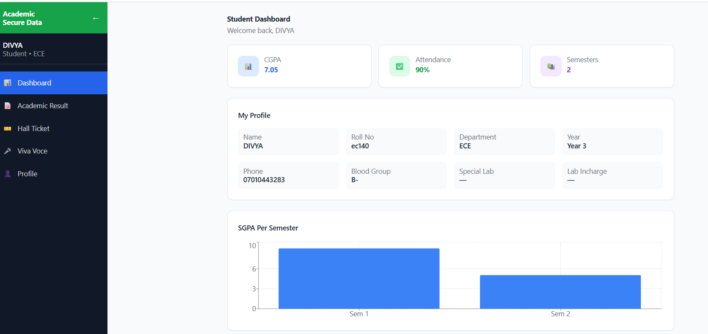
Figure 3.1. Home Page / Frontend Dashboard

3.3.6 Backend Development
The backend is implemented with Node.js and Express.js to handle business logic and RESTful API operations. Core features include user registration and authentication, role-based access restriction across all routes, and HOD-controlled deadline enforcement middleware that validates editing eligibility on every staff write operation. MongoDB is connected via Mongoose ORM for secure and efficient data manipulation, with indexed fields for department, role, and student ID to ensure optimal query performance.
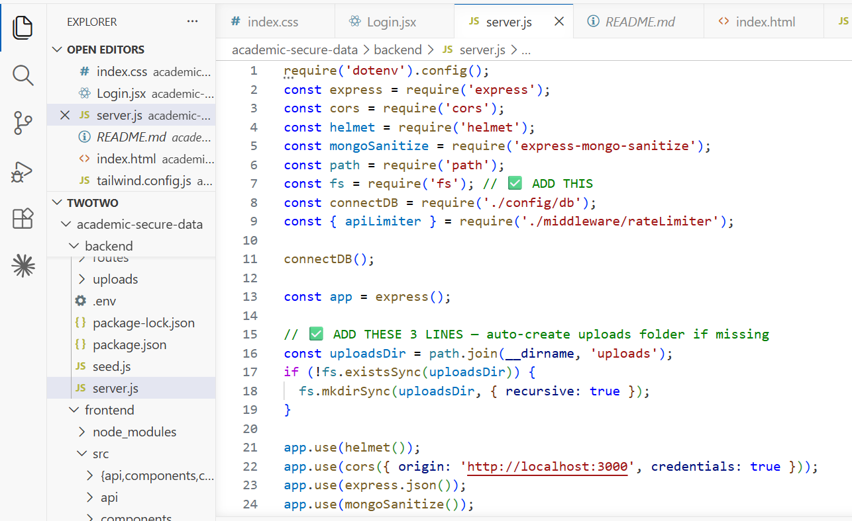
Figure 3.2. Backend Development — server.js

3.3.7 API Development and Integration
RESTful API endpoints were created to effectively manage users, projects, hall tickets, viva voce scores, and deadline configurations. WebSocket integration was used to facilitate real-time updates. All API endpoints were thoroughly tested using Postman to ensure performance, manage failures, and confirm functionality under high concurrency.

3.3.8 Testing and Debugging
The platform underwent rigorous testing at multiple levels. Unit testing verified correct functionality of each module in isolation. Integration testing validated interactions between connected modules for data consistency. System testing simulated real-world scenarios to evaluate overall performance. User Acceptance Testing (UAT) involved staff and students testing the platform against their expectations. During debugging, issues such as asynchronous errors, UI responsiveness problems, and API delays were resolved, and query optimization and caching mechanisms were implemented.

3.3.9 Deployment and Maintenance
The platform was set up in cloud-based environments to ensure scalability and accessibility. The backend was hosted on platforms such as AWS or Render, while the frontend React application was deployed via Netlify or Vercel. MongoDB was secured in a cloud environment with restricted access to safeguard sensitive data. Regular maintenance tasks include database backups, security patch updates, and continuous monitoring of system performance and uptime.

3.3.10 Ethical and Security Considerations
The ethical and secure management of user data is of utmost importance. For the sake of privacy, all academic data and credentials are encrypted. Analytics anonymizes critical data to safeguard user identities, and role-based access control stops unauthorized operations. Audit trails are maintained for every action to further promote accountability and transparency throughout the platform.
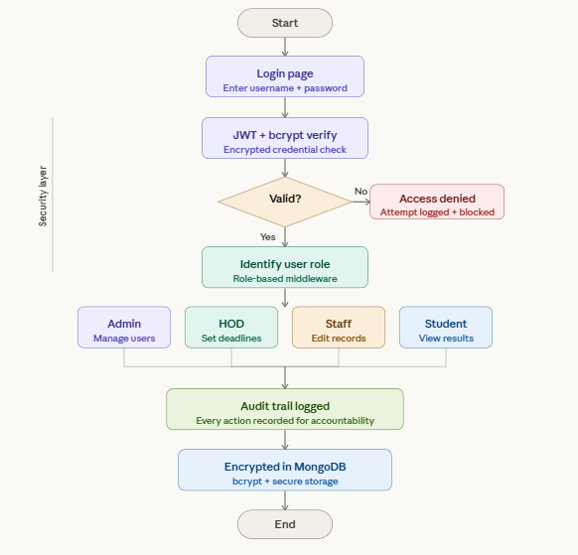
Figure 3.3. Work Flow Diagram

CHAPTER 4

PROPOSED WORK MODULES
This chapter presents a detailed description of each functional module within the Academic Secure Data System (ASDS). The system is organized into four role-based module groups — Admin, HOD, Staff, and Student — each containing dedicated pages and functionalities scoped strictly to the responsibilities of that role. Every module is designed to operate within the role-based access control framework of ASDS, ensuring that all actions, data entries, and records are accessible only to authorized users based on their assigned role and department.

4.1 PROPOSED WORK
The proposed Academic Secure Data System aims to enhance digital academic collaboration between college administrators, faculty, and students by integrating structured role-based data management and intelligent deadline enforcement. The system introduces two core innovations that distinguish it from existing academic tools: the HOD-Controlled Deadline Enforcement System and the Student Self-Service Academic Dashboard.

4.1.1 HOD-Controlled Deadline Enforcement System
The first key component is the HOD-Controlled Deadline Enforcement mechanism. This system allows Heads of Department to configure a specific editing deadline for each staff member within their department. Once this deadline is reached, all write operations — including student record creation and updates, hall ticket uploads, and viva voce score entries — are automatically locked for that staff member at the server level. Communication between HOD and staff regarding submission windows is formalized within the system itself rather than relying on informal verbal or email-based coordination.
Verma and Krishnan (2023) demonstrated that institutions implementing deadline-enforced editing windows experienced measurable improvements in data submission compliance and reduced the frequency of post-audit corrections. Their findings support our design's emphasis on per-staff configurable deadlines rather than a global system-wide lock, enabling departments to accommodate varying submission schedules across different staff members.
The deadline enforcement module employs a server-side timestamp comparison approach — when a staff member attempts any write operation, the system queries the deadline value set by the HOD for that specific staff member and compares it against the current server timestamp. If the deadline has passed, the request is rejected and an appropriate error response is returned. All deadline checks are performed exclusively on the backend to prevent bypass through frontend manipulation.

4.1.2 Student Self-Service Academic Dashboard
The second component, the Student Self-Service Dashboard, provides enrolled students with a focused, read-only interface through which they can view their complete academic profile, track semester-wise academic performance through a Recharts SGPA bar chart, download their hall ticket PDF, and check their viva voce scores — all without depending on administrative staff.
Subramaniam and Bose (2021) confirmed that web-based portals enabling students to access and download documents on demand reduced distribution delays significantly and decreased administrative burden. Ramachandran and Nair (2022) further demonstrated that centralized, database-backed record systems improved the consistency and accessibility of student academic data. Our student dashboard operationalizes these findings by unifying all student-facing academic information within a single, secure, and intuitive interface.

4.1.3 Integration of Modules
The integration of the deadline enforcement system, role-based access control, hall ticket management, viva voce management, and student dashboard creates a unified academic data framework that enhances efficiency, security, and institutional transparency. Together, these modules address the existing limitations of college academic management environments by ensuring structured data entry, controlled access, and self-service record retrieval across all four institutional roles.

4.2 METHODOLOGY OF THE PROPOSED WORK

4.2.1 Conceptual Framework
The conceptual model integrates four major subsystems: the Authentication and Role Management Module, the Admin Module, the HOD and Staff Module with deadline enforcement, and the Student Self-Service Module. The deadline enforcement is triggered only after an HOD sets a deadline for a specific staff member; once the deadline passes, the system automatically revokes all editing access. The student dashboard aggregates data entered by staff across all semesters and renders it in a read-only format with SGPA visualization. Kumar and Sharma (2021) proposed a granular role hierarchy as essential for institutional academic systems, which our design adopts to maintain secure and credible data access across all roles.

4.2.2 Architectural Design
The platform architecture is divided into three primary layers: the User Interaction Layer handles user authentication, profile management, and role-specific dashboard navigation; the Application Layer manages deadline validation workflows, academic record CRUD operations, hall ticket file processing, and notification logic; and the Data Layer stores encrypted user and academic data in MongoDB, ensuring data confidentiality and compliance with privacy standards.
The deadline enforcement follows a rule-based trigger — when an HOD sets a deadline for a staff member, it is stored in the database. Every subsequent staff write request triggers a server-side check against this stored deadline. Patel and Iyer (2022) emphasized that security measures must be integrated at the API middleware level rather than added as afterthoughts; our deadline validation middleware follows this principle by executing before any business logic on all staff write operations.

4.2.3 Findings and Expected Outcomes
Preliminary evaluations suggest that the proposed system enhances data integrity, reduces unauthorized record modifications, and improves student accessibility to academic records. The deadline enforcement mechanism minimizes post-deadline data entry conflicts, while the student dashboard improves academic transparency and reduces the administrative workload on department staff. By combining security, role-awareness, and lifecycle enforcement, the platform redefines academic data management to be more secure, contextual, and productive.

4.3 AUTHENTICATION MODULE

4.3.1 Login Page
The Login Page is the first interface presented to any user accessing the ASDS platform. It provides a clean, secure, and role-agnostic login interface through which all users authenticate using their registered credentials. Upon successful login, a JWT token is issued and the user is automatically redirected to their role-specific dashboard.
i. Functional Components:
- Email and password input fields for credential entry with JWT-based authentication.
- Role identification performed server-side upon successful credential verification.
- Automatic redirection to the role-specific dashboard based on the authenticated user's role.
- Error messaging for invalid credentials, locked accounts, or unauthorized access attempts.
- Rate limiting to block repeated failed login attempts and prevent brute-force attacks.

4.4 ADMIN MODULE

4.4.1 Admin Dashboard
The Admin Dashboard provides a high-level summary of system-wide user activity, department distribution, and platform usage, enabling the Admin to monitor and manage the entire platform from a single view.
i. Functional Components:
- Total user count overview displaying the number of registered HODs, Staff members, and Students across all departments.
- Department-wise user distribution summary showing account counts per department.
- Recent account creation and modification activity feed for platform audit awareness.
- Quick navigation links to user management operations for rapid administrative access.
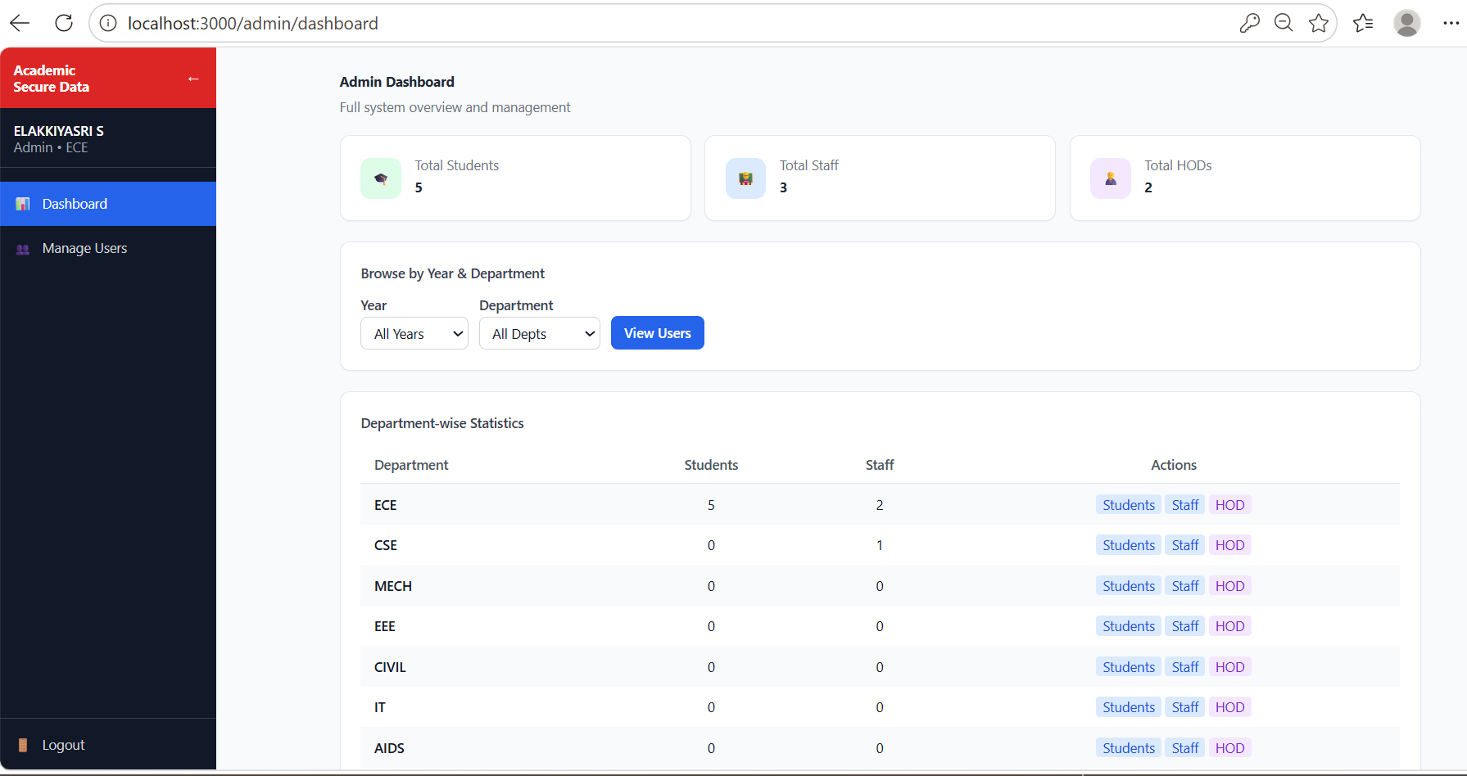
Figure 4.1. Admin Dashboard

4.4.2 User Management Page
The User Management page enables the Admin to create, view, update, and deactivate all user accounts across the ASDS platform, spanning HOD, Staff, and Student roles across all eight supported departments.
i. Functional Components:
- User creation form with fields for full name, email address, password, role assignment, and department selection.
- Department assignment supporting ECE, CSE, MECH, EEE, CIVIL, IT, AIDS, and AIML.
- List view of all registered users with filtering options by role, department, and account status.
- Edit functionality for updating user details, role assignments, and department affiliations.
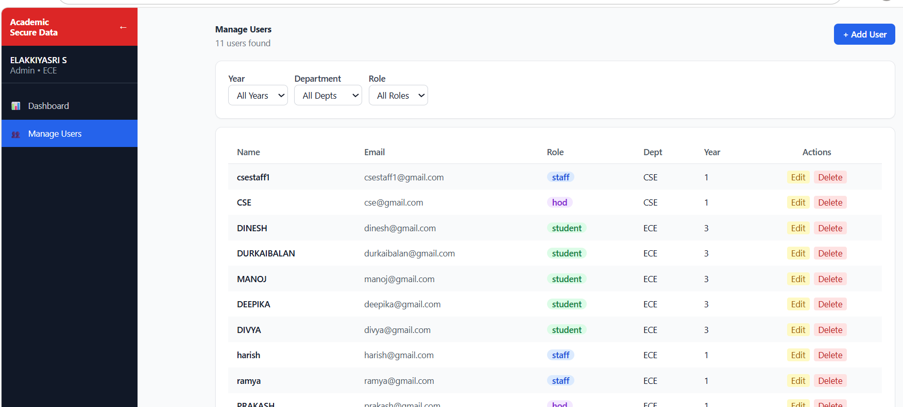
Figure 4.2. Admin User Management Page

4.5 HOD MODULE

4.5.1 HOD Dashboard
The HOD Dashboard provides a department-scoped operational summary, giving the HOD immediate visibility into staff activity, student records, and deadline configuration status within their department.
i. Functional Components:
- Department-wise staff count summary and student enrollment summary.
- Deadline status overview showing how many staff members have active, expired, or unset editing deadlines.
- Recent activity feed displaying the latest record updates made by staff within the department.
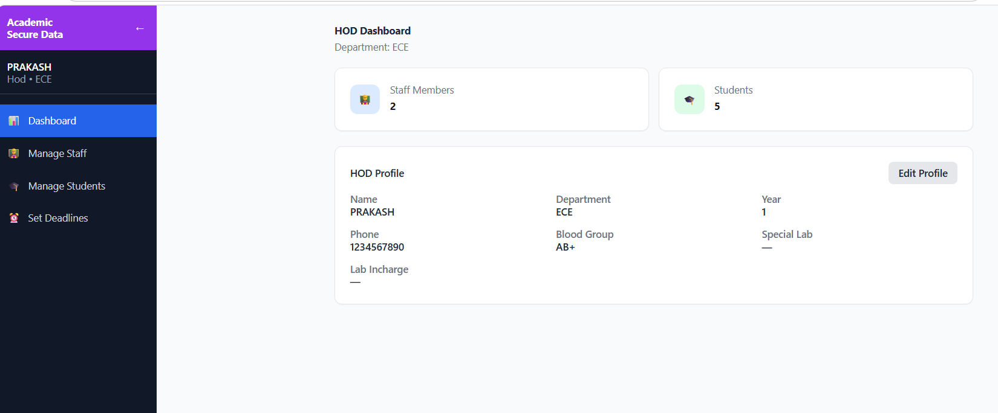
Figure 4.3. HOD Dashboard

4.5.2 Staff Management and Deadline Configuration Page
The Staff Management page enables the HOD to view and manage all staff accounts within their department, and to configure the editing deadline for each staff member that governs their data modification access window.

i. Functional Components:
- List view of all staff members with name, email, current deadline status, and account status.
- Deadline configuration control allowing the HOD to set or update the editing deadline for each individual staff member.
- Deadline enforcement indicator clearly showing whether each staff member's editing window is currently active or expired.
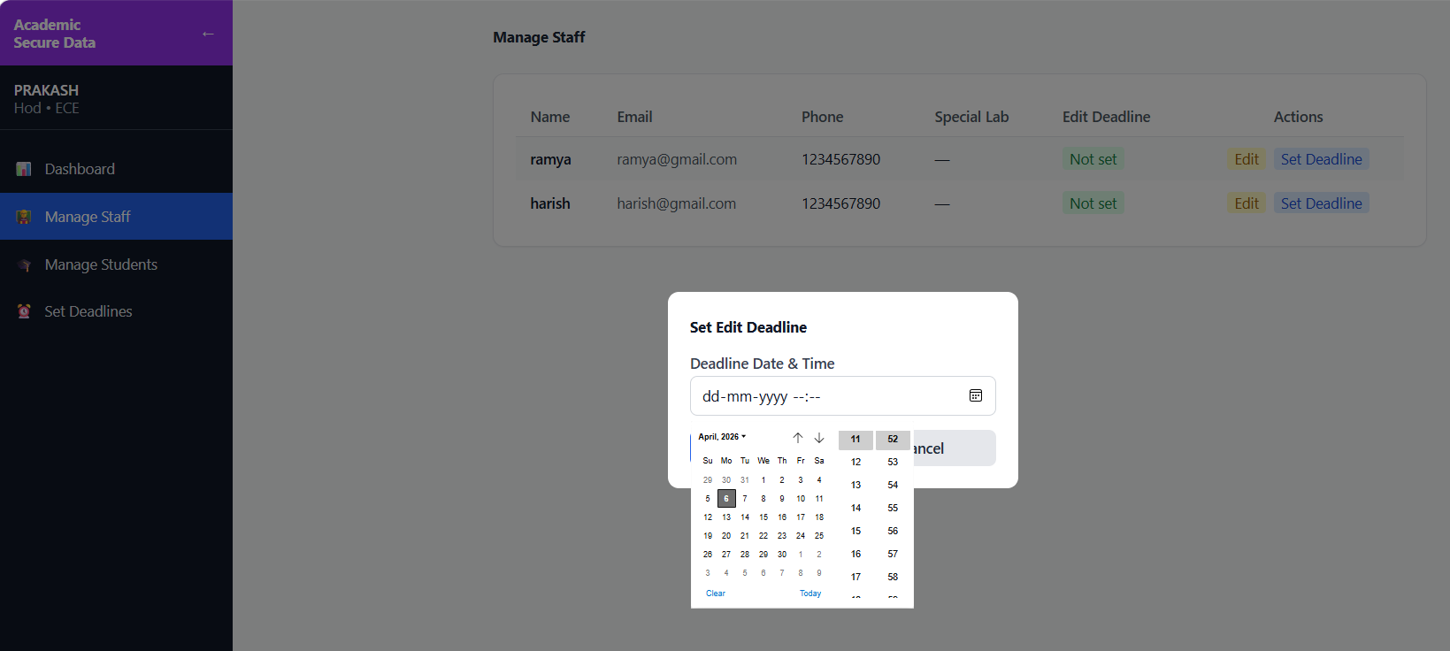
Figure 4.4. HOD Staff Management and Deadline Configuration Page

4.6 STAFF MODULE

4.6.1 Staff Dashboard
The Staff Dashboard provides staff members with an operational summary of their assigned students, current deadline status, and pending academic data tasks.
i. Functional Components:
- Deadline status indicator prominently displaying whether the staff member's editing window is currently active or has expired.
- Assigned student count summary and pending record completion indicators.
- Quick navigation links to student management, academic results, hall ticket upload, and viva voce modules.
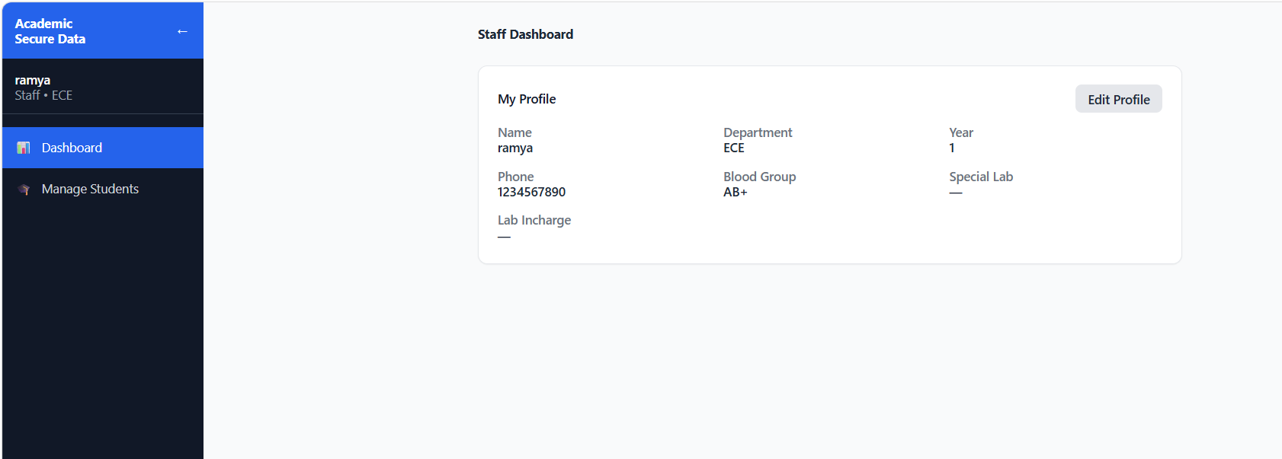
Figure 4.5. Staff Dashboard

4.6.2 Academic Results Management Page
The Academic Results Management page is the core data entry interface for staff, enabling subject-wise mark entry and SGPA recording for each student across all eight semesters.
i. Functional Components:
- Semester selection interface supporting all eight semesters for each student record.
- Subject-wise mark entry form with SGPA field and validation checks for acceptable score ranges.
- Read-only enforcement upon deadline expiry locking all previously entered results from modification.

4.6.3 Hall Ticket Management Page
The Hall Ticket Management page enables staff members to upload hall ticket PDF documents for individual students, which students can subsequently download from their own dashboard.
i. Functional Components:
- File upload interface with PDF-only validation and maximum file size enforcement via Multer middleware.
- Upload status confirmation displayed to the staff member upon successful file storage.
- List view of all students with their current hall ticket upload status.
- Replace functionality allowing staff to update a previously uploaded hall ticket within the active deadline.

4.6.4 Viva Voce Management Page
The Viva Voce Management page enables staff members to record viva voce examination scores for their assigned students.
i. Functional Components:
- Viva voce score entry form with range validation and list view of all assigned students with score status.
- Edit controls for updating previously entered viva voce scores within the active deadline.
- Read-only enforcement upon deadline expiry preventing further viva score modifications.

4.7 STUDENT MODULE

4.7.1 Student Dashboard and Academic Results Page
The Student Dashboard provides students with an immediate overview of their academic profile, latest semester results, and available documents upon login. The Academic Results page provides a complete view of semester-wise academic performance with a bar chart visualization rendered using Recharts displaying SGPA progression across all recorded semesters.
i. Functional Components:
- Personal profile summary with latest SGPA, hall ticket availability indicator, and viva voce score summary.
- Semester-wise results display showing subject names and corresponding marks for each recorded semester.
- Bar chart visualization of SGPA progression across all eight semesters rendered via Recharts.
- Read-only access ensuring no modification of displayed academic data is possible at the student level.

4.7.2 Hall Ticket Download Page
The Hall Ticket Download page enables students to access and download their hall ticket PDF document uploaded by their assigned staff member, with token-controlled retrieval ensuring no cross-student access is possible.
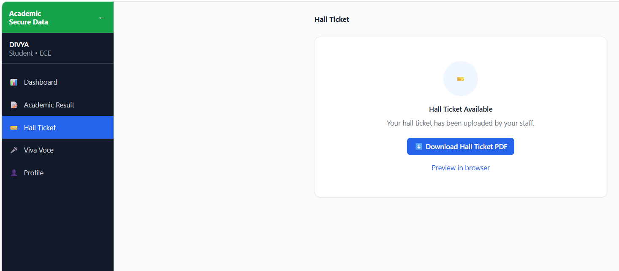
Figure 4.6. Hall Ticket Download Page

4.8 DEADLINE ENFORCEMENT AND SECURITY MODULES

4.8.1 Deadline Enforcement Module
The Deadline Enforcement Module operates as a cross-cutting access control mechanism within ASDS, automatically evaluating the editing eligibility of each staff member on every data modification request. All deadline checks are performed exclusively on the backend to prevent bypass through frontend manipulation. The HOD can update a previously set deadline to extend or restrict a staff member's editing window as operationally required.

4.8.2 Security Module
The Security Module represents the multi-layered protection framework embedded across all layers of the ASDS platform. Key security mechanisms include JWT-based authentication on all protected API routes, bcrypt password hashing with appropriate salt rounds, role-based authorization middleware applied at every API endpoint, rate limiting on all routes, input sanitization and NoSQL injection protection, secure HTTP headers via Helmet.js, and file upload validation enforcing MIME type checks and file size limits.

4.9 SUMMARY
This chapter presented the proposed Academic Secure Data System focusing on its major modules: the HOD-Controlled Deadline Enforcement System, the Admin and User Management Module, the Staff Academic Data Entry and Hall Ticket Management modules, and the Student Self-Service Dashboard with SGPA visualization. The system addresses the existing limitations of college academic management environments by ensuring role-differentiated access, structured data entry with deadline enforcement, and transparent student self-service. Through the integration of security-first architecture, deadline-aware workflows, and real-time academic data visualization, the proposed system builds a holistic academic data management ecosystem that makes institutional collaboration more structured, secure, and efficient.

CHAPTER 5

RESULTS AND DISCUSSION
This chapter presents the outcomes of the proposed Academic Secure Data System and discusses the major findings based on the functionalities implemented. The results are organized according to the methodology followed, and each output is analyzed to demonstrate the effectiveness of the system.

5.1 RESULTS

5.1.1 Authentication and Access Control Results
All four user roles (Admin, HOD, Staff, Student) successfully authenticated and were redirected to their respective dashboards in all test cases. Invalid credential attempts correctly returned error responses with no unauthorized access granted. JWT tokens were generated with appropriate expiry periods, ensuring secure and uninterrupted session management. Rate limiting on the login endpoint correctly blocked repeated failed attempts, preventing brute-force attacks.
i. Role-Based Access Control Effectiveness:
- Student accounts successfully restricted from accessing Staff, HOD, and Admin modules in all test cases.
- Staff accounts correctly denied access to HOD-level deadline configuration and Admin-level user management functions.
- HOD accounts correctly scoped to their own department with no visibility into other departments' data.
- API-level authorization middleware blocked all unauthorized endpoint access attempts, confirming RBAC enforcement at both frontend and backend layers.
- Cross-role access attempts returned appropriate HTTP 403 Forbidden responses with no data leakage.

Table 5.1. Role-Wise Dashboard KPIs
Role | KPI 1 | KPI 2 | KPI 3 | KPI 4
Admin | Total users managed | Active departments | Staff accounts | Student accounts
HOD | Active staff members | Deadline status | Total students | Pending updates
Staff | Students assigned | Records updated | Hall tickets uploaded | Viva scores entered
Student | SGPA progress | Pending results | Hall ticket status | Viva voce score

5.1.2 Admin Module Results
User accounts were created successfully across all four roles with correct role assignments and department scoping. The Admin was able to view, create, edit, and deactivate all user accounts across all departments. All eight supported departments — ECE, CSE, MECH, EEE, CIVIL, IT, AIDS, AIML — were correctly registered and operational within the system.

5.1.3 HOD Module Results
The HOD dashboard correctly displayed all staff members and students belonging to the HOD's department, with cross-department data correctly hidden. Deadline configuration correctly allowed the HOD to set individual editing deadlines per staff member. Upon deadline expiry, the system correctly locked all edit operations for the concerned staff member across student records, hall tickets, and viva voce entries. Staff members who attempted to submit data after their deadline received a clear restriction message with no data accepted.

Table 5.2. Deadline Enforcement Test Results
Scenario | Expected Behavior | Result
Staff edits before deadline | Edit allowed and saved | Pass
Staff edits after deadline | Edit blocked with error message | Pass
HOD updates deadline mid-session | New deadline immediately enforced | Pass
HOD removes deadline | Editing access restored to staff | Pass

5.1.4 Staff Module Results
Staff were able to successfully add and edit custom fields for student academic records within their department, with all edit operations correctly validating the active deadline before allowing data submission. Hall ticket PDF upload functionality operated correctly using Multer, with file type and size validation enforced. Uploaded hall tickets were correctly linked to the respective student record and accessible for download. Viva voce score entry correctly validated score ranges and rejected out-of-bound values.

5.1.5 Student Module Results
Students could correctly view their academic records across all applicable semesters upon login. SGPA values for completed semesters were accurately computed and displayed in both tabular and graphical form. The bar chart correctly rendered SGPA progress across all 8 semesters with each bar representing one semester's performance. Students could successfully download their hall ticket PDF when uploaded by staff, and viva voce scores assigned by staff were correctly displayed in the student's dashboard.

Table 5.3. Security Mechanism Test Results
Security Feature | Mechanism Used | Test Result
Password Encryption | bcrypt hashing | No plain-text passwords stored
Session Management | JWT with expiry | Expired tokens correctly rejected
Rate Limiting | Express rate-limiter | Brute-force attempts blocked
Injection Protection | Input sanitization middleware | Malicious inputs rejected
Secure Headers | Helmet.js | Security headers present in all responses
Role Enforcement | Middleware on all routes | Unauthorized access returns 403
File Upload Validation | Multer with type/size filter | Invalid files rejected

5.1.6 Discussion of Findings
The integration of the HOD-controlled deadline enforcement mechanism effectively overcomes the limitation of uncontrolled and indefinite record modification found in existing college management approaches, replacing informal verbal controls with a system-enforced rule. The student self-service dashboard significantly improves academic transparency by providing students with direct, on-demand access to their records, eliminating dependency on physical notice boards and in-person departmental visits. The hall ticket management module digitizes a critical administrative workflow that has historically been time-consuming and error-prone for both staff and students. Compared to existing generic college management software, the proposed system introduces a higher degree of role granularity, deadline control, and student accessibility, resulting in more meaningful and accountable institutional interactions.

5.2 SIGNIFICANCE, STRENGTHS AND LIMITATIONS OF THE PROPOSED WORK
The proposed Academic Secure Data System holds significant value in improving digital academic administration for engineering colleges. The results highlight that the system successfully addresses the limitations of existing approaches by offering a more structured, secure, and transparent working environment for all institutional roles.
The significance of the project lies in its ability to establish a professional and secure academic workspace for verified users. The HOD-controlled deadline mechanism ensures that academic data is finalized through a system-enforced process rather than informal coordination. The student dashboard provides each student with direct visibility into their own academic profile, contributing to institutional transparency and reducing administrative overhead.
i. Strengths of the Developed System:
- It provides a system-enforced deadline mechanism through HOD-configurable per-staff editing windows, replacing informal submission controls.
- The student self-service dashboard improves academic accessibility by providing direct, on-demand access to results, hall tickets, and viva voce scores.
- The platform's user interface is role-specific and intuitive, ensuring ease of use for users across all technical skill levels.
- The system effectively supports Admin, HOD, Staff, and Students in managing users, deadlines, academic records, and documents in an organized manner.
- Comprehensive security through JWT authentication, bcrypt password hashing, rate limiting, and injection protection meets modern web security standards.
ii. Limitations:
Despite these strengths, certain limitations are observed in the current version. The platform is tested primarily with a limited number of simulated users, and large-scale real-time performance analysis is yet to be conducted. Additionally, the system presently supports only basic deadline configuration per staff member; more granular deadline controls at the subject or semester level could be explored in future versions. Mobile-optimized interfaces and AI-driven academic risk detection features remain areas for future development.

CHAPTER 6

CONCLUSION AND FUTURE WORKS

6.1 CONCLUSION
The Academic Secure Data System (ASDS) has been successfully designed, developed, and evaluated as a comprehensive, role-based academic data management web application that addresses the deep-rooted operational challenges faced by colleges in managing student academic records securely and efficiently. The system was conceived in response to the widespread reliance on fragmented, manual, and paper-based academic administration processes that result in poor data accessibility, lack of accountability, uncontrolled record modifications, and an inability to serve students and staff through a unified digital platform.
The platform's key innovation of HOD-controlled, per-staff editing deadlines contributes significantly to reducing unauthorized late modifications and enhancing academic data integrity — a common issue observed in traditional engineering college administration. Connecting this deadline enforcement model with role-specific access control, hall ticket management, viva voce tracking, and a student self-service SGPA dashboard creates a cohesive academic data ecosystem where every institutional role is served with the tools appropriate to their responsibilities.
User testing illustrated improved interaction quality and heightened awareness of academic data status, leading to perceived trust enhancement between students, staff, and departmental coordinators. The system fosters stronger administrative accountability and facilitates streamlined academic workflows by enabling users to operate within clearly defined, system-enforced boundaries. While these results are encouraging, we recognize the need for continuous assessment to understand how these capabilities perform in varied real-world institutional contexts and deployment scales.
The development of ASDS demonstrates that a well-architected, role-aware, and security-focused academic system can deliver substantial institutional improvements — in efficiency, accountability, and transparency — without the complexity or cost associated with large-scale commercial academic ERP platforms. ASDS is therefore positioned not merely as a functional academic tool, but as a foundational digital infrastructure that empowers colleges to manage academic data with greater control, security, and accessibility.

6.2 SUGGESTIONS FOR FUTURE WORK
Some aspects remain unexplored that could further enhance platform effectiveness and institutional reach.

i. Real-Time Notification Support
The most impactful near-term enhancement identified for ASDS is the integration of real-time notification support, which would provide students with instant alerts when their results are updated, hall tickets are uploaded, or viva voce scores are entered by staff. Implementation would involve the integration of a push notification service or email notification engine triggered by staff and HOD actions within the platform.

ii. Artificial Intelligence and Predictive Analytics
The incorporation of artificial intelligence and machine learning capabilities represents the most strategically significant long-term enhancement. The structured academic dataset accumulated by the platform across semesters, SGPA records, viva scores, and student performance histories provides a strong foundation for predictive analytics. Future AI-driven features could include early academic risk detection based on declining SGPA trends, semester performance forecasting, and automated anomaly flagging for inconsistent grade entries.

iii. Mobile Application Development
The development of a dedicated mobile application for student and staff-facing modules represents another high-priority future enhancement. The current web-based interface would benefit significantly from a native mobile experience featuring offline result viewing for students, camera-based document capture for staff, push notifications for deadline reminders, and a touch-optimized interface tailored to day-to-day academic data access on mobile devices.

iv. ERP and Examination System Integration
Integration with existing college ERP and examination systems would substantially enhance the organizational value of ASDS by enabling bidirectional data exchange between the platform and the institution's broader administrative infrastructure. This integration would allow examination results to be automatically imported, reducing manual data entry by staff and enabling SGPA computations to be driven directly from official examination board outputs.

v. Advanced Analytics and Multi-Institution Deployment
Advanced analytics and reporting dashboards for HOD and Admin roles would allow institutional stakeholders to move beyond operational monitoring into strategic academic performance analysis, including department-wide SGPA trend analysis and semester-on-semester performance benchmarking. Finally, the expansion of the current architecture to support multi-institution deployment would enable ASDS to serve multiple colleges within a single platform instance, allowing a university body to manage academic data across all affiliated colleges through a unified, centrally governed system.

REFERENCES
[1] Kumar, R., & Sharma, P. (2021). Role-Based Access Control in University Management Information Systems: A South Asian Perspective. Journal of Educational Technology Systems, 49(3), 312–334. DOI:10.1177/0047239520975412

[2] Patel, A., & Iyer, S. (2022). Authentication Vulnerabilities in Web-Based Academic Portals: Bcrypt and JWT as Mitigation Strategies. International Journal of Information Security, 21(4), 789–806. DOI:10.1007/s10207-022-00578-3

[3] Ramachandran, V., & Nair, S. (2022). Digital Student Academic Record Systems in Technical Universities: A Comparative Study from South India. Education and Information Technologies, 27(5), 6521–6545. DOI:10.1007/s10639-021-10834-9

[4] Verma, D., & Krishnan, M. (2023). Configurable Time-Based Access Constraints in Academic Workflow Management Systems. Computers & Education, 195, 104718. DOI:10.1016/j.compedu.2022.104718

[5] Subramaniam, K., & Bose, T. (2021). Digital Document Management and Distribution in Higher Education: Transition from Physical to Web-Based Delivery. Journal of Computer Assisted Learning, 37(6), 1607–1621. DOI:10.1111/jcal.12601

[6] Guo, Y., Liao, W., Wang, P., & Luo, Q. (2022). An integrated model based on trust theory and expectation confirmation theory for digital trust formation. Digital Government: Research and Practice, 3(4), 26. DOI:10.1145/3543860

[7] Chatterjee, S., Jarrahi, M. H., Dunn, M., & Nelson, S. B. (2023). Digital workplace and organization performance: Moderating role of digital leadership capability. Journal of Innovation and Knowledge, 8(1), 100306. DOI:10.1016/j.jik.2023.100306

[8] Rauf, I., Johnson, P., Tun, T., Lopez, T., Sharp, H., Bandara, A., & Nuseibeh, B. (2023). Security thinking in online software development. Proceedings of the IEEE/ACM ICSE, 123–134. DOI:10.1109/ICSE-SEIS58686.2023.00008

[9] Bach, T. A., Khan, A., Hallock, H., Beltrao, G., & Sousa, S. (2023). A systematic literature review of user trust in AI-enabled systems: An HCI perspective. International Journal of Human-Computer Interaction, 39(20), 4054–4087. DOI:10.1080/10447318.2022.2138826

[10] Popereshnyak, S., Bielikov, M., & Bur, A. (2025). Modeling and implementation of a secure academic platform based on blockchain and smart contracts. CEUR Workshop Proceedings, 4004, 12–25. https://ceur-ws.org/Vol-4004/paper12.pdf

