|  |  |
| --- | --- |
| **Adverbs (They modify adjectives or adverbs)** | **Adjectives (They modify nouns and pronouns)** |
| Extremely | Happy |
| Quite | Sad |
| Really | **Big** |
| Fairly | Small |
| Rather | Bright |
| **Very** | Dark |
| Too | Beautiful |
| So | Ugly |
| Incredibly | Warm |
| Absolutely | Sandy |
| Surprisingly | Fast |
| Particularly | Slow |
| Totally | Smooth |
| Truly | Rough |
| Remarkably | Black |
| Moderately | Pink |
| Slightly | Tall |
| Hugely | Short |
| Especially | Cheerful |
| Completely | Gloomy |

Football

Describe the pictures:

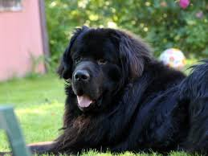 < Look at the **animal** in the photo. **It’s** a dog.

Dog

Garden

I use **it’s** because I already told you to look at the photo. you already know that **it’s** describing the **animal**.



|  |  |  |  |  |  |  |  |  |  |  |
| --- | --- | --- | --- | --- | --- | --- | --- | --- | --- | --- |
| Subject or **Pronoun** | + | Verb | + | Article | + | Adjective | + | Adjective | + | Noun |
| **It** | + | **is** | + | **a** | + | **big** | + | **black** | + | **dog** |

|  |  |  |  |  |  |  |  |  |
| --- | --- | --- | --- | --- | --- | --- | --- | --- |
| Subject or Pronoun or Article | + | Noun | + | Verb | + | Adverb | + | Adjective |
| **The** | + | **dog** | + | **is** | + | **very** | + | **big** |

**Notice:** The **noun** can be placed in two positions. The last word receives the emphasis.

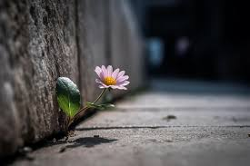< **This** is a flower

bricks

leaf

I use ‘**this’** because the text is speaking. The *text* is describing the picture that is next to *it*.

|  |  |  |  |  |  |  |  |  |  |  |
| --- | --- | --- | --- | --- | --- | --- | --- | --- | --- | --- |
| **Subject** or Pronoun | + | Verb | + | Article | + | Adjective | + | Adjective | + | Noun |
| **The flower** | + |  | + |  | + |  | + |  | + |  |

|  |  |  |  |  |  |  |  |  |
| --- | --- | --- | --- | --- | --- | --- | --- | --- |
| Subject or Pronoun or **Article** | + | Noun | + | Verb | + | Adverb | + | Adjective |
| **The** | + |  | + |  | + |  | + |  |

**Notice:** The **noun** can be placed in two positions. The last word receives the emphasis.

teddy bear

boy

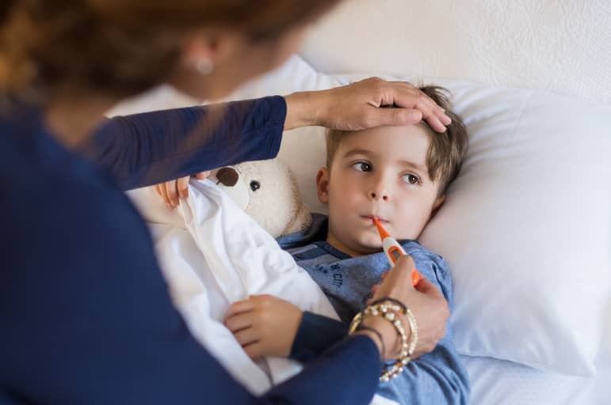< **This** is a boy. His name is Mark.

Mom?

bracelets

thermometer

I use ‘**this’** because the text is speaking. The *text* is describing the picture that is next to *it*.  
  
Also, we don’t use ‘**it’** for describing people.

|  |  |  |  |  |  |  |  |  |  |  |
| --- | --- | --- | --- | --- | --- | --- | --- | --- | --- | --- |
| **Subject** or Pronoun | + | Verb | + | Article | + | Adjective | + | Adjective | + | Noun |
| **Mark** | + |  | + |  | + |  | + |  | + |  |

|  |  |  |  |  |  |  |
| --- | --- | --- | --- | --- | --- | --- |
| **Subject** or Pronoun or Article | + | Verb | + | Adverb | + | Adjective |
| **Mark** | + |  | + |  | + |  |

**Notice:** The **noun** can be placed in two positions. The last word receives the emphasis.

Flower Bed

Garden

House

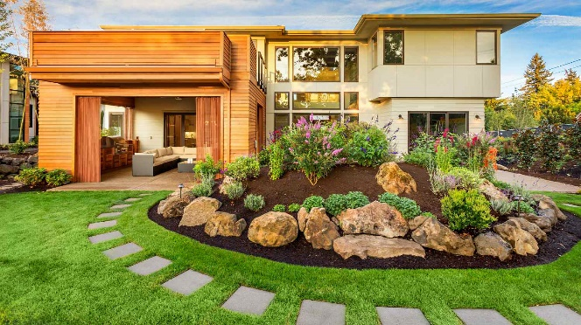

Path

|  |  |  |  |  |  |  |  |  |  |  |
| --- | --- | --- | --- | --- | --- | --- | --- | --- | --- | --- |
| Subject or Pronoun | + |  | + | Article | + | Adjective | + | Adjective | + | Noun |
|  | + |  | + |  | + |  | + |  | + |  |

|  |  |  |  |  |  |  |
| --- | --- | --- | --- | --- | --- | --- |
| Subject or Pronoun or Article | + |  | + | Adverb | + | Adjective |
|  | + |  | + |  | + |  |

Sand

Rocks

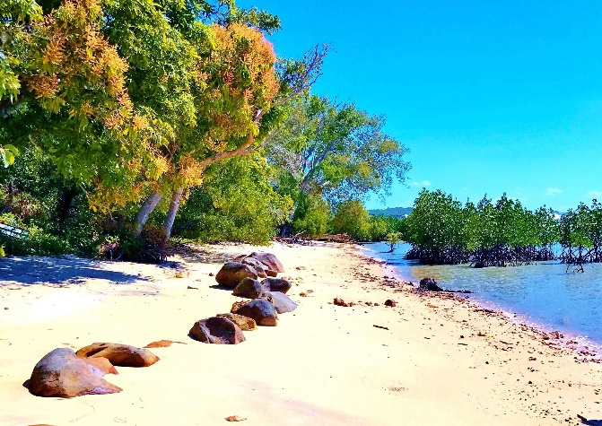

Beach

|  |  |  |  |  |  |  |  |  |  |  |
| --- | --- | --- | --- | --- | --- | --- | --- | --- | --- | --- |
| Subject or Pronoun | + | Verb | + |  | + | Adjective | + | Adjective | + | Noun |
|  | + |  | + |  | + |  | + |  | + |  |

|  |  |  |  |  |  |  |
| --- | --- | --- | --- | --- | --- | --- |
| Subject or Pronoun or Article | + | Verb | + | Adverb | + |  |
|  | + |  | + |  | + |  |