**It**

It’s (the contracted form of ‘it is’)

**Example use:**

**It’s** seven o’clock in the morning.

**It** rained heavily last night.

**It’s** sunny today.

**It’s** very cold in here.

Is **it** Monday tomorrow? Yes, **it** is.

**It’s** getting dark outside.

……………………………………………………..

Describe the weather outside!

The weather outside **is** wet and cold.

It’s wet and cold.

……………………………………………………..

How was your interview yesterday?

My interview yesterday **was** good.

It **was** good.

……………………………………………………..

Do you enjoy your new job?

My new job **is** okay so far.

It’s okay so far.

……………………………………………………..

What colour is your jumper/top?

My jumper/top **is** purple.

It’s purple.

……………………………………………………..

**Is** the floor clean?

The floor **is** clean.

It is.

……………………………………………………..

**Fill in the spaces:**

What time **is** it?

_________________ 5pm.

____ 5pm.

What year **is** it?

________________ 2024.

____ 2024.

Fishes in the Fresh Waters of Florida Gallery - Discover Fishes

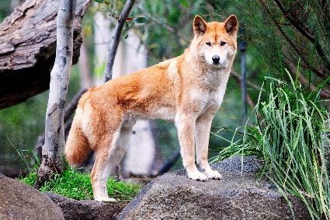**Does** that cloud look like a fish?

______________________ (long version)

______________________ (short version)

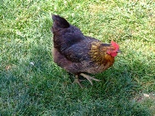**Does** a dingo eat chickens??

______________________ (long version)

Dingo: Australian Wild Dog

______________________ (short version)

**Answer the following questions using ‘it’:**

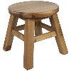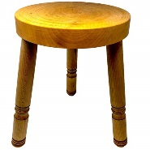Question 1: What year **is** it?  
Question 2: What colour **is** your hair?  
Question 3: How **was** your day?  
Question 4: How many legs does the big stool **have**?  
Question 5: **Is** it hot or cold?   
Question 6: **Is** the window closed?  
Question 7: **Has** it stopped raining yet?

Stool

**Word Jumble**

Q: Why do you use a tooth brush?

A: ______________________ (use/teeth/it/I/clean/my/to)

**Write 5 Sentences:**

Create **3** sentences using ‘**it**’ (use the present simple tense **and** three different verbs).  
Create **1** negative response using ‘**it**’ (use the present simple tense).  
Create **1** question using ‘**it**’ (use the present simple tense).