# TOXIC GAS ALARM USING 555IC

**Description**

**Smoke** is a collection of tiny solid, liquid and **gas** particles. Although **smoke** can contain hundreds of different chemicals and fumes, visible **smoke** is mostly carbon (soot), tar, oils and ash. **Smoke** occurs when there is incomplete combustion (not enough oxygen to burn the **fuel** completely).

In 2017, 3,400 people in the U.S. were killed by fire. Another 14,670 people were injured by fire – most of them cooking-related. The real tragedy in these numbers is that nearly all of these deaths and injuries were preventable. By making fire safety a priority, you can protect your home and your family from the ravages of fire and smoke. Knowing how to prevent a fire and knowing what to do when a fire breaks out can mean the difference between life and death for you and your loved ones.

Getting out of the house fast is essential, but you have very little time to react. A small flame can turn into an out-of-control fire in less than 30 seconds. And within a matter of minutes, your entire home can be engulfed in flames and toxic smoke.

Fatal fires often start late at night or early in the morning when people are asleep. Properly working smoke alarms can wake the entire family while there is still time to get out of the house. According to the Centers for Disease Control, more than one third of fire-related deaths are in homes without smoke alarms .But once people in your home are aware of the fire, they also need to know what to do. The environment created by a fire is confusing, disorienting, and potentially deadly. Creating and practicing an escape plan will help everyone, including children, stay focused on what they need to do to get out.

**WORKING PRINCIPLE**

When the ambient air is normal, the corresponding resistance value of the gas sensitive element QM-2, the resistance in the R3, RW voltage to make the 555 set, 3 pin output high level, and the alarm circuit is disconnected, no alarm. Voltage when the detection of gas sensor to gas, liquefied petroleum gas, gasoline, alcohol, smoke and other toxic gases, its resistance decreases, the resistor R3, RW partial pressure increases, thus the 555 reset, pin 3 output low level, making the relay and switch on the alarm circuit, sound and light alarm signal.

## NE555

The 555 timer IC is an integral part of electronics projects. Be it a simple project involving a single 8-bit micro-controller and some peripherals or a complex one involving system on chips (SoCs), 555 timer working is involved. These provide time delays, as an oscillator and as a flip-flop element among other applications.

Introduced in 1971 by the American company Signetics, the 555 is still in widespread use due to its low price, ease of use and stability. It is made by many companies in the original bipolar and low-power CMOS types. According to an estimate, a billion units were manufactured back in the year 2003 alone.

Depending on the manufacturer, the standard 555 timer package includes 25 transistors, 2 diodes and 15 resistors on a silicon chip installed in an 8-pin mini dual-in-line package (DIP-8). Variants consist of combining multiple chips on one board. However, 555 is still the most popular.

**GAS SENSOR**

A **gas detector** is a device that detects the presence of gases in an area, often as part of a safety system. This type of equipment is used to detect a gas leak or other emissions and can interface with a control system so a process can be automatically shut down. A gas detector can sound an alarm to operators in the area where the leak is occurring, giving them the opportunity to leave. This type of device is important because there are many gases that can be harmful to organic life, such as humans or animals.

Gas detectors can be used to detect combustible, flammable and toxic gases, and oxygen depletion. This type of device is used widely in industry and can be found in locations, such as on oil rigs, to monitor manufacture processes and emerging technologies such as photovoltaic. They may be used in firefighting.

**Gas leak detection** is the process of identifying potentially hazardous gas leaks by sensors. These sensors usually employ an audible alarm to alert people when a dangerous gas has been detected. Exposure to toxic gases can also occur in operations such as painting, fumigation, fuel filling, construction, excavation of contaminated soils, landfill operations, entering confined spaces, etc. Common

sensors include combustible gas sensors, photoionization detectors, infrared point sensors, ultrasonic sensors, electrochemical gas sensors, and semiconductor sensors. More recently, infrared imaging sensors have come into use. All of these sensors are used for a wide range of applications and can be found in industrial plants, refineries, pharmaceutical manufacturing, fumigation facilities, paper pulp mills, aircraft and shipbuilding facilities, hazmat operations, waste-water treatment facilities, vehicles, indoor air quality testing and homes.

## CIRCUIT DIAGRAM

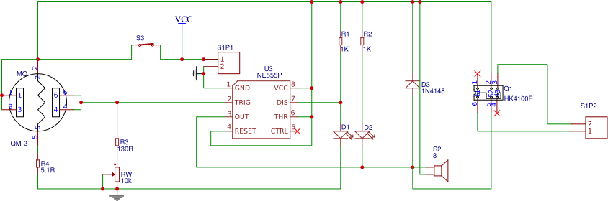

**COMPONENTS USED**

|  |  |
| --- | --- |
| **Component** | **Quantity** |
| QM-2 | 1 |
| SIP2 | 2 |
| NE555P | 1 |
| 1K | 2 |
| 130R | 1 |
| 5.1R | 1 |
| IR523B-W60W1 | 2 |
| 10K | 1 |
| 1N4148 | 1 |
| HK4100F | 1 |
| BUZZER | 1 |
| SPST-ON | 1 |

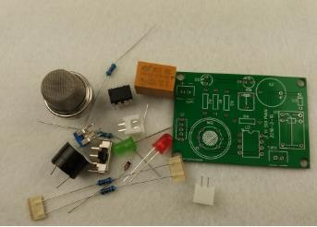**PCB DESIGN**

**Top Layer**

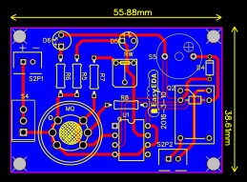

**Bottom layer**

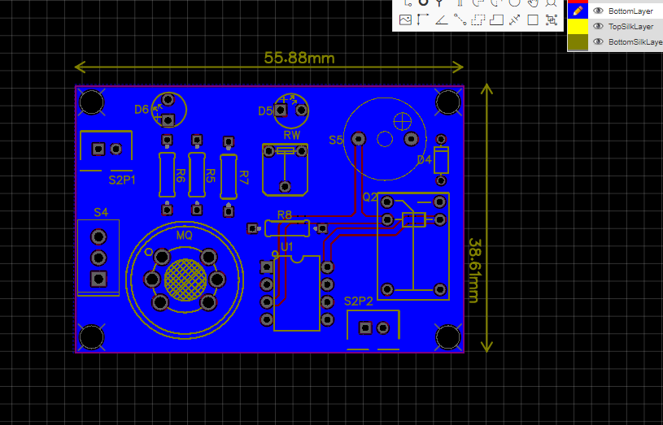

**OVERALL CIRCUIT**

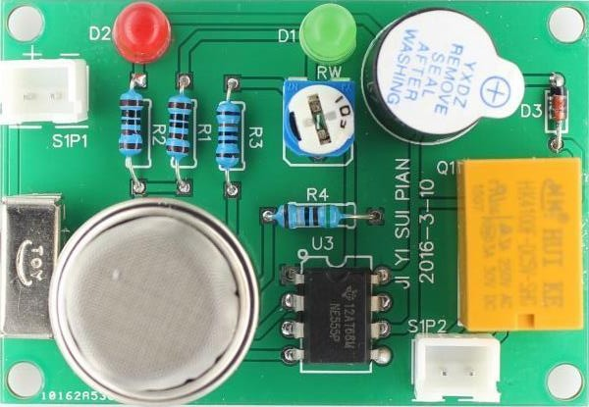

**TIPS**

Highly specialized not only in quick-turn PCB prototype and PCB assembly, but also medium and small volume PCB fabrication. We have three factories, established over 17,000 square meters; fully compliant with the ISO 9001:2008 quality management system, UL certified and committed to adhering to the strictest standards in manufacture and assembly.

Operating since 2015, **PCBGOGO** has delivered over US $1000000 worth of electronic components and prototyping services to more than 20000 customers all over the world.

Check here to order your PCB board online now.  
[http://www.pcbgogo.com](http://www.pcbgogo.com?code=y)