ETL with Talend

BOOK SALES


Contents
1 Referenced documents 3
2 Business Description 4
2.1 ThE GOAL 4
2.2 Business background 4
2.3 Problems because of poor data management 4
2.4 Benefits from implementing a Data Warehouse 4
3 Dimensions of a Business 4
4 Logical Scheme 8
5 ARCHITECTURE OF DATAWAREHOUSE LOAD 9

Referenced documents
ID | Title | Date | Path
1 | Business_Template_BookSales.docx | 06/05/22 | https://github.com/ELENA-VM/DWH_ON_PREMISE/blob/31e468e095627323c175dfe70477f4333a9a47b9/docs/Business_Template_Elena_Mozhenkova.docx
2 | Repository with the solution | 06/05/22 | https://github.com/ELENA-VM/DWH_ON_CLOUD

Business Description

ThE GOAL
The aim of the program is to move the on-premises solution "Book sales" to the Microsoft Azure cloud.

Business background
Books are companions for every person during in the life. In current times many people prefer to read electronic books. The Internet allows finding necessary literature doesn't go out from home. But paper books are also demanded in this hard competition. So that the business will succeed, you should very responsible approach for analyzing different metrics influencing sales. To collect, transform and analyze data you can use special tools.

Problems because of poor data management
Poor data management doesn’t let to correctly analyze the situation in the sales market. You can't do truth choice for growing the business. If you don’t use special instruments for common analysis business data, you won’t be competitive on market book sales.

Benefits from implementing a Data Warehouse
Using of a data warehouse can help you with the problems described above. Implementing a data warehouse can answer the following questions:

- Which category of books has the highest sales?
- What distribution sales by region?
- Quantity of new customers by period.
- Profit by Customer.
- Category book ranking.
Further processing data would also let you:
- Analyze places for business extension.
- Analyze the time period when increase sales.
- Customer preferences by book category.
- Price dynamics.
- And many other.

Dimensions of a Business
Design the dimensional model using four steps.
Step 1. Select business project
The main target to analyze the business – sales books from different stores and shops.
Step 2. Declare the Grain
Analyzing the business process can define the grain entity «sale» as the atomic element for research.
Step 3. Identify the dimensions
Define dimension table:
dim_store – data about shops and warehouses
dim_book – data about products of the company (slowly changing dimensions type 2 – storing history change row from the source system)
dim_customers – retail and wholesale buyers
dim_employee - store information about the staff of the business
dim_type_payments – kind of payments
dim_address – geography
dim_dates – date values
All dimension tables exclude “dim_time” generate their own unique surrogate primary key and
store link with source system use composite natural key(source_id + table_name + system_name).

Step 4. Identify the Facts
Table fact «fct_sales» store information:
- composite natural key – sales_id + table_namу + system_name
- foreign keys to dimension tables (book_surr_id, time_id, customer_suur_id, store_surr_id, employee_surr_id, address_surr_id, type_payment_surr_id)
- additive facts: quantity, sale_amount
- degenerate field: num_invoice

The Star schema model «Book sales»

Fig. 1 –Star schema

The 3NF schema model «Book sales»
For creating many-level architecture DWH also should create a high-level data model in 3NF. Model 3NF creating with a description business process and yet created the star model. The dimension tables were divided into different tables. For all tables exclude “ce_book_author” generate their own unique surrogate primary key and store link with source systems using a composite natural key (source_id + source_entity + source_system).

Fig. 2 –3NF schema

Logical Scheme

Create logical model of DWH load

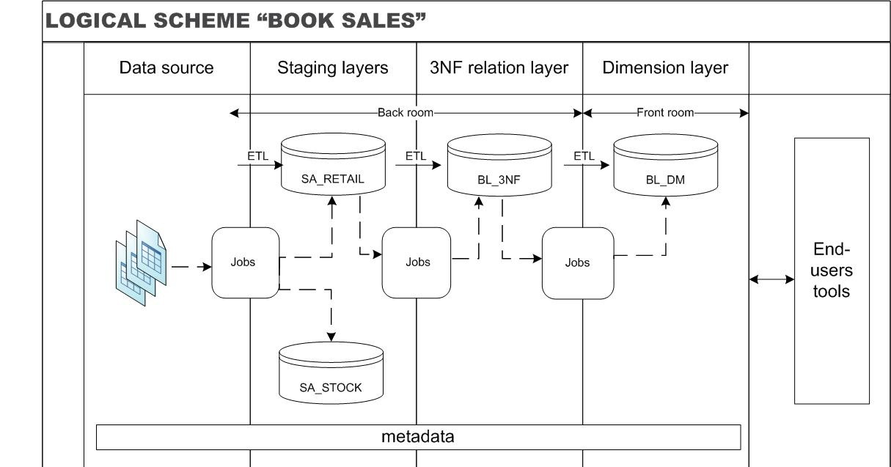

Fig. 3 – Logical model of DWH load

ARCHITECTURE OF DATAWAREHOUSE LOAD

The data flows through the solution as follows:
- The semi-structured data such as CSV files enter the special folder on the server for further analysis and storage
- For each data source prepared a job for loading to Staging layers (fig. 4-5).
- Every job has a component tRunJob which loads parameters for ETL from config file "config.cfg" (fig. 6).

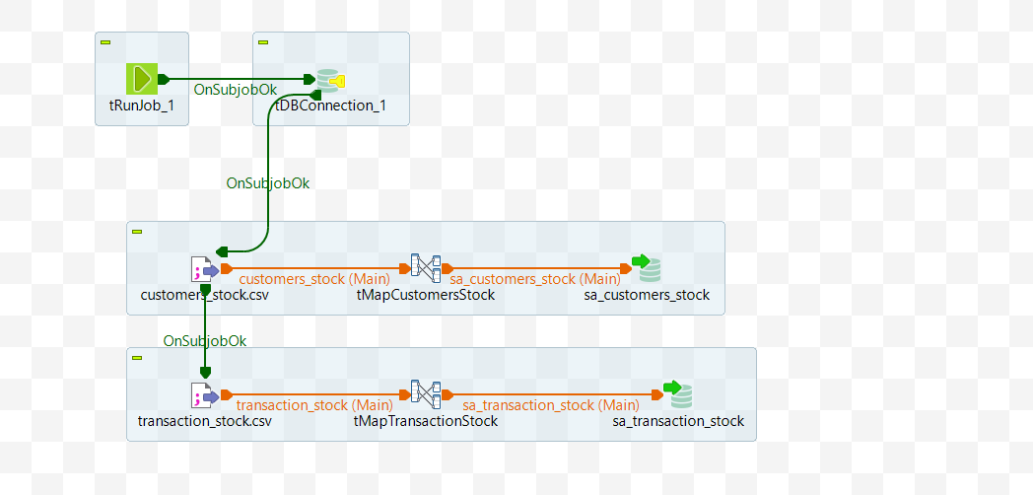

Fig. 4 – Load data to SA_STOCK layer

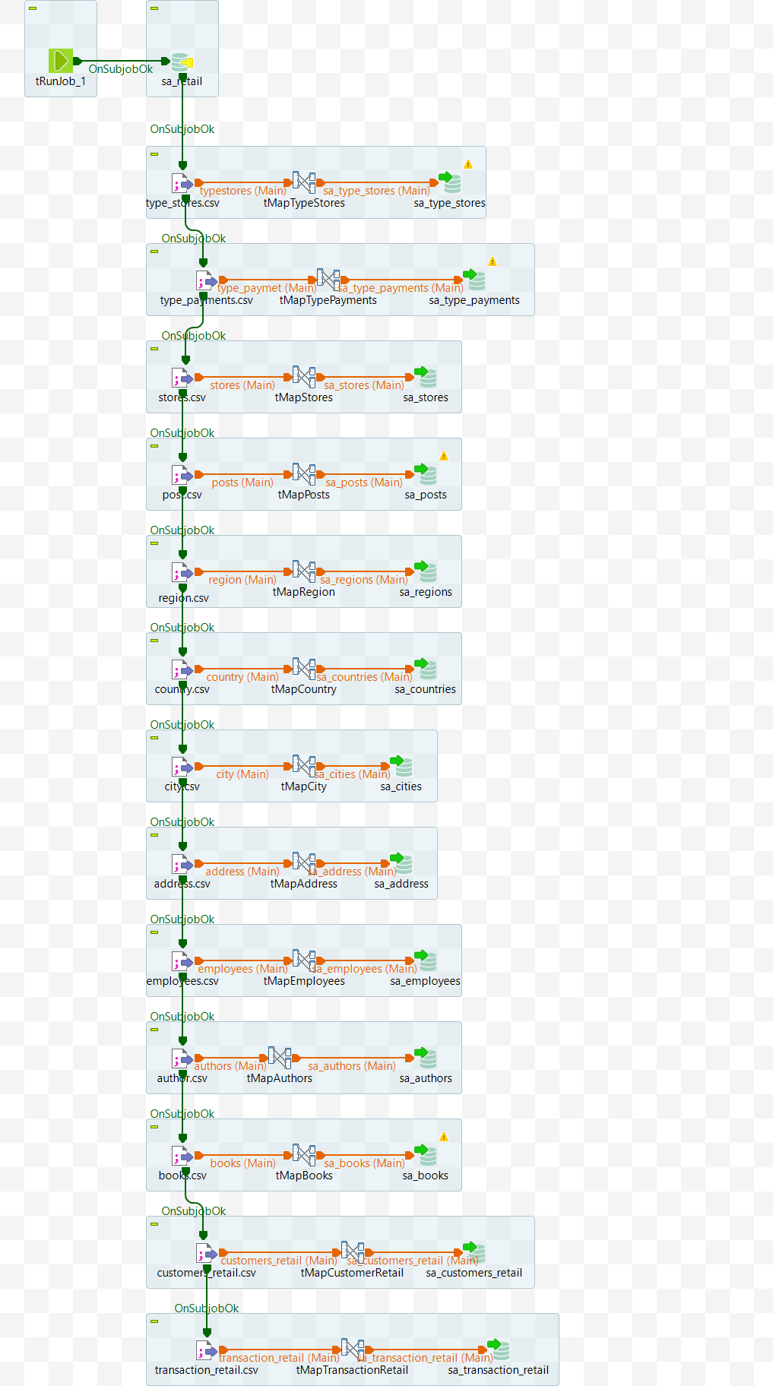
Fig. 5 – Load data to SA_RETAIL layer

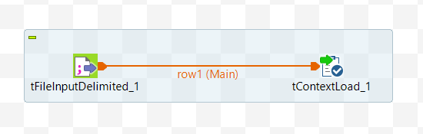

Fig. 6 – Load context from file

- The "load_bl_3nf_layer" job runs consequently jobs for load data on the BL_3NF layer (fig. 7).

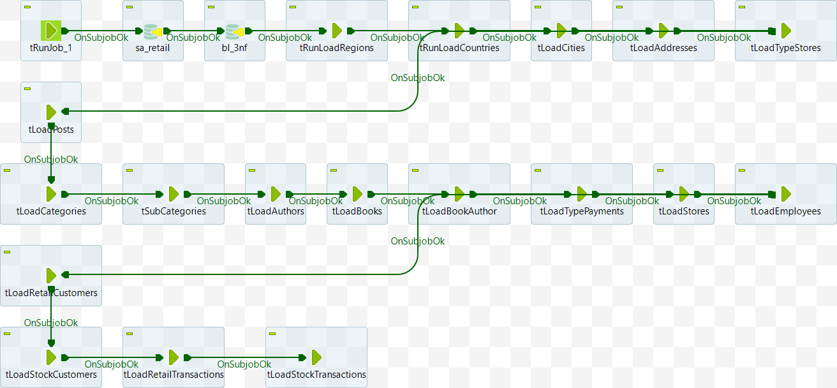

Fig. 7 – Load BL_3NF layer

- The "tRunLoadRegions" job loads the ce_regions table (fig. 8)
*
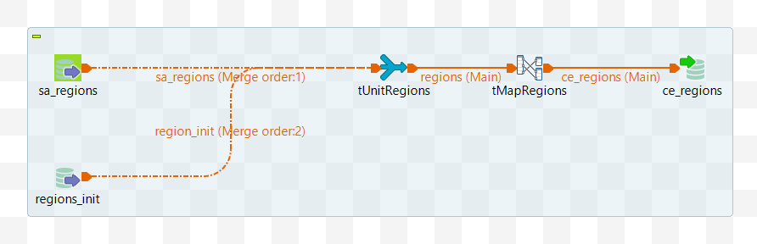
Fig. 8 – Job "process_regions"

- The "tRunLoadCountries" job loads the ce_countries table (fig. 9)

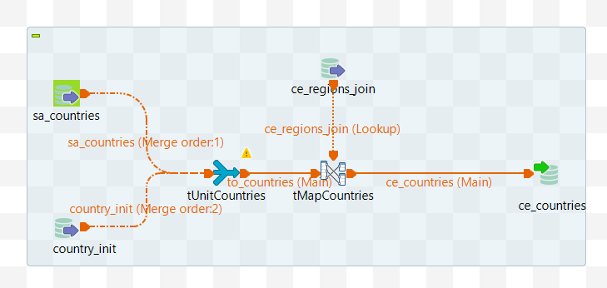
Fig. 9 – Job "process_countries"

- The "tRunLoadCities" job loads the ce_cities table (fig. 10)

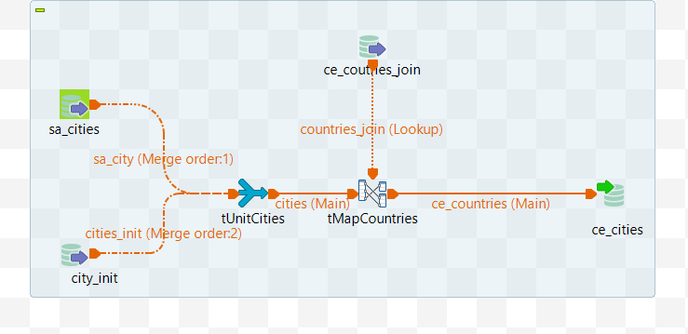
Fig. 10 – Job "process_cities"

- The "tRunLoadAddresses" job loads the ce_addresses table (fig. 11)

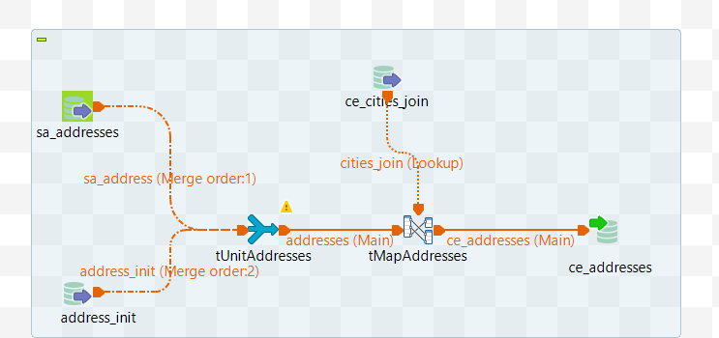
Fig. 11 – Job "process_addresses"

- The "tRunLoadTypeStores" job loads the ce_type_stores table (fig. 12)

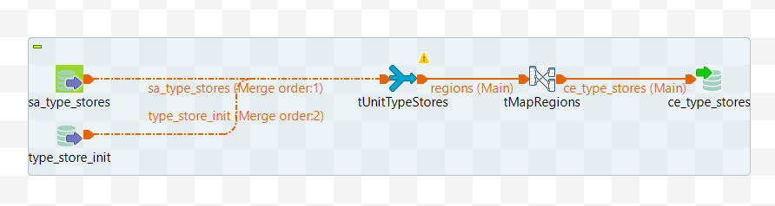
Fig. 12 – Job "process_type_stores"

- The "tRunLoadPosts" job loads the ce_posts table (fig. 13)

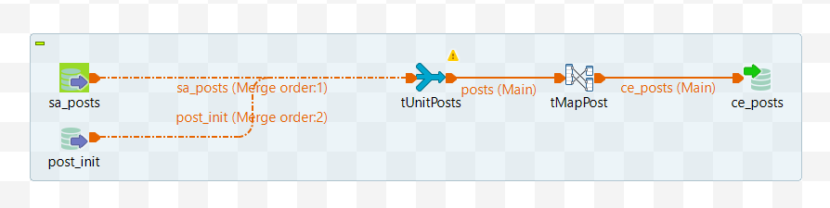
Fig. 13 – Job "process_posts"

- The "tRunLoadCategories" job loads the ce_categories table (fig. 14)

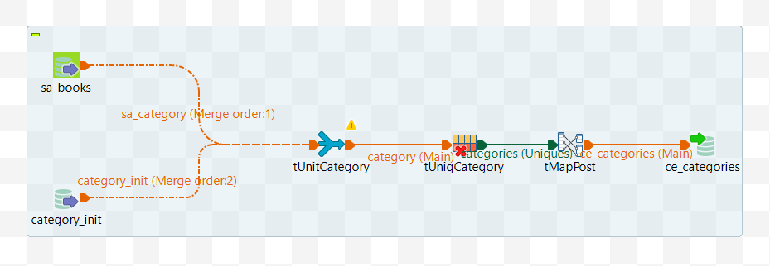
Fig. 14 – Job "process_categories"

- The "tRunLoadSubCategories" job loads the ce_sub_categories table (fig. 15)

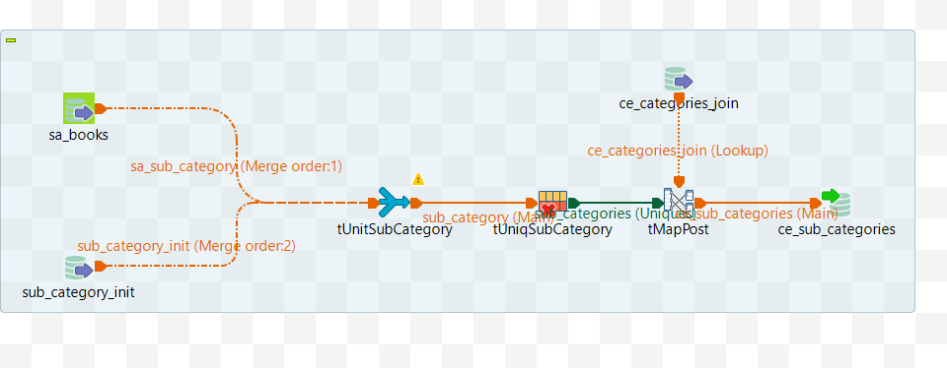
Fig. 15 – Job "process_sub_categories"

- The "tRunLoadAuthors" job loads the ce_authors table (fig. 16)

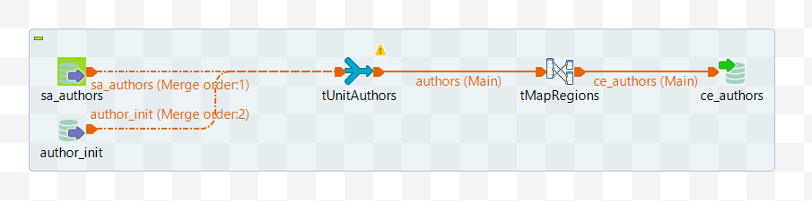
Fig. 16 – Job "process_authors"

- The "tRunLoadBooks" job loads the ce_books table (fig. 17)

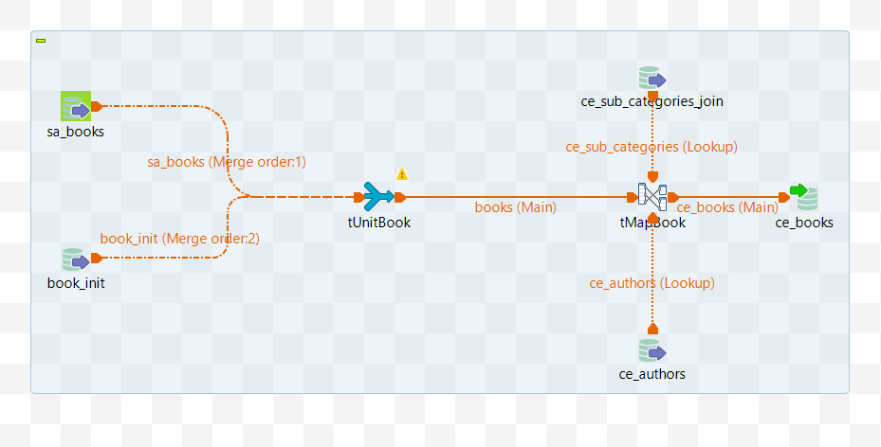
Fig. 17 – Job "process_books"

- The "tRunLoadBookAuthor" job loads the ce_books table (fig. 18)

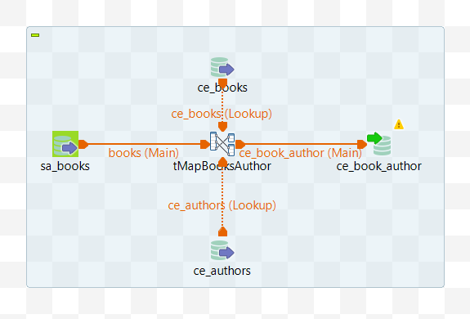

Fig. 18 – Job "process_book_author"

- The "tRunLoadTypePayments" job loads the ce_type_payments table (fig. 19)

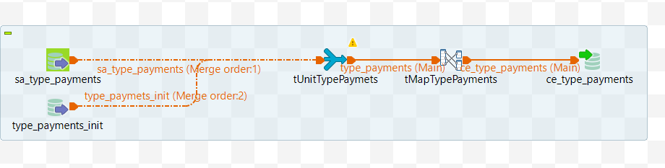

Fig. 19 – Job "process_type_payments"

- The "tRunLoadStores" job loads the ce_stores table (fig. 20)

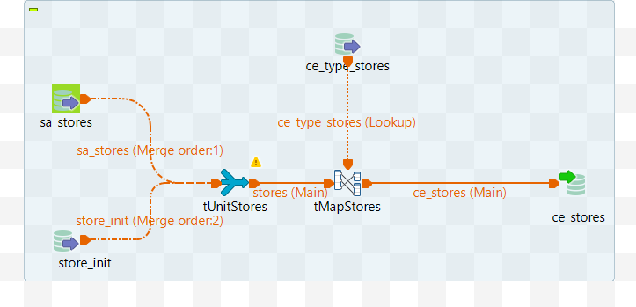

Fig. 20 – Job "process_stores"

- The "tRunLoadEmployees" job loads the ce_employees table (fig. 21)

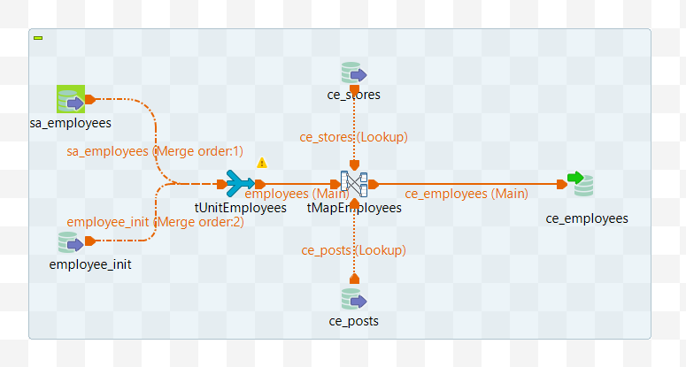

Fig. 21 – Job "process_employees"

- The "tRunLoadRetailCustomers" job loads the ce_customers from SA_RETAIL layer (fig. 22)

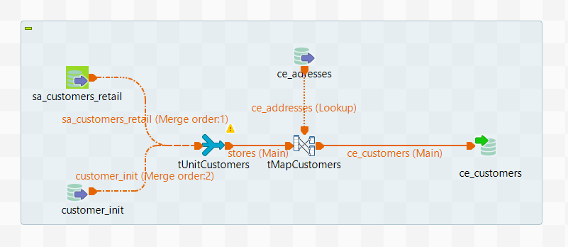

Fig. 22 – Job "process_retail_customer"

- The "tRunLoadStockCustomers" job loads the ce_customers table from SA_STOCK layer (fig. 23)

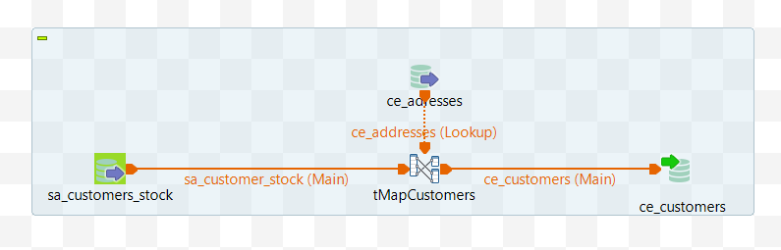

Fig. 23 – Job "process_stock_customer"

- The "tRunLoadRetailTransactions" job loads the ce_sales table from SA_RETAIL layer (fig. 24)

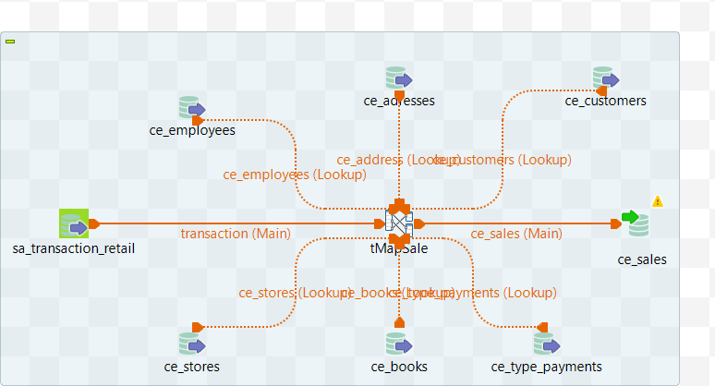

Fig. 24 – Job "process_retail_transactions"

- The "tRunLoadStockTransactions" job loads the ce_sales table from SA_STOCK layer (fig. 25)

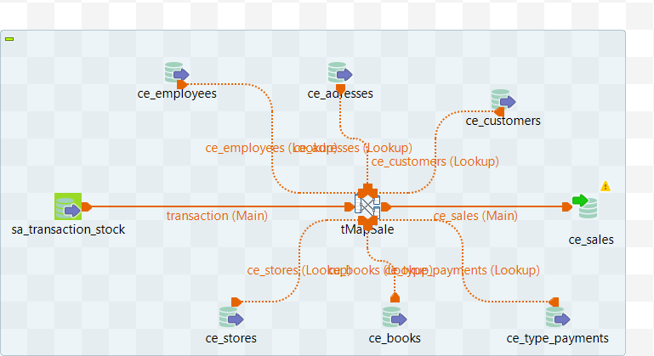

Fig. 25 – Job "process_stock _transactions"

- The "load_bl_dm_layer" job runs consequently jobs for load data from the BL_3NF layer to the BL_DM layer (fig. 26).

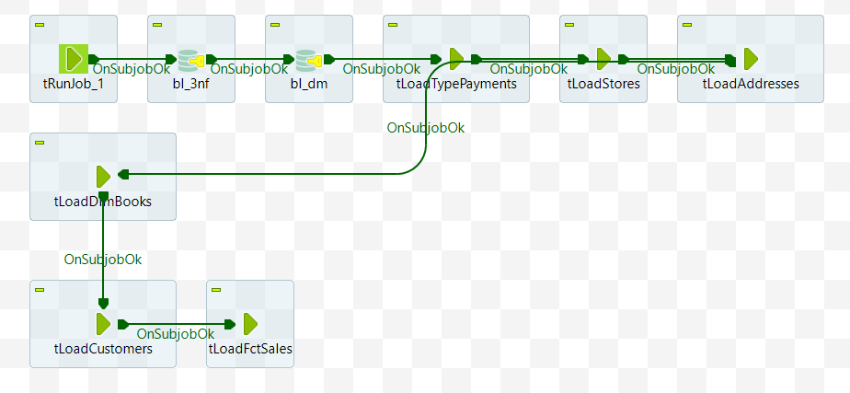
Fig. 26 – Load BL_DM layer

- The "tRunLoadTypePaymets" job loads the dim_type_payments table from BL_3NF layer (fig. 27)

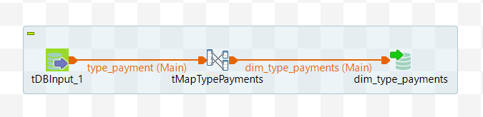

Fig. 27 – Job " process_dim_type_payments"

- The "tRunLoadStores" job loads the dim_stores table from BL_3NF layer (fig. 28)

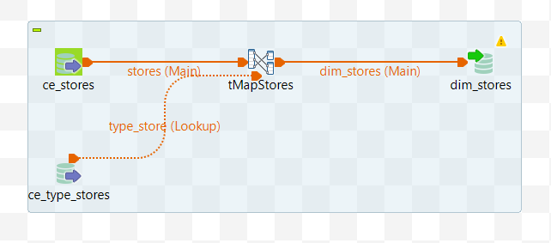

Fig. 28 – Job " process_dim_stores"

- The "tRunLoadAddresses" job loads the dim_addresses table from BL_3NF layer (fig. 29)

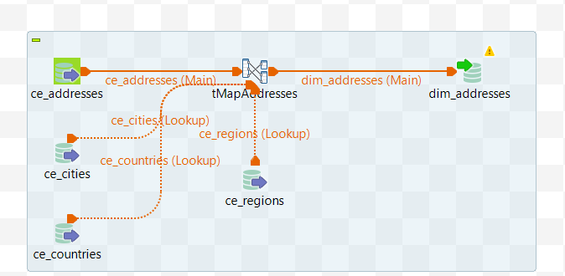

Fig. 29 – Job " process_dim_addresses"

- The "tRunLoadDimBooks" job loads the dim_books table from BL_3NF layer (fig. 30)

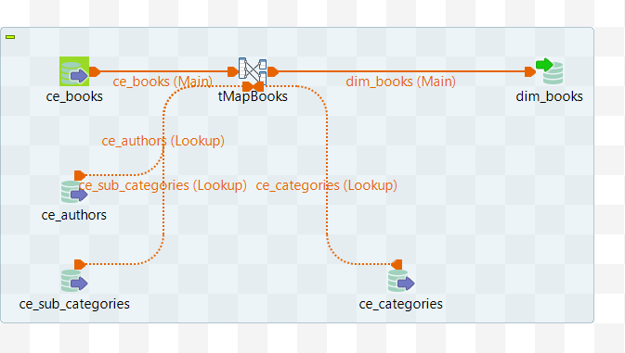

Fig. 30 – Job " process_dim_books"

- The "tRunLoadCustomers" job loads the dim_customers table from BL_3NF layer (fig. 31)

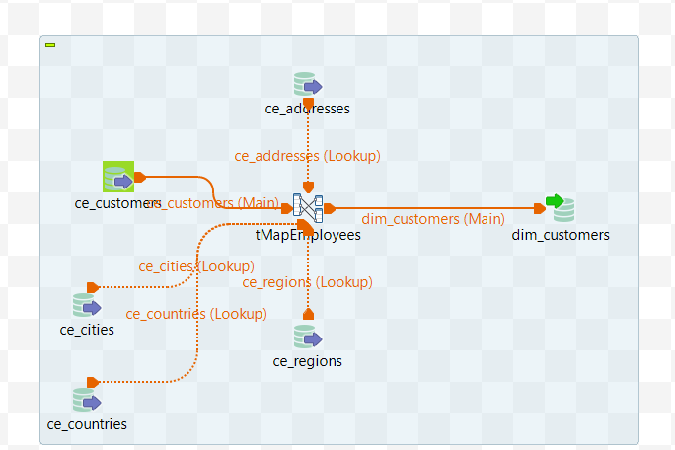

Fig. 31 – Job " process_dim_customers"

- The "tRunLoadFctSales" job loads the fct_sales table from BL_3NF layer (fig. 32)
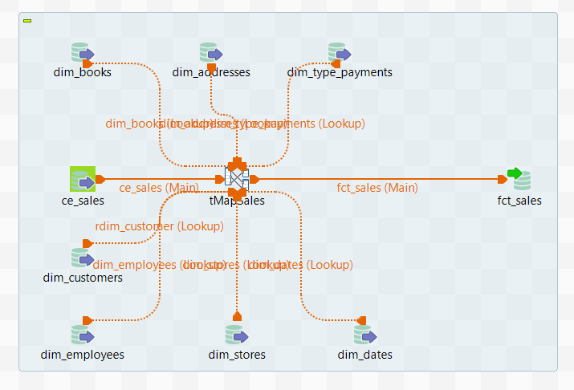

Fig. 32 – Job " process_fct_sales"

