VaultAgent DOCX Fixture
这是用于 VaultAgent 导入验证的固定 Word 样本。它包含普通段落、基础表格和一张内嵌图片。

Document Content
导入器应保留段落顺序、标题层级和表格单元格内容，并为内嵌图片建立可追踪的来源关系。

Structured Notes
- Source format: DOCX
- Expected locator: headings, paragraphs, table cells, and image relationship
Element | Fixture Value | Expected Parser Result
Paragraph | 优先保留段落顺序。 | paragraph locator
Table | 基础三列表格 | table cell locator
Image | 嵌入 PNG | image relationship

Embedded Fixture Image
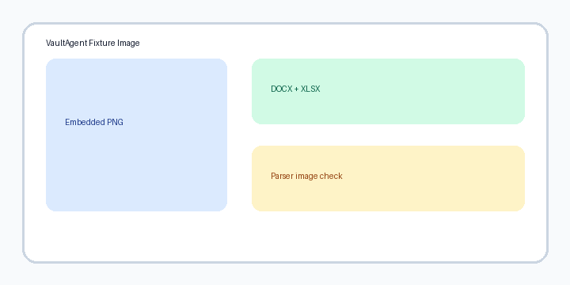
Figure 1. Deterministic embedded image for parser verification.

