**Recommendation System For Domain and Events**

Made by: Elita Menezes

(Machine Learning Intern)

Project Manager: Jayanth G S

1. **Design Model**

The project is divided into 2 main parts:

1. To train the model to classify the events and domains.

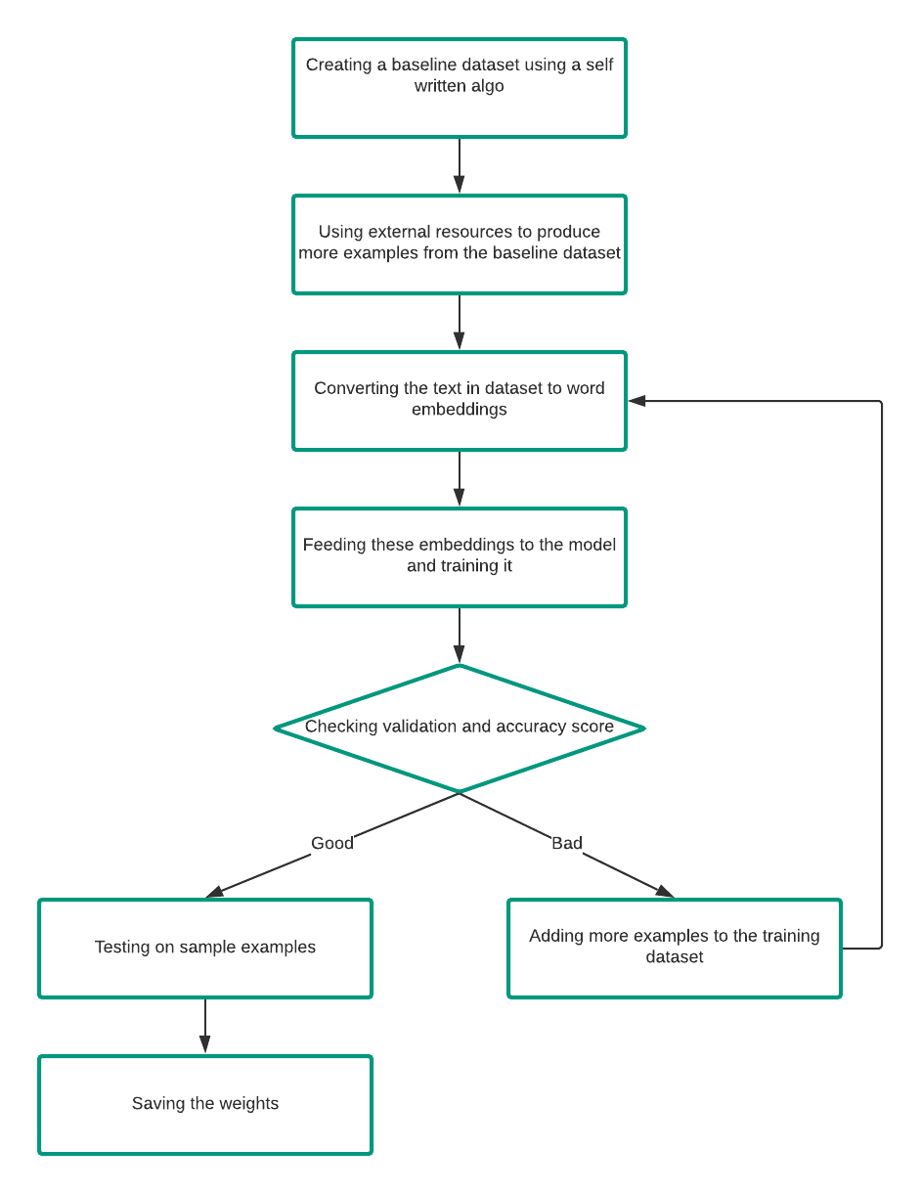

1. Using this trained model to classify the same, get employees matching the criteria from the database and produce a csv file of the same.

