How to edit and contribute subtitles on youtube
-- community contributions have to be allowed for the video by the video owner; use MT talk videos as a test: https://www.youtube.com/playlist?list=PLpiLOsNLsfmbeH-b865BwfH15W0sat02V)`

First, find the video and login with your google account. Click on the … symbol and then add translations.
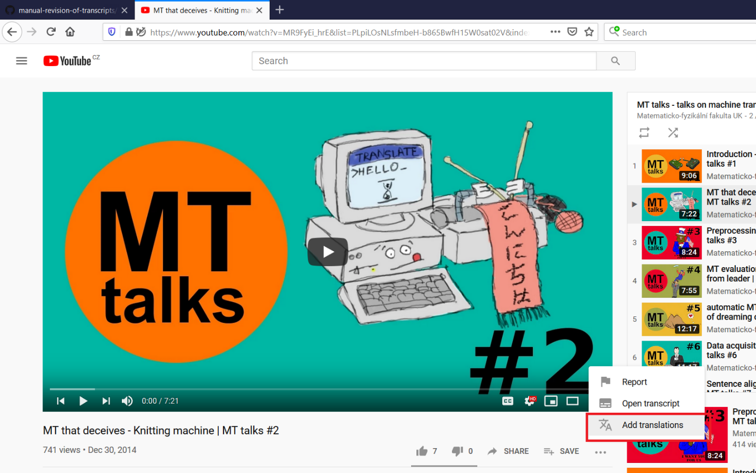

Here, you can edit the subtitles. Click on “Keyboard shortcuts” to display the list of very useful shortcuts that you should use. The shortcuts make editing quite intuitive and easy once you learn them. After you finish, make sure to click Submit contribution and “Yes, they are finished”, otherwise the video owner won’t be able to see your contribution.
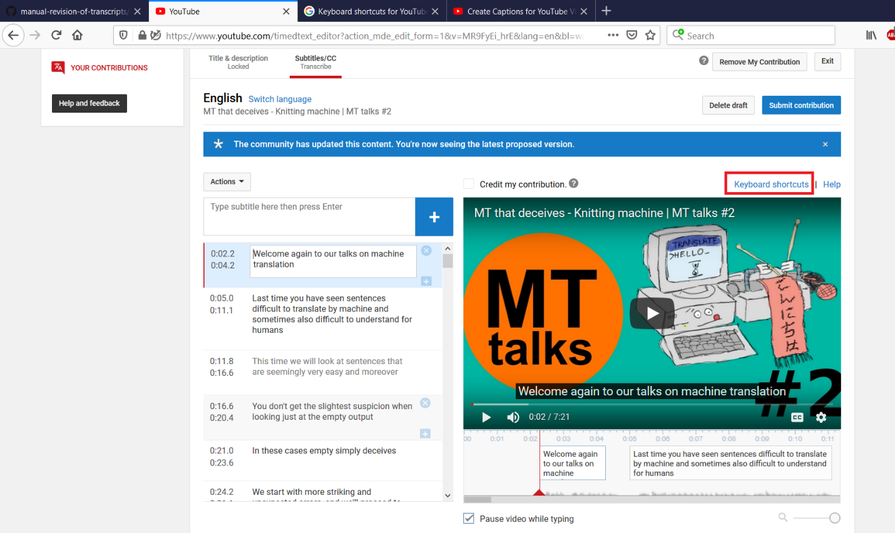

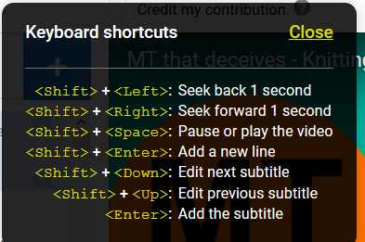

After your edit, make sure you see “submitted” and “Remove My Contibution” messages.
