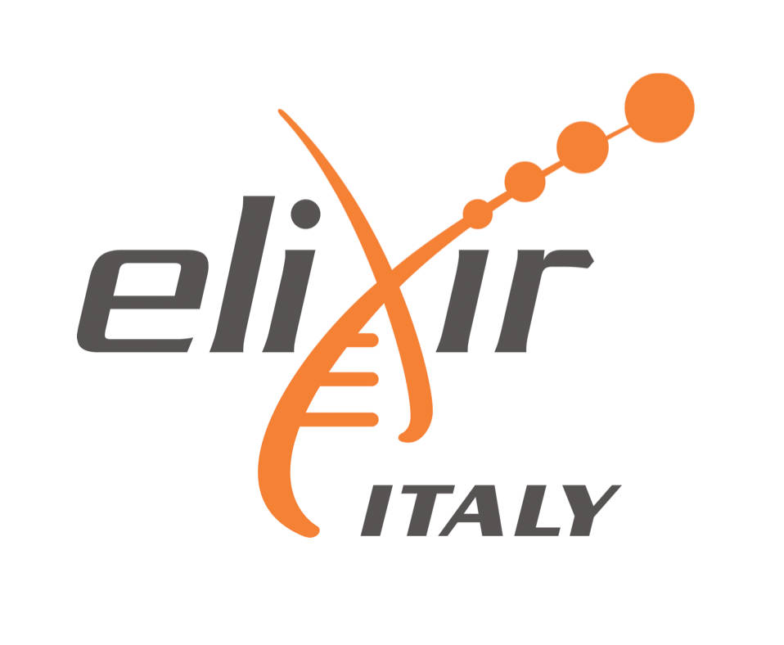

This is to certify that

.........................................................................................................

attended the lectures of the course organised by ELIXIR-ITA in collaboration with the University of Bologna

on

**Protein Networks and Systems Biology**

during the period 14-18 December 2015

Bologna, 18th December 2015

..........................................................................

ELIXIR-ITA Training Coordinator