Complete Application Setup with Kubernetes Components

**APPLICATION:**

mongo-express(Front-end) and mongo-DB(back-end)

**Kubernetes Components:**

* 2 Deployment/PODS
* 2 services
* 1 CONFIG map
* 1 secret

**Browser request flow (Through K8s):**

External URL: http://< IP Address of Node>:<Port of external service>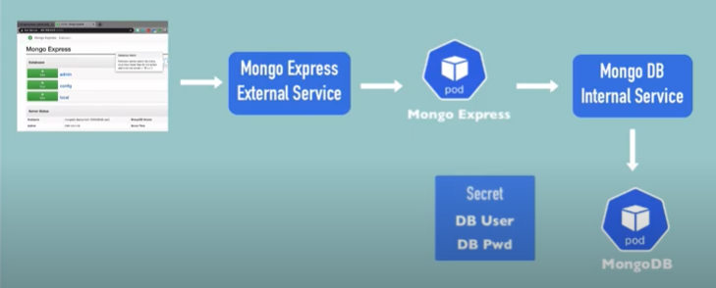

Internal Config Map DB URL:

Step1: Verification Command:

Kubectl get all

Step2: Creating MongoDB:

Go to docker hub <https://hub.docker.com/> and search for mongo

Go to the sections: Connect to MongoDB from another Docker container and environment variables. Add ports and env to the standard deployment.yaml file. To avoid plain text for username and password create secrets. Please do not type plain text username and password in yaml file. To encrypt the username and password go to unix termial and generate the encrypted username and password.

### Creating mongo-db.secrets.yaml file

Creating encrypted username and password using Unix server.

echo -n ‘username’ | base64

xxxxxxxxxx

echo -n ‘password’ | base64

yyyyyyyyyy

Using the encryption output create mongo-db.secrets.yaml (use the scretes.yaml template)

kubectl apply -f mongo-db.secrets.yaml

kubectl get secret

### Creating create mongo-db.yaml file

Take the deployment.yaml template and thencreate mongo-db.yaml using mongo db image in dockerhub and update the env section as like shown below giving reference to mongo-db.secrets created earlier.

env:

- name: MONGO_INITDB_ROOT_USERNAME

valueFrom:

secretKeyRef:

name: mongodb-secret

key: mongo-root-username

- name: MONGO_INITDB_ROOT_PASSWORD

valueFrom:

secretKeyRef:

name: mongodb-secret

key: mongo-root-password

kubectl apply -f mongo-db.yaml

kubectl get pod –watch

kubectl get all |grep mongo ** You should see 3 things pod, deployment and replicaset.

kubectl get pod -o wide

Kubectl describe pod <pod_name>

### Creating mongodb internal service

In the create mongo-db.yaml file add another document for mongodb internal service because mongodb internal service and mongodb belong together.

Add --- lines to separate two documents and then the services yaml template

kubectl apply -f mongo-db.yaml

kubectl get service

kubectl describe service <service_name>

Step3: Creating Mongo-Express:

Go to docker hub <https://hub.docker.com/> and search for mongo-express. Check for the port and environment variables. Three environment variables are important. 1) database to connect (ME_CONFIG_MONGODB_SERVER) 2) username (ME_CONFIG_MONGODB_ADMINUSERNAME) 3) password(ME_CONFIG_MONGODB_ADMINPASSWORD).

Use the standard deployment.yaml and make the necessary changes for image, label and container. Add port and env sections. For username and password env section, use the secrets created earlier. For db server create ‘configmap’ to avoid hard coding. In the configmap use clusterserivce url name (mongodb-service).

The order of execution is important. Before creating Mongo-Express deployment, configmap should be created because Mongo-Express deployment is having reference to configmap.

### Creating configmap

kubectl apply -f mongo-configmap.yaml

kubectl get ConfigMap

kubectl describe ConfigMap mongodb-configmap

### Creating mongo-express

kubectl apply -f mongo-express.yaml

kubectl get pods

kubectl logs <podname>

Server is open to allow connections from anyone (0.0.0.0)

basicAuth credentials are "admin:pass", it is recommended you change this in your config.js!

Step3: Creating external service to access Mongo-Express:

*Add 2nd document to the mongo-express yaml file and create a service with type as loadbalancer. Add Nodeport in the range of 30000-32767.*

*kubectl apply -f mongo-express.yaml*

*kubectl get service*

*NAME TYPE CLUSTER-IP EXTERNAL-IP PORT(S) AGE*

*kubernetes ClusterIP 10.96.0.1 <none> 443/TCP 154m*

*mongo-exporess LoadBalancer 10.102.37.160 <pending> 8081:30000/TCP 10s*

*mongodb-service ClusterIP 10.106.210.251 <none> 27017/TCP 64m*

conclusion:

*browser 🡪 Mongo Express External Service 🡪 Mongo Express Pod 🡪 Mongo DB Internal Service 🡪 Mongo DB Pod.*

References:

<https://cheatsheet.dennyzhang.com/kubernetes-yaml-templates>

*mongo-configmap.yaml*

*mongo-db.deployment.yaml*

*mongo-db-Secrets.yaml*

*mongo-express.yaml*