# Regression-Classification_MLP

Part one regression:

Model :
in this part I have used a simple Regression model there is its description :
The RegressionModel is the class who implement a simple neural network designed for regression tasks. Here's a description of its components:
1. Input Layer:
◦ Accepts an input tensor with a size corresponding to the number of input features (n_inputs).
2. First Hidden Layer (hidden1):
◦ A linear layer that transforms the input features into a higher-dimensional space represented by hidden_size.
◦ Introduces non-linearity through the weights and biases learned during training.
3. Activation Function (act1):
◦ Applies the sigmoid activation function element-wise.
◦ Introduces non-linearity to the model, allowing it to capture complex relationships in the data.
4. Second Hidden Layer (hidden2):
◦ Another linear layer that maps the output of the first hidden layer to a single output (1).
◦ This layer produces the final prediction for regression tasks.
5. Forward Pass:
◦ The forward method defines the forward pass of the model.
◦ Input data passes through the first hidden layer, followed by the sigmoid activation function, and then through the second hidden layer to generate the final regression output.

GridSearch :

Grid Search is a hyperparameter tuning technique used to systematically search through a predefined set of hyperparameter values for a machine learning model. The objective is to find the combination of hyperparameters that yields the best performance on a specific evaluation metric, typically through cross-validation.

For implement this technique I have integrate the class PyTorchWrapper

The PyTorchWrapper class serves as a bridge between PyTorch models and the scikit-learn ecosystem, allowing PyTorch models to be seamlessly integrated into scikit-learn's grid search and other functionalities. Here's a general overview of its role:
1. Compatibility with scikit-learn:
◦ Inherits from BaseEstimator and RegressorMixin, making it compatible with scikit-learn's estimator interface.
◦ This allows it to be used in scikit-learn pipelines, grid searches, and other utilities.
2. Model Configuration:
◦ Takes essential components for training a PyTorch model as parameters during instantiation, such as the PyTorch model itself, loss function (criterion), optimizer, batch size, epochs, and learning rate.
3. Training and Prediction:
◦ The fit method takes input data and target variables, converts them into PyTorch tensors, and trains the PyTorch model using the specified parameters.
◦ The predict method takes input data and performs predictions using the trained PyTorch model.
4. Integration with scikit-learn Grid Search:
◦ The class is designed to be used within scikit-learn's GridSearchCV for hyperparameter tuning.
◦ It facilitates the search for optimal hyperparameters by defining a parameter grid and handling the training and evaluation processes.
5. Parameter Configuration:
◦ Provides a set_params method to dynamically update hyperparameters, making it flexible for use in different scenarios.

After training :

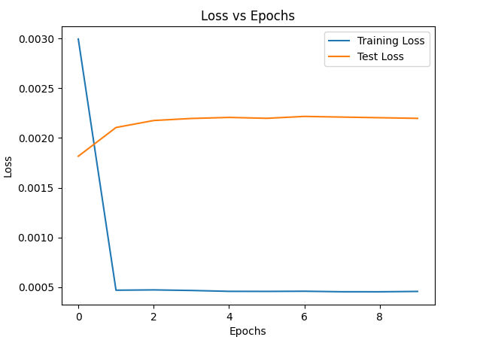

Regularization :

I have used the droupout technique :

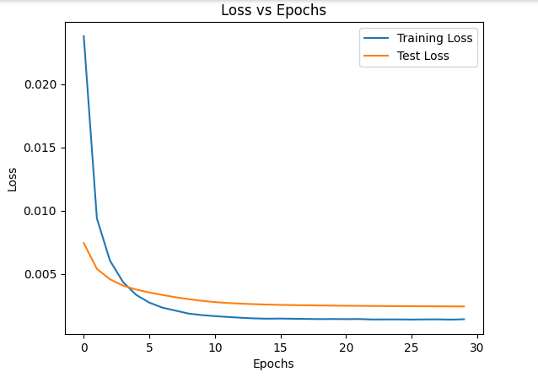

Part two multi class classification:

I have used a multiclass MLP using the softmax activation function there is the architecture of the model :

Input Layer:
◦ Accepts an input with a specified number of features (n_inputs).
◦ Represents the initial layer where input data is fed into the neural network.
2. First Hidden Layer (hidden1):
◦ A linear layer with 10 neurons.
◦ Employs the Rectified Linear Unit (ReLU) activation function after the linear transformation.
◦ Utilizes Kaiming Uniform initialization to initialize weights, which is beneficial for networks with ReLU activations.
◦ Incorporates dropout with a dropout rate of 0.2, introducing regularization to prevent overfitting during training.
3. Second Hidden Layer (hidden2):
◦ A linear layer with 8 neurons.
◦ Applies the ReLU activation function after the linear transformation.
◦ Utilizes Kaiming Uniform initialization for weight initialization.
4. Output Layer (hidden3):
◦ A linear layer with 3 neurons, indicating it is designed for a multi-class classification task with three output classes.
◦ Employs the Softmax activation function along the second dimension, producing class probabilities.
◦ Uses Xavier (Glorot) Uniform initialization for weight initialization.
Forward Pass:
• The forward method defines how input data passes through the layers during the forward pass.
• Input data flows through the first hidden layer with ReLU activation and dropout.
• The output of the first hidden layer is then processed by the second hidden layer with ReLU activation.

