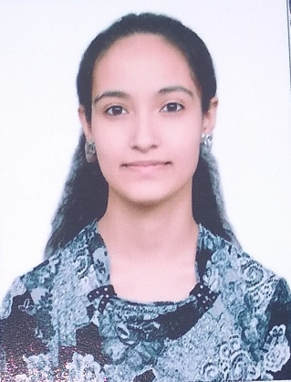

Ashneet kaur

Shastri colony, Ambala Cantt, Haryana

100331

+91-9729268040

[ashneet007kaur@gmail.com](mailto:ashneet007kaur@gmail.com)

**CAREER OBJECTIVES**

To pursue in an environment of growth and excellence where I can use my capabilities through sincerely dedication in earned job that would help me to achieve personal goals as well as organizational goals.

**EDUCATIONAL QUALIFICATIONS**

|  |  |  |  |  |
| --- | --- | --- | --- | --- |
| **Year** | **Degree** | **School/Institute** | **Board/University** | **%age/CGPA** |
| 2019-22 | Bachelors of Business Administration | CGC College of Business Administration, Landran | Punjab Technical University | 8.18 CGPA (upto 3rd sem) |
| 2018-19 | 10+2 | Major R.N. Kapoor D.A.V. Senior Secondary Public School, Ambala Cantt, Haryana | CBSE | 70% |
| 2016-17 | Matric | Major R.N. Kapoor D.A.V. Senior Secondary Public School, Ambala Cantt, Haryana | CBSE | 10 CGPA |

**COURSE WORK**

* Google Data Analytical E-learning course (Foundations: Data, Data, Everywhere) from coursera
* Fundamentals of accounting E-learning course (Understanding Financial statements: Company position) from coursera
* Excel for beginners E-learning course from Great learning
* Excel for intermediates E-learning course from Great learning

**INTERPERSONAL SKILLS**

* Ability to listen someone and then giving ideas to him/her.
* Ability to communicate with people in a confident way.
* Ability to handle the problems with positive attitude and in less time.
* Ability to work in a team and set up trust.

**HOBBIES/INTERESTS**

* Making still life and composition Paintings
* Listening to music
* Playing badminton
* Working on Microsoft applications

**PERSONAL INFORMATION**

**Date of Birth** : 07 October, 2001

**Gender / Marital Status**: Female / Single

**Language Proficiency**: English, Hindi

**DECLARATION**

*I do hereby declare that the above information is true to the best of my knowledge****.***

**_**Ashneet**_***(Signature)*

**Name:** Ashneet Kaur

**Date: 11/8/2021 Place: Ambala cantt**