Project Summary :
V-G.O.R. - The Gardening Robot
(September 2017 – May 2018)

Overview
This project was completed in the span of 8 months, as a capstone project for a 3-year tech degree.
“V-G.O.R., the (Vegetable) Garden Operating Robot, is a project aimed at making gardening easier and more efficient, without fully stripping away interactivity.” (project proposal)

Features
- Small robotic unit autonomously places seeds, waters plants, and removes weeds.
- The unit communicates data back to the owner regarding the state of the unit & garden.
- Combines compact size, with price effectiveness and efficiency.

Hardware Design
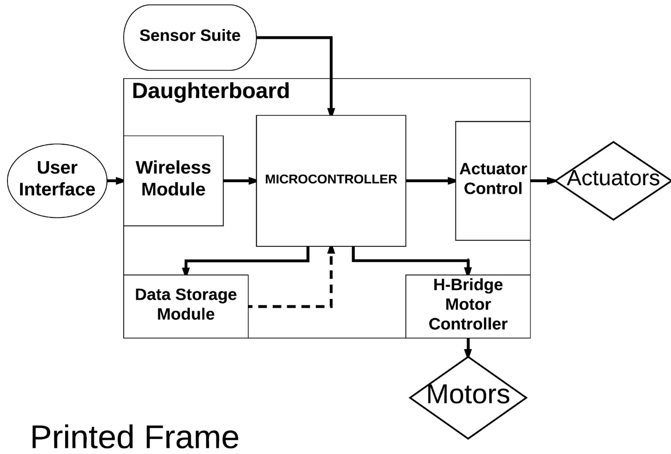
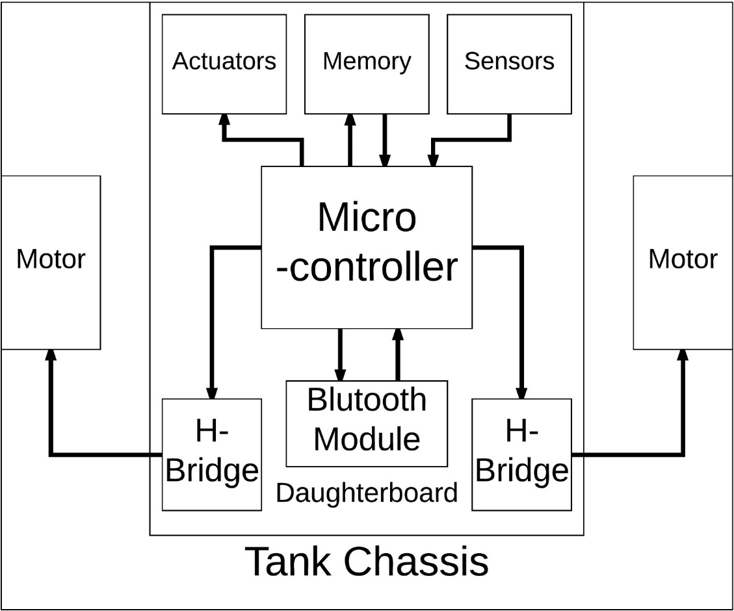
Materials used (partial list):
- STM Nucleo Microcontroller
- Tracked Robot Chassis
- Bluetooth Module
- H-bridge Motor Control Circuits
- Distance + Color Sensor

Software Design
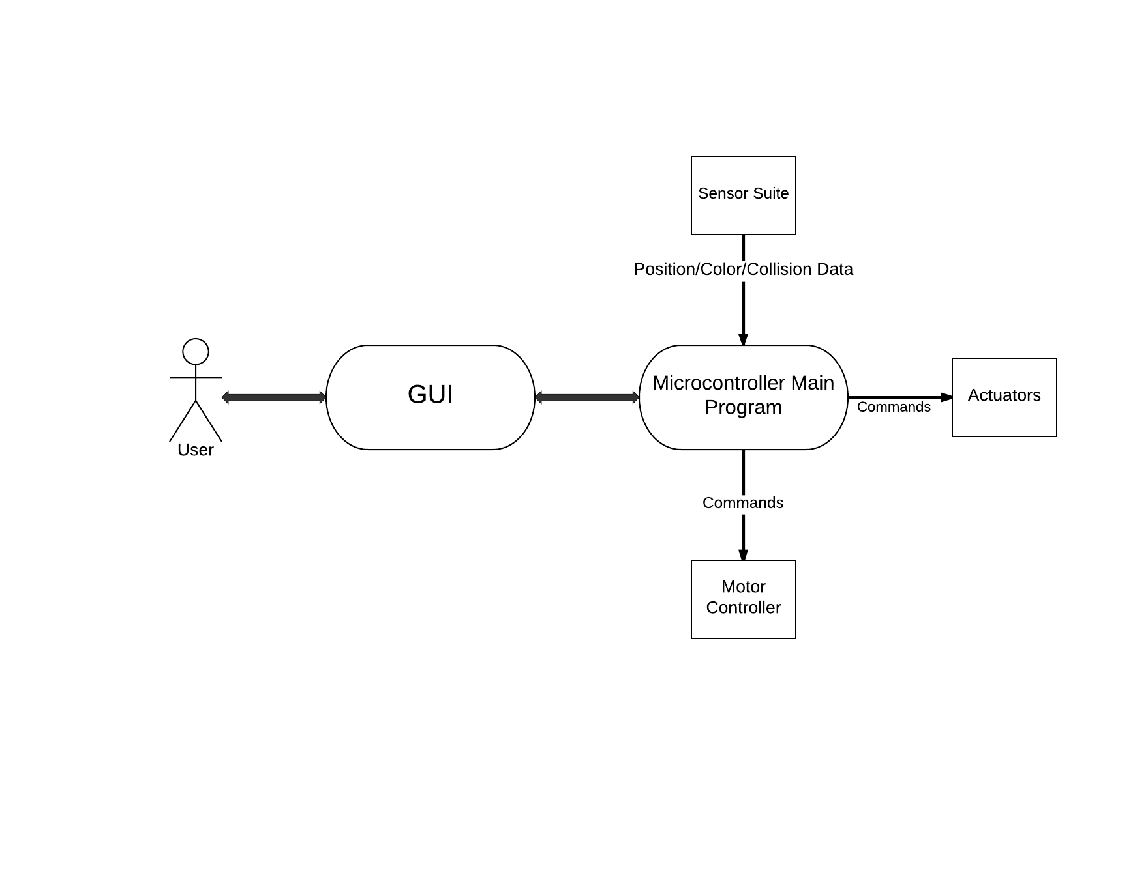
← Use-case diagram
- Android App;
- Serial Bluetooth communication;
- Data collection;
- Automation profiles & calibration;
- Optional “RC car-style” manual override.

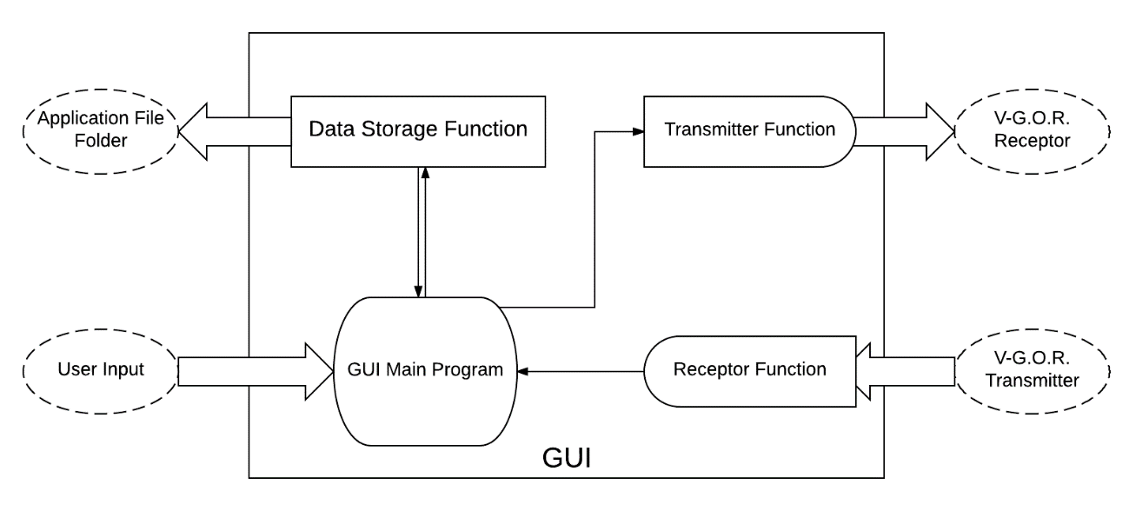
Graphical User Interface – Block Diagram:
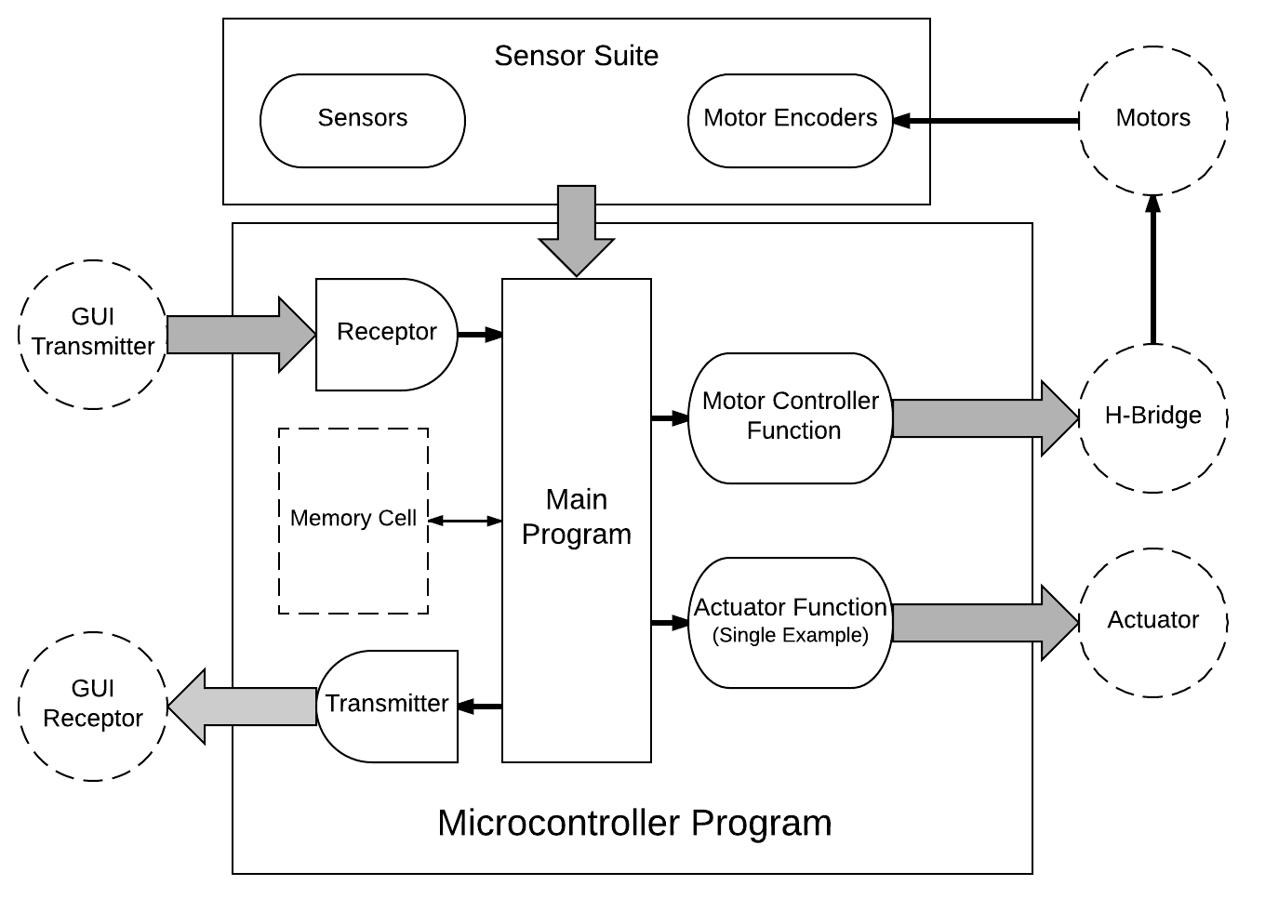

Firmware Block Diagram →

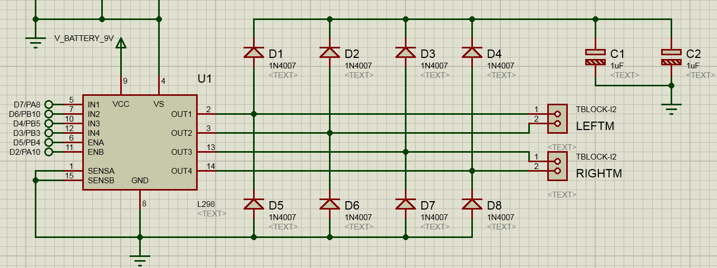
Implementation
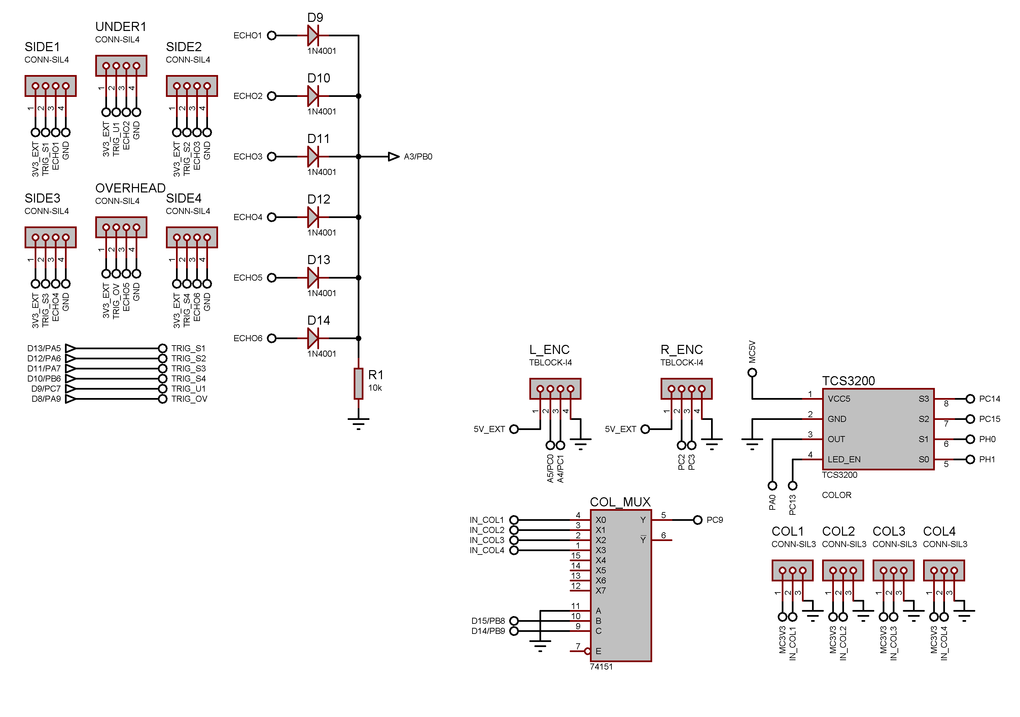

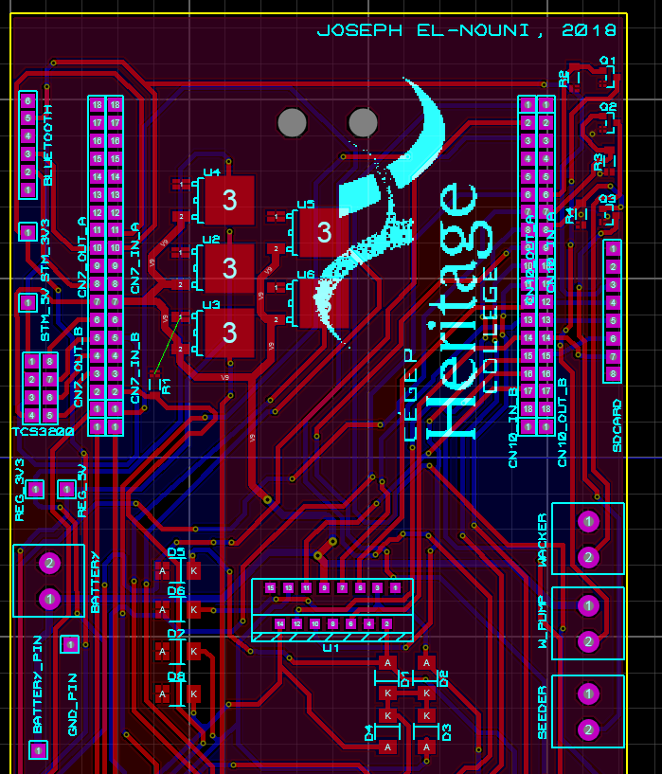
- Circuits & Prototype are turned into a PCB.
- The PCB is a “shield” for the Microcontroller.
- It is mounted to the chassis along with a battery.
- Data is recorded in an SD Card “black box”.
- It is gradually transferred to the Android Application.
- A control system adjusts for equal speed of both motors.
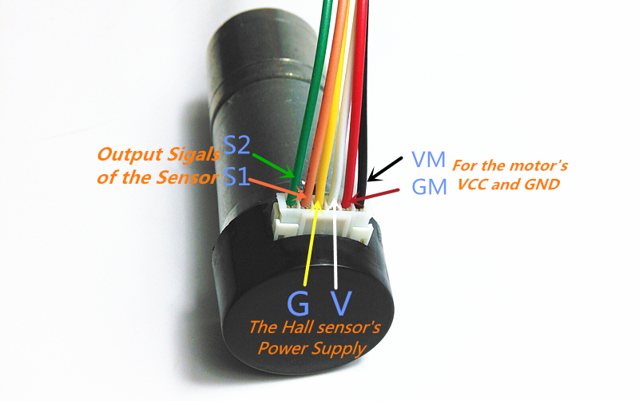
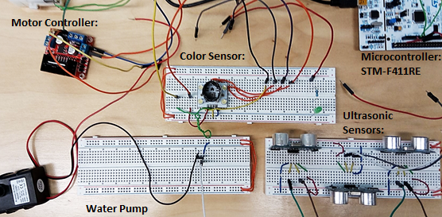
Results

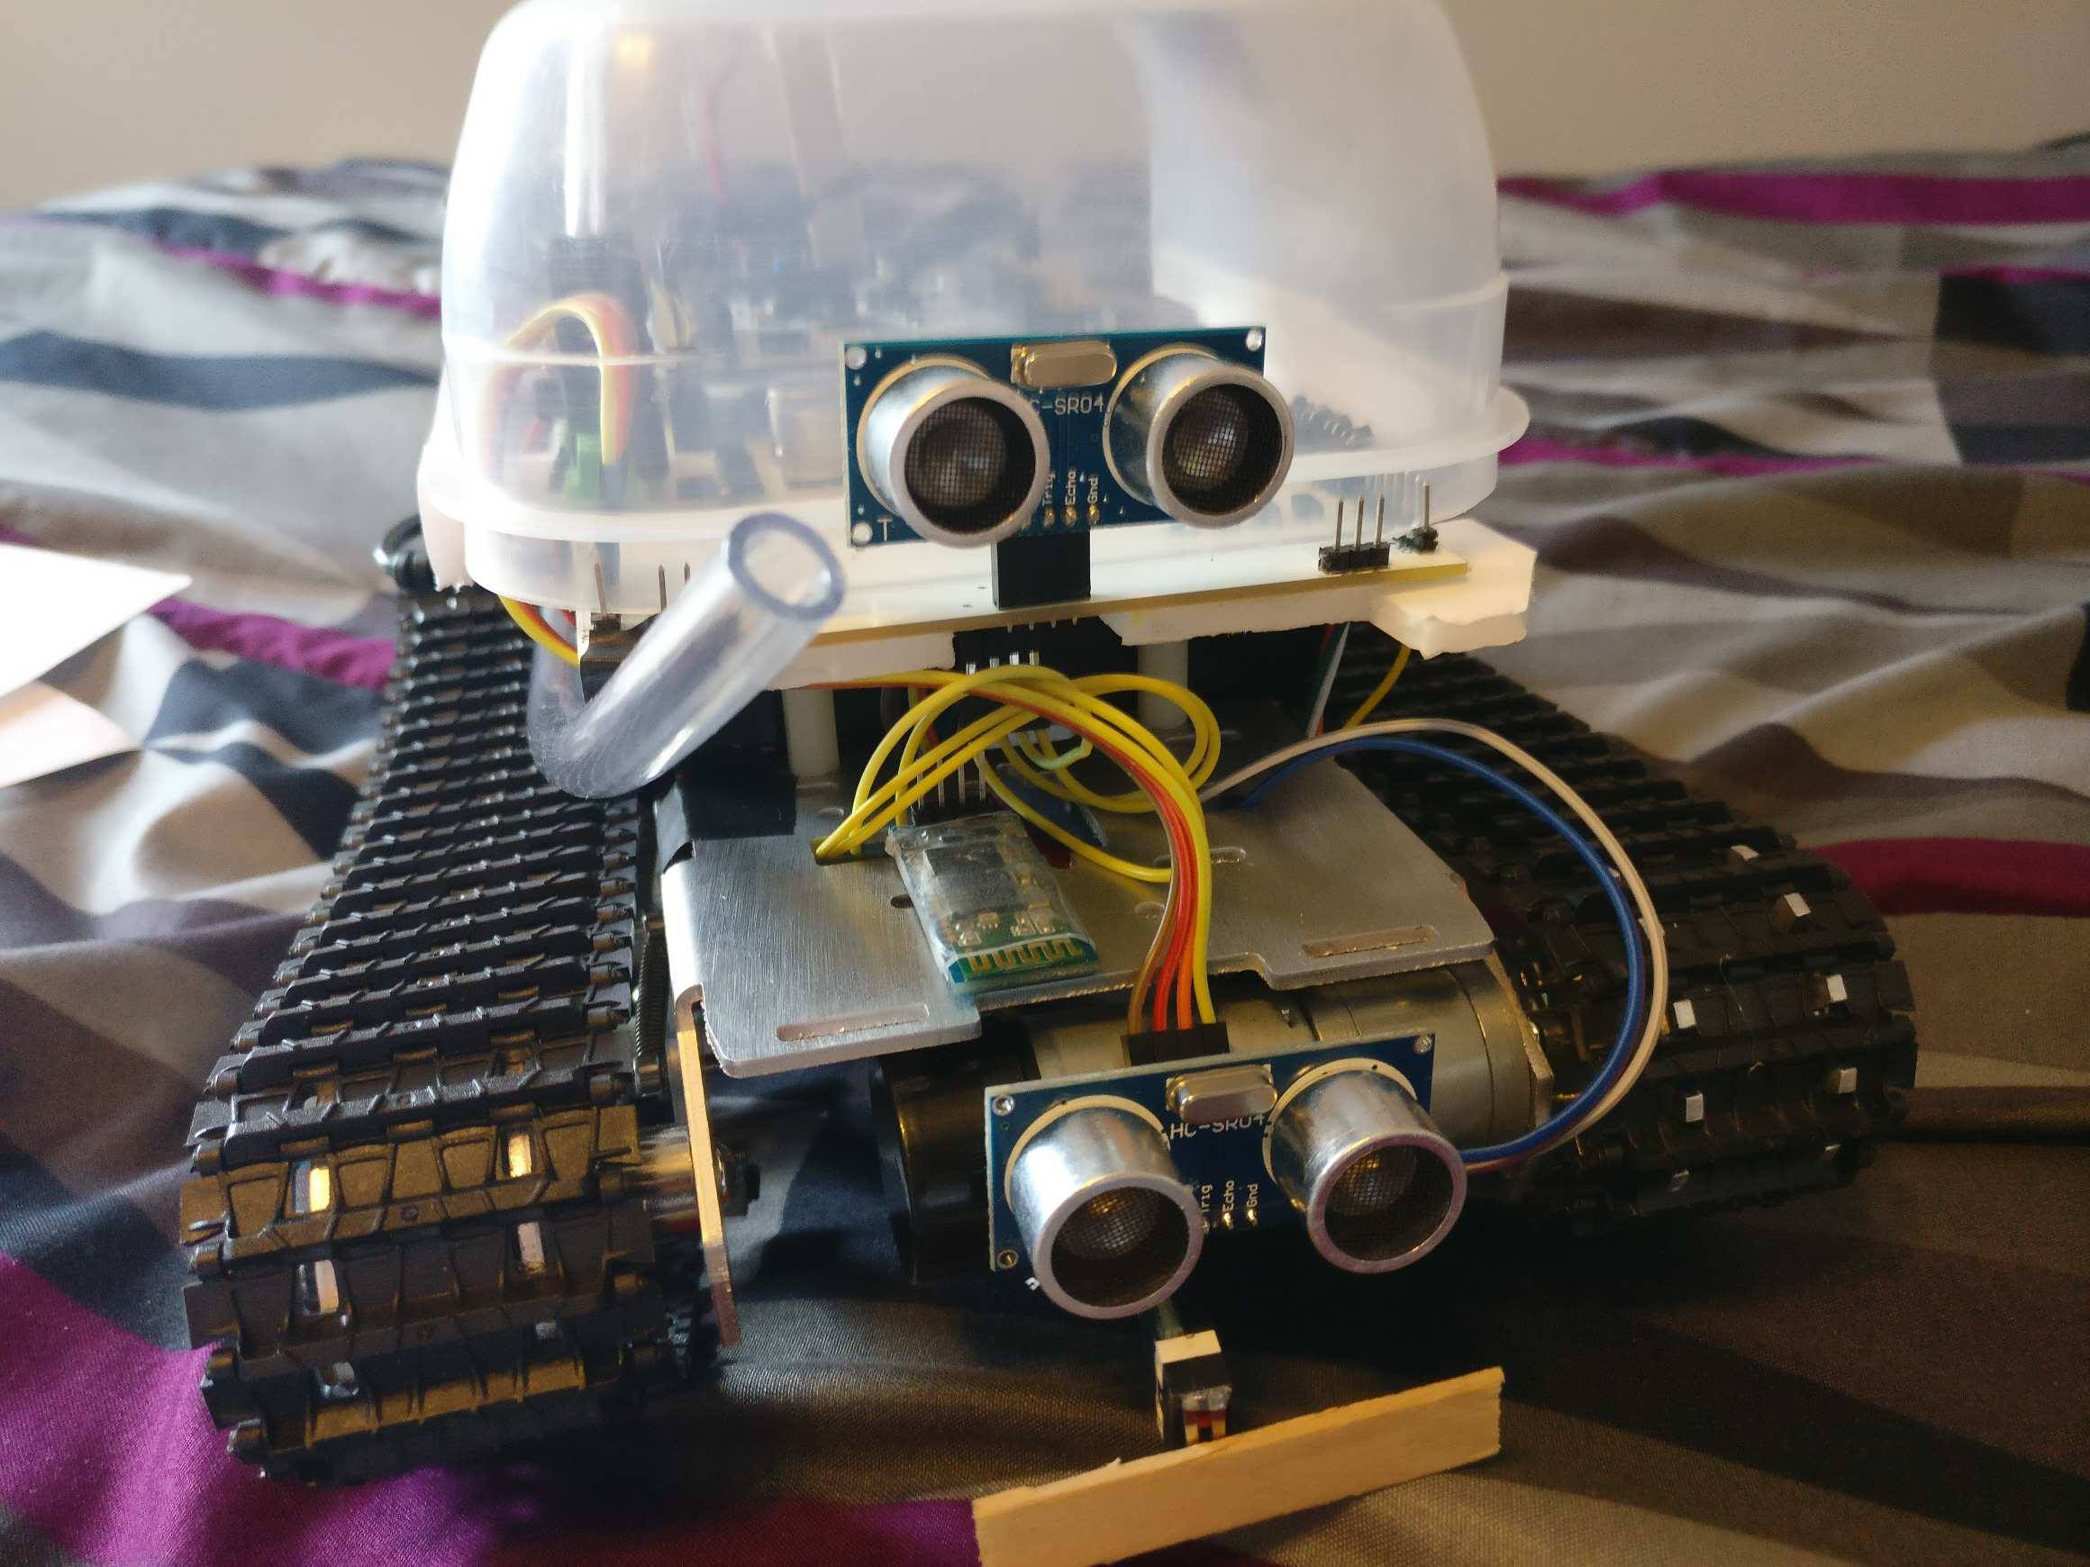
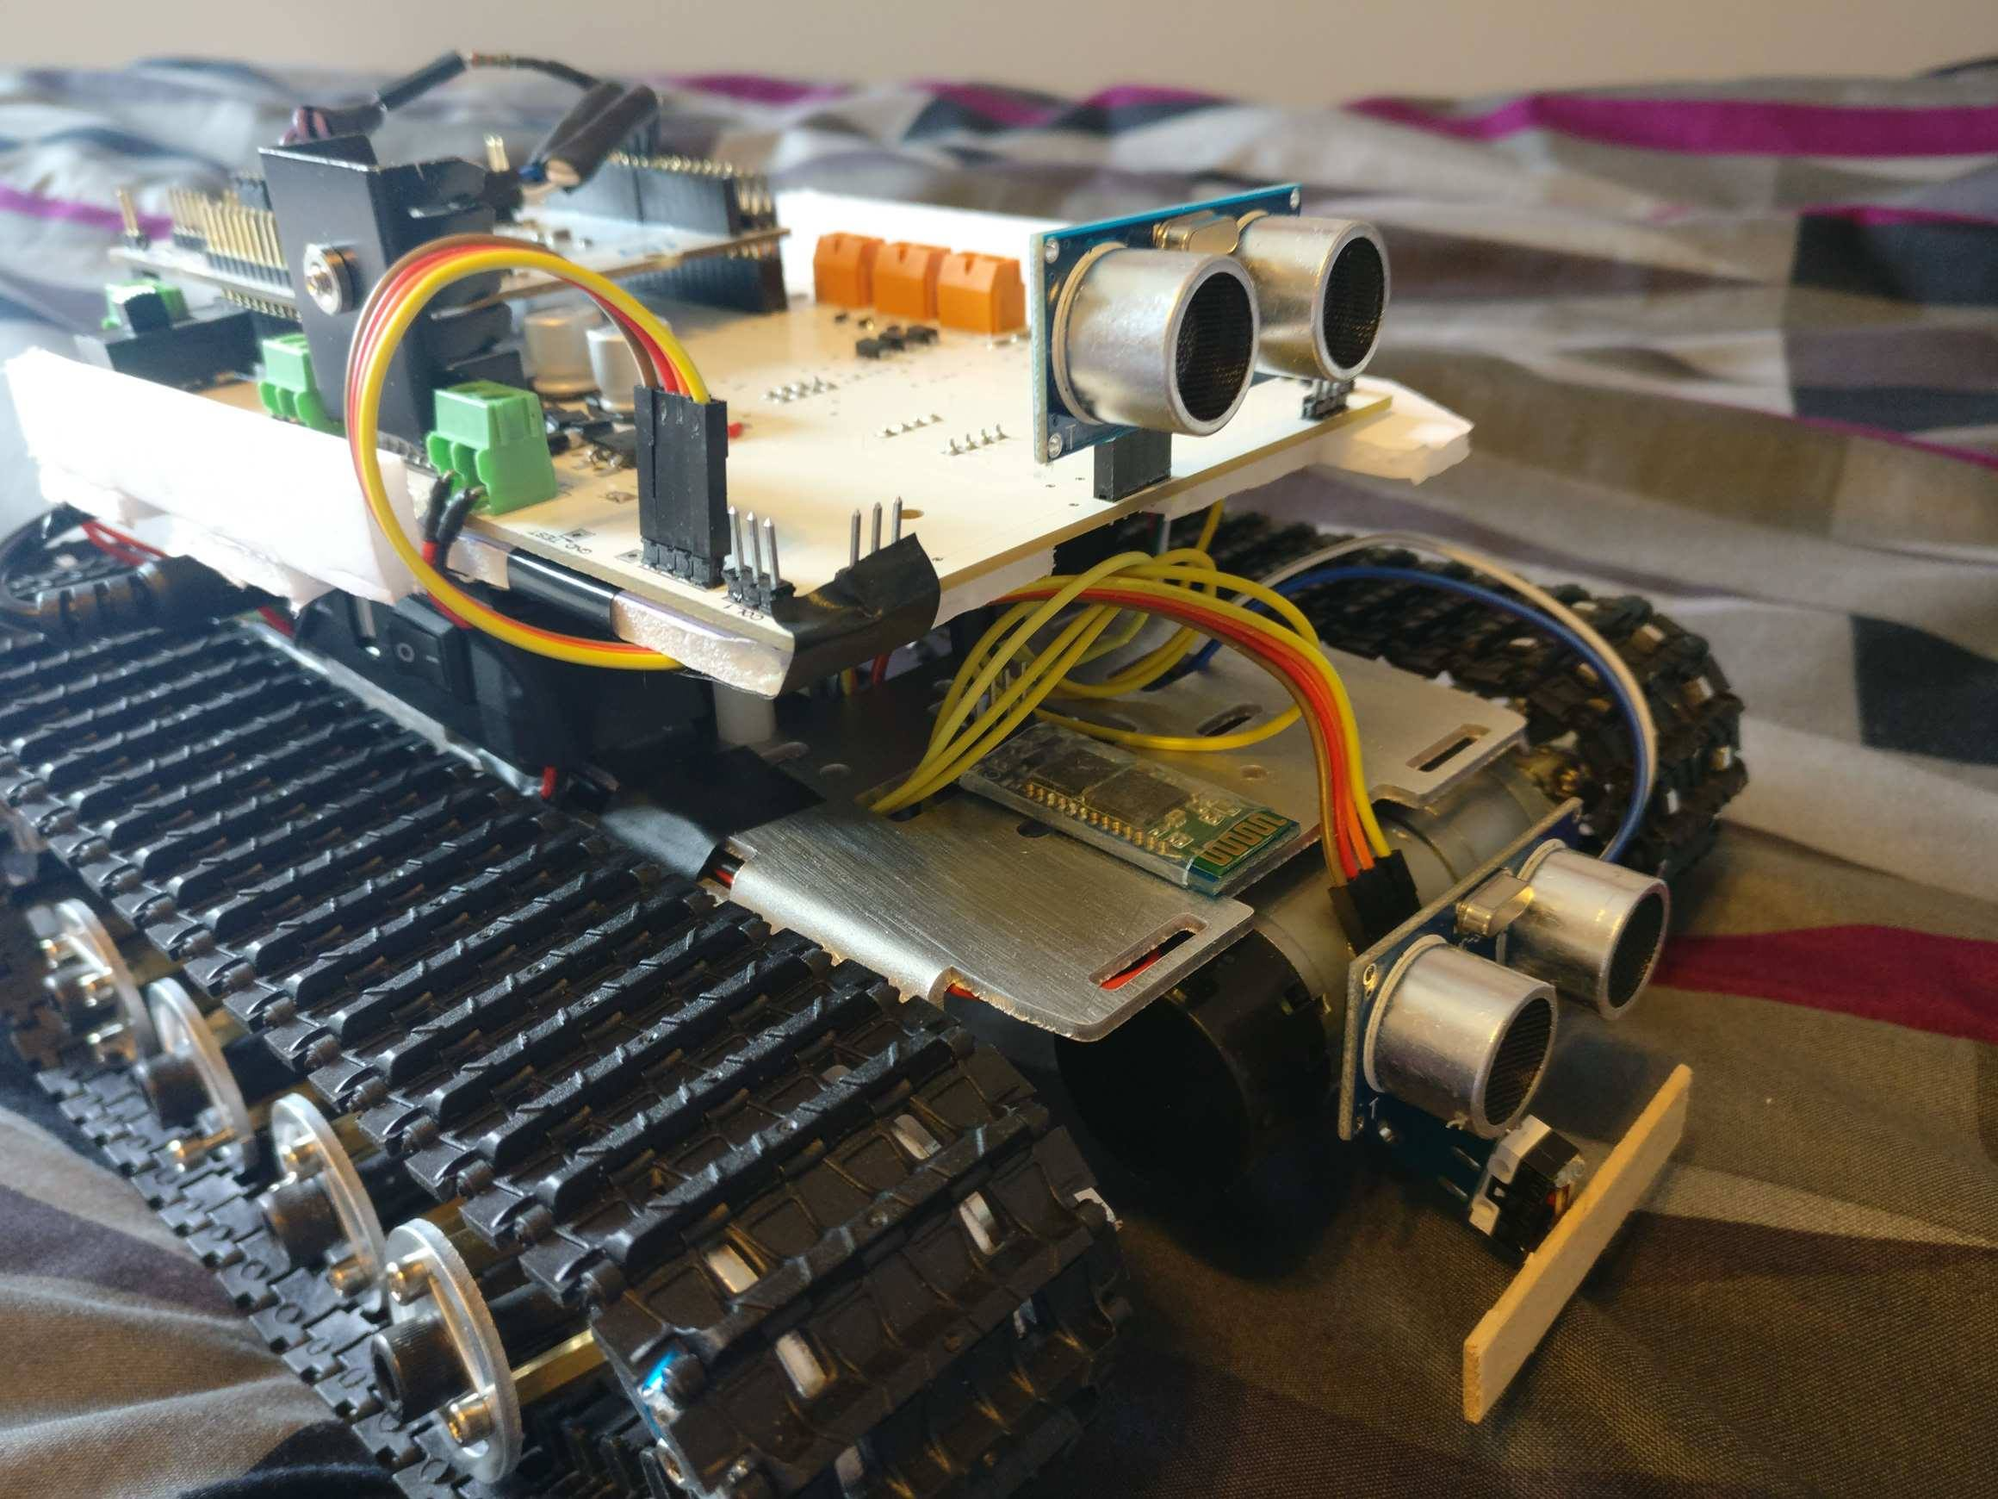

- Not a complete success; not a complete failure.
- Hardware was on-point. Software needed more work and time.
- GUI scope was not fully implemented (screenshots lost, will need to be remade).
- However, did have working motor control (RC car-like), working sensors, bluetooth, power management, weed whacker and water pump.
- Decent result considering lack of experience at the time.

Moving Forward (Version 2.0):
- Will seek superior chassis construction solutions. As opposed to paper-based construction, perhaps 3D-printed parts will prove more robust and adaptable.
- Software to be completely refactored. Now with more experience in software engineering methods/frameworks, closed-loop control systems, data algorithms and development for Android.
- Considering taking a look at AI-vision technology (via an SBC) as a means of expanding functionality in a way that is more scalable towards larger robotic units.

Document composed on 17th of March, 2023.

