**All Wedding Planning**



**Submitted By**

Abdullah Arshed

Shiraz Mazhar

2021-2025

**Institute of Computer Science**

**Khwaja Fareed University of Engineering & Information Technology**

**Rahim Yar Khan**

**2024**

**All Wedding Planning**

**Submitted to**

**Ms Humaira Anwar**

**Institute of Computer Science**

**In partial fulfilment of the requirements**

**For the degree of**

**Bachelor’s in Computer Science**

**By**

Abdullah Arshed

COSC211101028

Shiraz Mazhar

COSC211101034

Session 2021-2025

**Khwaja Fareed University of Engineering & Information Technology**

**Rahim Yar Khan**

**2024**

**DECLARATION**

We hereby declare that this project report is based on our original work except for citations and quotations which have been duly acknowledged. We also declare that it has not been previously and concurrently submitted for any other degree or award at Khwaja Fareed University of engineering & Information Technology or other institutions.

|  |  |  |  |
| --- | --- | --- | --- |
| Reg No : | _________________________ | Reg No : | _________________________ |
| Name : | _________________________ | Name : | _________________________ |
| Signature : | _________________________ | Signature : | _________________________ |
| Date : | _________________________ | Date : | _________________________ |

**APPROVAL FOR SUBMISSION**

I certify that this project report entitled ***All Weeding Planning*** was prepared by **Abdullah Arshed** and **Shiraz Mazhar** has met the required standard for submission in partial fulfilment of the requirements for the award of Bachelor’s in Computer Science at Khwaja Fareed University of Engineering & Information Technology.

Approved by:

**Signature :** _________________________

**Supervisor :** Ms. Humaira Anwar

**Date :** _________________________

**ACKNOWLEDGEMENT**

We would like to thank everyone who had contributed to this project. We would like to express our gratitude to our Project supervisor, *Ms Humaira Anwar* for her invaluable advice, guidance, and her enormous patience throughout the development of the project.

In addition, we would also like to express our gratitude to my/our loving parents and friends who had helped and given us encouragement.

**ABSTRACT**

**All Wedding Planning** is an all-inclusive digital platform designed to simplify the wedding planning process by offering a one-stop solution for all wedding-related services. This platform caters to the diverse needs of users by integrating services such as venue booking, catering, decorations, photography, and more under one virtual roof. By bringing together a wide range of vendors, All Wedding Planning eliminates the hassle of searching and coordinating with multiple service providers, offering a seamless and stress-free planning experience.

The platform is equipped with an automated bot assistant to handle user queries efficiently and provide immediate support. A comprehensive search functionality allows users to find services based on their location, preferences, and budget. To ensure a smooth experience, the system includes secure payment integration and automated email notifications to keep users informed about their bookings. Users can also leverage a personalized recommender system that offers tailored suggestions based on their preferences and history, enhancing the overall experience.

For business owners, **All Wedding Planning** offers opportunities to enlist their services and manage their listings effectively. The platform’s two-way communication system fosters transparent interactions between users and vendors, ensuring clarity and trust. With distinct user types and a feature-rich interface, All Wedding Planning is not just a wedding planning tool but a comprehensive ecosystem that transforms the complexities of wedding preparation into an enjoyable journey.

TABLE OF CONTENTS

Chapter 1 1

INTRODUCTION 1

1.1. Background 1

1.2. Introduction 1

1.3. Problem Statement 2

1.4. Objectives 2

1.5. Project Scope 3

1.6. Advantages of System 3

1.7. Relevance to the Study Program 3

1.8. Chapter Summary 4

Chapter 2 6

EXISTING SYSTEMS 6

2.1. Existing Systems 6

2.2. Drawbacks in Existing Systems 7

2.3. Examples of Existing Systems 8

2.4. Need to Replace Existing Systems 9

2.5. Chapter Summary 10

Chapter 3 11

REQUIREMENT ENGINEERING 11

3.1. Proposed System 11

3.2. Understanding the System 11

3.2.1. User Involvement 11

3.2.2. Stakeholders 12

3.2.3. Domain 12

3.2.4. Needs of System 12

Table 3.1 User Needs of System 12

3.3. Requirement Engineering 13

3.3.1. Functional Requirements 13

Table 3.2 Functional Requirement 01 13

Table 3.3 Functional Requirement 02 13

Table 3.4 Functional Requirement 03 14

Table 3.5 Functional Requirement 04 14

Table 3.6 Functional Requirement 05 15

Table 3.7 Functional Requirement 06 15

Table 3.8 Functional Requirement 07 15

Table 3.9 Functional Requirement 08 16

Table 3.10 Functional Requirement 09 16

Table 3.11 Functional Requirement 10 17

Table 3.12 Functional Requirement 11 17

Table 3.13 Functional Requirement 12 18

3.3.2. Non-Functional Requirements 18

3.3.3. Requirements Baseline 19

3.3.4. Need to Feature Mapping 19

3.4. Gantt Chart 20

3.5. Hurdles in Optimizing the Current System 20

3.6. Chapter Summary 21

Chapter 4 23

DESIGN 23

4.1. Software Process Model 23

4.1.1. Benefits of Selected Model 23

4.1.2. Limitations of Selected Model 24

4.2. Design 25

4.2.1. Methodology of the Proposed System 25

4.2.2. Entity Relationship Diagram 26

4.2.3. UML Diagrams 27

4.2.3.1. Use Case Diagram of the System 27

4.2.3.2. Class Diagram of the System 28

4.2.3.3. Activity Diagram of the System 29

4.2.3.4. Sequence Diagram of the System 30

4.2.3.5. Component Diagram of the System 30

4.3. Chapter Summary 31

# 

## INTRODUCTION

### Background

Wedding planning is often a complex and time-consuming process that involves coordinating numerous services, such as venue selection, catering, photography, and decorations. Traditionally, this process requires using multiple platforms and services, leading to inefficiencies and potential miscommunications. Small and medium-sized wedding vendors also struggle to compete in a crowded market, relying on outdated marketing methods and manual systems to manage bookings.

"All Wedding Planning" is designed to address these challenges by offering a centralized platform that integrates all wedding services into one user-friendly system. The platform allows users to easily search, compare, and book vendors, while providing real-time communication, secure payments, and a review system. It empowers vendors by giving them a digital presence and efficient tools to manage their services. Through personalized recommendations and dynamic pricing, "All Wedding Planning" provides a tailored experience for both users and vendors, streamlining the planning process and improving the overall wedding experience.

### Introduction

Weddings are monumental events, celebrated across cultures and societies with great enthusiasm and detail. However, the process of planning a wedding is often daunting, involving multiple decisions, extensive coordination, and significant financial investment. The traditional methods of wedding planning, though effective in smaller setups, struggle to meet the demands of modern couples who seek convenience, variety, and transparency.

The **All Wedding Planning** is introduced as a transformative platform designed to address these challenges. It provides users with access to a wide range of wedding services, including venues, catering, decorations, and photography, all integrated within a single platform. Businesses, on the other hand, benefit from tools that enable them to showcase their services, manage bookings, and engage with customers in real time.

This chapter sets the foundation for understanding the **All Wedding Planning** by exploring its background, identifying the gaps it aims to fill, and outlining its objectives, scope, and advantages.

### Problem Statement

Wedding planning is inherently complex due to the involvement of multiple vendors and service providers. Existing methods—both traditional and digital—fall short in addressing the needs of modern users. Couples often face the following challenges:

1. **Fragmented Platforms**: The absence of a single platform means users must rely on multiple tools to book different services.
2. **Time and Effort**: Researching vendors, comparing prices, and making bookings manually require significant effort.
3. **Transparency Issues**: The lack of reliable reviews and ratings makes it difficult for users to trust service providers.
4. **Limited Communication**: Traditional methods rely on in-person meetings or phone calls, while most digital platforms lack real-time communication tools.

For businesses, the challenges include limited visibility, inefficient booking systems, and difficulties in engaging with customers. The **All Wedding Planning** aims to resolve these issues by creating an integrated, user-friendly, and transparent platform.

### Objectives

The primary objectives of the **All Wedding Planning** are:

1. **To provide a centralized platform**: Users can search, book, and pay for wedding services such as venues, catering, and photography in one place.
2. **To enhance transparency**: A review and rating system ensures that users can make informed decisions.
3. **To streamline communication**: Real-time chat enables users and businesses to interact directly, fostering better coordination.
4. **To empower businesses**: Service providers can manage their listings, track bookings, and engage with customers efficiently.

**To ensure secure transactions**: Integration with Stripe provides a reliable payment system for users and businesses alike.

### Project Scope

The **All Wedding Planning** will include the following functionalities:

* **User Role**:
  + Registration, profile management, and personalized recommendations.
  + Searching and filtering services by category, price, and location.
  + Making bookings and payments securely online.
  + Leaving reviews and ratings to help other users.
* **Business Role**:
  + Creating profiles and listing services with descriptions, images, and pricing.
  + Managing bookings and responding to customer queries.
  + Tracking reviews and improving service offerings.
* **Core Features**:
  + Advanced search and filtering.
  + Secure payment gateway integration.
  + Real-time chat system for communication.
  + Review and rating system for transparency.

### Advantages of System

1. **Efficiency**: Reduces the time and effort required for wedding planning.
2. **Transparency**: Builds trust through reviews and ratings.
3. **Scalability**: Provides businesses with tools to reach a broader audience.
4. **Convenience**: Offers users a single platform for all wedding services.
5. **Security**: Ensures safe transactions through Stripe.

### Relevance to the Study Program

This project aligns with key areas of computer science, including:

* **Web Development**: Creation of a responsive, user-friendly platform.
* **Database Design**: Efficient management of user, service, and booking data.
* **Payment Integration**: Real-world application of secure online payment systems.
* **System Design**: Development of a scalable, maintainable architecture.

### Chapter Summary

This chapter presented a detailed introduction to the **All Wedding Planning**, a comprehensive and innovative platform designed to streamline the complexities of wedding planning. Weddings, being one of the most significant and memorable events in a person’s life, require meticulous coordination of multiple services such as venues, catering, decorations, photography, and entertainment. However, traditional wedding planning methods and existing fragmented digital solutions often fail to address the holistic needs of users and businesses.

The chapter began by exploring the **background** of wedding planning and highlighted the increasing reliance on technology to simplify the process. It emphasized the inefficiencies of traditional approaches, which rely heavily on manual communication, limited recommendations, and offline transactions. These conventional methods often lead to time wastage, miscommunication, and a lack of trust in service providers. Similarly, the limitations of existing digital platforms, which lack integration and focus on specific niches, were also discussed.

The **problem statement** underscored the challenges faced by users and businesses in the current wedding planning ecosystem. Users often struggle with finding and booking reliable service providers due to fragmented systems that lack transparency and efficiency. Businesses, on the other hand, face barriers in reaching their target audience and managing bookings effectively. The absence of a unified platform further complicates matters, resulting in a disjointed experience for all stakeholders involved.

To address these issues, the **All Wedding Planning** was introduced as a **one-stop solution** designed to cater to the needs of both users and businesses. The **objectives** of the platform were laid out, emphasizing its role in integrating advanced functionalities such as a secure payment gateway powered by Stripe, real-time communication through a chat system, and a transparent review and rating mechanism. These features not only simplify the process for users but also empower businesses to manage their services effectively and expand their reach.

The **scope** of the project was elaborated to include functionalities for both users and businesses. Users can search, filter, and book services based on their preferences, while businesses can list their offerings, manage bookings, and interact directly with customers. The platform also includes core features such as advanced filtering, secure online transactions, and transparent feedback mechanisms that foster trust and reliability in the system.

The **advantages** of the system were highlighted, showcasing its ability to address inefficiencies in traditional wedding planning methods. By offering a centralized platform, the **All Wedding Planning** saves time, enhances transparency, ensures security, and provides an equal opportunity for businesses of all sizes to compete and grow. The platform not only benefits users by simplifying their wedding planning journey but also creates value for businesses by improving their visibility and operational efficiency.

# 

## EXISTING SYSTEMS

### Existing Systems

The wedding planning industry has seen a significant shift toward digital solutions over the past decade. Platforms have emerged to help couples and families discover, compare, and book various services, ranging from venues to caterers, decorators, photographers, and more. These systems aim to reduce the manual effort involved in wedding planning while providing a wide variety of choices.

However, most existing systems cater to specific niches or limited functionalities, which leaves users juggling multiple platforms to fulfill their wedding needs. For example, some platforms specialize in listing venues, while others focus solely on catering or freelance services. Although these platforms have streamlined certain aspects of wedding planning, they fail to offer a comprehensive, integrated experience.

Some of the key types of existing systems include:

1. **Vendor Listing Platforms**: Websites or apps that compile directories of service providers, allowing users to search and contact vendors. Examples include **WeddingWire** and **The Knot**.
2. **Freelance Platforms**: General-purpose freelancing websites, such as **Fiverr** or **Upwork**, where users can hire photographers, decorators, or other wedding-related professionals.
3. **Event Management Apps**: Tools designed for managing guest lists, creating schedules, or sending invitations, such as **Eventbrite** or **Zola**.

While these systems offer valuable functionalities, their fragmented nature limits their ability to fully meet the needs of users and businesses.

### Drawbacks in Existing Systems

Despite their usefulness, existing systems come with several significant drawbacks that hinder their ability to provide a seamless and efficient wedding planning experience. These limitations include:

1. **Fragmentation**  
   Most platforms cater to specific aspects of wedding planning, such as finding venues or hiring photographers, leaving users to rely on multiple systems to meet all their needs. This fragmented approach increases the time and effort required to plan a wedding.
2. **Lack of Integration**  
   Existing systems often do not integrate core functionalities such as booking, payment processing, and communication. For example, users might find a vendor on one platform, contact them via email or phone, and complete the payment offline, leading to inefficiencies and potential miscommunication.
3. **Limited Search and Filter Options**  
   While many platforms allow users to search for vendors, their filtering options are often basic. Users cannot always search based on specific criteria such as availability, budget, or service quality, making it harder to find the best fit for their needs.
4. **Inconsistent Reviews and Ratings**  
   Reviews on existing platforms are often incomplete or unreliable, as there are no strict mechanisms to ensure authenticity. This lack of transparency makes it difficult for users to assess the quality of services before making a decision.
5. **No Real-Time Communication**  
   Many platforms lack built-in communication tools, forcing users to rely on external methods such as phone calls or emails. This slows down the decision-making process and increases the chances of miscommunication.
6. **Limited Support for Businesses**  
   Service providers, particularly small and medium-sized businesses, often struggle to create visibility on existing platforms. They lack tools to manage bookings efficiently, update service availability, or respond to customer inquiries in real time.

These drawbacks underline the need for a unified platform that integrates all aspects of wedding planning, offering convenience and transparency for both users and businesses.

### Examples of Existing Systems

1. **Wedding Wire :**
   * **Features**: WeddingWire provides a directory of wedding vendors, including venues, photographers, and caterers. Users can search by location and read reviews.
   * **Drawbacks**: It lacks integrated booking and payment systems, requiring users to contact vendors externally. The review system is not always reliable, and there are limited options for real-time communication.
2. **The Knot :**
   * **Features**: Similar to WeddingWire, The Knot offers a vendor directory along with planning tools like budget calculators and checklists.
   * **Drawbacks**: While it helps users organize their wedding, it does not offer direct booking or communication tools. Businesses also face challenges in managing inquiries efficiently.
3. **Fiverr/Upwork :**
   * **Features**: These platforms connect users with freelance professionals for services like photography or decoration.
   * **Drawbacks**: They are not wedding-specific, and users must sift through unrelated listings to find relevant professionals. Additionally, there is no support for integrated planning or payment processes.

These examples highlight the fragmented nature of existing systems and their inability to provide a comprehensive solution for wedding planning.

### Need to Replace Existing Systems

Given the limitations of current platforms, there is a clear need for a comprehensive system that integrates all aspects of wedding planning. The **All Wedding Planning** seeks to replace existing systems by addressing their shortcomings and offering the following advantages:

1. **Unified Platform:**  
   By combining vendor directories, booking tools, payment systems, and communication features into one platform, the **All Wedding Planning** eliminates the need for users to rely on multiple systems.
2. **Advanced Search and Filtering:**  
   The platform will allow users to search for services based on specific criteria such as city, price range, availability, and service quality, ensuring a tailored experience.
3. **Integrated Booking and Payments:**  
   Unlike existing systems, the **All Wedding Planning** will support seamless booking and secure online payments via Stripe, reducing inefficiencies and errors.
4. **Real-Time Communication:**  
   A built-in chat system will enable users and businesses to interact directly, fostering better coordination and faster decision-making.
5. **Transparent Reviews and Ratings:**  
   The platform will implement strict mechanisms to ensure the authenticity of reviews, helping users make informed decisions.
6. **Business Empowerment:**  
   Businesses will benefit from tools to manage their profiles, update availability, track bookings, and engage with customers, enabling them to grow and operate more effectively.

By addressing the shortcomings of existing systems, the **All Wedding Planning** aims to redefine the wedding planning experience for users and businesses alike.

### Chapter Summary

This chapter provided an analysis of existing wedding planning systems, highlighting their strengths and weaknesses. While platforms like WeddingWire and The Knot have made strides in simplifying certain aspects of wedding planning, their fragmented nature and lack of integration limit their effectiveness. The chapter also examined the challenges faced by users and businesses when using these systems, including inefficiencies in communication, limited functionality, and inconsistent reviews.

The **All Wedding Planning** was introduced as a solution to these challenges, offering a unified platform that integrates advanced features such as secure payments, real-time communication, and transparent reviews. By addressing the drawbacks of existing systems, the platform seeks to enhance the wedding planning experience and empower businesses to reach their full potential. The next chapter will focus on the requirements and design of the **All Wedding Planning**, setting the stage for its development.

# 

## REQUIREMENT ENGINEERING

### Proposed System

The proposed system, **All Wedding Planning**, is designed to simplify the wedding planning process by consolidating various services into a single platform. Users can access multiple services, such as venue booking, catering, photography, and decorations, without the need to navigate fragmented systems or offline solutions. The platform bridges gaps in existing systems by integrating search functionality, booking management, payment gateways, and real-time communication tools. The system prioritizes user-friendliness, transparency, and operational efficiency to redefine the wedding planning experience for users and businesses alike.

The primary aim of this project is to offer a seamless solution that addresses the challenges of fragmented service platforms, limited vendor visibility, and inefficient booking mechanisms. Through advanced features like secure payments, personalized recommendations, and a centralized dashboard, the system ensures accessibility and ease of use for all stakeholders.

### Understanding the System

To fully grasp the functionality and design of the proposed system, it's important to understand the roles of users, the stakeholders involved, and the domain in which the system operates.

#### User Involvement

Users play a critical role in shaping the system through feedback and participation during design and testing. Personas and user stories will be used to align the system's functionalities with user needs, ensuring a user-friendly interface and experience.

#### Stakeholders

The stakeholders of the proposed system include internal and external parties with varying interests in the system’s success:

* **Internal Stakeholders**: Project team, developers, and management.
* **External Stakeholders**: Service users, businesses, and regulatory authorities.

Understanding each stakeholder’s requirements and expectations will help in prioritizing features and setting realistic timelines for development.

#### Domain

The domain encompasses wedding planning services, including venue booking, catering, decorations, and photography. The platform integrates these services for efficient planning and execution.

#### Needs of System

To develop the system, it’s important to define the specific needs that the system must meet. These needs are captured in the following table:

### Table ‎3.1 User Needs of System

|  |  |  |
| --- | --- | --- |
| SR # | Needs | Need ID |
| 1 | Centralized platform for all services | N-001 |
| 2 | Payment System | N-002 |
| 3 | Real-time communication tools | N-003 |
| 4 | Review and rating system | N-004 |

### Requirement Engineering

#### Functional Requirements

### Table ‎3.2 Functional Requirement 01

|  |  |
| --- | --- |
| Functional Requirement ID | FR-01 |
| Name | Admin Dashboard |
| Description | Provides a unified platform where users can access and manage all wedding-related services from one dashboard. |
| Input | User login credentials, service selection. |
| Output | User dashboard with available services. |
| Precondition | User must have a registered account and be logged in. |
| Postcondition | User gains access to a personalized dashboard with relevant service options. |

### Table ‎3.3 Functional Requirement 02

|  |  |
| --- | --- |
| Functional Requirement ID | FR-02 |
| Name | Payment System |
| Description | Processes secure online transactions for booking services through an integrated payment gateway. |
| Input | Payment details (card info, amount, vendor ID). |
| Output | Transaction confirmation or failure message. |
| Precondition | Service must be selected, and payment method must be valid. |
| Postcondition | Payment is processed, and a receipt is generated for the user. |

### Table ‎0.4 Functional Requirement 03

|  |  |
| --- | --- |
| Functional Requirement ID | FR-03 |
| Name | Real-Time Chat |
| Description | Enables instant communication between users and vendors for inquiries and bookings. |
| Input | Messages entered by users or vendors. |
| Output | Real-time message exchange. |
| Precondition | User and vendor must be registered on the platform. |
| Postcondition | Message history is saved, and both parties can continue communication. |

### Table ‎0.5 Functional Requirement 04

|  |  |
| --- | --- |
| Functional Requirement ID | FR-04 |
| Name | Review System |
| Description | Allows users to provide feedback and rate vendors after utilizing their services. |
| Input | User rating and comments. |
| Output | Average rating and visible user reviews for vendors. |
| Precondition | User must have completed a booking with the vendor. |
| Postcondition | Reviews and ratings are updated on the vendor’s profile. |

### Table ‎0.6 Functional Requirement 05

|  |  |
| --- | --- |
| Functional Requirement ID | FR-05 |
| Name | AI Recommendations |
| Description | Provides personalized service suggestions based on user preferences and booking history. |
| Input | User preferences, location, and past booking data. |
| Output | List of recommended services and vendors. |
| Precondition | User must have some interaction history or set preferences. |
| Postcondition | Recommendations are updated based on user activity. |

### Table ‎0.7 Functional Requirement 06

|  |  |
| --- | --- |
| Functional Requirement ID | FR-06 |
| Name | Vendor Dashboard |
| Description | Enables vendors to manage service listings, track bookings, and respond to user queries. |
| Input | Vendor account credentials, service details. |
| Output | Dashboard with booking and service management tools. |
| Precondition | Vendor must have a verified account. |
| Postcondition | Services and bookings are updated based on vendor actions. |

### Table ‎0.8 Functional Requirement 07

|  |  |
| --- | --- |
| Functional Requirement ID | FR-07 |
| Name | Advanced Search |
| Description | Allows users to filter and search for services based on location, price range, and category. |
| Input | Search filters and keywords. |
| Output | Filtered list of services matching criteria. |
| Precondition | Relevant services must exist on the platform. |
| Postcondition | Users receive a tailored list of services. |

### Table ‎0.9 Functional Requirement 08

|  |  |
| --- | --- |
| Functional Requirement ID | FR-08 |
| Name | Dynamic Pricing |
| Description | The system allows vendors to set dynamic pricing for their services based on factors such as demand, seasonality, or booking time. |
| Input | Vendor input for pricing rules (e.g., price adjustments for peak seasons). |
| Output | Updated service prices based on dynamic pricing rules. |
| Precondition | Vendor must be registered and have active services listed. |
| Postcondition | Service prices are updated in real-time based on dynamic pricing criteria. |

### Table ‎0.10 Functional Requirement 09

|  |  |
| --- | --- |
| Functional Requirement ID | FR-09 |
| Name | Multi-Language Support |
| Description | Provides an interface in multiple languages to cater to a diverse user base. |
| Input | Language preference settings. |
| Output | Translated interface in the selected language. |
| Precondition | User must select a preferred language. |
| Postcondition | The platform operates in the chosen language. |

### Table ‎0.11 Functional Requirement 10

|  |  |
| --- | --- |
| Functional Requirement ID | FR-10 |
| Name | Notification System |
| Description | Sends timely notifications to users for booking updates, payment reminders, and service alerts. |
| Input | Trigger events (e.g., booking confirmed, payment due). |
| Output | Email, SMS, or app notification to the user. |
| Precondition | Notification triggers must be set up and active. |
| Postcondition | Users receive relevant notifications on time. |

### Table ‎0.12 Functional Requirement 11

|  |  |
| --- | --- |
| Functional Requirement ID | FR-11 |
| Name | Bot Assistant |
| Description | Provides automated responses to user queries, offering quick assistance and guidance on wedding services. |
| Input | User query or request. |
| Output | Relevant automated response or suggested actions. |
| Precondition | User must be logged in and accessing the platform. |
| Post condition | The bot provides a helpful response or directs the user to the appropriate service or information. |

### Table ‎0.13 Functional Requirement 12

|  |  |
| --- | --- |
| Functional Requirement ID | FR-12 |
| Name | Consultation Service |
| Description | Allows users and business owners to book consultation sessions for personalized advice on wedding planning or service management. |
| Input | User or vendor request for consultation. |
| Output | Scheduled consultation details (date, time, and topic). |
| Precondition | User or business owner must be registered on the platform. |
| Post condition | A consultation session is scheduled, and the user or business owner is notified with session details. |

#### Non-Functional Requirements

* **Performance:** System should handle at least 2000 concurrent users without significant degradation in performance.
* **Reliability:** The system must maintain 99.9% uptime to ensure constant availability.
* **Security:** The system must comply with global data privacy standards (e.g., GDPR, PCI-DSS) for secure user and payment data.
* **Usability:** System should provide an intuitive and easy-to-use interface for both technical and non-technical users.
* **Scalability:** The system must scale to accommodate growing users and new features without performance issues.
* **Availability**: The system should be available 24/7, especially during peak wedding seasons.
* **Maintainability**: The system should be easy to maintain with clear documentation and modular design.
* **Compatibility**: The system must be compatible with all modern browsers and mobile devices.
* **Localization**: The platform should support multiple languages and currencies to cater to a global audience.
* **Data Integrity**: Ensure that all user and transaction data remains accurate, consistent, and uncorrupted.

#### Requirements Baseline

**All Wedding Planning** system includes the final, approved version of both **functional** and **non-functional requirements** that will guide the design, development, and implementation of the platform. These requirements provide a clear and detailed specification of what the system must deliver and serve as the foundation for tracking progress and ensuring that the system meets all stakeholder needs.

#### Need to Feature Mapping

|  |  |  |  |  |  |
| --- | --- | --- | --- | --- | --- |
| # | N-001 | N-002 | N-003 | N-004 | N-005 |
| FR-01 | ✔ | 🗙 | ✔ | 🗙 | ✔ |
| FR-02 | 🗙 | ✔ | ✔ | ✔ | 🗙 |
| FR-03 | 🗙 | ✔ | ✔ | 🗙 | ✔ |
| FR-04 | ✔ | 🗙 | ✔ | ✔ | ✔ |
| FR-05 | ✔ | ✔ | ✔ | 🗙 | ✔ |
| FR-06 | 🗙 | ✔ | ✔ | ✔ | 🗙 |
| FR-07 | ✔ | 🗙 | ✔ | ✔ | ✔ |
| FR-08 | 🗙 | ✔ | ✔ | ✔ | ✔ |
| FR-09 | ✔ | ✔ | 🗙 | ✔ | 🗙 |
| FR-10 | ✔ | 🗙 | ✔ | ✔ | 🗙 |
| FR-11 | ✔ | 🗙 | 🗙 | 🗙 | ✔ |
| FR-12 | 🗙 | ✔ | ✔ | 🗙 | 🗙 |

### Gantt Chart

|  |  |  |  |  |  |  |  |  |
| --- | --- | --- | --- | --- | --- | --- | --- | --- |
| Activities | Sep | Oct | Nov | Dec | Jan | Feb | Mar | Apr |
| Planning |  |  |  |  |  |  |  |  |
| Requirements  Engineering |  |  |  |  |  |  |  |  |
| Design |  |  |  |  |  |  |  |  |
| Code |  |  |  |  |  |  |  |  |
| Testing |  |  |  |  |  |  |  |  |
| Delivery |  |  |  |  |  |  |  |  |

### Hurdles in Optimizing the Current System

This section highlights the potential challenges that might be encountered when optimizing the current system for "All Wedding Planning". These hurdles must be addressed to ensure smooth development, adoption, and long-term success of the platform.

* **Legacy System Limitations**: Since "All Wedding Planning" is introducing a unified platform for wedding services, it may need to integrate with legacy systems, such as individual vendor systems or outdated software used for bookings and payments. The existing systems may have technical debt, outdated technologies, or fragmented structures that make it difficult to integrate new features, such as real-time chat, AI-based recommendations, or secure payment gateways.
* **Data Migration**: Migrating data from various sources—such as vendor listings, user profiles, and booking histories—into the new system could be complex, especially when dealing with different data formats and structures. Ensuring that all historical data is accurately transferred while maintaining consistency and data integrity could pose a significant challenge, requiring careful mapping and testing to avoid data loss or corruption.
* **User Resistance**: Users (both couples planning weddings and service providers) may be used to traditional methods or older, fragmented platforms and may resist adopting the new "All Wedding Planning" platform. This resistance could come from vendors who are hesitant to change their existing systems for managing services and bookings or users who are comfortable with other tools. Overcoming this resistance would require clear communication of the platform's benefits, user-friendly design, and training materials.
* **Integration Issues**: "All Wedding Planning" will likely need to interface with third-party services like payment gateways (e.g., Stripe), email providers, or external APIs for features such as review management or vendor listings. Integrating these external services could require additional development, testing, and troubleshooting. Compatibility issues may arise, especially if third-party tools have different APIs, version updates, or security requirements, complicating integration and adding to the development timeline.

### Chapter Summary

Chapter 3, **Requirement Engineering**, laid the groundwork for the "All Wedding Planning" system by detailing the essential requirements for the platform. The chapter began with an overview of the **proposed system**, highlighting its goal to simplify the wedding planning process by consolidating various services, such as venue booking, catering, and photography, into a single platform. By bridging gaps in existing systems, the platform aims to improve search functionality, booking management, payment gateways, and communication tools, ensuring a seamless and user-friendly experience for both users and businesses.

The **understanding of the system** was further elaborated by identifying the roles of users, stakeholders, and the domain of wedding planning. It emphasized the importance of **user involvement** in shaping the platform’s features and functionality, with clear definitions of both **internal** and **external stakeholders**. The domain covers services such as venue selection, catering, and photography, all integrated into the platform for efficient planning.

The chapter proceeded with the **functional requirements** of the system, providing detailed descriptions of critical features, including secure payments, AI-based recommendations, real-time communication, vendor management, and more. Each feature was defined in terms of inputs, outputs, preconditions, and postconditions, ensuring clarity for developers and stakeholders.

**Non-functional requirements** were also defined, covering essential aspects like performance, scalability, security, usability, and availability. These requirements ensure that the system not only meets functional goals but also operates reliably and securely under various conditions.

The **requirements baseline** was established, marking the final, approved version of the functional and non-functional requirements. This serves as the foundation for the system's design and implementation. Additionally, the **need-to-feature mapping** was outlined to ensure that user needs are directly linked to system features.

The chapter concluded with an exploration of **hurdles in optimizing the current system**, identifying challenges such as legacy system limitations, data migration complexities, user resistance, and integration issues with third-party services. These hurdles must be addressed to ensure the smooth transition to the new platform.

Overall, Chapter 3 provided a comprehensive analysis of the system’s requirements, offering a clear roadmap for the development and optimization of "All Wedding Planning" to meet the needs of both users and businesses.

# 

## DESIGN

### Software Process Model

For the development of **All Wedding Planning**, the **agile software process model** is selected due to its flexibility, iterative approach, and focus on continuous improvement, which are essential for meeting the dynamic requirements of the wedding planning platform. The Agile model supports frequent updates, customer feedback, and iterative development cycles, making it ideal for a platform that needs to accommodate changing user demands and evolving features.

#### Benefits of Selected Model

The **Agile model** offers several key benefits for the development of "All Wedding Planning":

* **Flexibility and Adaptability**:  
  Agile's iterative nature allows the project to evolve with user feedback and market changes, ensuring that the platform can quickly adapt to new wedding industry trends and requirements.
* **Frequent Deliverables**:  
  With short sprints and incremental deliveries, the team can provide working features and updates regularly. This enables stakeholders to see progress early and throughout the development cycle.
* **User-Centric Development**:  
  Agile focuses on constant collaboration with stakeholders (including users, vendors, and business owners), which ensures that the platform meets their needs and expectations effectively.
* **Risk Reduction**:  
  By breaking the project into smaller chunks and having regular reviews, risks can be identified and mitigated early. This is crucial for minimizing issues like scope creep or missed deadlines.
* **Enhanced Quality**:  
  Agile emphasizes testing at each iteration, ensuring that bugs or issues are identified and fixed early, resulting in a higher-quality product upon delivery.
* **Faster Time-to-Market**:  
  Agile's iterative cycles allow for faster delivery of core features, enabling "All Wedding Planning" to reach users more quickly, and introduce necessary features sooner rather than waiting for a full product release.

#### Limitations of Selected Model

While the **Agile model** offers many benefits, there are certain limitations that must be considered for "All Wedding Planning":

* **Requires Strong Communication**:  
  Agile relies heavily on communication and collaboration among the development team and stakeholders. Any breakdown in communication can lead to misalignment with the user requirements or delays in development.
* **Constantly Changing Scope**:  
  Since Agile allows for flexibility and adaptability, there is a risk that the project scope might continuously change, leading to scope creep. This can make it difficult to define a clear final product and may delay the project if not properly managed.
* **Resource Intensive**:  
  Agile demands a high level of resource allocation, particularly in terms of team members' time and involvement. Frequent iterations and constant communication can be demanding for the development team.
* **Documentation Challenges**:  
  While Agile encourages working software over comprehensive documentation, for larger systems like "All Wedding Planning," it may be difficult to maintain the necessary documentation for the platform, which can impact long-term maintenance.
* **Difficult for Large Teams**:  
  As "All Wedding Planning" is a comprehensive platform with multiple features (payment integration, vendor management, etc.), managing a large Agile team can become complex, especially when ensuring all sub-teams align on the project’s goals and vision.

### Design

#### Methodology of the Proposed System

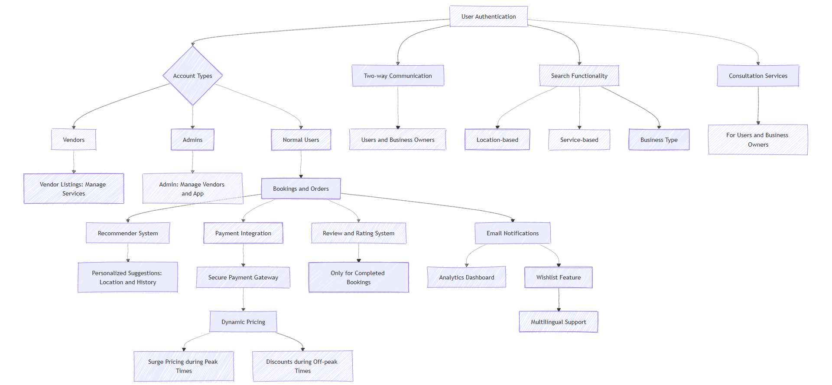

#### Entity Relationship Diagram

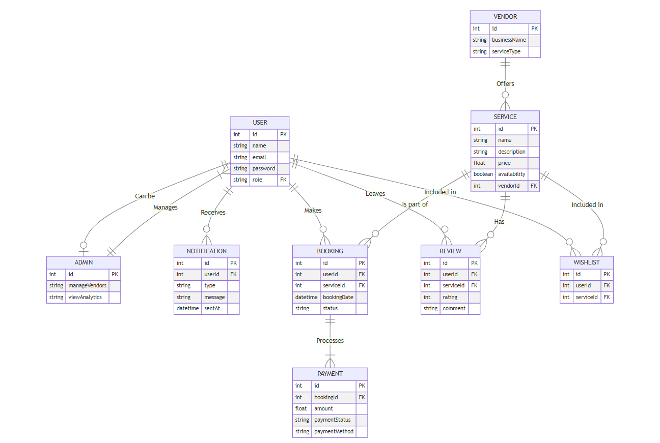

#### UML Diagrams

##### Use Case Diagram of the System

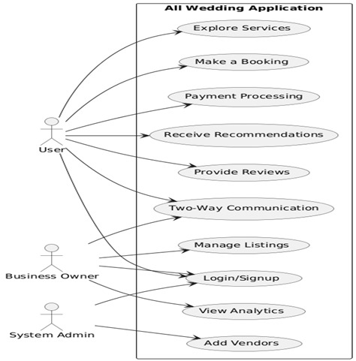

##### Class Diagram of the System

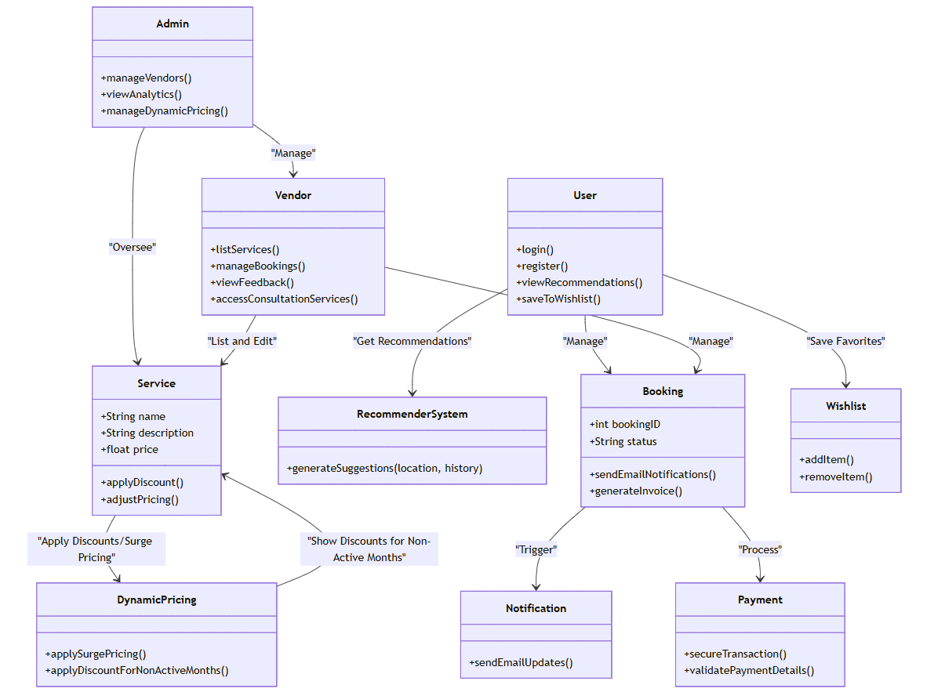

##### Activity Diagram of the System

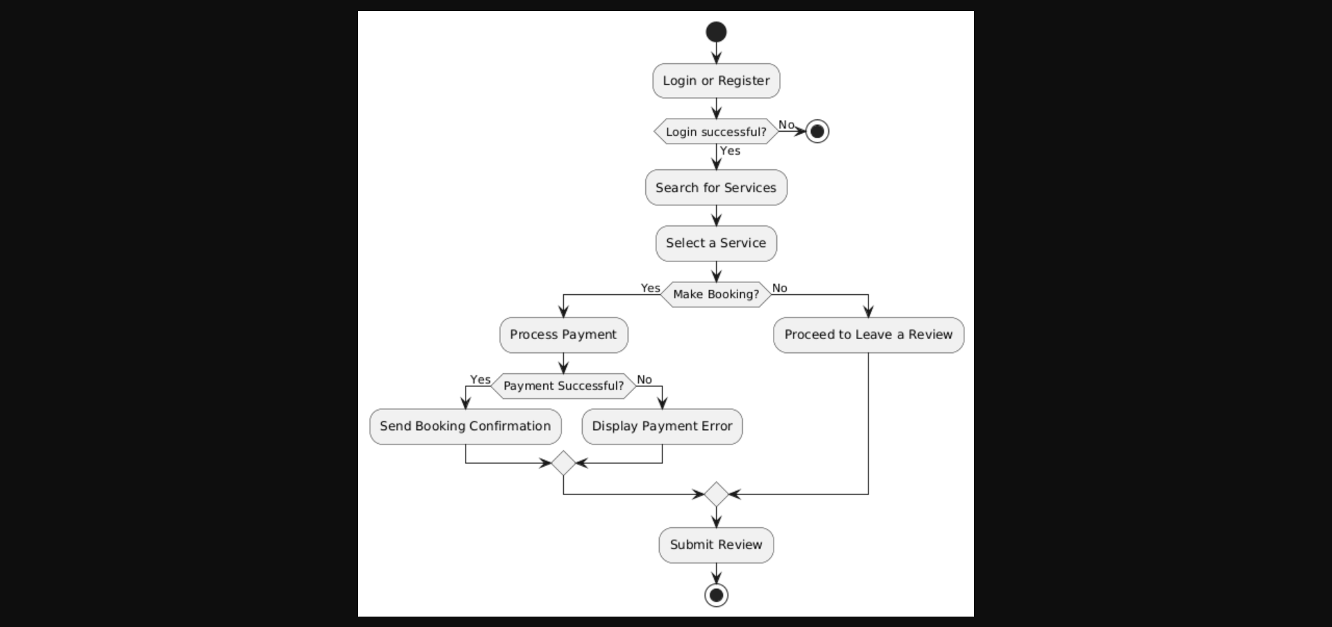

##### Sequence Diagram of the System

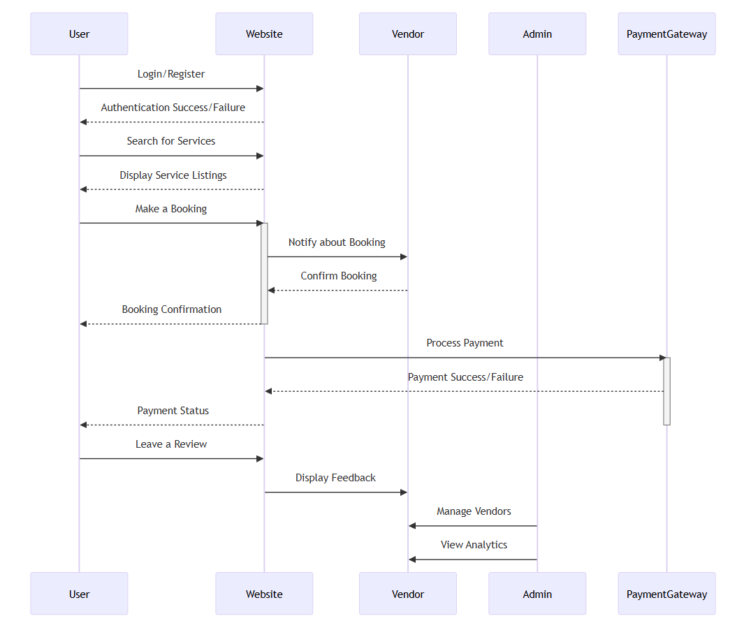

##### Component Diagram of the System

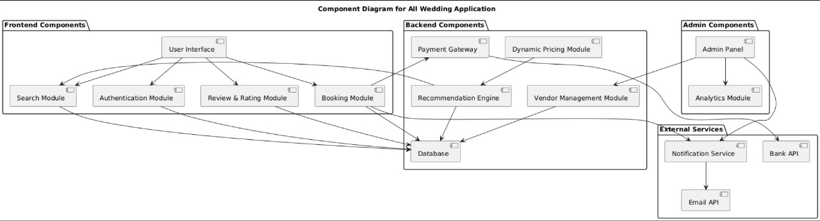

### Chapter Summary

Chapter 4, **Design**, focuses on the design phase of the "All Wedding Planning" system. The chapter begins by discussing the **software process model** used for development, which is the **Agile model**. Agile was selected due to its flexibility, iterative approach, and focus on continuous user feedback, making it suitable for the dynamic nature of wedding planning services.

The chapter outlines the **benefits of the Agile model**, including flexibility to accommodate changes, frequent delivery of features, user-centric development, and faster time-to-market. These advantages are particularly important for developing a platform that needs to evolve based on user demands and market trends.

However, the **limitations of the Agile model** are also addressed, such as challenges in managing constantly changing scope, resource-intensive requirements, and potential difficulties in maintaining proper documentation. These limitations must be managed to ensure smooth project execution.

Overall, the chapter establishes that Agile's benefits outweigh its limitations for the "All Wedding Planning" platform, ensuring the project stays responsive to user needs and able to deliver new features quickly. The design phase will continue to evolve based on user feedback, allowing the platform to remain adaptable and user-focused throughout development.