Name: Ryan Zhang

Date: 4/29/22

Wireshark Network Analysis Project

# Ethernet (Data Link Layer)

**Source MAC address (NO SHOW):**

**Destination MAC address:**

Cisco_c6:76:80 or e8:65:49:c6:76:80

# IP (Network Layer)

**ARP Traffic:**

**Source IP address (NO SHOW), company, geo location:**

# TCP (Transport Layer)

**Show a Three-Way Handshake, and the delay time between Request and ACK.**

**Show a Four-Way Handshake.**

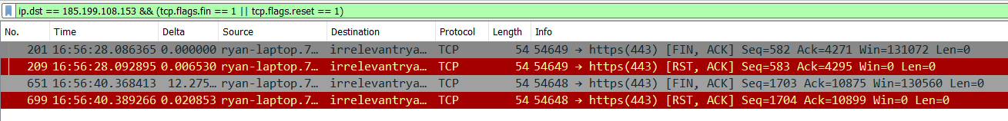

# HTTP (Application Layer)

**Show HTTP traffic.**



**Show how the Sequence numbers and acknowledge numbers are calculated.**

**(I did a different website because my website was too complex)**

|  |  |  |  |
| --- | --- | --- | --- |
| **No.** | **Syn** | **Ack** | **Length** |
| **1** | **0** | **0** | **0** |
| **2** | **0** | **1** | **0** |
| **3** | **1** | **1** | **0** |
| **4** | **1** | **1** | **258** |
| **5** | **1** | **259 (syn4 + len4)** | **0** |
| **6** | **1** | **259 (syn5 + len5)** | **197** |
| **7** | **259 (ack6)** | **198 (syn6 + len6)** | **0** |
| **8** | **198 (ack7)** | **259 (syn7 + len7)** | **1139** |
| **9** | **259 (ack8)** | **1337 (syn8 + len8)** | **0** |