# Add checkStyle schematron as default validation for XSLT files in oXygen ©

## Create a new rule for Document Type Association

Tools > Preference > “Document Type association”

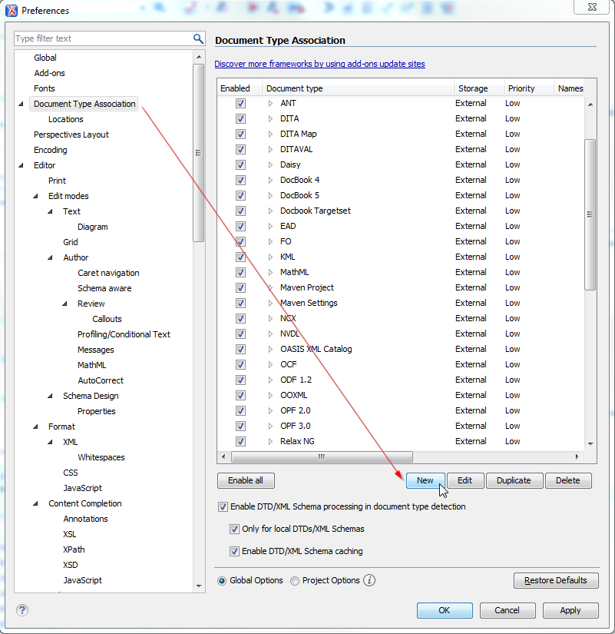

* Give a name to the association “ELS:checkXSLTstyle.sch” for example ;
* Add a new association rule ;
* Add an namespace rule mapped to the xslt namespace (<http://www.w3.org/1999/XSL/Transform>) :

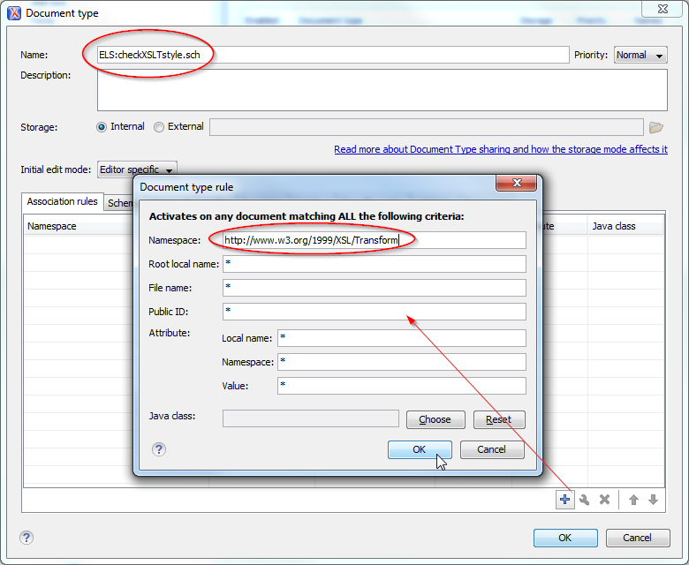

* Go to validation tab ;
* Add a new validation Scenario ;
* Give it a name “els:checkXSLTstyle.sch” ;
* Give it the path of checkXSLTstyle.sch on your local drive :

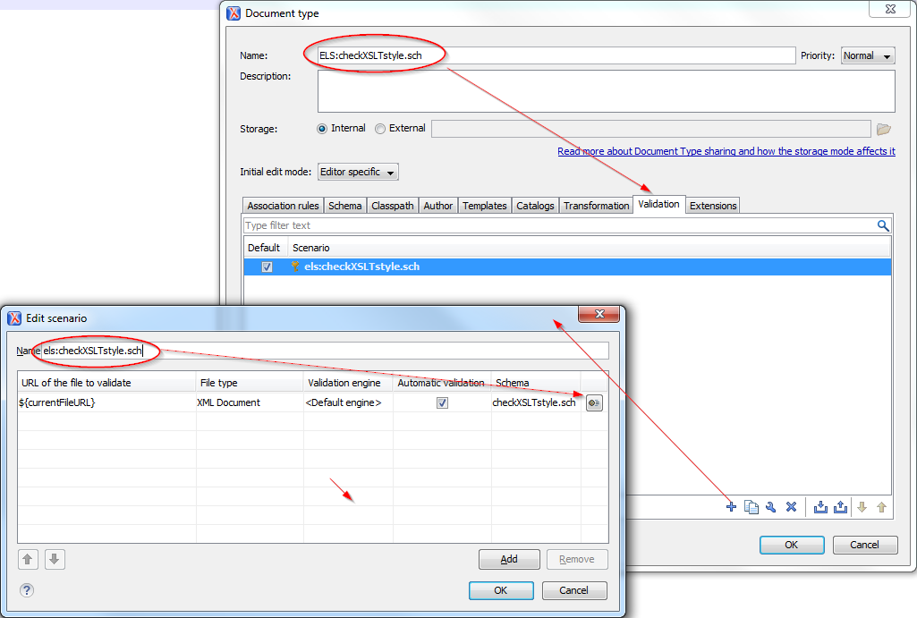

Click OK : Now when tou open a XSLT file, le schematron will be automatically applied !